Smart Blind Stick Using Arduino & Ultrasonic Sensor

Dr. S. I. Bakhtar1,Aditya V.Zade2,Arpan A,Kaithwas3,Aditya A.Walke4,Dinesh S.Malve5,Gufran Ali.Khan6

Assistant Professor in Electronics & Telecommunication Department,

Prof Ram Meghe College of Engineering and Management, Amravati (Maharashtra)1,

Third Year Student in Electronics & Telecommunication Department,

Prof Ram Meghe College of Engineering and Management, Amravati (Maharashtra)23456

Abstract:

TheprojectdescribesultrasonicblindwalkingstickwiththeuseofArduinouno.AccordingtoWorldHealthOrganization (WHO),30 millionpeoplearepermanentlyblindand2.85millionpeoplewithvisionimpairment.Ifyounoticethem,youcanverywellknowabout ittheycan'twalk withoutthehelpofother. Onehastoaskguidancetoreach theirdestination. Theyhavetofacemorestrugglesintheir lifedailylife. Using this blind stick, aperson can walkmore confidently. This stick detects theobject in front of the person and give responsetotheusereitherbyvibratingorthroughcommand.So,thepersoncanwalkwithoutanyfear.Thisdevicewillbebestsolution toovercometheirdifficulties. Wearegoingtoupgradetheproject byincreasing itsapplication. Inthisproject,wearegoingtousetwo ultrasonic sensors. Sonow, thissmart stick willhave an ultrasonic sensor tosensedistance from any obstacle andaRFremote using which the blind man could remotely locate his stick.

**Keywords:**Arduinouno,ultrasonicsensors,RFremote.

1. INTRODUCTION:

Visually impaired people arethe people whofindsitdifficult torecognize the smallest detail with healthy eyes. Those who have the visual acuteness of 6/60 or the horizontal range of the visual field with both eyes open have less than or equal to20 degrees. These peopleareregardedasblind.AsurveybyWHO(World HealthOrganization) carriedoutin2011estimatesthatintheworld,about1% of thehuman population isvisuallyimpaired (about70million people) andamongst them,about10% arefully blind (about7million people) and 90% (about 63 million people) with low vision. The main problem with blind people is how to navigate their way to wherever they want togo. Such people need assistance Aom others with good eyesight. Asdescribed byWHO, 10% of the visually impaired have nofunctional eyesight at all tohelp them move around without assistance and safely.

This study proposes a improved techniquefordesigningasmartsticktohelpvisuallyimpairedpeoplefortheirnavigation.Inthissystem,theultrasonicsensorsareused todetect obstacles byusingultrasonic waves. Bysensingtheobstacles, thesensor passesthereceived datatothemicrocontroller.The microcontroller processes the data and calculates if the obstacle is close enough to the person. If the obstacle is not close to the microcontroller,thecircuitdoes notdoanything. If theobstacle iscloseenough tothemicrocontroller,itsendsasignal tobuzzer. The systemconsistsoftwoultrasonicsensors,oneforthedetectinganyobstaclesinthepathofnavigationandtheotheroneisusedtodetect pits (by finding the depth). We can assign two different buzzers for two ultrasonic sensors respectively. We are also using an RF transmitter and receiver as aremote, tofind the stick when itis misplaced.

Ultrasonicsensorsusuallyworkinthefrequencyrangeof40 to70KHz.Theyhavearangeofmeasurement from2cmto5m.Wearegoingtouseawireless RFmoduleinthissystemandgenerally ithasarange of 50m. Therangeof RFdepends on thetype of module and it varies upto150m.

# LITERATURESURVEY:

* 1. Smart walking stick - An electronic approach toassist visually disabled persons byMohammad Hazzaz Mahmud, RanaSaha, and Sayemul Islam in this paper are the sensor based circuitry consisting of sensors ,Ultrasonic Sensor is used to detect obstacles, A PIC16F690 microcontrollerreadsthesesensorsanddrivesabuzzer, aLEDandamotor withPWM. Anaudiooutputisdesignatedby a buzzer alarm.
  2. Arm7 Based Electronic Travel Aid System for Blind People Navigation and Monitoring V. S. M. Madulika S #1, M. S. Madhan Mohan#2, CH.Sridevi#3, T. V. Janardhana rao#4 .This paper aimsatthedevelopment of an Electronic Travelling Aid(ETA) kit to helpthe blind people tofindobstaclefreepath.ThisETAisfixed tothestick of theblind people. When theobject isdetected near to the blinds' stick italertsthem with thehelp of vibratory circuit (speakers orhead phones).Thesystem consists of ultrasonic sensor, GPS Module, GSM Module and vibratory circuit (speakers or headphones).

## COMPONENTS:

Thebriefincoductionofdifferentmodulesusedinthesystem.

ArduinoUno:

Arduino UNO is a microcontroller board based on ATmega328p. It has 20pins out of which 16 digital input and output pins and 6 analog input pins,16MHZ Quartzcrystal, power jack,ICSPheader andreset button.Itisveryeasytoperform with arduino sinceitis userfriendly, TheOperation Voltageis5V, wecan directlyconnect ittocomputer with USB cable, power it with AC-DC adapter or battery.

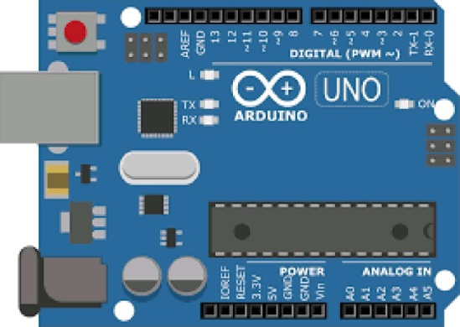

Fig1.ArduinoUNO

FeaturesofArduinoUNO:

* Theoperatingvoltageis5V
* Therecommendedinputvoltagewillrangefrom7vto12V
* Theinputvoltagerangesfrom6vto20V
* Digital input/outputpinsare14
* Analoginputpinsare6
* DCCurrentforeachinput/outputpinis40mA
* DCCurrentfor3.3VPinis50mA
* FlashMemoryis32KB
* SRAMis2KB
* EEPROMis1KB
* CLKSpeedis16MHz

#### UltrasonicSensor:

HC-SRC04ultrasonic sensorhas4pins-ground,Vcc,triggerandEcho.Itrangingfrom2cmto500cm(5m).Mainlyithastwoopening

—oneistransmitterwhichisusedtotransmitthesignalandanother oneisreceiverwhichisusedtoreceivethesignal. Itsendsultrasound waves at high frequency and receive back the signal.

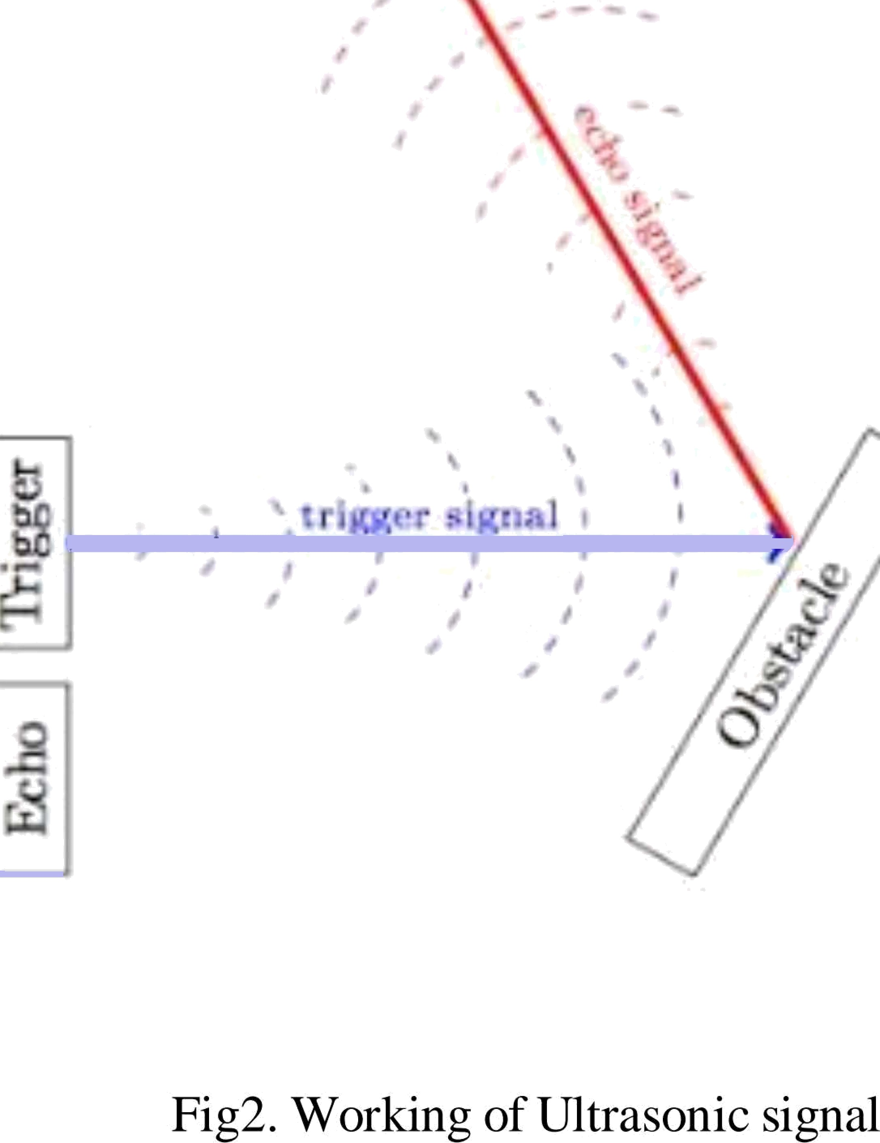

Distance=(timetaken*speedofsound)/2

**RFtransmitterandreceiver:**

Basically,theRFmodulesare433MHzRFoansmitter andreceiver modules.Thetransmitter drawsnopower whentransmitting logic zero whilefully suppressing thecarrier frequency thusconsume significantly low power in batteryoperation. When logicone issent carrier isfully on toabout 4.5mA with a 3volts power supply. Thedata issent serially from the transmitter which isreceived bythe tuned receiver. Transmitterand thereceiveraredulyinterfacedtotwo microcontrollersfor data cansfer.



Fig3.RFmodule

FeaturesofRFmodule:

* Receiverfrequency433MHz
* Receivertypicalfrequencyl05Dbm
* Receiversupplycurrent3.5mA
* Lowpowerconsumption
* Receiveroperatingvoltage5v
* Transmitterfrequencyrange433.92MHz
* Transmittersupplyvoltage3v6v
* Transmitteroutputpower4v-12v

#### Buzzer:

Abuzzer isa small yet efficient component toadd sound features toour project/system. Itis very small and compact 2-pin structure hencecan beeasilyusedon breadboard, PerfBoardandevenonPCBs whichmakesthisawidelyusedcomponent inmostelectronic applications.

Pos•ttive NegatŃe

Fig4.Buzzer

## WORKINGOFTHEPROJECT:

Connect the ultrasonic sensors totheArduino UNO. Theinput pins of trigger and echoof front ultrasonic sensor is pin no. 9and 10. Theinput pins of trigger and echoof ultrasonic sensor for pitdetection is pin no. 2and 3.Thebuzzers areconnected topins5 and 7. The buzzers areof different frequency and generate different sounds. First, we should calculate thedistance of theobstacle with the help of ultrasonic sensor, which is

Distance=(timetaken*0.034)/2

TheArduinocodetodetecttheobstacleandgeneratebuzzeroutputis: if (dist<50)J

Serial.println(timeptaken);

Serial.println(dist);Serial.println("Object Alert"); digitalWrite(Buzzer1,HIGH);

for(inti=dist;i>0;i--) delay (100);

digitalWrite(Buzzer1,LOW);

for(inti=dist;i>0;i--)

delay(100);

TheArduinocodetodetectthepitandgeneratebuzzeroutput is:

if (dist2>50) { Serial.println(time_taken2);

Serial.print1n(dist2);Serial.println("Depth Alert”); digitalWrite(Buzzer2,HIGH);

for(inti=dist2;i<l00;i--) delay (100);

digitalWrite(Buzzer2,LOW); for (int i=dist2; i<100;i--) delay (100);

RFwireless moduleisused todetect themisplacedblind stick.Thereceiver isconnectedtothe Arduino unowhilethetransmitter acts as a remote and it is withthe user. Withthehelp of transmitter, signal is sent to the receiver and output is givento the buzzer and it helps in navigating the misplacedblind stick.

# CONCLUSION:

It is worthmentioning at this point that theaim of this study which is thedesign and implementation of a smart walking stick for the blind has been fully achieved. TheSmart Stick acts asa basic platform for the coming generation of more aiding devices tohelp the visually impaired to navigate safely both indoor and outdoor. It iseffective and affordable.

Inadeveloping countrylikeIndia, thereisaneed for acost-effectivesolution sothat most ot the peoplecan havean effective product as proposedin this paper.