**MarkMe: Streamlined attendance marking & notifications**

**C.D. Patil 1, Aayan N. Shaikh2, Gauri A. Shete3, Snehal G. Ugale4, Simran S. Singh5**

1Assistant Professor, Artificial Intelligence & Data Science, Guru Gobind Singh College of Engineering & Research Center, Nashik, Maharashtra, India

2Student, Artificial Intelligence & Data Science, Guru Gobind Singh College of Engineering & Research Center, Nashik, Maharashtra, India

3Student, Artificial Intelligence & Data Science, Guru Gobind Singh College of Engineering & Research Center, Nashik, Maharashtra, India

4Student, Artificial Intelligence & Data Science, Guru Gobind Singh College of Engineering & Research Center, Nashik, Maharashtra, India

5Student, Artificial Intelligence & Data Science, Guru Gobind Singh College of Engineering & Research Center, Nashik, Maharashtra, India

**ABSTRACT**

This project creates a Telegram bot that can mark students' attendance automatically and notify respective students. When teachers provide date, subject, time slot in info pull, and absent roll numbers, the system collects this data and makes a record of absent students. It then alerts parents by email and WhatsApp so they receive a timely communication. Using Python, Telegram API, SMTP for email sharing, and PyWhatKit for sending WhatsApp messages the system manages itinerary schedule attendance. It streamlines the process, minimizing administrative workload, boosting accuracy, and increasing parental participation. This experiment showcases how messaging APIs.

**Keywords:** Attendance Automation, Telegram Bot, Parental Notification, Email Alerts, WhatsApp Messaging

1. **INTRODUCTION**

Managing attendance manually can be a tedious, time-consuming, and error-prone task, particularly in institutions with a large number of students. Traditional attendance methods, such as maintaining physical registers or manually entering data into spreadsheets, are often inefficient, prone to human error, and difficult to manage over time. As educational institutions move toward digital transformation, there is a growing need for a smarter and more automated approach to handling attendance records efficiently.

To address these challenges, this project presents an Automated Attendance Marking System that leverages a Telegram bot and OpenPyXL to streamline the attendance process. The system eliminates the need for manual data entry by allowing attendance to be marked seamlessly through Telegram. Once a student or teacher interacts with the bot, the data is automatically recorded and updated in an Excel spreadsheet using OpenPyXL, ensuring accuracy, consistency, and ease of record-keeping.

Beyond attendance recording, the system enhances communication between institutions and students by integrating real-time absentee notifications. If a student is marked absent, the system instantly sends an alert via email and WhatsApp, ensuring that students and their parents stay informed. This immediate notification mechanism helps reduce unintentional absences and encourages students to be more accountable for their attendance.

This automation provides numerous benefits. For educators, it significantly reduces the time spent on administrative tasks, allowing them to focus more on teaching. For students and parents, it offers a transparent and real-time attendance tracking system. Additionally, since the records are maintained digitally, administrators can easily analyze attendance trends, generate reports, and ensure compliance with institutional policies.

By combining Telegram’s ease of use, OpenPyXL’s data management capabilities, and the power of instant notifications, this system presents a modern, efficient, and hassle-free approach to attendance management. It is ideal for schools, colleges, universities, and organizations looking to modernize their administrative processes and improve attendance tracking through automation.

1. **METHODOLOGY**

The Automated Attendance Marking System is designed to simplify and streamline attendance management using a Telegram bot, Excel automation (OpenPyXL), and automated absentee notifications via email and WhatsApp. The methodology behind this system follows a structured approach to ensure smooth operation and reliability.

**2.1 User Interaction via Telegram Bot**

The process starts when a teacher or an authorized user interacts with a Telegram bot. This bot serves as the interface for marking attendance, making it easy to use from a mobile phone or computer. The bot provides options to:

* Mark attendance for a specific class.
* Retrieve attendance records.
* Send notifications to absentees.

**2.2 Automated Attendance Entry in Excel**

Once attendance is recorded through the Telegram bot, the system automatically updates an Excel sheet using the OpenPyXL library. This ensures that:

* Attendance records are maintained in a structured format.
* Data is saved in real time, reducing manual work.
* Reports can be generated easily for further analysis.

**2.3 Identifying Absent Students**

After updating the attendance data in Excel, the system scans the sheet to identify students who are absent. Their details, such as name, roll number, and contact information, are retrieved to send notifications.

**2.4 Sending Absentee Notifications**

To ensure that absentees are informed promptly, the system automatically sends notifications via email and WhatsApp. The messages include details about the missed class and can be customized to include warnings or reminders.

* Emails are sent using SMTP (Simple Mail Transfer Protocol) with pre-defined message templates.
* WhatsApp notifications are sent using an API, ensuring direct and instant communication with students or parents.

**2.5 Data Storage and Accessibility**

All attendance records are saved in the Excel sheet, making it easy to track attendance over time. The system allows users to retrieve and analyze attendance trends, helping institutions make informed decisions.

1. **MODELING AND ANALYSIS**

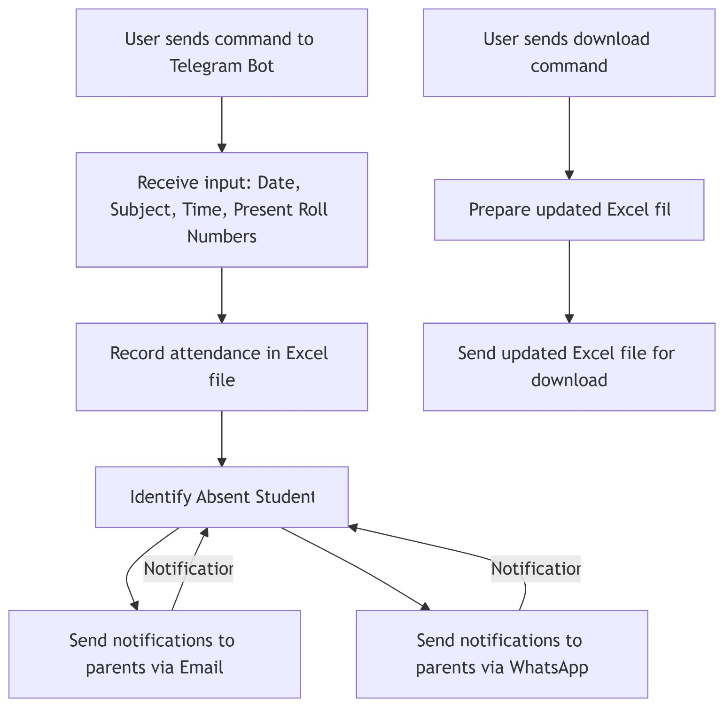

**Related Work:**

Automated attendance systems have gained significant attention in recent years due to the inefficiencies and challenges of traditional manual attendance tracking. Conventional methods, such as roll calls or paper-based registers, are not only time-consuming but also prone to human error and manipulation. Various researchers have explored different technological approaches to streamline this process and enhance accuracy, efficiency, and accessibility.

For instance, Khamaysah, Hijjeh, and Odeh (2024) developed an IoT-based attendance system that utilizes RFID and fingerprint authentication to mark attendance seamlessly. Their system integrates Wi-Fi modules to log attendance data directly into a database, reducing the need for manual record-keeping and making the process more secure and contactless. This approach significantly minimizes human intervention while ensuring reliable and real-time attendance tracking. The study also highlights how IoT can enhance administrative efficiency in educational institutions by automating repetitive tasks and improving data accuracy ([scholar.ppu.edu](https://scholar.ppu.edu/handle/123456789/9089?show=full&utm_source=chatgpt.com)).

Similarly, Hariono, Widya, and Yaqin (2022) proposed a Telegram bot-based attendance system integrated with Visual Basic 6.0, which enables students to mark attendance via fingerprint scans while automating notifications to parents through a Telegram bot. Their research emphasizes the importance of integrating communication tools with attendance systems to keep all stakeholders informed about students' presence or absence. The ability to send instant notifications enhances parental involvement and accountability in the attendance management process, making it an effective solution for schools and universities ([ejournal.unwaha.ac.id](https://ejournal.unwaha.ac.id/index.php/saintek/article/view/628?utm_source=chatgpt.com)).

Expanding on these existing methodologies, our project takes an innovative approach by integrating a Telegram bot with OpenPyXL for real-time attendance marking in Excel while also ensuring that absent students receive immediate notifications via email and WhatsApp. Unlike previous research that focuses solely on biometric authentication or IoT-based solutions, our system is designed to be user-friendly, cost-effective, and highly adaptable for educational institutions of various sizes. By leveraging Python automation and OpenPyXL, we ensure that attendance records are updated instantly in an Excel sheet, eliminating the need for manual entry and reducing the risk of data loss. The addition of automated absentee notifications via WhatsApp and email strengthens communication between educators, students, and parents, ensuring transparency and timely intervention when needed.

By combining automation, accuracy, and seamless communication, this system provides a modern, hassle-free solution for educational institutions looking to optimize their attendance tracking processes. Our research not only builds upon the advancements in attendance automation but also enhances it by introducing a multi-platform notification system that improves engagement and accountability. With the increasing adoption of digital solutions in education, such an automated system can play a crucial role in making attendance management more efficient, reliable, and accessible for both students and faculty.

1. **RESULTS AND DISCUSSION**

After starting our bot using the ‘/start’ command, it gives us two options; whether to download the attendance excel file if already some attendance record exists or to enter the attendance record. Let us select the ‘enter’ command to enter attendance for a particular day.

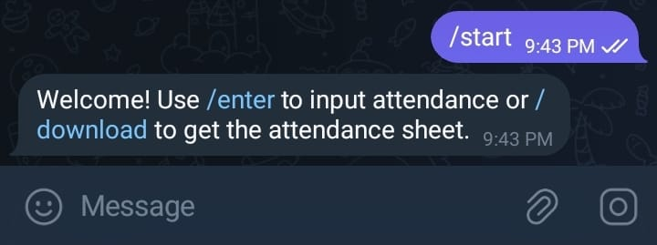

After selecting the ‘enter’ command, the bot will prompt you to enter date for which the attendance should be marked followed by subject name and time slot. After this you can enter the roll numbers of present students in the bot’s chat.

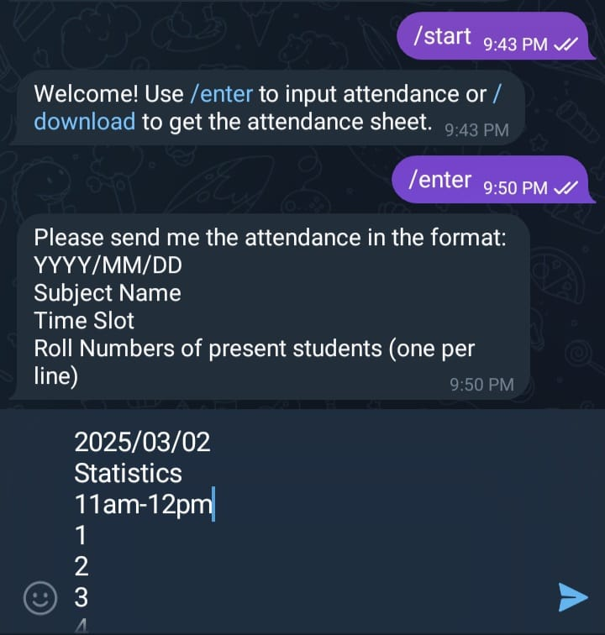

After sending this input to the bot, it take all the present roll numbers mentioned in the chat message and mark them present in the excel file for that particular day as the given date. After the excel file is updated, user/teacher will also get the details of the students which were absent as a reply by the bot and then E-mail and WhatsApp messages are sent to the parents of these absent students.

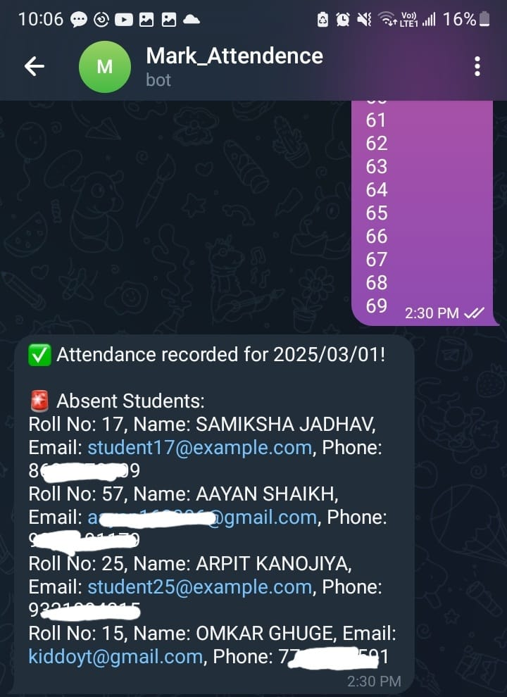

The WhatsApp message which you will get will look like this:

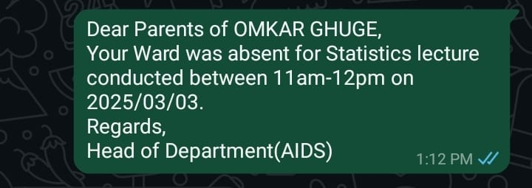

And the E-mail message will look like this:

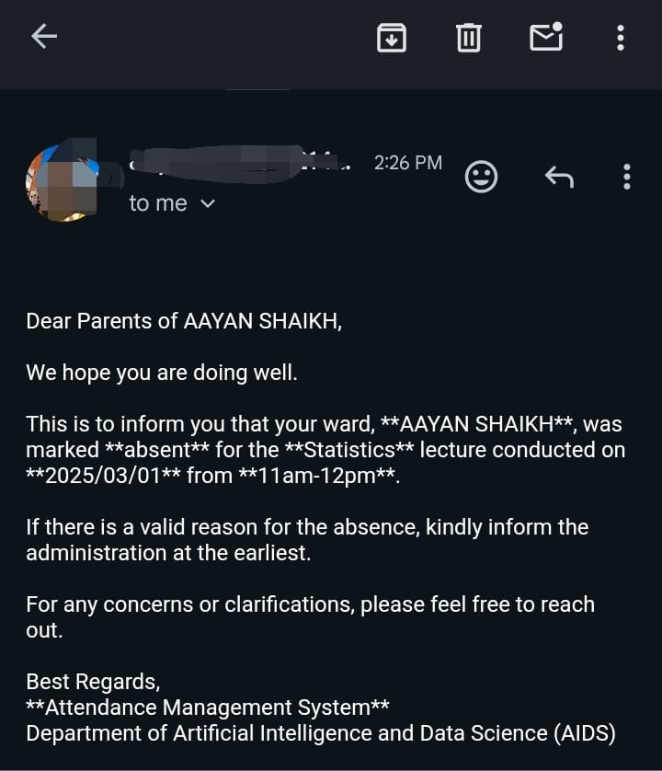

After entering the ‘download’ command, the bot will return you the attendance excel sheet as a reply for you to download and view.

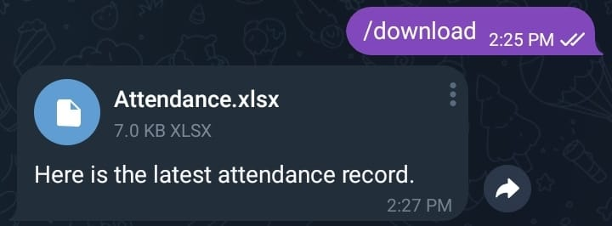

The downloaded excel file looks like this:

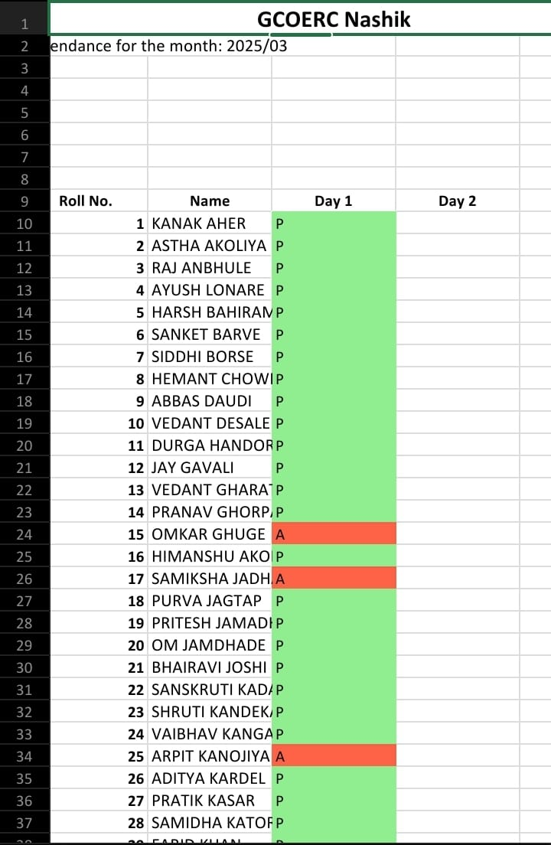

1. **CONCLUSION**

This project makes attendance marking faster, easier, and more efficient by using a Telegram bot to record attendance, Excel (OpenPyXL) to manage data, and email/WhatsApp to notify absent students. It reduces the hassle of manual tracking and ensures that students and parents stay informed.

With automation handling everything from marking attendance to sending notifications, the system saves time, minimizes errors, and improves communication. It’s simple to use and a great step toward making attendance management smarter and more reliable.

Going forward, features like database integration, biometric verification, or AI-based insights could make the system even better, helping institutions manage attendance effortlessly.

**ACKNOWLEDGEMENTS**

I would like to express my heartfelt gratitude to C.D. Patil, Head of the Department of Artificial Intelligence & Data Science, for their valuable guidance, encouragement, and support throughout the development of this research paper. Their insightful suggestions and continuous motivation played a crucial role in shaping this project.

Their expertise and constructive feedback helped me refine my ideas and improve the quality of this work. I am truly grateful for their time, patience, and willingness to assist me at every stage of the research.

1. **REFERENCES**

[1] "Students' Attendance Monitoring System with SMS Notification" by Fatheenursyaza Bakhri, Hawa Mohd Ekhsan, and Jiwa Noris Hamid. This study presents a system designed to monitor student attendance and automatically send SMS notifications to both students and their parents regarding absenteeism. ​[UiTM Institutional Repository+1jcrinn.com+1](https://ir.uitm.edu.my/id/eprint/59976/?utm_source=chatgpt.com)

[2] "Development of Student Attendance Reporting System Using WhatsApp Gateway with Android-Based Broadcasting Method" by Enjang Ali Nurdin, Wahyudin Wahyudin, and Deni Martin. This research focuses on creating an application that utilizes a WhatsApp gateway for reporting student attendance, facilitating communication between educational institutions and parents. ​[EUDL+1Jurnal Poliupg+1](https://eudl.eu/doi/10.4108/eai.12-10-2019.2296257?utm_source=chatgpt.com)

[3] "Development of Student E-Attendance System using QR-Code and WhatsApp Gateway with The Iterative Model Based on Android" by Mar’atuttahirah, Miftahulkhairah, and Ramadan Barik Alfito. This paper discusses an Android-based e-attendance system that integrates QR codes and WhatsApp Gateway to enhance attendance monitoring and reporting. ​[Jurnal Poliupg](https://jurnal.poliupg.ac.id/index.php/JTE/article/view/5026?utm_source=chatgpt.com" \t "_blank)

[4] "Automation System Software Assisting Educational Institutes for Attendance, Fee Dues, Report Generation Through Email and Mobile Phone Using Face Recognition" by R. Tamilkodi. This article explores a software system that aids educational institutions in automating attendance, fee dues, and report generation through email and mobile notifications, utilizing face recognition technology. ​[SpringerLink](https://link.springer.com/article/10.1007/s11277-021-08252-2?utm_source=chatgpt.com)