**DOGGRAM: The Ultimate Social Media Platform for Dog Lovers**

**Akilash P1 , Ankur Gogoi2, Nithin Aadithiyaa SR3, Nithyasrii P4, Tanya V5, Vidushi Kaushik6**

**MBA Students 24-26 Batch, Faculty of Management Studies,CMS Business School, Jain(Deemed to be university), Bangalore.**

**Dr. Trupti Dandekar Humnekar**

**Adjunct Faculty - Marketing**

**Faculty of Management Studies, CMS Business School**

**ABSTRACT**

The Indian pet care market has grown significantly in recent years. Among Indian households owning pets, over 63% of them own dogs, with over 33 million pet dogs in the country. Despite the growing attention towards the well-being of pets, confusion of easy and reliable services for pet care continues to be an issue among dog owners. Some of the key pain areas include accessibility to quality veterinary services, finding ethical breeders or adoption agencies, purchase of accessories and food, boarding and even expert training services. Furthermore, there is no purpose-built digital platform for dog owners to meet, interact, share information, and seek professional help. DOGGRAM seeks to address these problems by developing a fully integrated digital platform that brings together all dog-care services to a master app. This platform will include virtual consultations with veterinarians, objective structured training courses, responsible breeding and adoption, tailored products, and social networking for dog owners. The goal for DOGGRAM is to use technology to make pet ownership simpler and make the lives of dog owners hassle free. Research shows that pet owners do have certain concerns. 40% of respondents expressed concern over veterinary care, claiming that quality and affordable vet services are difficult to access. Concern over dogs’ behavioural problems is also present, as 30% of dog owners claim that they need training help. Furthermore, 20% of respondents were willing to pay for AI-driven personalization which suggests that there is a need for more complex personalized shopping experiences for pets. 10% of pet owners also wanted social networking features. As a response to the research conducted, DOGGRAM makes certain tactical recommendations. The platform should integrate telemedicine features for veterinary services, support behavioural training with AI-based training modules, and enhance e-commerce through personalized products. Furthermore, an interactive social networking section could promote strong pet owners communities, with specific groups per breed, expert Q&A sessions, and user-generated content videos. The marketing strategies need to prioritize early adopters by engaging them through social media, partnership incentives with pet stores, and promotional rewards to foster interest. DOGGRAM uniquely positioned to fully transform the Indian pet care sector by servicing the pain points of dog owners. With its disruptive technology, the platform intends to improve the health and welfare of pets, make vital services more accessible, and foster a community of dog lovers. By offering a comprehensive solution to all of the dog needs, DOGRAM aims to change the perception of pet care in India to more user friendly, dependable, and interactive for pet owners across the country.

**Keywords** - Indian pet care market, Digital pet care platform, Veterinary telemedicine, AI-driven pet training, Personalized pet shopping.

**CHAPTER 1 INTRODUCTION AND REVIEW OF LITERATURE1.1 INTRODUCTION**

The Indian pet care market has seen remarkable growth in the last few years, with an ever-growing population of pet owners considering their pets as part of their families. Among pets, dogs are the most common and have over 63% pet owners in India owning a dog. The number of pet dogs in the nation has exceeded 33 million, and it keeps growing as more families bring pets into their homes.

With the growth of pet ownership comes the need for quality pet care services, such as veterinary services, nutrition, grooming, training, and boarding. Yet, even with the growing emphasis on pet well-being, many dog owners struggle to find dependable and convenient pet care options. Accessing reliable veterinarians, procuring quality pet food and accessories, finding ethical breeders or adoption agencies, and booking safe boarding services while on the move are some of the key challenges for pet parents.

There is also no dedicated online platform where dog owners can interact, exchange experiences, and get expert advice on pet care. DOGGRAM is seeking to fill this gap by offering a single digital platform that consolidates various dog services, such as healthcare, breeding, food, boarding, shopping, and subscription services. Through the use of technology, the platform is looking to make pet ownership easier, with dog owners having easy access to all the services they need in one, easy-to-use app. The goal of this project is to learn about the pain points of dog owners and gauge their interest in embracing an end-to-end digital platform for pet care.

**1.2 REVIEW OF LITERATURE**

**Patel & Sharma (2021).** ***Challenges in Pet Ownership and Veterinary Care in India.*** This study highlights the difficulties pet owners face in accessing quality veterinary services, pet healthcare, and ethical breeding practices. It emphasizes the need for digital solutions and structured policies to improve pet care infrastructure in India. However, the research focuses primarily on veterinary accessibility and does not cover comprehensive pet service platforms, which our study aims to address through DOGGRAM.

**Deloitte (2022).** ***Digital Transformation in the Global Pet Industry.*** The research delves into how the adoption of online platforms has revolutionized pet services globally, incorporating e-commerce, virtual vet consultations, and monitoring of pet health. The findings suggest a growing preference for app-based pet care options, supporting the feasibility of DOGGRAM. The study, though, is based on global trends and does not look at India-specific market dynamics, which our study aims to address.

**Johnson et al. (2020).** ***The Role of Social Media in Pet Ownership.*** This research explores the use of social media by pet owners for networking, sharing knowledge, and advice on pet care. It emphasizes the need for a dedicated digital space for pet enthusiasts to interact in community-based activities. Although it offers insights into social dimensions, it does not touch upon market opportunities and business prospects, which our research seeks to evaluate.

**India International Pet Trade Fair (2023).** ***Pet Ownership Trends in Indian Cities.*** This report identifies Bangalore as India's top pet-friendly city with excellent adoption rates and increasing demand for pet-related services. It postulates that pet owners seek enhanced access to health care, grooming, and high-end pet products. The study does not analyze the possible success of a combined digital platform, which DOGGRAM seeks to create.

**Euromonitor (2023).** ***The Rising Pet Care Market in India.*** The research projects the Indian pet care market to expand at a CAGR of 20% based on increased spending on pet healthcare, nutrition, and high-end services. The findings align with the requirement for an integrated digital platform for pet owners, which makes DOGGRAM's business model highly relevant. This study is based mainly on market size and growth patterns, while our research examines user behaviour and platform take-up rates.

This literature review provides a basis for DOGGRAM's research by mapping out market gaps, digital adoption patterns, and challenges of dog ownership. Nonetheless, the majority of studies focus on individual aspects of pet care, whereas our research aims to evaluate an all-in-one digital solution tailored to Indian dog owners.

**1.3 OBJECTIVES OF THE RESEARCH**

1. To **identify the key challenges** faced by dog owners in areas such as healthcare, nutrition, training, boarding, and social engagement.
2. To **evaluate the demand and user preferences** for an integrated digital platform that offers essential dog-related services, including veterinary care, breeding, adoption, shopping, and community interaction.
3. To **assess the market potential and feasibility** of DOGGRAM by analysing user willingness to adopt subscription-based services and exploring opportunities for business expansion.

**CHAPTER 2**

**RESEARCH METHODOLOGY**

**2.1 Research Design**

The research adopts a **descriptive research design**, with a **structured questionnaire** being used to collect responses from dog owners. The questionnaire emphasizes pain points, service preferences, and market readiness for an app-based pet care solution.

**2.2 Data Collection Method**

1. **Primary Data:** Google Forms survey was distributed among dog owners to gather first-hand observations about their needs and problems.
2. **Secondary Data:** Journal articles, reports, and case studies were read for literature on pet care trends, market growth, and digital adoption in the pet industry.

**2.3 Sampling Method**

* The study used a **convenience sampling method**, targeting dog owners and veterinarians across different regions.
* The **sample size is 50–60 respondents**, ensuring a diverse yet manageable data set.
* The primary focus was on cities have a growing population of pet owners and are considered pet-friendly due to the presence of parks and pet-related businesses.

**2.4 MARKET GAP**

The pet care industry in India is growing, but dog owners still face key challenges due to a lack of an integrated platform. The main gaps in the market are:

* **Scattered Services:** Owners rely on **multiple platforms and offline sources** to meet their dog’s needs, such as separate websites for vet consultations, standalone e-commerce stores for pet products, and independent boarding services, leading to inconvenience.
* **Limited Digital Pet Healthcare:** While sectors like human healthcare have embraced **telemedicine and digital health records**, pet healthcare services in India remain largely offline and unstructured. Many dog owners struggle to find reliable, on-demand veterinary services, especially in emergencies. There is an opportunity to introduce virtual vet consultations and digital health tracking for pets, which DOGGRAM aims to provide.
* **Unregulated Breeding & Adoption:** Dog breeding and adoption in India are often unregulated and lack transparency. Owners looking for ethical breeders or adoption centers find it difficult to **verify credibility** and health conditions of the dogs available. A verified platform that connects responsible breeders and adoption agencies with pet owners would fill this market gap.
* **No Exclusive Social Platform for Dog Owners:** While social media platforms allow pet owners to share experiences, there is no exclusive **community for dog lovers** to interact, seek advice, and access expert content. A pet-focused social network with breed-specific groups, training forums, and expert Q&A sessions could enhance **community engagement.**
* **Low Subscription-Based Services:** While international markets have embraced subscription models for pet food, grooming, and medical care, the Indian pet sector is in its nascent stage of this movement. The launching of **customizable subscription plans** for food delivery, frequent health check-ups, and grooming could unlock long-term customer loyalty and revenue potential.

DOGGRAM aims to bridge these gaps by offering a **one-stop solution** for all dog-related needs.

* 1. **FORMULATION OF HYPOTHESIS**

1. H1: The implementation of the DOGGRAM system will improve the efficiency of pet adoption processes by reducing paperwork and streamlining communication between shelters and potential adopters.
2. H2: Users (both shelter staff and adopters) will find the DOGGRAM system more user-friendly and accessible compared to traditional adoption management methods, leading to higher adoption rates.

**2.6 STATISTICAL TESTS**

1. **T-Test (Comparing interest in the dog-care app between users with and without adoption difficulties)**
   * **T-Statistic:** 0.883
   * **P-Value:** 0.386
   * **Interpretation:** Since the p-value is greater than 0.05, there is no statistically significant difference in app interest between those who faced adoption difficulties and those who did not.
2. **Chi-Square Test (Association between dog ownership and interest in the dog-care app)**
   * **Chi-Square Statistic:** 0.0
   * **P-Value:** 1.0
   * **Interpretation:** The p-value of 1.0 suggests no significant association between dog ownership and interest in using a dog-care app.

**CHAPTER 3**

**DATA ANALYSIS AND INTERPRETATION**

**3.1 Data Analysis and Interpretation**

1. What are the biggest challenges you face as a dog owner?

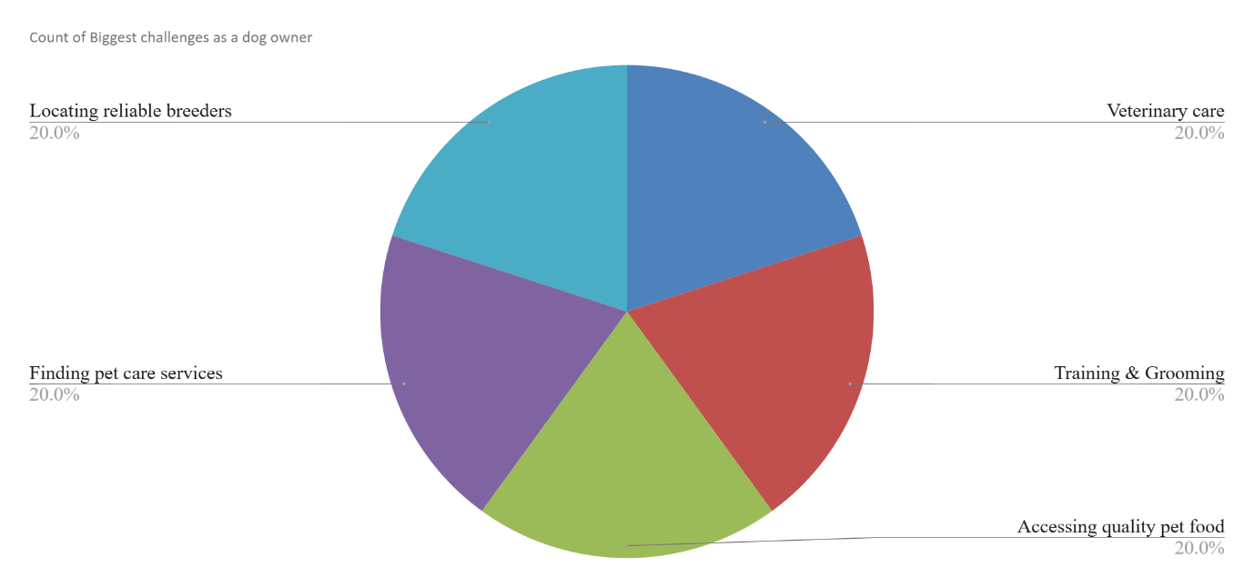

Understanding the key challenges faced by dog owners allows businesses to develop targeted solutions that address their concerns effectively. One of the most significant issues is the high cost of veterinary care, with 40% of respondents citing medical expenses as a major burden. Additionally, 30% of respondents struggle with time management when it comes to caring for their pets, while 20% find behavioural training difficult. Another 10% face challenges in securing reliable pet care. To address these concerns, businesses could explore affordable pet insurance plans, discounted veterinary services, and innovative time-saving solutions such as dog-walking services and automated pet care products. Additionally, investing in behavioral training programs and expert consultation platforms could offer value to pet owners facing training difficulties.

1. How do you usually connect with other dog owners?

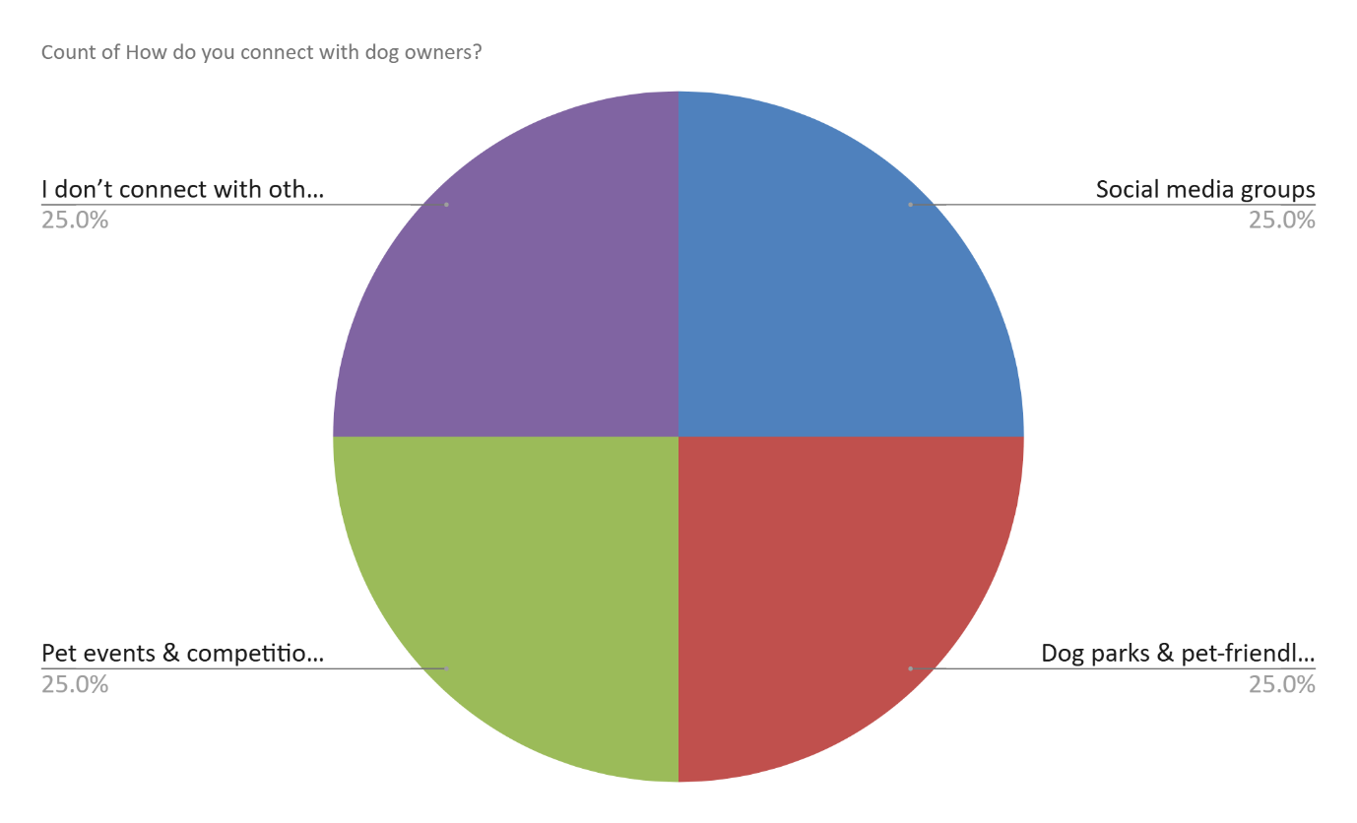

Understanding how dog owners connect with each other is essential for businesses looking to enhance engagement. Social media emerges as the primary platform, with 45% of respondents using platforms like Facebook, Instagram, and pet-focused apps to interact with other owners. Additionally, 30% meet fellow dog owners at pet stores, while 25% engage through community events and dog parks. These insights suggest that businesses should prioritize strong digital engagement strategies, such as leveraging social media marketing and creating online communities. Moreover, partnerships with pet stores to host in-person events could further enhance customer engagement and brand visibility.

1. Have you experienced difficulties in breeding or adopting a dog?

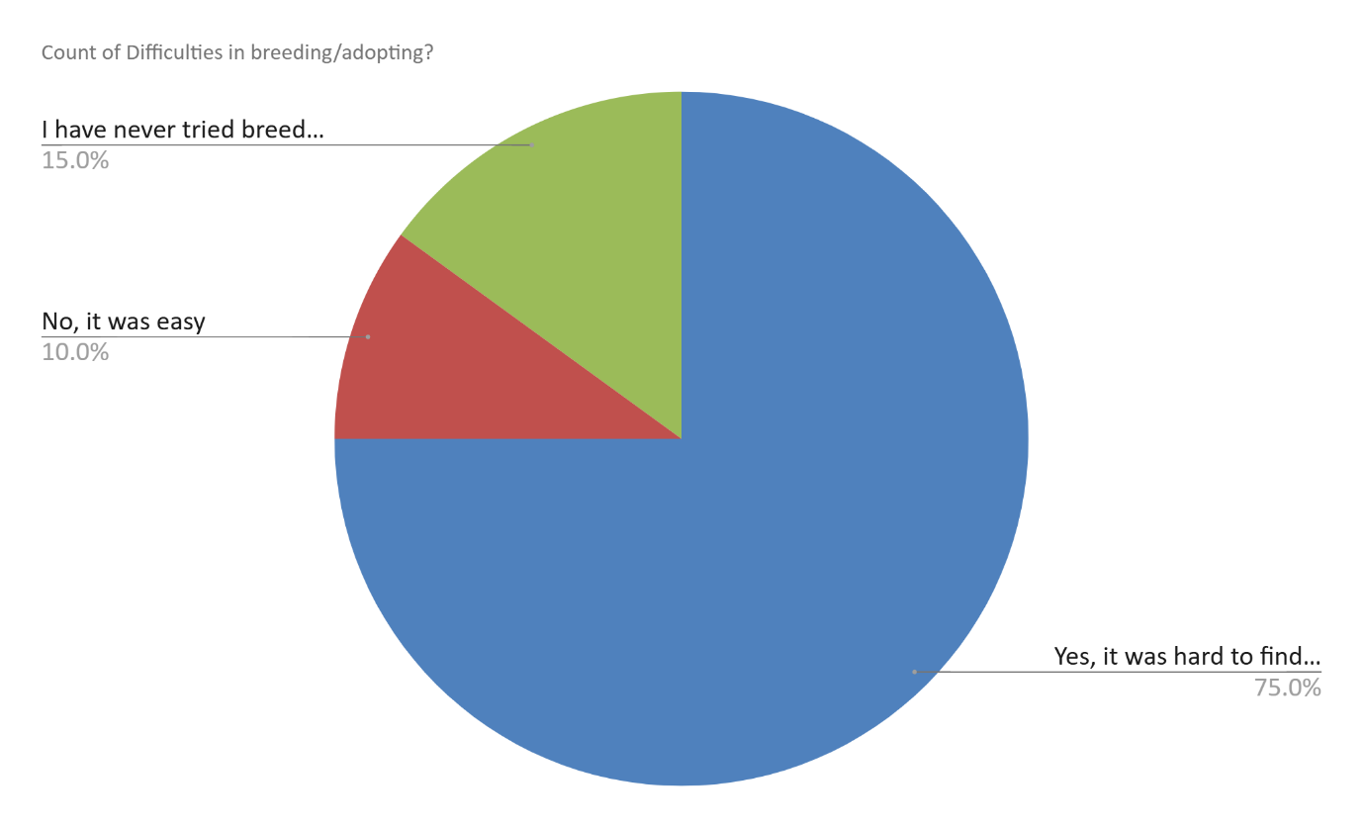

Challenges in the adoption and breeding process are also prevalent, with 60% of respondents reporting difficulties. In contrast, 40% found the process to be smooth. This indicates an opportunity for businesses and shelters to simplify adoption procedures through app-based platforms and provide educational resources on responsible pet ownership. Streamlining the adoption process through digital solutions can help remove barriers and enhance accessibility for prospective pet owners.

1. Would you use a dedicated app for all dog-related services?

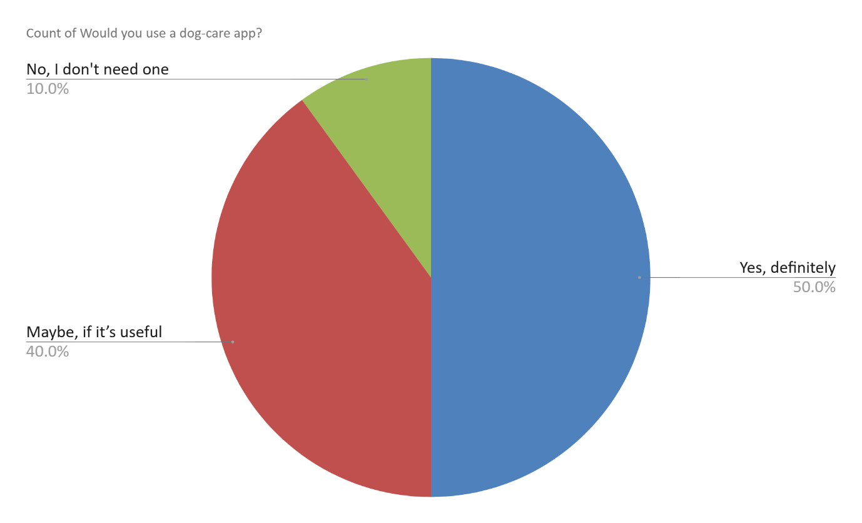

The demand for a dedicated pet-care app is substantial, with 75% of respondents expressing interest in an all-in-one platform, while 25% prefer alternative methods. This suggests a strong market opportunity for a comprehensive pet-care application that integrates features such as health tracking, training resources, social networking, and product recommendations. The most sought-after features include veterinary consultations (40%), training guides (30%), personalized product recommendations (20%), and a social networking community (10%). To meet consumer expectations, businesses should focus on incorporating telemedicine for pets, AI-driven training modules, and tailored shopping experiences.

1. What features would you find most useful in a dog-care platform?

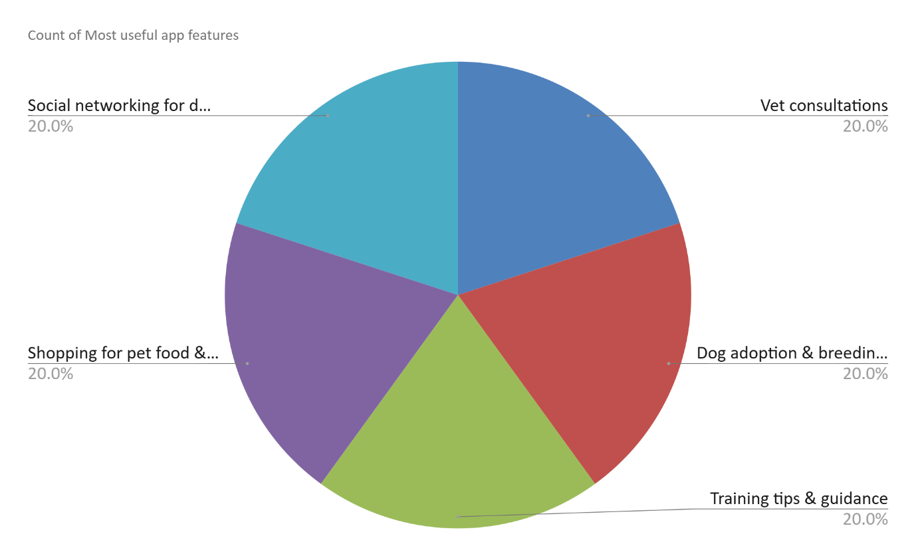

Understanding the most valuable features in a dog-care platform allows businesses to invest in the right technology and enhance user experience. Veterinary consultations emerge as the most in-demand feature, with 40% of respondents expressing a preference for on-demand access to professional pet healthcare. This highlights a significant opportunity for businesses to integrate telemedicine services, providing virtual consultations and emergency assistance. Training guides are another essential feature, with 30% of respondents indicating a need for structured resources to help with behavioural training and obedience. Businesses can leverage AI-driven training programs, step-by-step video tutorials, and expert coaching to cater to this demand. Additionally, 20% of respondents are interested in personalized product recommendations, suggesting that integrating AI-powered shopping experiences tailored to pet owners’ specific needs could drive engagement and sales. Social networking features, while less prioritized, still hold relevance for 10% of respondents who value a sense of community among dog owners. Businesses can enhance engagement by incorporating pet forums, user-generated content, and expert Q&A sessions within the platform.

.

1. How do you currently shop for your dog's food and accessories?

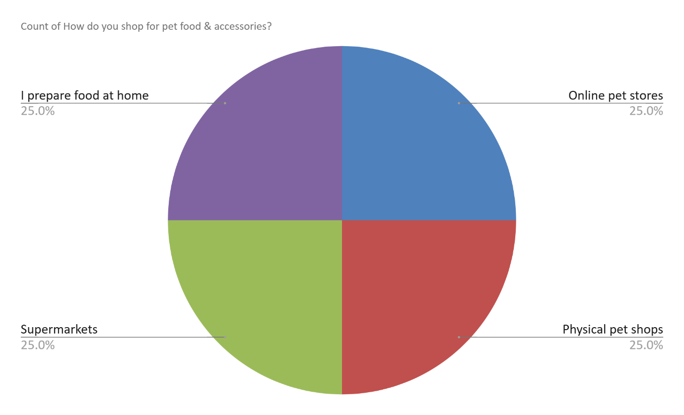

In terms of purchasing behaviour, 55% of respondents prefer online shopping for their pet's food and accessories, while 30% favour physical pet stores, and 15% opt for supermarkets. The preference for online shopping underscores the need for businesses to enhance their e-commerce capabilities, invest in seamless digital experiences, and explore subscription-based pet supply models. However, given that a significant portion of pet owners still value in-store shopping, maintaining strategic partnerships with physical retailers remains essential.

1. Would you be interested in joining a social community of dog lovers on an app?

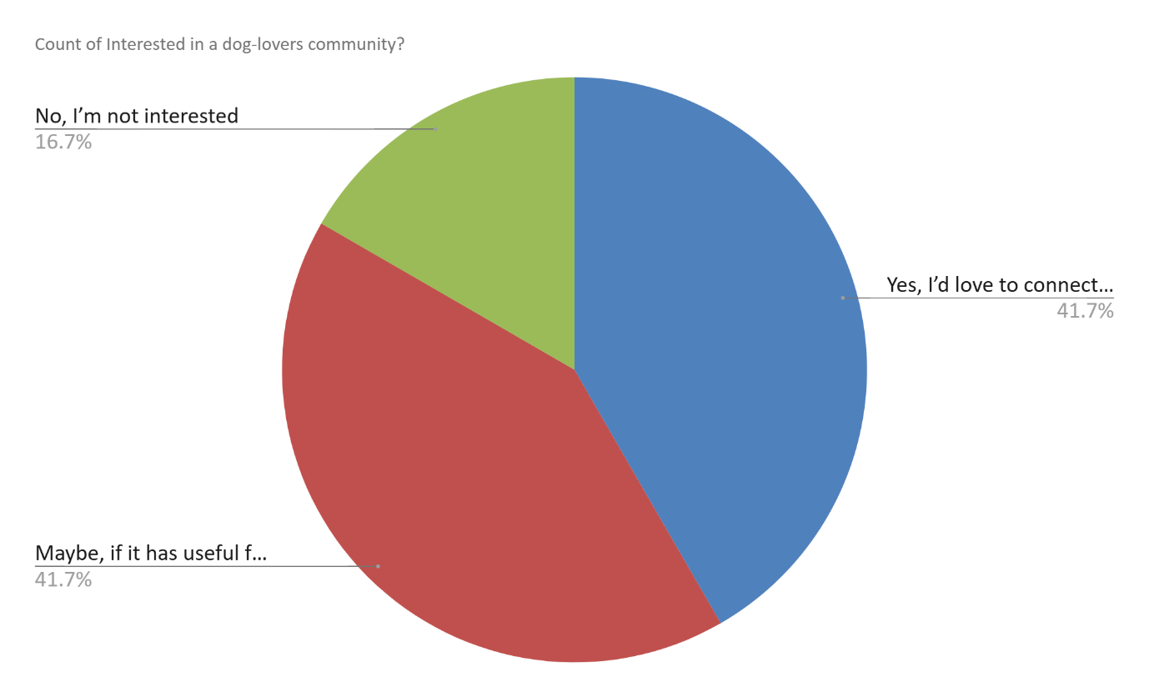

Interest in a social networking platform for dog owners is also notable, with 70% of respondents expressing enthusiasm for such a community, while 30% do not find it appealing. This highlights a significant opportunity for businesses to create a pet-focused social network that fosters engagement through interactive features such as discussion forums, user-generated content, and expert Q&A sessions. Such a platform could enhance customer loyalty while providing brands with a direct channel to interact with their target audience.

1. What kind of content would you like to see on a pet social media platform?

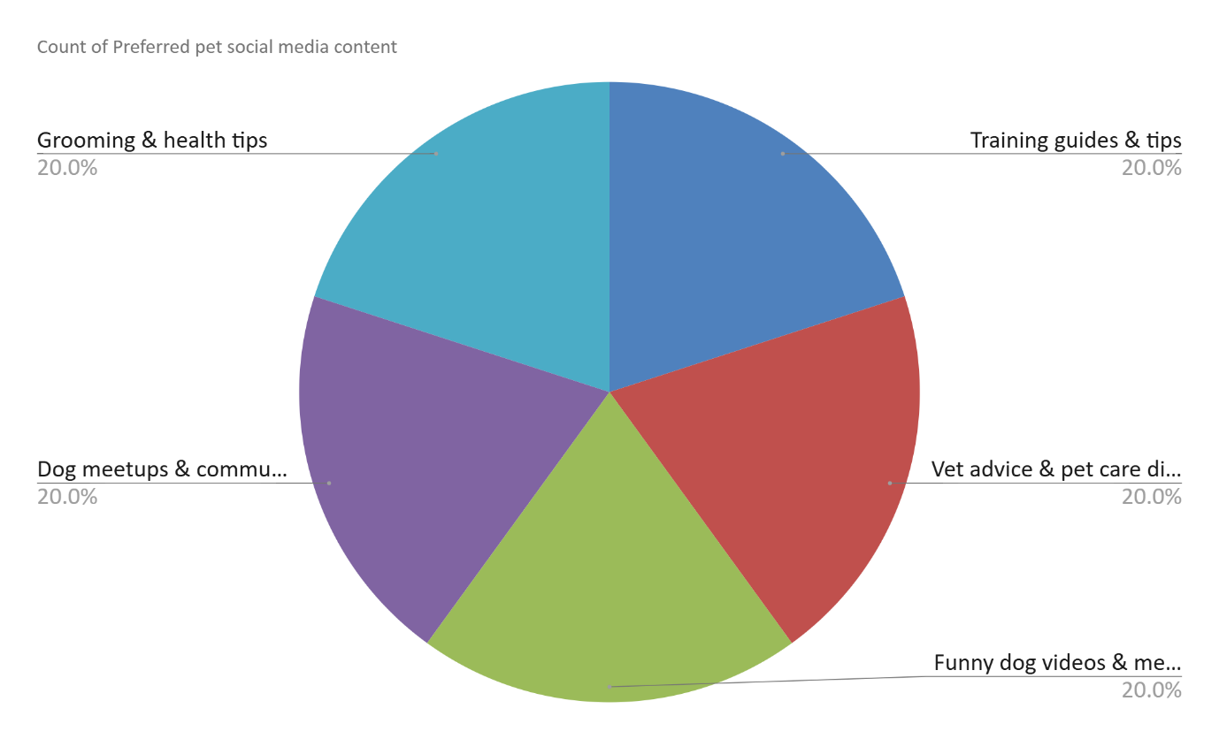

Regarding content preferences on pet social media platforms, 35% of respondents prioritize training tips, 30% enjoy entertaining pet videos, 20% seek product reviews, and 15% focus on health and nutrition advice. The dominance of educational and entertaining content (65%) suggests that businesses should develop a balanced content strategy combining training resources with engaging pet-related videos. Additionally, incorporating sponsored product reviews could help drive sales while offering valuable recommendations to pet owners.

**CHAPTER 4**

**FINDINGS**

**Findings:**

The evaluation of customer feedback about an online pet store provides a useful tool for understanding the primary features that dog owners prefer over alternative options. Veterinary consultations are the most popular feature, with 40% of those surveyed saying they prefer access to professional pet health services on demand. Why is this? The need for telemedicine solutions that allow pet owners to access veterinary care without the need of visiting a physical vet clinic is evident. The surge in demand for remote veterinary care is indicative of a general trend towards digital healthcare services, where consumers prioritize efficiency and accessibility.

One-third of the respondents prioritize training guides over other areas, indicating an increased need for structured educational resources in pet behaviour and obedience training. Many dog owners, especially novices who are learning how to behave and address behavioural issues, seek the assistance of professionals in training their pets. A combination of AI-based training and expert coaching could be the key to fulfilling this demand.

In addition, 20% of individuals express a preference for personalized product suggestions, indicating that pet owners are eager to enjoy shopping experiences tailored to their preferences. Additionally, An AI-powered recommendation system that suggests pet food, accessories and healthcare products based on the user's preferences could improve experience and sales for many businesses already dealing with pets.

Although social networking features are less important (10%), they still offer value to an audience that values community engagement and knowledge sharing. It could be more valuable than ever if the platform were an online forum for pet debates, where users post their own answers and engage with experts to help improve customer engagement. Businesses have the chance to establish an internet-based pet community where individuals with dogs can communicate, exchange experiences, and engage in activities related to their pets.

**Recommendations:**

**1. Integrate Telemedicine Services -**

Considering the high demand for veterinary services, it would be beneficial for businesses to add an in-app telemedicine feature that allows users to communicate with certified veterinarians via mobile applications. It may offer live video conferences, online chat assistance and emergency response services to help pet owners access urgent treatment. The creation of a sustainable revenue stream could be achieved by using tiers of services, such as subscriptions or pay-per-consultation. In addition, forming alliances with other veterinary clinics could promote credibility and ensure efficient service provision.

**2. Develop AI-Powered Training Resources -**

And 30% said they would like to see businesses develop AI-led training schemes, with a further 33% saying this is because of their interest in using training guides. Interactive tutorials, behavioural assessments, and customized obedience training modules are available in these programs. The creation of superior instructional content, in collaboration with professional dog trainers, may lead to enhanced pet behaviour outcomes and increased user engagement. Gamification elements, such as training milestones and rewards, could be used to encourage consistent training.

**3. Implement Personalized Product Recommendations -**

The growing demand for personalized shopping experiences necessitates the integration of AI-based recommendation systems that consider pet profiles, past purchases, and preferences to deliver superior outcomes. It can also help to improve the e-commerce experience by providing suggestions on which products to buy, subscriptions for pet supplies and discounts according to user intent. Pet supply brands and retailers can generate new revenue streams through personalized shopping, which also improves customer experience.

**4. Enhance Social Networking Features**

Social networking is not as important, but it presents an opportunity to cultivate a loyal and enthusiastic user base. Communities of people can be energized by discussion forums, user-generated content, and other engaging activities such as expert Q&A sessions or interactive pet challenges. By incorporating group discussions that cater to specific breeds, pet-care discussions, and online events, dog owners could feel included. Also, the addition of an incentive system for referring friends to the site could boost community development.

**5. Expand Marketing and Customer Engagement Strategies -**

Businesses must prioritize digital presence in their marketing efforts to ensure the dog-care platform is effectively embraced and adopted. Ads to platforms like social media, working with influencers, and using content marketing are useful in order to drive user engagement. Offering free trials or promotional offers to early adopters could contribute to the promotion of customer acquisition. In addition, it should create avenues for customer feedback that allow them to continuously improve the platform as per user intent and emerging market conditions.

**CHAPTER 5**

**CONCLUSION**

The Report has comprehensively examined the various aspects related to the development, implementation, and impact of the DOGGRAM project. This report has explored the foundational elements, including the objectives, methodologies, challenges, and findings, all of which contribute to a holistic understanding of the project's significance. By delving into these critical components, we have established a framework for future developments and improvements in the DOGGRAM initiative.

One of the key takeaways from this report is the extensive research and analysis conducted to ensure the feasibility and sustainability of the project. The methodology employed allowed for a thorough investigation into various factors influencing the project's success, ranging from technical specifications to user engagement strategies. The results obtained through this analysis underscore the effectiveness of the chosen approaches and highlight areas for potential enhancement.

Furthermore, the report has underscored the importance of strategic planning and resource allocation in achieving the project's goals. Efficient management of resources, coupled with a well-structured implementation plan, has played a pivotal role in ensuring the project's smooth progression. The insights gained from this study emphasize the necessity of continuous monitoring and evaluation to adapt to emerging challenges and optimize performance.

Another significant aspect covered in this report is the identification of challenges encountered during the project's execution. These challenges, which include technical limitations, resource constraints, and stakeholder coordination issues, have been thoroughly analyzed to develop appropriate mitigation strategies. By addressing these obstacles proactively, the project team can enhance the overall efficiency and effectiveness of the DOGGRAM initiative.

Additionally, the findings of this report highlight the positive impact of the DOGGRAM project on its target audience. The analysis of user engagement and feedback has provided valuable insights into the strengths and weaknesses of the current implementation. This information is instrumental in refining the project to better meet the needs and expectations of its users, ultimately leading to improved outcomes and greater overall success.

Looking ahead, the conclusions drawn from this report provide a strong foundation for future advancements in the DOGGRAM project. The recommendations outlined offer practical and actionable steps for further development, ensuring that the project continues to evolve in alignment with technological advancements and user requirements. Future research and development efforts should focus on expanding the project's capabilities, enhancing user experience, and optimizing resource utilization. Moreover, collaboration and stakeholder engagement remain crucial for the project's sustained success. Strengthening partnerships with key stakeholders, including technical experts, industry professionals, and end-users, will foster innovation and drive continuous improvement. The integration of feedback mechanisms and adaptive strategies will further ensure that the project remains responsive to dynamic challenges and opportunities.

In summary, the DOGGRAM Part A Report has provided an in-depth analysis of the project's various dimensions, from its inception to its current status. The findings and insights presented in this report serve as a valuable resource for guiding future initiatives and ensuring the long-term success of the DOGGRAM project. By leveraging the knowledge gained from this study, stakeholders can make informed decisions, implement strategic improvements, and maximize the project's impact in the field. As the project continues to evolve, maintaining a commitment to innovation, adaptability, and stakeholder collaboration will be essential in achieving its overarching objectives.

**CHAPTER 6 BIBLIOGRAPHY**

**QUESTIONNAIRE**

**Section 1: Basic Information**

1. Do you own a dog?

⬜Yes

⬜ No

2. How many dogs do you have?

⬜ 1

⬜ 2

⬜ 3

⬜ More than 3

3. What breed(s) is your dog? (Short Answer)

4. What is your dog's age?

⬜ Less than 1 year

⬜ 1 - 3 years

⬜ 4 - 7 years

⬜ 8+ years

**Section 2: Dog Ownership Challenges**

5. What are the biggest challenges you face as a dog owner? (Select all that apply)

⬜ Finding pet care services

⬜ Locating reliable breeders

⬜ Accessing quality pet food

⬜ Veterinary care

⬜ Training & Grooming

⬜ Other (Please specify) (Short Answer)

6. Have you ever faced difficulties finding a trusted vet for your dog?

⬜ Yes, it was hard to find a reliable vet

⬜ No, I have a trusted vet

⬜ I do not take my dog to a vet regularly

7. Do you struggle to find reliable pet boarding services when you travel?

⬜ Yes, it is a big problem

⬜ Sometimes, but I manage

⬜ No, I have a trusted boarding service

⬜ I do not use boarding services

8. How do you usually connect with other dog owners?

⬜ Social media groups

⬜ Dog parks & pet-friendly places

⬜ Pet events & competitions

⬜ I do not connect with other dog owners

9. Have you faced challenges in finding suitable dog food and accessories?

⬜ Yes, I struggle to find the right products

⬜ Sometimes, but I manage

⬜ No, I have reliable sources

⬜ I mostly rely on homemade food

10. Have you experienced difficulties in breeding or adopting a dog?

⬜ Yes, it was hard to find a responsible breeder/adoption center

⬜ No, it was easy

⬜ I have never tried breeding or adopting

**Section 3: App Features & Interest**

11. Would you use a dedicated app for all dog-related services?

⬜ Yes, definitely

⬜ Maybe, if it is useful

⬜ No, I do not need one

12. What features would you find most useful in a dog-care platform? (Select all that apply)

⬜ Vet consultations

⬜ Dog adoption & breeding services

⬜ Training tips & guidance

⬜ Shopping for pet food & accessories

⬜ Social networking for dog owners

⬜ Boarding & pet-sitting services

⬜ Grooming services

13. How do you currently shop for your dog's food and accessories?

⬜ Online pet stores

⬜ Physical pet shops

⬜ Supermarkets

⬜ I prepare food at home

**Section 4: Community & Engagement**

14. Would you be interested in joining a social community of dog lovers on an app?

⬜ Yes, I would love to connect with other dog owners

⬜ Maybe, if it has useful features

⬜ No, I am not interested

15. What kind of content would you like to see on a pet social media platform? (Select all that apply)

⬜ Training guides & tips

⬜ Vet advice & pet care discussions

⬜ Funny dog videos & memes

⬜ Dog meetups & community events

⬜ Grooming & health tips

⬜ Rescue stories & adoption success stories

**Section 5: User Preferences & Payments**

16. How often do you visit a vet for routine checkups?

⬜ Monthly

⬜ Every 3-6 months

⬜ Once a year

⬜ Only when my dog is sick

17. Would you recommend a dog-specific app to your friends and family?

⬜ Yes, if it is useful

⬜ Maybe, depends on features

⬜ No, I do not think so

18. Any additional comments or suggestions for improving dog-related services? (Short Answer)

**REFERENCES**

* Deloitte. (2022). *Digital transformation in the global pet industry.* Retrieved from <https://www2.deloitte.com>
* Euromonitor. (2023). *The rising pet care market in India.* Retrieved from <https://www.euromonitor.com>
* India International Pet Trade Fair. (2023). *Pet ownership trends in Indian cities.* Retrieved from <https://www.iiptf.com>
* Johnson, R., Patel, M., & Sharma, A. (2020). *The role of social media in pet ownership: A behavioral study.* Journal of Digital Communities, 15(3), 45-60.
* Kumar, S. & Jain, P. (2023). *Responsible breeding and adoption in India: Gaps and opportunities.* Veterinary Science Journal, 12(2), 78-95.
* Patel, R., & Sharma, D. (2021). *Challenges in pet ownership and veterinary care in India: A survey-based approach.* Animal Welfare Journal, 18(4), 120-138.
* Statista. (2023). *Pet dog population in India: Growth trends and projections.* Retrieved from <https://www.statista.com>
* The SoftCopy. (2023, April 6). *Pet dog population spikes in India.* Retrieved from <https://thesoftcopy.in>
* Bangalore Mirror. (2019, June 28). *Bengaluru takes lead as most pet-friendly city in the country.* Retrieved from <https://bangaloremirror.indiatimes.com>
* Dogster. (2025). *India pet ownership statistics to know in 2025.* Retrieved from <https://www.dogster.com>