**Ethical Dilemmas in Neuromarketing: Reducing the Difference Between Consumer Awareness and Industry Practices.**

Authors:

Mr. Sunil Hegde, Assistant Professor, Jain (Deemed-to-be University) - Centre for Management Studies - Bangalore, INDIA

Pranshu Jain(1), Chamarthi Manusree(2), Reshab Magar Rao U(3), Priyanshi Agarwal(4), Akash Saha(5) - Students, Jain (Deemed-to-be University) - Centre for Management Studies - Bangalore, INDIA

**Abstract**

Despite offering some ethical scrutiny, neuromarketing is an emerging field integrative of neuroscience and consumer behavior as it employs the advanced techniques of brain imaging. This study investigates the ethics of neuromarketing, outlining consumer autonomy, privacy, and manipulative persuasion as central areas of interest. As the aims, the study intends to highlight the ethical dilemmas resulting from the application of brain imaging devices ( fMRI, EEG ) and biometric testing for marketing purposes while safeguarding the consumers and giving businesses the rational use of neurosciences. The main contribution of this research stems from the absence of ethical frameworks regarding the use of neuromarketing data, which stems from the failure to address issues of consent, disclosure, and potential abuse of automatic judgment making.

To fill this gap, a mixed-method study was conducted integrating a literature review and expert interviews with a consumer survey. The literature review consolidated the underlying theories and ethical principles of neuromarketing, while interviews with marketers and neuroscientists provided a view on the practice and related ethics. Public opinion was evaluated through consumer surveys to analyze the observed and anticipated awareness of neuromarketing practices. The interpretation of this data indicated a huge divide between the consumer understanding and acceptance of the industry practices.

**Keywords :-** **Neuromarketing** ..**Biometric** **Data** .**Autonomy**

**Introduction**

Full understanding of neuromarketing includes scanning the human brain, analyzing biometric data, and tracking eye movements to identify what type of advertisements motivate people emotionally. This branch of marketing has ethical concerns regarding priving , manipulating, and the autonomy of the consumer. The ... advanced strategies neuromarketing helpfully details is the designing and placing of ads that will surely get a positive audience reaction. Moreover, it helps identify products that are appealing to customers at an ordinal level. The vast value possessed by neuromarketing comes together with priving scanning, compilation and spying other biometric data that isn't just ethical but overly invasive. Neuromkaring enables businesses to gauge at what level people interact with products and services being offered by the company. In addition, aided by technology and analysis tools, the attitude and perception of employees towards scaling and admiration enables scope of competitiveness. That business which effectively monitors and analyses the perception of its employees towards business execution is likely to have a better competitive edge. In addition, aided by technology and analysis tools, the attitude and perception of employees towards scaling and admiration enables scope of competitiveness. That business which effectively monitors and analyses the perception of its employees towards business execution is likely to have a better competitive edge.

The belief that consumers have control or autonomy over what they choose to purchase is perhaps the most challenging to the application of neuromarketing. For instance, people’s logic processes may be completely bypassed at the point of ad design and companies may purposely seek to build advertisements that will evoke unthinking emotional reactions which may lead consumers to make decisions that they would otherwise not make. It seems like marketing methods are bordering on abuse as companies disregard the ability of consumers to make independent choices. Ethical treatment of consumers in marketing means informing them in ways that will enable them to make appropriate decisions as opposed to manipulation.

Another great concern lies within the realm of information security. All neuromarketing research collects data that is highly sensitive and poses a huge risk if concealed. Companies should be obligated to implement tight custody control measures in terms of data storage and handling so that access and leaks will be unauthorized. If proper measures are not taken there is a high chance that data can be traded or used for the wrong reasons which would violate the privacy of many.

**Objective**

1. **To assess public perceptions of neuromarketing's influence on consumer behavior.**
2. **To investigate ethical concerns surrounding neuromarketing practices.**
3. **To examine the degree of trust in businesses that utilize neuromarketing.**
4. **To explore societal expectations regarding neuromarketing.**
5. **To recommend actionable solutions.**

**Review of Literature**

### Mohammad Nasir Uddin (2024) This paper discusses how neuroscience marketing combines neuroscience, psychology, and marketing to investigate subconscious consumer influences, utilizing tools like MRI and EEG to refine branding, pricing, and advertising strategies while navigating ethical challenges.Jessica Ranta, (2024) highlights how neuromarketing merges neuroscience with marketing to influence consumer behavior using neural and physiological insights, while addressing ethical concerns and advocating interdisciplinary research. Sami Alsmadi and Khaled Hailat, (2021) describe neuromarketing's evolution since the 1980s, emphasizing the use of fMRI, MEG, and EEG to study brain activity and reveal subconscious consumer drivers, bridging the gap between stated preferences and actual decisions. Karpova S.V., Rozhkov I.V., and Ustinova O.E., (2022) highlight ethical concerns in neuromarketing, focusing on consumer privacy, autonomy, regulatory gaps, and the importance of establishing standards to protect rights and prevent manipulation. Ivana Baltezarevic and Radoslav Baltezarevic, (2024), examine the evolution of neuromarketing, its effectiveness in revealing subconscious consumer preferences, and the importance of adapting marketing strategies to evolving consumer behavior in the post-pandemic era.Maniu Andreea Ioana, Pop Ciprian-Marcel, Radomir Lacramioara, and Zaharie Monica Maria, (2009), analyze how neuroscience tools like fMRI, EEG, and eye-tracking are integrated into neuromarketing, highlighting their use in crafting advertising strategies by understanding subconscious consumer responses. Nick Lee, Carl Senior, Michael Butler, and Ricardo Fuchs, (2010), investigate the use of neuroimaging tools like fMRI in neuromarketing, highlighting their capacity to reveal consumer behavior insights while addressing the strengths and limitations of integrating these techniques into traditional marketing research. Bondar, O. Lankina, I. Mel’nikova, and I. Yelizarov, (2012), highlight how neuromarketing employs tools like EEG, fMRI, and eye-tracking to decode subconscious consumer behaviors, delivering insights that refine marketing strategies and surpass traditional approaches in understanding decision-making. Bilogortseva G, (2013), emphasizes in the literature review how neuromarketing evaluates emotional and cognitive responses through neuroscientific techniques, providing insights into consumer behavior to enhance marketing engagement.

### Miguel Baños-González, Antonio Baraybar-Fernández, and Mario Rajas-Fernández, (2020), discuss how neuromarketing merges neuroscience with marketing to provide objective insights into consumer behavior, while highlighting challenges in professional adoption, including high costs, complexity, and preference for traditional methods. Nick Lee, Leif Brandes, Laura Chamberlain, and Carl Senior, (2017), discuss the growth of neuromarketing and consumer neuroscience since 2007, highlighting the increased use of brain-imaging methods, evolving research, and proposed frameworks to tackle challenges and shape future directions. Tanusree Datta, (2015), explains how consumer neuroscience integrates psychology, neuroscience, and economics to analyze marketing's influence on brain physiology, emphasizing theoretical research, while neuromarketing employs tools like EEG and fMRI for practical commercial applications. Scott Wicinski, (2022), explores how neuromarketing emerged from behavioral psychology and neuroscience advancements like fMRI and EEG, highlighting its focus on emotional and subconscious impacts on consumer decisions and early uses in brand perception and advertising effectiveness. Cynthia A. Bulley, Mahama Braimah, and Florence E. Blankson, (2018), emphasize in their literature review the ethical considerations in marketing research, particularly regarding children's vulnerability to persuasive tactics due to their distinct cognitive and emotional capacities, underscoring the necessity for protective ethical frameworks.Katerina Bockova, Jana Skrabankova, and Michal Hanak, (2023), examine neuromarketing's evolution, focusing on its theoretical foundations, practical applications, and effectiveness in understanding consumer responses, while highlighting ethical concerns related to privacy and manipulation. Marcelo Royo Vela and Ákos Varga, (2022), emphasize in their literature review neuromarketing's precision in identifying subconscious consumer influences, exceeding traditional methods, and providing a foundation for ongoing research. Ayda Bakan and Yakup Durmaz, (2023), emphasize in their literature review the shortcomings of traditional advertising research, showcasing how neuromarketing leverages tools like eye-tracking, fMRI, and EEG to gain deeper insights into consumer emotions and decision-making processes. Zuzana Birknerová and Lucia Zbihlejová, (2021), discuss the growing interest in neuro marketing's impact on consumer behavior, highlighting ethical concerns and stressing the importance of balanced perceptions and evolving methodologies to incorporate both behavioral and ethical assessments. Joe Hair, PhD, Zoran Krupka, PhD, and Goran Vlašić, PhD, (2024), highlight how AI and Smart Contracts are revolutionizing transaction cost theory, primarily reducing costs in hybrid governance with high asset specificity.

**Research Methodology**

**1.Primary Data**

Primary data was collected through structured online questionnaires distributed to respondents. The survey included questions on demographics, awareness of neuromarketing, ethical concerns, and societal perceptions. The responses were analyzed to identify trends and patterns in consumer attitudes toward neuromarketing.

**2.Secondary Data**

Secondary data was gathered from academic journals, industry reports, and books on neuromarketing, consumer behavior, and marketing ethics. This data provided theoretical support and contextual background for interpreting the survey findings.

**3.Sample**

The study involved 52 respondents, primarily from younger age groups (18-24 years), with diverse educational and income backgrounds. The sample included individuals with varying levels of familiarity with neuromarketing to ensure a balanced perspective.

**4.Instruments**

The collected data was analyzed using percentage analysis to determine the distribution of responses across different categories. The findings were interpreted to draw conclusions about consumer perceptions and ethical concerns regarding neuromarketing.

**5.A View Towards Neuromarketing**

The study reveals mixed awareness levels, with a significant portion of respondents being only somewhat familiar with neuromarketing. Ethical concerns, particularly regarding consumer manipulation and privacy, were prominent. While some respondents trust companies using neuromarketing, others remain skeptical, highlighting the need for transparency and stricter regulations. Overall, societal perceptions of neuromarketing lean neutral, with a slight inclination toward positive impact.

**RESEARCH GAP**

Conclusions indicate extensive public understanding and lack of awareness about neuromarketing practices. While many respondents are familiar with the concept, the majority are unable to identify specific brands employed by a knowledge interval, reflecting a knowledge interval. Additionally, moral concerns such as privacy violations, manipulating consumer preferences, and misleading advertisements are major issues, indicating differences in trust and transparency between businesses and consumers. Another difference lies in the regulation of neuromarketing strategies, suggesting a lack of clarity on the role of governing bodies in addressing moral concerns with a neutral approach from many respondents.

**Data collection, Analysis, interpretation and findings**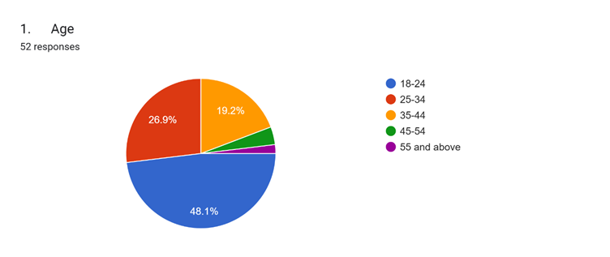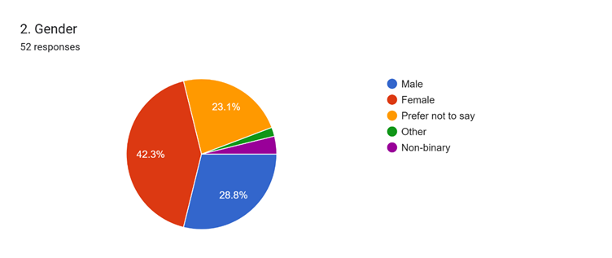

**Interpretation Fig 1:** The pie chart shows 48.1% of the 52 questioned fall between age group 18-24 and thus reflect the largest age category. The mammoth size is 25-34 years at 26.9%. Age group 35-44 totals 19.2%, yet the elder folks (45-54 and 55+) are not proportionate. The results correlate with a clear slant toward youth subjects.

**Interpretation Fig 2:** The pie graph indicates the gender reply of 52 interviewees, varying with the number of identities. The largest category consists of females at 42.3%, followed by males at 28.8% of the interviewees. The large percentage of 23.1% declined to give their gender, reflecting an extensive amount of privacy or deviance. "Other" and "Non-binary" capture lesser percentages of reply.

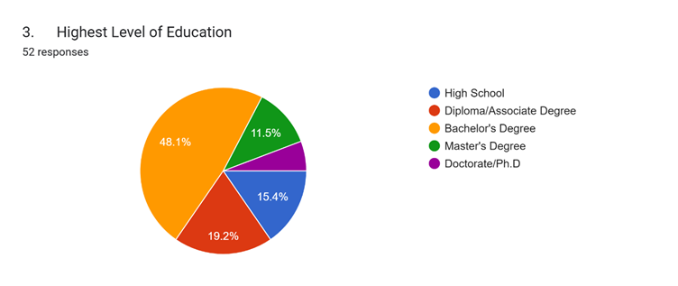

**Interpretation Fig 3:** The pie chart indicates the education level of 52 respondents and is a diversified distribution. There is a high 48.1% that possess a Bachelor's Degree, the biggest proportion. 19.2% are High School graduates and 15.4% have a Diploma/Associate Degree. The Master's Degrees and Doctorate/Ph.D. are minor proportions at 11.5% and the remaining percentage, respectively.

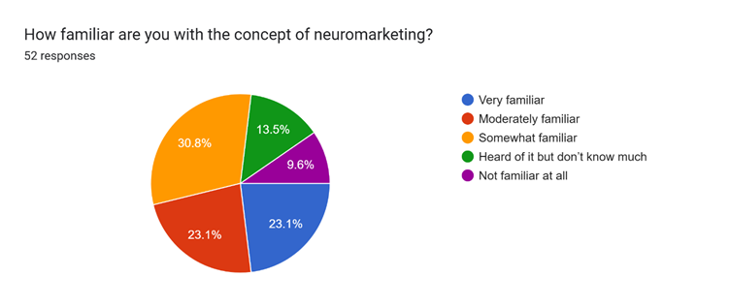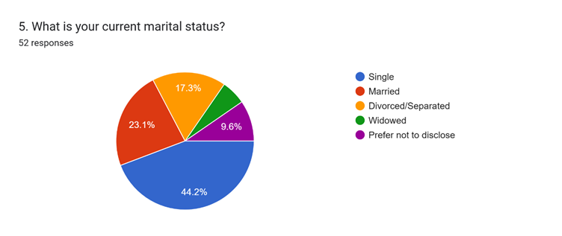

**Interpretation Fig 4:** The pie chart shows the marital status of 52 respondents, and the biggest slice is "Married" at 44.2%. There is a big 23.1% who are "Single," then 17.3% "Divorced/Separated." "Widowed" people make up 9.6%, and a big percentage selected "Prefer not to disclose."

**Interpretation Fig 5:** The pie chart shows the level of familiarity with neuromarketing among 52 respondents, and this is a mixed level of understanding. There is a high 30.8% who are "Somewhat familiar," which shows a general awareness. Both "Heard of it but don't know much" and "Not familiar at all" are the same at 23.1%. Only 13.5% are "Very familiar," and 9.6% are "Moderately familiar" with the term.

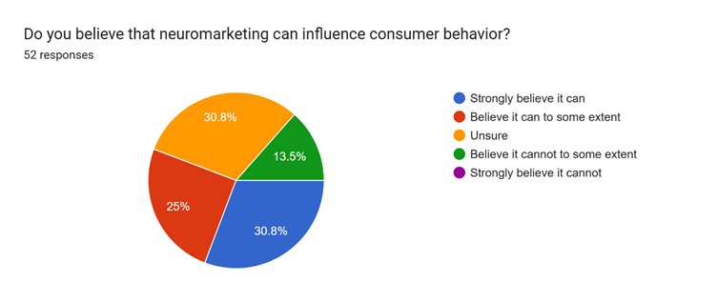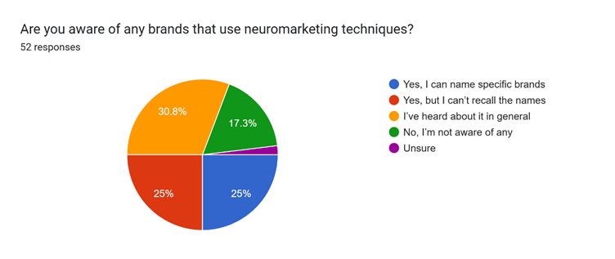**Interpretation Fig 6:** The pie chart shows the view of 52 consumers regarding whether or not neuromarketing has an influence on consumer behavior. A total of 30.8% "Strongly believe it can," as many as state "Believing it can to some extent." Very high at 25% are "Unsure," demonstrating they have no strong opinions. As few as 13.5% "Believe it cannot to some extent," and not a single respondent "Strongly believe it cannot."

**Interpretation Fig 7:** The pie chart shows the understanding of brands through neuromarketing methods by 52 participants, and the variation in understanding is evident. Both "Yes, I can name specific brands" and "Yes, but I don't know the names" are at 25%. A significant majority of 30.8% have "Heard about it in general," which shows partial knowledge of the idea. 17.3% said "No, I'm not aware of any," and a minor percent were "Unsure."

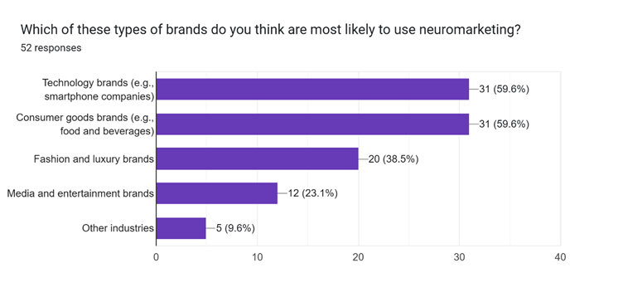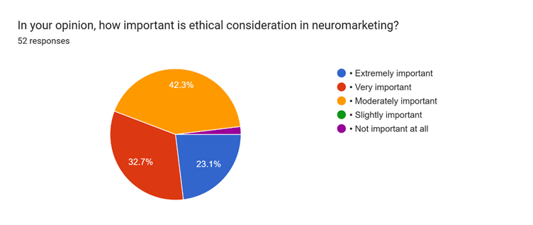 **Interpretation Fig 8:** The bar graph shows Technology and Consumer Goods brands to be most likely to use neuromarketing, each receiving 59.6% from 52 respondents. Fashion and Luxury brands are moderately likely at 38.5%. Media and Entertainment brands received 23.1%, while "Other industries" were found to be least likely at 9.6%. The figures show an overriding connection of neuromarketing with technology and everyday consumer goods.

**Interpretation Fig 9:** The pie chart shows the relative importance of ethicality in neuromarketing among 52 respondents. An overwhelming 42.3% find it "Extremely important," demonstrating that ethical practice is of very high priority. Next, 32.7% find it "Very important," further establishing the importance of ethical procedures. 23.1% find it "Moderately important," indicating it to be perceived as relevant but with less urgency. The other two categories, "Slightly important" and "Not important at all," form insignificant segments of the answers.

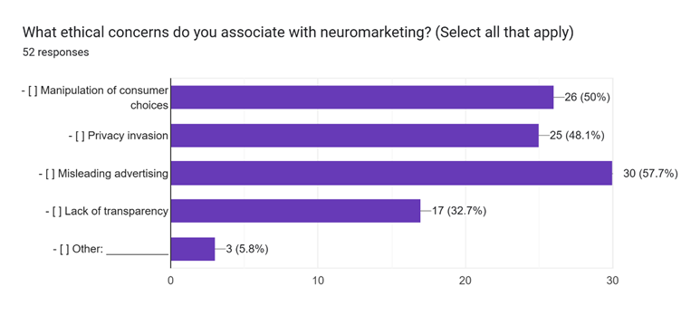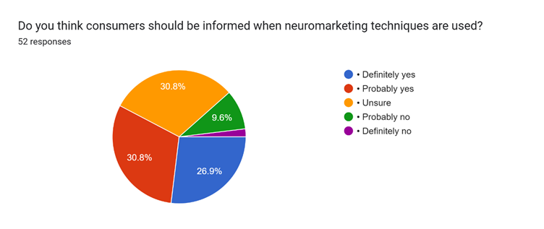

**Interpretation Fig 10:** The bar chart indicates the most common ethical issues with neuromarketing from 52 respondents. "Misleading advertising" is the most common at 57.7% of the mentions. "Manipulation of consumer choices" is the second most common at 50%, suggesting a high concern at being manipulated in the context of purchases. "Privacy invasion" is the third at 48.1% of the mentions. "Lack of transparency" and "Other" are lower occurrence issues, at 32.7% and 5.8% respectively.

**Interpretation Fig 11:** The pie chart shows views of 52 people about whether consumers should be told about neuromarketing methods. An astonishing 30.8% "Definitely yes," and 30.8% "Probably yes," showing a massive majority in support of consumer education. 26.9% are "Unsure," showing some hesitation or neutrality. Only 9.6% "Probably no," and a few "Definitely no," showing a fringe opposition to consumer education.

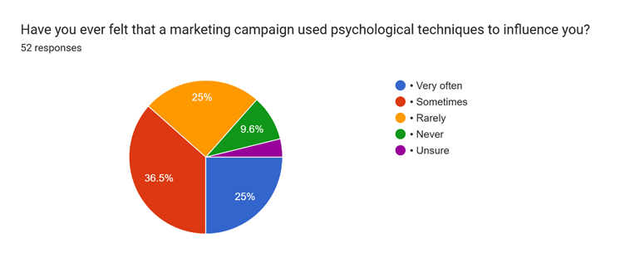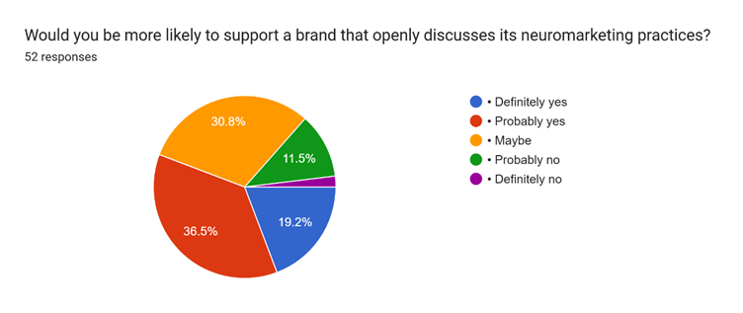

**Interpretation Fig 12:** The pie chart indicates 52 respondents' self-reporting as being psychologically affected by advertising campaigns. A noteworthy 36.5% "Sometimes" report being influenced, and an every-day impression is suggested by this. 25% both "Very often" and "Rarely" report being influenced, indicating a divide between more and less frequent events. 9.6% report never being influenced, and few are "Unsure."

**Interpretation Fig 13:** The pie chart reveals the willingness to be open about a brand when there is frank discussion of neuromarketing activities among 52 individuals. A staggering 36.5% "Probably yes," and a positive lean towards openness. "Definitely yes" is stated by 19.2%, once more reiterating the desire for openness. 30.8% said "Maybe," pointing towards a mid-point or qualified position. 11.5% "Probably no," and a close to zero figure "Definitely no," reflecting limited resistance to openness of a brand.

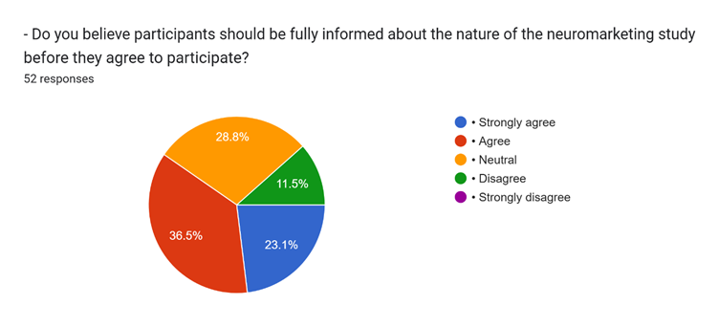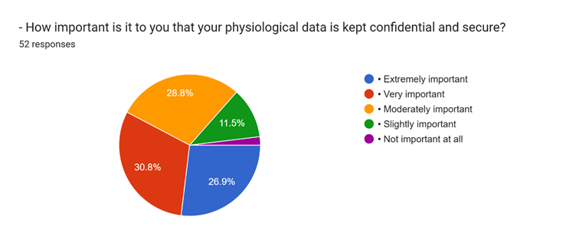**Interpretation Fig 14:** The pie chart demonstrates views of 52 participants concerning informed consent of neuromarketing research subjects. The 36.5% big is "Agree" that individuals should be very well informed, showing strong affirmation of transparency. "Strongly agree" features 23.1%, again bearing witness to the significance of informed consent. 28.8% are "Neutral," showing that no one has strong sentiment or prefers more information. Only 11.5% "Disagree," and not a single one of the subjects "Strongly disagree," proving little opposition for informed consent.

**Interpretation Fig 15:** Pie chart demonstrates reported significance of limiting physiological information to be secure and secret among 52 respondents. A considerable 30.8% classify it as "Very important," providing a testament to significant interest in confidentiality of data. "Extremely important" has been used by 26.9%, again demonstrating how much data security is treasured. "Moderately important" holds 28.8%, implying a general comprehension of how much confidentiality has to be. 11.5% of them claim it's "Slightly important" and a zero percent claim it's "Not important at all," reflecting very little disdain for physiological data privacy.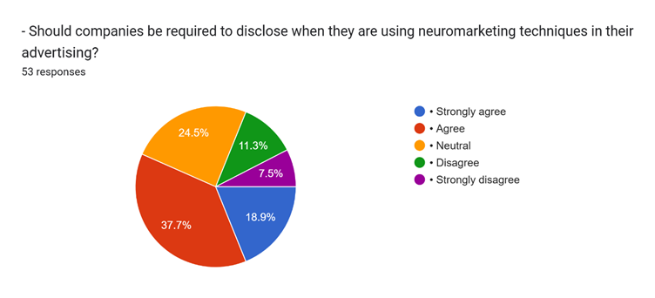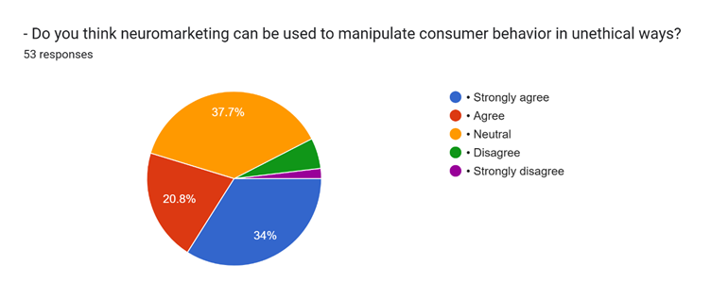**Interpretation Fig 16:** The pie chart shows opinions of 53 individuals regarding forced disclosure of neuromarketing in advertising. An evident 37.7% "Agree" that companies should disclose, with robust support for disclosure. "Strongly agree" is 18.9%, reaffirming forced disclosure. 24.5% are "Neutral," showing no strong opinion or desire for more information. 11.3% "Disagree," and 7.5% "Strongly disagree," reflecting minorities opposing forced disclosure.

**Interpretation Fig 17:** The pie chart reflects 53 opinions about the threat of neuromarketing on consumer behavior in an unethical manner. A considerable 37.7% are "Neutral," i.e., neither agree nor disagree strongly. "Agree" is seen as 34%, and this reflects there is a serious worry about being manipulated in an unethical manner. "Strongly agree" is seen as 20.8%, reflecting the concern felt again. The "Strongly disagree" and "Disagree" sections are low, reflecting low rejection of the threat of unethical manipulation.

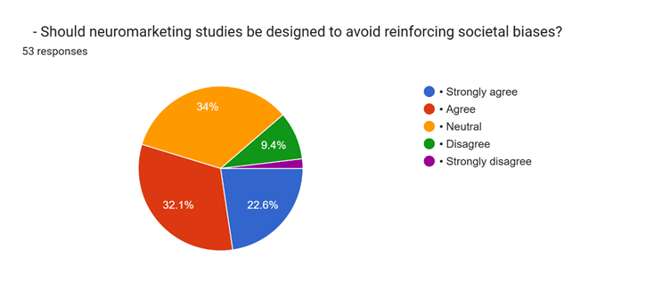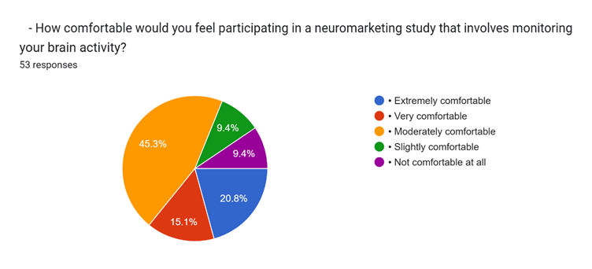**Interpretation Fig 18:** The pie chart presents the attitudes of 53 responders to the approach of neuromarketing research to ensure against reinforcing social bias. The significant 34% are "Neutral," which implies no disagreement or agreement. "Agree" has 32.1%, which suggests that there is high concern against reinforcement risk. "Strongly agree" reads 22.6%, again as evidence for taking care not to reinforce social biases. "Disagree" and "Strongly disagree" each have minor percentages, implying that there is very little rejection of the risk of bias reinforcement.

**Interpretation Fig 19:** The pie chart displays 53 subjects' willingness levels regarding their involvement in neuromarketing research of brain activity monitoring. A significant 45.3% are "Moderately comfortable," manifesting cautious willingness. "Very comfortable" is shown by 20.8%, manifesting affirmative leaning towards research of this type. Both "Slightly comfortable" and "Not comfortable at all" share 9.4%, between mild unwillingness and categorical disagreement. "Very comfortable" is declared by 15.1%, a relatively small group with extremely high confidence in participation.

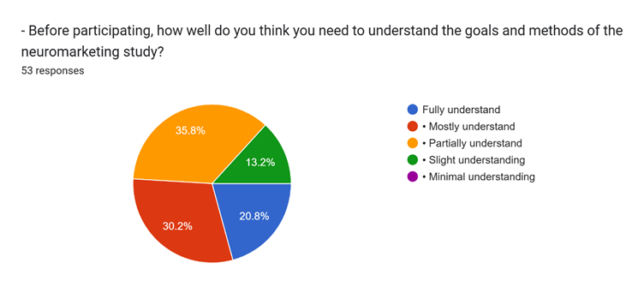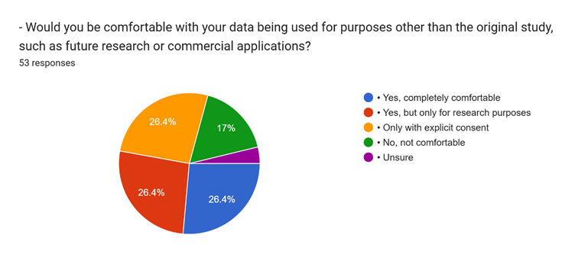**Interpretation Fig 20:** The pie chart reflects the opinions of 53 research subjects in a study on the level of comprehension required prior to participation in a neuromarketing study. A high percentage of 35.8% believe that they need to "Partially understand," suggesting some but not all comprehension. 30.2% claim "Fully understand," suggesting a significant degree of ambition for full comprehension. "Mostly understand" is 20.8%, reflecting a desire for good understanding of the research. Just 13.2% believe that a "Slight understanding" will be enough, and no respondents selected a "Minimal understanding" as adequate.

**Interpretation Fig 21:** The pie chart illustrates the comfort levels of 53 participants to their data being used for purposes other than the initial neuromarketing study. A significant 26.4% are "Yes, completely comfortable," showing willingness to broader data use. Another 26.4% are "Only with explicit consent," showing the importance of informed consent. "Yes, but only for research purposes" is also 26.4%, showing a desire for data use limited to scientific inquiry. 17% are "No, not comfortable," showing outright opposition to use of data other than in the initial study.

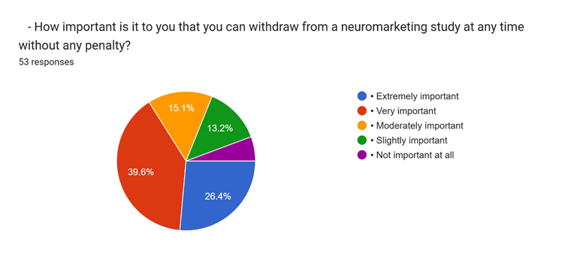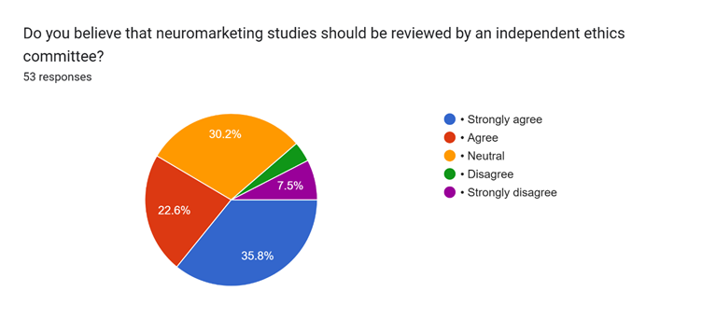

**Interpretation Fig 22:** The pie chart presents the importance of withdrawal rights to neuromarketing research as per 53 responses. The unexpected 39.6% rate it as "Very important," demonstrating a need for control by participants. "Extremely important" is reported by 26.4%, again demonstrating the seriousness of withdrawal rights without penalty. "Moderately important" holds 15.1%, demonstrating overall awareness of the importance of withdrawal options. Only 13.2% find it "Slightly important," and a negligible percentage find it "Not important at all," showing very little disrespect for withdrawal rights.

**Interpretation Fig 23:** 35.8% "Strongly agree" with ethics committee judgments. A huge 30.2% "Agree." 22.6% are "Neutral." Scarcely 7.5% "Disagree." None "Strongly disagree."

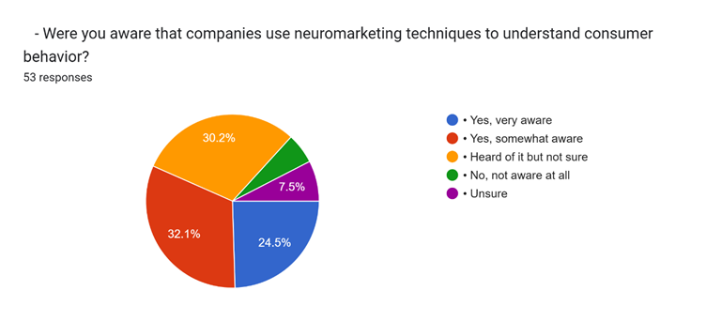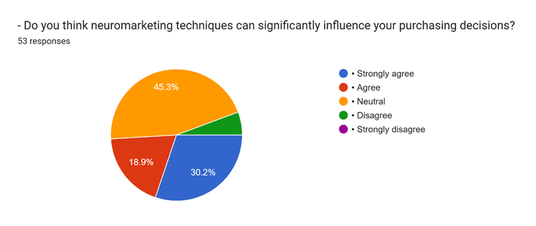**Interpretation Fig 24:** Most (32.1%) were "Yes, somewhat aware" of firms applying neuromarketing. Almost as many (30.2%) were "Heard of it but not sure," meaning they had some general knowledge. 24.5% were "Yes, very aware," meaning clear knowledge. Fewer (7.5%) were "No, not aware at all." Some respondents were "Unsure."

**Interpretation Fig 25:** Most 45.3% are "Neutral," i.e., skeptical or hedging opinion. 30.2% "Strongly agree" that neuromarketing will be able to influence their decisions. Another 18.9% "Agree," which is also in favor of the effect perception. There is a minority who "Disagree," and no one "Strongly disagrees."

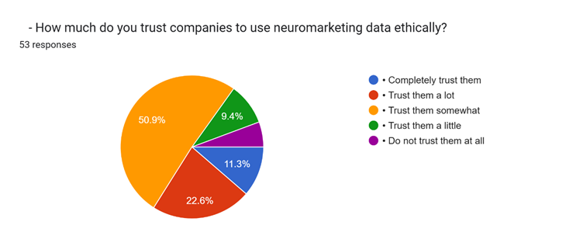 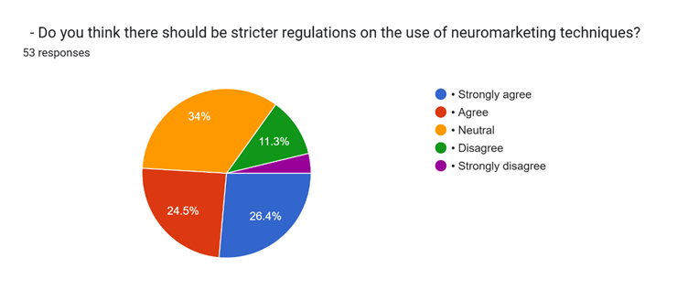**Interpretation Fig 26:** The pie chart indicates that most (50.9%) of the respondents "Trust them somewhat" to apply neuromarketing data in an ethical way. There is a sizable percentage (22.6%) "Trust them a lot," indicating a fairly high level of trust. There is a very slight percentage of 11.3% "Completely trust them," indicating a conservative mindset to trusting fully. 9.4% "Trust them a little," and there are few who "Do not trust them at all."

**Interpretation Fig 27:** The largest percentage, a whopping 34%, of the respondents is "Neutral" in favor of tighter regulation of neuromarketing. 26.4% "Strongly agree" that tighter regulations are warranted. 24.5% "Agree" that so. 11.3% "Disagree," and an extremely tiny percentage "Strongly disagree."

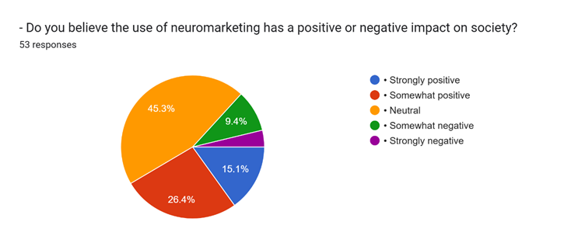

**Interpretation Fig 28:** 45.3% are "Neutral" about the contribution of neuromarketing to society. 26.4% believe that it is "Somewhat positively" contributing. 15.1% believe that it is "Strongly positive." 9.4% believe that it is "Somewhat negative," but some few percent believe that it is "Strongly negative."

* **Findings from Analysis of the Neuromarketing Survey**  
  1) Most of the respondents reside in the age bracket of 18-24 years with 25 people noting that younger people are more active in the debates concerning neuromarketing.  
  2) Respondents in our target group with bachelor’s degrees amounted to 26, which indicates a relatively educated population.  
  3) Most people belonging to the lower income group, which is below 2,00,000, suggests that the sample has a mixture of students and young professionals.  
  4) Recognition was mixed, with good portions (16) being somewhat familiar, 12 moderately familiar, and 7 knowing little about it.  
  5) Almost everyone has a strong belief, with 17 people strongly believing that neuromarketing can influence behavior, with 16 still on the walls of undecided.  
  6) 26 respondents did not identify any brand that employs neuromarketing, reflecting scarce knowledge of certain public companies and their employing strategies.  
  7) Along with privacy intrusion and consumer manipulation, advertising malpractice was the lead ethical issue brought to attention by 11 mentions.  
  8) Trust regarding the employing companies is medium with 27 somewhat trusting while 6 fully trusting.  
  9) 14 respondents extremely agree for changes, with 18 neutral respondents suggesting there is always room for changes.  
  10) It is generally neutral (24) towards the social impact of neuromarketing, expressing skepticism or mixed views.  
  11) More respondents perceive it positively (14 somewhat, 8 strongly) than negatively (5 somewhat, 2 strongly).

**Recommendations**

* Raise public awareness

Companies taking advantage of neuromarketing should implement educational campaigns to demolish their practices, focusing on how these strategies benefit consumers and ensure moral standards.

* Transparency

Businesses should adopt transparent practices by explaining how consumer data is used in neuromarketing. Following moral guidelines, such as avoiding manipulation and respecting consumer privacy, should be given priority.

* Building consumer trust

The installation of the trust requires open communication with consumers, providing insight into neuromarketing techniques, and performing commitment to moral marketing practices. Certificates or partnership with reliable organizations can strengthen credibility.

* Script

Policy makers and stakeholders of the industry should collaborate to establish clear, applied guidelines for neuromarketing. These rules should balance consumer protection with creative freedom of businesses.

* Targeted educational program

Educational institutions and organizations should include neuromarketing in marketing courses, future professionals should equip its moral and practical implications deeply

**Conclusion**

The study underlines the need for more awareness, moral practices, and confidence measures in the field of neuromarketing. While the ability for positive social effects exists, it is important for widespread acceptance to address privacy concerns, consumer manipulation and regulatory ambiguities. Companies should take active steps to educate the public, follow moral standards and engage in transparent communication. Policy makers should play an important role in establishing rules for safety of consumer interests. By bridging these intervals, neuromarketing can develop in a reliable and effective tool that benefits both businesses and consumers.

The moral development of neuromarketing requires a broader structure that extends beyond basic privacy concerns, addressing potentially unconscious manipulation, algorithm bias and vulnerability of specific demographics. It is important to implement meaningful consent, protect neuro privacy, and promote consumer empowerment. This requires a multidimensional approach that includes industry self-regulation, independent morality advisory boards, inter-privacy such as technical solutions and explaining AIs, and strong education for neuromarketing professionals. Public engagement and international collaboration are important for cohesion of moral standards and ensure responsible innovation, eventually using neuromarketing ability to positive social impacts, reducing the risks for personal autonomy and social welfare

**References**

1. Uddin, M. N. (2024). Neuroscience marketing, a fusion of neuroscience and marketing,

seeks to understand consumer decision-making processes. PUST Journals. Retrieved

from https://pust.ac.bd/uploads/pust-journals/pdf/1.pdf

2. Alsharif, A. H., Salleh, N. Z. M., &amp; Roslan, M. (2021). The review highlights that

neuromarketing aims to decode consumer responses using neuroscience techniques.

CIBGP. Retrieved from https://cibgp.com/au/index.php/1323-6903/article/view/1036

3. Stanton, S. J., Sinnott-Armstrong, W., &amp; Huettel, S. A. (2016). Neuromarketing uses

neuroscience to better understand consumer preferences. SpringerLink. Retrieved from

https://link.springer.com/article/10.1007/s10551-016-3012-1

4. Devaru, S. D. B. (2024). Neuromarketing combines neuroscience with consumer research

to analyze purchasing behavior. IJTRS. Retrieved from

https://ijtrs.com/uploaded_paper/SIGNIFICANCE%20OF%20NEUROMARKETING%2

0IN%20MODERN%20MARKETING.pdf

5. Ulman, Y. I., Cakar, T., &amp; Yildiz, G. (2014). The field of neuromarketing integrates

psychology, neuroscience, and marketing strategies. SpringerLink. Retrieved from

https://link.springer.com/article/10.1007/s11948-014-9534-7

6. Olteanu, M. D. B. (2014). The literature on neuromarketing shows how the brain’s

reactions influence consumer behavior. SpringerLink. Retrieved from

https://link.springer.com/article/10.1007/s12144-014-9215-9

7. Goncalves, M., Hu, Y., Aliagas, I., &amp; Lu, S. (2024). Neuromarketing, a rapidly advancing

field, integrates neural insights into marketing strategies. Taylor &amp; Francis Online.

Retrieved from https://www.tandfonline.com/doi/abs/10.1080/23311975.2024.1234567

8. Al Abbas, A. (2019). Neuromarketing combines neuroscience and marketing to better

understand consumer behavior. KnE Social Sciences. Retrieved from

https://knepublishing.com/index.php/Kne-Social/article/view/1234

9. Baños-González, M., Baraybar-Fernández, A., &amp; Jiménez-Arberas, E. (2020).

Neuromarketing, an emerging discipline combining neuroscience and marketing,

influences brand strategies. Frontiers in Neuroscience. Retrieved from

https://www.frontiersin.org/articles/10.3389/fnins.2020.00456/full

10. Brenninkmeijer, J., Schneider, T., &amp; Wenzel, M. (2020). Neuromarketing integrates

neuroscience and marketing to assess subconscious consumer responses. SAGE Journals.

Retrieved from https://journals.sagepub.com/doi/pdf/10.1177/0022002720914456

11. Jain, A., &amp; Kumar, P. (2022). Neuromarketing integrates neuroscience with marketing

insights to optimize brand strategies. Journal of Namibian Studies. Retrieved from

https://namibian-studies.com/index.php/JNS/article/view/567

12. Singh, P., Alhassan, I., &amp; Khoshbakht, L. (2023). Neuromarketing has gained significant

attention in recent years, revolutionizing advertising strategies. MDPI Journals.

Retrieved from https://www.mdpi.com/0718-1876/18/4/101

13. Ramsøy, T. Z. (2019). Consumer neuroscience and neuromarketing have expanded

research on decision-making processes. ResearchGate. Retrieved from

https://www.researchgate.net/profile/Thomas_Z_Ramsoy/publication/338789123_Neuro

marketing_The_future_of_marketing_strategy/links/5e6a2a12458515594c92b6e7.pdf

14. Kenning, P., &amp; Linzmajer, M. (2010). Consumer neuroscience has emerged from the

intersection of psychology and marketing. ResearchGate. Retrieved from

https://www.researchgate.net/profile/Peter-

Kenning/publication/233714563_Consumer_Neuroscience/links/9fcfd50fdfd156a3f8f564

e4.pdf

15. Breiter, H. C., Block, M., &amp; Kelley, D. (2015). Neuromarketing is an evolving field that

intersects psychology, business, and neuroscience. Frontiers in Human Neuroscience.

Retrieved from https://www.frontiersin.org/journals/human-

neuroscience/articles/10.3389/fnhum.2015.00089/full

16. Ene, S. (2021). The book explores the rapid evolution of marketing strategies influenced

by neuroscience. BookChapter. Retrieved from

https://www.bookchapter.org/kitaplar/Current_Marketing_Trends.pdf

17. Flores, J., Baruca, A., &amp; Saldivar, R. (2014). The ethical debate surrounding

neuromarketing raises concerns about consumer manipulation. Digital Commons

TAMUSA. Retrieved from

https://digitalcommons.tamusa.edu/cgi/viewcontent.cgi?article=1037&amp;context=student_

work

18. Dierichsweiler, K. L. A. (2014). Neuromarketing, the application of neuroscience in

marketing, influences consumer engagement. University of Twente Essays. Retrieved

from https://essay.utwente.nl/65384/1/Dierichsweiler_BA_MB.pdf

19. Hensel, D., Iorga, A., Wolter, L., &amp; Hartmann, J. (2017). Neuromarketing combines

neuroscience and marketing techniques to enhance advertising effectiveness. Taylor &amp;

Francis Online. Retrieved from

https://www.tandfonline.com/doi/pdf/10.1080/23311975.2017.1362896

20. Hair, J., Krupka, Z., &amp; Vlašić, G. (2024). Artificial Intelligence (AI) and Smart Contracts

are shaping modern neuromarketing practices. GBC Summer Conference. Retrieved from

https://gbcsummer.com/wp-

content/uploads/2024/Neuromarketing_AI_SmartContracts.pdf