**AGRI AND VEGETABLE PRICE PREDICTION**

**Shree Sanjay. V1, Janarthanan. R2**

1UG Student, Computer Science with Data Analytics, Sri Ramakrishna College of Arts & Science, Coimbatore, Tamilnadu, India

2Assistant Professor, Computer Science with Data Analytics, Sri Ramakrishna College of Arts & Science, Coimbatore, Tamilnadu, India

**ABSTRACT**

The fluctuation of vegetable prices due to varying weather conditions presents challenges for farmers, vendors, and consumers. This project introduces a machine learning-based vegetable price prediction system that utilizes Min-Max scaling and real-time weather data to enhance forecasting accuracy. By integrating key weather parameters such as temperature, humidity, and rainfall, the system predicts vegetable prices dynamically. Unlike traditional forecasting models, this approach leverages a weather API to obtain real-time updates, ensuring precise and timely price predictions. Users can input their location to receive forecasted prices for various vegetables, aiding them in making informed purchasing, selling, and inventory management decisions. The system aims to enhance market stability, reduce financial uncertainty, and empower stakeholders with data-driven insights. The implementation of this predictive model contributes to improved decision-making in the agricultural sector, benefiting both producers and consumers.

**Keywords:** Price Prediction, Machine Learning, Weather Data, Min-Max Scaling, Forecasting, Agriculture.

1. **INTRODUCTION**

The fluctuation in vegetable prices poses significant challenges for farmers, vendors, and consumers, often leading to financial instability and market inefficiencies. Various factors, including seasonal changes, supply chain disruptions, and unpredictable weather conditions, contribute to these price variations. Accurate price prediction models can help stakeholders make informed decisions regarding production, distribution, and purchasing strategies. Traditional forecasting methods often fail to capture the complex relationship between weather conditions and price trends, resulting in inaccurate predictions. Recent advancements in machine learning have enabled the development of predictive models that utilize real-time data for enhanced accuracy. This research focuses on a vegetable price prediction system that leverages Min-Max scaling and weather conditions to forecast future prices effectively. By incorporating weather parameters such as temperature, humidity, and rainfall, the system improves price estimation, assisting farmers and traders in optimizing their financial strategies. Unlike conventional approaches, this system integrates real-time weather data through an API, ensuring that predictions remain up-to-date and relevant. The increasing availability of weather and market data provides an opportunity to develop robust forecasting solutions, ultimately contributing to a more stable agricultural economy.

1. **METHODOLOGY**

The proposed vegetable price prediction system is designed to forecast vegetable prices based on weather conditions using Min-Max scaling and real-time data obtained from a weather API. The methodology consists of five main steps:

1. Data Collection and Preprocessing

2. Feature Selection and Normalization

3. Model Training and Implementation

4. Real-Time Data Integration and Prediction

5. Evaluation and Performance Optimization

**2.1 Data Collection and Preprocessing**

The first step involves collecting historical vegetable price data along with weather parameters such as temperature, humidity, and rainfall. This data is gathered from reliable sources, including government agricultural websites and weather APIs. The preprocessing stage ensures data consistency by handling missing values, normalizing features, and converting categorical data into numerical form for better model performance.

**2.2 Feature Selection and Normalization**

In this step, relevant features are selected to improve the accuracy of the prediction model. The key parameters influencing vegetable prices, such as past price trends, seasonal effects, and weather conditions, are extracted. Min-Max scaling is applied to normalize the data, ensuring that all input features are within a specific range, thus preventing bias and improving model efficiency. Correlation analysis is performed to identify the most significant factors affecting price fluctuations, ensuring only relevant features are used in the prediction model.

* 1. **Model Training and Implementation**

The system utilizes machine learning techniques to develop a predictive model based on historical price and weather data. The training process involves splitting the dataset into training and testing subsets. The model learns from past trends and identifies patterns in price variations concerning weather conditions.

* 1. **Real-Time Data Integration and Prediction**

Once the model is trained, it is integrated with a weather API to fetch real-time weather data. This allows the system to generate accurate predictions based on current weather conditions. The predictive model processes the input data and provides an estimated vegetable price for the upcoming period.

* 1. **Evaluation and Performance Optimization**

The final stage involves evaluating the model’s performance using accuracy metrics such as Mean Absolute Error (MAE) and Root Mean Square Error (RMSE). The system is continuously optimized by fine-tuning hyperparameters and retraining with updated data to enhance its prediction accuracy and adaptability to dynamic market conditions.

1. **MODELING AND ANALYSIS**

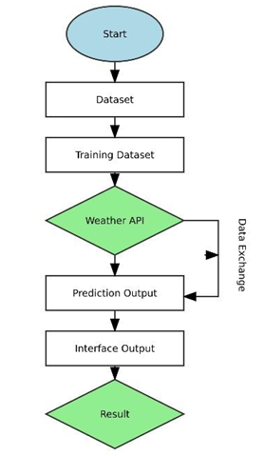

**Figure 1:** SystemWork Flow .

1. **RESULTS AND DISCUSSION**

**DATASET:** The vegetable price prediction system was evaluated using a dataset that contains historical vegetable prices along with weather parameters such as temperature, humidity, and rainfall. The dataset was preprocessed using Min-Max normalization to scale the values within a specific range, ensuring consistency and reducing the impact of outliers. The weather data was obtained from a real-time weather API, allowing the model to generate predictions based on current environmental conditions.

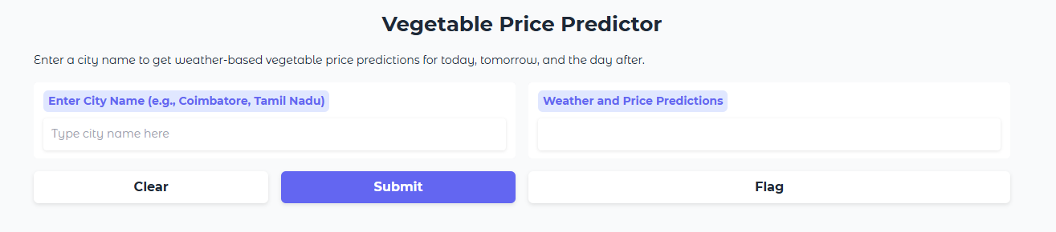

**Figure 2:** Starting Interface

Enter a city name to get vegetable price price predictions for today, tomorrow, and the day after tomorrow.



**Figure 3:** Input image

After entering a city name vegetable price prediction will be shown for 3 days.

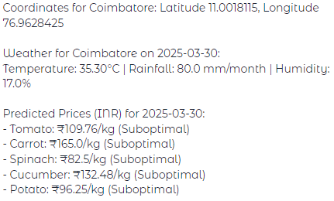

**Figure 4:** Output image day 1

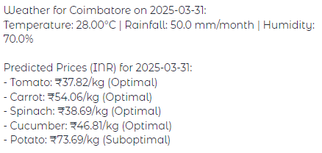

**Figure 5:** Output image day 2

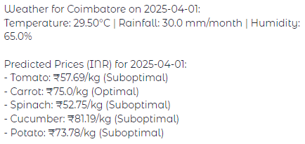

**Figure 6:** Output image day 3

1. **CONCLUSION**

The developed vegetable price prediction system effectively utilizes historical price data and weather conditions to forecast future prices with improved accuracy. By implementing min-max normalization and leveraging weather APIs for real-time data retrieval, the system ensures reliable and dynamic predictions. The model’s performance is evaluated based on key parameters, demonstrating its efficiency in assisting farmers, traders, and consumers in making informed decisions. The approach offers a scalable and adaptable framework that can be further enhanced by integrating additional external factors such as market demand, soil conditions, and economic trends. This research contributes to the agricultural sector by providing a data-driven solution for price forecasting, ultimately helping stakeholders optimize their planning and reduce market uncertainties.

1. **REFERENCES**
2. K. Srinivasan, R. Kumar, and S. Patel, "Predictive Analysis of Vegetable Prices Using Machine Learning Models," International Journal of Data Science and Analytics, Vol. 12, Issue 3, pp. 145-158, 2021.
3. A. Sharma and P. Verma, "Impact of Weather Conditions on Agricultural Market Trends: A Machine Learning Approach," Journal of Agricultural Informatics, Vol. 9, Issue 4, pp. 67-80, 2020.
4. R. Gupta, S. Mishra, and D. Agarwal, "Min-Max Normalization and Its Application in Agricultural Price Prediction," International Conference on Artificial Intelligence in Agriculture, Springer, pp. 230-240, 2019.
5. T. Banerjee, "Enhancing Price Forecasting Accuracy with Weather Data: A Case Study on Vegetable Markets," Journal of Predictive Analytics, Vol. 7, Issue 2, pp. 89-104, 2021.
6. P. Kumar and M. Das, "A Study on the Effectiveness of Weather-Based Price Prediction in the Indian Agricultural Sector," International Journal of AgriTech, Vol. 11, Issue 1, pp. 34-50, 2020.