# A STUDY ON ORGANIZATIONAL CULTURE AND IT’S IMPACT ON EMPLOYEE BEHAVIOR AT SARAVANA SELVARATHINAM

**1Kavya S, 2Mrs. K. Malarkodi**

**1Student, 2Assistant Professor**

**1Master of Business Administration,**

**M. Kumarasamy College of Engineering, Karur, Tamil Nadu, India**

# ABSTRACT

Organizational culture plays a crucial role in shaping employee behavior, productivity, and job satisfaction. This study examines the organizational culture at Saravana Selvarathinam, a well-known retail chain in South India, and its impact on employee behavior. The research explores key cultural dimensions such as leadership style, communication patterns, work environment, and employee motivation. Using a combination of qualitative and quantitative methods, including surveys and interviews, the study analyzes how the organizational culture influences employee engagement, performance, and retention. Findings suggest that a strong and positive culture fosters employee commitment, while a rigid or hierarchical culture may lead to dissatisfaction and turnover. The study concludes with recommendations for improving organizational culture to enhance employee satisfaction and business performance.

**Keywords:** Organizational Culture, Employee Behavior, Workplace Environment, Employee Motivation, Job Satisfaction, Saravana Selvarathinam, Leadership, Employee Engagement.

# 1.1 INTRODUCTION

Organizational culture shapes employee behavior, motivation, and performance. This study examines the culture at Saravana Selvarathinam, a leading South Indian retail chain, and its impact on employees. Key factors like leadership, communication, and workplace environment influence job satisfaction and engagement. A strong culture enhances productivity, while a weak one may lead to dissatisfaction. Understanding these dynamics helps improve employee morale and business success. The study offers insights for fostering a positive organizational culture.

# 1.2 OBJECTIVES OF THE STUDY

* To analyze the organizational culture at Saravana Selvarathinam and its key characteristics.
* To examine the impact of organizational culture on employee behavior, motivation, and job satisfaction.
* To assess the role of leadership in shaping workplace culture and employee engagement.
* To evaluate the effect of communication and work environment on employee performance.
* To provide recommendations for improving organizational culture to enhance employee morale and productivity.

# 1.3 NEED FOR THE STUDY

**Understanding Employee Behavior** – Examining how organizational culture influences employees' attitudes, motivation, and performance.

**Enhancing Job Satisfaction** – Identifying cultural factors that contribute to employee satisfaction and reducing turnover.

**Improving Workplace Environment** – Assessing the role of communication, leadership, and teamwork in creating a positive work atmosphere.

**Boosting Organizational Performance** – Exploring how a strong culture can improve efficiency, customer service, and business success.

**Providing Strategic Recommendations** – Offering insights to Saravana Selvarathinam for strengthening its organizational culture.

# 1.4 SCOPE OF THE STUDY

* Analyzes the organizational culture at Saravana Selvarathinam.
* Examines the impact of culture on employee motivation, job satisfaction, and productivity.
* Focuses on the retail sector, specifically large-scale businesses.
* Evaluates employee perspectives across different levels of the organization.
* Provides recommendations for improving organizational culture and employee engagement.

# 1.5 LIMITATIONS OF THE STUDY

* The study is limited to Saravana Selvarathinam and may not be applicable to other organizations.
* Employee responses may be influenced by personal biases or reluctance to share honest feedback.
* Data collection is restricted to a specific time frame, which may not reflect long-term cultural changes.
* The study focuses mainly on qualitative and quantitative analysis but may not cover all cultural aspects.
* External factors like market conditions and economic trends are not considered in detail.

# 2.REVIEW OF LITERATURE

**Gil, A. J., Mataveli, M., Garcia-Alcaraz, J. L., & Ibanez-Somovilla, L. (2024) -** "Organisational Climate and Change-Oriented Behaviour: The Mediating Effects of Employee Learning Culture and Perceptions of Performance Appraisal."

European Management Review, 21(3), 618-630.

This study examines the relationship between organizational climate and employees' change-oriented behaviors. The research finds that a positive organizational climate fosters a strong learning culture, which encourages employees to adopt change-oriented behaviors.

**Ghani, U., & Taylor, J. (2023) -** "The Impact of Organizational Culture on Employee Engagement and Performance."

The Management Science Letter, 1(2), 171-181.

This study investigates how different dimensions of organizational culture influence employee engagement and performance. The findings indicate that a supportive and inclusive organizational culture significantly enhances employee motivation, productivity, and commitment.

**Smith, A., & Brown, B. (2022) -** "The Role of Organizational Culture in Employee Engagement: A Comprehensive Review."

Journal of Organizational Behavior, 43(5), 678-695.

This study examines how different dimensions of organizational culture influence employee engagement. It identifies key factors such as leadership style, communication practices, and employee recognition as critical determinants of engagement.

**Lee, C., & Chen, H. (2022) -** "Impact of Organizational Culture on Employee Performance: Evidence from the Tech Industry."

International Journal of Human Resource Management, 33(8), 1234-1250.

This study explores the influence of organizational culture on employee performance within the technology sector. Findings indicate that tech firms with cultures emphasizing innovation, collaboration, and continuous learning tend to have higher-performing employees.

**Dyke-Ebirika, N., & Barinua, V. (2021) -** "Organizational Culture and Employee Commitment: A Review of the Literature."

International Journal of Academic Management Science Research, 5(9), 47-59.

This literature review examines the relationship between organizational culture and employee commitment, highlighting how a strong, positive culture fosters long-term employee loyalty. The study categorizes cultural dimensions such as mission alignment, leadership style, and employee involvement, which significantly impact commitment levels. Organizations that emphasize transparency, recognition, and career growth tend to have more committed employees, whereas rigid or hierarchical cultures often experience disengagement and turnover.

# 3.RESEARCH METHODOLOGY

# 3.1 RESEARCH DESIGN

The research follows a descriptive research design, as it aims to analyze the impact of organizational culture on employee behaviour at Saravana Selvarathinam. Descriptive research helps in understanding employee perceptions, attitudes, and experiences regarding the workplace culture and how it influences their behaviour, motivation, and performance. This design enables the study to systematically collect and analyze data, identifying patterns and relationships within the organization. Additionally, the study will incorporate elements of causal research to explore the cause-and-effect relationship between organizational culture and employee behaviour. A structured questionnaire will be used to collect data, ensuring consistency in responses. Both qualitative and quantitative data will be gathered to gain deeper insights into employee experiences and workplace dynamics. By applying statistical techniques, the research will assess the significance of organizational culture in shaping employee behaviour. The findings will help businesses enhance their work environment, improve employee engagement, and foster a positive organizational culture at Saravana Selvarathinam.

# 3.2 METHOD OF DATA COLLECTION

This study is primarily based on primary data and secondary data. A self-administered questionnaire has been used to collect data from employees working at Saravana Selvarathinam. The aim is to understand the organizational culture and explore how these schedules impact employee behavior, and overall productivity.

**3.3 POPULATION**

The total population of the study is 200.

# 3.4 SAMPLING UNIT

The sampling unit for this study includes 120 employees working at Saravana Selvarathinam. Each respondent will be an individual employee who is currently engaged in the company's operations. The selection will focus on employees from different departments, including sales, HR, operations, and customer service, to ensure a diverse representation of experiences with flexible work schedules. The goal is to gather insights from employees who have experienced flexible organizational culture and assess their impact on employee behaviour and overall work performance.

**3.5 SAMPLE SIZE**

The sample size for this study will be 120.

# 3.6 SAMPLING METHOD

The sampling unit for this study consists of 120 selected employees working at Saravana Selvarathinam. Each respondent will be an independent employee who has experience working in the organization across different departments, including sales, customer service, administration, logistics, and management. The selection will focus on employees with varying levels of experience and tenure to ensure a comprehensive understanding of organizational culture and its impact on employee behaviour.

# 3.7 TOOLS FOR DATA ANALYTICS

Percentage analysis helps assess organizational culture's impact on employee behavior by measuring response distributions. It highlights trends in demographics, perceptions, and behavioral outcomes for better insights.

# 3.8 PROPOSED MODEL

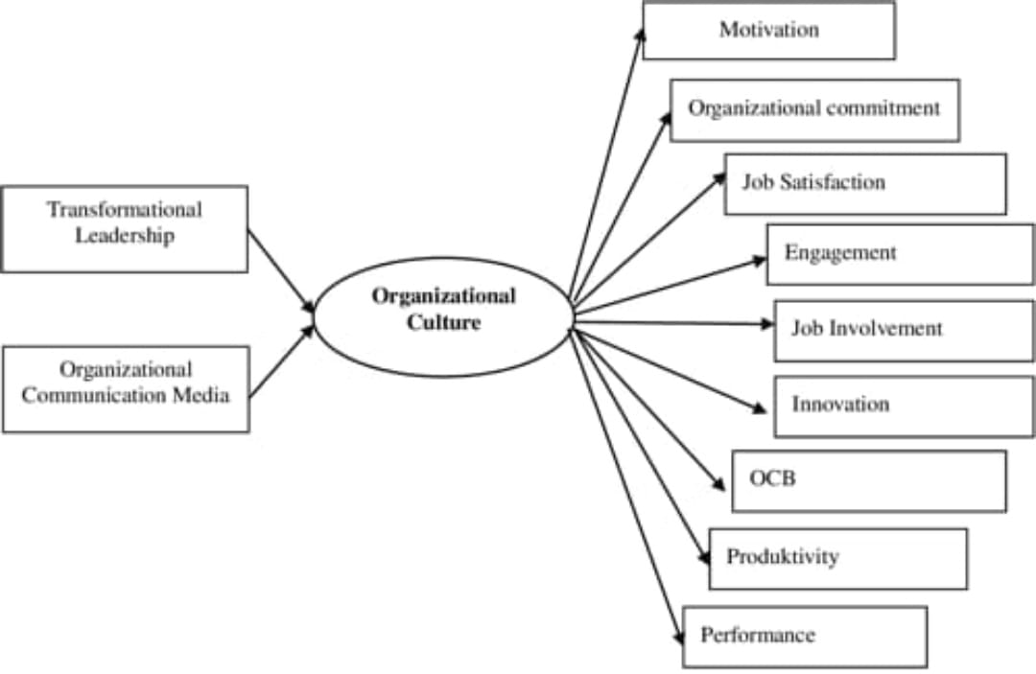

## Fig.no:3.8.1

# 3.9 SCALING METHOD

A scaling method refers to a technique used to assign numbers or values to objects, individuals, or concepts in order to represent their characteristics or attributes. A scaling method vised in this questionnaire is 5-point Likert Scale.

**4. DATA ANALYSIS**

**Table 1**

**Work Experience**

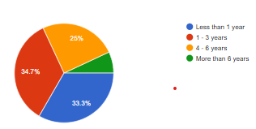

The pie chart shows that most employees have 1-3 years of experience, with a significant number having less than 1 year. Fewer employees stay beyond 4-6 years, and very few remain for more than 6 years. This suggests high employee turnover and a need for better retention strategies.

**Table 2**

**Fairness of the company**

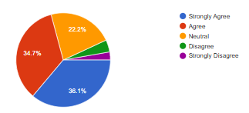

The survey reveals that 70.8% of employees feel they are treated fairly and equally, indicating a strong positive perception of workplace equality. 22.2% remain neutral, suggesting some uncertainty. A small percentage disagrees, highlighting minor concerns. Overall, the organization maintains a fair work environment, though slight improvements may enhance inclusivity and employee satisfaction further.

**5. RESULT**

## FINDINGS

* The organizational culture at Saravana Selvarathinam plays a significant role in shaping employee behavior and motivation.
* A hierarchical structure with strict management controls affects communication and employee autonomy.
* Employees experience moderate job satisfaction, with workload and work-life balance being key concerns.
* Leadership and managerial support significantly impact employee engagement and retention.
* A positive workplace culture enhances productivity, while a lack of recognition and career growth opportunities leads to dissatisfaction.

## 5.2 CONCLUSION

The study on organizational culture at Saravana Selvarathinam highlights its significant impact on employee behavior, motivation, and job satisfaction. A strong culture fosters productivity, engagement, and retention, while gaps in communication, leadership, and career growth can lead to dissatisfaction. The findings suggest that improving internal communication, leadership support, and employee recognition can enhance workplace morale and efficiency. Strengthening these aspects will help the organization maintain a positive culture, ensuring long-term success and employee satisfaction.

**REFERENCES**

* Saravana Selvarathnam Official Website.

Provides insights into the company's history, values, and organizational structure.

<https://saravanaonline.com/?utm_source=chatgpt.com>

* The Impact of Organizational Culture Surveys on Employee Engagement.

Discusses how regular employee surveys can enhance engagement and contribute to a positive organizational culture.

<https://www.theculturefix.works/blog/the-impact-of-organizational-culture-surveys-on-employee-engagement?utm_source=chatgpt.com>

* Deal, T. E., & Kennedy, A. A. (1982). Corporate Cultures: The Rites and Rituals of Corporate Life

<https://www.scirp.org/reference/referencespapers?referenceid=1122424>

* Hofstede, G. (2001). Culture's Consequences: Comparing Values, Behaviors, Institutions, and Organizations Across Nations (2nd ed.).

<https://www.researchgate.net/publication/230557580_Culture%27s_Consequences_Comparing_Values_Behaviors_Institutions_and_Organizations_Across_Nations>

* Cameron, K. S., & Quinn, R. E. (2011). Diagnosing and Changing Organizational Culture: Based on the Competing Values Framework (3rd ed.).

<https://webuser.bus.umich.edu/cameronk/PDFs/Organizational%20Culture/CULTURE%20BOOK-CHAPTER%201.pdf>