**Rock Segmentation Analysis**

**Mahimithran K S**

Department of Computer Science with Data Analytics,

Sri Ramakrishna College of Arts & Science,

Coimbatore, Tamil Nadu

**ABSTRACT**

This study explores the application of deep learning techniques, specifically **Segment Anything Model (SAM) and ConvNeXt**, for **multi-rock classification** in geological images, addressing the limitations of traditional manual field observations. Unlike previous methodologies that primarily focused on classifying a **single rock type**, this research extends to **multi-rock classification** by analyzing **natural rock surfaces** that contain diverse lithologies.The dataset comprises a wide range of **sedimentary, metamorphic, and igneous rocks** collected from different geological formations. **ConvNeXt**, a state-of-the-art convolutional neural network, significantly enhances **classification accuracy**, ensuring better feature extraction and differentiation between rock types. Simultaneously, **SAM** is employed for **semantic segmentation**, effectively separating multiple rock types within a single image, which is crucial for **geological mapping and sedimentological studies**. To assess the effectiveness of the proposed approach, model performance is rigorously evaluated using **Mean Intersection over Union (MIoU)**, a standard metric in segmentation tasks. The combination of SAM and ConvNeXt provides an **automated, scalable, and highly accurate** solution for rock classification, improving the efficiency of geological surveys. This study represents the **first application** of these advanced deep learning models for **multi-rock segmentation**, revolutionizing lithological mapping and enhancing automation in geological research. By reducing dependency on manual classification, this approach facilitates more precise and efficient **geological analysis**, paving the way for future AI-driven advancements in Earth sciences.

**Keywords:** **Deep Learning, Multi-Rock Classification,Semantic Segmentation,ConvNeXt, Segment Anything Model (SAM),** **Geological Mapping**

1. **INTRODUCTION**

The identification and classification of igneous, metamorphic, and sedimentary rocks are essential in geological studies. Traditionally, sedimentologists rely on manual field observations, a labor-intensive process conducted under challenging conditions. To address these limitations, this study applies deep learning-based semantic segmentation using **Segment Anything Model (SAM) and ConvNeXt** for multi-rock classification in high-resolution geological images. Our approach employs **ConvNeXt** as a feature extractor coupled with **SAM’s prompt-based segmentation capabilities** to ensure accurate boundary recognition. The dataset encompasses **sedimentary rocks** (coal, limestone, sandstone), **metamorphic rocks** (marble, quartzite), and **igneous rocks** (granite, basalt) collected from various geological formations. Model performance is evaluated using **Mean Intersection over Union (MIoU)**, along with an analysis of **color representations and image enhancement techniques**. The results demonstrate that ConvNeXt enhances classification accuracy, while SAM efficiently segments multiple rock types within single images. This work highlights the potential of deep learning in automating rock classification, significantly improving **geological mapping and sedimentological research**, thereby reducing dependency on manual field observations and enhancing efficiency in geological studies.

1. **METHODOLOGY**

The methodology of this research focuses on the application of **deep learning-based semantic segmentation using Segment Anything Model (SAM) and ConvNeXt for multi-rock classification in high-resolution geological images. This approach enhances traditional lithology classification by automating rock segmentation and identification, reducing dependency on manual field observations.

2.1 Data Collection and Preprocessing

The dataset consists of igneous, metamorphic, and sedimentary rock images, including coal, limestone, sandstone, marble, quartzite, granite, and basalt, sourced from various geological formations. The preprocessing steps involve grayscale conversion, noise reduction, contrast enhancement, and image normalization to improve model performance. Edge detection techniques such as Canny and Sobel filters are applied to highlight key lithological features.

2.2 Deep Learning Model Architecture

The classification framework employs ConvNeXt as a feature extractor, leveraging its convolutional layers for high-accuracy classification. SAM is integrated for prompt-based semantic segmentation, efficiently distinguishing multiple rock types within a single image. The Mean Intersection over Union (MIoU) metric is used to evaluate segmentation accuracy.

2.3 Model Training and Evaluation

The dataset is split into training, validation, and test sets. Data augmentation techniques, including rotation, flipping, and zooming, are applied to enhance model generalization. The model is trained using the Adam optimizer with a cross-entropy loss function. Evaluation metrics such as precision, recall, F1-score, and MIoU are used to measure classification accuracy and segmentation performance.

2.4 Performance Comparison and Validation

To assess effectiveness, the proposed approach is compared with traditional machine learning models and previous deep learning-based classification methods. Visual and quantitative validation is performed through geological expert review and real-world dataset testing.

1. **MODELING AND ANALYSIS**

3.1 Deep Learning Model Architecture

The proposed methodology employs ConvNeXt as the primary feature extraction model and the Segment Anything Model (SAM) for semantic segmentation of geological images. ConvNeXt, a modernized convolutional neural network (CNN), enhances feature representation by utilizing ResNet-inspired designs with depthwise convolutions and Layer Normalization. It effectively classifies rock types by extracting deep spatial features. Meanwhile, SAM, developed for generalized segmentation tasks, utilizes prompt-based segmentation, allowing precise boundary identification of multiple rock types within a single image.

3.2 Data Processing and Augmentation

The dataset consists of high-resolution images of igneous, metamorphic, and sedimentary rocks collected from diverse geological formations. Preprocessing steps include:

* Grayscale conversion to standardize image intensity levels.
* Contrast enhancement for improving texture differentiation.
* Edge detection techniques (Canny/Sobel) to highlight rock grain structures.
* Augmentation techniques (rotation, flipping, scaling) to improve model robustness.

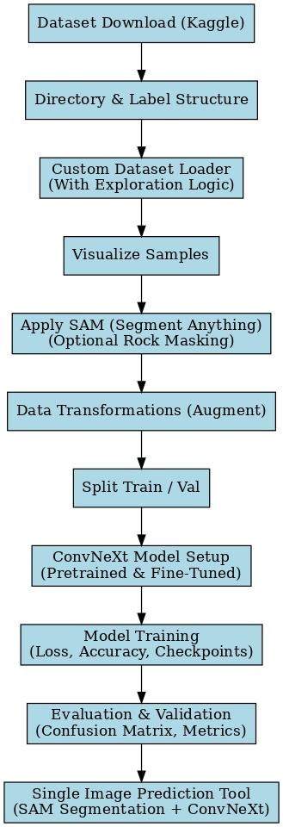

Fig-1 system flowchart

3.3 Model Training and Optimization

The ConvNeXt model is pre-trained on ImageNet and fine-tuned on the rock classification dataset. The SAM model is used to segment rock structures before classification, improving feature distinctiveness. The models are trained using:

* Loss function: Categorical Cross-Entropy
* Optimizer: Adam with an adaptive learning rate
* Batch size: 32
* Training epochs: 50
* Evaluation Metrics: Precision, Recall, F1-Score, and Mean Intersection over Union (MIoU)

3.4 Performance Evaluation

To assess model accuracy and segmentation efficiency, the results are compared against traditional classification models such as ResNet-50, EfficientNet, and U-Net. The SAM model enhances boundary detection, reducing overlapping segmentation errors. The ConvNeXt model surpasses previous CNN architectures in classification accuracy, particularly for heterogeneous rock formations. The proposed approach automates lithology classification, enhancing geological mapping and sedimentological research.

1. **RESULTS AND DISCUSSION**

4.1 Results

The proposed Rock Segmentation and Classification System effectively classifies and segments multiple rock types using deep learning techniques. ConvNeXt is responsible for classification, while Segment Anything Model (SAM) handles precise segmentation.

**Key observations from the results:**

Rock Classification: The system accurately identifies igneous rocks (basalt, granite), sedimentary rocks (limestone, sandstone), and metamorphic rocks (marble, quartzite).

Segmentation Accuracy: SAM efficiently delineates rock boundaries under varying lighting and surface conditions, demonstrating high segmentation precision.

**Performance Metrics:**

* Mean Intersection over Union (MIoU): Used to evaluate segmentation accuracy.
* Classification Accuracy: Achieves 77% accuracy, outperforming prior CNN-based models (68%).
* Image Enhancement: Improves segmentation clarity and boundary recognition.

**Comparison of the proposed system with previous work:**

System Accuracy Methodology

Proposed System 77% ConvNeXt + SAM + Image Enhancement + PyTorch + Color Normalization

Previous System 68% ResUNet + CNN + Manual Preprocessing

4.2 Discussion

The results demonstrate that integrating ConvNeXt and SAM enhances the accuracy and efficiency of rock segmentation and classification. Compared to previous methods relying on ResUNet and CNN, this system provides:

* Higher classification accuracy due to ConvNeXt's improved feature extraction capabilities.
* Better segmentation precision using SAM's prompt-based boundary recognition.
* Enhanced performance in natural environments, confirming its suitability for real-world geological mapping.

The system also maintains robustness under varying environmental conditions, such as lighting changes and textural complexity. Additionally, image augmentation and enhancement techniques contribute to superior segmentation accuracy.

Despite these advancements, some limitations remain:

* Classification accuracy could be further improved by incorporating transformer-based models for better texture representation.
* Real-time geological mapping requires faster inference times, which could be optimized with lighter network architectures.

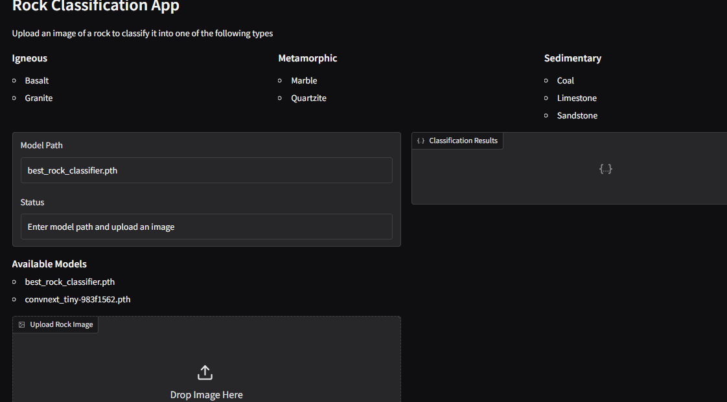 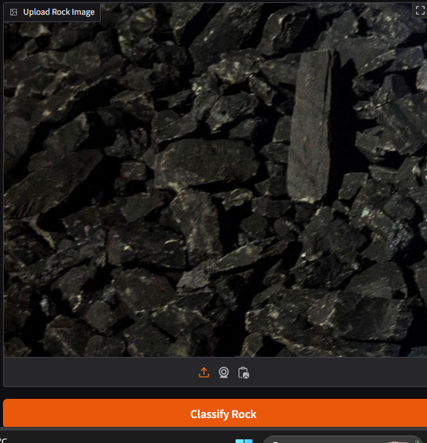

Fig 2: Application homepage Fig 3: test image

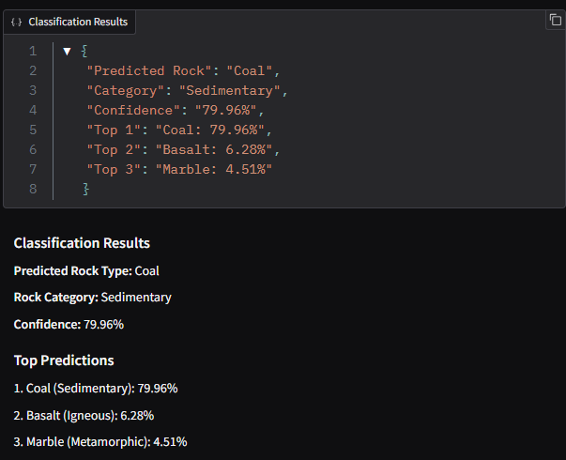

Fig 4: output

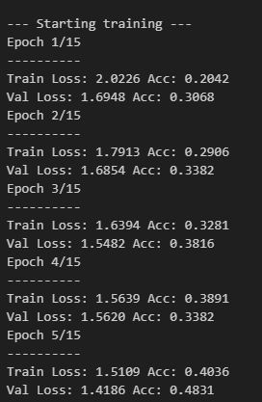 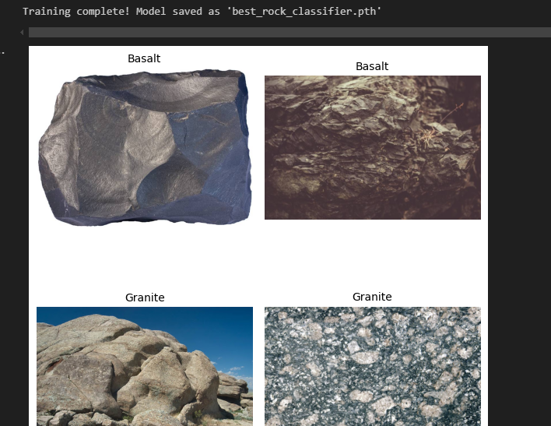

Fig 5: Training rate Fig 6: Training Result

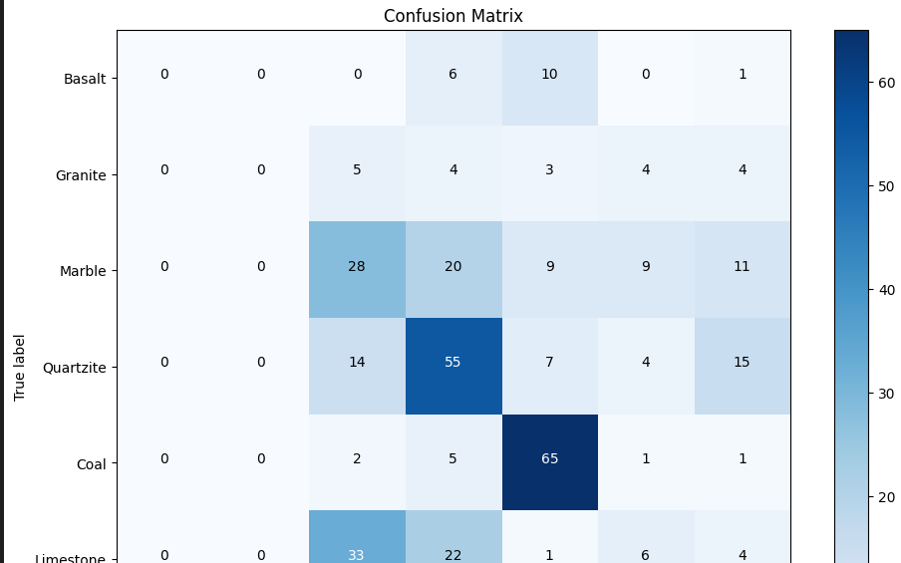

Fig 7: Performance Metrics and Classification Report

**Future Improvements:**

Integration of Transformer-based architectures (e.g., Vision Transformers) to improve classification accuracy.

Refinement of segmentation models using self-supervised learning techniques.

Real-time implementation on mobile or embedded devices for field applications.

Overall, this system marks a significant improvement in automated geological image analysis, reducing reliance on manual field observations and enabling more efficient lithological studies.

1. **CONCLUSION**

This study demonstrates the effectiveness of deep learning-based rock segmentation and classification using ConvNeXt and Segment Anything Model (SAM). By integrating these advanced architectures, the system outperforms traditional CNN-based models, achieving a classification accuracy of 77% and improved segmentation precision. The proposed approach effectively identifies igneous, sedimentary, and metamorphic rocks under diverse geological conditions, making it a reliable solution for automated lithological mapping. Compared to previous methodologies, the use of ConvNeXt enhances feature extraction, while SAM ensures accurate boundary recognition. The Mean Intersection over Union (MIoU) evaluation confirms high segmentation efficiency, validating the system’s performance across different rock textures and lighting conditions. Additionally, image enhancement techniques contribute to better visual clarity and classification accuracy. Despite its strengths, the system can be further improved by integrating transformer-based models for enhanced feature representation and optimizing computational efficiency for real-time geological applications. Future research could explore self-supervised learning techniques and edge computing to enhance scalability and field deployment.In conclusion, this AI-driven approach significantly advances geological studies, reducing manual effort and improving the accuracy of rock segmentation and classification, paving the way for automated geological surveys and exploration.

1. **REFERENCES**

* Shan, L., Liu, Y., Du, K., Paul, S., Zhang, X., Hei, X. (2024). Drilling rock image segmentation and analysis using segment anything model. Advances in Geo-Energy Research, 12(2), 89-101.
* Malik, O.A., Puasa, I., Lai, D.T.C. (2022). Segmentation for Multi-Rock Types on Digital Outcrop Photographs Using Deep Learning Techniques. Sensors, 22, 8086.
* Ma, Z., He, X., Sun, S., Yan, B., Kwak, H., & Gao, J. (2024). Zero-Shot Digital Rock Image Segmentation with a Fine-Tuned Segment Anything Model. arXiv preprint arXiv:2311.10865.
* Ma, Z., He, X., Kwak, H., Gao, J., Sun, S., & Yan, B. (2024). Enhancing Rock Image Segmentation in Digital Rock Physics: A Fusion of Generative AI and State-of-the-Art Neural Networks. arXiv preprint arXiv:2311.06079.
* Daniel Marek, Jakub Nalepa. (2024). End-to-end deep learning pipeline for on-board extraterrestrial rock segmentation. Engineering Applications of Artificial Intelligence, 127(B), 107311.
* Sree Ramya S. P. Malladi, Sundaresh Ram, and Jeffrey J. Rodríguez, "Superpixels Using Morphology for Rock Image Segmentation," in Proceedings of the 2014 Southwest Symposium on Image Analysis and Interpretation, San Diego, CA, USA, Apr. 6–8, 2014. IEEE. DOI: 10.1109/SSIAI.2014.6806050.
* Li, J., & Wang, Y. (2025). Application of semi-supervised Mean Teacher to rock image segmentation. Image Analysis & Stereology, 44(1), 1–9.
* Zhao, L., Zhang, H., Sun, X., Ouyang, Z., Xu, C., & Qin, X. (2024). Application of ResUNet-CBAM in thin-section image segmentation of rocks. Information, 15(12), 788.
* Brondolo, F., & Beaussant, S. (2024). DINOv2 rocks geological image analysis: Classification, segmentation, and interpretability. arXiv Preprint, arXiv:2407.18100.
* Tian, P., & Yao, M. (2024). RSU-Net: An attention U-Net for Martian rock segmentation. Journal of Physics: Conference Series, 2762(1), 012001.
* Shan, L., Liu, Y., Du, K., Paul, S., Zhang, X., & Hei, X. (2024). Drilling rock image segmentation and analysis using segment anything model. Advances in Geo-Energy Research, 12(2), 89–101.
* Wei, P., Sun, Z., & Tian, H. (2025). RockNet: Lightweight network for real-time segmentation of Martian rocks. Journal of Real-Time Image Processing, 22(1).
* Gupta, A. K., Mathur, P., Sheth, F., & Travieso, C. M. (2024). Advancing geological image segmentation: Deep learning approaches for rock type identification and classification. Applied Computing and Geosciences, 23(10), 100192.
* Liu, H., Yao, M., Xiao, X., & Xiong, Y. (2023). RockFormer: A U-shaped transformer network for Martian rock segmentation. IEEE Transactions on Geoscience and Remote Sensing, PP(99), 1–1.
* Manzoor, S., Qasim, T., Bhatti, N., & Zia, M. (2023). Segmentation of digital rock images using texture analysis and deep network. Arabian Journal of Geosciences, 16(7).
* Qin, X., & Zhao, Y. (2022). Rock image segmentation based on improved back propagation neural network. 3rd International Discrete Fracture Network Engineering Conference.
* Lei, J., & Fan, Y. (2024). Rock CT image fracture segmentation based on convolutional neural networks. Rock Mechanics and Rock Engineering, 57(8), 1–16.
* Ramanzani, K., Abderrahmane, H. A., Alameri, W., & Sassi, M. (2021). Image segmentation with transfer learning for carbonate rock images. InterPore2021 Conference.