**“EFFICIENT LOGISTIC MANAGEMENT: THE OMVISHKAR EXPORTS APPROACH”**

P.S. Arunmozhi1, Dr. R. Kandavel2

1MBA Student, School of Arts, Humanities and Management, Jeppiaar University, Chennai.

2School of Arts, Humanities & Management, Jeppiaar University, Chennai.

[**arunmozhi19082002@gmail.com**](mailto:arunmozhi19082002@gmail.com)

[**krkandavel@gmail.com**](mailto:krkandavel@gmail.com)

**ABSTRACT**

In today's business landscape, companies are increasingly adopting supply chain and logistics management to minimize costs, boost performance, and enhance operational efficiency. Modern logistics involves coordinating and integrating the movement of materials and products from physical, organizational, and informational perspectives. This study focuses on efficient logistics management at Omvishkar Exports, covering critical logistics functions such as transportation, warehousing, packaging, inventory control, freight forwarding, customs clearance, and information management. Reducing costs in each logistics activity significantly impacts the overall expense and elevates the company's performance. This research utilizes a descriptive approach, gathering data from 120 middle managers and employees within the company. The study's primary hypothesis is thoroughly validated by the survey results, demonstrating that effective management of inventory, storage, warehousing, transportation, and information flow is essential for logistics managers aiming to minimize overall company costs. The findings confirm the vital role of logistics managers in optimizing all logistics activities to achieve heightened business efficiency.

**INTRODUCTION:**

The rise of modern industrialization has brought to light several management challenges, with cost control and reduction being among the most critical. One effective approach to addressing these challenges involves implementing logistics and supply chain management strategies that adhere to established standards. This is achievable using modern technologies, including Electronic Data Processing (EDP) and Radio Frequency Identification (RFID) systems. Since material costs typically make up more than 60% of total production expenses, these materials are often maintained as inventory, ranging from raw materials to work-in-progress and finished products. Leveraging modern EDP technology, combined with operations research techniques such as Economic Order Quantity (EOQ), Just-In-Time (JIT) management, and ABC analysis for material classification, has significantly enhanced vendor-managed inventory (VMI). This, in turn, has optimized machine throughput time on the shop floor. Efficient movement of large quantities of goods domestically and internationally relies heavily on a robust freight transportation system. This complex network includes roads, bridges, railway tracks, airports, seaports, navigable waterways, pipelines, and specialized equipment. In this context, a freight forwarder plays a pivotal role, acting as an individual or company responsible for dispatching shipments via asset-based carriers and arranging transportation space as needed.

**REVIEW OF LITERTURE:**

According to Tritos Laosirihongthong (2013), organizations operate in a manner that meets both customer expectations and legal obligations. The influence of these two factors drives companies to adopt environmentally responsible practices. As a result of both internal and external pressures, many organizations have institutionalized reverse logistics strategies.

Christopher (2010) identified three primary functions related to logistics: creating an information flow that precedes the movement of goods, accompanies them during transit, and follows them afterward. Historically, the significance of accurate information in achieving optimal logistical performance has often been underestimated. Although many elements of information management are vital to logistics operations, order processing holds the highest priority (Bowersox et al., 2010). A lack of understanding regarding the critical nature of order processing has led to distortions and operational failures that negatively impact logistics performance (Bowersox et al., 2010).

Nowakowska and Grunt (2007) the effective functioning of logistics information system requires the use of hardware and technology transfer; and the information system must be customized to serve the logistics system effectively to enhance the line of communication With the emergence of ICT, information flow provides a special advantage to link one activity with the others and make real-time data created in activity widely available, both within the firm and with outside suppliers, channels, and customers. For information flow to be effective and efficient. It must enhance the firm’s logistics by planning, controlling, coordinating and monitoring the logistics process

According to Stevenson (2009), order processing refers to the collection of tasks involved in fulfilling a customer’s request for goods or services.

**OBJECTIVES OF THE STUDY:**

* To study the logistics management practics.
* To find the relationship between organization performance and logistics practices.
* To find out the operation performance of the company.
* To understand the logistics management practices and its implementation in organization.

**SCOPE OF THE STUDY:**

* The scope of the field is increasing the logistics and supply chain management.
* The company can recognize the importance of effectiveness in the transportation and distribution.
* The success seems to depend on effective IT support and transportation in logistics.
* It also growing faster than the overall economy of the company.

**NEED FOR THE STUDY:**

* It needs to analyse new and cost-effective way of manufacturing or providing services in transportation.
* It improves productivity and enhance employee mood.
* To analyses company’s resources in an effective manner.
* The optimum utilization of workers and other resources at the work process and purpose is to work together.

**RESEARCH METHODOLOGY**:

The Research methodology is a method to solve the research problem systematically. It involves gathering data, use of statistical ways, interpretations and drawing conclusions about exploration data. Chi-square has been used for descriptive statistical analysis and excel has been used for statistical modelling analysis with 120 sample.

**DATA COLLECTION:**

Data refers to a collection of systematized information, generally the results of experience, observation or trial, or a set of demesnes. To achieve the objectives of this study, both primary and secondary data sources were utilized.

**SOURCES OF DATA COLLECTION:**

Data is collected through primary and secondary sources.

**PRIMARY DATA:**

Primary data is the information collected for the first time; there are several methods in which the data is compiled. In this project it was obtained by means of questionnaires. Questionnaire was prepared and distributed to the employees.

**SECONDARY DATA:**

Additional insights were gathered from industry reports, research papers, organizational records, and previous studies on efficient logistics management.

**SAMPLE SIZE**:

The sample is selected based on random sampling technique drawn from one organization. A sample of 120 employees is selected and analysis has been done by questionnaire.

**DATA ANALYSIS AND INTERPRETATION:**

**PERCEPTION OF EFFICIENT LOGISTICS MANAGEMENT: THE OMVISHKAR EXPORTS APPROACH**

**1) Age Respondents**

Table 1; Age respondents.

|  |  |  |  |
| --- | --- | --- | --- |
| SI NO | PARTICULARS | NO OF RESPONDENTS | PERCENTAGE |
| 1 | Age 18-30 | 18 | 15 % |
| 2 | Age 31-40 | 63 | 52. 5 % |
| 3 | Age 41-50 | 30 | 25 % |
| 4 | Age 51-58 | 9 | 7.5 % |

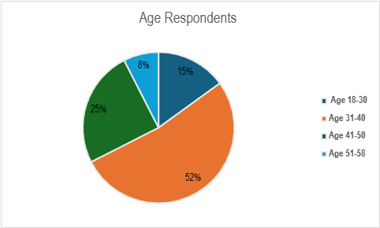

**Data Interpretation and Findings:** From the above table 15% respondents are 18-30 age group, 52.5% respondents are 31-40, 25% are 41-50 age group and 7.5% of the respondents are 51 -58 age group. Majority of the respondents are from the age group of 31-40 which they are working in this organization.

**2) Gender Respondents**

Table 2: Gender Respondents

|  |  |  |  |
| --- | --- | --- | --- |
| SI NO | Particulars | No of respondents | Percentage |
| 1 | MALE | 81 | 67.5 % |
| 2 | FEMALE | 39 | 32.5 % |
| TOTAL |  | 120 | 100 % |

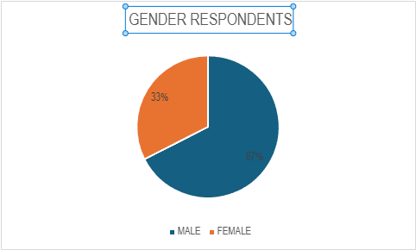

**Data Interpretation and Findings:** From the above table, respondents are 67.5% are Male and rest of 32.5% of the respondents are Female according to the Gender. Majority of respondents are Male which they are 67.5% working in the company and warehouse.

**3) Effective Tracking**

Table 3: Effective Tracking

|  |  |  |  |
| --- | --- | --- | --- |
| SI NO | PARTICULARS | NO OF RESPONDENTS | PERCENTAGE |
| 1 | ORDERING DATE | 30 | 25 % |
| 2 | SHIPMENTS DATE | 42 | 35 % |
| 3 | MIDDLY OF THE DELIVERY | 18 | 15 % |
| 4 | DELIVERING DATE | 30 | 25 % |
| total |  | 120 | 100 |

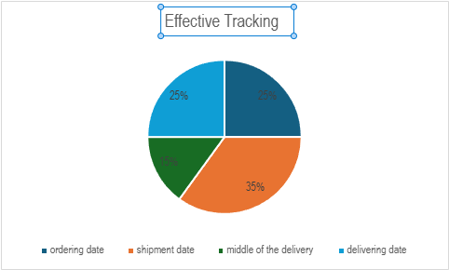

**Data Interpretation and Findings:** From the above table of tracking means, 25% of respondents are from ordering date, 35% from shipment date, 15% from middle of delivery and 25% are from delivering date. From the above table 35% of respondents said that effective tracking means is possible after the shipment date.

**4) Effective Mode of Transportation**

Table 4: Mode of Transportation

|  |  |  |  |
| --- | --- | --- | --- |
| SI NO | PARTICULARS | NO OF RESPONDENTS | PERCENTAGE |
| 1 | ROADWAYS | 24 | 20 |
| 2 | RAILWAYS | 18 | 15 |
| 3 | AIRWAYS | 75 | 62.5 |
| 4 | WATERWAYS | 3 | 2.5 |
| TOTAL |  | 120 | 100 |

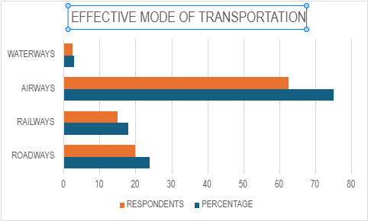

**Data Interpretation and Findings:** From the table, medium of transportation takes survey to the respondents according to that 20% are Roadways, 15% are Railways, 62.5 are Airways and 2.5 are only for Waterways. Majority of respondents are answered Airways is the most safe and quickest mode transportation.

**SUGGESTION:**

* Even majority of the respondents are agreed that the logistics management practices are effective in case of purchase of raw material, reducing defective pieces and helps in reduction of transportation cost, less percentage of respondents have given neutral and negative opinion. Company can implement the logistics management practices in full fledge
* Based on the observation the information system for logistics management is implemented in the company which is not in full fledge. If it is implemented fully then most of the practices will be systematically done.
* Middle level managers opinions somewhat differ with supervisors which can be corrected.

**CONCLUSION:**

The research on Efficient logistics management: The Omvishkar Exports approach focused on evaluating the effectiveness of the logistics practices implemented within the company. It examined the overall performance of the organization in relation to its logistics management strategies. As a manufacturing company, Omvishkar Exports has established a robust logistics management system, which is essential for its operations. These practices significantly contribute to enhancing the company’s overall performance.

**REFERENCES:**

1. Bowersox, D., Closs, D., and Cooper, B.M. (2007). Supply Chain Logistics Management. New York: McGraw Hill.
2. Delfmann, W., and Gehring, M. (2003). Successful Logistics through IT. Supply Chain Forum: International Journal, 4 (1), 51–56.
3. Esper, T. L., Fugate, B. S., and Davis-Sramek, B. (2007). Logistics learning capability: sustaining the competitive advantage gained through logistics leverage. Journal of Business Logistics, 28 (2), 57–82.
4. Fugate, B.S., Mentzer, J.T., and Stank, T.P. (2010). Logistics Performance: Efficiency, Effectiveness, and Differentiation. Journal of Business Logistics, 31 (1), 43–62.
5. Hassini, E. (2008). Building competitive enterprises through supply chain management. Journal of Enterprise Information Management, 21 (4), 341– 344.