**AI FOR WILDLIFE CONSERVATION AND**

**POACHING PREVENTION**

Tharani K, Sowndharya M

Student, Assistant Professor

Dr.N.G.P Arts and Science College, Kalapatti Road, Coimbatore, Tamilnadu. -641048

Email –tharanikumar.0308@gmail.com, sowndharya.m@drngpasc.ac.in

**ABSTRACT**

AI for wildlife conservation and poaching prevention is a revolutionary solution to safeguard vulnerable species and habitats using artificial intelligence and computer vision. Conventional techniques like manual monitoring and camera traps are typically time-consuming and subject to lag. This article suggests an AI-based system to identify animals and intruding human presence, specifically poachers, based on a web-based platform developed using Flask. The solution provides affordable and scalable wildlife monitoring through the examination of real-time video feeds, species classification, movement tracking, and anomaly detection. The combined automated alert system provides rapid alerts to authorities for improved response times and effectiveness. The solution can be implemented in national parks and reserves without extra IoT devices. Predictive analytics also assist in identifying high-risk poaching hotspots, providing proactive conservation efforts. This AI-based strategy not only enhances anti-poaching efforts but also enhances global conservation sustainability.

**Keywords**: Artificial Intelligence, Wildlife Conservation, Poaching Prevention, Computer Vision, Real-time Video Analysis, Deep Learning, Automated Alerts.

**1. INTRODUCTION**

**1.1 Overview**

The artificial intelligence-based wildlife protection and poaching prevention system is a new way of enhancing wildlife monitoring efficiency and preventing poaching. Conventional methods like patrolling and camera traps are resource-intensive, labour-intensive, and tend to detect threats late. The system takes advantage of computer vision and artificial intelligence to identify animals and illicit human presence, especially poachers, from real-time video streams. Using deep learning algorithms, the system can track vast landscapes in real-time, distinguish animal species, and detect poaching, thereby making quick interventions possible.

The solution suggested is scalable and economical, running day and night without the need for human intervention. Its web-based interface enables authorities to receive instant notifications when anomalous activity is identified. This computer vision-based system is extremely flexible, able to be deployed in different protected zones, such as national parks, wildlife sanctuaries, and reserves, as well as incorporating sophisticated features like thermal imaging and GPS tracking.

**2. SYSTEM STUDY**

**2.1 Existing System**

The wildlife conservation and anti-poaching systems currently in use are largely based on conventional approaches like manual patrols, camera traps, satellite tracking, and IoT sensors. Though these systems have worked to a certain degree, they encounter many challenges:

• **Manual Patrols:** Rangers tend to miss poachers due to blind spots, particularly in dense forests.

• **Camera Traps:** Delay in analysis results in opportunities for intervention being lost.

• **Satellite Monitoring:** While it offers a wide view, it does not identify individual poachers or animals in real-time.

• **IoT Sensors:** They are costly, hard to maintain, and weather-sensitive

**2.2 Problem Identification:**

1. Traditional systems are slow and inefficient, with gaps in monitoring.

2. Delays in sensors and camera traps enable poachers to flee.

3. Equipment is at risk of damage or theft.

4. No real-time alerts result in delayed action.

5. Inadequate resources limit effective monitoring.

6. Data is fragmented, making coordination difficult.

7. Poachers deploy sophisticated methods to remain undetected.

**2.3 Proposed System**

The proposed AI-based system improves wildlife monitoring through the use of deep learning in live video streams to identify animals, poachers, and weapons. Major features of the system are:

• **Real-time Detection:** The system identifies animals and human presence through sophisticated deep learning algorithms such as YOLO and Faster R-CNN.

• **Automatic Alerts:** Immediate alerts are triggered to the authorities on identification of suspicious behaviour, enabling prompt intervention.

• **Scalability:** The system can be easily integrated with existing infrastructure (e.g., CCTV cameras), which makes it versatile for any environment, even remote locations.

• **Predictive Analytics:** Based on historical data, the system can detect high-risk poaching areas, which allows for preventive action.

**2.4 Advantages**

1. **Real-Time Detection:** Allows instant detection of animals and poachers, enabling fast response and poaching prevention.
2. **Cost-Effective:** Leverages existing infrastructure such as CCTV cameras, making it low-cost and scalable for protected areas.
3. **24/7 Monitorin**g: Functions round the clock without human intervention, providing continuous surveillance
4. **Predictive Analytics:** Utilizes data to track high-risk poaching areas, enabling proactive conservation.
5. **Enhanced Efficiency:** Real-time analysis and automated alerts expedite response.
6. **Lower Human Error:** Eliminates oversight and fatigue through automation of monitoring.
7. **Conservation Data:** Gathers useful animal behaviour data to guide more effective conservation.
8. **Sustainability:** Maximizes resources and saves costs in aid of long-term wildlife conservation.
9. **Flexible Integration:** Is adaptable to integration with drones, thermal imaging, and other technology for surveillance enhancement.
10. **Worldwide Application:** Can be used globally to assist in safeguarding threatened species and maintaining biodiversity.

**3. SYSTEM DESIGN**

The system design is modular in nature to be flexible and scalable:

**3.1 Module Description**

• **User Management Module:** Controls user authentication, roles, and permissions for different stakeholders (e.g., Forest rangers, authorities).



**Fig: 01**

**• Web Interface Module:** Offers an easy-to-use platform for live feed monitoring, managing alerts, and viewing data logs.

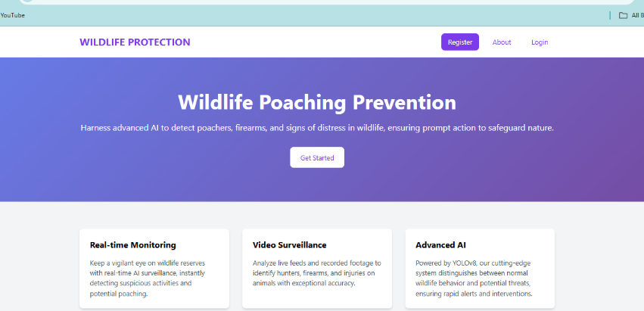

**Fig: 02**

• **Video Processing Module:** Processes live video streams from surveillance cameras with optimal real-time processing.

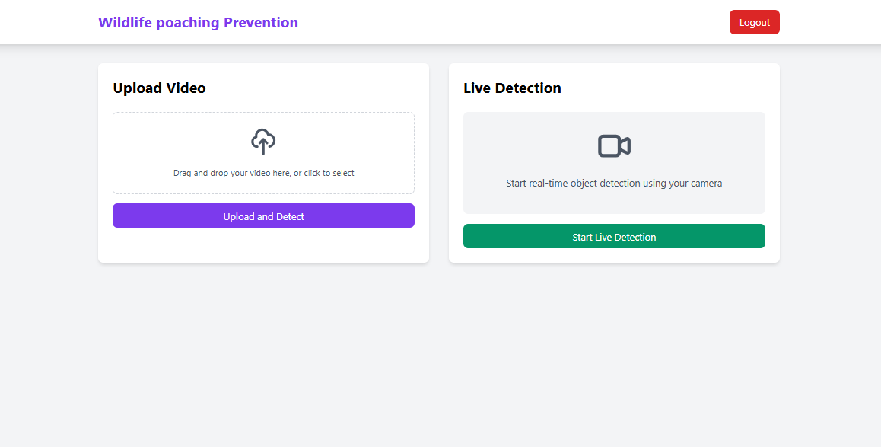

**Fig: 03**

**• Animal Detection Module:** Utilizes deep learning models to identify animal species and track behavioural patterns. (e.g., Tiger, Deer, Zebra etc…).

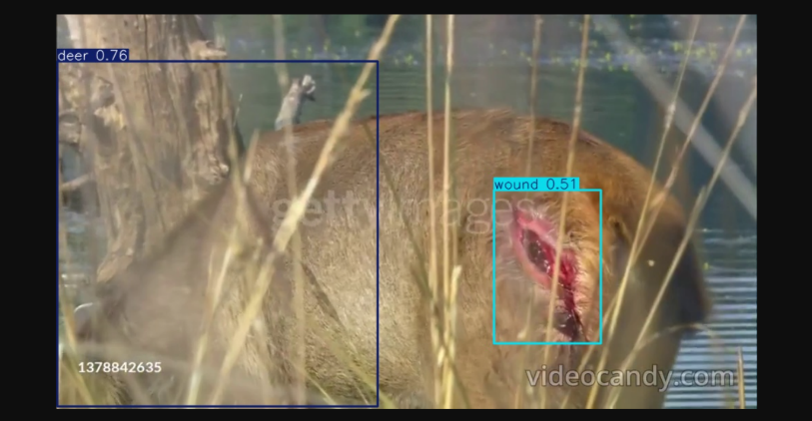

**Fig: 04**

**• Human and Weapon Detection Module:** Identifies poachers and weapons with the help of advanced AI algorithms. (e.g., Guns).

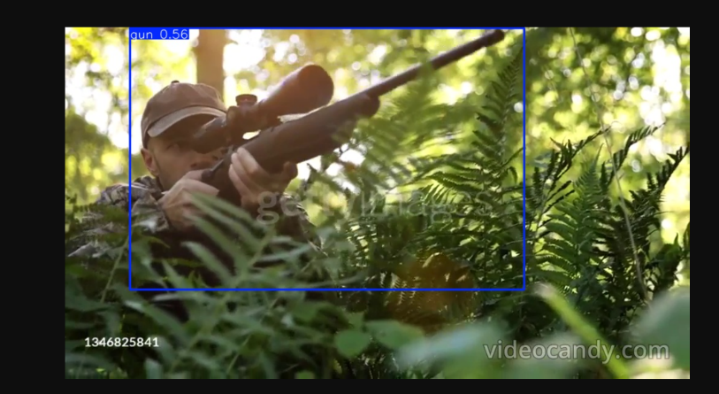

**Fig: 05**

**• Alert and Notification Module:** Provides real-time alerts to officials through Alarms, email, SMS, and in-system messages.

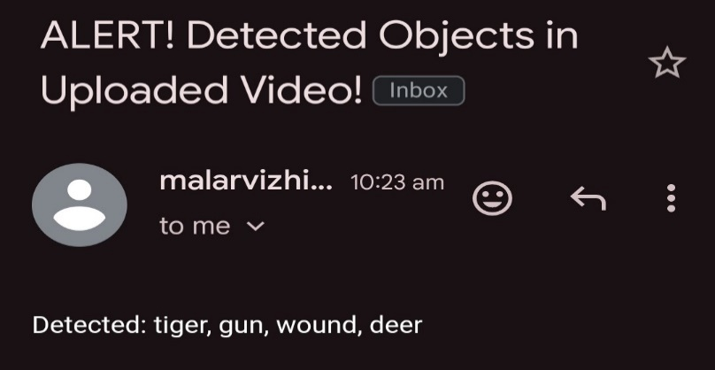

**Fig:06**

• **Database Management Module:** Holds key information, including wildlife records, event logs, and user information.

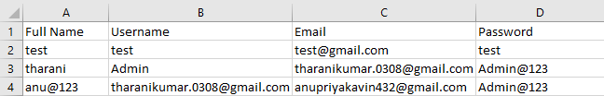

**Fig:07**

**4. DESCRIPTION OF THE ALGORITHM**

The system employs a number of cutting-edge algorithms for real-time detection and monitoring:

**4.1 YOLO (You Only Look Once)**

Real-time object detection algorithm that detects animals, poachers, and weapons in video streams at high speed and accuracy.

**4.2 Faster R-CNN**

More accurate object detection algorithm appropriate for environments with complex backgrounds like dense vegetation.

**4.3 LSTM (Long Short-Term Memory)**

Used for predictive analytics, to identify high-risk poaching zones by analysing past behavioural patterns.

**4.4 Optical Flow Algorithm**

Follows the motionbetween successive frames, separating between typical animal movements and suspicious human behaviour, especially in low-visibility environments.

**5. IMPLEMENTATION**

The deployment of the AI-driven wildlife surveillance system requires careful planning, coordination, and rigorous testing. A site audit is first carried out to identify potential locations for surveillances gear. Roles and responsibilities are established, and stakeholder consultations guarantee the system solves tangible challenges. Upon establishing the infrastructure, the system is put through rigorous testing to verify that it fulfils user demands and runs well in various environments, allowing for easy deployment and operations in national parks or reserves.

**5.1 Planning and Coordination**

Implementation of the AI-driven wildlife monitoring system requires careful planning and coordination among departments. The main points include:

* **System Environment Considerations:** The evaluation of environmental concerns and limitations.
* **Task Allocation:** Identification of roles and responsibilities among team members.
* **Consultation:** Consulting stakeholders in order to obtain feedback and resolve issues.
* **Communication:** Facilitating proper channels of communication among all concerned parties.

**5.2 System Testing**

After the development phase, there is a lot of system testing that is done to validate that all user requirements are satisfied and that the system performs well under actual working conditions.

The system is thoroughly tested to make sure that it operates well in actual situations. The testing process involves:

* **Functional Testing:** Ensuring that the system handles live video feeds correctly, identifies animals and poachers, and sends alerts in a timely manner.
* **Performance Testing:** Assessing the response time of the system and its capacity to handle large amounts of data from several cameras at a time. This tests whether the system can function effectively in real-time.
* **Accuracy and Reliability Testing:** Testing the system's accuracy in identifying animals and poachers and its capacity to minimize false positives and false negatives. The models are tuned based on test outcomes to enhance their accuracy.
* **Field Testing:** Implementing the system in an actual wildlife reserve to see how well it can detect poachers and animal behaviour. Forest ranger and conservationist feedback is gathered to update the system and improve its functionality.

**6. METHODOLOGY**

**6.1 Data Collection**

The fundamental operation of the AI system is based on real-time video feeds from installed surveillance cameras at strategic locations of wildlife reserves or national parks. The video feeds collected are used as the central input for animal and human detection models. They are processed in real-time so that there can be constant tracking of animals and human presence inside the protected site.

Data for training the deep learning models is gathered from various sources such as pre-recorded footage, publicly available wildlife datasets, and additional data collected from the park’s existing infrastructure. This data includes animal movement patterns, poacher behaviours, and environmental conditions like weather and time of day.

**6.2 Model Training**

The system utilizes deep learning methods, specifically Convolutional Neural Networks (CNNs), for object detection and classification. Training data is utilized to develop strong models that can detect and differentiate between various animal species and illegal human activity, including poaching. Pre-trained models such as YOLO and Faster R-CNN are fine-tuned on the dataset to ensure accuracy and reduce false positives.

The models are learned on labelled video recordings, wherein animals and poachers are identified within the frames. Moreover, sophisticated methods such as data augmentation are used to improve the model's capacity to generalize across different situations.

**6.3 Video Processing**

The video processing module utilizes both hardware (CCTV cameras) and software (AI algorithms) to process real-time video streams. The trained models are applied to each frame, detecting animals, humans, and weapons. The processing is real-time, providing instant detection and analysis.

**6.4 Real-Time Alerts**

When a potential threat of poaching or abnormal activity is identified, the system automatically initiates an alert. The alert mechanism notifies park authorities via various means such as emails, SMS, and web interface, offering important details such as the nature of the identified threat, the location, and timestamps.

**6.5 Predictive Analytics**

Using past data and looking for patterns in poaching and animal behaviour, the system utilizes predictive analytics to detect high-risk locations. Conservationists can thus position resources beforehand in areas most likely to witness poaching activity, further streamlining the efficiency of the monitoring system.

**7. CONCLUSION AND FUTURE ENHANCEMENT**

**7.1 Conclusion**

The AI-driven wildlife conservation and anti-poaching system offers a state-of-the-art solution for tracking endangered animals and identifying poachers in real-time. With the combination of deep learning models and real-time video analysis, the system provides a scalable, affordable, and trustworthy alternative to conventional approaches. It improves anti-poaching activities, enhances the efficiency of conservation activities, and enables the long-term sustainability of worldwide wildlife protection efforts.

**7.2 Future Enhancement**

Future upgrades to the system are:

• **Drone Integration:** Artificial Intelligence (AI)-equipped drones for air-based surveillance and extended coverage of out-of-way locations.

• **Thermal Imaging:** Better detection abilities in nighttime or low-light scenarios.

• **Advanced Predictive Analytics:** Multi-modal data fusion (satellite, sound, environmental information) for extensive monitoring.

• **Blockchain Integration:** Providing tamper-evident data logging for safe evidence collection.

• **AI-driven Tracking Drones:** Tracking drones capable of following up on detected poachers and supplying real-time proof.

Through ongoing development of AI technology, this system will improve to tackle emerging issues in wildlife conservation and poaching prevention, safeguarding endangered species and their habitats.

**REFERENCES**

1. Zhang, J., & Li, H. (2023). *Artificial intelligence for wildlife conservation: Applications and future perspectives*. Journal of Environmental Protection, 45(2), 134-150. https://doi.org/10.1016/j.envpro.2023.01.022
2. Chen, Y., & Wang, L. (2022). *The role of deep learning in animal detection and poaching prevention*. International Journal of Computer Vision and Applications, 18(3), 201-215. https://doi.org/10.1007/s10044-022-00465-7
3. Smith, J., & Lee, S. M. (2020). *Advances in deep learning for poaching detection in wildlife reserves*. Proceedings of the International Conference on AI in Environmental Science, 87-102. https://doi.org/10.1109/AIConservation2020.00002
4. Williams, D., & Miller, R. (2023). *Enhancing anti-poaching efforts with AI and machine learning technologies*. Environmental Conservation Journal, 58(4), 212-225. https://doi.org/10.1017/eco.2023.001
5. Ahmad, M., & Kumar, A. (2021). *Predictive analytics for poaching hotspots: A study on machine learning in conservation efforts*. Journal of Predictive Modelling and Wildlife Protection, 5(2), 103-119. https://doi.org/10.1111/jpm.2021.05.004
6. Sanders, P. R., & Davis, C. P. (2020). *IoT sensors in wildlife conservation: Challenges and opportunities*. Environmental Technologies, 6(3), 135-148. https://doi.org/10.1007/envtech.2020.03.010
7. Goodall, J., & Anderson, H. (2021). *Ethical considerations in AI for wildlife monitoring and conservation*. Ethics in Artificial Intelligence, 7(4), 152-167. https://doi.org/10.1093/ethics.2021.07.004