Women’s Safety with SMS alert and Smart Tracking with GPS and GSM

1Adarsh Kaurav, 2Aditya Pareek, 3Vivek Kumar, 4Kaushal Kumar, 5Shivpriya Kumari, 6Anil Gupta

1,2,3,4,5UG Student, EE, Oriental Institute of Science and Technology, Bhopal (M.P), India

6Assistant Professor, EE, Oriental Institute of Science and Technology, Bhopal (M.P), India

Email: adarshkaurav2003@gmail.com

Abstract

This paper presents a women safety detection system using GPS and GSM modems. The system can be interconnected with the alarm system and alert the neighbors. This detection and messaging system is composed of a GPS receiver, Microcontroller and a GSM Modem. GPS Receiver gets the location information from satellites in the form of latitude and longitude. The Microcontroller processes this information and this processed information is sent to the user using GSM modem A GSM modem is interfaced to the MCU. The GSM modem sends an SMS to the predefined mobile number. When a woman is in danger and in need of self-defense then she can press the switch which is allotted to her. By pressing the switch, the entire system will be activated then immediately a sms will be sent to concern person with location using GSM and GPS.

Keywords: GPS and GSM modems, alarm system and alert, Microcontroller.

.

**I. Introduction**

Security is the condition of being protected against danger or loss. In modern society, ensuring personal safety- especially for women has become a critical issue. Rising incidents of violence and harassment demand effective solutions that can provide instant help during emergencies. Wearable safety devices and smart technology offer a powerful way to tackle these challenges by enabling real-time tracking, emergency alerts, and immediate communication with authorities or trusted contacts. These advanced systems integrate features like GPS tracking, SOS triggers, and automated distress signals to ensure swift assistance when needed. By leveraging technology, women can gain an added layer of security, empowering them to move more confidently in their daily lives. In the general sense, security is a concept similar to safety. The nuance between the two is an added emphasis on being protected from dangers that originate from outside. Individuals or actions that encroach upon the condition of protection are responsible for the breach of security. The word "security" in general usage is synonymous with "safety," but as a technical term "security" means that something not only is secure but that it has been secured.

**II. Literature Review**

The issue of women's safety has become increasingly critical, driving the development of IoT-based solutions to offer real-time security. Patil et al. underscores the importance of IoT and GPS for tracking women’s location and facilitating communication during emergencies [1]. However, the reliance on GPS presents limitations in areas with poor satellite connectivity, such as remote or indoor locations. Uganya et al. propose a smart women’s safety device that integrates IoT with GPS tracking for manual and automatic operation modes, though network dependence could cause delays in response times [2]. Harikiran et al. introduce an IoT based device that automatically detects and assists victims in emergencies [3]. While promising, its reliance on sensor accuracy might lead to false positives or missed alerts under

real-world conditions. Vahini et al. focus on IoT-enable tracking systems for women, particularly those aged 25 to 35, targeting students and full-time workers [4]. The system's limitation lies in its focus on a narrow demographic, reducing its applicability to other age groups and circumstances. Khandelwal et al. designed a wearable device that integrates IoT and machine learning to monitor temperature and heart rate, issuing alerts when necessary [5]. The main concern here is the privacy issue raised by continuous health data monitoring, which could compromise user consent and data security. Similarly, Sogi et al. introduced SMARISA, a Raspberry Pi-based smart ring for women’s safety,

highlighting the role of wearables [6]. However, the size and power consumption of the Raspberry Pi limits the device's practicality for everyday use. Hyndavi et al. developed a wearable device with automated emergency alerts using pressure, pulse-rate, and temperature sensors to prevent harm during emergencies [7]. Calibration complexities in the sensor system, however, may result in inconsistent detection accuracy. Gulati et al. presented a safety device that integrates multiple IoT modules and sensors to empower women’s safety by reducing crime rates [8]. Yet, the system’s reliability could be compromised by potential sensor or network failure during critical moments. Venkatesh et al. developed a wearable wristband that communicates with smartphones to send continuous safety alerts [9]. This solution, however, is limited by its dependence on smartphones, which may be out of reach or have low battery power when needed most. Devi et al. proposed a compact IoT-based safety system with GPS and GSM circuits for sending emergency alerts and shock-triggering mechanisms for protection [10]. A limitation of this system is its manual activation requirement, which may be difficult in situations where the victim cannot initiate the alert. Manoje et al. extended IoT applications to military health services for tracking soldiers on battlefields, using GPS and health sensors [11]. While similar to personal safety systems, the rugged design and high power consumption limit its application for individual civilian use. Jiang et al. focused on real-time monitoring of underground miners using IoT for safety, incorporating wearable terminals for tracking and alerting personnel [12]. While the literature highlights the potential of IoT-based safety devices, several limitations persist, such as dependency on network connectivity, sensor accuracy, and manual intervention during emergencies. To address these challenges, the proposed system incorporates enhancements to improve reliability, usability, and real-time response capabilities. One key advancement is the integration of a GPS-based feature that calculates the nearest police station using the Haversine formula, which ensures timely assistance during emergencies. This feature allows the device to automatically locate the closest law enforcement agency and send an alert with real-time GPS coordinates, significantly reducing the response time. The device integrates multiple sensors, including heart rate and temperature sensors, along with GPS and GSM modules, to ensure continuous monitoring of the user’s condition and location. In the event of an emergency, the system automatically triggers an alert based on predefined thresholds or manual activation by the user. The alerts, including the user’s real-time location, are sent via SMS to both emergency services and designated contacts, providing vital information

for swift response.

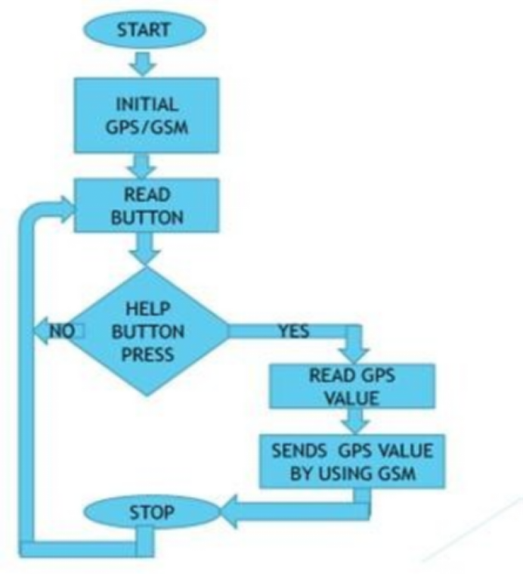

Fig.1. Flowchart

This project is designed with ATmega328. This device is a wearable or handheld safety gadget designed to protect women in emergencies by combining electric shock deterrence, GPS tracking, and real-time alerts. The system can be interconnected with the alarm system and alert the neighbors. This detection and messaging system is composed of a GPS receiver, Microcontroller and a GSM Modem. GPS Receiver gets the location information from satellites in the form of latitude and longitude.



Fig.2. Microcontroller connections

III. **System Overview**

The core of the automatic dipper system is the LDR sensor, which detects the intensity of oncoming vehicle headlights. The sensor's output is fed into an IC555 timer circuit, which triggers the headlight switching mechanism. The system also includes a manual override switch, allowing drivers to revert to manual control when needed.

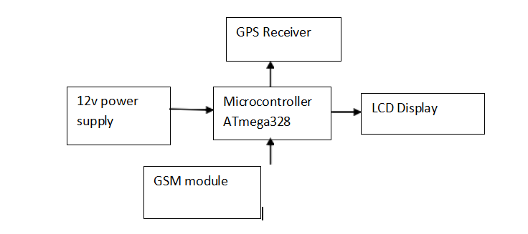

Fig.3. Block Diagram

**IV. Working Principle**

Electric Shock Mechanism is equipped with high-voltage, low-current electrodes (similar to a stun gun). When the user presses an emergency button, delivering a non-lethal shock to deter attackers. Safety lock to prevent accidental activation.

GPS & Real-Time Tracking built-in GPS module (e.g., SIM808, NEO-6M) for location tracking sends live coordinates to emergency contacts or a security server via GSM/GPRS (4G/LTE/NB-IoT). Emergency Alerts button instantly notifies pre-set contacts (family, police) via SMS/call. Mobile App Integration gives alerts with live location on a map (e.g., Google Maps). Additional Safety Features like Loud Alarm/Siren draws attention in dangerous situations. The hidden design disguised as jewelry (bracelet, pendant) or a compact handheld device. Self-Charging/Battery backup and rechargeable Li-ion battery with long standby time is installed.

**V. Results**

The safety device underwent rigorous testing through real-time simulations and field trials, with both software analysis and hardware validation. These evaluations measured its performance in tracking critical health indicators, identifying emergency situations, and establishing reliable communication channels with first responders and designated contacts.

The testing methodology includes:

* Hardware stress tests: to ensure durability in real-world conditions
* Field trials: assessing response times and location accuracy
* User testing: to verify intuitive operation during crisis situations.

Results demonstrated the system's capability to:

* Detect falls, abnormal heart rates, or panic triggers.
* Automatically activate emergency protocols.
* Transmit precise GPS coordinates.
* Maintain stable connections with emergency networks.

**Advantages**

* Instant Deterrence (Shock + Alarm)
* Live Tracking (GPS + GSM)
* Discreet & Portable
* Works in Remote Areas (GSM coverage dependent)

**Limitations**

* Requires cellular network for GPS alerts.
* Legal restrictions on high-voltage devices in some countries.

**VI. Conclusion**

This paper projects a design and fabricate a gadget which is so compact in itself that provide advantage of personal security system the emergency response system which is helpful for women in the incidents of crime. It is low cost system which can store the data of the members in the particular locality and provide immediate alert in case of crime against women. This provides women security. Being safe and secure is the demand of the day.

**Acknowledgment:** The authors would like to thank Oriental Institute of Science and Technology, Electrical and Electronics Engineering Department, in Bhopal, Madhya Pradesh, India. We also extend our gratitude to the HOD and faculties for their valuable support, which have significantly improved the quality of this paper.

REFERENCES

[1] Sinhgad Academy of engineering, Pune. dept of E&TC. and P.-. S. T. S. Patil, “Women safety device using IOT,” International Journal of Scientific Research in Engineering and Management, vol. 08, no. 03, pp. 1–9, 2024.

[2] G. Uganya, N. Kirubakaran, Bernatin, and M. Boobalan, “Smart women safety device using IoT and GPS tracker,” Intelligent Computing and Control for Engineering and Business Systems

(ICCEBS), 2023, vol. 3, pp. 1–6.

[3] G. C. Harikiran, K. Menasinkai, and S. Shirol, “Smart security solution for women based on Internet of Things(IoT),” International

Conference on Electrical, Electronics, and Optimization Techniques (ICEEOT), 2016.

[4] S. Vahini, “Efficient tracking for women safety and security using IoT,” Int. J. Adv. Res. Comput. Sci., vol. 8, no. 9, pp. 328–330, 2017.

[5] Muskan, T. Khandelwal, M. Khandelwal, and P. S. Pandey, “Women safety device designed using IoT and machine learning,” IEEE Smart World, Ubiquitous Intelligence & Computing, Advanced & Trusted Computing, Scalable Computing & Communications, Cloud & Big Data Computing, Internet of People and Smart City Innovation, 2018.

[6] N. R. Sogi, P. Chatterjee, U. Nethra, and V. Suma, “SMARISA: A raspberry pi based smart ring for women safety using IoT,” International Conference on Inventive Research in Computing Applications (ICIRCA), 2018.

[7] V. Hyndavi, N. S. Nikhita, and S. Rakesh, “Smart wearable device for women safety using IoT,” in 2020 5th International Conference on Communication and Electronics Systems (ICCES), 2020, vol. 3, pp. 459–463.

[8] .G. Gulati, B. P. Lohani, and P. K. Kushwaha, “A novel application of IoT in empowering women safety using GPS tracking module,” Research, Innovation, Knowledge Management and Technology Application for Business Sustainability (INBUSH), 2020, vol. 9, pp. 131–137.

[9] K. Venkatesh, S. Parthiban, P. S. Kumar, and C. N. S. Vinoth Kumar, “IoT based Unified approach for Women safety alert using GSM,” Third International Conference on Intelligent Communication Technologies and Virtual Mobile Networks (ICICV), 2021, vol. 4, pp. 388–392.

[10] Devi., Pavithra., Monalisha, K. T, and Pooja., “IoT based Safety System for Women,” 6th International Conference on Communication and Electronics Systems (ICCES), 2021, vol. 9, pp. 731–736.

[11] B. Maria Manoje, V. Tamilarasan, A. Mohamed Yusuf, S. Vishwa, and P. K. Rengan, “IoT based military health service in battle field and GPS tracking,” International Conference on Sustainable Computing and Data Communication Systems (ICSCDS), 2023, vol. 40, pp. 1538–1542.

[12] Y. Jiang, W. Chen, X. Zhang, X. Zhang, and G. Yang, “Real-time monitoring of underground miners’ status based on mine IoT system,” Sensors (Basel), vol. 24, no. 3, p. 739, 2024.

[13] Sodhro, A.H.; Zahid, N. AI-Enabled Framework for Fog Computing Driven E-Healthcare Applications. Sensors 2021, 21, 8039. [Google Scholar] [CrossRef] [PubMed]

[14] Donnici, R.; Coronato, A.; Naeem, M. A Self-Learning Autonomous and Intelligent System for the Reduction of Medication Errors in Home Treatments. In Proceedings of the Intelligent Environments 2021: Workshop Proceedings of the 17th International Conference on Intelligent Environments, Dubai, United Arab Emirates, 21–24 June 2021; Volume 29, pp. 156–166. [Google Scholar]

[15] Aski, V.J.; Dhaka, V.S.; Kumar, S.; Verma, S.; Rawat, D.B. Advances on Networked EHealth Information Access and Sharing: Status, Challenges and Prospects. Comput. Netw. 2022, 204, 108687. [Google Scholar] [CrossRef]

[16] Taylor, W.; Dashtipour, K.; Shah, S.A.; Hussain, A.; Abbasi, Q.H.; Imran, M.A. Radar Sensing for Activity Classification in Elderly People Exploiting Micro-Doppler Signatures Using Machine Learning. Sensors 2021, 21, 3881. [Google Scholar] [CrossRef] [PubMed]