**Structural Analysis of Battery Thermal Management System’s Frame for Electric Vehicle**

Bharat Saini1 Dr Meenu Gupta2 Sunil Soni3 Dr Akhileshwar Singh4

1Pranav Vikas India Pvt. Ltd. 2National Institute of Technology Kurukshetra 3Pranav Vikas India Pvt. Ltd. 4Pranav Vikas India Pvt. Ltd.

bharat.saini1119@gmail.com

**Abstract**

This research involves the CAD drafting, meshing, and structural assessment of a frame assembly in CATIA, HyperMesh, and OptiStruct, to assess the structural behavior of the assembly with changes in the material and geometric representation of the structure. The frame is designed in CATIA to provide a visual of the frame, and then meshed in Hypermesh to discretize the finite element model. OptiStruct is used as a solver to assess static, modal, and frequency response function (FRF). Analysis with six different cases is performed by changing the material (aluminium and steel) and the channel thickness (1mm, 1.5mm, and 2mm). Static analysis quantifies the response of the frame to applied loads, while modal analysis provides the natural frequencies and mode shapes. The FRF analysis can measure the frequency effects on the behavior of the structural response. A comparison of the two different materials and channel thickness is performed to assess the impacts on structural integrity, dynamic behavior, and overall vibrational response of the structure. The study will assist in identifying selection criteria to systematically optimize material and geometric parameters for improved reliability and function. The study provides an integrated approach utilizing CATIA, HyperMesh, and OptiStruct which is a systematic, efficient and effective method for the design and analysis of frame assemblies in any sector leading to improved performance and durability.

**Keyword-** BTMS, Frame, Static & FRF Analysis

**Introduction**

For a long time, humans have been striving to improve their everyday lives with technology. From the 16th to the mid-18th centuries, The Industrial Revolution dramatically changed the ways humans participated in their daily routines, especially concerning manufacturing processes. The invention that fulfilled these technological dreams was the automobile, a mechanism that helps humans move goods and people. The first automobile was commercially developed even before the Industrial Revolution by Ferdinand Verbiest in 1672. After that, Nicolas-Joseph Cugnot developed a steam-powered automobile in 1769, followed by new inventions that advanced automobile's engines in the 19th century, such as the internal combustion engine by de Rivas and Samuel Brown's tests in the year of 1826. However, as concerns regarding pollution developed, electric vehicles (EVs) were made available to promote cleaner forms of transportations. Another interesting vehicle invention came by Anyos Jedlik in 1828, when he invented the first electric motor. Within today's electric vehicles are lithium-ion batteries. The lithium-ion battery takes part in many significant aspects of the vehicle, such as efficiency, range, and cost. It's especially important to maintain a battery temperature that is within an optimal range of temperature, which helped spur the development of Battery Thermal Management Systems (BTMS). This battery thermal management system ensures stability and safety through a number of cooling methods, such as air cooling, heat pipes, phase change materials, and liquid cooling. Again, of these methods of cooling, liquid cooling is often the most efficient process, and it includes a number of components (compressors, chillers, condensers, pumps, and cold plates) that work together to manage battery temperature.

Finite Element Analysis (FEA), once an expensive and labor-intensive structural analysis method, is now a viable option for a range of industries, while still being considered appropriate for only a few (i.e. nations such as nuclear, aerospace, and automotive). The dramatic reduction in cost occurred due to improving computational power and the development of user-friendly modeling and meshing tools (i.e. Computer-Aided Design (CAD)). Today, FEA is considered suitable not only for mechanical analysis of stress and deflection, but is also used in the analysis of temperature, fluid flow, and magnetic fields. The transition from "cut and try" to "model and analyze" provides for fast design iterations, allowing for engineers to better refine product designs, while still in the design phase. Today, FEA is coupled with advanced optimization techniques (i.e. programable algorithms) to support engineers in create multiple designs and selecting the most appropriate (weight, function, model). In stage of the optimization process, algorithms have been developed to automate the algorthc process for multiple iterations, changing the possible combinations of variables within established constraints. The finite element method assumes that a solution region, that defines an engineering challenge (problem or behavior characteristic) can be compartmentalized, discretized into smaller behaviors or feasible elements connected by connection points called nodes, which define the behavior of the system. The element's solutions are modeled and calculated from the computed solutions and combined with known or unknown interpolation functions (often polynomial) at each node of the element. The solutions for each element are then summed into mass or energy balance and can be discovered to better model complex structures (problems) such as fluid flow in un-regular geometries or stress in complex structural engineering challenges.

In the study by Satyendra Pratap Singh, Nitish Sharma, and Shukla Ashish Chandrakant [1], air pollution in India, especially in industrial and transportation sectors, is a major concern, contributing to millions of early deaths annually. They highlight the potential of electric vehicles (EVs) in reducing greenhouse gas emissions and oil imports, while addressing challenges to their widespread adoption in India. Perujo, Adolfo [2] explores the impact of electric vehicle recharging on the electric grid and the environment. His study suggests that while EVs can reduce CO2 emissions, improper integration into the power grid may cause significant electricity demand fluctuations, requiring smart regulations for optimal use. Ginzburg, Menachem [3] discusses using finite element analysis (FEA) to redesign objects for manufacturability, advocating for more widespread use of FEA in complex design projects to improve efficiency. Xuewen Wang, Bo Li, and Zhaojian Yang [4] focus on the electrostatic precipitator’s structural integrity, optimizing its main frame design through FEA to reduce weight and material waste, improving the system's overall performance. Wang P, Li L, and Wu J [5] studied the lightweight optimization of a deep-sea poly metallic nodule miner’s (PNM) front collector (FC), showing that structural optimization could significantly reduce weight while maintaining performance, especially using materials like aluminum alloys. Vijaykumar P, Patel R [6] and Rahman R, Tamin N, Kurdi O [7] both explore chassis optimization for vehicles. While Vijaykumar's work emphasizes maximizing stress and deflection limits, Rahman’s study on truck chassis uses FEA to predict fatigue failure points, which helps improve vehicle design longevity. Chen Y, Zhu F [8] focused on the stress and fatigue analysis of a dump truck’s sub-frame using ANSYS, identifying key stress points and optimizing the structure to prevent fatigue cracks. Singh Patel A, Chitransh J [9] also conducted chassis optimization, focusing on weight, stress, and deformation, comparing various cross-sections for heavy vehicle chassis to improve design. Rahul L. Patel, Divyesh B. Morabiya, and Anil N. Rathour [10] used size optimization in truck chassis to improve weight efficiency, applying Pro Mechanica software. Balaguru S, Elango Natarajan, Ramesh S, and Muthuvijayan B [11] applied FEA and modal analysis to scooter frames to identify critical stress points, improving their design. Li S, Feng X [12] optimized an all-aluminum vehicle body structure, focusing on weight reduction and performance enhancement through structural sensitivity analysis. Van den Nieuwenhof B, Coyette J [13] and Junhui Yin, Li Xu, Hao Wang, Peng Xie, Shucheng Huang, Hangxin Liu, Zhonghai Yang, Bin Li [14] both focused on dynamic structural analysis and optimization, exploring innovative algorithms to improve computational efficiency in large-scale structural vibration analysis. Bostic S, Fultok R [15] implemented parallel computing in Lanczos vibration analysis, improving computational speed and performance in structural vibration problems.

**Structural design of the BTMS frame:**

Structural stability refers to a structure's ability to maintain its equilibrium when subjected to external loads that induce compressive stresses. This is particularly important in design engineering, where understanding the load-displacement behavior, formulating governing equations, and calculating critical loads are essential. In vehicles, the frame plays a crucial role in supporting various components. It must be robust enough to withstand forces such as shock, twisting, and vibrations. Stress analysis using the Finite Element Method (FEM) can pinpoint the critical stress points, which are crucial for predicting fatigue failure. These critical points help in estimating the frame’s durability.

In this study, two materials are used to analyze the vehicle frame:

1. **AL 6061-T6 Aluminium**: A widely used heat-treatable alloy from the 6xxx group, it combines silicon and magnesium to form magnesium silicide (Mg2Si). This material has excellent machinability, corrosion resistance, formability, and weldability, making it ideal for structural applications.
2. **AISI 1037**: A carbon steel, known for its high toughness, strength, and corrosion resistance. This material undergoes precipitation hardening to achieve high mechanical properties. It is often used in wrought products and is well-suited for industrial applications requiring durability and strength.

The frame structure is categorized into three types based on thickness, with each frame having a square cross-section. The thickness options are:

1. 2 mm 2. 1.5 mm 3. 1 mm

The dimensions of the frame are as follows:

* Length : 700 mm Width : 544 mm Height : 300 mm

Six different frame cases are modeled and analyzed to determine which frame performs best under vibration and shock conditions. The analysis aims to identify the most durable frame that can withstand the stresses induced during assembly.

|  |  |  |  |
| --- | --- | --- | --- |
| **Material** | **Thickness** | **Frame Weight** | **Assembly Weight** |
| **Al6061-T6** | 1 mm | 2.8 kg | 43.9 kg |
| **Al6061-T6** | 1.5 mm | 4.2 kg | 45.3 kg |
| **Al6061-T6** | 2 mm | 5.6 kg | 46.8 kg |
| **AISI 1037** | 1 mm | 7.5 kg | 48.8 kg |
| **AISI 1037** | 1.5 mm | 11.4 kg | 52.7 kg |
| **AISI 1037** | 2 mm | 15.4 kg | 56.7 kg |

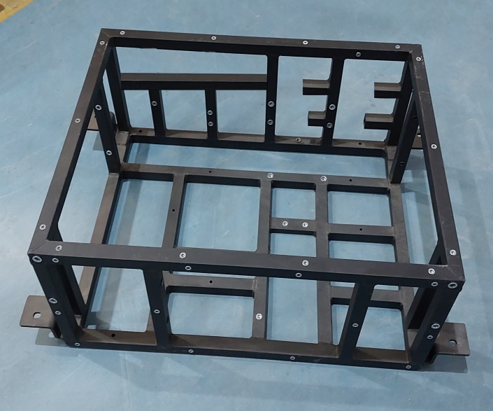

Bottom Frame

Vertical Frame

Assembly Bracket

Mounting Positions

Top Frame

Fig 1- Frame structure of the Battery thermal management System

**Cad and meshing of frame:**

The initial step in FEA is to perform meshing, which consists of subdividing the structure into finite elements so that an infinite number of degrees of freedom can be converted into a finite number of degrees of freedom. Meshing is intended to try and mimic the original body as closely as possible with an objective of the best combination of accuracy and computational efficiency. Meshing must consider the shape, size, number of elements, and the distribution of elements. Hypermesh is a fantastic software product used in the meshing process that can ease the creation of high-quality meshes. Hypermesh includes both shell and solid element meshing algorithms that can mesh completely by hand, and in combination with automatic meshing, Hypermesh also has domain specific techniques such as sound vibration harshness (SVH), fatigue, crash simulations, and optimization state of the art capabilities. When you begin the meshing process for computer-aided design (CAD) models, it is important to understand what parts of the CAD model should be meshed, and the parts of the CAD model that are not necessary to be meshed since meshing is a lot of effort from a computational standpoint. Often times good CAD geometry needs to be filtered to eliminate unneeded geometries for the simulation being run such as name plates which do not contribute to the simulated response. The benefit of cleaning up the design will lower the effort associated with meshing and it will allow the analysis to be performed quicker. The process of FEA is calculated at discrete points and the results will be extrapolated throughout the discrete points throughout the model. The objective of hypermesh is to provide better meshing while preserving the geometry's integrity, and proper geometry cleanup is crucial before beginning the meshing process.

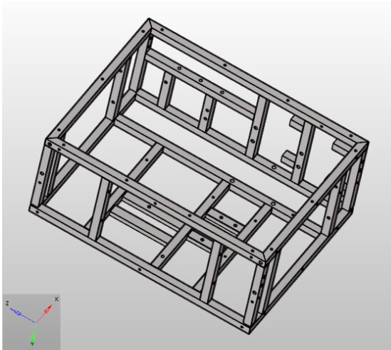 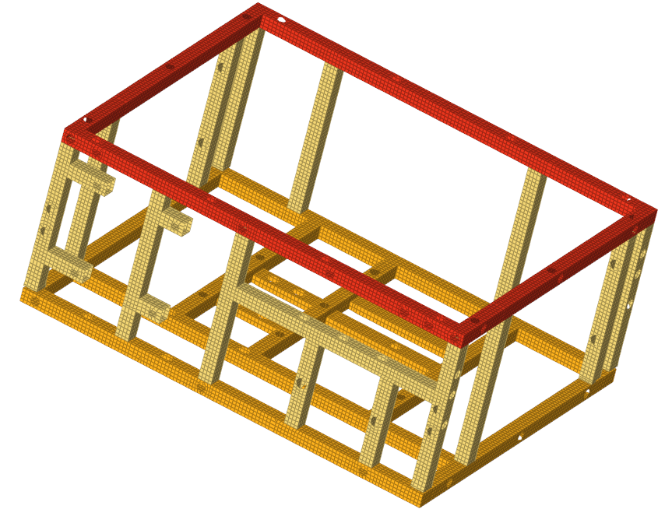

Cad data of the frame structure Mesh data of the frame structure

Fig 2- Cad & mesh model of frame system

In this frame meshing the number of elements and the quality check parameters are as following:

|  |  |
| --- | --- |
| Element size | 6 mm |
| Total no. of element | 28759 |
| No. of trias (CRIA3) | 81 |
| No. of quad (QUAD4) | 28678 |

Quality check report for the frame structure mesh:

|  |  |  |
| --- | --- | --- |
| Quality Check | Limiting Value | No. of failed element |
| Mesh type |  | Manual Mesh |
| Warpage > | 10 | 0 |
| Aspect Ratio > | 5 | 4 |
| Skew Angle > | 60 | 0 |
| Jacobian < | 0.6 | 3 |
| Min angle for quad < | 40 | 0 |
| Max angle for quad > | 135 | 2 |
| Min angle for tria < | 15 | 0 |
| Max angle for tria > | 140 | 0 |
| % of tria | 2 | 0.002 |
| Total no. of element | 28759 |  |

**Analysis of frame:**

1. **Static analysis:** Static analysis was carried out for six frames in order to investigate the stress behaviour under static loading conditions. Especially the stress contours showing the distribution of the stress at the top, bottom and vertical sections of the frame have been calculated. The most critical loading condition is XYZ which affects the frame with 44145 N force in the X, Y and Z directions.

The static loading analysis results for the six frame cases are summarized as follows:

1. **Case 1 - Al 2mm**: The stress induced in the frame is below the material’s yield stress, making it the safest choice for static loading. Stress contours for top, bottom, and vertical frames show minimal stress.
2. **Case 2 - Al 1.5mm**: Stress is slightly higher than in Case 1 but still below the yield stress, making it safe for use.
3. **Case 3 - AISI 1037 (Steel) 2mm**: Stress levels are below the yield stress, but higher than in Cases 1 and 2, still safe for static loading.
4. **Case 4 - AISI 1037 (Steel) 1.5mm**: Similar to Case 3, stress is below yield stress and safe for use.
5. **Case 5 - Al 1mm**: Stress is higher than in previous cases but still below the yield stress, making it safe.
6. **Case 6 - AISI 1037 (Steel) 1mm**: Stress levels are slightly higher than in Case 5 but still within safe limits.

The XYZ loading condition was used for stress contour visualization across top, bottom, and vertical frames.

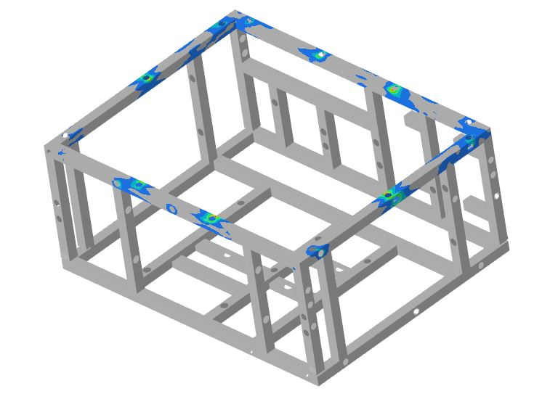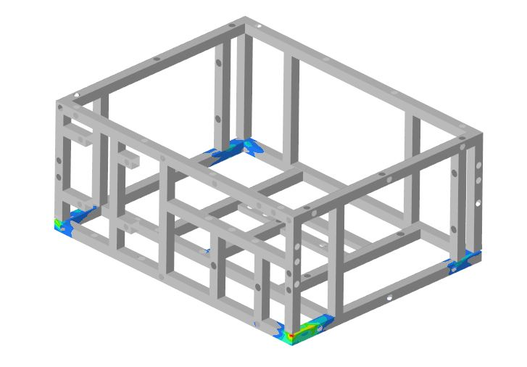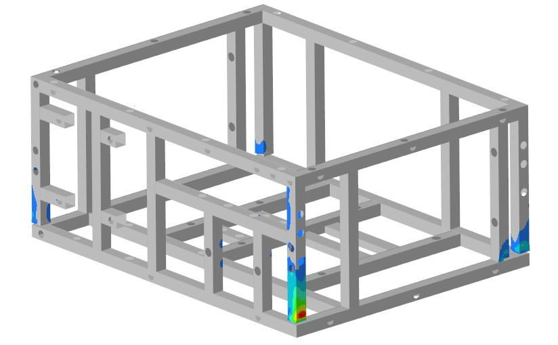

1. Top Frame b) Bottom Frame c) Vertical Frame

Location of maximum stress in frame under static loading condition

1. **Modal analysis:** In the modal analysis, the outcomes are the natural frequency of the system and the mode shapes that are associated with that natural frequency. The deformation that a component would experience when vibrating at its natural frequency is known as a mode shape. The ability to ensure that the frequency of any applied periodic loading does not coincide with a structure's modal frequency and prevent resonance, which could produce massive responses and ultimately failure, makes it useful to know the modal frequencies of a structure. Modal analysis is important because of the following reasons:

* Determine the system's mode shapes and natural frequencies.
* Check the system for rigid modes and the connection between its parts.
* Recognise whether the Boundary Conditions applied to the system are accurate.
* One can identify which parts of the part need to be changed to increase performance.
* A modal analysis should precede any subsequent dynamic simulations of this system because it helps forecast the dynamic responses that this system will exhibit.

Case 1 Aluminium Frame:

|  |  |  |
| --- | --- | --- |
| Mode shape 1  Frequency =169.18 Hz | Mode shape 2  Frequency = 169.77 Hz | Mode shape 3  Frequency =213.44 Hz |
| Mode shape 4  Frequency =225.94 Hz | Mode shape 5  Frequency = 257.25 Hz | Mode shape 6  Frequency =274.22 Hz |

Case 2 Steel Frame:

|  |  |  |
| --- | --- | --- |
| Mode shape 1  Frequency =178.22 Hz | Mode shape 2  Frequency = 178.98 Hz | Mode shape 3  Frequency =225.13 Hz |
| Mode shape 4  Frequency =238.05 Hz | Mode shape 5  Frequency = 271.09 Hz | Mode shape 6  Frequency =288.95 Hz |

1. **FRF Analysis:** Frequency Response Function (FRF) is a dynamic analysis technique used for various purposes, including determining a structure's resonant frequencies, damping, and mode shapes. It is essentially a measurement function based on frequency and is often referred to as a "transfer function" that describes the relationship between the input (x) and output (y) of a linear, time-invariant system in the frequency domain. The FRF analysis is crucial for understanding how a system responds to different frequencies of excitation. For the battery thermal management system, we performed an FRF analysis to evaluate how well the structure performs under dynamic conditions. The results revealed that the "g" value has a significant effect on how the assembly behaves along the Y-axis, where the direction of "g" corresponds with the Y-axis. As a result, the stress values along the Y-axis are critical in determining whether the assembly will pass or fail. We ranked the results based on performance, with the best design listed first and the worst design last, showing the induced stresses in the frame accordingly.

The FRF loading analysis results for the six frame cases are summarized as follows:

1. **Case 1: Al 2mm**  
   The Aluminium 2mm frame induces the least stress, well below the material's yield stress, making it the safest option for dynamic loading.
2. **Case 2: AISI 1037 (Steel) 2mm**  
   The stress induced in the Steel 2mm frame is below the yield stress but slightly higher than Aluminium 2mm. It is still safe for dynamic loading, with stress values and contours in the Y loading shown.
3. **Case 3: Aluminium 1.5mm**  
   The stress induced in the Aluminium 1.5mm frame is below the yield stress but higher than the previous cases. It remains safe for dynamic loading, with stress contours in the Y loading displayed.
4. **Case 4: AISI 1037 (Steel) 1.5mm**  
   The stress induced in the Steel 1.5mm frame exceeds the yield stress, which could lead to failure. Critical failure zones and stress values are shown.
5. **Case 5: Aluminium 1mm**  
   The stress induced in the Aluminium 1mm frame exceeds the yield stress, indicating potential failure. Stress values and the critical failure zone are displayed.
6. **Case 6: AISI 1037 (Steel) 1mm**  
   The stress in the Steel 1mm frame exceeds the yield stress, making it unsafe for use. The stress values and failure zone are shown in the contours.



a) Top Frame b) Bottom Frame c) Vertical Frame

Location of maximum stress in frame under FRF loading condition

According to the FRF analysis, the critical frequencies for the Aluminium frame are 16 Hz in the X direction, 25 Hz in the Y direction, and 16 Hz in the Z direction for all top, bottom, and vertical frames. On the other hand, the Steel frame exhibits critical frequencies of 18 Hz in the X direction, 26 Hz in the Y direction, and 18 Hz in the Z direction across all frames. The maximum stress values are observed when the system vibrates at these critical frequencies, indicating that the frame's dynamic response at these points could lead to potential failure if not properly managed.

**Conclusion:**

The purpose of this study is to design the frame of the BTMS system while looking at yield stress to assume failure criteria. Six cases were evaluated using Aluminum and Steel with thicknesses of 1mm to 2mm. A number of deductions can be made from static analysis, modal analysis, frequency response function and test results. The stress values of the cases were below the yield stress in static loading conditions, which meant that at the load level tested there was no potential for permanent deformation, therefore the structural integrity will be assured. This shows that the selected material will be able to transfer load with no performance issues.Modal analysis provided a description of the compartment frames dynamic characteristics in terms of natural frequency and mode shape. Correlating the finite element model predictions with those from experimental modal analysis was helpful for examining the validity of the finite element model and making any amendments required.The frequency response function evaluated the behavior of the structure to dynamic excitation. This provided data on the resonate frequencies as well as global damping characteristics of the structure. Three of the 6 cases passed while 3 failed (Al 2mm, Steel 2mm, Al 1.5mm passed, Steel 1.5mm, Al 1mm, Steel 1mm failed). The results exhibited stable dynamic behavior in the passed cases in that the energy passed through the structure effectively dissipating energy and minimizing the potential of a strong resonant frequency. These results highlight the importance of material and material thickness for the overall dynamic behavior of the structure and its stability.

**Reference**

[1] S. Singh, N. Sharma, C. Shukla, and S. Singh, “Electric vehicles in India: A literature review,” in 7th International Conference on “New Frontier in Energy, Engineering and Science (NFEES), 2021, pp. 19–20.

[2] A. Perujo and B. Ciuffo, “The introduction of electric vehicles in the private fleet: Potential impact on the electric supply system and on the environment. A case study for the Province of Milan, Italy,” Energy Policy, vol. 38, no. 8, pp. 4549–4561, Aug. 2010.

[3] M. Ginzburg and E. Ka, “A feasibility study of the finite element analysis method applied to the redesign for manufacturability of mechanical products,’’ 1986

[4] X. Wang, B. Li, and Z. Yang, “Finite Element Analysis and Lightweight Optimization Design on Main Frame Structure of Large Electrostatic Precipitator,” Advances in Materials Science and Engineering, vol. 2018, 2018.

[5] P. J. Wang, L. Li, and J. Bin Wu, “Research on the lightweight structural optimization design of the front collector of the polymetallic nodule miner,” Ocean Engineering, vol. 267, Jan. 2023.

[6] P. Vijaykumar and R. I. Patel, “Structural analysis of automotive chassis frame and design modification for weight reduction,” International Journal of Engineering Research & Technology, ISSN, pp. 2181–2278, 2012.

[7] R. A. Rahman, N. Tamin, and O. Kurdi, “STRESS ANALYSIS OF HEAVY DUTY TRUCK CHASSIS AS A PRELIMINARY DATA FOR ITS FATIGUE LIFE PREDICTION USING FEM,” 2008.

[8] Y. Chen and F. Zhu, “The finite element analysis and the optimization design of the Yj3128-type dump truck’s sub-frames based on ANSYS,” in Procedia Earth and Planetary Science, Elsevier B.V., 2011, pp. 133–138.

[9] A. Singh Patel and J. Chitransh, “IJESRT INTERNATIONAL JOURNAL OF ENGINEERING SCIENCES & RESEARCH TECHNOLOGY DESIGN AND ANALYSIS OF TATA 2518TC TRUCK CHASSIS FRAME WITH VARIOUS CROSS SECTIONS USING CAE TOOLS,” Int J Eng Sci Res Technol, vol. 5, no. 9, 2016.

[10] R. L. Patel, D. B. Morabiya, and A. N. Rathour, “Weight optimization of chassis frame using Pro-Mechanica,” SSRG Int J Mech Eng (SSRG-IJME), vol. 1, no. 8, pp. 4–9, 2014.

[11] S. Balaguru, E. Natarajan, S. Ramesh, and B. Muthuvijayan, “Structural and modal analysis of scooter frame for design improvement,” Mater Today Proc, vol. 16, pp. 1106–1116, 2019.

[12] S. Li and X. Feng, “Study of structural optimization design on a certain vehicle body-in-white based on static performance and modal analysis,” Mech Syst Signal Process, vol. 135, Jan. 2020.

[13] B. Van den Nieuwenhof and J. P. Coyette, “Modal approaches for the stochastic finite element analysis of structures with material and geometric uncertainties,” Comput Methods Appl Mech Eng, vol. 192, no. 33–34, pp. 3705–3729, Aug. 2003.

[14] J. Yin et al., “Accurate and fast three-dimensional free vibration analysis of large complex structures using the finite element method,” Comput Struct, vol. 221, pp. 142–156, Sep. 2019.

[15] S. W. Bostic and R. E. Fulton, “Implementation of the Lanczos method for structural vibration analysis on a parallel computer,” Comput Struct, vol. 25, no. 3, pp. 395–403, 1987.

[16] J. K. Krouse, “FINITE-ELEMENT ANALYSIS BRANCHES OUT,” Machine Design, vol. 57, no. 13, pp. 72–79, 1985.

[17] J. Rodriguez-Velazquez and A. Seireg, “Optimizing the shapes of structures via a rule-based computer program,” Computers in Mechanical Engineering, vol. 4, no. 1, pp. 20–28, 1985.

[18] G. N. Vanderplaats and H. Sugimoto, “A general-purpose optimization program for engineering design,” Comput Struct, vol. 24, no. 1, pp. 13–21, 1986.

[19] L. J. Segerlind, Applied finite element analysis. John Wiley & Sons, 1991.

[20] R. Desai Shrikar and H. Shinde Harshada, “Finite Element Analysis: Basics And Its Applications In Dentistry.,” Indian journal of dental sciences, vol. 4, no. 1, 2012.

[21] J.-P. Geng, K. B. C. Tan, and G.-R. Liu, “Application of finite element analysis in implant dentistry: a review of the literature,” J Prosthet Dent, vol. 85, no. 6, pp. 585–598, 2001.

[22] N. K. Jain and N. D. Mittal, “Finite element analysis for stress concentration and deflection in isotropic, orthotropic and laminated composite plates with central circular hole under transverse static loading,” Materials Science and Engineering: A, vol. 498, no. 1–2, pp. 115–124, 2008.

[23] S. Xiang, G. Li, W. Zhang, and M. Yang, “A meshless local radial point collocation method for free vibration analysis of laminated composite plates,” Compos Struct, vol. 93, no. 2, pp. 280–286, 2011.

[24] A. Salih, “Weighted residual methods,” Department of Aerospace Engineering Indian Institute of Space Science and Technology. Thiruvananthapuram, 2016.

[25] S. P. Bandgar, “DESCRITIZATION OF A STRUCTURAL MEMBER FOR LINEAR STATIC ANALYSIS,”2017.