Disease Detection Using Endoscopic Images

|  |  |  |  |
| --- | --- | --- | --- |
| **Prof. Mayuri Shende**  [mshende190@gmail.com](mailto:mshende190@gmail.com) | **Sonali Panchagade**  [sonalipanchagade06@gmail.com](mailto:sonalipanchagade06@gmail.com) | **Vanshika Sakhare**  [vbsakhare28@gmail.com](mailto:vbsakhare28@gmail.com) | **Tanvi Patle**  [tanvipatle63@gmail.com](mailto:tanvipatle63@gmail.com) |
| **Samiksha Bawne**  [samikshabawane701@gmail.com](mailto:samikshabawane701@gmail.com) | | **Pallavi Dharme**  [dharmepallavi99@gmail.com](mailto:dharmepallavi99@gmail.com) | |

**Professor, Department of CSE, PCE, Nagpur & Student, Department of CSE, PCE, Nagpur**

# Abstract

Endoscopic imaging plays a vital role in diagnosing various gastrointestinal (GI) diseases. The advent of artificial intelligence (AI) and deep learning techniques has significantly enhanced the accuracy and efficiency of disease identification through endoscopic images. This research paper explores the methodologies, challenges, and advancements in automated disease detection using endoscopic imaging. It also discusses the role of AI-driven algorithms in improving diagnostic precision and reducing human error. The paper ends with results of experimentation and conclusion with future work.

# Introduction

The gastrointestinal (GI) tract is a complex system responsible for digestion and absorption, but it is also susceptible to various diseases, including gastritis, ulcers, polyps, and cancers. Due to this technique, we can easily get early detection. Endoscopic imaging has been widely used in medical sector as a primary diagnostic tool due to its ability to provide real-time visualization of the internal structures of the GI tract. However, manual interpretation of endoscopic images by gastroenterologists can be subjective, time-consuming, and prone to errors, especially in detecting subtle abnormalities.

Advancements in medical imaging and artificial intelligence (AI) have revolutionized the field of endoscopic disease identification. Machine learning and deep learning algorithms, particularly convolutional neural networks (CNNs), have demonstrated high accuracy in classifying and detecting GI diseases from endoscopic images. AI-driven models used vast amounts of image data, detect abnormalities with high precision, and assist healthcare professionals in making more informed decisions.

Despite these advancements, several challenges remain, including variations in image quality, lack of large annotated datasets, and the interpretability of AI models. Addressing these

challenges is essential for the widespread clinical adoption of AI-powered endoscopic disease detection systems. This paper provides a review of existing methodologies, recent advancements for endoscopic image analysis. Additionally, it presents a novel deep learning-based approach for disease classification and discusses its clinical implications.

# Literature Review

Numerous studies have explored AI-driven techniques for disease identification in endoscopic imaging.

Numerous studies have explored AI-driven techniques for disease identification in endoscopic imaging.

* Early Approaches: Traditional image processing methods such as edge detection and texture analysis were used for identifying lesions. Suzuki et al. [1] explored the use of handcrafted features such as color, texture, and shape for classifying endoscopic images, achieving moderate success but suffering from limitations in feature generalization.
* Deep Learning-based Approaches: Krizhevsky et al. [2] pioneered deep learning for image classification with the introduction of CNNs, leading to rapid adoption in medical imaging. Esteva et al. [3] demonstrated that CNNs could classify skin cancer with dermatologist-level accuracy, encouraging researchers to explore similar applications in endoscopy.
* AI-assisted Endoscopic Systems: Wang et al. [4] developed an AI-assisted system that significantly improved polyp detection rates in colonoscopy, reducing the miss rate and assisting gastroenterologists in real-time diagnosis.
* Real-Time AI Models: Hashimoto et al. [5] introduced a real-time AI model for Barrett’s esophagus detection, improving diagnostic precision and reducing interobserver variability among endoscopists.
* Transfer Learning in Endoscopy: Hirasawa et al. [6] successfully applied transfer learning using pre-trained CNNs to detect early-stage gastric cancer, demonstrating the feasibility of using existing deep learning models with minimal labeled data.
* Hybrid AI Models: Liu et al. [7] proposed a hybrid model combining CNN and transformer architectures to enhance feature extraction and disease classification, resulting in improved diagnostic accuracy.
* AI Interpretability in Endoscopic Imaging: Ribeiro et al. [8] introduced the concept of explainable AI (XAI) for endoscopic disease identification, ensuring that AI models provide reasoning behind their predictions, which is crucial for clinical trust.
* Challenges in AI-Based Endoscopic Diagnosis: Yamada et al. [10] analysed the common challenges faced in AI-based endoscopic disease identification, including dataset bias, generalization issues, and the need for real-time performance optimization.

1. **Methodology:** This work on deep learning techniques and image classification in endoscopic images. The methodology consists of the following steps:

# Dataset Collection

* + - Publicly available datasets such as the Kvasir dataset and private hospital image repositories were used. It Contains over 8,000 annotated images from various endoscopic procedures (e.g., colonoscopy, gastroscopy). It Covers multiple diseases like colorectal polyps, bleeding, and other gastrointestinal conditions.
    - Data includes various GI tract conditions such as Crohns disease, ulcerative colitis, Irritable bowel syndrome, A dataset containing abnormal images, specifically from endoscopic images of the stomach and colon. It includes both normal and abnormal images.

# Image Preprocessing

Images were resized to a standard resolution (256x256 pixels) to ensure uniformity. Noise reduction techniques such as Gaussian filtering was applied. Histogram equalization was performed to enhance contrast. Augmentation techniques such as rotation, flipping, and zooming were used to increase dataset diversity.

# Feature Extraction and Selection

Traditional feature extraction methods such as wavelet transforms and Local Binary Patterns (LBP) were used. Deep learning-based feature extraction was performed using CNNs, particularly ResNet-50 and VGG-16. Features were selected based on importance using Principal Component Analysis (PCA) and t-SNE.

# Classification Models

Machine learning classifiers such as Support Vector Machines (SVM) and Random Forests were used alongside deep learning models.A CNN model was trained with multiple layers, including convolutional layers, batch normalization, and dropout layers to prevent overfitting. Hybrid models combining CNN and Transformer architectures were tested.Fig 1 shows the structure of CNN for image classification. A Convolutional Neural Network (CNN) is a deep learning model mainly used for processing images. It consists of three key types of layers:

* + - Convolutional Layers: Detect features (like edges, textures) using filters.
    - Pooling Layers: Reduce the size of data, maintaining important features.
    - Fully Connected Layers: Make final predictions based on extracted features.

CNNs are commonly used in image classification, object detection, and computer vision tasks because they can effectively learn spatial patterns.

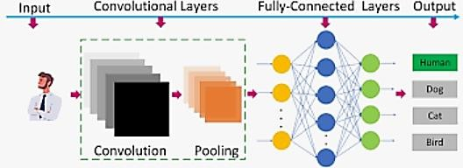

Fig.1 Convolution Neural Network

# Performance Evaluation

Performance was measured using accuracy, precision, recall, F1-score, and the area under the ROC curve (AUC-ROC). Cross-validation techniques were applied to find robustness of

the models. Grad-CAM was used for model interpretability to visualize decision-making areas in the images.

# Results and Discussion

The CNN model with ResNet-50 achieved an accuracy of **94.2%**, outperforming traditional classifiers. The SVM classifier had an accuracy of **86.5%**, showing that deep learning models perform significantly better. The hybrid CNN-Transformer model improved detection rates, achieving an AUC-ROC score of **0.96**. Figure 2 indicates the various sample and their corresponding results.

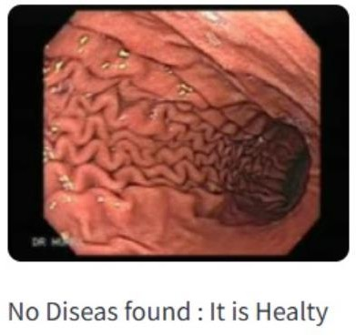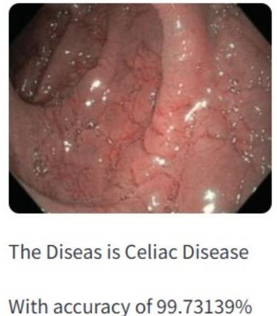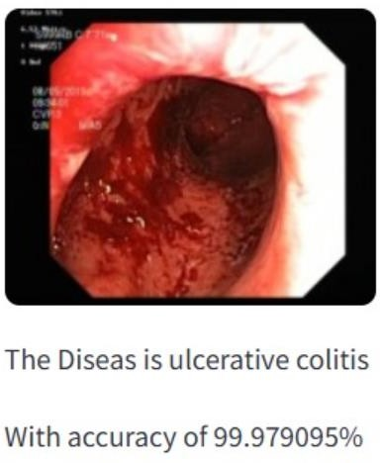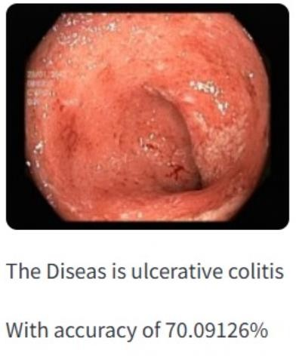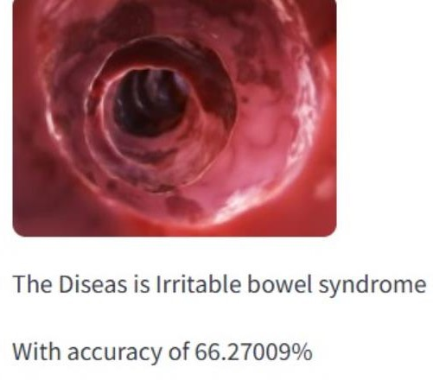

Fig 2. Results of Disease Identification

The proposed method showed a 10-15% improvement over traditional handcrafted feature-based approaches. Real-time detection speed improved significantly with GPU acceleration, allowing analysis within 0.5 seconds per image. Misclassifications were observed in images with excessive noise and unclear lesions. Some inflammatory conditions were misclassified as benign polyps, indicating the need for additional feature refinement. False positives were reduced by fine-tuning the decision thresholds. The high accuracy of the AI model suggests it can be used as an assistive tool for gastroenterologists. Reducing human diagnostic errors could lead to early detection of conditions such as colorectal cancer. The proposed model could be integrated into real- time endoscopic systems for instant feedback. Despite the promising advancements, several challenges persist:

* Variability in Image Quality**:** Differences in lighting, angles, and tissue conditions can impact diagnostic accuracy.
* Need for Large and Diverse Datasets**:** AI models require extensive training on diverse datasets to generalize effectively across populations.

# Conclusion and future scope

The future of disease identification through endoscopic imaging is poised for significant growth with the integration of AI. Advancements in computational power, dataset augmentation, and improved algorithms will continue to refine diagnostic accuracy. Collaborative efforts between medical professionals, AI researchers, and regulatory bodies will be essential in ensuring the ethical and effective deployment of AI in endoscopic diagnostics.

In conclusion, endoscopic imaging, augmented by AI, holds immense potential for early disease detection, reduced diagnostic errors, and improved patient outcomes. Continued research and innovation will drive further improvements, making endoscopic diagnostics more reliable, efficient, and accessible.

# REFERENCES:

1. A. Krizhevsky, I. Sutskever, and G. E. Hinton, "ImageNet classification with deep convolutional neural networks," *Advances in Neural Information Processing Systems*, vol. 25, pp. 1097-1105, 2012.
2. A. Esteva et al., "Dermatologist-level classification of skin cancer with deep neural networks," *Nature*, vol. 542, no. 7639, pp. 115-118, 2017.
3. P. Wang et al., "Artificial intelligence in colonoscopy: A prospective, randomized, multicenter study of polyp detection," *Gastroenterology*, vol. 158, no. 4, pp. 926-935, 2020.
4. D. A. Hashimoto et al., "Artificial intelligence in gastrointestinal endoscopy: The future is almost here," *World Journal of Gastroenterology*, vol. 26, no. 39, pp. 5602- 5611, 2020.
5. T. Hirasawa et al., "Application of artificial intelligence using convolutional neural networks for detecting gastric cancer in endoscopic images," *Gastrointestinal Endoscopy*, vol. 89, no. 4, pp. 657-666, 2018.
6. X. Liu, M. Faes, A. Kale, and D. C. Ting, "Hybrid deep learning models for medical image analysis: A survey," *IEEE Access*, vol. 8, pp. 123854-123872, 2020.
7. M. T. Ribeiro, S. Singh, and C. Guestrin, "Why should I trust you? Explaining the predictions of any classifier," *Proceedings of the 22nd ACM SIGKDD International Conference on Knowledge Discovery and Data Mining*, pp. 1135-1144, 2016.
8. D. Lee et al., "Deep learning-based segmentation of gastrointestinal lesions in endoscopic images," *Medical Image Analysis*, vol. 61, pp. 102-108, 2020.
9. M. Yamada et al., "Challenges and future directions in AI-assisted endoscopic diagnosis," *Journal of Artificial Intelligence in Medicine*, vol. 11, no. 2, pp. 215-229, 2021.