SUPPLY CHAIN MANAGEMENT SYSTEM USING BLOCKCHAIN

SANJU KANNAN .R , Dr. P. SAKTHI MURUGAN

B.Sc. Computer Science with Cognitive Systems

Dr. N. G. P. Arts and Science College

Coimbatore, India

Abstract:

The Supply Chain Management (SCM) System Using Blockchain leverages blockchain technology to address key inefficiencies in traditional supply chains, such as lack of real-time visibility, fraud, data tampering, and delayed transactions. By utilizing a decentralized and immutable distributed ledger, the system creates a transparent and secure record of every transaction across the supply chain, from raw material procurement to final product delivery. This enables stakeholders such as manufacturers, suppliers, distributors, and consumers to track the movement and status of goods in real time, ensuring accountability and reducing the risk of fraud. The system enhances operational efficiency by automating critical processes like inventory management, order fulfillment, and payment processing, while reducing the potential for human error. Blockchain’s immutable nature guarantees data integrity and security, providing a higher level of protection compared to traditional systems.

Keywords:

Blockchain technology, Distributed ledger, Transparency, Real-time visibility, Fraud prevention.

1. **INTRODUCTION**

The modern supply chain is an intricate system involving various stakeholders, from suppliers and manufacturers to distributors, retailers, and consumers. However, traditional supply chain systems face several significant challenges, such as a lack of real-time visibility, inefficient tracking methods, fraud, data tampering, and transaction delays. These inefficiencies can lead to financial losses, breaches of trust among participants, and difficulties in meeting regulatory compliance requirements. Blockchain technology presents a transformative solution to these issues by providing a decentralized, immutable, and transparent ledger. With blockchain, every transaction is recorded in a secure and verifiable manner, ensuring data integrity and eliminating concerns about unauthorized modifications or fraud. Its decentralized nature ensures that no single party has control over the entire system, enhancing trust and accountability among all stakeholders. Moreover, blockchain’s transparency enables stakeholders to track the flow of goods from origin to final delivery, which is particularly beneficial in industries like pharmaceuticals, food, and luxury goods, where traceability is critical. Additionally, smart contracts can automate processes such as order fulfillment and payment processing, streamlining operations and reducing reliance on intermediaries. By incorporating blockchain into supply chain management, businesses can significantly enhance security, reduce fraud, improve operational efficiency, and ultimately build a more robust and trustworthy supply chain.

1. **SYSTEM STUDY**
   1. Existing System

The existing supply chain management system operates on a traditional framework that heavily depends on centralized databases, manual record-keeping, and multiple third-party intermediaries to facilitate transactions and oversee logistics. While this system has been in place for decades, it suffers from several fundamental issues that hinder efficiency, transparency, security, and reliability. One of the most pressing concerns is the lack of real-time visibility into the movement of goods, which creates bottlenecks, delays, and mismanagement of inventory. Since data is stored in isolated silos across different stakeholders such as manufacturers, suppliers, distributors, and retailers, there is no unified platform for tracking and verifying information. This results in inconsistencies, data discrepancies, and a lack of trust among participants, making it difficult to trace the origin and status of products accurately.

* 1. PROBLEM IDENTIFICATION

The modern supply chain system, involving multiple stakeholders such as suppliers, manufacturers, distributors, retailers, and consumers, faces several critical challenges, including a lack of real-time visibility, inefficient tracking, fraud, data tampering, and delays in transactions.

* Existing systems lack transparency, making it hard to track the flow of goods and ensure traceability, especially in critical industries like pharmaceuticals, food, and luxury goods.
* The need for a more secure, transparent, and efficient solution to address these challenges.
* Opportunity to implement blockchain technology to provide decentralized, immutable, and transparent transaction records.
* Blockchain can ensure real-time traceability, improve data integrity, reduce fraud, and automate processes with smart contracts, enhancing operational efficiency and stakeholder trust.
  1. PROPOSED SYSTEM

The proposed Supply Chain Management System using Blockchain introduces a decentralized and transparent approach to managing supply chain operations. By leveraging blockchain technology, the system ensures that every transaction and movement of goods is recorded in an immutable ledger, accessible to all authorized stakeholders. This enhances transparency, builds trust, and eliminates the possibility of data tampering. The system enables real-time tracking of products from raw material sourcing to final delivery, providing end-to-end traceability and improving overall efficiency. Smart contracts are used to automate key processes such as order fulfillment, inventory updates, and payments based on predefined conditions, reducing the need for manual intervention and minimizing human errors. The decentralized nature of blockchain removes reliance on a single central authority, reducing the risk of fraud and increasing the reliability of the system.

1. **SYSTEM CONFIGURATION**

3.1 HARDWARE REQUIREMENTS

* Platform : Windows 7 and Above
* Processor : Pentium IV
* RAM : 4 GB Hard Disk : 500 GB
* Monitor : HP ELITEBOOK

3.2 SOFTWARE REQUIREMENTS

* operating system : WINDOWS 11PRO
* front-end : HTML, CSS, JavaScript.
* Internet Browser : Google Chrome, Microsoft Edge.
* Block chain : Ethereum,Solidity,Ganache.
* Code Editor : Visual Studio code

3.3 SOFTWARE DESCRIPTION

HTML is the foundation of web content, using tags to structure information and support multimedia, semantic elements, and accessibility. It organizes content with core elements like <head> and <body>, while semantic tags such as <nav> and <article> improve SEO and accessibility. The future of HTML includes better accessibility, Web Components, AI integration, and Progressive Web Apps (PWAs) for offline capabilities and enhanced performance. CSS separates style from content, controlling layout, colors, and fonts to create visually appealing and responsive websites. It has evolved with advanced features like animations and media queries for device adaptation. CSS improves performance, cross-browser compatibility, and integrates with JavaScript and frameworks like Bootstrap.Bootstrap is a front-end framework that simplifies responsive design with a 12-column grid system, customizable components, and utility classes. It accelerates development with mobile-first design, cross-browser compatibility, and strong community support.JavaScript powers interactive web experiences, offering features like DOM manipulation, asynchronous programming, and cross-platform compatibility.

1. **SYSTEM DESIGN**
   1. MODULE DESCRIPTION

Data Flow Diagrams (DFDs) use specific notations to represent different components of the system. Entities (External Users or Systems) are depicted as rectangles, indicating the sources or destinations of data. Processes, which handle data transformation, are represented by circles or ovals, describing key system operations like data processing and analysisThese notations help structure DFD Levels (0, 1, and 2), ensuring clear visualization of how data moves through the stress detection system, from user input to processing, classification, storage, and result generation.

* 1. SYSTEM FLOW DIAGRAM

The system flow diagram represents the step-by-step process of supply chain management using block chain. System flow involving Suppliers, Manufacturers, and Distributors/Consumers interacting with various modules. Users interact with the View Reports section, which triggers contracts, manages inventory requests, sends/receives product data, registers logins, and utilizes the Supply Chain Analytics & Reporting Module. The Smart Contracts Module includes Inventory Management, Product Traceability, and User Management. The Payment Processing Module handles transactions, integrating with a Blockchain Ledger and Database. This structured flow ensures efficient management of supply chain operations, from inventory and product tracking to user management and payment processing, leveraging blockchain technology for secure and transparent transactions.

Several rules of thumb are used in drawing DFD‟S

• Process should be named and numbered for an easy reference. Each name should be representative of the process.

• The direction of flow is from top to bottom and from left to right. Data traditionally flow from source to the destination although they may flow back to the source. One way to indicate this is to draw long flow line back to a source. An alternative way is to repeat the source symbol as a destination. Since it is used more than once in the DFD, it is marked with a short diagonal.

• When a process is exploded into lower level details, they are numbered.

• The names of data stores and destinations are written in capital letters. Process and dataflow names have the first letter of each work capitalized

* A **Data Flow Diagram (DFD)** is a graphical tool used to describe and analyze the movement of data through a system.
* It serves as a **central tool** and the foundation for developing other system components.

DFD illustrates the **transformation of data** from input to output through processing, often independent of physical components.

* These diagrams are known as **logical data flow diagrams**, focusing on the flow of data rather than hardware or software specifics.
* A DFD is also referred to as a **“bubble chart”**, representing processes as bubbles.
* The purpose of a DFD is to **clarify system requirements** and identify key transformations that will later be developed into programs during system design.

FLOW CHAT

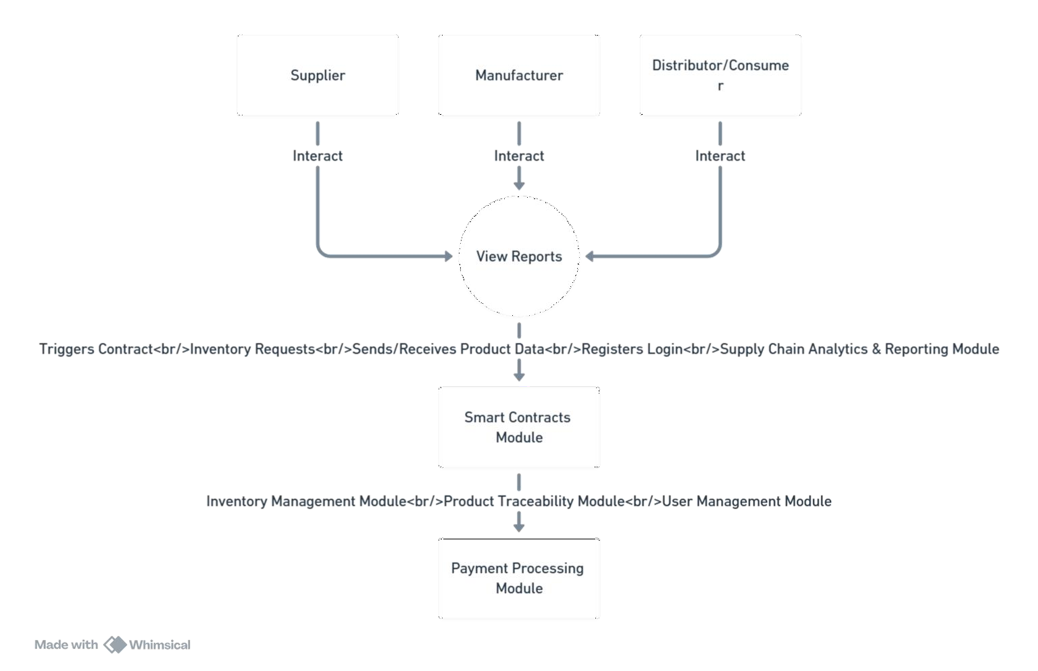

4.3 INPUT DESIGN

The input design for the system involves multiple user roles: Suppliers, Manufacturers, and Distributors/Consumers. Each user interacts with the system through the View Reports section, which captures inputs such as contract triggers, inventory requests, product data, login credentials, and analytics queries. The Smart Contracts Module processes inputs related to inventory management, product traceability, and user management. The Payment Processing Module handles transaction data, recording it in the Blockchain Ledger and Database. Inputs are designed to be user-friendly, ensuring seamless data entry and validation to maintain accuracy and integrity. This structured input design supports efficient data flow and system functionality, enabling robust supply chain management and secure transactions.

4.4 OUTPUT DESIGN

The output design for the system focuses on delivering clear, actionable information to users. The View Reports section generates outputs such as contract statuses, inventory levels, product data summaries, and comprehensive supply chain analytics. These reports are presented in an easy-to-read format, often including charts and graphs for better visualization. The Smart Contracts Module provides outputs related to inventory updates, product traceability details, and user management statuses. The Payment Processing Module outputs transaction confirmations and blockchain ledger entries, ensuring transparency and security. All outputs are designed to be accessible and informative, enabling users to make data-driven decisions efficiently. This output design ensures that users receive timely and accurate information to support their operations.

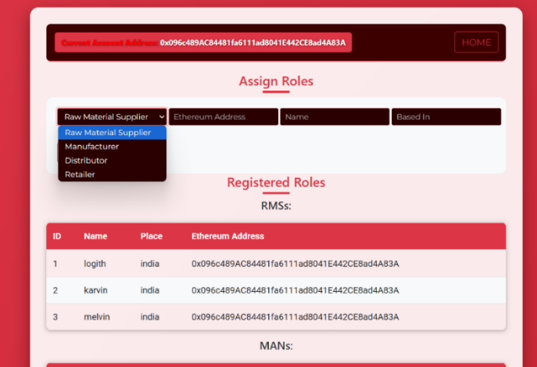

**Fig 1: Registration page**

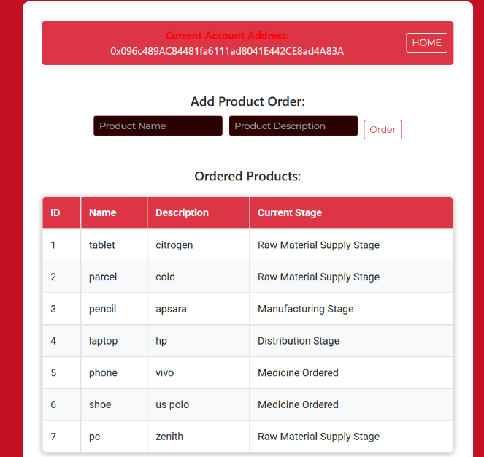

**Fig 2: Ordered material**

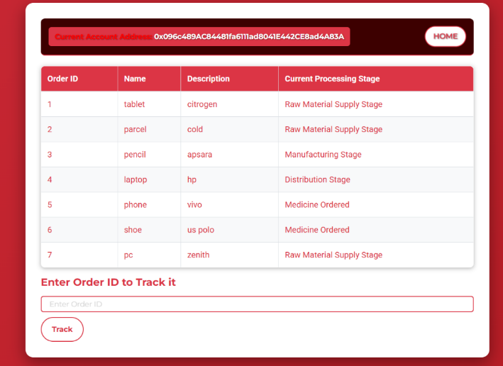

**Fig 3:Track materials**

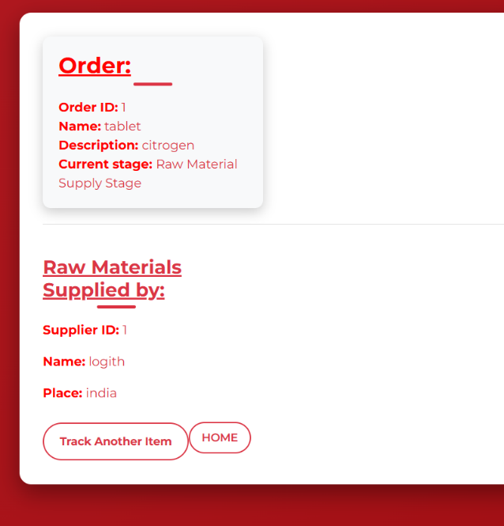

**Fig 4:Order summary**

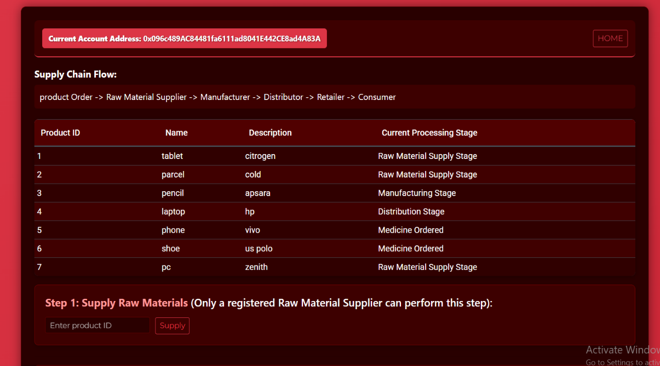

**Fig 5:Supply materials**

4.5 Database Design Overview

The database is structured to support a blockchain-based supply chain management system, ensuring security, transparency, and efficiency.

* 1. User Management

• Stores user authentication and role-based access (user_id, username, password, role, email).

• Ensures secure login, unique identification, and role-based permissions.

* 1. Product Tracking & Traceability

• product_id, product_name, batch_no, and origin uniquely identify products.

• current_status and timestamp track the supply chain journey in real-time.

1. **SYSTEM TESTING**

System testing for the Supply Chain Management System Using Blockchain evaluates the entire system’s functionality, performance, and reliability. It verifies end-to-end workflows, ensuring seamless tracking of goods from origin to delivery. Smart contract execution is tested to confirm automated processes like payment release and order fulfillment work as intended. Data integrity is validated to ensure all transactions are accurately recorded and immutable. Real-time visibility is checked to confirm stakeholders can access verified, tamper-proof data. Security mechanisms are tested to ensure protection against cyberattacks and unauthorized access. Interoperability with external systems, such as inventory and payment platforms, is validated. Additionally, scalability and performance under load are tested to ensure the system handles high transaction volumes efficiently. System testing ensures the solution meets all functional and non-functional requirements.

1. **SYSTEM IMPLEMENTATION**

The implementation of the Supply Chain Management System Using Blockchain involves a structured approach to ensure seamless integration, functionality, and long-term sustainability. The process begins with requirements gathering and system design, where stakeholder needs are analyzed, and the architecture is defined, including blockchain networks, smart contracts, and integration with existing supply chain systems. o During development, blockchain protocols (e.g., Ethereum, Hyperledger) are selected, and smart contracts are coded to automate processes like order fulfillment, payments, and inventory management. APIs are developed to enable interoperability with external systems, such as ERP and inventory management platforms. o The system is then deployed in a phased manner, starting with pilot testing in a controlled environment to validate functionality, security, and performance. Feedback from stakeholders is incorporated to refine the system before full-scale deployment.

Post-implementation, maintenance is critical to ensure the system remains efficient and secure. Regular updates are performed to address bugs, enhance features, and adapt to evolving regulatory requirements. Monitoring tools are implemented to track system performance, detect anomalies, and prevent potential security breaches. o Data backups and disaster recovery plans are established to ensure business continuity. Additionally, user training is conducted to familiarize stakeholders with the system, ensuring smooth adoption and maximizing its benefits.

1. **CONCLUSION**

The Supply Chain Management System Using Blockchain is a transformative solution that addresses the limitations of traditional supply chains while preparing businesses for future challenges. By leveraging blockchain’s immutable ledger, the system ensures data integrity, transparency, and trust among stakeholders. Every transaction is securely recorded, enabling realtime tracking of products from origin to delivery. This transparency is particularly valuable in industries like pharmaceuticals, food, and luxury goods, where product authenticity and compliance are critical. Consumers can access detailed product information, fostering trust and loyalty, while businesses gain a competitive edge through ethical sourcing and full disclosure. Operationally, the system enhances coordination among supply chain participants, reducing redundancies, minimizing inventory mismanagement, and enabling rapid issue resolution. Smart contracts automate processes like payments and order fulfillment, reducing delays, paperwork, and disputes. This automation improves cash flow management and simplifies cross-border transactions, ensuring compliance with financial regulations

1. **FUTURE ENHANCEMENTS**

The Supply Chain Management System Using Blockchain offers significant potential for future enhancements to further revolutionize supply chain operations. Integration with IoT and AI can enable real-time tracking and predictive analytics, optimizing logistics and decision-making. Expanding the system to new industries, such as automotive and electronics, will broaden its applicability. Enhanced interoperability with ERP and CRM systems will ensure seamless data flow across platforms. Advanced sustainability tracking features can help companies meet ESG goals, while decentralized identity solutions will improve security and privacy. Tokenization of assets could enable fractional ownership and secure trading. Quantum-resistant cryptography will future-proof the system against emerging threats. Additionally, user-friendly interfaces, mobile applications, and Blockchain-as-a-Service (BaaS) models will make the system more accessible.

**BIBLIOGRAPHY**

1. Nakamoto, S. (2008). Bitcoin: A Peer-to-Peer Electronic Cash System. Retrieved from https://bitcoin.org/bitcoin.pdf o The foundational whitepaper on blockchain technology, providing insights into decentralized systems and cryptographic security.
2. Tapscott, D., & Tapscott, A. (2016). Blockchain Revolution: How the Technology Behind Bitcoin Is Changing Money, Business, and the World. Penguin Random House. o A comprehensive exploration of blockchain's potential across industries, including supply chain management.
3. Swan, M. (2015). Blockchain: Blueprint for a New Economy. O'Reilly Media. o Discusses the technical and economic implications of blockchain technology, with applications in various sectors.

1. Crosby, M., Pattanayak, P., Verma, S., & Kalyanaraman, V. (2016). Blockchain Technology: Beyond Bitcoin. Applied Innovation Review, Issue No. 2. o Explores blockchain's applications beyond cryptocurrencies, including supply chain transparency and security.
2. IBM Blockchain. (2020). Blockchain for Supply Chain: Building Transparent and Efficient Supply Chains. Retrieved from https://www.ibm.com/blockchain/supplychain o A practical guide on implementing blockchain in supply chains, with case studies and technical insights.
3. Krizhevsky, A., Sutskever, I., & Hinton, G. E. (2012). "blockchain for supply chain." Advances in Neural Information Processing Systems (NeurIPS)