**A REVIEW ON FORMULATION AND EVALUATION OF HERBAL TOOTH POWDER**

**Author: Sonawane Saurabh Ashok**

**Dr. Naikwadi college of pharmacy jamgaon Sinnar. 422103 (MH).India.**

**Prof. Madhuri R Kale,**

**Research Guide. Dr. Naikwadi college of pharmacy jamgaon Sinnar. 422103 (MH).India.**

**ABSTRACT**

Herbal tooth powder are made of various constituent which are available in wide range in the markets.The consumer believe that using herbal based tooth powder are safe,effective and less toxic,therefore this study is to provide an alternative to the consumer.

The formulation of herbal tooth powder using: Clove powder,Cinnamon

powder,Pepper powder,Neem powder,Rock salt,Khair powder,Babul Sal powder,Arjuna powder,Basil,Liquorice,Ritha,Triphala,Lodhra,Pudina.The oral cavity infection are the most common types of infection.Dental caries is an infectious disease cause damage or lead to tooth loss.

Therefore in the present work the formulation and evaluation of herbal tooth powder was planned and screening of the ingredients of herbal powder.

**KEYWORDS**: Herbal tooth powder,safe,less toxic

**INTRODUCTION**

Oral hygiene is very important for the health. Bacterial infections (i.e. tooth decay) that begin in the mouth can escalate to systemic infections and harm the organs if bacterial infections not treated [1] . Oral hygiene is important for several reasons which are following as:

* Mouth will be dry and unpleasant.
* The lips and tongue may be crack and bleed.
* The person appetite may be affected.
* Heart and Gum disease -Gum diseases are bacterial infection that affect human mouth. Cariogenic bacteria that affect gum can enter blood stream and deposit in heart blood vessels and cause heart disease.
* Diabetes and Gum Disease -Periodontal disease may increases blood sugar levels, and make more difficult for individual diabetes person.
* Preterm birth –Gum disease may increases the risk of preterm delivery and giving birth to a low weight baby. Because the cariogenic bacteria release toxins that reach in placenta through the mother’s blood stream and affect the growth and development of the foetus(1).

**Dentifrices**’ are which used to clean the teeth and other parts of the oral cavity using a finger or a tooth brush(2). In the second half of 20 century modern toothpastes were developed to treat specific diseases such as tooth sensitivity, gum diseases, etc(3). ‘Dentifrices’ are generally made up of additional ingredients depending on the type of physical form and for the purpose of making it medicated.

**Types of Tooth Powder(4,5,6)**

1. Whitening Tooth Powder-The purpose is to freshen breath, help gums and reduce the amount of inflammation in the mouth. It is used to polish and whiten a person’s teeth.
2. Natural Tooth Powder-Ingredient like sea salt which act as an abrasive, natural chalk and certain essential oils like peppermint, eucalyptus used in the natural tooth powder.
3. Herbal Tooth Powder-Sore or bleeding gums also can benefit from herbal tooth powder. Can have a variety of ingredients. Baking soda, powdered chalk, and white clay are common. Herbal tooth powder has been around for centuries and many believe it to be as essential part of any teeth cleaning regimen.
4. Homemade Tooth Powder-These powders also can be made at home. Homemade herbal tooth powder can be beneficial because they may cost less and the person making it will know what ingredients he is putting in his mouth or in the mouth of his children.

* **Ideal properties (7)**

Ideal tooth powder should bear the following characteristics.

1. Good abrasive effect
2. Non irritant
3. Cost effective
4. Non toxic
5. Prolonged effect
6. Impart no stain in tooth
7. Preserve the mouth fresh and hygienic

.

**Objectives:**

The oral hygiene is of utmost importance in health care system as it is not only related with health as a whole but it is also linked with physical appearance and societal communication senses, as well as bad breath and other oral problems play adverse effect on personality and self-confidence. The tooth pastes and tooth powders available in the market may have harmful ingredients; many statutory warnings related with cautious use of it are being floated in social media.

**DRUG PROFILE**

**1 Clove**

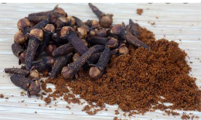

**Synonyms:** Caryophylius aromaticus, Eugenia aromatica.

**Parts used:** Clove (dried flower ud), leaf, stem

**Constituents:** Volatile oil, clove bud oil(15- 18%) containing eugenol (80- 90%), eugenol acetate (2- 27%), other include methyl salicylase, methyl eugenol, benzaldehyde

**Herbal use :** Clove has been traditionally used as a carminative, anti emetic, toothache remedy and counter irritant.

**2 Black paper**

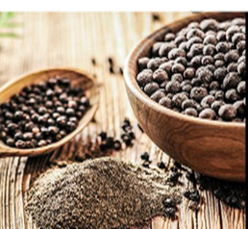

**Common name**: Black pepper, White pepper

**Parts used**: Fruit

**Chemical constituents :**

**Uses**: To improve digestion

**3 Liquorice**

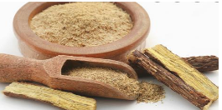

**Synonyms:** Glycyrrhiza glabra

**Part use:** Roots

**Uses:**

-Traditionally used in herbal medicine as an expectorant

- Used in herbal medicine to relieve inflammation of the gastrointestinal tract.

**4 Cinnamon**

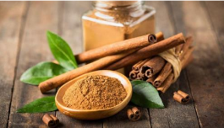

**Common name:** Ceylon cinnamon, true cinnamon

**Parts used:** Branch bark, Shoot bark

**Uses:** Used in bowel complaints such as dyspepsia, diarrhoea and vomiting

**4 Neem**

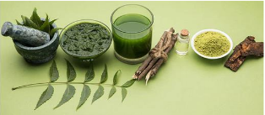

**Biological name:** Azadirachta indica A., Nimba, Nim, Nimb

**Morphology description:** A large evergreen tree, with long spreading branches forming a broad crown. The bark is Grey and rough, the leaves are alternate , the leaflets 8- 19, glossy and bluntly serrate, the flowers are white or pale yellow.

**Uses:** anti-inflammatory, anti-fungal and anti-aging. It also helps keep cancer at bay and is used as an aid in Yogic sadhana.

**5 Basil**

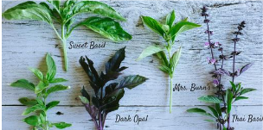

**Biological name**: Ocimum tenuiflorum.

**Common name**: Holy basil, Rama Tulsi, sacred basil, Tulsi

**Part used**: Leaf

**Uses: Anti-inflammatory**

**6 rock salt**

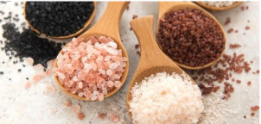

Naturally occurring rock salt was formed from the evaporation of inland seas. Its primary constituents are **sodium, chloride, calcium, magnesium, potassium, and sulfate**. Rock salt generally contains between 90 to 98% sodium chloride.

**Common name**: Halite

**Chemical formula:** NaCl

**Uses:** Table salt is essential for human life. A large amount of the commercially mined rock salt is prepared for human consumption.

**7 khair**

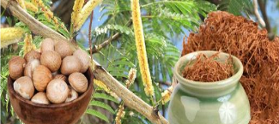

Khair is an herb and medium deciduous tree widely distributed in tropical countries. The leaves, shoots, and wood are used to make medicine. We are one of the renowned Ahmadabad based **Khair (Acacia catechu) Chal Powder Manufacturers**, Suppliers and Exporters in India at reliable prices. In foods and beverages, catechu is used as a flavouring agent.

**Uses:**

• Bleeding ,Injuries , Diarrhea

**8 Babul sal**

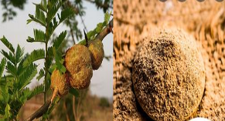

In the interiors and waterless regions, the Babul Tree is one of those very few trees that is able to find adequate nourishment and attains an average height of 5 m to 20 m. The Babul Tree is a slow growing species but is moderately long-lived and preferably grows in sandy or sterile regions, with the climate dry during the greater part of the year.

**Uses:**

**Tooth-Brushing**

The tender twig of the Babul Tree is used as a toothbrush in south-east Africa, Pakistan and India.

**Medicinal Uses**

The leaves, bark, gum and pods of the Babul Tree are used for medicinal purposes(8)

**9 Arjuna**

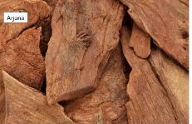

**Synonyms:** Terminalia arjuna, Sadad, Sajada, , Bilimatti, Neermatti,

**Source:** Plant Based

Arjuna also known as the “Arjun tree” is a widely grown tree in India. It has various medicinal properties like antioxidant, anti-inflammatory and antimicrobial.

Arjuna also helps control diarrhea, asthma and cough(9)

**Uses:** Strengthening the heart muscle and improving circulation

Managing cholesterol levels

**10 Ritha**

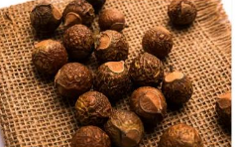

**Synonyms:** Sapindus mukorossi, Haithaguti, Ritha, Aritha, Dodan, Kanmar, Rithe, Thali

**Source:** Plant Based

Reetha or Soapnuts is also called as Arishtak in Ayurveda and “Soap nut tree” in India. It is well known for its traditional medicinal uses and is commonly used as a hair cleanser. Reetha is extensively used to make natural hair care products as it makes hair shiny, healthy and lustrous (10,11,12).

**Uses:** Reetha is used in Ayurveda and is an ingredient in cleansers and shampoos

**11 Triphala**

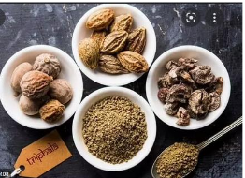

Triphala Churna is a powder, a combination of three fruits- haritaki, bibhitaki and amla. These fruits are dried thoroughly, powdered and mixed in the right proportions to make Triphala churn.

**Uses:** **cleanse the colon, smoothen the digestive system, and boost overall health**

**12 Lodhra**

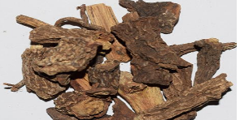

The Lodhra tree belongs to the genus *Symplocos.* It is widely used in various Ayurvedic medicines. *Symplocos* and its various species possess a wide range of metabolites with potential medicinal value against many different diseases.

**Chemical Constituents:** Lodhra comprises of loturine, loturidine, colloturine, flavonoids, tannins, salireposide, symplocoside, betasito-glycoside, symploveroside, and benzoylsalireposide

**Uses**: Antioxidant , Anti-acne, Anti-ulcer, Hypolipidemic

**13 Pudina**

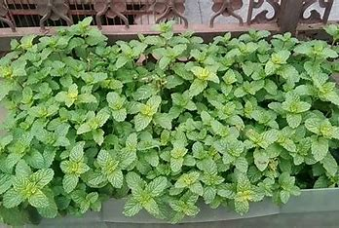

Pudina is the most popular kitchen herb in India along with coriander. The scientific name of Pudina is Mentha spicata subsp. spicata, and it belongs to family Lamiaceae (The mint family). Pudina is commonly known as Garden mint in English. While other mint varieties are high

maintenance, Pudina can be grown effortlessly in India

**Uses:** relieving digestive issues, soothing headaches, reducing inflammation, easing respiratory problems, and improving skin health.

**CONCLUSION**

The ingredients used in the present work, possess antibacterial effect and to maintain oral hygiene as it can be claimed by its results as effective toothpaste. Any herbal toothpaste is considered safe to use twice a day and it does not cause any harmful effects, instead imparts good freshness and away from bad odour. Oral hygiene can be maintained in a reliable, safe and inexpensive way by using herbal tooth pastes. In the former strategies, phytochemicals have been widely studied for their antimicrobial activity. A variety of plants with potent activity are known to be traditionally used for dental hygiene world-wide. The marketed formulation were evaluated as per WHO guidelines and as mentioned in Indian herbal pharmacopoeia. Tooth powder is a good to use that gently scrubs and beautifully polishes our teeth. With the effective work on all its parameters, this tooth powder can be explored for all its application and other hidden aspects

**REFERENCES**

1. Geethika, P. M., Amareswara, R. B. and Kameswararao, S., 2014. Antibacterial activity of Szygiumcumini in herbal tooth paste. International journal of inventions in pharmaceutical sciences, 2(3): 724-729.

2. <https://www.1mg.com/ayurveda/arjuna-10241>.

3. Balkrishnan A.Reetha.Ayurved Jadi Buti Rehsya. Danik Bhaskar.2017

4. Goyal S, Kumar D, Menaria G.Medicinal plants of the genus sapindus (sapindaceae) - a review of their botany, phytochemistry, biological activity and traditional uses.Journal of Drug Delivery & Therapeutics.2014:4(5);7-20

5. https://www.1mg.com/ayurveda/reetha-46

6. https://www.netmeds.com/health-library/post/triphala-an-ayurvedic-wonder-for detoxification-and-rejuvenation

7 Singh P, Singh R, Gupta LN, Kumar N. Lodhra-A Single Remedy For Different Ailments [Internet]. Vol. 6, International Journal of Pharmaceutical & Biological Archives. 2015. Available from: [www.ijpba.info](http://www.ijpba.info)

8 . Shashikiran ND. Pharmacognosy. Journal of Indian Society of Pedodontics and Preventive Dentistry. 2016;34(2):103–103. Available from: 10.4103/0970- 4388.180371

9 Rajasekaran Aiyalu, Arul Kumaran Govindarjan, Arivukkarasu Ramasamy; Formulation and evaluation of topical herbal gel for the treatment of arthritis in animal model; BJPS, Jul./Sep., 2016; 52(3)

10 . Roshan Telrandhe, Pawan Deshmukh, Mahendra Gunde; Formulation and evaluation of herbal toothpaste: compared with marketed preparation. IJPDA, 2017; 5(10): 406-410

11 Mealey BL, Rose LF. Diabetes mellitus and inϑlammatory periodontal diseases.Current Opinion in Endocrinology, Diabetes and Obesity.2008;15(2):135– 141. Available from: 10. 1097/med.0b013e3282f824b7

12 Martin A., Swarbrick J. and Cammarata A. Physical Pharmacy. 3rd ed., Varghese Publishing House, Bombay, 1991, pp.492-521.

13 Cikrikci S, Mozioglu E, Yilmaz H. Biological activity of curcuminoids isolated from curcuma longa. Rec Nat Prod 2008;2:19-24.

14 . <https://www.indianetzone.com/4/babul_tree.htm>

15 NC Mohire, AV Yadav, Chitosan-based polyherbal toothpaste: as novel oral hygiene product, Indian Journal of Dental Research, 2010; 21(3): 380-384. http://dx.doi.org/10.4103/0970- 9290.7080