AI BASED PLANT GROWTH PREDICTION USING LABVIEW AND MYRIO

# Dr.K.Gaayathry1, Deepthi Swarnaa M2, N.Anjali3

*1Assistant Professor, Department of Instrumentation and control engineering, Saranathan college of engineering, Trichy, India.*

*2Student, Department of Instrumentation and control engineering, Saranathan college of engineering,*

*Trichy, India.*

*3Student, Department of Instrumentation and control engineering, Saranathan college of engineering, Trichy, India.*

# ABSTRACT:

The Precision Agriculture using AI-based plant growth prediction project acquired by modern agriculture and artificial intelligence (AI) plays a crucial role in optimizing plant growth. This project focuses on the development of AI-based plant growth prediction systems using labVIEW and Myrio. The system integrates sensors to monitor environmental parameters such as temperature, air humidity, soil moisture, and water level. These actual data inputs are processed using algorithms for machine learning to predict plant growth patterns and propose optimal growth conditions.LabVIEW acts as the main interface for data collection, processing and visualization, while Myrio acts as a hardware controller, connects to sensors and performs AI based predictions.AI models are trained using historical systems growth data and environmental conditions, so they can be stored with real-time recommendations for irrigation and fertilization. The proposed system improves agricultural efficiency by reducing resource waste and improving yields. With real-time monitoring and predictive analytics, this AI-controlled approach provides farmers and researchers with intelligent decision-making tools.

**Keywords:** AI Plant Growth Prediction, LabVIEW, Myrio**,** Machine Learning, Precision Agriculture, Sensor Integration.

**INTRODUCTION:**

Traditional plant growth tracking methods regularly depend upon time-ingesting and erroneous manual observations and measurements. With improvements in artificial intelligence (AI) and embedded structures, shrewd agricultural solutions had been advanced to beautify efficiency and productivity. This venture makes a specialty of developing an AI-pushed plant increase prediction system the use of LabVIEW and NI Myrio. By means of integrating real-time sensor data with machine gaining knowledge of algorithms, the device can examine plant increase patterns and propose finest cultivation situations. Key environmental elements including temperature, humidity, soil moisture, and light intensity notably impact plant growth, and non-stop tracking allows information-pushed choices to enhance crop yield and performance. LabVIEW serves because the primary interface for statistics series, processing, and visualization, at the same time as Myrio functions as a hardware controller, integrating a couple of sensors to acquire actual-time facts. AI models, trained on historic environmental datasets,

offer predictive insights and actual-time hints for irrigation, lighting, and fertilization.

The proposed device targets to minimize useful resource wastage, maximize yields, and decorate precision agriculture generation. Through leveraging AI and automation, farmers and researchers can correctly optimized.

# 2. LITERATURE REVIEW:

1. Predicting Plant Growth from Time-Series Data Using Deep Learning, 2021. This study presents a deep learning approach to predict plant growth by generating segmentation masks of root and shoot systems based on time-series data. The method was tested on Arabidopsis and Brassica rapa plants, showing strong performance in matching expert annotations.

2. Using AI Approaches for Predicting Tomato Growth in Greenhouse Environments. Advances in Intelligent Systems and Computing, 2021. This research employs machine learning and deep learning techniques, including LSTM networks, to predict tomato yield and plant growth variations under different light treatments in greenhouse environments.

3. Using Deep Learning to Predict Plant Growth and Yield in Greenhouse Environments, 2019. This paper utilizes deep learning techniques, particularly LSTM networks, to predict plant growth and yield in greenhouse settings, focusing on tomato yield forecasting and Ficus benjamina stem growth.

4. AI-Based Plant Growing System with Real-time Sensor Data Analysis, 2021. This project integrates artificial intelligence and real-time sensor data analysis to optimize plant growth conditions. Machine learning algorithms interpret data from various sensors, providing insights into environmental parameters crucial for plant health.

5.Using AI To Predict Plant Growth, 2018. This article discusses an AI-based approach developed by researchers at Skoltech to predict plant growth, aiming to improve the efficiency of precision farming

6. Application of Artificial Intelligence in Greenhouse Control, 2018. This review explores the application of artificial intelligence techniques in greenhouse control systems, discussing various AI methods used to optimize plant growth environments.

7.Development of a Smart Irrigation System Using IoT and Machine Learning, 2020. This paper presents the development of a smart irrigation system that utilizes IoT devices and machine learning algorithms to predict soil moisture levels and optimize water usage for plant growth.

8.A Review on Applications of Machine Learning in Agricultural Crop Production Computers and Electronics in Agriculture, 2018. This review covers various applications of machine learning techniques in agricultural crop production, including plant growth prediction, yield estimation, and disease detection.

9.Design and Implementation of a Greenhouse Monitoring System Based on IoT and LabVIEW, International Journal of Computer Applications, 2019. This paper discusses the design of a greenhouse monitoring system that uses IoT sensors and LabVIEW for real-time data acquisition and control to optimize plant growth conditions.

10.Development of an Automated Hydroponic System Using LabVIEW, International Journal of Engineering Research and Technology, 2017. This study presents the development of an automated hydroponic system controlled using LabVIEW, aiming to enhance plant growth by monitoring and adjusting nutrient solutions.

# 3. MATERIAL AND EXPERIMENTAL STRUCTURE:

# This section outlines the hardware components, software tools, and experimental setup used to enhance the AI-based plant growth prediction system utilizing LabVIEW and NI MyRIO.The project combines hardware (sensors, controllers) and software (LabVIEW, AI models) for real-time plant growth prediction.The NI MyRIO is a compact embedded controller designed for real-time data acquisition and processing, making it ideal for applications requiring precise monitoring and control. Various sensors are integrated into the system to collect essential environmental data. A soil moisture sensor measures the water content in the soil to optimize irrigation, while a temperature and humidity sensor (LM35) monitors ambient conditions. Additionally, a water level sensor tracks the height of water within a plant, providing real-time data on its current level. To act upon the gathered data, actuators such as a cooling fan regulate greenhouse temperature based on sensor inputs, ensuring optimal plant growth conditions. A power supply unit provides the necessary power for MyRIO and the sensors, ensuring uninterrupted operation. The entire setup is housed within a plant growth chamber or greenhouse to create a controlled environment for testing plant growth under various conditions.

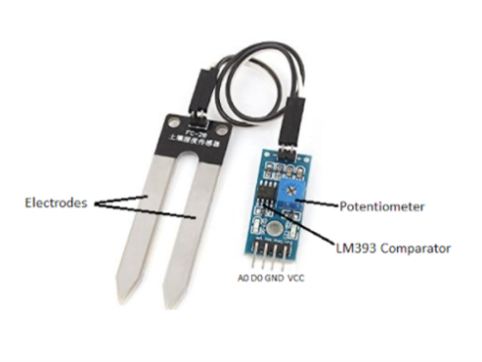

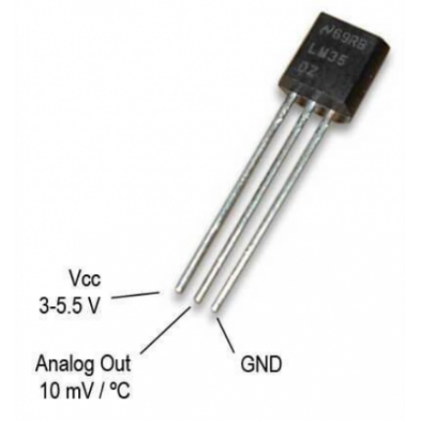 **Figure 1- Moisture Sensor**

**Figure 2- Temperature sensor (lm35)**

For software implementation, LabVIEW is used for real-time sensor data acquisition, visualization, and control. AI and machine learning models, trained using historical plant growth data, predict future growth trends, allowing for data-driven decision-making. Python plays a crucial role in AI model development and integration with LabVIEW, enabling advanced analytics. Additionally, MyRIO's FPGA configuration is utilized for real-time signal processing, ensuring automated decision-making for optimal plant growth conditions. This combination of hardware and software components creates an efficient and intelligent system for monitoring and optimizing plant growth.

### ****4. METHODOLOGY****

#### ****1. Data Acquisition****

The first step in the experimental setup involves real-time data acquisition from various environmental sensors that monitor key parameters influencing plant growth. These include a temperature and humidity sensor (DHT11 or LM35) to measure ambient conditions, a soil moisture sensor to assess the water content in the soil, and a water level sensor to track irrigation levels. These sensors are interfaced with **NI MyRIO**, an embedded controller capable of high-speed data acquisition and processing. The sensors provide continuous analog or digital signals, which are read by MyRIO through its input ports. The collected data is then transmitted to **LabVIEW**, a graphical programming environment that enables real-time data logging, visualization, and initial analysis. LabVIEW processes the sensor data, displaying real-time readings on the dashboard and storing them for further processing. Additionally, MyRIO can be programmed to trigger immediate control actions, such as turning on a cooling fan or adjusting irrigation levels, based on predefined thresholds. This ensures that the system maintains optimal plant growth conditions, even before AI-based predictions are applied.

#### ****2. Data Preprocessing****

Once the sensor data is collected in LabVIEW, it is transmitted to a **Python-based AI model** for further analysis using **serial communication** (USB, UART) or a **TCP/IP network**. Before the data can be fed into a machine learning algorithm, it undergoes a crucial preprocessing phase to enhance accuracy and reliability. The first step involves **handling missing values,** ensuring that sensor malfunctions or temporary disconnections do not compromise the dataset. Next, **normalization and scaling** techniques are applied to standardize the data, preventing any one feature (such as temperature) from dominating the model's learning process. Additionally, **feature selection** is performed to identify the most relevant parameters influencing plant growth, eliminating redundant or low-impact variables. The data is then split into training and testing sets, where historical sensor readings are used to train the AI model while new, unseen data is used for validation. This preprocessing step ensures that the dataset is clean, structured, and optimized for training an accurate predictive model.

#### ****3. Machine Learning Model Development****

To develop an AI-driven plant growth prediction system, a machine learning model is trained using **historical plant growth data** alongside real-time environmental conditions. The dataset consists of sensor readings collected over time, labeled with corresponding plant growth metrics such as leaf size, height, or overall health status. Several machine learning algorithms are explored to identify the best-performing model, including **Linear Regression, Decision Trees, Random Forest, and Neural Networks**. Linear Regression is used for simple trend analysis, while Decision Trees and Random Forest offer more complex pattern recognition capabilities by considering multiple environmental factors simultaneously.

Neural Networks, particularly deep learning models, can further enhance predictive accuracy by capturing nonlinear relationships between variables. The trained model is continuously evaluated using performance metrics such as **Mean Squared Error (MSE), Root Mean Squared Error (RMSE), and R-squared values** to ensure accurate predictions. The final model is selected based on its ability to generalize well to unseen data, providing reliable predictions for future plant growth trends.

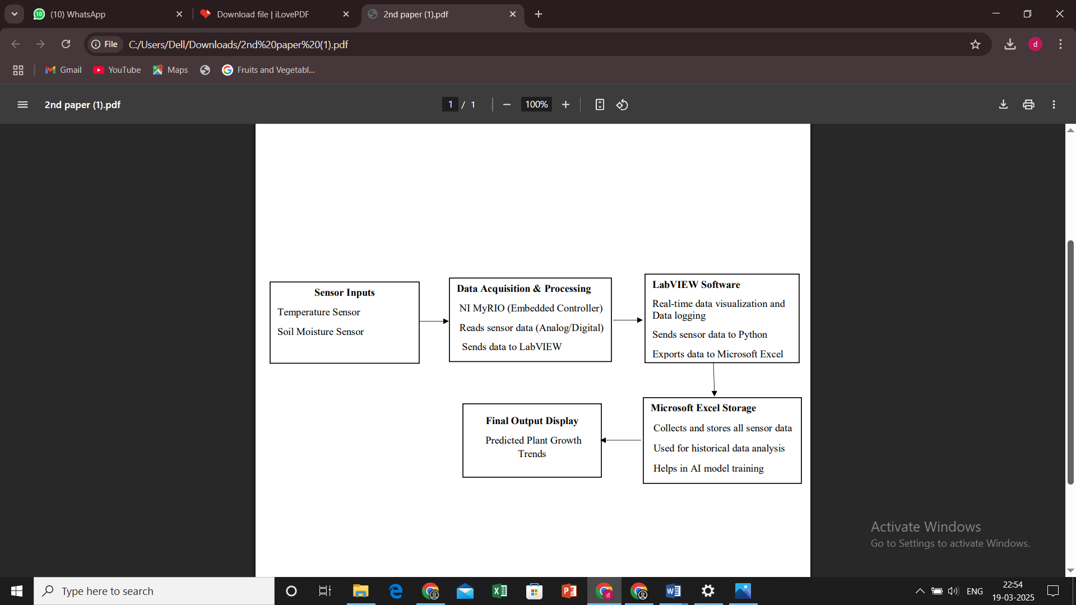

**Figure 3: Block Diagram**

#### ****4. Real-Time AI Integration with LabVIEW and MyRIO****

After successful training, the AI model is deployed into the **real-time monitoring system**, where it continuously processes live sensor data and generates predictions for plant growth. The real-time integration is achieved by setting up a **bidirectional communication link between LabVIEW and Python**, allowing the AI model to receive new sensor inputs and return predictions instantly. LabVIEW acts as the interface for visualization, displaying both raw sensor readings and AI-generated predictions in a user-friendly format. Additionally, the AI model’s predictions are used to trigger **automated control actions** in response to environmental changes. For example, if the model predicts that low soil moisture levels will negatively impact plant growth, LabVIEW can automatically instruct MyRIO to activate the irrigation system, ensuring timely watering. Similarly, when high temperature readings are detected, a cooling fan can be switched on to maintain an optimal greenhouse environment. To enhance real-time decision-making, **MyRIO's FPGA (Field-Programmable Gate Array) configuration** is utilized for high-speed signal processing, reducing response time and improving system efficiency. The AI model continues to learn and adapt as more real-time data becomes available, ensuring its predictions remain accurate and relevant over time.

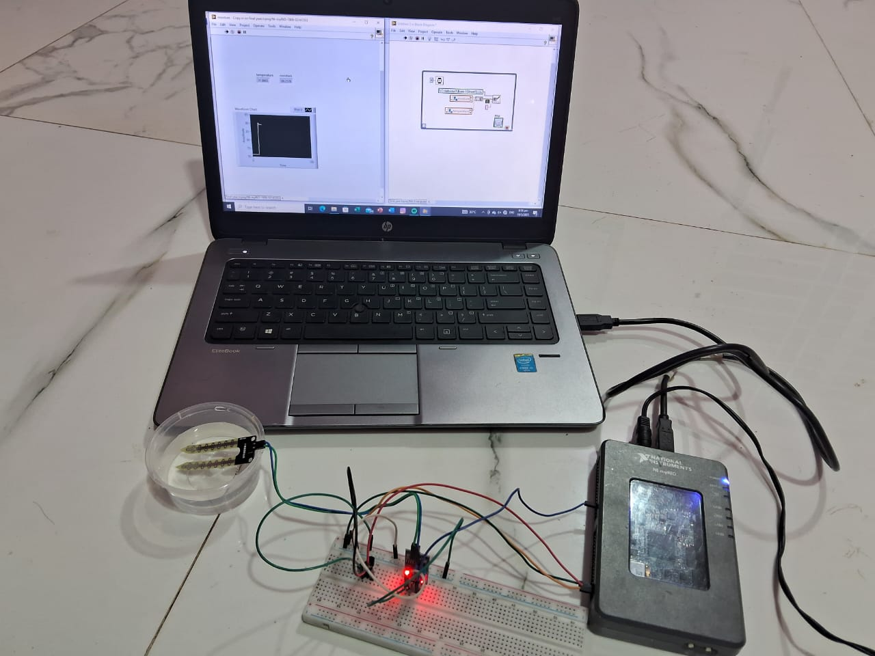

**Figure 4: Hardware Connection Diagram**

#### ****5. System Optimization and Validation****

The final phase involves **optimizing and validating the system** to ensure its effectiveness in predicting and improving plant growth. To validate the AI model’s accuracy, its predictions are compared against actual plant growth measurements recorded over a testing period. Any discrepancies between predicted and actual outcomes are analyzed, and the model is fine-tuned accordingly. Techniques such as **cross-validation** and **hyper parameter tuning** are applied to refine the model, improving its predictive capabilities. Additionally, performance metrics such as **Precision, Recall, F1-score, and Confusion Matrix** are used to evaluate classification models.

The system is further optimized by adjusting sensor placement, refining the AI model’s learning parameters, and improving MyRIO’s control logic. Long-term deployment trials are conducted in **controlled greenhouse environments** to assess how well the AI-driven system adapts to varying climate conditions. If necessary, additional sensors can be integrated to enhance the system’s capabilities. Ultimately, the validated and optimized AI-based plant growth prediction system provides a **highly efficient, data-driven approach** to precision agriculture, enabling farmers and researchers to **maximize plant yield and sustainability** while minimizing resource wastage.

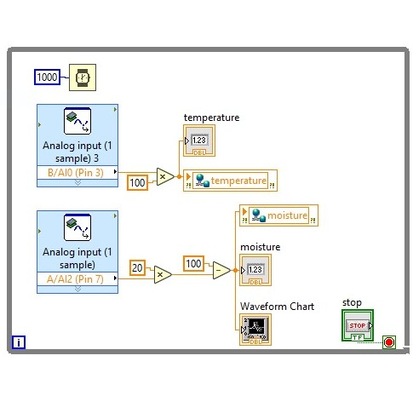

**Figure 5: labVIEW stimulation**

**6. Data logging into Excel using labVIEW.**

Data logging into Excel using LabVIEW is a crucial process for collecting and storing data from sensors, instruments, or user inputs for further analysis. LabVIEW provides built-in tools such as Write to Spreadsheet File.vi and the Report Generation Toolkit to facilitate seamless integration with Excel. Data can be acquired from various sources, which includes sensors and then processed before being logged.

The Write to Spreadsheet File.vi saves data in CSV format, making it easily accessible in Excel, while the Report Generation Toolkit enables direct writing to XLSX files with advanced formatting options.Once logged, the data can be analyzed, visualized, and interpreted in Excel to gain insights and make informed decisions.



**Figure 6: Data logging into excel**

# 5. CONCLUSION

The AI-based plant growth prediction system integrating NI MyRIO, LabVIEW, and Python-based machine learning provides an efficient and intelligent approach to precision agriculture. By leveraging real-time sensor inputs from humidity, temperature, and soil moisture sensors, the system continuously monitors environmental conditions and5. predicts plant growth trends using advanced AI models. The integration of LabVIEW ensures seamless data acquisition, visualization, and actuator control, while Python enables predictive analytics through machine learning algorithms. Real-time decision-making is further enhanced by MyRIO’s FPGA capabilities, allowing automated control actions to optimize plant growth conditions. Through continuous learning and adaptation, the system improves accuracy over time, enabling farmers and researchers to make data-driven decisions that enhance crop yield, reduce resource wastage, and promote sustainable agriculture. Ultimately, this innovative approach demonstrates the potential of AI and IoT in revolutionizing modern farming practices, paving the way for smarter and more efficient agricultural systems.

# 6 .REFERENCES

[1] Predicting Plant Growth from Time-Series Data Using Deep Learning. Robail Yasrab, Jincheng Zhang, Polina Smyth, Michael P. Pound,Remote Sensing, 2021.

[2] Using AI Approaches for Predicting Tomato Growth in Greenhouse Environments. Bashar Alhnaity, Simon Pearson, Georgios Leontidis, Stefanos Kollias, Advances in Intelligent Systems and Computing, 2021

[3] Using Deep Learning to Predict Plant Growth and Yield in Greenhouse Environments. Bashar Alhnaity, Simon Pearson, Georgios Leontidis, Stefanos Kollias, arXiv preprint arXiv:1907.00624, 2019

[4] AI-Based Plant Growing System with Real-time Sensor Data Analysis, Chidrupa, GitHub Repository, 2021

[5]Using AI To Predict Plant Growth, Adi Gaskell,The Horizons Tracker, 2018.

[6] Application of Artificial Intelligence in Greenhouse Control, Xiaoqian Zhang, Yu Jiang, Lihong Xu, et al. IFAC-PapersOnLine, 2018.

[7]Development of a Smart Irrigation System Using IoT and Machine Learning, R. K. Gupta, S. R. N. Reddy, Procedia Computer Science, 2020.

[8]A Review on Applications of Machine Learning in Agricultural Crop Production, S. Liakos, P. Busato, D. Moshou, et al. Computers and Electronics in Agriculture, 2018.

[9]Design and Implementation of a Greenhouse Monitoring System Based on IoT and LabVIEW, M. A. Mazidi, S. Saidi, International Journal of Computer Applications, 2019.

[10]Development of an Automated Hydroponic System Using LabVIEW A. Kumar, R. K. Singh, International Journal of Engineering Research and Technology, 2017.