**Artificial Intelligence in Healthcare: A study of consumer acceptance** Dr. Sakthi Kamal Nathan Sambasivam¹, Safi ullah Shaikh2, Dimple Aswani2, Nirjara Jain2, Umair Ahmed2, Keshav Sarda2,

1 Assistant Professor, Centre for Management Studies JAIN (Deemed-to-be University) and 2 BBA Students Centre for Management Studies JAIN (Deemed-to-be University)

# ABSTRACT

The perception and acceptance of AI in healthcare is a combination of several factors like optimism, uncertainty and ethical concerns.

While some individuals view AI as a helpful tool that increases accuracy, eases administrative framework and process, improves results,

Others express their concerns about data privacy, reduction of human interaction and touch, algorithmic bias and ethical concerns about medical decisions and human rights. Trust and acceptance in AI-assisted healthcare decisions and solutions are affected by factors like knowledge, exposure, experience and regulatory oversight.

As we see AI rapidly being integrated into the healthcare industry in this age, it is crucial to understand the public’s opinions to implement this idea completely. From encouraging acceptance, ensuring ethical implementation, and increasing AI’s potential to help human expertise rather than replacing it.

This perception extends to healthcare and medicinal experts, who play a crucial part in adoption before the general public. While doctors and experts recognise the efficiency and benefits of AI, some remain cautious about its limitations.

This research paper dwells into the complexity of integrating AI into healthcare and analysing the acceptance of such technology being implemented into an important and vital field like healthcare and interpreting the responses based on primary data collection in the form of a questionnaire.

The findings of this provide us with a better understanding granted by the age group of the sample size, in relation to their trust with Artificial Intelligence and Healthcare.

**Keywords**: Perception, scepticism, medicine, patient care, job displacement, ethical concerns,

data privacy, virtual assistants, medical decisions, AI and doctor collaboration, risks, trust issues,

1

transparency, policies, medical knowledge, medical research, integration in healthcare institutions and hospitals, acceptance, robotic surgery, diagnosis, treatment plans, AI vs. doctors, personalised medicine, affordability, monitoring, surgeries.

# INTRODUCTION

Artificial Intelligence (AI) in Healthcare, provides insight into the perception of consumers ranging from trust to scepticism.

On one side, a certain group of people per industry uses AI as an innovative tool that helps the

healthcare industry in areas like diagnosis, treatment and overall results of health. One of the key features that consumers value, is the ability of AI to process enormous data and reduce human error, resulting in the efficiency of the doctors.

Looking on the other hand, consumers also tend to seem sceptical, especially medical students and experts viewing it as a threat to their career, privacy and data concerns and biased AI algorithms.

The trust and understanding a consumer gives in, is affected by the individual’s exposure to AI knowledge and technology.

The very definition of Artificial Intelligence, tells us about the implementation of natural language, machine learning and deep learning techniques to improve the efficiency and effectiveness of the healthcare industry.

These characteristics are used in the detection of diseases or health conditions like cancer, a predictive analysis of the intensity of the problem, virtual health chatbots or assistants, and drug knowledge.

AI has seemed to make work easier by providing usefulness in automating appointments and routine administrative duties and thus giving healthcare experts and doctors more time and space to focus on patient care.

From this perception, we can say AI is unable to replace a doctor’s job completely, however, it is a necessary resource for improving the framework of achieving accuracy, efficiency and accessibility.

By giving access to AI for the automation duties,and reducing the workload of healthcare staff, AI has seen to improve itself in the operational efficiency of the healthcare333 industry. AI- powered platforms and virtual assistants are improving and increasing access to care, particularly in less developed places.

The questionnaire here is a direct access to the perception of AI in healthcare that individuals have. It gives insights to several important aspects like familiarity with AI, trust ready to be

2

given in AI- driven diagnoses, ethical concerns, data privacy, and willingness to accept and use AI- driven medical decisions.

The questionnaire gathers information on both the benefits and risks associated with AI in healthcare, this survey aims to interpret and understand the general public’s perception and opinion that could increase adoption of AI in healthcare

# REVIEW OF LITERATURE

### Opportunities and challenges of artificial intelligence in healthcare

Oksana Iliashenko, Zilia Bikkulova, Alissa Dubgorn Abstract

This research explores the current applications of Artificial Intelligence (AI) in healthcare. By examining various definitions and understanding AI as a machine's ability to mimic intelligent human behavior, the study aims to map the landscape of AI startups and classify existing AI systems within healthcare. The research methodology involves statistical observation through the analysis of current AI projects in the market. The findings of this study provide valuable insights into the opportunities and challenges associated with integrating AI technologies into healthcare practices.

### Application of artificial intelligence-based technologies in the healthcare industry:

DonHee Lee, Seong No Yoon

The study explores the application of AI in healthcare, highlighting its potential to improve patient diagnosis, treatment, nursing efficiency, and hospital management. While AI offers promising opportunities, challenges such as data privacy and ethical concerns need to be addressed for successful implementation.

### Artificial intelligence (AI) and internet of things (IoT) in healthcare:

Vaibhav Thakare, Gauri Khire, Manisha Kumbhar

The study explores the potential of AI-enabled IoT in healthcare, highlighting its ability to improve preventative public health services, patient engagement, and healthcare delivery. It also discusses challenges and opportunities for AI and IoT in the healthcare sector.

### Healthcare uses of artificial intelligence: Challenges and opportunities for growth

Eric Racine, Wren Boehlen,

This study explores the potential of AI in healthcare for tasks like imaging analysis and risk prediction. It highlights the benefits like faster diagnosis and lower costs, but also raises

3

ethical concerns like data privacy, transparency, and potential bias in AI algorithms. The authors propose addressing these challenges as opportunities for growth in healthcare organizations.

### Explainable AI for healthcare : opportunities and challenges

Deepti Saraswat, Pronaya Bhattacharya, Ashwin Verma, Vivek Kumar Prasad, Sudeep Tanwar, Gulshan Sharma, Pitshou N Bokoro, Ravi Sharma

This research explores the concept of Healthcare 5.0, which leverages AI, IoT, and big data for real-time patient monitoring and improved wellness. The study identifies challenges like lack of explainability in AI models as roadblocks to achieving Healthcare 5.0. It proposes Explainable AI (EXAI) as a solution to bring transparency and trust to AI-based healthcare applications. The authors even propose an architecture for implementing EXAI in medical imaging analysis and provide a case study for ECG monitoring.

### Application of artificial intelligence in the health care safety context: opportunities and challenges

Samer Ellahham, Nour Ellahham, Mecit Can Emre Simsekler

This study explores AI applications in healthcare, highlighting its potential to improve safety through better data analysis. However, challenges like safe design and clear protocols are crucial for ensuring responsible and safe implementation of AI in healthcare.

### Generative AI in medicine and healthcare: promises, opportunities and challenges

Peng Zhang, Maged N Kamel Boulos

The study explores the potential of Generative AI in medicine and healthcare, highlighting its applications and benefits. It also discusses challenges like trust, veracity, and ethical considerations. The study concludes that Generative AI will play an increasingly important role in healthcare as it evolves and regulations are established.

### Artificial Intelligence Applications in Medicine: A Rapid Overview of Current Paradigms

The study provides a brief overview of AI applications in medicine, highlighting its potential benefits for all stakeholders in the healthcare industry. It emphasizes the importance of understanding AI tools for medical practitioners and researchers to contribute to its development.

**The role of artificial intelligence in healthcare: a structured literature review** Ilvana Secinaro, Davide Calandra, Aurelio Secinaro, Vivek Muthurangu, Paolo Biancone The study explores the emerging field of AI in healthcare using a multi-disciplinary approach. It

highlights the potential applications in areas like diagnostics, patient data, and

4

decision-making. The study also identifies the US, China, and UK as leading contributors in AI healthcare research.

### Artificial intelligence in healthcare: Foundations, opportunities and challenges

Patrick Glauner

AI, the next industrial revolution, is rapidly transforming healthcare. It automates decision-making, improves patient care, reduces wait times and costs. This chapter introduces AI in healthcare, explores future opportunities, addresses challenges, and emphasizes the need for data literacy.

### A review of the role of artificial intelligence in healthcare

Secinaro, S., Calandra, D., Secinaro, A., Muthurangu, V., & Biancone, P. Artificial intelligence (AI) is gaining traction in healthcare, yet multidisciplinary research encompassing fields like accounting, business management, decision sciences, and health professions remains sparse.

This study employed a structured literature review protocol to analyze 288 peer-reviewed papers extracted from Scopus. Utilizing both qualitative and quantitative variables, the

researchers assessed authors, journals, keywords, and collaboration networks among scholars, enhanced by the Bibliometrix R software package.

### A review of the role of artificial intelligence in healthcare

Al Kuwaiti, A., Nazer, K., Al-Reedy, A., Al-Shehri, S., Al-Muhanna, A., Subbarayalu, A. V. Artificial intelligence (AI) is reshaping the healthcare sector, with applications in medical imaging, diagnostics, virtual care, and drug discovery. This literature review identifies emerging research trends focused on health services management, predictive medicine, and clinical decision-making. The United States, China, and the United Kingdom lead in published studies. Keyword analysis highlights AI's role in assisting physicians with diagnoses, disease predictions, and personalized treatment plans. However, challenges such as data quality and ethical considerations must be addressed for effective AI integration.Understanding these

dynamics will aid researchers and healthcare professionals in navigating future AI developments.

### The Role Of AI In Healthcare:Revolutionizing Patient Care And Well-Being

Rayhan, A., Rayhan, R., & Rayhan, S

Recent advancements in artificial intelligence (AI) are significantly transforming the healthcare industry, particularly in enhancing patient care and well-being. This article

examines AI's potential to revolutionize healthcare delivery through applications indiagnostic accuracy, precision medicine, drug discovery, and process automation. It also highlights ethical considerations essential for responsible and equitable AI deployment. By synthesizing

5

real-world case studies, the article showcases successful AI implementations in healthcare settings, providing insights for future advancements in the field.

### Revolutionising healthcare: the role of artificial intelligence in clinical practice Alowais,

S. A., Alghamdi, S. S., Alsuhebany, N., Alqahtani, T., Alshaya, A. I., Almohareb, S. N., ... & Albekairy, A. M.

Healthcare systems are complex, but artificial intelligence (AI) has the potential to improve patient care and quality of life. This review article provides an overview of AI's current

applications in clinical practice, including disease diagnosis, treatment recommendations, and patient engagement, while addressing ethical and legal challenges. By equipping healthcare

providers with essential knowledge, the study supports effective AI adoption in healthcare organizations. A comprehensive review of indexed literature from PubMed, Scopus, and EMBASE was conducted to explore the impact of AI in healthcare settings and its potential outcomes.

### Applications of Artificial Intelligence (AI) in healthcare: A review

Shaheen, M. Y

Artificial intelligence (AI) is transforming modern healthcare by enabling technologies that can predict, learn, and act across various applications, from uncovering genetic relationships to controlling surgical robots. This study focuses on three emerging areas of AI in healthcare: drug discovery, clinical trials, and patient care.Findings indicate that AI accelerates the drug discovery process for pharmaceutical companies and automates target identification, while also improving data monitoring efficiency. AI-assisted clinical trials manage large data volumes, yielding highly accurate results. Additionally, medical AI systems enhance patient care by analyzing medical data to provide insights that improve quality of life.

# VARIABLES

**Independent**: Includes the factors influencing a change in the dependent variables

1. Implementation of AI in healthcare.
2. the type of AI technology that will be used,
3. the level of data available and the quality for AI systems
4. Acceptance by the healthcare industry for AI, including health experts, infrastructure and training.

6

**Dependent**: The outcomes and effects of which arrive from the independent variables.

* 1. Faster and personalized patient outcomes
  2. Resistance to AI adoption
  3. The operational efficiency is improved in hospitals

**Intervening**: Factor that mediate the relationship between independent and dependent variables.

1. Ethical concerns and regulatory policy regulations AI implementation
2. Perception about the risk and credibility of AI systems among patients and clinicians.
3. Acceptability by training programs and institutions to improve staff competency in using AI tools.
4. General acceptance and perception towards AI- driven solutions and decisions.

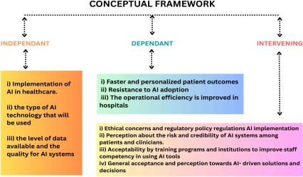

7

# OBJECTIVES

1. To understand the use of AI in customised medicine- Analysing how AI-driven models help in patient care and personalised treatment.
2. Analysis of AI applications improving planning, diagnostic precision, patient care in order to understand the impact of AI in healthcare outcomes.
3. To implement the integration of AI in clinical areas, examine how AI based solutions enhance decision making.
4. The study of data protection and privacy, algorithmic bias, and ethical problems with AI given solutions in order to know the problems and limitations of AI.
5. To evaluate potential of AI’s innovation in healthcare in future- Determining new trends and developments in AI that could be added in healthcare too for better results.
6. To evaluate how well AI can improve and enhance medical education and training of students.
7. To provide suggestions on methods of implementation of AI in healthcare.

# HYPOTHESIS

1. The diagnostic tools based on AI will be better at detecting diseases early and accurately than traditional methods, leading to better health outcomes for patients.
2. With the help of AI in hospitals and clinics, we can reduce the cost and help with reducing the waiting time. It is both cost effective and time efficient.
3. Problems like data privacy, algorithmic bias, and the lack of transparency will slow down the adoption of AI in healthcare.
4. AI tools will keep people interested with their treatment plan which will lead to better and improved health conditions.

8

1. AI will fasten the drug discovery process by finding drug targets and track the results more effectively.
2. AI models will help by providing understandable AI models which will gain trust of both doctors and patients.
3. AI will identify potential risks and will help avoid it or provide safety measures in the healthcare field.

# RESEARCH METHODOLOGY

**Primary Data**: The primary data used in this research paper is the survey conducted through forms sent through a sample size.

**Secondary Data**: In terms of secondary data, literature and articles relevant to the subject were studied and have been applied to the relevant fields to draw conclusions. These can be found in the Review of Literature and references.

**Sample Size**: A sample size of 25 respondents was utilised to conduct the research.

9

# DATA ANALYSIS AND INTERPRETATION

We can analyse the data in relation to the question and follow a simple format to analyse how the responses reflect in the research.

Question 1

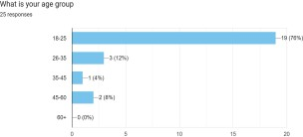

The majority of our respondents fall in the 18-25 age category. This skews the findings into a more acceptable or approachable sample size in terms of technology and AI being used in the medical fields.

Question 2

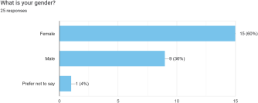

The majority of the sample size is female.

10

Question 3

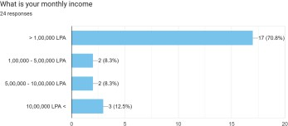

The monthly income can be indicative of the public and private sector divide in healthcare, especially that is evident in India and how the country has different expectations of services offered based on income, further establishing AI and its place in the sector based on trust.

Question 4

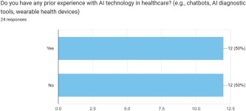

The split indicates the use of AI is growing and the market's full potential is yet to be explored. The indication being the mass production of easy to adapt gadgets and devices.

11

Question 5

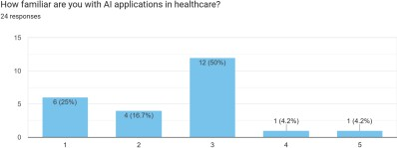

The familiarity of the respondents with AI can be seen through this- proving that while the familiarity is increasing the results are annotated more with the lower numbers on the scale.

Question 6

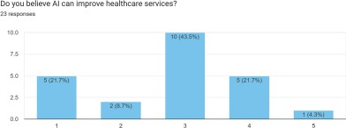

The belief in AI is at an average- While hopeful at one hand, there are still bigger doubts that can be shown through the 43% still choosing three at the scale.

12

Question 7

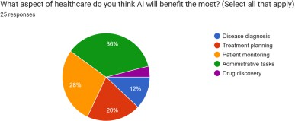

The majority believes that Administrative Tasks is where AI can be the most beneficial to the consumers- With surprisingly Drug Discovery being the lowest at 4%.

This is in correlation with people's trust in AI, as the most carefree tasks can be handed to AI in this belief and the most effective ones be in Patient Monitoring and Treatment Planning follow lead.

13

Question 8 8

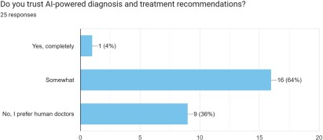

To sum up the trust followed through from the previous question- it is evident that the sample size while hopeful with 64% answering ‘somewhat’ the lead in absolute answers is taken by No with 36% believing only human doctors would suffice.

Question 9

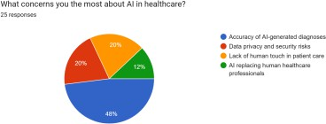

The biggest concern highlighted with 48% is the accuracy of AI models. Ironically the lowest answer with a replacement of human doctors was ranked least.

14

Question 10

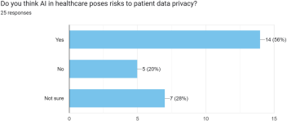

Data Privacy was the second biggest concern, hence the high response of Yes is an acceptable reading and can be assessed of the recent concerns with AI being used to record keep personal information.

Question 11

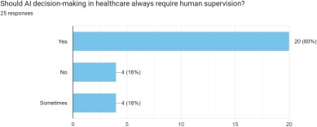

The reliability of human doctors and AI being at an high would benefit the trust of the consumers in the use of AI.

15

Question 12

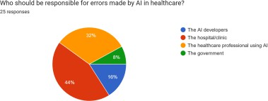

A

primary responsibility of errors can be rightfully be handed to the hospitals implementing AI and deservingly as different models need to be trained for different scenarios and hospitals would

have the complete control over which one they would chose- the only exception being policies made by the government, as represented being the lowest, also explains that AI would be implemented in a more capitalistic laissez faire method.

Question 13

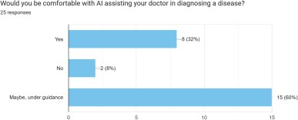

When asked the question directly influencing trust- it is established that the results are hopeful when some form of human intervention is brought into the equation.

16

Question 14

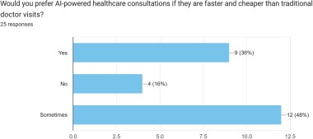

The

previous statements are further solidified by the introduction of price into the equation, when the high prices of healthcare are substituted by AI- people are more likely to rely upon it.

17

Question 15

Hence proves, all the questions leading up to the same conclusion that people would be more willing to accept AI in healthcare if supported with human intervention.

Question 16

As we had predicted, people are more hopeful in the way things are turning out to be and for a brighter

future with AI.

18

## Suggestions

The suggestions this research paper would like to present towards the industry and to oversee the impactful integration of AI in healthcare in regards and from context to the acceptance of people and the findings based on this study.

1. Educate the public and spread awareness

Can conduct workshops and webinars and include other online resources and teach people about how AI in healthcare works. Clear the misconception that people have regarding AI in the health sector.

1. Ensure data privacy and security

Make sure to keep the patient's data safe and give this the highest priority. Clearly communicate about how the data is handled and earn the trust of the patients.

1. Encourage doctor collaboration

Make sure that medical staff and doctors are trained how to use AI so that they get extra help and can make decisions quickly. AI should help them not replace them.

1. Affordable and accessible

Ensure that AI is available and accessible to everyone, even the poorer region. it can be done with the help of government, easy payment and partnerships.

1. Personalisation with AI

AI can be used to track and personalize every patient's unique need. AI can analyze how patients will react to certain treatments based on their personal data.

## Conclusion

This complex issue of integrating AI in healthcare provided with the aspects of optimism, uncertainty and ethical concerns gives us the concluding statement that consumer perception is mixed.

When analysing the factor of trust in terms of the consumers and AI- the acceptance aspect of the research comes into the picture- These are mostly influenced by the experience of the consumer, their knowledge about AI and extending from the trust in regulatory bodies to oversee the operation.

19

This research provides us insights into the role of healthcare professionals- Strictly based on consumer perception, experts should recognise the benefits of AI and work upon the limitations

and be cautious of errors.

This research provides insights into how different age groups understand and perceive AI in healthcare, which confirms targeted strategies for adoption.

AI provides enhancement and assistance in the healthcare industry with treatment, diagnosis, efficiency, effectiveness and accuracy.

## References

1. Iliashenko, O., Bikkulova, Z., & Dubgorn, A. (n.d.). Opportunities and challenges of artificial intelligence in healthcare. This study investigates the current applications of AI in healthcare, focusing on its ability to mimic intelligent human behavior. By analyzing AI startups and existing systems, it provides insights into the integration of AI technologies in healthcare practices.
2. Lee, D., & Yoon, S. N. (n.d.). Application of artificial intelligence-based technologies in the healthcare industry. This research highlights AI's potential to enhance patient diagnosis, treatment, nursing efficiency, and hospital management while addressing challenges like data privacy and ethical concerns.
3. Thakare, V., Khire, G., & Kumbhar, M. (n.d.). Artificial intelligence (AI) and internet of things (IoT) in healthcare. This study explores how AI-enabled IoT can improve public health services, patient engagement, and healthcare delivery while discussing related challenges and opportunities.
4. Racine, E., & Boehlen, W. (n.d.). Healthcare uses of artificial intelligence: Challenges and opportunities for growth. This research examines AI's role in imaging analysis and risk prediction, emphasizing benefits like faster diagnoses and cost reduction alongside ethical concerns such as data privacy and algorithmic bias.
5. Saraswat, D., Bhattacharya, P., Verma, A., Prasad, V. K., Tanwar, S., Sharma, G., Bokoro,

P. N., & Sharma, R. (n.d.). Explainable AI for healthcare: Opportunities and challenges. The study introduces Healthcare 5.0 and proposes Explainable AI (EXAI) to enhance transparency in medical applications like imaging analysis and real-time monitoring.

20

1. Ellahham, S., Ellahham, N., & Simsekler, M. C. E. (n.d.). Application of artificial intelligence in the health care safety context: Opportunities and challenges. This research

focuses on how AI improves safety through data analysis while emphasizing the need for safe design and clear protocols.

1. Zhang, P., & Boulos, M. N. K. (n.d.). Generative AI in medicine and healthcare: Promises, opportunities and challenges. The study discusses the applications of Generative AI in medicine while addressing issues like trustworthiness, veracity, and ethical considerations.
2. Secinaro, I., Calandra, D., Secinaro, A., Muthurangu, V., & Biancone, P. (n.d.). The role of artificial intelligence in healthcare: A structured literature review. This multidisciplinary study examines AI's applications in diagnostics and decision-making while identifying leading contributors to AI research globally.
3. Glauner, P. (n.d.). Artificial intelligence in healthcare: Foundations, opportunities and challenges. This chapter highlights how AI is transforming healthcare by automating decision-making processes to improve patient care while emphasizing the importance of data literacy.
4. Al Kuwaiti, A., Nazer, K., Al-Reedy, A., Al-Shehri, S., Al-Muhanna, A., & Subbarayalu,

A. V. (n.d.). A review of the role of artificial intelligence in healthcare. This review explores AI's impact on medical imaging, diagnostics, virtual care, and drug discovery while addressing challenges like data quality and ethical concerns.

1. Shaheen, M. Y. (n.d.). Applications of artificial intelligence (AI) in healthcare: A review. This study highlights how AI is transforming healthcare by enabling technologies for drug discovery, clinical trials, and patient care. It emphasizes AI's ability to accelerate pharmaceutical processes, automate target identification, and enhance patient care through data analysis.
2. Zhang, P., & Boulos, M. N. K. (n.d.). Artificial intelligence applications in medicine: A rapid overview of current paradigms. This research provides a concise overview of AI's impact on medicine, focusing on its benefits for stakeholders in the healthcare industry and the importance of understanding AI tools for advancing medical practices.
3. Alowais, S. A., Alghamdi, S. S., Alsuhebany, N., Alqahtani, T., Alshaya, A. I., Almohareb, S. N., & Albekairy, A. M. (n.d.). Revolutionizing healthcare: The role of artificial intelligence in clinical practice. This review examines AI's integration into

21

clinical settings for disease diagnosis, treatment recommendations, and patient engagement while addressing ethical and legal challenges.

1. Glauner, P. (n.d.). Artificial intelligence in healthcare: Foundations, opportunities, and challenges. This chapter explores how AI is revolutionizing healthcare by automating decision-making processes to improve patient care and reduce costs while emphasizing the need for data literacy.
2. Secinaro, I., Calandra, D., Secinaro, A., Muthurangu, V., & Biancone, P. (n.d.). A review of the role of artificial intelligence in healthcare. This literature review identifies global trends in AI healthcare research and highlights its applications in medical imaging, diagnostics, virtual care, and drug discovery while discussing challenges like data quality and ethical concerns.