**Microfinance - A Study of Allied Opportunities and Challenges**

**1Hrutuja Arun Takwale, 2 Dr. M. A. Dande**

1Student, Department Of Business Administration And Research, Shri Sant Gajanan Maharaj College Of Engineering Shegaon.

2Assistant professor, Department Of Business Administration And Research, Shri Sant Gajanan Maharaj College Of Engineering Shegaon.

**Email Id:** [1hrutujatakwale@gmail.com](mailto:1hrutujatakwale@gmail.com), 2 [F_3124006@ssgmce.ac.in](mailto:F_3124006@ssgmce.ac.in)

**Contact No:** 1 9307973739, 29423619555

**Abstract**

Microfinance is at the forefront of financial inclusion in providing basic financial services like small loans, savings, and insurance to excluded individuals and enterprises, particularly in developing nations. Starting from the innovation of Muhammad Yunus and the Grameen Bank in Bangladesh, microfinance has empowered poor people by supporting entrepreneurship, enhancing livelihoods, and alleviating poverty. Even though it has been successful, the microfinance industry is confronted with serious challenges, such as high interest rates, over-indebtedness, and sustainability of microfinance institutions (MFIs). The complexity of microfinance delivery is further compounded by differing regulatory environments and challenges in reaching the most vulnerable. This study examines the possibilities and challenges of microfinance, highlighting its potential as a driver of long-term economic growth, especially in supporting entrepreneurship, women empowerment, and rural development. Based on a comprehensive literature review, case studies, and empirical evidence, the dissertation evaluates how microfinance can be maximized to more effectively serve the needs of poor communities while reducing the challenges that undermine its sustainability. Maintaining a balance between offering opportunities and solving inherent challenges is key to ensuring the long-term sustainability of microfinance as an instrument of inclusive economic development.

**Keywords**

Microfinance, Financial Inclusion, Women Empowerment, Entrepreneurship, Microfinance Institutions (MFIs), Poverty Reduction, Economic Development, Small Loans, Over-indebtedness, Regulatory Challenges, Sustainable Development.

**Microfinance - A Study of Allied Opportunities and Challenges**

**Introduction**

Microfinance refers to the delivery of a range of basic financial services, including small loans, savings, insurance, and other related products, to people and businesses not served by the formal financial sector. The financial model usually focuses on the low-income group, mainly in developing countries, to empower these people in an attempt to improve their economic condition, promote entrepreneurship, and eradicate poverty. The concept of microfinance gained a global audience through the efforts of Nobel Laureate Muhammad Yunus and Grameen Bank in Bangladesh, focusing on how tiny loans can alter the lives of the marginalized. Over the years, microfinance has evolved to become an essential tool for pushing financial inclusion, giving subordinated groups access to credit, building assets, and therefore generating greater income.

Challenges in the Microfinance Sector However, the microfinance sector also poses significant challenges. High interest rates, over-indebtedness, and the sustainability of microfinance institutions (MFIs) have cast a shadow over its effectiveness in poverty reduction. Furthermore, microfinance delivery is more complex in light of the variance in countries' regulatory environments as well as the challenge that trying to reach the most in need presents. This dissertation reviews and analyses the opportunities as well as the challenges in microfinance based on literature, case studies, and their empirical analysis of how microfinance can be optimized to be more responsive to the needs of low-income people while creating better responses to its challenges. Small-loan lending, as well as provision of other financial services, has become a catalysing impetus in the promotion of economic development, especially in developing economies. It provides possibilities to resource-poor groups for access to credit, savings, and insurance opportunities that the formal banking system does not provide.

Microfinance provides myriad other allied opportunities in addition to the overall objective of financial inclusion in enhancing entrepreneurship, women's empowerment, and rural development. However, issues of high interest rates, over-indebtedness, and sustainability of MFIs present major challenges. This dissertation looks into allied opportunities and challenges that exist among microfinance clients with the aim of assessing whether microfinance can be a catalyst in long-term economic upliftment. Microfinance has developed as one of the critical instruments of financial inclusion. It is being advanced as microcredits and other fundamental banking services for those individuals who are either excluded or incapable of accessing the regular and traditional banking systems. It has evolved as an important instrument in raising living standards by promoting entrepreneurship for poor people. Millions have been able to access full-access credit, savings, insurance, and training operations mainly in developing countries through MFIs.

In sum, microfinance offers great opportunities like fostering entrepreneurship, supporting women's involvement in the economy, and boosting the growth of local economies. However, it also brings formidable challenges like sustainability to MFIs, high interest rates for clients, and dangers of over-indebtedness among borrowers. Long-term sustainability of microfinance as a tool of development becomes important if it strikes the right balance between providing opportunities and mitigating the challenges. There are sets of issues equally at the client level and related with the ability of microfinance to contribute toward more inclusive forms of economic growth, arising when discussing the opportunities and challenges with microfinance.

**Literature Review**

1. **Yunus, M. (2003) and Grameen Bank Model:** the work of Muhammad Yunus had been quite instrumental in placing microfinance at the forefront of poverty alleviation tool entities, especially after the success of Grameen Bank in Bangladesh. Yunus in explaining relates that microfinance provides a role by enhancing the chances that their assets grow, exposing them less vulnerability in an otherwise adverse environment for their capacity to stand in negotiating their interest rate with lenders.
2. **Khandker, S.R. (1998):** "Fighting Poverty with Microcredit: Experience in Bangladesh," where he analyzed the impact of microfinance on poverty and income inequality; concluding it has an important role in lifting household income and general well-being.
3. **Armendáriz, B and Morduch, J. (2010):** Speaks to the rationale of microfinance in "The Economics of Microfinance," where the authors argued how microfinance assists women entrepreneurship through the provision of credit that is not available in many traditional banking systems, hence enabling women in many developing nations.
4. **Mayoux, L. (2002):** In her study "Microfinance and Women's Empowerment: Rethinking 'Best Practice,' " Mayoux stresses how, although microfinance itself has the potential to empower women, it really only does if programs are designed and delivered in a powerful way.
5. **Hermes, N. and Lensink, R. (2011):** In "Microfinance: Its Impact, Outreach, and Sustainability," the authors state that microfinance impacts not only individual economic development but also more widely social development through encouraging entrepreneurship and promoting better living standards in low income communities.
6. **Hulme, D. and Mosley, P. (1996):** Finance Against Poverty: Authors discuss the impact of microfinance in combating poverty while advocating differentiated strategies with regard to differences in local contexts. The authors further argue that whereas it might be possible through microfinance to help alleviate the economic circumstances of the poor, it was well-designed to avoid their debt trap.
7. **Ledgerwood, J. (1999):** Microfinance Handbook: An Institutional and Financial Perspective presents a holistic approach that would be useful for practitioners to know how microfinance institutions (MFIs) can be structured to take into consideration both financial sustainability and outreach to the poor. The operations and financial and institutional challenges facing MFIs are covered.
8. **Weis, J. and Montgomery, H. (2005):** In the paper, Microfinance and Poverty Reduction: What is the Evidence?, the authors analyze the empirical research concerning the effectiveness of microfinance interventions on poverty reduction and economic growth. Indeed, according to the authors, even though microfinance positively contributes to processes of poverty reduction, such applications often have mixed outcomes for ultra poor.
9. **Banerjee, A., Karlan, D., and Zinman, J. (2015):** In the study Six Randomized Evaluations of Microcredit: Introduction and Further Steps, the authors examine whether microcredit influences incomes, consumption, poverty, and its other effects across a number of countries by the application of randomized control trials. They report that, although microcredit has some effects on business formation, its impacts on incomes and consumption and even poverty are usually quite modest.
10. **Schreiner, M. and Colombet, H. H. (2001):** In Microfinance, Regulation, and the Poor, Schreiner and Colombet discuss some of the challenges that MFIs face in terms of regulation and the need to create frameworks that balance the protection of consumers with the mandates that allow MFIs to reach the underserved.
11. **Goetz, A. M. and Gupta, R.S. (1996):** Their article "Who Takes the Credit? Gender, Power, and Control Over Loan Use in Rural Credit Programs in Bangladesh," published in World Development argues that microcredit initiatives sometimes bring about unintended impacts on women empowerment through loans controlled by their male household members and thus restraint over their choices and agency.
12. **Swain, R. B., and Wallentin, F.Y. (2009): "**Does Microfinance Empower Women? Evidence from Self-Help Groups in India", International Review of Applied Economics; the findings show that women participating in microfinance report a higher level of empowerment, depending significantly on the structure of microfinance programs and community support.
13. **Morduch, J. and Haley, B. (2002):** "Analysis of the Effects of Microfinance on Poverty Reduction." This paper is a critical analysis of microfinance institutions (MFIs) and their impact on poverty reduction, especially in rural areas. Morduch and Haley analyze socio-economic impacts and limitations of microfinance in truly changing lives, discussing pitfalls to avoid and improving designs for MFIs.
14. **Karim, L. (2011):** "Microfinance and Its Discontents: Women in Debt in Bangladesh." This book critically engages with microfinance via a gendered perspective that sheds light on its normally ignored effects on Bangladeshi women. The author unpacks ethnographic studies of the ways in which debt and microcredit programs can have complex and, at times, adverse impacts on women's social and economic standing.
15. **Lensink, R. and Pham, T.T.T. (2012):** "The Impact of Microcredit on Self Employment Profits in Vietnam." In this study, the impact of microcredit is analyzed concerning business and self-employment profits in Vietnam. On the whole, it would be concerning both sides of impact and contrasts the fact that without complementary training of business skills, microcredit can neither generate neither constant positive results.
16. **Honohan, P. (2004):** "Financial Sector Policy and the Poor: Selected Findings and Issues." In the paper, the policies of financial inclusion which affect the poor were presented in focus on microfinance. The author investigates the tough issues in providing financial services in poor regions in respect of danger of over-indebtedness and market distortions.
17. **Banerjee, A.V., and Duflo, E. 2011:** "Poor Economics: A Radical Rethinking of the Way to Fight Global Poverty." In multiple case studies, Banerjee and Duflo vindicate an intuitive intuitive perspective on how financial interventions like microfinance can only be successful under certain circumstances only.
18. **Hassan, M.K. and Sanchez, B. (2009**): "Efficiency Analysis of Microfinance Institutions in Developing Countries." In this study, the paper aims to undertake an examination of the operational efficiency of MFIs while also examining their ability to balance social missions with the financial sustainability element. In this regard, the authors consider MFIs in different countries to determine the factors that would result in successful outreach without compromising quality.

**Research Methodology:**

**Objectives:**

* To analyze the opportunities for microfinance in fostering financial inclusion.
* To explore the challenges faced by microfinance institutions (MFIs) in reaching and serving low-income clients.
* To assess DFS usage in widening microfinance outreach and operational efficiency
* To assess the effects of competition from commercial banks on the viability of microfinance institutions
* To analyze the credit risk management practice of microfinance and its relevance to sustainability
* To suggest pragmatic recommendations for overcoming the key challenges in the microfinance sector through findings.

**Data Collection Method :**

• **Primary Method of Data Collection:** Structured Questionnaire was used to collect primary data.

• **Secondary Data Collection:** Books, Journals, reports, magazines, websites were used to collect secondary data.

• **Population and Sampling Population:** The total population of the microfinance recipients and other stakeholders in the geographic area under study. These can include women entrepreneurs, rural communities or some specific regions.

**Guidelines for Sample Size**

* Small Scale Study (Local, Focused Group): 50-100 participants. Best for qualitative approach: focus groups, interviews, case studies.
* Medium Scale Study (Regional or City-based Study): 200-500 participants. Best for quantitative survey involving both borrowers and microfinance institutions.
* Large Scale Study (National or Multi-Region Study): 500-1000+ participants. Best for those who want to capture broader patterns across diverse groups.

**Sampling Techniques**: Simple random sampling

**Collection of data through**: Google forms

**Hypothesis :**

* **Null Hypothesis (H₀):**

Access to microfinance does not have a material impact on the economic empowerment and business development of women entrepreneurs in the study location.

* **Alternative Hypothesis (H₁):**

Access to microfinance has a material impact on the economic empowerment and business development of women entrepreneurs in the study location.

The following charts visualize the impact of **Microfinance - A Study of Allied Opportunities and Challenges** based on survey responses.

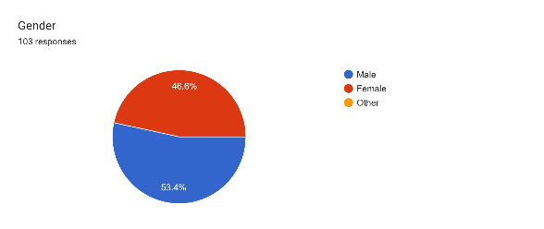

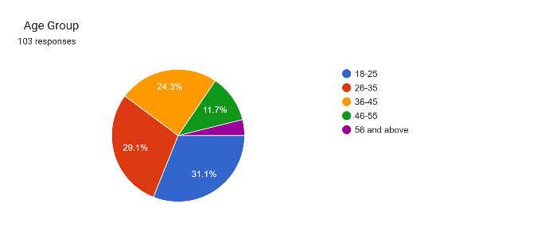

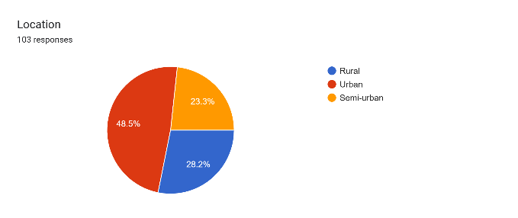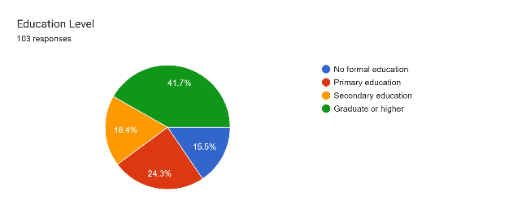

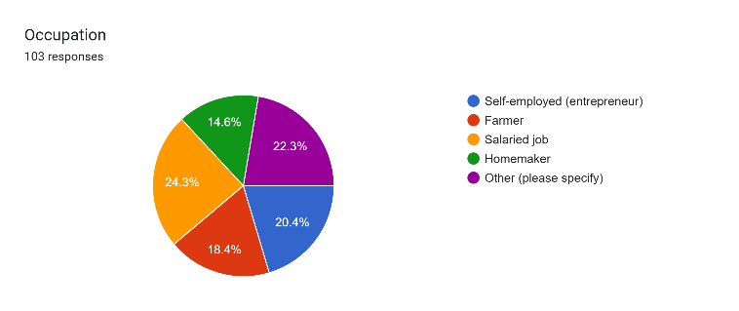

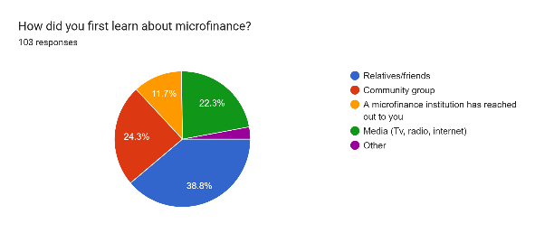

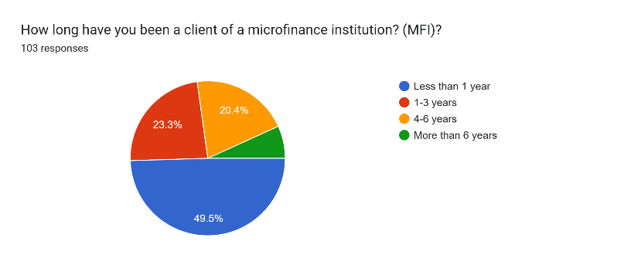

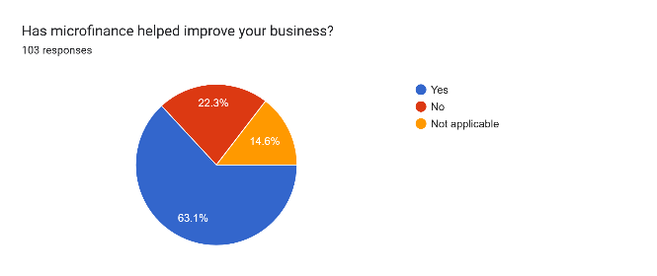

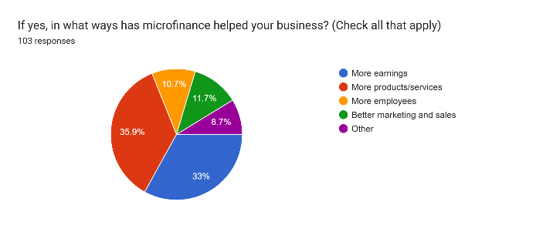

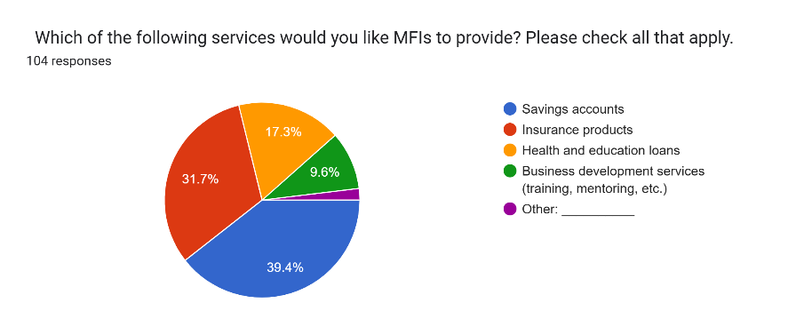

**Conclusion**

Microfinance has proven to be an effective instrument in extending financial inclusion, supporting entrepreneurship, and improving the lives of marginalized groups, especially in developing nations. Microfinance has provided millions with access to tiny loans, savings, insurance, and other basic financial services that have enabled them to access the formal financial system. Microfinance has made a considerable contribution to increasing the involvement of women in economic life as well as supporting local economies. Yet, even with these opportunities, the industry is not without its challenges. High costs of borrowing, over-borrowing, and the viability of microfinance institutions (MFIs) call into question the long-term impact of microfinance on poverty reduction. Regulatory issues country by country also complicate the provision of microfinance services, preventing access to those most in need.

For microfinance to remain a driver of sustainable economic growth, there must be a balance between deepening financial inclusion and minimizing the underlying risks of the sector. Combating these issues with innovative models, improved regulatory regimes, and client-focused methodologies can maximize the reach of microfinance, keeping it a working and effective solution for long-term economic development.

**Suggestions**

* Regulatory Barriers and Women's Access to Microfinance – Examine how various regulations influence women entrepreneurs' access to financial services.
* Evaluating the Efficiency of Digital Microfinance Models for Women Entrepreneurs – Discuss how technology can minimize barriers and enhance financial inclusion.
* Sustainability and Inclusion: How MFIs Can Balance Profitability and Outreach – Examine how MFIs can be financially sustainable while reaching marginalized communities.
* Mitigating Over-Indebtedness among Women Borrowers in Microfinance – Discuss causes and implications of over-borrowing and recommend risk reduction strategies.
* Role of Financial Literacy in Increasing the Impact of Microfinance on Women Entrepreneurs – Research the potential for improving borrowing and repayment behavior through financial education.

**Bibliography**

* **Khandelwal, R. S. (2019).** Opportunities and Challenges Faced by Microfinance Institutions in India: Analysing their Impact on Poverty Alleviation and Economic Development. Indian Journal of Economics and Development.
* **Patel, A., & Sharma, S. (2020).** Microfinance and Rural Development in India: Benefits and Obstacles of Microfinance Programs. Journal of Rural Development.
* **Gupta, M., & Verma, S. (2018).** Impact of Microfinance on Women’s Empowerment in India: Opportunities and Limitations. International Journal of Gender and Development.
* **Joshi, P., & Agarwal, N. (2021).** Challenges and Prospects of the Microfinance Sector in India: A Comprehensive Review of Regulatory, Operational, and Social Issues. Indian Journal of Finance.
* **Armendáriz, B., & Morduch, J. (2010).** The Economics of Microfinance (2nd ed.). Cambridge, MA: MIT Press.
* **Helms, B. (2006).** Access for All: Building Inclusive Financial Systems. Washington, D.C.: World Bank Publications.