**Influencers shaping brand perception through social media marketing in skincare industry**

Authors:

1Mr. Sunil Hegde

2Palak Agarwal, 3Shivam Malla, 4Devansh Saraogi 5Darshan Balgaonkar ⁶U Yashwanth

1Assistant Professor, Jain (Deemed-to-be University) – Center for Management Studies - Bangalore, India

23456Students, Jain (Deemed-to-be University) - Center for Management Studies - Bangalore, India

Abstract:  
  
The social media revolution has totally transformed the way customers engage with beauty brands, away from conventional advertising to more experiential and personal content by influencers. Whether dermatologists or skincare aficionados, these influencers talk about their experience, product picks, and morning routines in their own lingo, to the joy of their followers. They have thereby become a sort of establishment that provides credible information, shaping consumer attitudes and shopping habits.

This research investigates the influence of influencer marketing on consumer trust and brand image in the skin care market. In accordance with the responses received, the study revealed that a large majority (88.3%) of the participants are between 18–24 years old, and 65% of the total are female. Further, 75% of the participants possess an undergraduate degree, and 63% earn below ₹50,000 per month. Whereas looking at skin care practices, 46.7% is multi-step and 45% do not spend more than ₹1,000 per month on skincare. Social media is also observed to be one among the product discoverability and buying behavior drivers and 61.7% respondents confessed that their buying behavior gets influenced by posts from influencers. Platforms such as Instagram, TikTok, and YouTube are also used very effectively to engage in conversations with audiences via tutorials, product demonstration, and interactive content.

With influencer marketing increasing, brands have to perfect their art of building trust, engaging, and cultivating brand loyalty. Through this study, readers are provided with insight into what people think influencer marketing is, enabling brands to reach deeper into what drives trust and buying behavior in the modern digital age.

**Keywords**- Influencer marketing, skin care industry, brand credibility, social media, brand loyalty

**Introduction:**

Social media has drastically changed how people find and engage with skin care brands. Unlike the traditional advertising - scripted and commercial - with social media influencers, an individualized and very genuine form of advertising has taken off. The influencer can be a skin care professional, a dermatologist, or someone who enjoys skin care, but each offers some insight about their personal experiences, recommendations, and routines around skin care through what feels like a personal voice. As a result, they have positioned themselves as trusted voices in their field, changing how consumers view brands and products.

It is perhaps the most important reason that influencers can be so influential, by earning trust from their followers. People are more likely to accept recommendations from someone with whom they see and interact on a regular basis, especially when that person is providing genuine reviews or discussing their past experiences. Many skincare brands recognized this shift and ended the relationship and began creating a relationship with influencers, creating content that feels almost natural or not too overtly sponsored. Be it a product demo, a tutorial on a skincare routine, or a more casual live question and answer session, influencers continue to provide the most accessible means of bridging the gap, connecting shoppers with brands, while making skincare feel more personal and less complicated.

Social media outlets like Instagram, TikTok, and YouTube are making it easier than ever for influencers to engage their followers in a captivating way. Short videos, before-and-after results, and interactive content allow shoppers to see actual results before making a decision to purchase. This form of interactive marketing has reshaped the skincare brand marketplace, allowing for brands to reach bigger audiences, and have trustworthiness that traditional marketing can’t achieve.

The focus of this research is to investigate the role of influencers on consumer perceptions of skincare brands based on feedback we gathered as part of this research. Understanding how people evaluate influencer marketing will provide a more accurate assessment of influencer marketing, when it pertains to trust, sales and brand loyalty. The skincare market will not stop growing and it is clear that influencers will play a role in establishing trends and driving consumer decisions.

**Objectives:**

1) To examine the impact of social media influencers on consumers' perceptions and trust in skin care brands.

2) To investigate how influencer marketing stacks up against traditional advertising in the skin care products space.

3) To assess how consumers interact with influencer-generated content and the effect it has on their purchasing behavior.

4)To identify and examine the factors that contribute to influencer marketing and their effectiveness such as authenticity, credibility, and style of content.

5)To provide guidance to skincare brands in improving their use of influencer marketing through consumer perception and brand loyalty.

**Review of Literature:**

Hanadi Salhab (August 2024) Influencer marketing remains one of the most influential strategies in marketing, particularly in attitudes towards brands and consumer engagement on social media. Several studies have assessed the social media influencer's role in consumer trust, consumption behavior, and brand loyalty. Jordanian local brand study research findings in support of influencer marketing being an important factor for positive attitudes towards brands and trust building is confirmed by the qualitative questionnaire and interview study on consumer attitudes of buying behavior.

Kaedio Potter, Favour Olaoye (October 2024) Local Jordanian brands verify that social presence would be the mediator in effecting this. Herman Aditya (July 2024) Simultaneously, Indonesian research on brand management emphasizes the key role of influencers in generating brand awareness and customer loyalty, and therefore, corporations engage micro-influencers and invest in socially responsible educational efforts. Anber Shlash (June 2024) A Jordanian consumer behavior case study emphasizes the key role cultural congruence plays in influencer marketing, revealing how culturally congruent influencers exert the heavy influence of establishing brand trust and credibility. Priya N. Rakate (September 2024) A 15 years and above internet purchaser survey that identifies some of the most prevailing determinants through product description, seller service, site security, and convenience and thereby illuminates how e-commerce and social media marketing strategy can be maximized. Wenxi Wu (August 2024) An example of this is that of French fashion brand Jacquemus of effective social media promotion—via brand image, creative visual, and celebrity influencer endorsement—to achieve significant revenue growth. Barbara Olga Antczak (June 2024) Organic marketing actions like product reviews, social media, email marketing, and influencer marketing are of utmost importance in driving customer buying behaviors via the creation of relationships between consumers and brands. Jingjing Wang (July 2024) A review of social media marketing policy of ZARA in China illustrates that despite as much as the company bankrolls on popularity of Weibo and Little Red Book, its bases can be made stronger with live streaming campaigns as well as influence collaboration. Jiayin Cao (June 2024) Moreover, using user interaction, advertisement effectiveness, and customer satisfaction as performance measures to gauge social media marketing success allows businesses to refine their campaigns and receive increased returns on investments. Tasnimul Arefin (September 2024) Social media influencers are also responsible for playing varied roles in carrying out current marketing that affect brand participation and consumer behaviors based on their perceived credibility and relatability. Influencers have the greatest influence with experience and trust power to drive consumer decision-making and build brand awareness. Hira Zaidi and Asif Ali Syed (April 2023) Indian businesses' transition from traditional celebrity endorsement to social media influencer (SMI) marketing had an impact on consumers' purchase intention towards brands. Kaledio Potter and Favour Olaoye (July 2024) Empirical research indicates that if followers are organically endorsing a product, their supporters will likely build trust in the brand, leading to positive attitudes and consumption behavior. Morgan Glucksman (December 2017) A case study of Lucie Fink, a lifestyle influencer, proposes that people's lives as represented through her experiences and unique content actually make a difference and affect the perception of brands. Sweeney, K. (June 2018) Similarly, luxury brand promotion studies and Instagram influencer studies also support that influencer endorsements create considerable brand image, induce desire, and enhance purchase intentions. Richardson A (September 2024) Comparative research comparing user-generated content with influencer-generated content also compares their differing impacts on consumer attitudes, thereby providing marketers' strategic implications. Jun-Hwa Cheah (December 2017) Another research into the persuasiveness, attractiveness, and credibility of the influencer indicates that they are excellent predictors of influencer marketing-consumer purchase behavior. Crystal Abidin (August 2016) Fashion influencer activities on Instagram, using #OOTD advertorial campaigns, is an example of how these participants positively create content to make brands more prominent.

Nils S. Borchers (September 2019) The credibility that influencers attain is significant in building the consumer's trust as authentic endorsements boost brand communication power. Deeya David (December 2020) Further studies on influencer specialization and engagement confirm these players as good predictors in brand loyalty development and authentication of consumer attitudes towards brands. Darshana T Jayasinghe (March 2021) Increased usage of social media platforms such as Instagram, TikTok, and YouTube has transformed marketing, with influencer marketing taking the lead in the buying behavior of consumers.

As influencer marketing dynamics continue to shift, there is a pressing need for companies to leverage data insights in informing best influencer partnerships and driving maximum brand engagement.

**Research Gap:**

Current literature does not provide a narrow examination of the role of influencers in fashioning brand thinking and the skincare space, where trust and authenticity are particularly important. There is also a lack of research on influencer type and platform type in the skincare space. Additionally, comparative research between influencer marketing and traditional advertising is limited in the skincare space, and lacks depth. The purpose of this study is to fill some of the voids of influencer credibility, trust, and engagement of the consumer.

**Research Methodology-**

**Primary data:**

A standardised Google Forms survey was created and sent to a large audience in order to learn how consumers view brand perception from the eyes of influencers. The main instrument for collecting data was this survey, which made it possible to compile a variety of consumer insights from the skincare industry.

**Secondary data:**

This study uses secondary research through Research papers and academic publications, market studies and industry reports from companies in addition to primary data collecting to give a more comprehensive picture of how consumers view brand perception through influencers.

**Sample-**

The sample size is determined as 60 respondents' opinions on brand perception through influencers.

**Instrument-**

To analyse the data percentage analysis method was applied.

**Data analysis and interpretations:**

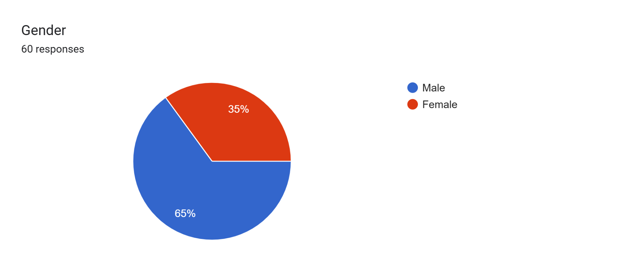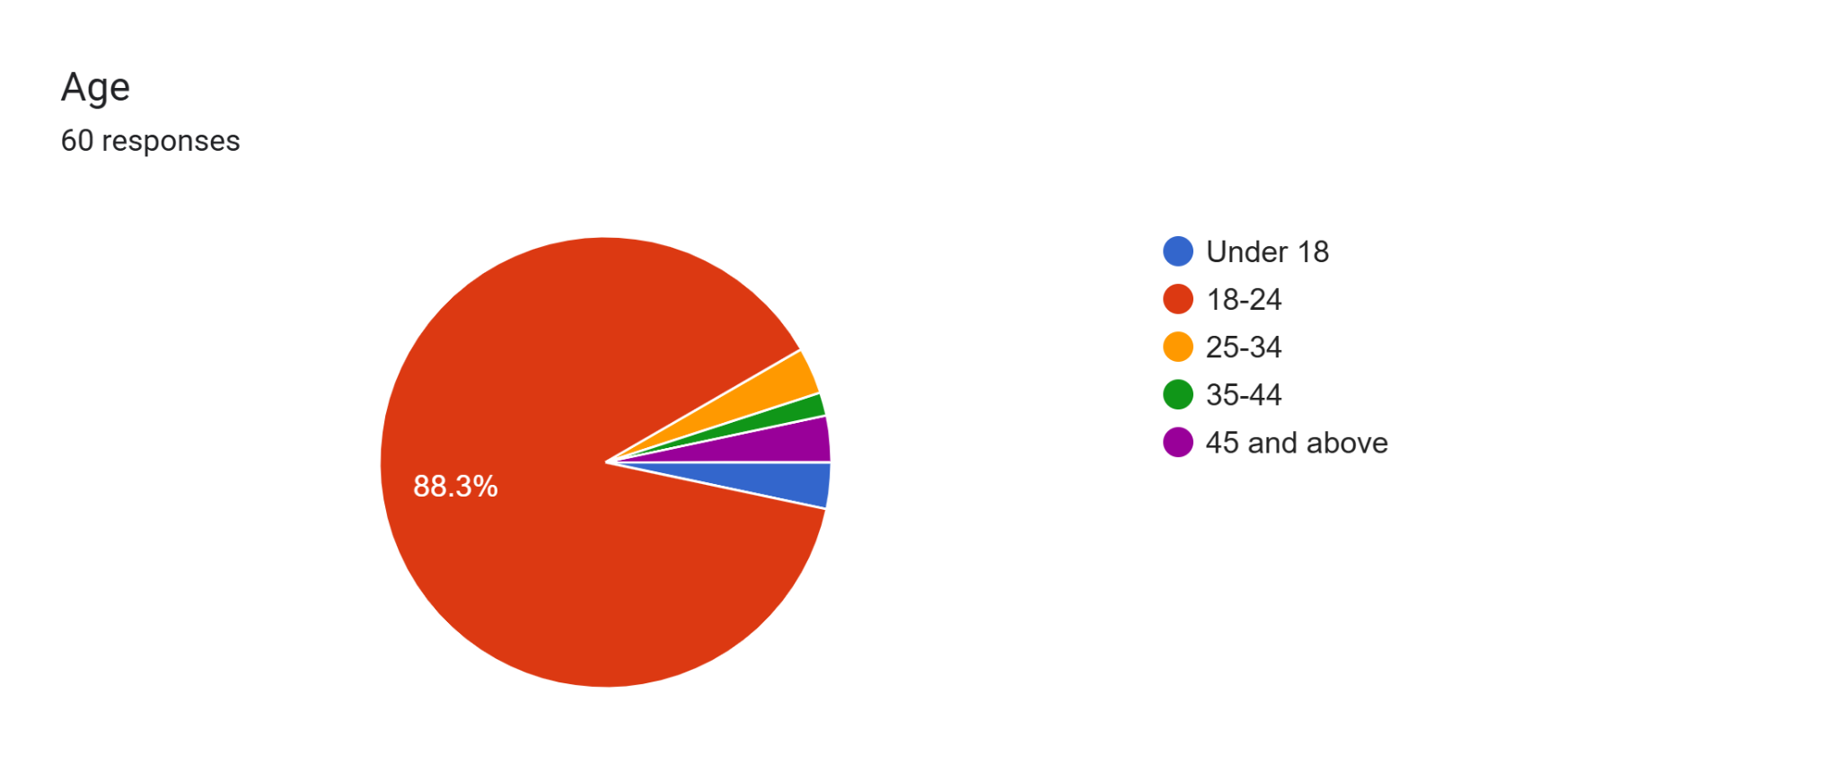

**Interpretation:** Fig1: The age distribution of 60 respondents is displayed in this pie chart. The vast majority, 88.3%, are between the ages of 18 and 24. The remaining respondents, who make up a small portion of the total, are distributed among the other age groups (under 18, 25–34, 35–44, and 45+). The graph indicates a notable concentration of young adults between the ages of 18 and 24.

**Interpretation:** Fig2:The gender distribution of the 60 participants in the study is shown in this pie chart.

Majority Female: With 65% of the total respondents, women make up the vast majority of the sample.

Minority Male: The remaining 35% of the respondents are male.

In essence, the chart indicates a significantly higher participation rate from females compared to males within this study.

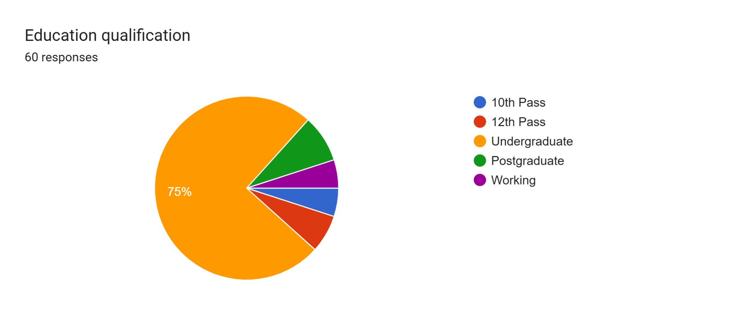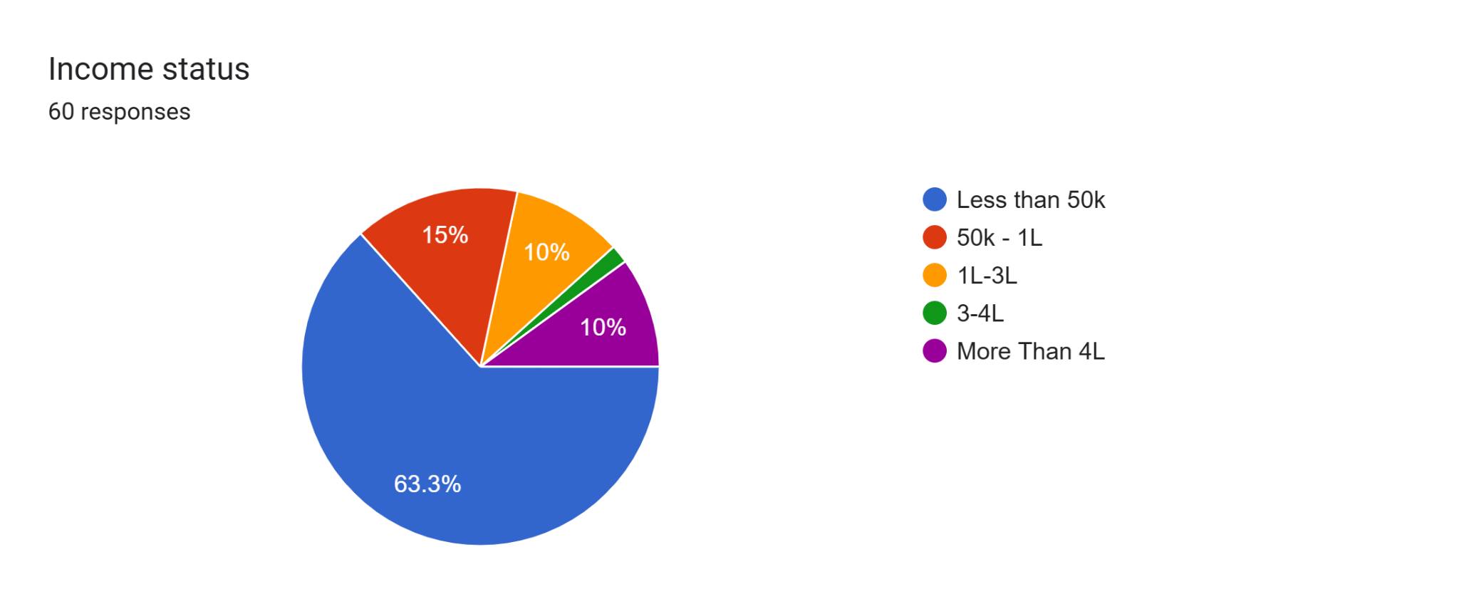

**Interpretation:** Fig3: The distribution of 60 respondents' educational backgrounds is depicted in the pie chart; the vast majority (75%) have undergraduate degrees, with the remaining 25% being divided among other categories.

**Interpretation:** Fig4: The income status of 60 respondents is shown in the pie chart, which indicates a notable concentration (63.3%) in the "Less than 50k" income bracket. The remaining respondents are spread across higher income brackets; 10% fall into the 50k-1 L and 1L-3L brackets, 15% fall into the 3-4L bracket, and 1.7% surpass 4L, suggesting a bias towards lower income levels.

Forms response chart. Question title: How would you describe your skincare routine?
. Number of responses: 60 responses.Forms response chart. Question title: What’s your go-to budget for skincare products per month?
. Number of responses: 60 responses.

**Interpretation:** Fig5: The way people explain their skincare regimens is displayed in this chart. The majority of people (46.7%) take a lot of steps, or "extensive." Some people only do the bare minimum (20%) or a few steps (31.7%). Only 1.6% of respondents enjoy trying new things. In general, a lot of people enjoy a thorough skincare regimen.

**Interpretation:** Fig6: The majority of respondents (45%) spend less than ₹1000 per month on skincare, as shown in the pie chart. A focus on lower-budget skincare spending is evident in the other budget ranges, which include ₹1500-₹2000 (30%), ₹2000-₹3000 (18.3%), and a small percentage (6.7%) exceeding ₹4000.

Forms response chart. Question title:  How do you usually discover new skincare products?
. Number of responses: 60 responses.Forms response chart. Question title:  Which of these best describes your skin type?
. Number of responses: 60 responses.

**Interpretation:** Fig7: According to the pie chart, which displays the skin types of 60 respondents, the vast majority (55%) identify as "Oily." 15% of skin types are "Combination" and 15% are "Sensitive," while 11.7% are "Dry." The fact that only 3.3% of respondents say they are "Not sure" suggests that oily skin is highly prevalent in this group.

**Interpretation:** Fig8: According to the pie chart, advertisements and brand websites are the most common way for 33.3% of respondents to find new skincare products. Dermatologists and specialists are cited by 21.7% of respondents, whereas social media and influencers make up 28.3%. The predominance of online discovery methods is demonstrated by the fact that in-store browsing is the least common at 5% and recommendations from friends and family make up 11.7%.

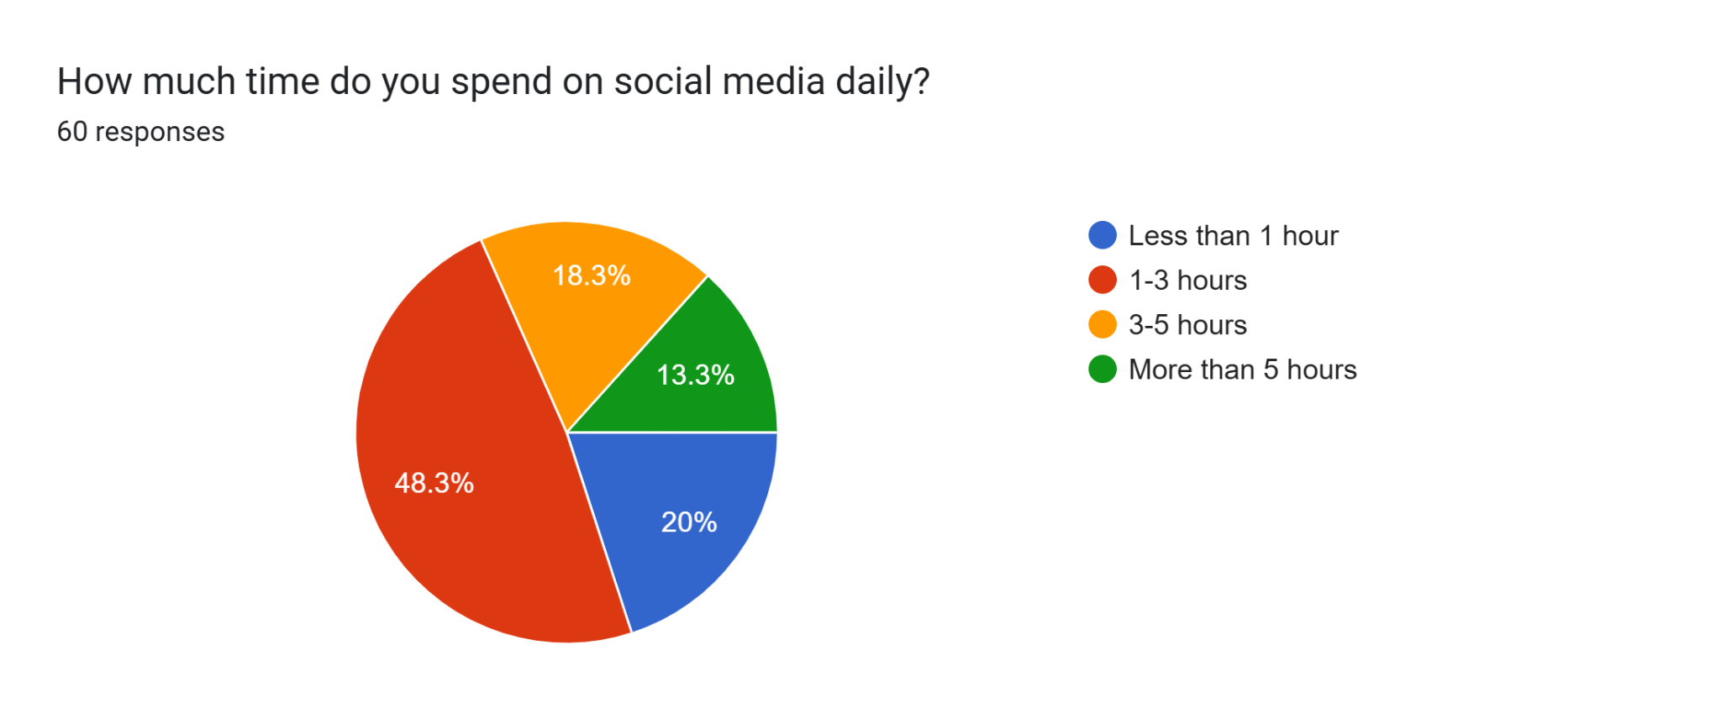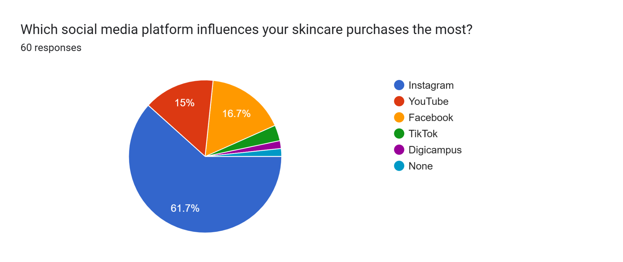

**Interpretation:** Fig9: According to the pie chart, 48.3% of 60 respondents use social media for one to three hours every day. The majority of people use social media in a moderate way, with 18.3% spending less than an hour, 20% spending three to five hours, and 13.3% spending more than five hours.

**Interpretation:** Fig10: The majority of respondents (61.7%) say social media has no influence over their skincare purchases. Overall, social media has a very small impact, with Facebook (16.7%) and Instagram (15%) having some influence.

Forms response chart. Question title: Have you ever purchased a skincare product based on an influencer’s recommendation?
. Number of responses: 60 responses.Forms response chart. Question title: Do you follow skincare influencers on social media?
. Number of responses: 60 responses.

**Interpretation:** Fig11: The majority of respondents (48.3%), according to the pie chart, do not follow skincare influencers on social media. While 23.3% are unsure ("Maybe"), 28.3% do follow influencers. This suggests a reluctance to follow influencers in this group.

**Interpretation:** Fig12: According to the pie chart, 41.7% of the 60 respondents have bought skincare products after hearing about them from influencers, while the majority (58.3%) have not. This suggests that for the majority of respondents in this group, influencer recommendations have little direct impact on purchasing decisions.

Forms response chart. Question title:  What factor makes you trust a skincare influencer the most?
. Number of responses: 60 responses.

Forms response chart. Question title: What type of skincare influencer content influences you the most?
. Number of responses: 60 responses.

**Interpretation:** Fig13: "Before-and-after results" and "product reviews" are equally important content types from skincare influencers, according to 60 respondents (33.3% each). "Brand collaborations" have the least influence (11.7%), while "skincare routines" have the most (21.7%). This suggests that results-driven content and hands-on demonstrations are preferred over promotional partnerships.

**Interpretation:** Fig14: At 33.3% each, "Authenticity and honesty" and "Expertise in skincare" are equally significant factors for 60 respondents when it comes to trusting a skincare influencer. At 21.7%, "engagement with followers" has the most influence, whereas "collaborations with reputed brands" has the least, at 11.7%. This indicates that influencers who are sincere and informed are preferred over those who are only interested in brand collaborations.

Forms response chart. Question title: What is the biggest drawback of influencer marketing in skincare?
. Number of responses: 60 responses.Forms response chart. Question title:  Do influencer endorsements impact your perception of a skincare brand?
. Number of responses: 60 responses.

**Interpretation:** Fig15: According to 60 respondents, 50% of them stated that "Misleading claims" is the largest disadvantage of influencer marketing in the skincare industry. At 21.7%, "Lack of transparency in product effectiveness" ranks as the second most common concern, followed by "Overpriced products" at 15% and "Paid promotions affecting credibility" at 13.3%. This suggests that the integrity and openness of influencer endorsements are the main areas of concern.

**Interpretation:** Fig16: Out of 60 respondents, 33.3% rely on "Personal experience," while 36.7% say influencer endorsements "Sometimes" affect how they view a skincare brand. 8.3% are positively impacted, and 21.7% trust "Brand advertisements more." This demonstrates that influencer endorsements have a mixed effect, with skepticism toward influencers and personal experience being common.

Forms response chart. Question title:  Have you stopped using a skincare brand after a negative review by an influencer?
. Number of responses: 60 responses.Forms response chart. Question title: When a skincare influencer promotes a brand, what aspect influences you the most?
. Number of responses: 60 responses.

**Interpretation:** Fig17: According to 60 respondents, "The influencer's personal experience" has the greatest impact on a skincare influencer's decision to endorse a brand (43.3%). At 25% each, "Brand reputation" and "scientific claims and ingredients" have an equal amount of influence, whereas "discounts and offers" have the least. This indicates a preference for authentic, personal testimonials over promotional or technical information.

**Interpretation:** Fig18: Out of 60 respondents, 51.7% have discontinued using a skincare brand following an influencer's unfavorable review, whereas 48.3% have not. This suggests that among this demographic, unfavorable influencer reviews can have a big effect on brand loyalty and consumer behavior.

Forms response chart. Question title: Would you be more likely to purchase a skincare product endorsed by:
. Number of responses: 60 responses.Forms response chart. Question title: What type of influencer collaboration is most effective for skincare brands?
. Number of responses: 60 responses.

**Interpretation:** Fig20: The most successful influencer partnership for skincare brands, according to 60 respondents, is "Unpaid, organic product reviews" (58.3%). "Brand ambassador partnerships" have the least impact (11.7%), while "sponsored posts/videos" and "giveaway campaigns" have equal influence (15%). This suggests that genuine, unsponsored reviews are strongly preferred over other types of influencer partnerships.

**Interpretation:** Fig21: "A dermatologist or skincare expert" is the most influential endorser, according to 60 respondents, who are 53.3% more likely to buy a product that they recommend. "A celebrity" has the least influence, followed by "a beauty influencer with a large following" (21.7%) and "a micro-influencer with high engagement" (20%). This suggests that expert endorsements are strongly preferred over those of other influencer categories.

Forms response chart. Question title: Skincare influencers help me make better purchasing decisions.
. Number of responses: 60 responses.Forms response chart. Question title:  I trust skincare influencers more than traditional advertisements.
. Number of responses: 60 responses.

**Interpretation:** Fig22: Of the 60 respondents, 21.7% agree and 43.3% disagree that they trust skincare influencers more than traditional ads. 6.7% strongly agree, 10% are neutral, and 18.3% strongly disagree. This suggests that this group is generally less trusting of skincare influencers than of traditional advertising.

**Interpretation:** Fig23: Of the 60 respondents, 23.3% agree that skincare influencers help them make better purchases, while 50% disagree. 3.3% strongly agree, 10% strongly disagree, and 13.3% are neutral. This suggests a general lack of trust in the influence of skincare influencers on this group's purchasing choices.

**Research Findings:**

1. Age: 88.3% of those surveyed are in the 18–24 age range.
2. Gender: Sixty-five percent of respondents are women.
3. Education: 75% of respondents hold an undergraduate degree.
4. Income: Sixty-three percent of those surveyed earn less than ₹50,000.
5. Skincare Routine: Most participants (46.7%) follow a thorough, multi-step skincare routine.
6. Skincare Spending: Forty-five percent of those surveyed said they spend less than ₹1,000 a month on skincare.
7. The majority of people (55%) have oily skin.
8. Product Discovery: Most participants (33.3%) use brand websites and advertisements to discover new products.
9. The majority of respondents (48.3%) reported using social media for one to three hours daily.
10. Social Media Influence on Purchases: Most respondents (61.7%) believe social media has no influence on their purchases.

**Recommendation:**

* For Skin Care Consumers

Follow the Right People – Not all influencers are skincare experts. Follow only dermatologists , estheticians, or experienced beauty bloggers who back up their recommendations with science, not hype.

Do Your Own Research – Only Just because an influencer likes a product does not mean it is right for you. Read reviews, research ingredients, and see if the product is good for your skin type before buying.

Participate, But Be Cautious – Ask questions in the comment, try to read a few reviews, and see if the influencer is revealing sponsorships .

Don't Believe in Quick Fixes – Influencers use filters and perfect lighting. Real skincare results are not immediate, so be cautious of miracle or faster results statements . Look Out for Too Many Endorsements , If an influencer constantly endorses new products, their advice might be more about money than skincare . Stick with those who give balanced and honest reviews.

* For Skincare Brands

Select Influencers Who Care – Instead of using the very big names, work with influencers who would actually use and believe in your products. a smaller but engaged audience is better than a massive but apathetic audience. Be Authentic – Customers appreciate honesty. Encouraging influencers to say both the positives and negatives about your products builds long-term trust. Employ a Mix of Content – Buzz can be created by bite-sized videos on TikTok and Instagram, but more detailed YouTube reviews and live Q&As create stronger connections. Try to do what works best for your viewers. Track Engagement Not Views – A million views are not worth anything if people are not actually engaging with or buying your products. Look for substantial interaction such as comments, sharing, and word-of-mouth endorsements .Honesty about Sponsorships – Mark sponsored collaborations openly and encourage influencers to be transparent about them. Consumers will trust more those brands that do not try to hide the commercial nature of things.

* For Future Researchers

Think Long-Term Effect – Do influencers actually generate long-term loyalty, or do consumers move from one fad product to the next? And Research can help brands make smarter investments. Compare Influencer Types – Who performs best: dermatologists, beauty bloggers, or lifestyle influencers? And More research can help brands choose their ideal partners. Find the Best Social Media Platforms – TikTok, YouTube, and Instagram are all popular, but which is really generating more sales and interest in skin care advertising Understand Consumer Trust Issues – Most consumers are wary of sponsored content. Brand and influencer transparency can result from understanding how sponsorships affect consumer trust.

**Conclusion:**

It cannot be denied that social media influencers affect brand perceptions within the skincare category. As social media increasingly influences consumers in their product recommendations, influencers are becoming critical participants in creating trust, brand awareness, and purchase decisions .This study examined the ways in which influencers influence brand perception including their ability to provide authentic connections to audiences, product demonstrations, and personalized reviews. It is worth noting that among participants, influencers are often seen as more relatable and credible than traditional advertising, making influencer marketing an impactful approach employed by skincare brands.

By analyzing and interpreting the data, this research highlighted important aspects related to the efficacy around influencer marketing, including influencer credibility, engagement, and potential platform use. This research revealed that while influencers present some advantages for brands, there are some challenges including skepticism regarding paid promotions and calls for a higher level of transparency. The research further indicates that, when considering influencer types, dermatologists, beauty bloggers, and lifestyle influencers are not equal in terms of influence, and brands must carefully decide what influencer to use according to their audience and levels of expertise.

The study also aims to fill the gaps in the existing literature on influencer marketing by comparing the relative effectiveness of influencer-led campaigns with authentic advertising tactics in the skincare industry. The results of this study provide brands with material recommendations to start updating their marketing strategies, particularly with regards to engaging stakeholders in influencer collaborations once relevant information is presented for consideration by the general public, consumer, and commercial purchasers in the sector.

In conclusion, influencer marketing has revolutionized the skincare industry by changing how consumers view and engage with brands. Brands must focus on transparent, authentic, and meaningful brands and on behalf of the brand/activity engagement and loyalty as social media evolves. Future research might explore long-term influences of influencer marketing collaboration on brand loyalty and consumer purchasing behavior. Marketers can use some of the strategies in this study to begin amplifying their overall marketing strategy message about authenticity, transparency, and overall loyalty to their audience in an increasingly digital world.

**References:**

Hanadi Salhab (August 2024) *Social media marketing: Rise of social media influencer marketing and Instagram*. ResearchGate.<https://www.researchgate.net/publication/382960348>

Kaedio Potter, Favour Olaoye (October 2024)  *Investigating the role of social media influencers in shaping brand perceptions and purchase intentions*. ResearchGate.<https://www.researchgate.net/publication/384637761>

Herman Aditya (July 2024) *Role of social media influencers in brand management in Indonesia*. ResearchGate.<https://www.researchgate.net/publication/382016839>

Anber Shlash (June 2024) *The impact of influencer marketing on brand perception: A study of Jordanian customers influenced on social media platforms*. ResearchGate.<https://www.researchgate.net/publication/381093215>

Priya N. Rakate (September 2024) *Effectiveness of social media as a marketing tool*. ResearchGate.<https://www.researchgate.net/publication/383895829>

Wenxi Wu (August 2024) *Social media and marketing strategies of fashion brands*. ResearchGate. <https://www.researchgate.net/publication/350748796>

Barbara Olga Antczak (June 2024) *The influence of digital marketing and social media marketing on consumer buying behavior*. ResearchGate. <https://www.researchgate.net/publication/383895829>

Jingjing Wang (July 2024) *Analysis of ZARA’s social media marketing strategy in China*.ResearchGate.<https://www.researchgate.net/publication/382571990>

Jiayin Cao (June 2024) *The application of statistical methods in social media marketing effectiveness evaluation*. ResearchGate. <https://www.researchgate.net/publication/382016839>

Tasnimul Arefin (September 2024) *Impact of social media influencers on customer engagement and brand perception*. ResearchGate.<https://www.researchgate.net/publication/350748796>

Hira Zaidi and Asif Ali Syed (April 2023) *Social media and influencer marketing strategies: A conceptual review on contemporary applications*. ResearchGate.<https://www.researchgate.net/publication/350004633>

Kaledio Potter and Favour Olaoye (July 2024) *The impact of social media influencers on purchase intention and the mediation effect of customer attitude*. ResearchGate.<https://www.researchgate.net/publication/321832168>

Morgan Glucksman (December 2017) *Lifestyle branding and influencer marketing*. Elon University.<https://eloncdn.blob.core.windows.net/eu3/sites/153/2017/12/08_Lifestyle_Branding_Glucksman.pdf>

Sweeney, K. (June 2018) *Influencer-generated content benefits and differences vs. user-generated content*. Influencity.<https://influencity.com/blog/en/influencer-generated-content-benefits-and-differences-vs.-user-generated-content>

Richardson A (September 2024) *The impact of social media influencers on consumer behavior: A marketing perspective*. ScienceDirect.<https://www.sciencedirect.com/science/article/pii/S0148296317306381>

Jun-Hwa Cheah (December 2017) *Measuring social media marketing effectiveness through consumer engagement and advertising impact*. Sage Journals.<https://journals.sagepub.com/doi/10.1177/1329878X16665177>

Crystal Abidin (August 2016) *Understanding digital marketing trends in influencer marketing*. Taylor & Francis.<https://www.tandfonline.com/doi/full/10.1080/1553118X.2019.1634075>

Nils S. Borchers (September 2019) *Impact of social media influencers on purchase behavior in India*. IJIRT.<https://ijirt.org/publishedpaper/IJIRT165696_PAPER.pdf>

Deeya David (December 2020) *The role of influencer marketing in brand growth and consumer decision-making*. EasyChair.<https://easychair.org/publications/preprint/tG7r>

Darshana T Jayasinghe (March 2021) *Consumer behavior and influencer marketing: A strategic analysis*. ResearchGate. <https://journals.sagepub.com/doi/10.1177/1329878X16665177>