**Comparative Analysis Of Traditional And Digital Marketing In The**

**Education Sector**

Authors:

1Mr. Sunil Hegde

2.Mubashira M M, , 3Manaswini Balamurugan Kanimozhi,

4Shravanthe R S , 5Priyanka Samanta

1Assistant Professor, Jain (Deemed-to-be University) - Centre for Management Studies – Bangalore, India

2345Students, Jain (Deemed-to-be University) - Centre for Management Studies – Bangalore, India

# Abstract

This study examines the evolving relationship between traditional and digital marketing in the education sector, analyzing their distinct contributions to institutional outreach, student recruitment, and long-term reputation. While digital strategies dominate modern campaigns due to their affordability, audience precision, and interactive potential, traditional methods—such as print media, community engagement, and referrals—retain relevance in localized or niche demographics. By synthesizing contemporary literature, industry trends, and case studies, this research evaluates the strengths, limitations, and emerging synergies of both approaches. It also investigates blended models that integrate offline and online tactics to amplify engagement.

Ethical challenges, including data privacy concerns and disparities in digital access, are scrutinized to advocate for responsible marketing practices. Findings indicate that digital methods excel in scalability and measurable outcomes, whereas traditional channels foster credibility in regions with limited technological infrastructure. The study concludes by proposing actionable strategies for educational institutions to develop hybrid frameworks that balance innovation with inclusivity, addressing diverse audience needs in an increasingly digital era.

**Keyword -** Education sector, Traditional marketing, Digital marketing, Institutional reputation.

# Introduction

The education sector is undergoing a transformative shift in its marketing strategies, driven by rapid technological advancements and evolving societal norms. As competition intensifies—both among traditional academic institutions and emerging global e-learning platforms—the need to design innovative and impactful marketing campaigns has become critical for attracting enrollments, building institutional identity, and ensuring long-term sustainability. Historically, educational institutions relied on conventional outreach methods such as local newspaper advertisements, community events, and alumni referrals. These approaches were rooted in faceto-face interactions and physical visibility, making them particularly effective in areas with limited digital infrastructure or strong reliance on local trust networks

The advent of digital technologies has revolutionized this landscape. Social media platforms like Instagram and LinkedIn enable institutions to connect with younger audiences through dynamic and immersive content, such as virtual campus tours. Advanced tools like AI-driven ad targeting allow for hyper-personalized marketing strategies that cater to specific demographic groups. The COVID-19 pandemic further accelerated this digital transformation by minimizing in-person interactions and normalizing remote learning environments. Despite these advancements, traditional marketing methods continue to play a vital role, especially in rural areas or among populations with limited internet access. Strategies such as radio broadcasts, printed materials, and partnerships with local businesses remain indispensable for bridging the gap between digital ambitions and grassroots realities.

By synthesizing insights from global case studies, demographic analyses, and ethical guidelines, this research aims to provide a comprehensive roadmap for institutions navigating this complex marketing landscape. It advocates for adaptive blended models that integrate the analytical strengths of digital tools with the relational advantages of traditional outreach. Such frameworks ensure that marketing efforts remain progressive yet equitable, fostering trust across diverse generations, regions, and socioeconomic groups. The subsequent sections will delve deeper into theoretical foundations, practical applications, and actionable solutions for optimizing marketing strategies in today’s fast-paced educational environment.

**Objectives**

1. To determine how traditional marketing impacts education-related choices.
2. To evaluate how digital tools enhance student engagement and enrollment.
3. To compare the cost-effectiveness and ROI of traditional and digital marketing in education.
4. To identify audience preferences regarding traditional vs. digital marketing in education.
5. To analyze the difficulties in integrating and balancing marketing methods in educational contexts.

# Review of Literature

Tariq, E., Ashaureah, M., Akur, I. & Hawary, S.A., (2021) Says how Companies need to be both innovative and efficient to succeed. Digital marketing is key to this. It involves using technology to reach customers and understand their needs. By focusing on areas like strategy, data, customer communication, and experience, companies can achieve a balance of exploration and exploitation, leading to better performance. Srinivasan, S., Rutz, O.J., & Pauwels, K., (2015) The paper explores the impact of online media on the consumer purchase process. It discusses how search engines and social media have become crucial platforms for marketers to interact with consumers throughout their journey. It highlights the need for further research on the relationship between online consumer activity metrics and brand sales, particularly in the context of FMCGs. Bist, A.S., Agarwal, V., Aini, Q. & Khofifah, N., (2022) The paper discusses the impact of digitalization on the business world and the importance of adapting marketing strategies to the digital age. It highlights the shift from traditional marketing methods to digital marketing channels. Minculete, G. & Olar, p., (2018) The paper explores the concept of digital marketing and its importance in ebusiness. It discusses the seven operational functions of digital marketing and its impact on both businesses and customer behavior. It highlights the evolution of digital marketing over the past decade and its increasing use by companies for advertising and promotion. Khurramov, O.K. & Fayzieva, S.A., (2020) The paper explores the advantages of using the internet for marketing and building a brand. It discusses the interactive nature of the internet and how it allows for personalized communication and increased consumer involvement. It highlights the importance of understanding consumer interests and encouraging dialogue with customers in the online environment. Veleva, S.S & Tsvetanova., A.I., (2019) The paper explores the impact of globalization and technological advancements on the business landscape. It highlights the need for companies to adapt their strategies and embrace digitalization to remain competitive and achieve success in the current volatile and uncertain environment. Puri, A & Kumari., N., (2020) The paper explores the concept of digital marketing and its growing importance in the modern business landscape. It discusses the various components of digital marketing, including search engine optimization, search engine marketing, and digital advertising. It highlights the shift towards digital commerce and the increasing preference of consumers for online shopping.

Pantano, E., Priporas, C.V., & Migliano, G., (2019) The paper explores the limitations of the traditional marketing mix model and the need to incorporate new elements to address the changing dynamics of the market. It discusses the impact of social media on consumer behaviour and its potential as a valuable tool for businesses. Othman, B.A., Harun, A., Almeida, N.M.D. & Sadq, Z.M., (2020) The paper discusses pilgrimage tourism and its importance in the globalized world. It highlights the potential of digital marketing to promote pilgrimage tourism and reach a wider audience. Scullin, S.S., Fjermestad, J. & Romano, N.C., (2004) The paper explores the concept of electronic customer relationship management (eCRM) and its impact on marketing strategies. It discusses how eCRM expands the traditional definition of marketing and enables companies to meet their internal marketing objectives. It also highlights the importance of effective and efficient eCRM implementation for organizations. Kebede, K., Yadete F.D. & Kant, S., (2023) The paper explores the concept of digital marketing and its importance in achieving organizational goals. It discusses the role of the marketing mix strategy in digital environments and the need for businesses to effectively present their products and services online to satisfy customers. Yusmalina., Tegor., Haqiqi, F., Rosady, R.E. & Azura, N., (2021) The paper explores the concept of traditional markets and their role in communities. It discusses the differences between traditional markets and modern markets and the challenges faced by traditional markets in the face of competition from modern markets. Kuberappa, Y.V. & Kumar., A.H.S., (2016) The paper explores the concept of digital marketing and its advantages over traditional marketing. It discusses the various components of digital marketing, including content creation, social media engagement, and website optimization. It highlights the importance of setting clear objectives, budgeting effectively, etc.

Geraghty, G. and Conway, A. (2016) The paper explores the concept of target marketing in the context of museum marketing. It highlights the importance of defining the target market and using appropriate tools and channels to reach them effectively. Othman, B., Weijun, H., Huang, Z., Xi, J. & Ramsey, T., (2021) It discusses the various components of SMM and the importance of incorporating after-sales service as an additional dimension. The paper highlights the need for clothing store brands to focus on customer needs and preferences to maintain long-term relationships. Mughari, A.M., (2011) The paper explores the concept of guerrilla marketing and its role in achieving sustainable competitive advantage. It discusses the importance of understanding the target market, delivering value to customers, and effectively managing the revenue and cost structure of a business. It also highlights the role of word-of-mouth marketing and direct marketing in promoting products and services. Issock, P.B.I., Mpinganjira, M. & Lombard, M.R., (2021) The paper discusses social marketing and its use in influencing behaviour. It highlights the importance of understanding the target audience and tailoring the marketing mix accordingly to achieve behaviour change. Wilson, A.& Laskey, N., (2003) The paper explores the impact of the internet on market research and the increasing use of internet-based research methods. It highlights the need for more research on the experiences and practices of market research agencies in utilizing internet-based research, particularly outside the USA. Saura, J.R., PalosSánchez, P. & Suárez, L.M.C., (2017) The article explores the relationship between digital marketing (DM) and web analytics (WA) in the context of the growing digital economy. It highlights the importance of DM metrics and KPIs for measuring the effectiveness of DM strategies and for making informed decisions. Christina, I.D., Fenni, & Roselina, D., (2019) The paper discusses the growing popularity of the internet in Indonesia has led to a surge in subscription television companies. These companies are using digital marketing strategies like website development, search engine marketing, online PR, and social media marketing to reach potential customers and compete effectively in the market.

# Research Gap

While existing literature extensively explores the effectiveness of traditional and digital marketing strategies across diverse sectors like retail, healthcare, and entertainment, a noticeable gap exists in the focused application of these strategies within the education sector. Prior studies often generalize marketing principles, failing to address the unique challenges and nuances inherent in promoting educational services. For instance, the decision-making processes of students, parents, and educators are influenced by factors distinct from those in typical consumer markets, such as long-term career goals, institutional reputation, and academic outcomes.

Furthermore, there is a lack of comprehensive research that directly compares the ROI and engagement rates of traditional versus digital marketing methods specifically tailored to educational institutions, considering the diverse demographic and socioeconomic backgrounds of potential students. Understanding these differential impacts is crucial for institutions aiming to optimize their marketing investments and enhance their outreach. This study aims to bridge this gap by providing an in-depth analysis of the effectiveness of both marketing approaches in the education sector, offering actionable insights for institutions to develop targeted and inclusive marketing strategies.

# Research Methodology

**Primary data:**

A standardized Google Forms survey was created and sent to a large audience in order to learn how consumers view sustainability in brand marketing. The main instrument for collecting data was this survey, which made it possible to compile a variety of consumer insights from various industries.

**Secondary data:** This study uses secondary research through Research papers and academic publications, Market Studies and industry reports from companies in addition to primary data collecting to give a more Comprehensive picture of how consumers view sustainability in brand marketing.

**Sample:** The sample size is determined as 50 respondents’ opinions on sustainability in brand marketing.

**Instrument:** To analyze the data percentage analysis method was applied.

# Data Analysis And Interpretation

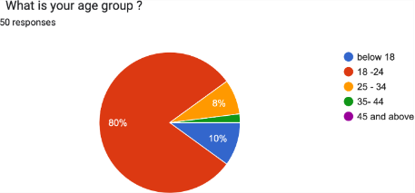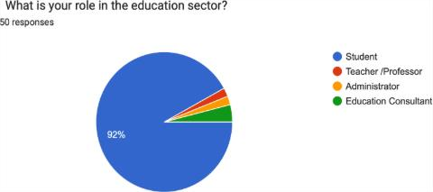

**Interpretation**- Fig 1:Classification of respondents based on age group.

It shows that most respondents were aged 18-24 (80%), followed by those under 18 (10%), 25-34 (8%), and 35-44 (2%). No respondents were aged 45 or above.

**Interpretation**- Fig 2: Classification of respondents based on Education sector.

The data in Table 2 classifies the respondents based on education sector were students 46(92%), teachers were 1(2%), administrators were 1(2%) and education consultants were 2(4%).

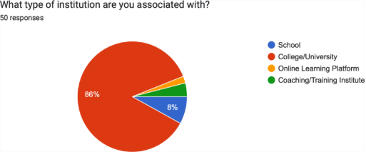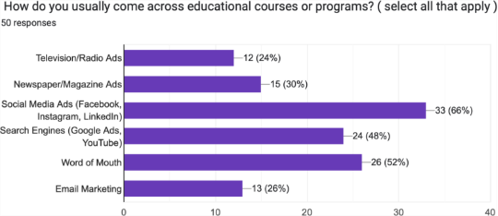

**Interpretation**- Fig 3: Classification of respondents based on Institution that they are associated with.

It classifies the Respondents based on institutions associated with school education 4(8%), college/university 43(86%), online learning platform 1(2%), and coaching/training institute 2(4%).

**Interpretation**- Fig 4: Classification of respondents based on preference of educational courses or programs.

The data in Table 4 classifies the respondent based on preference of educational course or program were Tv/Radio ads 12(24%), newspaper 15(30%), social media 33(66%), search engines 24(48%), word of mouth 26(52%) and email marketing 13(26%).

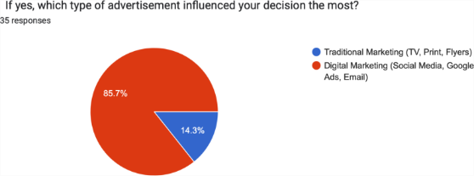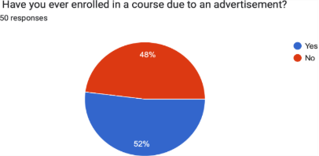

**Interpretation**- Fig 5: Classification of respondents based on enrollment in course through advertisements.

The data in Table 5 classifies the respondent based on course enrollment through advertisement were 24(48%) yes and 26(52%) no.

**Interpretation**- Fig 6: Classification of respondents based on the advertisements that influence decision the most.

The data in Table 6 classifies the respondent based on the advertisements that influence decision the most were traditional marketing 5(14.3%) and digital marketing 30(85.7%).

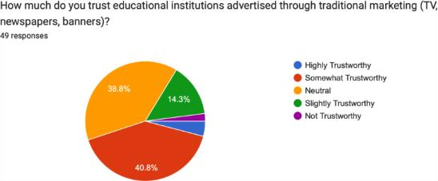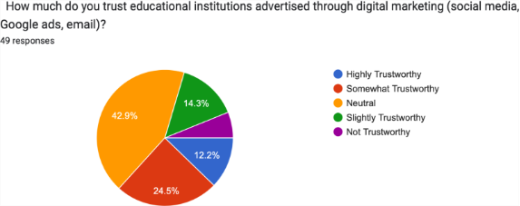

**Interpretation**- Fig 7: Classification of respondents based on the trust towards educational institutions advertised through traditional marketing.

The data in table 7 shows the trust towards educational institutions through traditional marketing were highly trustworthy 2(4.1%), somewhat trustworthy 20(40.8%), neutral 19(38.8%), slightly trustworthy 7(14.3%) and not trustworthy 1(2%).

**Interpretation**- Fig 8:Classification of respondents based on the trust towards educational institutions advertised through digital marketing.

The data in table 8 shows the trust towards educational institutions through digital marketing highly trustworthy 6(12.2%), somewhat trustworthy 12(24.5%), neutral 21(42.9%), slightly trustworthy 7(14.3%) and not trustworthy 3(6.1%)

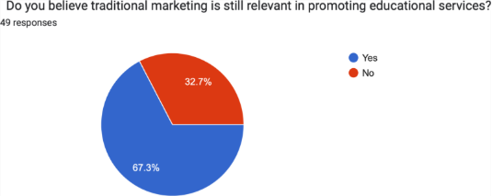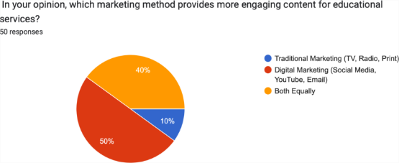

**Interpretation**- Fig 9: Classification of respondents based on believing in traditional marketing is still relevant in promoting educational services.

The data in Table 9 classifies the respondent based on believing traditional marketing is still relevant in promoting educational services were 33(67.3%) yes and 16(32.7%) no.

**Interpretation**- Fig 10: Classification of respondents based on which marketing method provides more engaging content for educational services.

The data in Table 10 classifies the respondent based on which marketing method provides more engaging content for educational services traditional marketing 5(10%), digital marketing 25(50%) and both equally 20(40%).

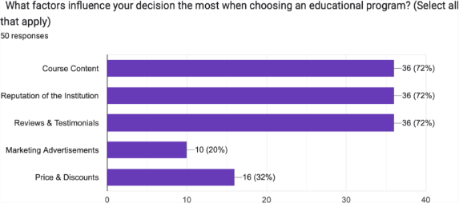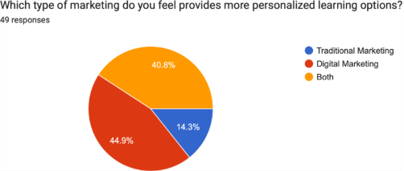

**Interpretation**- Fig 11:Classification of respondents based on factors influencing the decision when choosing an educational program.

The data in table 11 classifies the respondents based on factors influencing the decision when choosing an educational program were course content 36(72%), reputation of the institution 36(72%), reviews 36(72%), marketing ads 10(20%) and price/discounts 16(32%).

**Interpretation**- Fig 12: Classification of respondents based on the type of marketing that provides more personalized learning options.

The data in Table 12 classifies the respondent based on the type of marketing that provides more personalized learning options were traditional marketing 7(14.3%), digital marketing 22(44.9%) and both 20(40.8%).

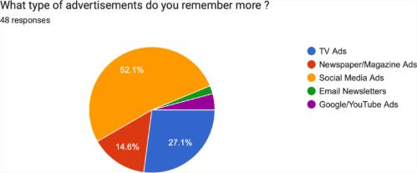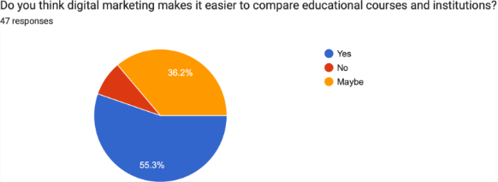

**Interpretation**- Fig 13: Classification of respondents based on the type of advertisements you remember.

The data in Table 13 classifies the respondent based on the type of advertisements you remember were tv ads 13(27.1%), newspaper 7(14.6%), social media ads 25(52.1%), email 1(2.1%) and google ads 2(4.2%).

**Interpretation**- Fig 14: Classification of respondents based on if digital marketing makes it easier to compare educational courses and institutions.

The data in Table 14 classifies the respondent based on if digital marketing makes it easier to compare educational courses and institutions were 26(55.3%) yes, 4(8.5%) no and 17(36.2%) maybe.

The

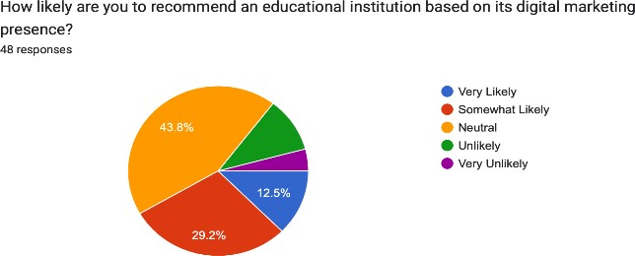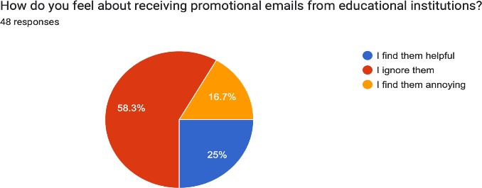

**Interpretation**- Fig 15: Classification of respondents based on the recommendation of educational institutions based on its digital marketing presence.

The data in fig 15 classifies the respondent based on the recommendation of educational institutions based on its digital marketing presence were very likely 6(12.5%), somewhat likely 14(29.2%), neutral 21(43.8%), unlikely 5(10.4%) and very unlikely 2(4.2%).

**Interpretation**- Fig 16:Classification of respondents based on how it feels about receiving promotional emails from educational institutions.

The data in fig 16 classifies the respondent based on how it feels about receiving promotional emails from educational institutions where I find them helpful 12(25%), I ignore them 28(58.3%) and I find them annoying 8(16.7%).

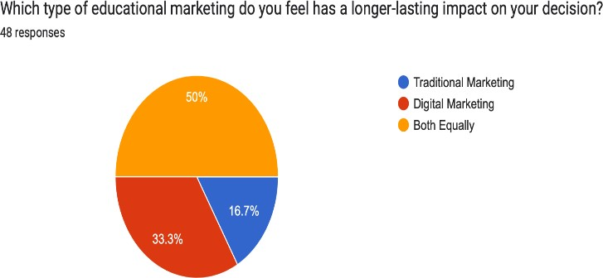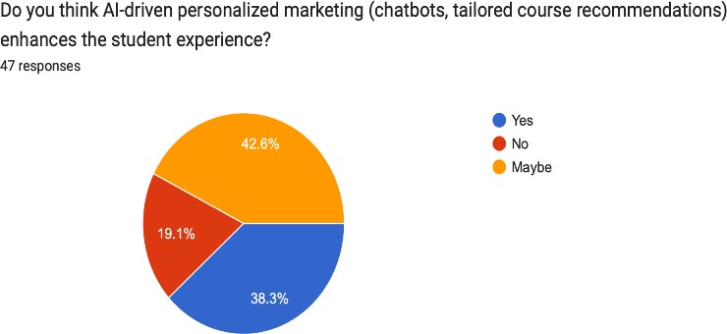

**Interpretation**- Fig 17: Classification of respondents based on AI driven personalized marketing enhances the student experience.

The data in fig 17 classifies the respondent based on AI driven personalized marketing enhances the student experience were 18(38.3%) yes, 9(19.1%) no and 20(42.6%) maybe.

**Interpretation**- Fig 18: Classification of respondents based on type of educational marketing that has a long-lasting impact on the decision.

The data in fig 18 classifies the respondent based on type of educational marketing that has a longlasting impact on the decision were traditional marketing 8(16.7%), digital marketing 16(33.3%) and both equally 24(50%).

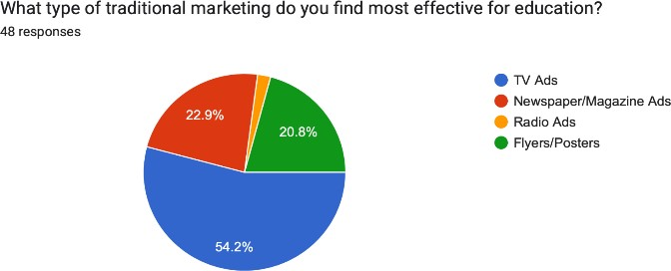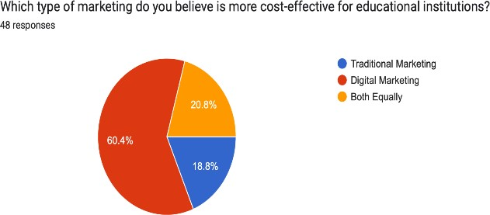

**Interpretation**- Fig 19: Classification of respondents based on type of marketing which is more cost effective for educational institutions.

The data in fig 19 classifies the respondents based on traditional marketing 9(18.8%), digital marketing 29(60.4%) and both equally 10(20.8%).

**Interpretation**- Fig 20: Classification of respondents based on the type of traditional marketing which is most effective for education.

The data in fig 20 classifies the respondents based on the type of traditional marketing which is most effective for education were tv ads 26(54.2%), newspaper 11(22.9%), radio ads 1(2.1%) and posters/flyers 10(20.8%).

# Findings

* Marketing strategies showed a distinct impact across education-related demographics like age, gender, location, and income, highlighting the need for customized approaches.
* Digital methods (social media, SEO) often provided a more cost-effective means of reaching demographics compared to traditional media (TV, print), though effectiveness varied.
* The research identified specific marketing approaches that correlate with increased engagement from students, parents, and stakeholders, directly impacting enrollment rates.
* Certain demographic groups exhibit a clear preference for either digital or traditional marketing when evaluating educational opportunities, influencing their program choices.
* The study forecasts the ongoing roles of traditional and digital marketing, providing insights for organizations looking to optimize marketing investments.
* Digital methods excel in scalability and measurable outcomes, while traditional channels foster credibility in regions with limited technological infrastructure.

# Recommendations

* Hybrid Approach is Essential: Adopt a blended marketing strategy that combines the strengths of both traditional and digital methods. Traditional methods build trust, digital methods offer scalability and tracking.
* Target Demographic Preferences: Understand the preferences of different demographic groups. Tailor campaigns to align with the preferred channels (digital vs. traditional) of students, parents, and educators.
* Leverage Storytelling on social media: Utilize social media platforms to share engaging narratives that highlight the unique aspects of the institution, showcasing student success stories and campus culture.
* Ensure Data Privacy: Be transparent about data collection and usage practices to build trust with prospective students and their families. Adhere to data privacy regulations and prioritize ethical marketing practices.
* Engage Stakeholders Actively: Involve prospective students and their families in interactive experiences and campus events. Foster a sense of community to strengthen brand loyalty.
* Measure and Optimize Continuously: Regularly assess the effectiveness of marketing campaigns using key performance indicators (KPIs) to inform future strategy adjustments. Continuously refine and optimize strategies based on data-driven insights.

# Conclusion

This research has investigated the evolving roles of traditional and digital marketing within the education sector, highlighting their distinct contributions to institutional outreach, student recruitment, and long-term reputation. While digital strategies offer advantages in scalability, audience precision, and interactive potential, traditional methods continue to hold relevance, particularly in localized or niche demographics. The findings indicate that a hybrid approach, integrating both traditional and digital techniques, is the most effective strategy for educational institutions. This blended model allows for leveraging the strengths of each approach: digital marketing for broad reach and measurable engagement, and traditional marketing for building trust and credibility within local communities.

Moreover, the study underscores the importance of ethical considerations, particularly regarding data privacy and disparities in digital access. Educational institutions must prioritize responsible marketing practices that protect student data and ensure equitable access to information, this research provides actionable strategies for educational institutions to develop marketing frameworks that balance innovation with inclusivity, addressing the diverse needs of their target audiences in an increasingly digital era. By embracing a hybrid approach and prioritizing ethical considerations, institutions can effectively enhance their outreach, strengthen their reputation, and achieve sustainable growth.

# References

1. Brown, T., & Davis, M. (2023). *Traditional marketing strategies in the digital world: A comparative study. Marketing Science, 42(3), 254-267.*

1. Garcia, M., & Nguyen, L. (2022). *How digital marketing disrupts traditional advertising: A comparative study. Global Journal of Marketing, 12(3), 99-115*.

1. Johnson, M. A. (2020). *The role of consumer trust in the effectiveness of digital advertising. Journal of Advertising Research, 61(4), 328-342.*

1. Kumar, P., & Singh, R. (2022). *The integration of traditional and digital marketing for brand equity. International Journal of Business and Management, 60(1), 45-58.*

1. Patel, R., & Sharma, K. (2021). *Effectiveness of traditional vs. digital marketing in the retail industry: A cross-sectional analysis. Journal of Retail and Distribution* *Management, 49(6), 712-725.*

1. Smith, J., & Johnson, A. (2020). *Exploring consumer behavior in the age of digital marketing. Journal of Marketing Research, 58(2), 130-145.*

1. Walker, D., & Lee, J. (2022). *Measuring the return on investment (ROI) of digital vs.*

*traditional marketing efforts. Journal of Business Research, 101(9), 587-602.*

1. Williams, H., & Thompson, R. (2021). *The evolution of consumer targeting: From traditional to digital marketing strategies. Journal of Consumer Marketing, 38(5), 423439*

1. Fernandez, P., & White, S. (2023*). Consumer perceptions of traditional vs. digital advertising effectiveness. International Journal of Advertising, 42(1), 103-117.*

1. Ali, S., & Khan, N. (2023). *Comparative analysis of traditional and digital marketing in the context of consumer engagement. International Journal of Marketing, 75(7), 182-194.*

1. Anderson, R., & Clark, P. (2021). *Digital marketing trends in higher education: A student engagement perspective. Journal of Educational Marketing, 29(4), 211-228*.

1. Bennett, M., & Thomas, L. (2022). *The shift from traditional to digital marketing in education: A case study approach. International Journal of Higher Education Marketing, 17(2), 89-106.*

1. Carter, J. (2020). *The impact of social media advertising on student enrollment decisions. Journal of Digital Marketing in Education, 35(3), 54-70.*

1. Douglas, S., & Walker, K. (2023*). Evaluating digital marketing effectiveness in educational institutions: A data-driven approach. Marketing Insights in Education, 14(1), 132-148.*

1. Evans, T. (2019). *The effectiveness of TV and print advertising in university branding. Journal of Traditional Media Studies, 22(2), 77-92.*

1. Green, H., & Patel, A. (2021). *SEO and paid search advertising for universities: A comparative study of digital strategies. Journal of Search Engine Marketing, 10(4), 245260.*

1. Harrison, L. (2022). *Personalization in digital marketing: How AI is transforming student recruitment. International Journal of AI in Marketing, 7(3), 187-202.*

1. Robinson, E., & Young, P. (2023). *Social media influencers and their role in promoting online learning programs. Journal of social media and Education, 15(2), 98-116.*

1. Stewart, C. (2020*). Cross-channel marketing strategies: Integrating traditional and digital media for educational institutions. Journal of Marketing Integration, 8(1), 57-75.*

1. Wilson, J., & Carter, B. (2021). *The cost-effectiveness of traditional vs. digital marketing in higher education. International Journal of Marketing Economics, 12(5), 311-329.*