**Financial Performance Analysis Using Ratio Analysis: A Study with Special Reference to Tata Consultancy Services Ltd.**

**Anitta Baby1 & Dr. Mohan Kumar R2**

**1 PG Student, Department of Commerce (PG), Kristu Jayanti College (Autonomous), Bengaluru**

**2 Professor, Department of Commerce (PG), Kristu Jayanti College (Autonomous), Bengaluru**

[babyanitta11@gmail.com](mailto:babyanitta11@gmail.com)

**Abstract**

This study looks closely at the financial results and profitability of Tata Consultancy Services Ltd. (TCS), a well-known global company based in India that specializes in information technology services and consulting. TCS, a well-known player in the global IT sector with its main office in Mumbai, offers cutting-edge technological solutions to customers across several industries. Examining the company's financial performance, profitability, and overall financial health are the objectives of this research. This research is crucial for management, creditors, and investors since it provides valuable insights about the company's strengths, weaknesses, and potential for growth. With a descriptive methodology, the study makes use of secondary data from the company's released financial statements for five consecutive fiscal years, from 2020 to 2024. Through an examination of these financial statements, the research seeks to evaluate the company's solvency, profitability patterns, and liquidity situation throughout the given time frame. One of the primary analytical methods used in this study is ratio analysis, which is a vital instrument for assessing several facets of TCS's financial well-being. The company's financial strengths and opportunities for development will be better understood by looking at a variety of financial measures, including profitability, liquidity, efficiency, and leverage ratios. This study's ultimate objective is to present a thorough financial analysis of TCS, giving stakeholders a detailed understanding to aid in strategic decision-making.   
**Key Words:** Financial Performance Analysis, Financial ratios, Liquidity and Profitability Analysis.

**Introduction**

Ratio analysis is a crucial process for investors to understand a company's activities and financial status. It helps in determining and assessing the components of financial statements, including efficiency, profitability, and risk management. This research aims to examine a company's financial situation through ratio analysis, using annual reports from Tata Consultancy Services Ltd. as a secondary data source. Ratio analysis serves as the foundation for business-to-business and intra-business comparisons. The study covers profitability, solvency, and liquidity ratios, helping identify problems and make recommendations for improving performance. This report provides valuable information on the company's financial status and helps identify areas for improvement. Overall, ratio analysis is essential for investors to fully comprehend a company's activities and financial status.

**Review of Literature**

**Rohan P Joseph, Bhuvaneshwar D & Ibha Rani (2023)** The largest fast-moving consumer products firm in India is Britannia Industries Limited. The study aims to assess I.E. Britannia Industries Ltd., the leading FMCG firm in India, in terms of its financial performance between 2018 and 2022. After obtaining Britannia's income and financial records from Money Control, the essential data was utilized to produce financial ratios over a span of five years. Liquidity and profitability ratios were compared using a graphical depiction.

**Mehta J, Sharma S, and Raj R (2021)** The Indian IT sector has contributed significantly to the country's development during the last 20 years. This study looks at the financial performance of 13 Indian IT companies from 2007 to 2020–21, with a focus on liquidity, leverage, profitability, and efficiency. Infosys outperformed the competition in terms of current ratio, net profit, and gross profit, making it the most fulfilling of the two companies. Third place went to HCL, and fourth place went to TCS.

**Jabin S. (2021)** The COVID-19 pandemic has had a significant influence on Bangladesh's accounting sector, leading to increased job instability, remote work, the use of new technologies, virtual meetings and trainings, and cybersecurity issues. A thorough questionnaire was supplied to 190 randomly selected accountants from Bangladesh for this study. The study suggests that these trends will probably become the new norm, transforming the global economy and the accounting sector.

**Dodia B M (2020**) This study uses ratio analysis to evaluate the financial performance of two pharmaceutical companies, focusing on their competitiveness, knowledge, management, capital structure, dividend policy, profits, investments, and corporate social responsibility. Comparative analysis is used to evaluate management, product, strategy, economy, financial position, and market price justice.

**A. R. Dave and D. R. Shah (2018)** examined the financial performance of five Indian information technology enterprises over a ten-year period using significant data in both absolute and relative ways. According to the study's findings, organizations had more equity-driven working capital and were more effective with their working capital as sales rose.

**Statement of Problem**

Understanding a company's profit and loss statement and balance sheet helps improve your ability to assess its financial performance and operations. Evaluating how the financial statement's components relate to one another is essential for determining the company's performance and current situation. This study looks at Tata Consultancy Service Limited's financial performance using a range of approaches.

**Objectives**

1. To understand financial statements' worth and their connection to financial indicators.   
   2)To assess the liquidity and solvency of the business.   
   3)To determine the profitability of the business

**Scope of Study**

The research focuses on Tata Consultancy Services Ltd. Analyzing the company's financial performance helps to clarify the company's position, the implementation of members' economic engagement, and the business's duty to its members. The balance sheet, profit and loss account, and ratios from previous fiscal years are gathered for this analysis.

**Research Methodology**

The study aims to analyze Tata Consultancy Services' financial performance using secondary data from various sources, including the company's annual reports.

**Limitations**

1. The study only looks at secondary data from the last five years.
2. Only Tata Consultancy Service Ltd. is the subject of the study.

**Analysis And Interpretation**

**Table 1: Current Ratio**

|  |  |  |  |
| --- | --- | --- | --- |
| **YEAR** | **CURRENT ASSETS** | **CURRENT LIABILITIES** | **CURRENT RATIO** |
| **2020** | 79194 | 24026 | 3.296179139 |
| **2021** | 83160 | 28525 | 2.915337423 |
| **2022** | 94192 | 37901 | 2.485211472 |
| **2023** | 92784 | 39324 | 2.35947513 |
| **2024** | 94918 | 43061 | 2.204268363 |

**Chart 1.2**

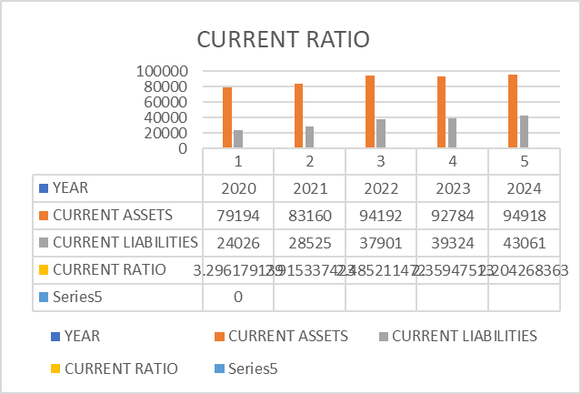

**Interpretation**  
It is evident from the following chart that the company's liquidity situation has been shifting as its current ratio has been declining from 3.2961 to 2.2042.

**Table 2: Debt To Equity Ratio**

|  |  |  |  |
| --- | --- | --- | --- |
| **Year** | **Total Debt** | **Total Shareholders’ Equity** | **Debt To Equity Ratio** |
| **2020** | 104975 | 74368 | 1.411561424 |
| **2021** | 109381 | 74794 | 1.462430141 |
| **2022** | 121263 | 77173 | 1.571313801 |
| **2023** | 119827 | 74538 | 1.607596125 |
| **2024** | 121148 | 72120 | 1.679811425 |

**Chart 2.1**

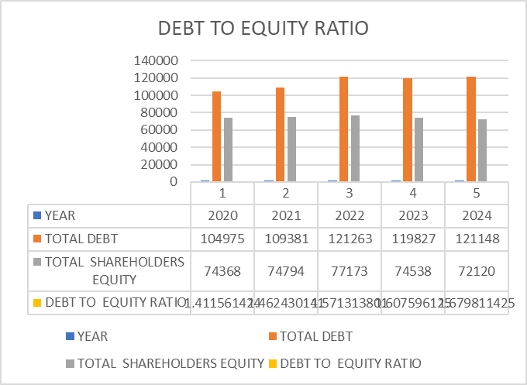

**Interpretation**

The debt-to-equity ratio for five years is displayed in the above figure. This ratio shows the proportion of debt to equity. The ratio is rising annually, according to the graphic. The ratios are 1.4624,1.5713,1.6075,1.6798 and 1.67981 for 2020–2024.

**Table 3: Profitability Ratio**

|  |  |  |  |
| --- | --- | --- | --- |
| **Year** | **Gross Profit** | **Sales** | **Profitability Ratio** |
| **2020** | 131306 | 139388 | 0.942017964 |
| **2021** | 135963 | 141363 | 0.961800471 |
| **2022** | 160341 | 167827 | 0.955394543 |
| **2023** | 190354 | 195682 | 0.972772151 |
| **2024** | 202359 | 209632 | 0.965305869 |

**Chart 3.1**

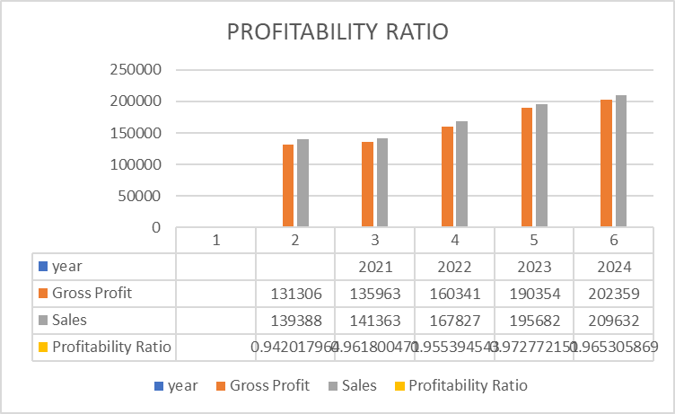

**Interpretation**

Profitability ratios measure business organization efficiency and survival. The 2020 ratio was 0.9420, slightly increased to 0.9727 in 2023, and slightly decreased by 0.96530. The ratio varies annually.

**Table 4: Quick Ratio**

|  |  |  |  |
| --- | --- | --- | --- |
| **Year** | **Cash And Equivalents** | **Current Liabilities** | **Quick Ratio** |
| **2020** | 4824 | 24026 | 0.200782486 |
| **2021** | 3142 | 28525 | 0.110148992 |
| **2022** | 13692 | 37901 | 0.361256959 |
| **2023** | 4543 | 39324 | 0.115527413 |
| **2024** | 6599 | 43061 | 0.153247718 |

**Chart 4.1**

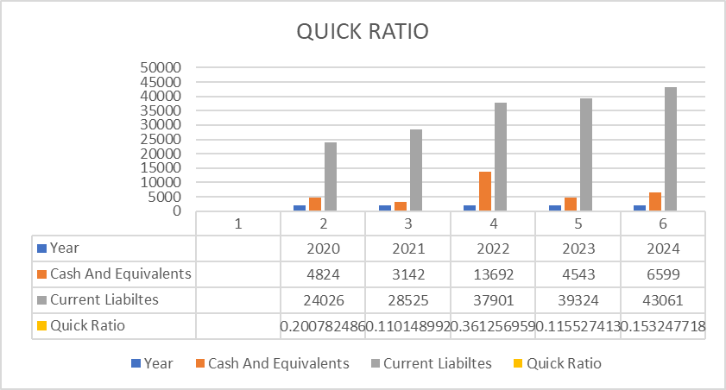

**Interpretation**

The quick ratio, or acid-test ratio, compares a company's short-term obligations and liquidity, fluctuating annually. It initially increased in 2022, then declined in 2023 after that it slightly increased by 0.15324

**Conclusion**  
The study was conducted at Tata Consultancy Service Ltd. to ascertain the financial performance of the organization using ratio analysis. The company's five-year financial report is examined, and it is concluded that its overall financial performance is good. An extremely useful examination of the company's financial performance was given in this report using its financial papers. Based on the statistics, the company's financial performance has been inconsistent every year, thus it has to enhance its efficiency. Revenue and balance sheets from the previous two years are included in the study, along with statistical data and trends found in the documents. Because of my research, I now know a lot more about how to read, comprehend, and assess financial statements.

**References**

**Journals**

* Rohan Joseph P, Bhuvaneshwar D, & Dr. Ibha Rani. (2023, May). A Study on the Financial Performance Analysis of Britannia Industries Ltd. Emerging Trends in Business & Technology, ISBN: 978-81-963044-0-9.
* Mehta, J., Raj, R., & Sharma, S. (2021). FINANCIAL PERFORMANCE ANALYSIS OF SELECTED INDIAN IT COMPANIES: A COMPARATIVE STUDY.
* Jabin, S. (2021). The impact of COVID-19 on the accounting profession in Bangladesh.
* Dodia, B. M. (2020). A COMPARATIVE STUDY OF FINANCIAL ANALYSIS OF CADILA AND TORRENT PHARMACUTICALS IN GUJRAT STATE. Towards Excellence, 12(4).

**Websites**

* <https://kpmg.om>
* <https://taxadda.com>
* <https://www.tcs.com>