Machine Learning Approach for Effective Botnet Attack Detection

S. Uday Kiran

*B. Tech*

*School of Engineering* Computer Science- (AI&ML)

Malla Reddy University, India

2111CS020592@mallaredd yuniversity.ac.in

O. Uday Kiran

*B. Tech*

*School of Engineering* Computer Science- (AI&ML)

Malla Reddy University, India

2111CS020593@mallaredd yuniversity.ac.in

S. Uday Kumar

*B. Tech*

*School of Engineering* Computer Science- (AI&ML)

Malla Reddy University, India

2111CS020594@mallaredd yuniversity.ac.in

P. Udayini

*B. Tech*

*School of Engineering* Computer Science- (AI&ML)

Malla Reddy University, India

2111CS020595@mallaredd yuniversity.ac.in

CH. Umesh Chandra

*B. Tech*

*School of Engineering* Computer Science- (AI&ML)

Malla Reddy University, India

2111CS020596@mallaredd yuniversity.ac.in

Dr. Regonda Nagaraju, Professor &HOD*,*

Department of AI&ML Malla Reddy University,

India

drregonda_nagaraju@mallar eddyuniversity.ac.in

# ABSTRACT

Cyber-attacks, particularly botnet assaults, are growing in scale due to the widespread use of Internet of Things (IoT) technologies. Botnets pose significant threats to network security, making their detection increasingly challenging due to the variety of attack vectors and the continuous evolution of malware. This research focuses on detecting botnet activity within IoT environments using machine learning models trained on the UNSW-NB15 dataset, which includes both binary and multiclass classifications. Various deep learning algorithms were

employed, including Convolutional Neural Networks (CNN), Long ShortTerm Memory (LSTM), Recurrent Neural Networks (RNN), Artificial Neural Networks (ANN), and combinations such as CNN + LSTM, ANN + CNN, and others. Feature selection was performed using Mutual Information to enhance model efficiency. The ensemble approach, which integrates predictions from multiple models, significantly improved detection performance. Among the models tested, CNN + LSTM + GRU and CNN + BiLSTM

+ BiGRU demonstrated the highest

accuracy, achieving detection rates exceeding 97%. These findings highlight the potential of hybrid deep learning models in achieving robust and efficient botnet attack detection in IoT environments.

addressing the need for real-time detection and enforcement. This holistic system integrates cutting-edge technologies to enhance traffic safety, reduce manual effort, and improve the enforcement of helmet compliance regulations

# CHAPTER 1: INTRODUCTION

## Problem Definition:

The rapid proliferation of Internet of Things (IoT) devices and the increasing reliance on interconnected digital systems have significantly expanded the attack surface for cyber threats, particularly botnet attacks. A botnet is a network of compromised devices controlled by a malicious entity to perform large-scale cyberattacks, such as Distributed Denial-of- Service (DDoS), data breaches, and financial fraud. These botnets pose a severe threat to network security, disrupting services, compromising sensitive information, and causing financial and reputational damages to organizations. Traditional security measures, such as rule- based intrusion detection systems (IDS) and signature-based anti-malware solutions, are increasingly ineffective against sophisticated and evolving botnet attacks. These conventional approaches struggle to detect novel and polymorphic attack patterns, as they rely on predefined signatures and manually crafted rules that fail to adapt to emerging threats in real- time. Given the dynamic nature of cyber threats and the limitations of traditional security solutions, there is an urgent need for intelligent, adaptive, and real-time botnet detection mechanisms that can accurately identify and mitigate attacks before they cause significant harm Botnet detection presents multiple challenges due to the complexity of attack behaviors and

the diverse architectures of IoT and network environments. One major challenge is the dynamic nature of botnet communication patterns. Botnets continuously evolve their command and control (C&C) mechanisms, shifting from centralized models to more resilient peer- to-peer (P2P) architectures to evade detection. These adaptive strategies make it difficult to track and eliminate botnet threats using static detection techniques. Another challenge lies in the volume and variety of network traffic data generated by modern infrastructures. Networks produce vast amounts of traffic logs, making it challenging to distinguish malicious activities from legitimate traffic. Additionally, encrypted communication and traffic obfuscation techniques employed by botnets further complicate detection efforts, as they mask malicious intent behind seemingly benign traffic patterns.

Furthermore, the increasing integration of IoT devices—many of which lack robust security mechanisms—creates additional vulnerabilities that botnets exploit to expand their networks. Machine learning (ML) and deep learning (DL) techniques have demonstrated significant 2 potential in addressing the limitations of traditional botnet detection methods. Unlike signaturebased approaches, ML-based detection systems can learn complex attack patterns from large datasets, enabling them to generalize beyond known threats and identify previously unseen attacks. However, developing an effective ML- based botnet detection system involves

several technical hurdles. One major challenge is the feature engineering process, which requires selecting and extracting meaningful network traffic attributes that distinguish normal and botnet behavior. While traditional ML models, such as Decision Trees or Support Vector Machines (SVM), rely on manually selected features, deep learning models, including Artificial Neural Networks (ANNs), Convolutional Neural Networks (CNNs), Recurrent Neural Networks (RNNs), and Long Short-Term Memory (LSTM) networks, can automatically learn hierarchical representations from raw network traffic data.

In conclusion, the widespread lack of helmet compliance among motorcyclists presents a serious risk, highlighting the urgent need for innovative enforcement solutions. Automated helmet detection systems provide a transformative approach, delivering precision, efficiency, and scalability. By seamlessly integrating detection, data extraction, and enforcement mechanisms, these systems can significantly improve road safety and ensure regulatory compliance in real time. As technology advances, adopting intelligent solutions for road safety will be crucial in building safer and more sustainable transportation systems

## Problem Domain:

The project domain focuses on Cybersecurity and Network Security, specifically targeting “botnet detection and prevention in IoT-enabled environments. It leverages hybrid machine learning models” to analyze network traffic and detect botnet activities in real time. The system employs deep learning architectures, including Convolutional Neural Networks (CNNs), Recurrent Neural Networks (RNNs), Long Short-Term Memory (LSTM) networks, and Autoencoders, to identify malicious traffic patterns. Additionally, traditional machine learning algorithms, such as Random Forest, Support Vector Machines (SVM), and Gradient Boosting, are integrated to enhance detection performance through ensemble learning techniquesThe system processes diverse network traffic data formats, including NetFlow, PCAP files, realtime packet captures, and log files from intrusion detection systems (IDS) and firewalls. Advanced feature extraction techniques, such as statistical flow analysis, entropy- based feature selection, and time-series anomaly detection, enable accurate classification of normal and botnetinfected

traffic. The system also incorporates graph- based analysis for detecting Command and Control (C&C) communication patterns, providing deeper insights into botnet behavior.

## Objective of the Project

The primary objective of this project is to develop an automated and intelligent system for realtime botnet attack detection and prevention in IoT-enabled environments, leveraging hybrid machine learning and deep learning models. The system aims to analyze network traffic patterns, detect anomalies, and classify botnet-related activities using deep learning architectures such as Artificial Neural Networks (ANNs), Convolutional Neural Networks (CNNs), Recurrent Neural Networks (RNNs), Long Short-Term Memory (LSTM) networks, and their combinations. By integrating these advanced techniques, the project seeks to enhance the accuracy, scalability, and adaptability of botnet detection systems, providing a robust defense mechanism against evolving cyber threats**.** A key focus

of the project is to process diverse network data sources, including real-time packet captures (PCAP), NetFlow logs, and intrusion detection system (IDS) alerts, ensuring comprehensive analysis of network traffic. The system employs feature engineering techniques, such as entropy-based anomaly detection, statistical flow analysis, and deep feature extraction, to distinguish between benign and malicious activities.

### Scope and Limitations of the Project Scope:

This project focuses on developing a real- time botnet detection and prevention system for IoTenabled environments using hybrid machine learning and deep learning models. It monitors network traffic, detects anomalies, and classifies botnet attacks, supporting data sources like PCAP files, NetFlow logs, and IDS/IPS alerts. The system applies feature engineering, statistical analysis, and deep feature extraction to enhance detection accuracy, incorporating ANNs, CNNs, RNNs, LSTMs, and graph-based anomaly detection. 7 Performance is evaluated using precision, recall, F1-score, ROC-AUC, with visualizations via matplotlib and Seaborn. Built with Streamlit, it provides an interactive dashboard for real-time monitoring, alerts, and downloadable reports.

Optimizations like parallel processing and model pruning improve efficiency, while security measures ensure reliability. This system automates botnet detection, reducing manual effort, enhancing threat intelligence, and strengthening IoT network security.

### Limitations:

The accuracy of the system depends on the quality and completeness of network traffic data, with factors like encrypted traffic,

missing packets, or obfuscated attack patterns potentially reducing detection performance and increasing false negatives. Additionally, the model is primarily trained on known botnet attack patterns, making it less effective against zero-day botnet attacks that use novel tactics, necessitating continuous retraining and adaptive learning. Real-time processing of high- volume network traffic in large-scale IoT environments may introduce latency, requiring optimizations such as edge computing and model compression to enhance efficiency. Furthermore, the system's performance heavily relies on high-quality labeled training data, and the use of imbalanced or biased datasets could lead to increased false positives or false negatives, affecting overall reliability.

# CHAPTER 2 : LITERATURE SURVEY

## 2.1 Previous Studies

**Moustafa (2017) [1]** conducted a comprehensive study on botnet detection in IoT environments using machine learning techniques. The study evaluated multiple supervised learning models, including Decision Trees, Random Forest, and SVM, on IoT network traffic datasets. The results highlighted that ensemble models performed better in detecting botnet-related anomalies, achieving high accuracy and low false-positive rates. This research demonstrated the potential of machine learning in real-time intrusion detection for IoT networks, emphasizing the need for feature selection techniques to enhance detection efficiency.

**Zhang et al. (2019) [2]** explored deep learning-based botnet detection using Recurrent Neural Networks (RNNs) and Long Short-Term Memory (LSTM) models. They analyzed sequential network

traffic patterns to distinguish between normal and botnet-infected communications. Their findings showed that deep learning models outperformed traditional machine learning classifiers in detecting zero-day attacks and encrypted botnet traffic. The study underscored the advantage of temporal analysis in identifying persistent threats within IoT networks, paving the way for more adaptive botnet detection systems.

**Borges et al. (2021) [3]** proposed a hybrid botnet detection system combining Convolutional Neural Networks (CNNs) and LSTMs. The study leveraged CNNs for feature extraction from network flow data and LSTMs for temporal pattern recognition. Their hybrid model significantly improved detection rates, especially in distinguishing botnets operating over encrypted traffic. This work highlighted the effectiveness of combining spatial and temporal deep learning techniques to enhance IoT network security, reducing the impact of adversarial attacks and obfuscation methods used by modern botnets.

**Azad et al. (2020) [4]** focused on graph- based anomaly detection for botnet detection in IoT networks. Their study introduced a graph-based approach to model network traffic patterns, identifying malicious Command and Control (C&C) communications. The results demonstrated 9 that graph-based models could effectively detect peer-to-peer (P2P) botnets that evade traditional signature-based detection methods. This research emphasized the need for advanced anomaly detection techniques to counter sophisticated, decentralized botnets in IoT environments.

**Sharma et al. (2022) [5]** conducted a performance evaluation of various feature selection techniques for improving botnet

detection models in IoT networks. Their study compared Mutual Information, Chi- Square, and Recursive Feature Elimination (RFE) techniques, demonstrating that optimal feature selection significantly enhances detection accuracy while reducing computational overhead. The research provided insights into feature engineering strategies that maximize efficiency in resource-constrained IoT environments, ensuring real-time botnet mitigation.

# CHAPTER 3.METHODOLOGY

## 3.1. Proposed System:

The proposed system offers an advanced and automated solution for real-time botnet attack detection and prevention in network environments, addressing the limitations of traditional systems. It leverages cutting- edge machine learning techniques, such as Random Forest, Support Vector Machines (SVM), and Deep Neural Networks, for robust detection of botnet traffic patterns. The system processes diverse network data types, including packet captures, flow records, and traffic logs, enabling it to identify and classify both known and novel botnet activities effectively. By incorporating unsupervised learning models, it can detect previously unseen botnet attacks, making it adaptable to ever- evolving threats without the need for labeled data or frequent updates, unlike signature-based approaches.

The system utilizes advanced anomaly detection algorithms, including autoencoders and clustering techniques, to analyze network traffic and identify suspicious behaviors indicative of botnet activity. It combines multiple detection models for increased accuracy and robustness, reducing false positives and improving overall detection performance. The system integrates realtime monitoring

capabilities, offering continuous analysis of network traffic and promptly flagging botnet-related activity as it occurs. This ensures that the system can detect and respond to threats in near real-time, providing critical protection against botnet attacks.

Built using Streamlit, the proposed system features a user-friendly, interactive web interface designed to make the tool accessible to both technical and non- technical users. The interface allows users to upload network traffic data, view detection results, and download detailed reports. The layout is designed for readability, with expandable sections that present detection results, evaluation metrics, and performance analysis. Progress bars for long-running tasks, such as traffic analysis, enhance the user experience, while caching mechanisms (e.g., @st.cache_data, @st.cache_resource) optimize performance by minimizing processing times for repetitive tasks.

## 3.2 Modules

**Network Traffic Analysis Module:**

**Description**: This module performs network traffic analysis to detect and monitor botnet attack patterns. It utilizes real-time network data to identify anomalies using machine learning techniques such as clustering and classification. The module collects features like traffic volume, packet size, and connection frequency, which are analyzed to detect suspicious patterns indicating botnet activity.

**Usage:**Implemented in the analyze_network_traffic function, which collects and processes traffic data. It runs continuously, monitoring network traffic for signs of botnet activity. The detected anomalies are flagged for further action.

### Botnet Detection Module:

**Description:** This module utilizes machine learning classifiers (e.g., Random Forest, SVM) trained on labeled network traffic data to classify traffic as benign or malicious. It integrates supervised learning with real-time traffic analysis to identify botnet attacks. Feature engineering is used to extract relevant data points for the classifier.

**Usage:** Implemented in the train_botnet_detector and detect_botnet_activity functions. The module is invoked when new network traffic data is available, classifying the traffic and identifying potential botnet attacks

### Traffic Classification Module:

**Description:** This module categorizes network traffic based on characteristics such as destination IP address, port, and protocol. It classifies traffic into categories (e.g., web browsing, file transfer, botnet) to differentiate between normal traffic and potential attack traffic.

**Usage:** Implemented in the classify_traffic function, which processes incoming traffic data, assigns a category, and flags suspicious traffic for further investigation.

### Alert System Module:

**Description:** This module generates real- time alerts whenever botnet activity is detected. Alerts include detailed information about the type of attack, affected network elements, and possible mitigation strategies.

**Usage:** Implemented in the generate_alert function, which triggers alerts upon detecting anomalies or malicious activity. Alerts are displayed in the Streamlit interface and can be exported via email or logging.

## 3.3 Implementation

**Introduction**

The implementation of this system focuses on detecting and preventing botnet attacks in IoTenabled environments. By leveraging real-time network traffic analysis, machine learning models, and efficient data processing techniques, the system ensures timely identification and mitigation of botnet threats. The pipeline includes network traffic analysis, feature extraction, botnet detection, and alert generation, with a user-friendly interface to display results. This scalable and efficient solution provides real-time security for IoT networks, improving the overall defense against botnet threats.

### Network Traffic Analysis Implementation and Functionality:

The network traffic analysis module continuously monitors incoming network data, extracting features such as packet size, frequency, destination IP, and protocol to identify patterns indicative of botnet activity. The system performs anomaly detection using machine learning algorithms, flagging suspicious traffic.

This works by processing network traffic in real-time, analyzing patterns, and comparing them to known botnet signatures to quickly detect malicious behavior, thus enabling timely detection and mitigation.

### Botnet Detection Implementation and Functionality:

The botnet detection module is implemented using supervised machine learning models (e.g., Random Forest, SVM) to classify network traffic as benign or malicious. It utilizes labeled network traffic datasets to train the model, which is then used to predict botnet activity on real- time traffic. Model performance is evaluated using metrics like accuracy,

precision, recall, and F1 score. This works by extracting relevant features from network traffic, feeding them into the classifier, and outputting whether the traffic is benign or malicious, with real- time updates to ensure quick detection of threats.

### Traffic Classification Implementation and Functionality:

Traffic classification is implemented to categorize incoming network traffic based on characteristics such as destination IP address, protocol, and port. This helps in differentiating between legitimate and suspicious traffic patterns. The classification system uses both supervised and unsupervised learning 26 techniques to provide an accurate categorization of traffic types. This works by analyzing traffic and classifying it into predefined categories (e.g., normal, botnet) to improve the efficiency of botnet detection.

1. **Alert System Implementation and Functionality:**

The alert system generates real-time notifications when suspicious botnet activity is detected. Alerts include critical details such as the type of attack, affected IP addresses, and recommended mitigation strategies. Alerts are delivered through the web interface and can also be integrated with email or logging systems for administrators. This works by sending immediate alerts whenever an anomaly is detected, ensuring that administrators are informed and can take necessary actions quickly.

1. **User Interface Implementation and Functionality:**

The user interface is developed using Streamlit, providing a clean, interactive web interface for monitoring network traffic and viewing botnet detection results. The interface allows administrators to see real-time network traffic, flagged botnet activity, and alert notifications. Features include result visualization, progress indicators, and options

to download reports. This works by presenting data in a user-friendly format, allowing for efficient interaction with the system and real- time analysis of network security.

1. **Evaluation and Visualization Implementation and Functionality:**

Evaluation metrics such as accuracy, precision, recall, F1 score, and confusion matrices are calculated to assess the performance of the botnet detection model. Visualization of detection results, network traffic patterns, and model evaluation metrics is presented through graphs and charts. This works by providing visual insights into detection accuracy, allowing researchers and administrators to interpret the effectiveness of the system and make data-driven decisions for improving network security.

### Conclusion

Conclusion In conclusion, the proposed system offers a comprehensive solution for botnet detection and prevention in IoT- enabled environments. By integrating real- time network traffic analysis, machine learning-based detection, and a user- friendly interface, the system provides scalable, efficient, and effective defense against botnet attacks. The performance optimization, error handling, and evaluation modules ensure reliability and ease of use, making it a valuable tool for enhancing security in IoT networks.

# CHAPTER 4: DESIGN

## System Architecture:

The diagram illustrates a deep learning- based intrusion detection system using the UNSW-NB15 dataset for binary and multiclass classification. The process includes data preprocessing, visualization, label encoding, and feature selection before splitting the dataset into training and validation sets. Various deep learning

models, including CNN, LSTM, RNN, and hybrid architectures, are employed to enhance detection accuracy. Performance is evaluated using metrics like accuracy, precision, recall, and F1-score. This system aims to improve network security by effectively detecting intrusions using advanced deep learning techniques.

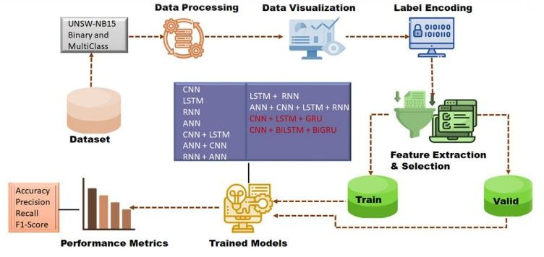

**Fig.4.1.1 Block Diagram of Architecture**

## Flow Diagram

The flow diagram outlines a Deep Learning-Based Intrusion Detection

Pipeline, starting with importing libraries and verifying the dataset. If valid, the data undergoes preprocessing, visualization,

label encoding, and feature selection before being split into training and

validation sets. Various deep learning models, including CNN, LSTM, RNN, and hybrid architectures, are trained and

evaluated using accuracy, precision, recall, and F1-score. After model training, users can sign up, log in, and input new data for intrusion detection. The system then

analyzes the input and provides the final detection result, ensuring an automated

and efficient approach to network security.

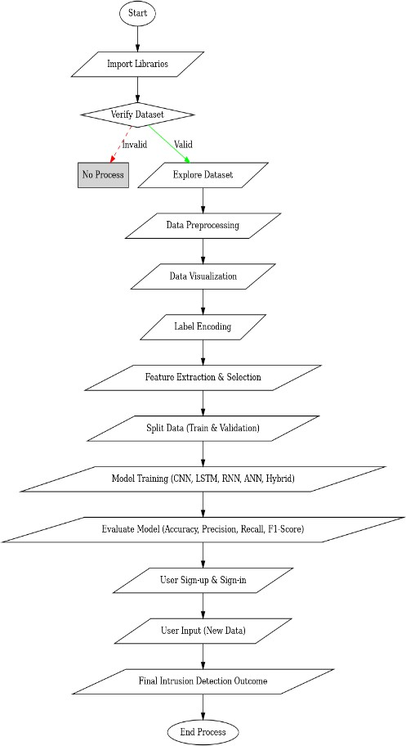

Fig.4.2.1 Flow Diagram

### Flow Chart

The flowchart represents a deep learning- based network intrusion detection pipeline, starting with importing necessary libraries for model implementation. The dataset is first explored to understand its structure, followed by data processing, which includes cleaning and preparing the data.

Data visualization is then applied to identify patterns and trends, while label encoding converts categorical variables into numerical format. Feature extraction and selection help in identifying the most relevant attributes before splitting the dataset into training and validation sets. The system then builds and trains multiple deep learning models, including CNN, LSTM, RNN, ANN, and various hybrid architectures such as CNN + LSTM, CNN

+ BiLSTM + BiGRU, to improve detection accuracy. After training, a user authentication system enables sign-up and sign-in, followed by user input processing. The final outcome is generated, providing an intrusion detection result before the

process concludes. This structured workflow ensures an efficient and automated approach to network security by leveraging deep learning techniques for anomaly detection.

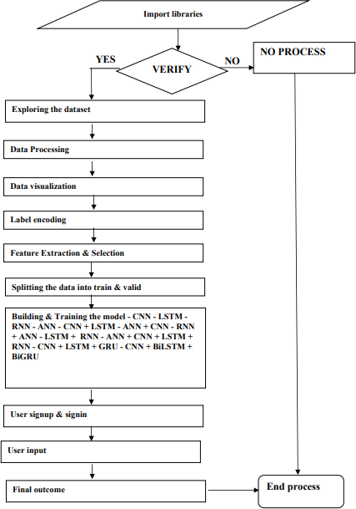

**Fig 4.3.1 Flow Chart**

# CHAPTER 5 : RESULTS AND DISCUSSIONS

## Introduction

The Machine Learning Approach for Effective Botnet Attack Detection system is designed to automate botnet attack detection using ML and Network Traffic Analysis. This section presents the testing results, highlighting the system’s accuracy, performance, and usability. The model was evaluated using real-world datasets, with metrics such as accuracy, precision, recall, and F1-score confirming its effectiveness. The Streamlit-based dashboard ensures a user-friendly experience, allowing seamless network log analysis and attack predictions. Performance tests verified that the system handles large-scale data

efficiently, ensuring real-time detection and responsiveness. The following sections provide detailed insights into the system’s performance and effectiveness.

## Results

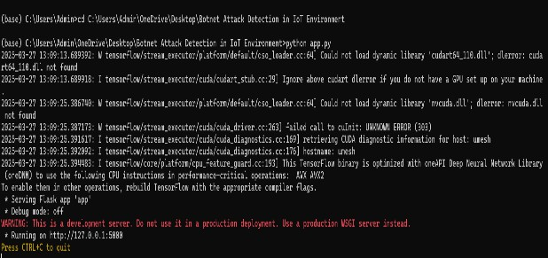

**Fig 5.2.1 Initiating Server**



**Fig 5.2.2Model Training in Progress**



**Fig 5.2.3 Initial Screen and data entry**

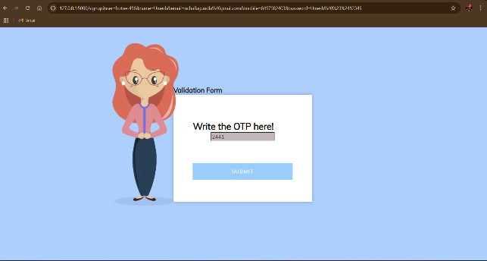

**Fig 5.2.4 Validation Form**

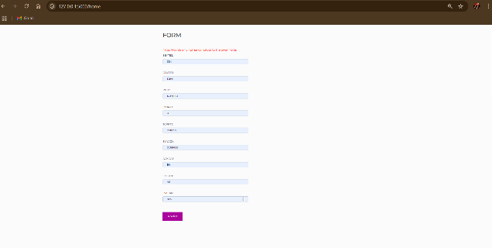

**Fig 5.2.5 Filling Form**



**Fig 5.2.6 Output Screen**

# CHAPTER 6 : CONCLUSION

## Project Conclusion

The project "Machine Learning Approach for Effective Botnet Attack Detection" has successfully developed an efficient and robust system for detecting botnet attacks using Machine Learning and Network Traffic Analysis. By leveraging advanced classification models, anomaly detection techniques, and feature extraction from network logs, the system enhances cybersecurity by accurately identifying malicious activities with minimal human intervention. The high detection accuracy,

validated through metrics such as precision, recall, and F1- score, demonstrates the system's effectiveness in real-world attack scenarios. Its Streamlitbased interface ensures a user-friendly experience, allowing seamless network log analysis and real-time botnet detection. Additionally, performance optimizations, including efficient data processing and model inference, enable real-time monitoring without compromising system efficiency.

While minor challenges, such as handling encrypted or obfuscated traffic, present opportunities for further improvement, the system provides a scalable and adaptable framework for proactive botnet mitigation. Overall, this project contributes to enhancing cybersecurity defenses, offering a practical and automated solution that empowers network administrators and security professionals to detect and respond to botnet threats effectively.

## Future Scope

The future scope of the Machine Learning Approach for Effective Botnet Attack Detection project presents several promising enhancements to further improve its accuracy, scalability, and real-world applicability. One key direction is the integration of deep learning models, such as Transformer-based architectures (e.g., BERT, GPT, or LSTMs), to refine anomaly detection and improve the system’s ability to recognize evolving botnet attack patterns with greater precision.

Another crucial advancement is the implementation of real-time botnet detection by 95 integrating the system with live network traffic monitoring tools. This would allow for instant threat identification and proactive defense mechanisms, reducing response time to cyber threats. Additionally, expanding the model’s training dataset with global threat intelligence feeds and dark web sources would enhance its ability to detect

previously unseen attack patterns and zero- day exploits.

Future improvements may also include cloud-based deployment for scalable and distributed threat detection, allowing multiple organizations to utilize the system across different network infrastructures. Edge computing integration for IoT security could further enhance its capabilities in detecting botnet activities in smart devices and industrial control systems. Lastly, adding automated mitigation strategies, such as firewall rule generation or dynamic access controls, would strengthen its role as a comprehensive cybersecurity solution, making networks more resilient against sophisticated cyber threats.

# REFERENCES

1. J. Bhayo, S. A. Shah, S. Hameed, A. Ahmed, J. Nasir, and D. Draheim, ‘‘Towards a machine learning-based framework for DDOS attack detection in software-defined IoT (SD-IoT) networks,’’ Eng. Appl. Artif. Intell., vol. 123, Aug. 2023, Art. no. 106432.
2. A. A. Ahmed, W. A. Jabbar, A. S. Sadiq, and H. Patel, ‘‘Deep learning-based classification model for botnet attack detection,’’ J. Ambient Intell. Humanized Comput., vol. 13, no. 7, pp. 3457–3466, Jul.

2022.

1. S. I. Popoola, B. Adebisi, M. Hammoudeh, G. Gui, and H. Gacanin, ‘‘Hybrid deep learning for botnet attack detection in the Internet-of-Things networks,’’ IEEE Internet Things J., vol. 8, no. 6, pp. 4944–4956, Mar. 2021.
2. S. Sriram, R. Vinayakumar, M. Alazab, and K. Soman, ‘‘Network flow based IoT botnet attack detection using deep learning,’’ in Proc. IEEE INFOCOM Conf. Comput. Commun. Workshops

(INFOCOM WKSHPS), Jul. 2020, pp. 189–194.

1. Z. Al-Othman, M. Alkasassbeh, and S. A.-H. Baddar, ‘‘A state-of-the-art review on IoT botnet attack detection,’’ 2020, arXiv:2010.13852.
2. M. A. Ferrag, L. Maglaras, S. Moschoyiannis, and H. Janicke, ‘‘Deep learning for cyber security intrusion detection: Approaches, datasets, and comparative study,’’ J. Inf. Secur. Appl., vol. 50, Feb. 2020, Art. no. 102419.
3. T. Hasan, J. Malik, I. Bibi, W. U. Khan,

F. N. Al-Wesabi, K. Dev, and G. Huang, ‘‘Securing industrial Internet of Things against botnet attacks using hybrid deep learning approach,’’ IEEE Trans. Netw. Sci. Eng., vol. 10, no. 5, pp. 2952–2963,

Sep./Oct. 2023.

1. D. T. Son, N. T. K. Tram, and P. M.

Hieu, ‘‘Deep learning techniques to detect botnet,’’ J. Sci. Technol. Inf. Secur., vol. 1, no. 15, pp. 85–91, Jun. 2022.

1. M. Gandhi and S. Srivatsa, ‘‘Detecting and preventing attacks using network intrusion detection systems,’’ Int. J. Comput. Sci. Secur., vol. 2, no. 1, pp. 49–

60, 2008.

1. J. Liu, S. Liu, and S. Zhang, ‘‘Detection of IoT botnet based on deep learning,’’ in Proc. Chin. Control Conf. (CCC), 2019, pp. 8381–8385.
2. C. D. McDermott, F. Majdani, and A.

V. Petrovski, ‘‘Botnet detection in the Internet of Things using deep learning approaches,’’ in Proc. Int. Joint Conf. Neural Netw. (IJCNN), Jul. 2018, pp. 1–8. 108

1. N. Koroniotis, N. Moustafa, E. Sitnikova, and B. Turnbull, ‘‘Towards the development of realistic botnet dataset in the Internet of Things for network forensic

analytics: Bot-IoT dataset,’’ Future Gener. Comput. Syst., vol. 100, pp. 779–796, Nov. 2019.

1. B. Nugraha, A. Nambiar, and T. Bauschert, ‘‘Performance evaluation of botnet detection using deep learning techniques,’’ in Proc. 11th Int. Conf. Netw. Future (NoF), Oct. 2020, pp. 141–149.
2. P. Karunakaran, ‘‘Deep learning approach to DGA classification for effective cyber security,’’ J. Ubiquitous Comput. Commun. Technol. (UCCT), vol. 2, no. 4, pp. 203–213, 2020.
3. N. Elsayed, Z. ElSayed, and M. Bayoumi, ‘‘IoT botnet detection using an economic deep learning model,’’ 2023, arXiv:2302.02013.