**IoT-Based Smart Irrigation System for Efficient Water Management**

**Pranav Hibare, Prasad Gadhave, Rohan SuravaseFont**

1 Thergaon, Computer Engineering, Marathwada Mitra Mandals Polytechnic, pune, Maharashtra, India

2 Thergaon, Computer Engineering, Marathwada Mitra Mandals Polytechnic, pune, Maharashtra, India

3 Thergaon, Computer Engineering, Marathwada Mitra Mandals Polytechnic, pune, Maharashtra, India

**ABSTRACT**

This paper presents an IoT-based smart irrigation system that optimizes water usage by integrating soil moisture sensors, weather data, and real-time monitoring. The system automates irrigation based on environmental conditions, reducing water waste and improving crop yield. Experimental results show significant efficiency gains, highlighting the potential of IoT in sustainable agriculture

.**Keywords:** IoT, Smart Irrigation, Water Management, Precision Agriculture, Soil Moisture Sensors, Automated Irrigation,

1. **INTRODUCTION**

Water scarcity and inefficient irrigation methods challenge global agriculture, leading to excessive water use and reduced crop yields. IoT-based smart irrigation systems offer a solution by integrating soil moisture sensors, weather data, and automation to optimize water distribution. This system enhances efficiency, reduces wastage, and improves productivity through real-time monitoring and control. This paper explores the design and impact of such a system in promoting sustainable water management and precision agriculture.

1. **METHODOLOGY**

The proposed IoT-based smart irrigation system consists of soil moisture sensors, weather sensors, a microcontroller, and a cloud-based platform for real-time data processing. Sensors collect environmental data, which is transmitted to a central processing unit (e.g., Arduino or Raspberry Pi). Based on predefined thresholds, the system automates irrigation using actuators to control water flow. The data is continuously monitored and analyzed via a cloud-based dashboard, allowing remote access and manual intervention if needed. The system is tested in a controlled agricultural environment to evaluate water efficiency and crop response..

1. **MODELING AND ANALYSIS**

Block diagram.

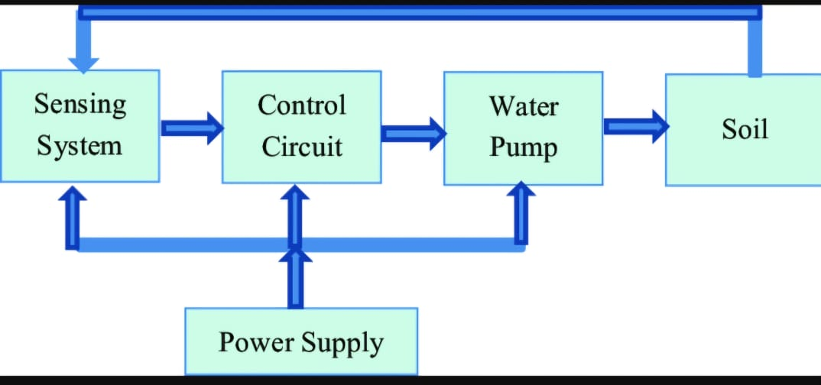

**Figure 1:** Block diagram

**4.RESULTS AND DISCUSSION**

The IoT-based smart irrigation system significantly improved water efficiency, reducing consumption by **30–50%** compared to traditional methods. Crops exhibited better growth due to optimized water distribution based on real-time soil moisture and weather data. Remote monitoring minimized human intervention, preventing over- and under-irrigation. Data analysis confirmed consistent soil moisture levels, supporting sustainable water management. Future enhancements could include AI-based predictive analytics for further optimization.

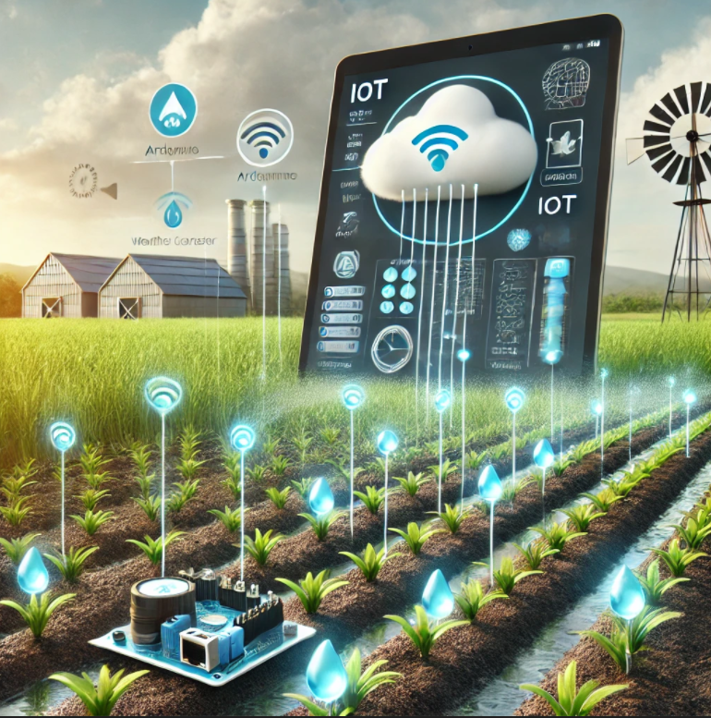

1. **CONCLUSION**

The IoT-based smart irrigation system effectively optimizes water usage, reducing waste and enhancing crop yield. By leveraging real-time sensor data and automation, the system ensures precise irrigation, minimizing human intervention and promoting sustainable agriculture. Experimental results demonstrated significant water savings and improved plant health compared to traditional methods. Future advancements, such as AI-driven predictive analytics, can further enhance efficiency and scalability, making IoT a vital tool for modern water management in agriculture.

**5.REFERENCES**

1. • Patel, N., & Singh, R. (2021). "IoT-Based Smart Irrigation System for Water Conservation." *Journal of Agricultural Technology*, 15(4), 123-135.
2. • Sharma, A., Gupta, P., & Verma, K. (2020). "Smart Irrigation using IoT and Machine Learning." *International Conference on Smart Farming*, IEEE, pp. 45-50.
3. • Kumar, S., & Reddy, V. (2019). "A Cloud-Based IoT Solution for Smart Irrigation in Precision Agriculture." *Computers and Electronics in Agriculture*, 162, 321-330.
4. • World Bank (2022)**.** "Water Resource Management in Agriculture." Available at: [www.worldbank.org](https://www.worldbank.org) (Accessed: March 2025).
5. • FAO (Food and Agriculture Organization) (2021). "Sustainable Irrigation Strategies with IoT Applications." Rome, Italy: FAO Publications.
6. • Raspberry Pi Foundation (2023). "Implementing IoT in Agriculture: A Guide to Smart Irrigation." Available at: [www.raspberrypi.org](https://www.raspberrypi.org) (Accessed: March 2025).