**REVIEW PAPER ON HYDRAULIC CHARACTERISTICS OF GSB MIX**

***Prashant Kumar1*, Shivani2***

*1Student, 2Assistant Professor*

*Sat Priya Group of Institutions, Rohtak*

***\*Corresponding Author***

***E-mail Id:-prashantkumar160293@gmail.com***

***ABSTRACT***

Good drainage is essential for the operation of the road. Excessive moisture in the substrate, sub-base and sub-base can cause premature problems and premature failure of the coating. Therefore, the cost of road maintenance and the cost of improving water quality should be compared when choosing an appropriate repair strategy. Therefore, it is necessary to analyze the effects of different types of waterproofing on road properties.A granular base (GSB) is placed near the surface of the foundation and below the bearing layer in the structure for drainage and load transfer into the layer.

In India, pavement design guidelines recommend GSB thickness based on subgrade performance and design traffic conditions. By examining the permeability of the GSB mixture, it is necessary to understand the importance of the fluidity of the GSB mixture in road construction. Current guidelines in India recommend the use of natural sand, calcareous soil, gravel, crushed stone or a combination of these in GSB layers. In special cases, the use of crushed slag, crushed stone, bricks and kankar will be allowed. While the above connections may meet design standards, it is unclear whether they will meet the minimum AASTO code requirement of 300 m/day.

***Keywords:-*** *waterproofing, subgrade, granular base, compacted subgrade, crushed concrete*

**INTRODUCTION**

A granular base (GSB) is placed just above the subgrade and below the base layer in the pavement structure as shown in Fig. The main purpose of providing granular subgrades (GSB) in road pavements is to serve stability and drainage function. In India, current guidelines recommend the use of natural sand, moorum, gravel, crushed stone or a combination of these in the GSB layer. Crushed slag, crushed concrete, brick and kankar may be allowed in special cases.

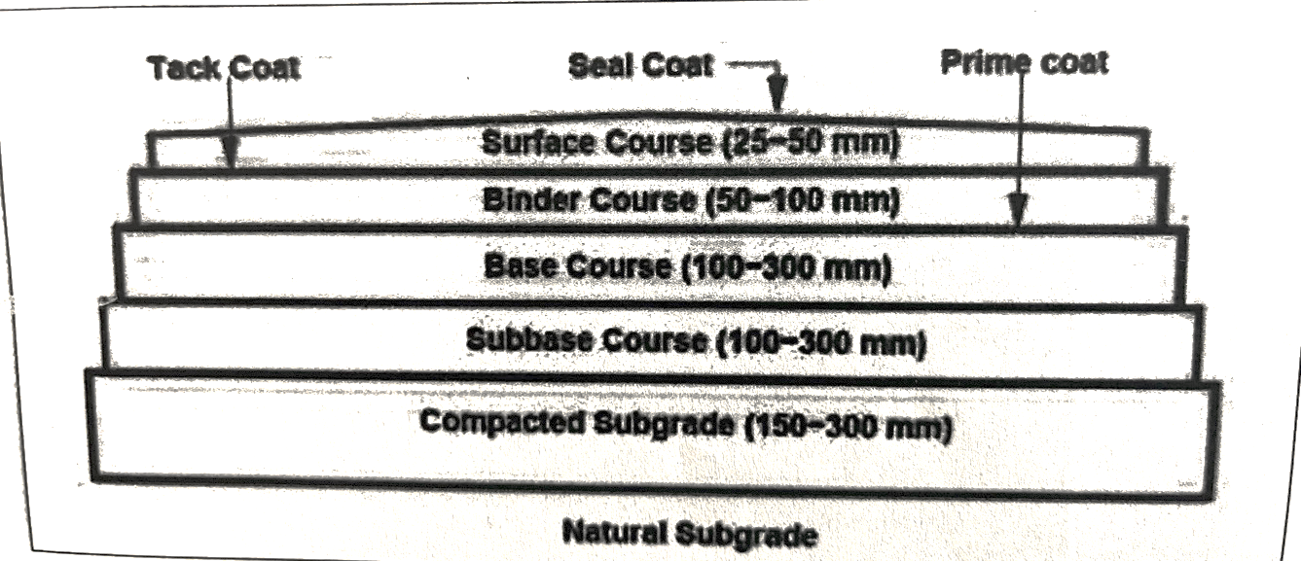

Fig. Cross-section of a pavement structure

In recent years, numerous studies have shown that a large percentage of road pavements in India are threatened by excessive moisture in the pavement structure and increasing traffic loads and volumes. Excessive moisture occurs in the construction of the roadway due to insufficient drainage of the subgrade and subgrade. According to the AASHTO Guide (1993), most pavement design methods are used to design the pavement to resist the combined effects of loading and moisture. However, they do not take into account the potential destructive effects of water in the roadway structure. As a result, these pavements have a shorter lifespan than intended, moisture enters the pavement structure either through cracks, joints, pavement surfaces and shoulders, or by ground water from a broken aquifer or high water table When water becomes trapped in the pavement structure, it causes it has many negative effects, as described below.

(1) Reduced strength of unbound granular materials,

(2) Reduced strength of roadbed soils,

(3) Pumping of concrete pavements with subsequent faulting. cracking, and general shoulder deterioration, and

(4) Pumping of fines in the aggregate base under flexible pavements with resulting loss of support.

**LITERATURE REVIEW**

Excessive moisture in the pavement structure (surfacing, subgrade and subgrade) and subgrade can cause a variety of problems that lead to overall damage to the pavement and ultimately total destruction of the pavement if remedial measures are not taken.

Unsatisfactory pavement performance from excessive subsurface water can be found in both asphalt concrete (AC) and portland cement (PCC) pavements. If the pavement structure and subgrade become saturated with groundwater and/or infiltration, its ability to carry dynamic loads caused by traffic can be significantly impaired. For asphaltic concrete (AC) pavements, this deterioration is primarily the result of the temporary development of very high pore water pressure and subsequent loss of strength in the unbonded subgrade, subgrade, and subgrade under dynamic loading. In a Portland cement (PCC) pavement, water and fines are sprayed, called pumping, at the joints between slabs and/or edges between slabs and shoulders. Concrete slabs may crack due to lack of adequate support (Cedergren et al. 1973).

According to Moulton (1980), the effects of excessive subsurface water can be classified into two general categories: (1) slope instability, including sliding and sliding of incised slopes and side hill fills, and (2) unsatisfactory pavement properties as manifested by, e.g., premature rutting, cracking , breakdowns, increasing roughness and a relatively rapid decline in usability. Slope instability occurs when applied shear stresses exceed the strength of the soil or rock mass along the potential sliding surface. Subsurface water can contribute to this instability by increasing stress levels and reducing shear strength.

Another adverse effect of excessive moisture results from freeze-thaw cycles (Moulton, 1980). If water is present in the base, subgrade, and subgrade, the moisture will migrate through the capillary strip toward the frost front to enlarge the ice lenses. During the freezing season, the growth of ice lenses can lead to substantial lifting of the underlying pavement structure. This is called the frost-sublimation phenomenon. During the spring thaw period, melting ice lenses cause subsoil saturation. Since thawing generally occurs from top to bottom, excess moisture from the subgrade will flow into voids that exist in the pavement structure.

The permeability coefficient of granular soil is influenced by its particle size distribution. Consequently, well-sorted soils can be expected to be less permeable than more uniform soils. Cedergren and Harry (1987) illustrated a graph showing permeability for soils of varying gradation and density.

A drainage layer as a base is preferable (Huang, 1993). In addition to the base layer, permeable materials treated with cement can be used as a surface layer. It has been widely used as a surface course in states such as Florida, New Mexico, and Utah (Ghafoori and Dutta, 1995).

**PHYSICAL PROPERTIES OF MATERIAL & METHODS OF TESTING**

Specific Gravity: The specific gravity tests were conducted on material to know the porosity of the material. The tests were carried out using Pycnometer shown in fig. and following observations are taken.

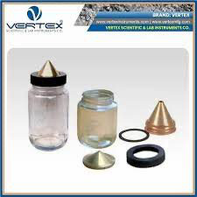 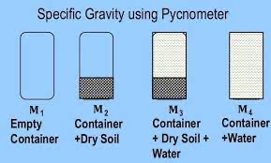

Figure. Pycnometer used in laboratory Figure. Measurement taken in Pycnometer

A particular size of aggregate is taken for which specific gravity is to be determine. An empty pycnometer is taken and weighed as W₁. After that Aggregates are filled in pycnometer up to its two-third height and weighed as W2, then the pycnometer having aggregates is filled with water up to its top and then pycnometer is tightened with its conical cover having a hole of 6mm diameter at its apex, again water is filled in pycnometer through the hole of conical cover to remove the entrapped air from the pycnometer, rotation of pycnometer is done while filling the water, it helps in removing the entrapped air from aggregates. Water is filled until no air bubble is seen in pycnometer, after removing air bubble it is weighed as W3. At last pycnometer is emptied and filled with water only, having no air bubble and weighed as W4. The specific gravity of aggregates is then determined as per IS 2386 part III-1963 by using equation 4.

Gs = (W2-W1) / (W4-W1)-(W3-W2)

eq" (4)

Where  
W-1 weight of empty Pycnometer

W2-weight of Pycnometer dry material

W3-weight of Pycnometer material water

W4-weight of Pycnometer+ water

Bulk Density: The bulk density of aggregates is measured by using a mould having diameter six times more than the size of aggregate as shown below

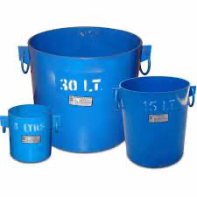  
Fig. Cylinder used in laboratory for measuring density of aggregates.

Aggregates of same sizes are filled in five layers in a cylinder shown in figure 3.3 having a volume calculated as VT. Every layer of aggregate is compacted with 25 number of blows with the tamping rod having round end. The weight of aggregate fully filled the cylinder is noted as Ws. And then bulk density of aggregate is determined as per IS 2386 part III-1963 by using equation 5.  
Ms Vt

eq" (5)

Where  
ys-Bulk density of aggregate

Ms-Mass of aggregate

V-Total volume of aggregate

Aggregate Impact test: Impact test is carried out to determine the impact value of coarse aggregate passing through 12.5mm IS sieve and retained on 10mm IS sieve The testing machine used is shown in fig. The maximum value of aggregate impact test as per MORTH (2013) should not be more than 40 %. The test sample. consists of aggregates passing 12.5mm IS sieve and retained on 10mm IS sieve and dried in oven for four hours at a temperature of 100°c to 110c and cooled. The aggregates are filled up to about one-third full in the measuring cylinder and tamped 25 tomes with rounded end temping rod. Further quantity of aggregates is then added up to two-third full in cylinder and again 25 strokes of tamping rod are given. The cylinder is now filled with the aggregate to over flow, tamped 25 times. The surplus aggregates are struck off using the tamping rod as straight edge. The net weight of aggregate is measure to nearest gram and this weight of aggregate is noted as A.  
The aggregate impact test machine is placed with its bottom plate flat on the horizontal floor so that the hammer guide column are vertical. The cup is fixed firmly in position on the base of the machine and the whole of the test sample from the cylindrical measure is transferred to the cup and compacted by tamping rod with 25 strokes. The hammer is raised until its lower face is 380mm above the surface of aggregate in the cup and allowed to fall freely on the aggregates. The sample is subjected to a total of 15 such blows of the hammer, each blow being delivered at an interval of not less than one second. The crushed aggregate is then removed from cup and the whole of it sieved on 2.36 mm sieve until no further significant amount passes. The fraction passing this sieve is weighted accurate to 0.1g and is noted as C. And the impact value of aggregate is determined as per IS 2386 part III-1963, by using equation (6). The fraction retained on the sieve is also weighted and if the total weight of the fraction passing and retained on the sieve is added, it should not less than the original weight of the specimen by more than one gram, if the total weight is less than the original by over one gram, the result should be discarded and a fresh test camed out.

**CONCLUSIONS**

The objectives were fulfilled through experimentation and analysis of test data. A constant head permeability setup was designed to study the permeability of different types of grading of GSB mix. Tap water collected in a water tank was passed through the specimens in order to determine the permeability, of different gradations of GSB mixes

Several tests were conducted in the laboratory for this study. Material are prepared and compacted into a horizontal permeameter made of metallic plate. All specimen dimensions were 30cm x 30cm x 30cm. For tests only tap water was used, to pass through the specimens. The flow of water was continued until it reached to a steady state of flow.

REFERENCES

1. IS 2386 part III (1963), Method of test for aggregate. Specific Gravity. Density Impact value, and Water absorption Bureau of Indian Standards (BIS) .

2. IS 383 (1970) Indian standard specifications for Course and fine aggregates from natural source of concrete" (second revision).  
3. Cedergren, H.R. KH. O'Brien, and J.A. Arman, (1973) "Guidelines for the Design of Subsurface Drainage Systems for Highway Structural Sections Report No. FHWA-RD-30-72, Washington, DC.  
4. Moulton L.K. (1980). "Highway Sub drainage Design", Federal Highway Administration, Report No. FHWA-TS-80-224.

5. Ridgeway H.H. (1982). "Infiltration of water through the pavement surface" Transportation research record no. 616, pp. 98-100. Washington D.C.