“**A Study on Intersection of Innovation and sustainability. How Technology drives Corporate Environmental Responsibility”**.

Authors: -

¹Mr. Sunil Hegde, ²Arvind Krishna P, ³Eshika Singhania, ⁴Varshini Umesh,

⁵Priyanshu Mevawalla, ⁶Sameer Umar.

¹Assistant Professor, ²³⁴⁵⁶Students, Bachelor of Business Administration

Jain (Deemed–to–be University) - Center for Management Studies, Bangalore.

**Abstract**

Innovation and sustainability work together, focusing on how new technologies are pushing companies to be more environmentally responsible. With the planet facing serious challenges, businesses are turning to creative tech solutions to lessen their impact.This research dives into how things like AI, blockchain, and renewable energy are helping companies cut down on carbon emissions, use resources smarter, and embrace a circular economy where nothing goes to waste. We're combining theory with real-world examples to understand what makes companies adopt these green technologies, from internal company culture to government regulations. Our goal is to show how smart innovation can actually boost profits while also protecting the environment. Ultimately, we argue that technology is key to making real, lasting changes in how businesses operate, to a more sustainable future.

**Keywords:-** Innovation, Sustainability, Technology, Corporate Environmental Responsibility (CER).

**Introduction**

Think about it: we're living in a time of incredible tech advancements, yet we're also facing a serious environmental crisis. Industries are booming, we're buying more stuff, and it's putting a huge strain on our planet. Climate change, disappearing wildlife, and dwindling resources it's a real wake-up call. This means companies can't just focus on making money anymore. They've got to step up and be environmentally responsible. And that's where innovation and sustainability meet it's not just a good idea, it's absolutely necessary. We used to think of innovation as just a way to make more money. But now, with all these environmental challenges, we need to use it to protect our planet. This paper is all about exploring how new technologies are changing the way companies do business, pushing them towards a more sustainable future. Being environmentally responsible isn't just about charity anymore. It's become a core part of how companies operate, affecting everything from their daily routines to their supply chains. This shift is happening because people are more aware, regulations are stricter, and investors are focusing to things like environmental, social, and governance (ESG) performance.

Technology is our biggest ally in tackling these sustainability challenges. It gives us the tools to monitor, manage, and reduce our environmental impact. From using AI to save energy to using blockchain to make sure our supply chains are transparent, tech is crucial. One of the biggest areas where tech is making a difference is in cutting down on carbon emissions. We need to fight climate change, so we're seeing more solar and wind power, and smart grids powered by AI are making energy distribution more efficient. Plus, there are promising developments in carbon capture technology. Making the most of our resources is another key part of being environmentally responsible. Technologies like 3D printing, advanced materials, and better recycling are helping us move towards a circular economy, where we minimize waste. These innovations let companies design products that last longer and can be recycled.

Technology also makes supply chains more transparent, letting companies track their environmental impact and ensure ethical sourcing. Blockchain, for example, helps us trace where products come from, building trust with customers. But, of course, there are challenges. Getting companies to adopt these sustainable technologies isn't always easy. Things like leadership commitment and company culture play a big role and government regulations can either help or hinder progress.

**Objectives**

1. To find out how exactly does tech help companies be more environmentally responsible.
2. To examine what cool new technologies are actually being used to help the environment things like AI, blockchain, and renewable energy to see how they're being applied in the real world.
3. To identify what makes companies actually use these green technologies.
4. To understand what helps or hinders companies when they try to adopt sustainable practices is its internal company culture, government rules, or something else entirely?
5. To provide companies practical advice on using tech for sustainability and to provide useful tips and recommendations that companies can actually use.

**Review Of Literature**

Several studies highlight the intertwined nature of sustainability and digital transformation in contemporary business. Researchers like Tran Thi My Dung and Nguyen Duc Bao Long (2023) observed that in Long An Province, businesses achieving a balance between green innovation and digital tools gained a significant competitive edge, emphasizing stakeholder involvement. Changchun Zhu and colleagues (2022) demonstrated the impact of large data analytics on enhancing sustainable supply chains within Pakistan's automotive sector, revealing how data-driven insights improve operational efficiency while maintaining eco-friendly practices. Zoltán Csedő et al. (2022) explored the energy sector’s post-pandemic corporate governance, noting that flexibility and innovation were vital for upholding ESG commitments. Further, Nuria Chaparro-Banegas et al. (2023) conducted a bibliometric analysis to identify key themes in eco-innovation research, stressing the importance of policy and collaboration. Morteza Ghobakhloo and associates (2021) examined Industry 4.0 technologies and their role in sustainable innovation, identifying benefits such as improved collaboration and greener production.Whereas, Baskar, Shaji George (2024) discussed major technological trends and their influence on business and IT leadership, offering strategic recommendations for navigating modernization and ESG commitments. Fujia Li and co-authors (2023) explored responsible innovation in China, highlighting the impact of government policies and institutional frameworks.Florian Lüdeke-Freund (2019) introduced a framework for sustainable business model innovation, focusing on entrepreneur’s roles as well as external influences.Baoliang Hu (2020) discuss relationship of CSR as well as the business model innovation, finding that CSR efforts enhance public perception and adaptability.Thijs Geradts and Nancy Bocken (2019) conducted a qualitative study examining organizational barriers and enablers in sustainable business model innovation.Adriana Grigorescu and her team (2019) identified key drivers of sustainability-focused innovation, including government policies and technological investment.Finally, Barbara Brenner (2018) explored how digital transformation can integrate sustainability, offering a framework for developing sustainable business models through digitalization.Collectively, these studies underscore the evolving landscape where technological advancement and sustainable practices are increasingly inseparable, shaping the future of business. A collection of scholarly works delves in the relationship of organizational capabilities, innovation, as well as sustainable business practices. Dzhengiz and Niesten (2019) explored how a company's capacity to absorb and utilize external knowledge cultivates the managerial skills necessary for environmental sustainability. Vanhaverbeke and Peeters (2005) examined the challenges large corporations face in adapting to disruptive innovation, focusing on the ability to balance established strengths with the pursuit of new opportunities. Serrano-García and colleagues (2021) investigated the factors that drive green product innovation within the manufacturing sector, proposing a model to assist companies in developing and evaluating their sustainable capabilities. Sun and Guo (2022) analysed digital transformation impact on green innovation, suggesting policy changes to address the productivity paradox. Di Vaio et al. (2022) reviewed the ethical and responsible innovation practices within the Asian fashion industry, highlighting the discrepancies between stated commitments and actual implementation. Roblek and their team (2020) compared how academic and media sources portray Industry 4.0 and sustainability intersection, emphasizing importance in a blended perspective. Song and associates (2023) identified the diverse influences that shape digital innovation within businesses, arguing that a combination of factors, rather than a single element, is crucial for success. Finally, Zhu and others (2023) explored how open innovation can foster corporate social responsibility, pointing to the value of stakeholder collaboration while also noting the necessity for further theoretical refinement. Collectively, these studies paint a picture of businesses navigating an environment where adaptation, ethical conduct, and sustainable innovation are increasingly vital for long-term viability. exploring the multifaceted landscape of sustainable business practices, recent studies have shed light on the diverse factors driving green innovation. Severo and Guimarães (2021) examined how generational differences in Portugal and Brazil perceive influence on collaborative innovation models on eco-innovation, and its subsequent environmental sustainability impact, highlighting critical roles of stakeholder integration. Li and Wang (2023) investigated the burgeoning digital economy in China, revealing its positive influence on green innovation within industrial enterprises, particularly state-owned entities, through enhanced public awareness and optimized energy structures. Saxena, Seetharaman, and Shawarikar (2024), through a systematic literature review, identified key enablers for sustainable innovation, such as strong leadership, adaptable capabilities, and meaningful stakeholder engagement, proposing a conceptual framework grounded in sustainability theories.Lastly, Li and colleagues (2022) delved into the mechanisms behind enterprise green innovation, employing a coevolutionary theory lens and meta-analysis to demonstrate how economic, political, social, and technological environments significantly shape green innovation behaviors, and how these behaviors, in turn, positively impact environmental performance, while also accounting for regional variations.Finally, all of these studies offer a nuanced insights of the complex interplay between innovation, sustainability, and organizational dynamics, providing practical advices to businesses as well as policymakers striving to foster a more environmentally conscious and economically viable future.

**Research Methodology**

1. **Primary Data** - This research utilized a combination of primary and secondary data sources. For the primary data collection, a survey was administered to a sample of 50 individuals. The participants were selected from a broad age range, specifically those 18 years and older.
2. **Secondary Data** - To supplement this firsthand information, secondary data was gathered from a variety of sources. These included scholarly articles and research found through Google Scholar, providing a comprehensive background and contextual framework for the study. To analyse the data percentage analysis method was applied.

**Research Gap**

**There is not really much how well green technologies work over the long haul.** A lot of studies tell us what could happen, but we need to know if these technologies actually deliver on their promise’s years down the line. We need to follow companies over time to see the real impact. **We're treating all industries the same, but they're not.** We know tech can help, but how does it change things in a factory compared to an office? We need to look at specific industries and compare them to see what's really happening. **We’re forgetting about the people side of things.** We're focused on the tech and the money, but what about fairness? Will everyone have access to these technologies? Will people lose their jobs? How do we make sure AI is used ethically for the environment? **We’re not digging deep enough into company culture.** We know it matters, but how exactly? Does a boss who's super passionate about sustainability make a bigger difference? How do we get employees excited about using these new technologies? **The rules are always changing, and we're struggling to keep up.** New regulations are popping up all the time. How are these rules affecting companies' ability to use sustainable tech? We need to figure out how to make tech and regulations work together.

**Data Analysis and Interpretation**

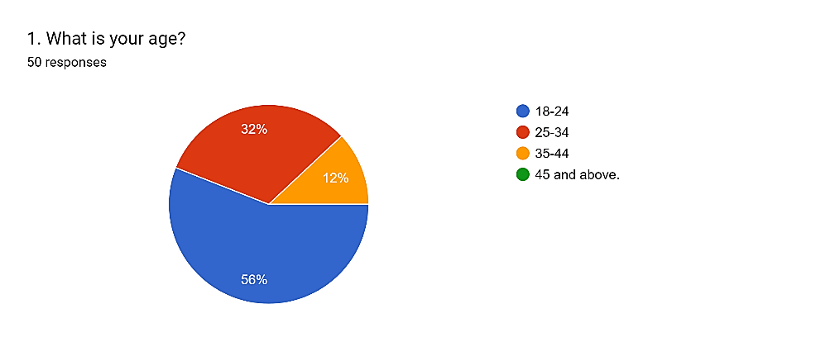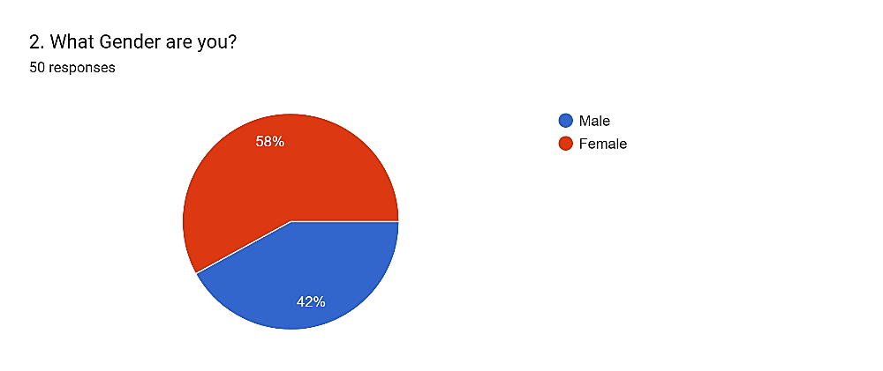

**Fig.1** - Interpretation: - From the analysis above, 56% respondents are age (18-24), whereas 32% are age (25-34), and 12% are age (35-44).

**Fig.2** - Interpretation: - From the analysis above, majority respondents are Female (58%) and male (42%).

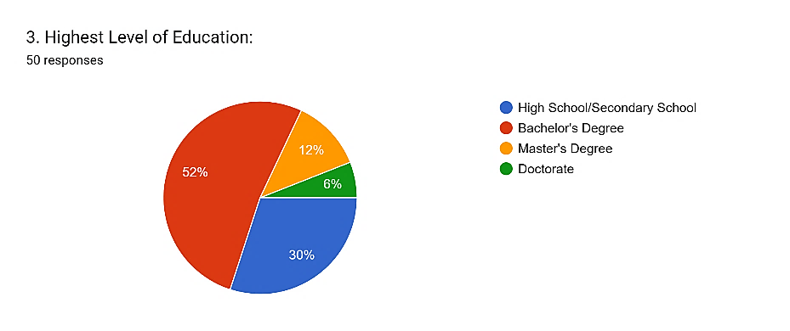 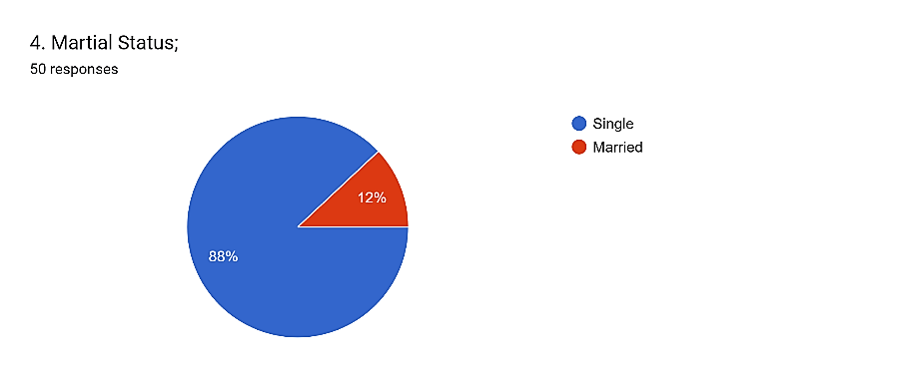

**Fig.3** - Interpretation: - From the analysis above, we see almost 30% of the respondents have done High School/Secondary School, whereas 52% in Bachelor's Degree, 12% in Master's Degree, and 6% in Doctorate.

**Fig.4** - Interpretations: - From the analysis above, majority of the respondents are single (88%) and the rest are married (12%).

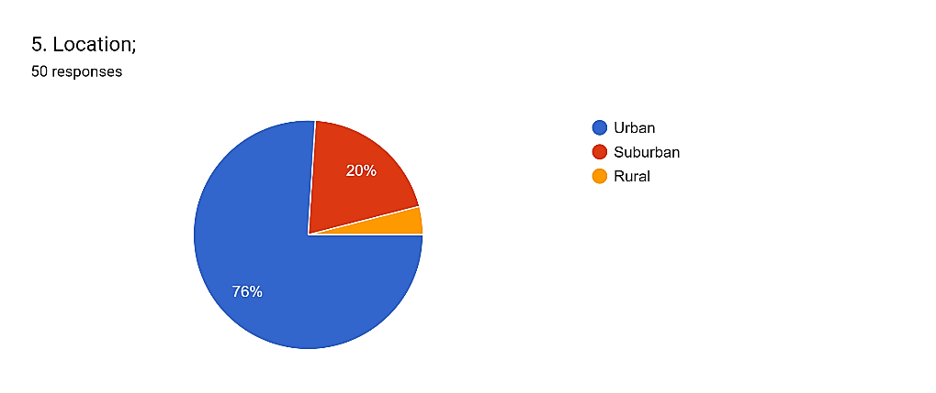 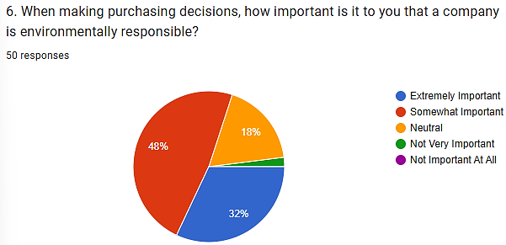

**Fig.5** - Interpretations: - From the analysis above, majority of the respondents are from urban (76%), whereas 20% are from Sub-urban and 4% are from Rural.

**Fig.6** - Interpretations: - From the analysis above, 32% of the respondents say it’s Extremely Important that a company is environmentally responsible, 48% say it’s Somewhat Important, 18% remain Neutral and 4% say it’s Not Very Important during any purchasing decisions.

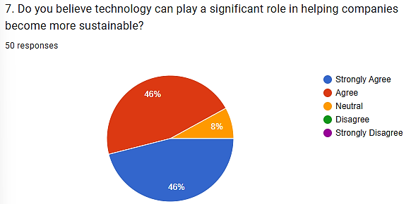 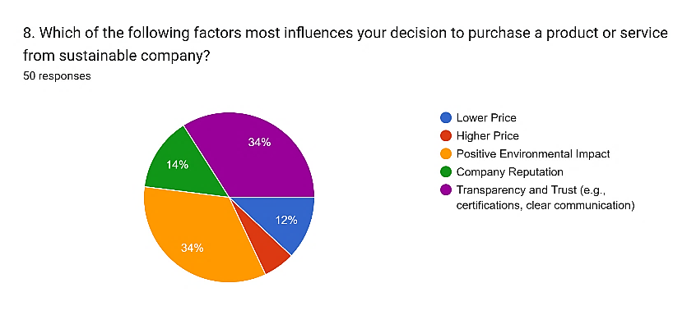

**Fig.7** - Interpretations: - From the analysis above, 46% respondents strongly agree that technology plays a significant role in helping companies become more sustainable and the other 46% also agree, whereas the rest 8% respondents remain Neutral.

**Fig.8** - Interpretations: -From the analysis above, 12% respondents say lower price of a product or service influences their purchase decisions, 6% say higher price, 34% say A company’s Positive Environmental impact, 14% say company reputation, and 34% say its Transparency and Trust.

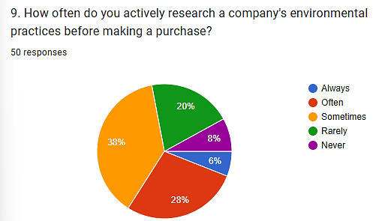 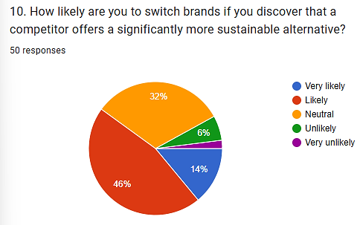

**Fig.9** - Interpretations: - From the analysis above, about 6% respondents make a purchase by always researching a company's environmental practices, 28% say often, 38% say sometimes, 20% say rarely and 8% never.

**Fig.10** - Interpretations: - From the analysis above, 14% of the respondents say they are Very Likely to switch brands if they discover that a competitor offers a significantly more sustainable alternative, whereas majority 46% of the respondents say Likely, 32% respondents remain Neutral, 6% respondents say Unlikely and 2% said Very Unlikely.

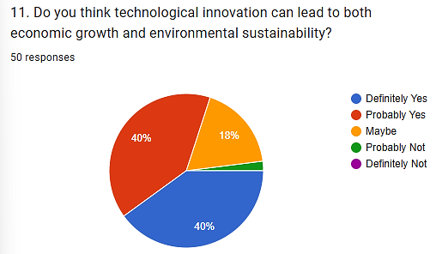 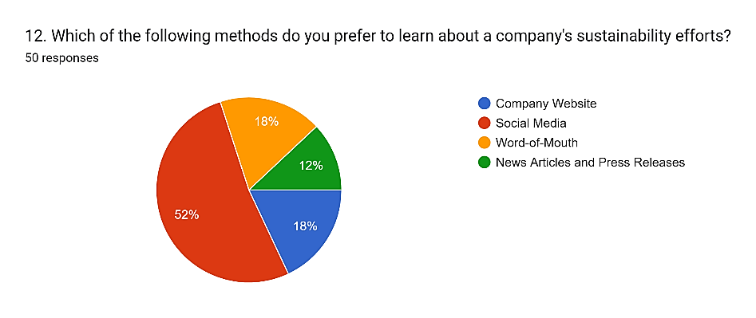

**Fig.11** - Interpretations: - From the analysis above, 40% of the respondents say Definitely yes technological innovation can lead to both economic growth and environmental sustainability, the other 40% say Probably yes, and 18% say Maybe and 2% say Probably Not.

**Fig.12** - Interpretations: - From the analysis above, 18% of the respondents prefer company websites to learn about a company's sustainability efforts, 52% of the respondents say social media, the other 18% prefer Word-of-Mouth, and the rest 12% respondents prefer News Articles and Press Releases.

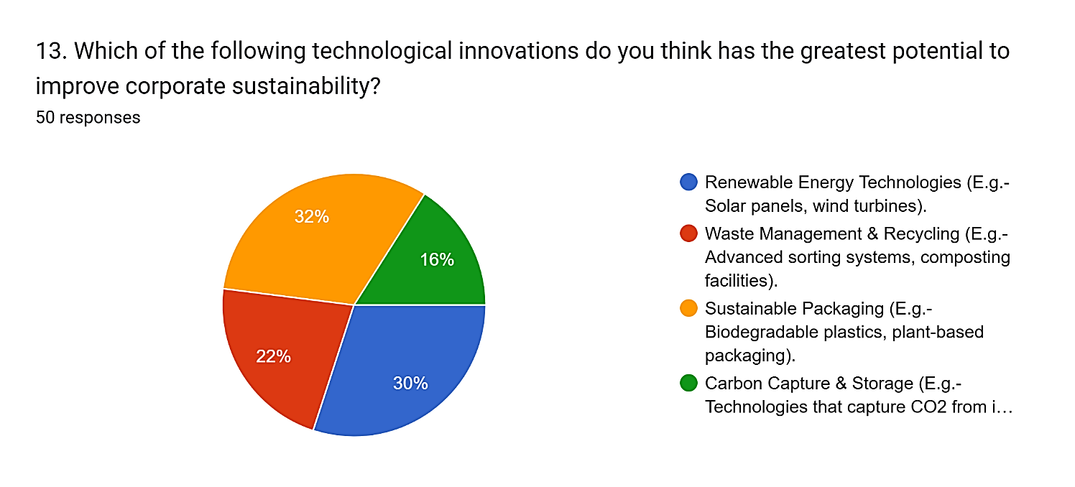

**Fig.13** - Interpretations: -From the analysis above, about 30% of the respondents say Renewable Energy Technologies (E.g. – Solar panels, wind turbines), has the greatest potential to improve corporate sustainability, 22% respondents say Waste Management & Recycling (E.g.-Advanced sorting systems, composting facilities), 32% respondents say Sustainable Packaging (E.g.-Biodegradable plastics, plant-based packaging) and 16% respondents say Carbon Capture & Storage (E.g.- Technologies that capture CO2 from industrial emissions & store it underground).

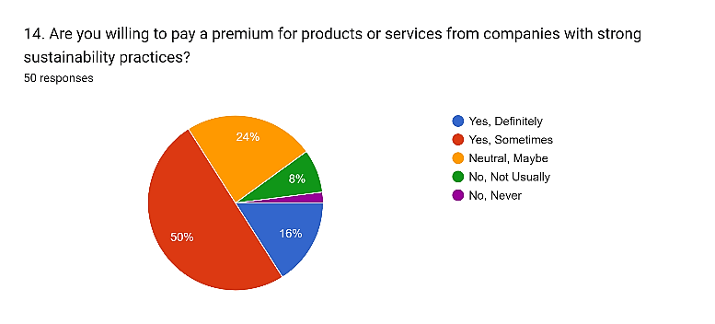 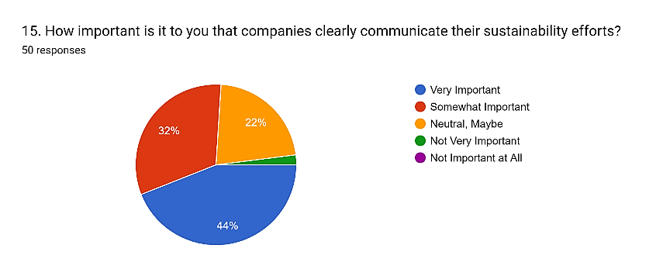

**Fig.14** - Interpretations: - From the analysis above, 16% of respondents are definitely yes willing to pay a premium for products or services from companies with strong sustainability practices, majority 50% of them say Yes, Sometimes, 24% remain Neutral, Maybe, and 8% say No, Not Usually, and 2% say No, never.

**Fig.15** - Interpretations: - From the analysis above, about 44% of respondents say it’s Very Important that companies clearly communicate their sustainability efforts, 32% say Somewhat Important, whereas 22% remain Neutral, Maybe, and 2% say it’s Not Very Important.

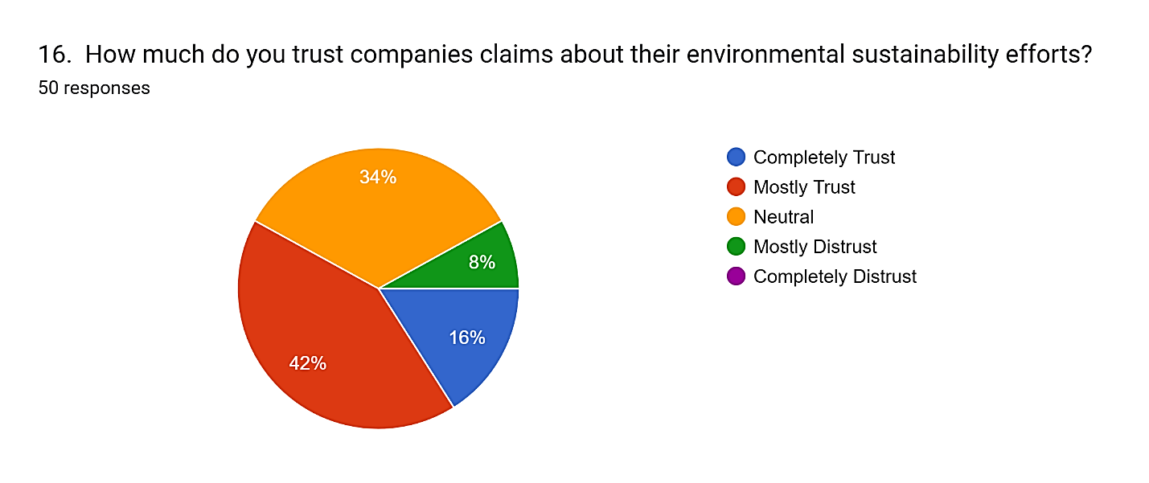

**Fig.16** - Interpretations: - From the analysis above, about 16% of respondents Completely Trust companies claims about their environmental sustainability efforts, whereas majority of 42% respondents Mostly Trust, and 34% of respondents remain Neutral and 8% of respondents Mostly Distrust.

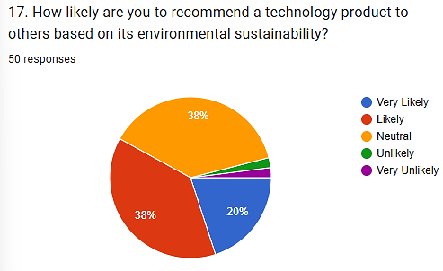 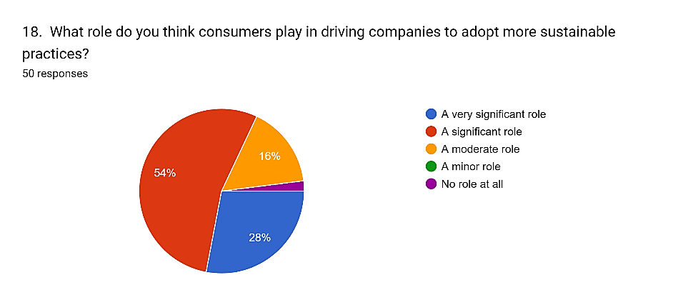

**Fig.17** - Interpretations: - From the analysis above, about 20% of respondents are Very Likely to recommend a technology product to others based on its environmental sustainability, 38% say Likely, and the other 38% remain Neutral and 2% say Unlikely and the other 2% say Very Unlikely.

**Fig.18** - Interpretations; - From the analysis above, about 28% of respondents think consumers play a very significant role in driving companies to adopt more sustainable practices, and majority of 54% respondents say a significant role, and 16% say a moderate role and 2% say no role at all.

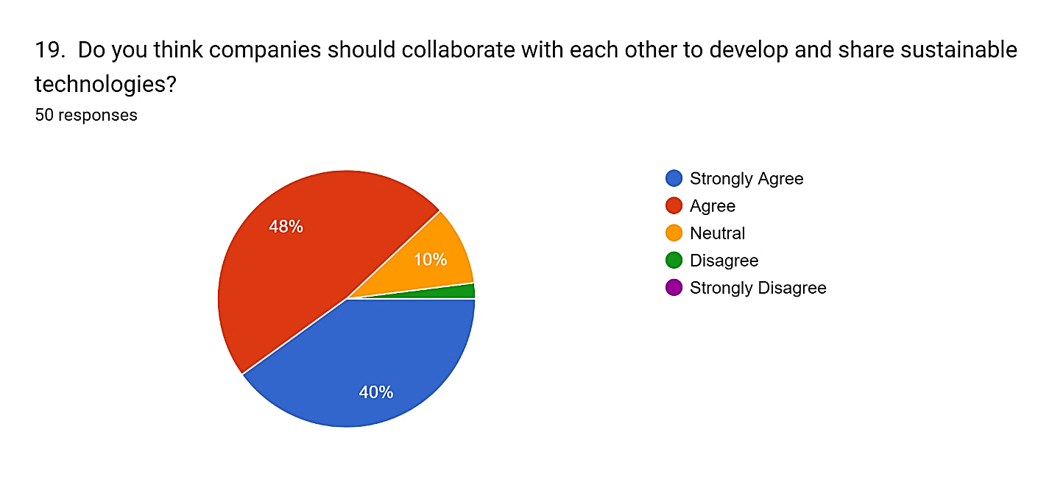

**Fig.19** - Interpretations: - From the analysis above, almost 40% of the respondents Strongly Agree that companies should collaborate with each other to develop and share sustainable technologies and majority of 48% agree that companies need to collaborate, whereas 10% remain Neutral and 2% respondents Disagree that companies need to collaborate.

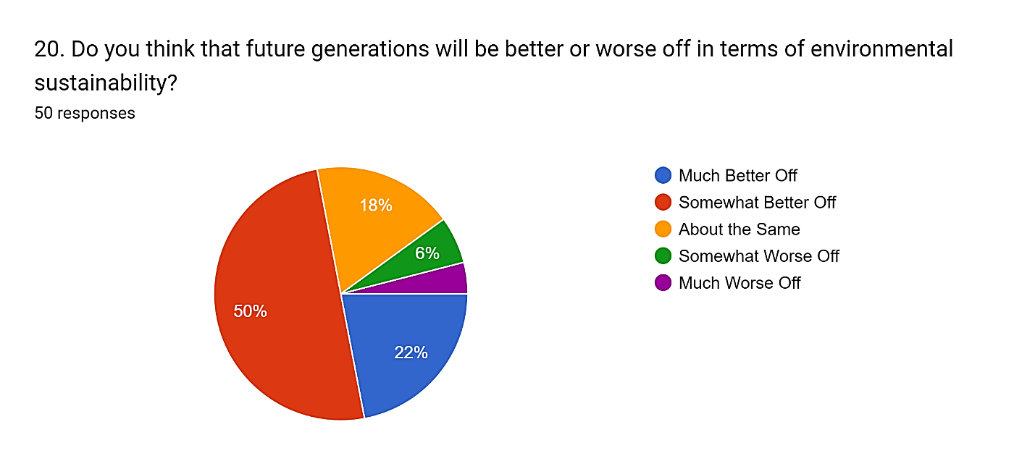

**Fig.20** – Interpretations: - From the analysis above, about 22% of respondents say that the future generations will be much better off, majority of 50% say somewhat better off, 18% say about the same and the rest 10% say it will be worse off.

**Findings**

1. **Young Audience** – About (56%) are **18-24 age group**, making them the most dominant demographic.
2. **More Female Respondents** – Women make up a **larger share (58%)** of the respondents compared to men (42%).
3. **Higher Education Levels** – A significant portion (52%) have earned a **Bachelor’s degree**, reflecting a well-educated group.
4. **Urban Majority** – Most participants (76%) reside in **urban areas**, while suburban (20%) and rural (4%) populations are smaller.
5. **Sustainability Matters in Purchases** – Nearly **half (48%)** of respondents consider a company's environmental responsibility **somewhat important** when making purchasing decisions.
6. **Technology as a Sustainability Driver** – A staggering **92%** believe that technology plays a **key role** in helping businesses become more sustainable.
7. **Trust and Transparency Influence Buying Choices** – For **34% of respondents**, a company’s **transparency and trustworthiness** (such as certifications and clear communication) have the greatest impact on their purchasing decisions.
8. **Research Before Buying** – While some buyers actively investigate a company's environmental efforts, **38% "sometimes"** look into a company before making a purchase.
9. **Switching to Sustainable Brands** – A strong **46%** of respondents say they are **likely** to switch brands if a competitor offers a significantly more sustainable alternative.
10. **Technology as a Dual Force** – **80%** of respondents believe technological innovation can drive both **economic growth** and **environmental sustainability** simultaneously.
11. **Social media as a Key Information Source** – More than half (52%) rely on **social media** as their preferred way to learn about a company's sustainability efforts.
12. **Sustainable Packaging Stands Out** – Among various sustainability technologies, **32%** consider **eco-friendly packaging** (like biodegradable materials) to have the greatest potential.
13. **Mixed Willingness to Pay More** – While some are highly committed, **50%** of respondents are **sometimes** willing to pay eco-friendly products premium.
14. **Clear Sustainability Communication is Essential** – **44%** of respondents believe it is **very important** for companies to be open about their sustainability initiatives.
15. **Trust Issues with Corporate Claims** – Though not entirely sceptical, **42%** say they **mostly trust** companies’ claims about their environmental efforts, while others remain neutral or doubtful.
16. **Recommending Green Tech** – When it comes to technology products, **38%** are **likely** to recommend them based on sustainability, but on equal percentage remain neutral.
17. **Consumers Drive Change** – A majority (**54%**) believe that consumers play a **significant role** in pushing companies to adopt sustainable practices.
18. **Collaboration is Key** – Nearly **48%** agree that companies should **work together** to develop and share sustainable technologies.
19. **Optimism for the Future –** Despite environmental concerns, **50%** of respondents believe that future generations will be **somewhat better off** in terms of sustainability.

Thus, these findings/insights highlight a growing awareness and concern for sustainability, especially among young, urban and educated consumers. Transparency, trust and technology are key factors shaping consumer purchasing behavior and expectations for businesses.

**Recommendations**

1. **For Businesses: How to Actually Make a Difference:**

* Don't just install tech, see if it really works over time. Track the environmental and financial benefits of your green tech for years, not just months. Set up systems to constantly measure how you're doing.
* Make sustainability part of your company's DNA. Get your leaders on board, and train your employees so everyone understands and cares about being green.
* Be open and honest about your impact. Use tools like blockchain to show where your products come from, and publish regular reports on your progress. Build trust with your customers and partners.
* Listen to what your customers want. Research their preferences for sustainable products and use their feedback to improve.

1. **For Policymakers: Making it Easier to Go Green:**

* Create rules that can keep up with fast-changing technology. Make regulations flexible and offer incentives for businesses that invest in sustainability.
* Fund research into new green technologies. Support collaboration between universities, companies, and government.
* Educate the public about sustainability. Launch campaigns to encourage people to make eco-friendly choices.
* Reward businesses that embrace the circular economy. Offer financial incentives for those who reduce waste and reuse materials.

1. **For Researchers: Digging Deeper and Finding Real Answers:**

* Follow companies over time to see the long-term impact of green tech. Don't just look at short-term results.
* Don't forget about the people side of sustainability. Explore the ethical and social implications of new technologies.
* Talk to the people who are actually using these technologies. Conduct interviews and gather qualitative data to understand the human experience.

**Conclusion**

"So, here's the thing: we're living in a time when tech is changing everything, but we're also facing some serious environmental challenges. That's why it's absolutely crucial for companies to start thinking about sustainability as a core part of their business. We've seen how technology can really help—things like AI, blockchain, and renewable energy are making a real difference in how companies operate and move towards a greener future. We've learned that just throwing technology at the problem isn't enough. It's about how companies are run, what the rules are, and making sure we're doing things ethically. Companies need to look beyond quick wins and really track how their green tech is performing over time. They need to figure out what works best for their industry and get everyone on board with sustainability.

Governments have a big role to play too. They need to create rules that encourage innovation and support research. And researchers? Well, they need to keep digging, looking at the long-term effects, the ethical questions, and how this all plays out in different industries. We still have a lot to learn, like how much this stuff really costs, how small businesses can get involved, and how much consumer choices matter. By tackling these questions, we can get a much clearer picture of how innovation and sustainability work together.

To conclude, it's going to take everyone working together. Companies need to use tech to be more responsible, governments need to create the right environment, and researchers need to provide the insights. If we can do that, we can build a future were making money and protecting the planet go hand in hand."

**References**

Zhu, C., Du, J., Shahzad, F., & Wattoo, M. U. (2022). Environment Sustainability Is a Corporate Social Responsibility: Measuring the Nexus between Sustainable Supply Chain Management, Big Data Analytics Capabilities, and Organizational Performance. *Sustainability*, *14*(6), 3379. <https://doi.org/10.3390/su14063379>

Csedő, Z., Magyari, J., & Zavarkó, M. (2022). Dynamic Corporate Governance, Innovation, and Sustainability: Post-COVID Period. *Sustainability*, *14*(6), 3189. <https://doi.org/10.3390/su14063189>

Ng, T. C., Lau, S. Y., Ghobakhloo, M., Fathi, M., & Liang, M. S. (2022). The Application of Industry 4.0 Technological Constituents for Sustainable Manufacturing: A Content-Centric Review. *Sustainability*, *14*(7), 4327. <https://doi.org/10.3390/su1407432>

Dr.A.Shaji George, & Dr.T.Baskar. (2024). Driving Business Transformation Through Technology Innovation: Emerging Priorities for IT Leaders. Partners Universal Innovative Research Publication (PUIRP), 02(04), 1–14. <https://doi.org/10.5281/zenodo.13286732>

Li, F., Owen, R., & Shaw, G. (2023). Framings of innovation, responsibility, and responsible innovation in China: insights from a case study undertaken with Chinese businesses. *Journal of Responsible Innovation*, *10*(1). <https://doi.org/10.1080/23299460.2023.2217594>

Grigorescu, A., Maer-Matei, M. M., Mocanu, C., & Zamfir, A.-M. (2020). Key Drivers and Skills Needed for Innovative Companies Focused on Sustainability. *Sustainability*, *12*(1), 102. <https://doi.org/10.3390/su12010102>

Dzhengiz, T., Niesten, E. Competences for Environmental Sustainability: A Systematic Review on the Impact of Absorptive Capacity and Capabilities. *J Bus Ethics* **162**, 881–906 (2020). <https://doi.org/10.1007/s10551-019-04360->

Sun S, Guo L (2022) Digital transformation, green innovation and the Solow productivity paradox. PLoS ONE 17(7): e0270928. <https://doi.org/10.1371/journal.pone.0270928>

Di Vaio, A., Hassan, R., D’Amore, G. *et al.* Responsible innovation and ethical corporate behavior in the Asian fashion industry: A systematic literature review and avenues ahead. *Asia Pac J Manag* **41**, 1129–1173 (2024). <https://doi.org/10.1007/s10490-022-09844-7>

Roblek, V., Thorpe, O., Bach, M. P., Jerman, A., & Meško, M. (2020). The Fourth Industrial Revolution and the Sustainability Practices: A Comparative Automated Content Analysis Approach of Theory and Practice. *Sustainability*, *12*(20), 8497. <https://doi.org/10.3390/su12208497>

Song, Q., Chen, X., & Gu, H. (2023). How Technological, Organizational, and Environmental Factors Drive Enterprise Digital Innovation: Analysis Based on the Dynamic FsQCA Approach. *Sustainability*, *15*(16), 12248. <https://doi.org/10.3390/su15161224>

Xue, L., Zhang, Q., Zhang, X., & Li, C. (2022). Can Digital Transformation Promote Green Technology Innovation? *Sustainability*, *14*(12), 7497. <https://doi.org/10.3390/su14127497>

Severo, E. A., & De Guimarães, J. C. F. (2021). Antecedent and Consequents of Eco-Innovation for Sustainability: Generations’ Perceptions in Brazil and Portugal. *International Journal of Professional Business Review*, *7*(1), e0280. <https://doi.org/10.26668/businessreview/2022.v7i1.280>

Liu, J., Lau, S., Liu, S. S., & Hu, Y. (2024). How Firm’s Commitment to ESG Drives Green and Low-Carbon Transition: A Longitudinal Case Study from Hang Lung Properties. *Sustainability*, *16*(2), 711. <https://doi.org/10.3390/su16020711>

Su, X., & Ding, S. (2024). Research on the Configuration Paths of Low-Carbon Transformation of Heavily Polluting Enterprises. *Sustainability*, *16*(14), 5826. <https://doi.org/10.3390/su16145826>

Li, X., Dai, J., He, J., Li, J., Huang, Y., Liu, X., & Shen, Q. (2022). Mechanism of Enterprise Green Innovation Behavior Considering Coevolution Theory. *International Journal of Environmental Research and Public Health*, *19*(16), 10453. <https://doi.org/10.3390/ijerph191610453>

Saxena, P. K., Seetharaman, A., & Shawarikar, G. (2024). Factors That Influence Sustainable Innovation in Organizations: A Systematic Literature Review. *Sustainability*, *16*(12), 4978. <https://doi.org/10.3390/su16124978>

Chen, Y., & Jin, S. (2023). Corporate Social Responsibility and Green Technology Innovation: The Moderating Role of Stakeholders. *Sustainability*, *15*(10), 8164. <https://doi.org/10.3390/su15108164>

Vaz, C. R., Rauen, T. R. S., & Lezana, Á. G. R. (2017). Sustainability and Innovation in the Automotive Sector: A Structured Content Analysis. *Sustainability*, *9*(6), 880. <https://doi.org/10.3390/su9060880>

Franceschini, S., Faria, L., & Jurowetzki, R. (2016). Unveiling scientific communities about sustainability and innovation. A bibliometric journey around sustainable terms. Journal of Cleaner Production, 127, 72-83. <https://doi.org/10.1016/j.jclepro.2016.03.142>.

Zhu, S., Sun, H., Zhang, B., Yang, Z., & Xia, X. (2023). Bilateral Effects of ESG Responsibility Fulfillment of Industrial Companies on Green Innovation. *Sustainability*, *15*(13), 9916. <https://doi.org/10.3390/su15139916>

Melane-Lavado, A., & Álvarez-Herranz, A. (2020). Cooperation Networks as a Driver of Sustainability-Oriented Innovation. *Sustainability*, *12*(7), 2820. <https://doi.org/10.3390/su12072820>