**REVIEW PAPER ON DELAY AND FUEL CONSUMPTION ON TOLL PLAZA**

***Pramod Kumar1*, Shivani2***

*1Student, 2Assistant Professor*

*Sat Priya Group of Institutions, Rohtak*

***\*Corresponding Author***

***E-mail Id:-pramodkumary510@gmail.com***

***ABSTRACT***

Indian roads carry a huge volume of traffic, more than 40% of the total traffic is carried by national highway having length less than 2% of total road length in India. Thus the national highways contribute to carrying a great proportion of traffic density. With the great significance of national highways, existing checkpoints in Indian road like toll plaza, intersection, cause a halt in the vehicular movement. Further, the ever increases traffic volume causes delay in journey time and hence result in extra fuel consumption.  
In the current study, delay in journey time and the resulting extra fuel consumption at Gharaunda toll plaza (Haryana) is estimated on NH 44 (earlier NH 1). The delay in journey time is computed by using Control Delay Method of Highway Capacity Manual (HCM 2000). The control delay method has initial delay, queue time, stop delay and acceleration delay. Considering this control delay method, a stretch of total 400 meters around the toll plaza is taken for the delay time assessment study, that is, a point from where vehicle start decelerating from 80% of design speed, moving towards zero speed and again accelerating to the 80% of design speed. The study includes surveys of traffic volume for determination of Lean Hours, Average Hours and Peak Hours, called as Congestion levels. The survey is conducted during weekdays and weekend both, to minimize the abruptions in experimental data. Assessment of total delay during Peak Hours, Average Hours and Lean Hours is done manually using stopwatch. And, the extra fuel consumption of different type of vehicles due to a specific non optimum speed range is calculated. For assessing the fuel consumption at non optimum speed, values of fuel consumption are taken from the graph of Speed v/s Fuel Consumption curves from CRRI Annual Data Report, 2009-10. Computed extra fuel consumption and delay give a better insight into comparing the results at different level of congestion and thus providing a base for better planning of road infrastructure.

***Keywords:-*** *Fuel consumption, geometric delay, immobilized, toll plaza, acceleration*

**INTRODUCTION**

Delay at toll plaza is associated with the time lost by the vehicle because of toll collection and traffic conditions. Delay is defined as the actual travel time and travel time in ideal conditions (absence of traffic control, geometric delay, any incident and when there are no other vehicles on road). Capacity of toll plaza and estimation of level of service procedure are built around the concept of average Control Delay per vehicle. Control Delay can be categorized into deceleration delay, stopped delay and acceleration delay. Stopped delay is easier to measure which is defined as the delay when vehicle is fully immobilized, while the delay measured by acceleration and deceleration vehicle is categorized as acceleration and deceleration delay, respectively. As per HCM 2000, Control Delay is comprised of initial deceleration delay, queue move up time, stop delay, and final acceleration delay.

**LITERATURE REVIEW**

Sekhar et. al. [2013] estimated the delay and fuel losses during the idling of vehicles at signalized intersection in Ahmedabad through a 16 hour classified traffic volume count survey at four intersections. To find the delay characteristics and existing speed on the selected patch, GPS based velocity box (V-Box) was installed in the car. It was done by using VISSIM micro simulation software with the help of GEH statistics. GEH is a widely used statistics for comparing the modeled values and observed values evolved through simulation tools.  
  
Pal and Sarkar [2012], determined delay, noise pollution and fuel loss during idling in Agartala city. This is done experimentally by filling the fuel tanks and running them at idling condition. As per the study results it is analyzed that the delay at all intersections under study during peak hours is more than 60 seconds/ vehicle. Another study at Agartala shows a wastage of 389.68 liters of diesel and 810.38 liters of petrol per day during vehicle idling.

Tiwari et. al. [2013] also estimated fuel wastage due to idling of vehicle at road traffic signal in Indore, Madhya pradesh. The classified traffic volume study was conducted for 12 hours.  
(8:00a.m. to 10:00p.m.). The study is conducted at seven signalized intersection in Indore for a complete week (Monday to Sunday) to estimate the extra fuel consumption because of idling of vehicles on signalized intersection. This study shows that about 5.9 x 10 liters per year petrol & diesel (3.6 x 10' liters petrol and 2.3 x 10' liters diesel) are being wasted.

Parida and Gangopadhyay [2008] estimates the fuel loss when vehicles are in idling condition at signalized intersection in Delhi. 12 signalized intersections of varying traffic volume are considered to estimate fuel loss of vehicles in idling condition. Out of these 12 intersection 2 were of low volume, 2 were of medium volume and 8 were of heavy volumes. The intersections having 75000 vehicles per day were categorized as low volume, 75000 100000 were as medium volume and> 100000 were taken as high volume intersection. To collect the classified traffic volume data, 24 hours traffic survey is conducted at high volume intersection and 16 hours survey at low and medium volume intersection. For idling fuel consumption measurement, FP213S detectors, DF210A for two wheelers including two stock and four stock engine respectively are used, also FP2140H flow detector and DF 210 for four wheeler fuel consumption are utilised. The study reflects that 0.37 million kilograms of CNG, 0.41 million liters of petrol and 0.13 million liters of diesel is wasted just because of idling of vehicles every day in Delhi. Worth of this much amount of fuel is Rs. 27.25 million per day and Rs. 9944.5 million per annum.

**METHODOLOGY**  
The current study uses traffic volume data and speed data to analyze the delay in journey time and extra fuel consumption due to Toll Plaza. Also this analyzed data is further used to compare the actual distance travelled by the vehicle and the distance that can be travelled by the vehicle with the same amount of fuel in absence of toll plaza at a non-optimum speed.

**SITE SELECTION**

The study area of Gharaunda is in Karnal (Haryana). It is a toll Plazza which is at the entry of Karnal from Southern direction. Considering the rapid city development, it is likely to experience more travel demands. NHAI data shows an annual traffic growth of 13%. The elected toll plaza site is 13.8 kms away from the city Karnal.

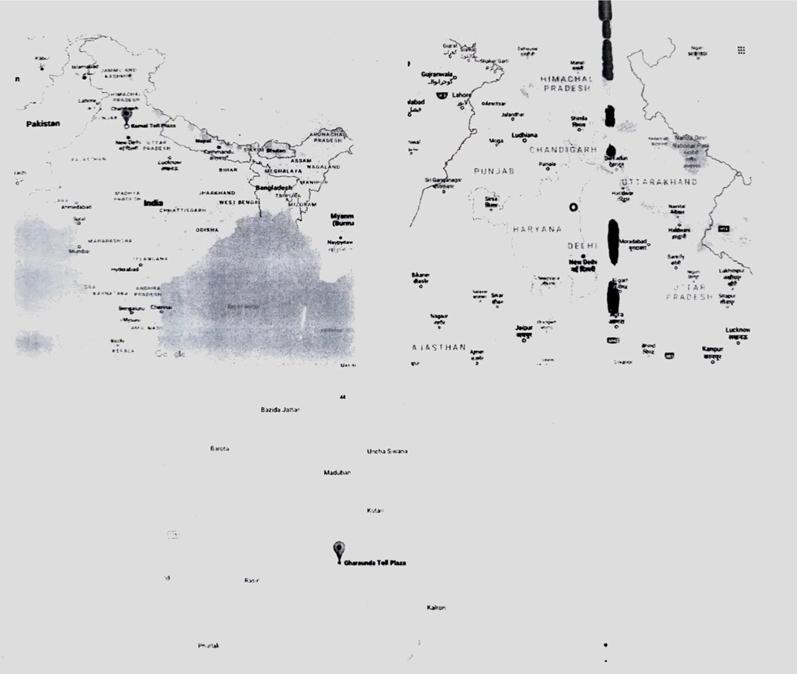

Figure. Location of Gharaunda Toll Plazza

There are total 13 toll gates at Gharaunda toll plaza from Panipat to Jalandhar and 13 toll gates from Jalandhar to Panipat.

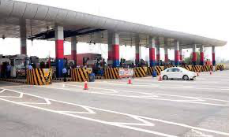

Figure. Gharaunda toll plaza

**METHODS OF DATA COLLECTION**  
Traffic volume data and speed data is collected at the selected location. Hourly classified traffic volume is located from NHAI, where-as for delay and fuel consumption study, delay time and speed data is collected with the help of Stop Watch and Radar Gun.

Traffic Volume Data of NHAI

Hourly classified traffic volume data is obtained from NHAI for 24 x 7. The data was collected by a team of expert by manual method. Traffic data collected by NHAI during december 2022 is own in Table 1 to Table 6 in Annexure for both Panipat to Jalandhar and Jalandhar to Panipat section. Daily Average on the hourly basis for Panipat to Jalandhar and Jalandhar to Panipat shown in Table below respectively.

Table. Panipat to Jalandhar Average Daily Traffic

|  |  |  |  |  |  |  |
| --- | --- | --- | --- | --- | --- | --- |
| Time | Car/Jeep/van | Bus | LCV | HCV | Tractor | Vehicles |
| 8 am - 9 am | 475 | 52 | 121 | 153 | 10 | 811 |
| 9 am – 10 am | 475 | 52 | 106 | 133 | 14 | 780 |
| 10 am – 11 am | 578 | 89 | 116 | 150 | 14 | 947 |
| 11 am – 12 noon | 570 | 82 | 123 | 156 | 16 | 947 |
| 12 noon – 1 pm | 577 | 85 | 111 | 156 | 17 | 946 |
| 1 pm – 2 pm | 616 | 73 | 119 | 169 | 15 | 992 |
| 2 pm – 3 pm | 565 | 60 | 125 | 179 | 18 | 947 |
| 3 pm – 4 pm | 468 | 65 | 108 | 155 | 15 | 811 |
| 4 pm – 5 pm | 573 | 68 | 123 | 168 | 17 | 949 |
| 5 pm – 6 pm | 523 | 66 | 126 | 156 | 17 | 888 |
| 6 pm – 7 pm | 509 | 68 | 120 | 148 | 13 | 858 |
| 7 pm – 8 pm | 453 | 65 | 116 | 144 | 10 | 788 |
| 8 pm – 9 pm | 441 | 51 | 178 | 243 | 11 | 924 |
| 9 pm – 10 pm | 399 | 61 | 167 | 259 | 8 | 894 |
| 10 pm – 11 pm | 345 | 57 | 171 | 266 | 8 | 847 |
| 11 pm – 12 am | 339 | 51 | 201 | 308 | 9 | 908 |
| 12 am – 1 am | 308 | 43 | 166 | 279 | 10 | 806 |
| 1 am – 2 am | 246 | 47 | 150 | 264 | 7 | 714 |
| 2 am – 3 am | 242 | 37 | 167 | 262 | 9 | 717 |
| 3 am – 4 am | 206 | 33 | 177 | 277 | 8 | 701 |
| 4 am – 5 am | 186 | 35 | 152 | 257 | 8 | 638 |
| 5 am – 6 am | 217 | 38 | 160 | 251 | 9 | 675 |
| 6 am – 7 am | 241 | 43 | 160 | 245 | 9 | 698 |
| 7 am – 8 am | 244 | 44 | 124 | 194 | 9 | 615 |

Table. Jalandhar to Panipat Average Daily Traffic

|  |  |  |  |  |  |  |
| --- | --- | --- | --- | --- | --- | --- |
| Time | Car/Jeep/van | Bus | LCV | HCV | Tractor | Vehicles |
| 8 am - 9 am | 285 | 52 | 82 | 113 | 5 | 537 |
| 9 am – 10 am | 324 | 45 | 88 | 118 | 7 | 582 |
| 10 am – 11 am | 493 | 60 | 109 | 123 | 15 | 800 |
| 11 am – 12 noon | 577 | 56 | 118 | 131 | 11 | 893 |
| 12 noon – 1 pm | 580 | 54 | 117 | 123 | 15 | 889 |
| 1 pm – 2 pm | 543 | 65 | 119 | 123 | 16 | 866 |
| 2 pm – 3 pm | 542 | 79 | 125 | 125 | 13 | 884 |
| 3 pm – 4 pm | 520 | 66 | 119 | 115 | 13 | 833 |
| 4 pm – 5 pm | 549 | 66 | 130 | 132 | 17 | 894 |
| 5 pm – 6 pm | 595 | 74 | 143 | 138 | 15 | 965 |
| 6 pm – 7 pm | 526 | 78 | 141 | 143 | 8 | 896 |
| 7 pm – 8 pm | 514 | 71 | 176 | 173 | 7 | 941 |
| 8 pm – 9 pm | 419 | 44 | 198 | 306 | 13 | 980 |
| 9 pm – 10 pm | 363 | 45 | 184 | 318 | 12 | 922 |
| 10 pm – 11 pm | 353 | 42 | 164 | 282 | 11 | 852 |
| 11 pm – 12 am | 307 | 40 | 146 | 288 | 11 | 792 |
| 12 am – 1 am | 281 | 50 | 163 | 273 | 9 | 776 |
| 1 am – 2 am | 222 | 43 | 208 | 290 | 11 | 774 |
| 2 am – 3 am | 194 | 63 | 193 | 300 | 8 | 758 |
| 3 am – 4 am | 165 | 92 | 180 | 241 | 10 | 688 |
| 4 am – 5 am | 155 | 60 | 176 | 259 | 9 | 659 |
| 5 am – 6 am | 157 | 50 | 176 | 244 | 13 | 640 |
| 6 am – 7 am | 196 | 48 | 163 | 258 | 16 | 681 |
| 7 am – 8 am | 227 | 42 | 195 | 287 | 11 | 762 |

Speed Study and Delay Data

In the presence of toll plaza vehicles moving on design speed decelerate, crosses the toll and again accelerate to achieve the design speed. In the present study delay is computed as the extra time taken by the vehicles to cross the toll location. In order to calculate this delay, time consumed by the vehicles to cross the Toll Plaza location is work out by following process.  
  
An observer observes the vehicle approaching the toll location with radar gun and starts stop watch as soon as the vehicles speed reduces to 80% of the design speed. After crossing the toll vehicle start accelerating and the stop watch is stopped as soon as vehicles attain 80% of design speed.  
  
Radar Gun is a device used to measure the speed of a moving object. A radar gun may be hand- held, mounted in a vehicle or mounted on a tripod stand also. It works on the phenomenon of Doppler Effect.

**CONCLUSIONS**

The study presented in dissertation has been conducted to evaluate the effect of toll plaza on delay and fuel consumption. The site selected for the study is Gharaunda toll plaza on NH 44 (earlier NH 1) in Karnal. Following main conclusion are drawn from the work:  
i. It is observed that the variation of traffic on NH 44 at Gharaunda toll plaza indicates an average of maximum 992 vehicles (1843 PCUs) passing during 1:00p.m. to 2:00 p.m. (peak hour) and a minimum of 615 vehicles (1476 PCUs) during 7:00 a.m. to 8:00 a.m. (lean hour) from Panipat to Jalandhar.  
ii. The average hourly traffic data reflects the variation of traffic on NH 44 at Gharaunda toll plaza indicating a maximum 2221 PCUS (908 vehicles) passing during 11:00 p.m. to 12:00 a.m. (peak hour) and a minimum of 1452 PCUs (780 vehicles) during 9:00 a.m. to 10:00 am. (lean hour) from Panipat to Jalandhar. This may be attributed to the more number of buses and LCVs plying from 11:00 p.m to 12:00a.m.

**REFERENCES**

1. <http://www.nbtis.org/nhai/TollInformation.aspx?TollPlazalD-155>  
  
2. Sekhar ([et.al](http://et.al/) 2013) "Estimation of delay and fuel loss during idling of vehicles at signalised intersection in ahmedabad", 2nd Conference of Transportation Research Group of India (2nd CTRG)  
  
3. Gangopadhyay S. and Parida P. (2009), "Estimation of Fuel Loss during Idling at Signalized Intersections in Delhi, Indian Roads Congress", (IRC), Vol.12

4. Pal Manish and Sarkar Dipankar (2012) "Delay, fuel loss and noise pollution during idling of vehicles at signalised intersection in agartala city", Civil and Environmental Research, ISSN 2222-1719 (Paper) ISSN 2222-2863 (Online), Vol 2, No.6, 2012.