**Helmet Guard Pro: Intelligent Traffic Monitoring for Helmet Compliance and Road Safety**

M.Srinidhi

*B. Tech*

*School of Engineering* Computer Science-(AI&ML)

Malla Reddy University, India

2111CS020546@mallaredd yuniversity.ac.in

D.Sri Ajay

*B. Tech*

*School of Engineering* Computer Science-(AI&ML)

Malla Reddy University, India

2111CS020547@mallaredd yuniversity.ac.in

G.Bharath

*B. Tech*

*School of Engineering* Computer Science-(AI&ML)

Malla Reddy University, India

2111CS020548@mallaredd yuniversity.ac.in

A.Sri Charan

*B. Tech*

*School of Engineering* Computer Science-(AI&ML)

Malla Reddy University, India

2111CS020549@mallaredd yuniversity.ac.in

S.Surya Prakash

*B. Tech*

*School of Engineering* Computer Science-(AI&ML)

Malla Reddy University, India

2111CS020550@mallaredd yuniversity.ac.in

Prof Dr. Syed Saba Raoof

*B. Tech*

*School of Engineering* Computer Science-(AI&ML)

Malla Reddy University, India

syedsabaraoof@gmail.com

**ABSTRACT**

Traffic violations in India, particularly motorcycle riders not wearing helmets, have led to a significant rise in accidents and fatalities. The current method of monitoring such violations relies heavily on CCTV footage, requiring traffic police to manually analyse frames, identify violations, and zoom in to capture license plate numbers. This process is timeconsuming and demands considerable manpower, especially with the increasing number of motorcyclists. To address this issue, this project proposes an automated system capable of detecting helmet violations and extracting the license plate number of the offending vehicle. Recent advancements in research have explored solutions using CNN, R-CNN, LBP, HoG, and Haar features. However, these approaches often face limitations in efficiency, accuracy, and speed. The developed system leverages deep learning techniques to detect non-helmet riders and extract license plate numbers. Object detection is performed at three levels: identifying the rider and motorcycle using YOLOv2, detecting the presence of a helmet with YOLOv3, and recognizing the license plate using YOLOv2. Optical Character Recognition (OCR) is employed to extract the license plate registration number. The entire process is optimized for video input to ensure high-speed execution, addressing the need for real-time detection and enforcement. This holistic system integrates cutting-edge technologies to enhance traffic safety, reduce manual effort, and improve the enforcement of helmet compliance regulations

**CHAPTER 1: INTRODUCTION**

**1.1. Problem Definition:**

Road safety is a critical concern worldwide, with millions of accidents occurring due to negligence and non-compliance with traffic regulations. Among these concerns, ensuring helmet compliance among motorcyclists remains a major challenge despite stringent laws and extensive awareness campaigns. The persistent non-compliance continues to contribute to preventable injuries and fatalities worldwide. Existing surveillance systems often rely on manual intervention, leading to inaccuracies and inefficiencies that hinder the effective enforcement of helmet laws. Additionally, the lack of integration between helmet detection and enforcement mechanisms creates monitoring gaps, reducing accountability. Addressing this issue requires the development of automated solutions capable of detecting helmet usage, extracting necessary vehicle details, and enforcing penalties in real-time. Such advancements would improve road safety and promote adherence to regulations.

A key challenge in this domain is the need for automated systems that can accurately determine helmet compliance. Conventional surveillance approaches depend heavily on human observation, making them susceptible to errors and inefficiencies. The emergence of technologies like computer vision, machine learning, and artificial intelligence (AI) presents new opportunities to automate this process. By leveraging these innovations, sophisticated helmet detection algorithms can be deployed to identify non-compliant riders with high precision. This significantly reduces dependence on manual monitoring while enhancing the efficiency of enforcement measures.

The consequences of helmet non-compliance extend beyond individual riders, impacting families, healthcare systems, and national economies. Injuries resulting from helmetless accidents often lead to long-term disabilities, placing a heavy financial burden on victims and healthcare providers. Additionally, law enforcement agencies struggle to manage helmet law violations effectively due to limited resources and outdated monitoring techniques. Implementing an automated helmet detection system would not only improve compliance but also reduce the strain on emergency services and ensure that road safety regulations are upheld consistently.

Moreover, integrating helmet detection systems with existing surveillance infrastructure is essential for maximizing their effectiveness. Such integration allows for real-time monitoring across various road networks, providing law enforcement with valuable insights to address violations swiftly. Additionally, incorporating vehicle information extraction capabilities within these systems can further streamline enforcement. By automatically retrieving key details such as license plate numbers and vehicle registration data, authorities can efficiently issue penalties to violators, ensuring effective enforcement of helmet regulations.

The implementation of automated helmet compliance detection systems marks a major advancement in road safety enforcement, offering unparalleled efficiency and accuracy. Powered by AI and machine learning, these systems can continuously adapt to changing road conditions and rider behaviors, improving their performance over time. Their scalability also makes them suitable for deployment across diverse locations and infrastructure, maximizing their impact on enhancing road safety.

In conclusion, the widespread lack of helmet compliance among motorcyclists presents a serious risk, highlighting the urgent need for innovative enforcement solutions. Automated helmet detection systems provide a transformative approach, delivering precision, efficiency, and scalability. By seamlessly integrating detection, data extraction, and enforcement mechanisms, these systems can significantly improve road safety and ensure regulatory compliance in real time. As technology advances, adopting intelligent solutions for road safety will be crucial in building safer and more sustainable transportation systems

**1.2. Problem Domain:**

Road safety remains a critical concern, with a significant focus on ensuring helmet compliance among motorcyclists. Despite stringent regulations and widespread awareness campaigns, non-compliance with helmet laws continues to be a major issue, resulting in preventable injuries and fatalities. Existing surveillance systems often rely on manual monitoring, which is prone to inaccuracies and inefficiencies. Additionally, the lack of seamless integration between helmet detection and enforcement mechanisms leads to gaps in monitoring and accountability.To address these challenges, this project aims to develop an automated solution capable of accurately detecting helmet compliance, extracting relevant vehicle details, and enforcing penalties in real time. By leveraging advanced technologies such as computer vision and machine learning, the proposed system seeks to enhance road safety, improve law enforcement efficiency, and ensure stricter adherence to traffic regulations.

**1.3. Objective of the Project:**

Wearing a helmet while riding a motorcycle is paramount for safety. It serves as a protective barrier against head injuries by minimizing the deceleration of the skull during collisions. The cushioning inside the helmet absorbs the impact and spreads it over a larger area, reducing the severity ofinjuries. Additionally, it acts as a mechanical barrier between the head and any objects the rider may come into contact with. In the realm of traffic management, adherence to rules and regulations is crucial to minimizing accidents and fatalities. However, manual surveillance through CCTV cameras can be resourceintensive and time-consuming. To address this challenge, a proposed methodology utilizes advanced technologies like YOLOv2, YOLOv3, and OCR (Optical Character Recognition) for efficient helmet detection, license plate extraction, and issuance of challans. The process begins with the collection of datasets, which serve as the foundation for training neural networks. Moving object detection and background subtraction techniques help identify relevant objects in the traffic scene. Neural networks, such as YOLOv2 and YOLOv3, enable real-time object classification, allowing for the accurate detection of helmets and license plates. Once detected, OCR algorithms extract alphanumeric characters from license plates for identification and challan issuance. By automating these processes, the proposed system reduces the reliance on manual intervention and enhances the efficiency of traffic surveillance. Furthermore, the integration of SQL facilitates seamless data management and record-keeping for enforcement purposes. In conclusion, the implementation of a full helmet detection system coupled with license plate extraction and challan issuance holds significant promise in improving road safety and traffic management. Through the fusion of advanced technologies and methodologies, it contributes to the overarching goal of minimizing accidents and injuries on the roads.

**1.4. Scope and Limitations of the Project:**

**Scope**

The integration of YOLOv5 in a deep learning-based surveillance system marks a significant step forward in improving road safety in India. This project aims to leverage state-of-the-art technology to precisely detect motorcyclists and assess helmet compliance, directly contributing to the enforcement of safety regulations aimed at reducing injuries and fatalities.

By utilizing YOLOv5, a cutting-edge object detection algorithm, the system can accurately identify motorcyclists in realtime video feeds. This capability ensures efficient helmet detection, a crucial aspect in mitigating head injuries during accidents. Given the high rate of non-compliance with helmet regulations, this project addresses a critical factor contributing to road fatalities.

The potential impact of this initiative is substantial. By accurately identifying riders who fail to wear helmets, the system plays a vital role in preventing injuries and saving lives. Additionally, integrating deep learning technology into surveillance systems enhances the overall efficiency of traffic law enforcement, enabling authorities to take timely action against non-compliant riders.

Furthermore, this initiative aligns with both national and global road safety objectives, reinforcing the importance of responsible riding and adherence to traffic regulations. By focusing on helmet compliance, the project contributes to fostering a culture of safety-conscious behavior among motorcyclists, ultimately reducing accident rates.

In conclusion, the deployment of YOLOv5- based surveillance systems represents a proactive approach to road safety enforcement in India. By leveraging advanced deep learning techniques for precise helmet detection, this project holds the potential to make significant strides in reducing road accidents and ensuring higher compliance with safety regulations.

**CHAPTER 2 : LITERATURE SURVEY**

**2.1 Previous Studies**

**Abu H. M. Rubaiyat, et al. [1]** In current situation, many come across various problems in traffic regulations in India which can be solved with different ideas. Riding motorcycle/mopeds without wearing helmet is a traffic violation which has resulted in increase in number of accidents and deaths in India. Existing system monitors the traffic violations primarily through CCTV recordings, where the traffic police have to look into the frame where the traffic violation is happening, zoom into the license plate in case rider is not wearing helmet. But this requires lot of manpower and time as the traffic violations frequently and the number of people using motorcycles increasing day- by-day. What if there is a system, which would automatically look for traffic violation of not wearing helmet while riding motorcycle/moped and if so, would automatically extract the vehicles’ license plate number. Recent research has successfully done this work based on CNN, R-CNN, LBP, HoG, HaaR features, etc. But these works are limited with respect to efficiency, accuracy or the speed with which object detection and classification is done. In this research work, a Non-Helmet Rider detection system is built which attempts to satisfy the automation of detecting the traffic violation of not wearing helmet and extracting the vehicles’ license plate number. The main principle involved is Object Detection.

**Kunal Dahiya, Dinesh Singh[2]** states that In this paper, they propose an approach for automatic detection of bike- riders without helmet using surveillance videos in real time. The proposed approach first detects bike riders from surveillance video using background subtraction and object segmentation. Then it determines whether bike-rider is using a helmet or not using visual features and binary classifier. Also, users present a consolidation approach for violation reporting which helps in improving reliability of the proposed approach. In order to evaluate our approach, they have provided a performance comparison of three widely used feature representations namely histogram of oriented gradients (HOG), scale- invariant feature transform (SIFT), and local binary patterns (LBP) for classification. The experimental results show detection accuracy of 93.80% on the real-world surveillance data. It has also been shown that proposed approach is computationally less expensive and performs in real-time with a processing time of 11.58 ms per frame.

**Maharsh Desai, et al. [3]** suggests that Bike riding is a lot of fun, but accidents happen. People choose motorbikes over car as it is much cheaper to run, easier to park and flexible in traffic. In India more than 37 million people are using two wheelers. Since usage is high, accident percentage of two wheelers are also high compared to four wheelers. Motorcycles have high rate of fatal accidents than four wheelers. The impacts of these accidents are more dangerous when the driver involves in a high-speed accident without wearing helmet. It is highly dangerous and can cause severe deaths. So, wearing a helmet can reduce these number of accidents and may save the life. This paper aims for avoidance of accidents and develop helmet detection system. People intend to use background subtraction and optical character recognition for fall detection and for helmet detection they use background subtraction and Hough transform descriptor.

**Romuere Silva[4]** proposed that Motorcycle accidents have been rapidly growing throughout the years in many countries. Due to various social and economic factors, this type of vehicle is becoming increasingly popular. The helmet is the main safety equipment of motorcyclists; however, many drivers do not use it. The main goal of helmet is to protect the drivers head in case of accident. In case of accident, if the motorcyclist does not use can be fatal. This paper aims to propose a system for detection of motorcyclist without helmet. For this, they have applied the circular Hough transform and the Histogram of Oriented Gradients descriptor to extract the image attributes. Then, the Multi-Layer Perceptron classifier was used and the obtained results were compared with others algorithms. Traffic images were captured by cameras from public roads and constitute a database of 255 images. Indeed, the algorithm step regarding the helmet detection accomplished an accuracy rate of 91.37%.

**M.T.Ubaid[14]** suggested that Casualty rates are increasing rapidly in Asian countries due to carelessness of the motorcyclists. Helmet helps to ingest the collision, and hence it prevents head injuries which lead to death. But ensuring that riders wear helmets and monitors to detect those who’re not is an exhausting task and more prone to error due to physical limitations of human beings. An automatic system is proposed for which a custom dataset in Lahore, Pakistan is generated to detect helmets. The proposed method uses Efficient Det approach to recognize helmets. Efficient Det provides better computational accuracy and proficiency than previously proposed models. The proposed system was later compared with other models as well and achieved 95.23% accuracy for helmet and non-helmet.

**CHAPTER 3.METHODOLOGY**

**3.1. Existing System:**

The current dependence on manual monitoring of traffic violations through CCTV footage is highly labor-intensive and time-consuming, especially considering the growing number of motorcycles on the roads. However, the emergence of automated systems presents a promising solution to these challenges. Imagine a system equipped with advanced algorithms that can seamlessly detect motorcyclists riding without helmets and simultaneously extract the license plate numbers of the violating vehicles.

Recent research has explored multiple techniques for object detection and classification, including Convolutional Neural Networks (CNN), Region-based CNN (R-CNN), Local Binary Patterns (LBP), Histogram of Oriented Gradients (HoG), and Haar features. While these methods have demonstrated potential, they often encounter limitations in efficiency, accuracy, or processing speed.

To overcome these constraints, integrating cutting-edge technologies such as deep learning and computer vision offers a highly efficient and scalable approach. By leveraging real-time processing algorithms like YOLO (You Only Look Once), the proposed system can ensure rapid and precise detection of helmet violations, eliminating the need for manual intervention.

Automating the detection process not only reduces dependency on human resources but also enables proactive enforcement of traffic laws. This results in increased compliance, enhanced road safety, and improved traffic regulation enforcement.

In conclusion, the development of an automated helmet violation detection system with integrated license plate recognition represents a major advancement in traffic monitoring and enforcement. By utilizing state-of-the-art deep learning algorithms, this system can significantly enhance efficiency, accuracy, and enforcement speed, ultimately contributing to safer roads and improved compliance with safety regulations.

**3.2 Proposed System:**

The proposed system is designed to enhance road safety by detecting helmet violations among two-wheeler riders and issuing challans for non-compliance. It consists of a structured pipeline of sequential modules, each contributing to the accurate identification and enforcement of helmet regulations.

**1.Object Detection with YOLOv2**

The initial module leverages YOLOv2, a deep learning-based object detection model, to analyze uploaded images and identify the presence of a motorbike and its rider. If both entities are detected, the system proceeds to the next stage. This preliminary filtering mechanism ensures that computational resources are efficiently utilized by focusing only on relevant images.

**2. Helmet Detection with YOLOv3**

Once a motorbike and its rider are detected, the system utilizes YOLOv3, an advanced object detection algorithm, to determine whether the rider is wearing a helmet. If the system detects helmet compliance, no further action is required. However, if the rider is not wearing a helmet, the process advances to the next step.

**3. Number Plate Extraction with OCR**

In this stage, the system extracts the vehicle's number plate data using Python Tesseract OCR 11 (Optical Character Recognition) API. The OCR technology processes the image, identifies and extracts the license plate number, which is crucial for issuing penalties to violators.

**4. Challan Issuance and Database Management**

The final module is responsible for challan issuance and database management. Based on the extracted license plate number, a challan is generated and the violation record is stored in an SQL database. This centralized database ensures efficient record-keeping, facilitates tracking of repeat offenders, and enables data-driven enforcement strategies.

**3.3 Modules**

**YOLO (You Only Look Once)**

**Description:**YOLO (You Only Look Once) is a state-of-the-art object detection algorithm that utilizes a single neural network to predict bounding boxes and class probabilities directly from full images in real-time. Its efficiency lies in the ability to detect objects with high accuracy while maintaining impressive processing speed.

**Usage:**YOLO serves as a powerful core algorithm for detecting objects such as persons, motorcycles, helmets, and license plates in real-time from video footage. By leveraging YOLO's speed and accuracy, your system caneffectively identifynonhelmet riders and swiftly extract license plate numbers, contributing to enhanced traffic safety and enforcement efforts.

**OCR (Optical Character Recognition)**

**Description:**OCR (Optical Character Recognition) is a technology that converts scanned images of text into machineencoded text. It is commonly used to extract text from documents, images, or videos for further processing and analysis. Key advantages include improved data digitization, enhanced text searchability, and streamlined document management workflows.

**Usage:**OCR is employed to extract text from images or video frames containing license plates. By implementing OCR algorithms, the system can convert the visual representation of license plate numbers into machine-readable text, enabling further processing and analysis. This extracted text can then be utilized for tasks such as vehicle identification and traffic regulation enforcement based on license plate information.

**CNN (Convolutional Neural Network)**

**Description:**A Convolutional Neural Network (CNN) is a deep learning architecture widely used for image recognition and classification tasks. It consists of convolutional layers that extract hierarchical features from input images, pooling layers for dimensionality reduction, and fully connected layers for classification. CNNs leverage spatial locality and shared weights to effectively learn patterns, making them powerful tools for object detection and segmentation.

**Usage:**CNNs can be employed for object detection and classification tasks, such as identifying persons, motorcycles, and helmets from video footage. By utilizing their ability to learn hierarchical features directly from images, CNNs enhance the accuracy of detecting non-helmet riders and other traffic violations. Additionally, CNNs can be applied to extract contextual information and improve the robustness of license plate recognition in varying environments.

**SQLite**

**Description:**SQLite is a lightweight, selfcontained, serverless, and transactional SQL database engine. Unlike traditional SQL databases, it operates without a separate server process, reading and writing directly to ordinary disk files. Due to its simplicity, efficiency, and zeroconfiguration requirements, SQLite is widely used in embedded systems, mobile devices, and small to medium-sized applications.

SQLite supports most standard SQL features, including transactions, triggers, and views, while also offering advanced functionalities such as full-text search and virtual tables. Its small footprint makes it an excellent choice for environments with limited resources.

One key aspect of SQLite is its single-user design, making it less suitable for applications requiring high concurrency or heavy write loads. However, for projects that prioritize simplicity, portability, and ease of deployment, SQLite provides a robust solution with minimal setup and broad platform compatibility.

**3.4 Implementation**

**Introduction**

In recent years, road safety—particularly concerning motorbike riders—has gained significant attention worldwide. With an increasing number of motorbike accidents leading to injuries and fatalities, there is a pressing need for effective safety measures and monitoring systems.

To address this challenge, innovative solutions leveraging advanced technologies such as deep learning, image processing, and database management have emerged. This section details the architecture and functionality of a comprehensive motorbike rider monitoring system designed to enhance road safety through automated inspection and enforcement.

**1.Upload Image**

The system begins with an image upload module, where users can submit images for safety inspection. This serves as the entry point for the evaluation process, allowing users to upload images of motorbike riders either from personal devices or surveillance cameras. The intuitive interface ensures ease of use, enabling seamless initiation of the assessment cycle.

**2. Detect Motorbike & Person**

Once an image is uploaded, the system employs advanced object detection techniques, particularly YOLOv2 (You Only Look Once), to identify motorbikes and riders within the frame. This module plays a crucial role in accurately detecting the primary subjects of interest. Utilizing state-of-the-art deep learning algorithms, the system ensures high precision and recall rates, allowing for robust identification even in complex visual environments.

**3. Detect Helmet**

Since helmet usage is a crucial safety regulation, the system integrates a dedicated module to detect whether riders are wearing helmets. Using sophisticated image processing algorithms, the system analyzes images to identify helmet usage. This functionality ensures compliance with safety norms and helps reduce the risk of head injuries in accidents.

**4. Issue Challans**

When a violation—such as riding without a helmet—is detected, the system automatically issues challans to the respective riders. These challans serve as penalties for non-compliance with safety regulations, encouraging adherence to road safety norms. The system seamlessly integrates with the administrative framework to efficiently generate and deliver challans.

**5. Video Processing**

To extend its capabilities beyond static images, the system includes a video processing module for real-time monitoring. This allows continuous surveillance and analysis by capturing video footage through an activated camera. The feature enhances the system’s effectiveness in detecting safety violations as they occur, enabling proactive intervention and risk mitigation.

**6. Video Helmet Detection**

Building on its video processing capabilities, the system includes a specialized module for analyzing uploaded videos. By examining video data over time, it can identify behavioral patterns and assess compliance with safety regulations. Advanced algorithms detect instances of helmet usage and other safety-related behaviors, providing valuable insights for targeted enforcement actions.

**7. Exit**

Upon completing the safety assessment process and issuing challans, the system ensures proper closure of operations. This exit module enhances efficiency and reliability by managing system functionality in an orderly manner.

**8. Extract License Plate Number**

Before issuing challans, the system extracts license plate numbers from captured images or videos. This critical step enables accurate identification of motorbike riders and links them to their respective vehicles. By utilizing advanced image processing techniques, the system ensures precise extraction of license plate information for seamless integration with administrative databases.

**9. Challan Issuance**

Once license plate numbers are extracted, the system processes them into SQL commands using the SQLite library. This module generates queries to update the database with challan details, including the violator’s information and the nature of the violation. Maintaining structured records supports efficient data retrieval, analysis, and informed decision-making.

**10. Retrieve Challan Details**

Users can enter their license plate numbers to retrieve details of issued challans. This module, built using the Tkinter framework, ensures smooth user interaction with the system. The intuitive interface and responsive design enhance user experience, fostering transparency and engagement.

**Conclusion**

The motorbike rider monitoring system represents a proactive approach to enhancing road safety through automated inspection and enforcement mechanisms. By leveraging cutting-edge technologies such as deep learning, image processing, and database management, the system provides a comprehensive solution for monitoring rider behavior, enforcing safety regulations, and maintaining violation records.

With its user-friendly interface and seamless administrative integration, the system is poised to make a significant impact in promoting safer road environments and reducing motorbikerelated accidents.

**CHAPTER 4: DESIGN**

**4.1 System Architecture:**

Our architecture for automated helmet compliance detection and enforcement is designed to leverage cutting-edge technologies and methodologies to enhance road safety and traffic management.

By integrating computer vision techniques, such as YOLOv2 and YOLOv3 for helmet detection, along with optical character recognition (OCR) for license plate extraction, our system efficiently identifies violations and issues penalties in real time.

Through seamless integration and automation, the system minimizes reliance on manual intervention while significantly improving the efficiency of traffic surveillance. This transformative approach to enforcing helmet laws contributes to the broader objective of reducing accidents and injuries on the roads.

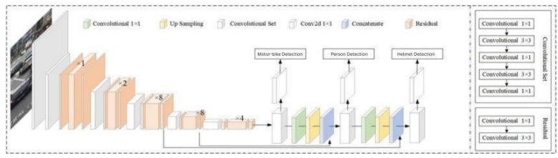

**4.2 Block Diagram of Architecture**

The flowchart illustrates the process flow of an automated helmet compliance enforcement system designed to ensure road safety and adherence to traffic regulations.

1. **Image Upload:** The process begins when a user uploads an image for analysis.

2. **Motorbike & Person Detection:** The system identifies the presence of a motorbike and its rider using advanced object detection techniques.

3. **Helmet Detection:** The system analyzes whether the detected rider is wearing a helmet.

* If a helmet is detected, the process may proceed to license plate extraction for record-keeping.
* If no helmet is detected, the system automatically issues a challan for noncompliance

4**. License Plate Extraction & Challan Issuance:** The system extracts the license plate number and issues a challan if necessary.

5. Additional Functionalities: Users can

* View a video demonstration of helmet detection,
* Access challan details, or
* Exit the system.

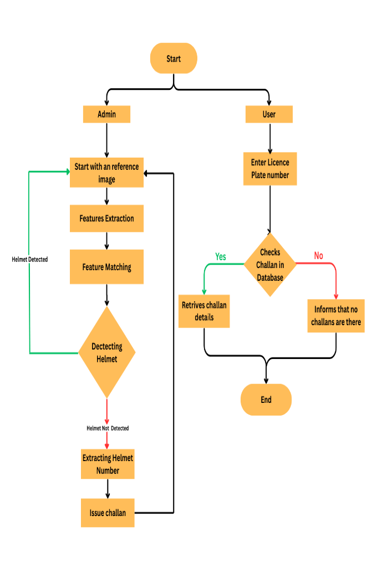

**Fig 4.2.1: Home Page**

**CHAPTER 5 : RESULTS AND DISCUSSIONS**

**5.1 Introduction**

The results presented in this section demonstrate the performance and effectiveness of our traffic violation detection system designed to enhance road safety through automated monitoring and enforcement. By employing advanced deep learning techniques such as object detection, optical character recognition (OCR), and texture analysis, our system aims to accurately identify instances of traffic violations, including riding without a helmet and unregistered vehicles. This section provides an in-depth analysis of the system's performance metrics, including detection accuracy, processing speed, and real-world applicability. Through rigorous

evaluation and validation, we assess the system's capability to contribute to proactive enforcement measures and improve overall traffic safety outcomes

**5.2 Results**



Fig 5.2.1: Home Page



Fig.5.2.2 Admin Login



Fig5.2.3: Admin Page After Login

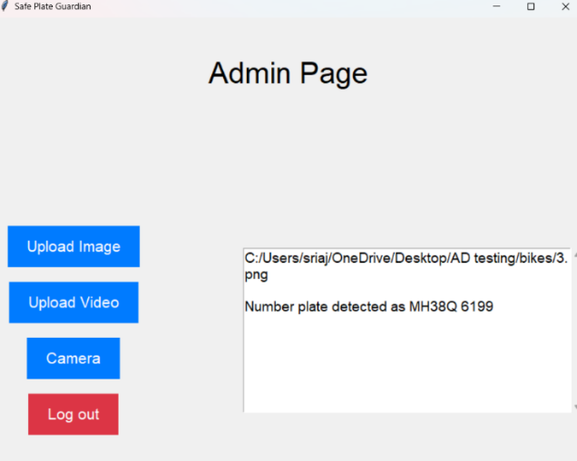

Fig 5.2.4 Admin After Uplaoding Image

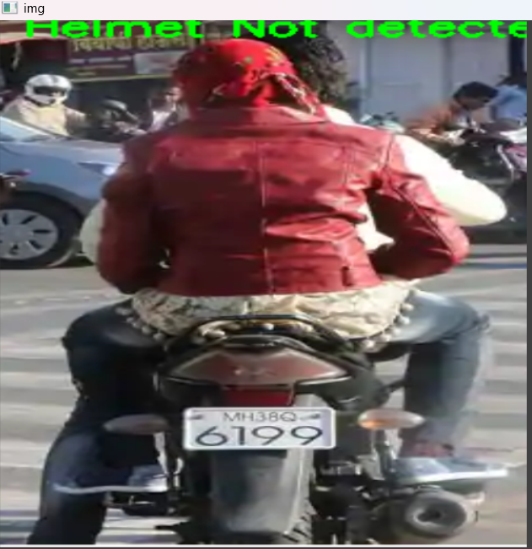

Fig 5.2.5 Generating Image if User Is Not Wearing Helmet



Fig 5.2.6 Generated Image If Helmet Is detected

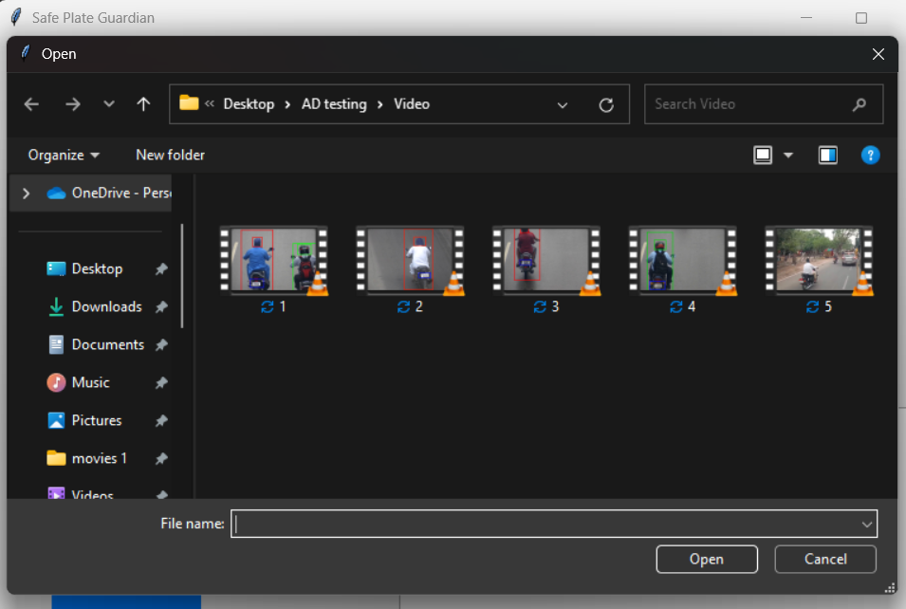

Fig5.2.7: Asks To Uplaod a Video if We want to generate output Using Video

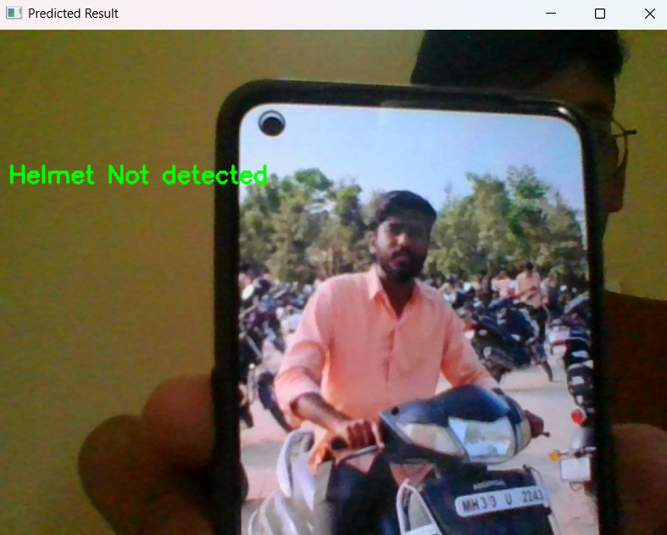

Fig 5.2.8 Generated Output AfterUsing Camera as an input.

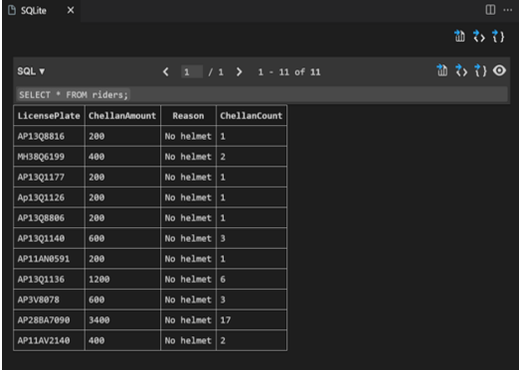

Fig.5.2.9 Updating Details in the database



Fig 5.2.10 User Page

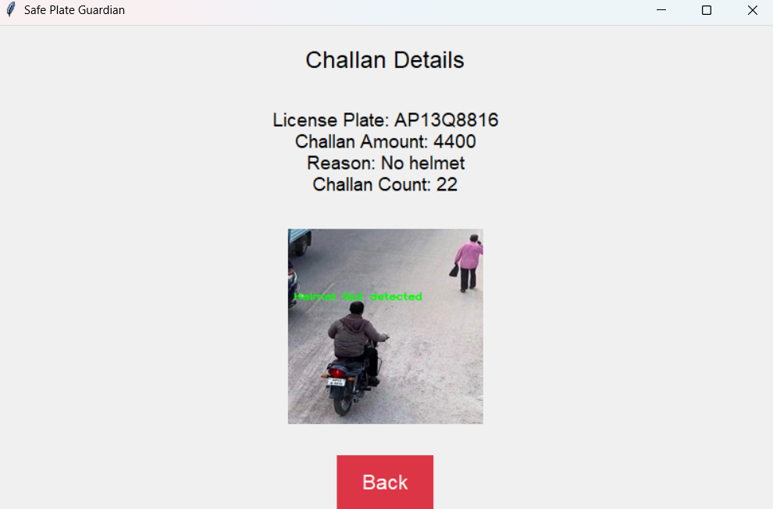

Fig 5.2.11 Extracted Number And Amount Will be Displayed On The Application If helmet Is Not Detected

**CHAPTER 6 : CONCLUSION**

**6.1 Project Conclusion**

The Non-Helmet Rider Detection System is designed to automatically identify motorcycle riders who are not wearing helmets and issue challans accordingly. The system takes a video file as input and utilizes YOLO-based object detection to recognize motorcycles, riders, helmets, and license plates. If a rider is detected without a helmet, OCR (Optical Character Recognition) is applied to extract the motorcycle's license plate number from the video frame. Along with the extracted text, the corresponding video frame is also captured for verification purposes. The system then stores the license plate details in an SQL database and issues challans for violations. Additionally, a web-based interface allows users to check their issued challans and access relevant details. By integrating deep learning, computer vision, and database management, this system efficiently enforces helmet compliance, enhancing road safety and reducing manual intervention in traffic monitoring.

**6.2 Future Scope**

Real-time Alerts and Notifications: Enhance the system to send real-time alerts and notifications to traffic authorities or law enforcement agencies when a traffic violation is detected. This could include SMS alerts, email notifications, or integration with existing communication systems

Vehicle Tracking and Monitoring: Extend the system to incorporate vehicle tracking and monitoring capabilities, enabling authorities to track the movement of vehicles with a history of traffic violations. This could involve integrating GPS technology or leveraging data from other traffic monitoring systems.

Advanced Analytics and Reporting: Implement advanced analytics and reporting features to analyze historical violation data, identify patterns and trends, and generate insightful reports for decision-making and policy formulation.

Mobile Application Development: Develop a mobile application companion to the webbased system, allowing users to access violation records, receive alerts, and report violations directly from their smartphones. This would increase the accessibility and usability of the system for both authorities and the general public.

Integration with Traffic Management Systems: Integrate the system with existing traffic management systems, such as traffic signal control systems or intelligent transportation systems (ITS), to enable seamless data exchange and coordination for improved traffic flow and safety.

Expansion to Other Traffic Violations: Expand the scope of the system to detect and manage other types of traffic violations, such as speeding, illegal parking, or lane violations. This would provide a comprehensive solution for enforcing traffic regulations and enhancing road safety.

Machine Learning Model Refinement: Continuously refine and optimize the machine learning models used in the system, such as YOLO for object detection or OCR for license plate recognition, to improve accuracy and efficiency over time.

Multi-Camera Integration: Expand the system to support integration with multiple cameras located at different intersections or traffic hotspots. This would enable comprehensive coverage of a larger area and facilitate cross-referencing of violation data for more accurate enforcement.

Integration with Smart City Initiatives: Align the project with smart city initiatives by integrating with other smart city infrastructure, such as smart traffic lights, smart parking systems, or environmental sensors. This integration can enable data sharing and collaboration between different city systems to optimize traffic management and urban planning.

**REFERENCES**

[1] Abu H. M. Rubaiyat, Tanjin T. Toma, Masoumeh Kalantari-Khandani, “Automatic Detection of Helmet Uses for Construction Safety”, IEEE/WIC/ACM International Conference on Web Intelligence Workshops (WIW), 2021.

[2] Kunal Dahiya, Dinesh Singh, C. Krishna Mohan, “Automatic Detection of Bike-riders without Helmet using Surveillance Videos in Real-time”, International joint conference on neural network (IJCNN). IEEE, 2019.

[3] Maharsh Desai, Shubham Khandelwal, Lokneesh Singh, Prof. Shilpa Gite, “Automatic Helmet Detection on Public Roads”, International Journal of Engineering Trends and Technology (IJETT), Volume 35 Number 5-May 2021, ISSN: 2231-5381.

[4] Romuere Silva, “Helmet Detection on Motorcyclists Using Image Descriptors and Classifiers”, 27th SIBGRAPI Conference on Graphics, Patterns and Images.IEEE, 2020.

[5] Romuere Silva, Kelson Aires, Thiago Santos, Kalyf Abdala, Rodrigo Veras, Andr´e Soares, “Automatic Detection of Motorcyclists without Helmet”, 2013 XXXIX Latin America Computing Conference (CLEI). IEEE,2019.

[6] Xinhua Jiang “A Study of Low-resolution Safety Helmet Image Recognition Combining Statistical Features with Artificial Neural Network”.ISSN: 2021, 1473-804x.

[7] S.Dutta,A.Datta,N.Das Chakladar, S.K.Pal, S.Mukhopadhyay, R.Sen “Detection of tool condition from the turned surface images using an accurate grey level co-occurrence technique”. Precision. Engineering Vol.36, 458– 466,2019.44

[8] Timo Ahonen, Abdenour Hadid, and Matti Pietikäinen. “Face recognition with local binary patterns”, ECCV, pp. 469–481, 2020.

[9]C.Stauffer and W.Grimson, “Adaptive background mixture models for real- time tracking,” in Proc. of the IEEE Conf. on

Computer Vision and Pattern Recognition (CVPR), vol. 2,2021.

[10]R.Silva, K.Aires, T.Santos, K.Abdala, R.Veras, and A. Soares, “Automatic detection of motorcyclists without helmet,” in Computing Conf. (CLEI), XXXIX Latin American, pp. 1–7, Oct 2020.

[11] A.Soni and A.P.singh, “Automatic motorcyclist helmet rule violation detection using tensorflow & keras in openCV”,2020 IEEE International Students’ Conferenece on Electrical Electronics and Computer Science(SCEECS),2020.

[12] C.Rohith et al., "An efficient helmet detection for MVD using deep learning", 2019 3rd International Conference on Trends in Electronics and Informatics (ICOEI), 2019.

[13] C.Henry, S.Y.Ahn and S.W.LEE, “Multinational license plate recognition generalized character sequence detection”, IEEE Access,vol.8,pp.35185- 35199,2020

[14] M.T.Ubaid et al. “Automatic helmet Detection using EfficientDet’’, 2021 International conference on Innovative computing (ICIC),2021.

[15] J.Shashiranga et al. “Automated license plate recognition: a survey on methods and techniques”, IEEE Access, vol.9,pp.11203-11225,2020.