**Android-Based Waste Classification System**

**Mrs. T. Leena Prema Kumari*1, Ms. Almas Banu*2**

*1Head, Assistant Professor, Fatima College, Madurai, India.

*2III B.Sc IT, Fatima College, India.

**I. Abstract**

Waste management is a critical environmental concern, requiring innovative solutions to ensure efficiency and sustainability. Traditional manual sorting is labor-intensive and prone to errors. This project introduces an AI-driven Waste Classification System utilizing Google ML Kit and Roboflow to automate waste detection and classification. Users can capture or upload images of waste, which the system processes in real time to determine waste categories. The results are stored in a Firebase Database, enabling admins to review and manage classification records. By leveraging machine learning, this system aims to enhance waste management efficiency, promote sustainable disposal, and minimize human intervention.

**II. Introduction**

Waste disposal has become a pressing global issue. Effective waste management solutions are essential to maintaining environmental balance. Conventional waste classification methods involve manual sorting, which is inefficient, costly, and susceptible to misclassification. This project presents a robust waste classification model utilizing AI-based image recognition techniques to improve classification accuracy and streamline the waste disposal process. By analyzing image data through machine learning algorithms, the system can categorize different types of waste automatically.

**Android-Based Waste Classification System**

**Database Module**

**Machine Learning Module**

**Admin Module**

**User Module**

**III. Existing System and Challenges**

**Limitations of Existing System**

* **Manual Effort:** Labor-intensive and slow process.
* **High Costs:** Increased operational expenses due to human involvement.
* **Human Error:** Subjective judgment leading to incorrect sorting.
* **Health Risks:** Exposure to hazardous waste materials.
* **Limited Scalability:** Inefficiencies in large-scale implementation.
* **Environmental Impact:** Inefficient waste sorting leads to pollution and resource wastage.

**IV. Research Objectives**

* The objective is to assess the effectiveness of AI-based waste classification in automating waste management systems and reducing manual sorting errors.
* This research aims to evaluate the impact of machine learning models in accurately categorizing waste materials into predefined types.
* The goal is to develop an AI-driven classification function that can predict waste categories based on visual data, enhancing the efficiency of recycling processes.
* To enhance the performance of the classification model by implementing image pre-processing techniques such as noise reduction and feature extraction.
* To integrate real-time classification capabilities into an Android-based system, ensuring immediate and accurate waste categorization.
* To improve the system's accuracy by utilizing optimization techniques that minimize discrepancies between actual and predicted classifications.

**V. Proposed System**

The AI-powered Waste Classification System leverages Google ML Kit and Roboflow for real-time waste categorization. Users upload images of waste, and the system classifies them based on predefined categories. The system enhances classification accuracy, reduces human intervention, and streamlines waste management processes.

**Key Features**

* **Automated Classification:** Reduces dependency on manual sorting.
* **Real-Time Analysis:** Provides instant results.
* **Improved Accuracy:** AI-powered classification ensures precise results.
* **Cost-Effective:** Reduces labor and operational costs.
* **Health & Safety Benefits:** Minimizes direct exposure to hazardous waste.
* **Scalability:** Easily deployable across various locations.
* **Environmental Benefits:** Enhances efficiency in recycling and waste disposal.
* **User-Friendly Interface:** Simple and intuitive Android application.

**VI. System Architecture and Design**

**1. User Module**

* Uploads waste images.
* Receives waste classification results.
* Requests waste collection services.
* Tracks request status.

**2. Admin Module**

* Reviews waste classification requests.
* Updates waste collection status.
* Manages classification records in Firebase Database.

**3. Machine Learning Module**

* Uses Google ML Kit for waste image classification.
* Ensures high precision in waste categorization.

**4. Database Module**

* Stores classification records and waste collection requests.
* Provides real-time synchronization between users and admins.

**VII. Methodology**

**Methodology – Waste Classification Using Google ML Kit**

The **Android-Based Waste Classification System** leverages **Google ML Kit**, an on-device machine learning framework, to automate the classification of waste materials. Traditional manual waste sorting is inefficient and error-prone, leading to environmental pollution and ineffective recycling. This system aims to improve waste management by using **AI-driven image classification**, allowing users to capture images of waste and receive immediate categorization results. The integration of **Google ML Kit, Firebase Realtime Database, and Android development** ensures seamless real-time waste classification, minimal latency, and offline processing capabilities.

The proposed methodology consists of the following phases: **data collection, preprocessing, feature extraction, model training, classification, real-time processing, and system evaluation**.

**Data Collection and Preprocessing**

**Data Collection**

A high-quality dataset is crucial for training the waste classification model. Images of various waste types are collected from:

* Publicly available datasets (e.g., TrashNet, TACO dataset).
* User-submitted images from the mobile application.
* Manually curated datasets created through real-world waste collection.

Each image is labeled according to waste categories such as plastic, organic, metal, glass, and paper. Additional metadata, including timestamps, geolocation, and classification confidence score, is stored for future reference.

**Preprocessing Techniques**

To enhance the accuracy of classification, preprocessing techniques are applied:

* Noise Reduction: Filters out blurs, distortions, and unwanted artifacts.
* Image Resizing: Standardizes images to a fixed resolution for consistent model input.
* Segmentation: Detects and isolates waste objects from the background using contour detection.
* Data Augmentation: Applies transformations (rotation, flipping, brightness adjustment) to improve dataset diversity and model generalization.
* These preprocessing steps ensure that only high-quality, clean data is used for training, thereby improving the efficiency of the classification model.

**Feature Extraction and Waste Classification Using Google ML Kit**

**Why Google ML Kit?**

Google ML Kit provides on-device image classification without requiring a continuous internet connection. Unlike cloud-based models, which introduce latency and security concerns, ML Kit processes images locally on the Android device, making it an efficient and privacy-focused solution.

**Waste Classification Process**

1. **User Input:** The user captures or uploads a waste image through the Android app.
2. **Image Preprocessing:** The system enhances the image quality using ML Kit’s built-in features.
3. **Feature Extraction:** Key features such as color, texture, edges, and shape patterns are identified using deep learning techniques.
4. **ML Model Processing:** The Google ML Kit classification model analyzes the extracted features and predicts the waste category.
5. **Result Display:** The app provides immediate feedback, displaying the waste category and confidence score.
6. **Data Storage:** The classification results are logged in Firebase Realtime Database for tracking and monitoring.

This structured pipeline ensures fast, accurate, and real-time classification, allowing users to efficiently dispose of waste in the correct category.

**Model Training and Optimization**

**Transfer Learning with Google ML Kit**

To enhance classification accuracy, the system employs transfer learning, fine-tuning a pre-trained Google ML Kit model with a custom waste dataset. MobileNet and EfficientNet are commonly used lightweight models that balance accuracy and computational efficiency.

**Optimization Techniques**

To improve model performance, various optimization methods are used:

* **Loss Function:** The system uses Cross-Entropy Loss to minimize classification errors.
* **Adam Optimizer:** Adjusts learning rates dynamically to improve model convergence.
* **Dropout Regularization:** Prevents overfitting by randomly deactivating certain neurons during training.
* **Hyperparameter Tuning:** Adjusting batch size, learning rate, and dropout rates enhances classification accuracy.

By implementing these strategies, the Google ML Kit model achieves high precision and recall, making it suitable for real-world waste classification applications.

**Real-Time Implementation and System Integration**

**Android Application Development**

The Android app serves as the primary interface for users to classify waste. It is built using Java/Kotlin in Android Studio, integrating Google ML Kit for on-device classification. The app offers:

* **Camera & Image Upload Options:** Users can capture live images or select existing ones.
* **Real-Time Classification:** The ML Kit model processes images instantly and provides waste category suggestions.
* **Offline Mode:** ML Kit’s on-device processing enables classification even without an internet connection.

**Firebase Database Integration**

To store and analyze classification data, Firebase Realtime Database is integrated into the system. This allows:

* **Storing Classification Results:** Each waste classification record is logged with metadata.
* **User Activity Tracking:** Admins can monitor user-submitted waste classifications.
* **Trend Analysis:** Waste categorization data helps identify waste patterns and optimize recycling efforts.

This cloud-based integration ensures seamless data synchronization while preserving offline functionality.

**Performance Evaluation and System Testing**

**Performance Metrics**

The classification system is evaluated using multiple performance metrics:

* **Accuracy:** Measures how correctly the model classifies waste categories.
* **Precision & Recall:** Evaluates how well the model distinguishes between similar waste materials.
* **F1-Score:** Ensures a balance between precision and recall for optimal classification.
* **Processing Time:** Analyzes the time taken to classify an image in real-time.
* **User Feedback Analysis:** The system adapts based on user corrections, improving classification accuracy over time.

**Challenges and Improvements**

* **Handling Complex Waste Mixtures:** The system occasionally struggles with waste that contains multiple materials (e.g., paper with plastic coating). Future improvements include training the model with multi-label classification to enhance mixed waste recognition.
* **Expanding the Dataset:** Collecting more labeled images from real-world waste disposal sites will further improve model generalization.

By continuously refining the classification model based on real-world feedback, the system evolves to achieve higher accuracy and efficiency.

**VIII. Results and** **Discussion**

**1. Image Classification**

The system efficiently classifies a wide variety of debris—from wood and plastic to mixed waste—by processing uploaded images in real time. Through AI-based modeling, each image is analyzed to determine its specific waste category, allowing for better sorting and environmental management. By incorporating a broad dataset, the model ensures that even diverse or complex debris types are recognized accurately, ultimately streamlining cleanup efforts.

**2. Upload Screen**

A user-friendly interface, labeled “Keep it clean, keep it green,” provides a straightforward method for submitting debris photos. By tapping the “Upload an Image” button, users can quickly capture or select an existing picture, making it easy for both casual and frequent users to contribute data. This intuitive design lowers the barrier to participation, encouraging more individuals to document waste and support environmental initiatives.

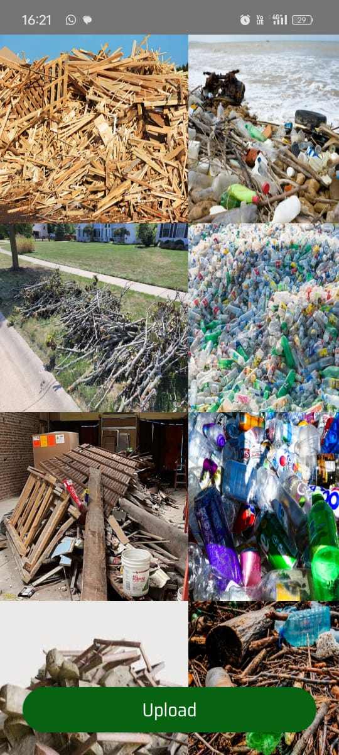

**3. Classification Output and Details**

Once an image is uploaded, the app immediately displays the determined debris type (e.g., natural or plastic), a calculated debris level (such as 44%), and an estimated cleanup time (e.g., seven hours). These real-time insights help users understand the severity and type of debris, enabling them to make informed decisions about cleanup actions. By providing actionable information, the system closes the loop from data collection to on-the-ground response.

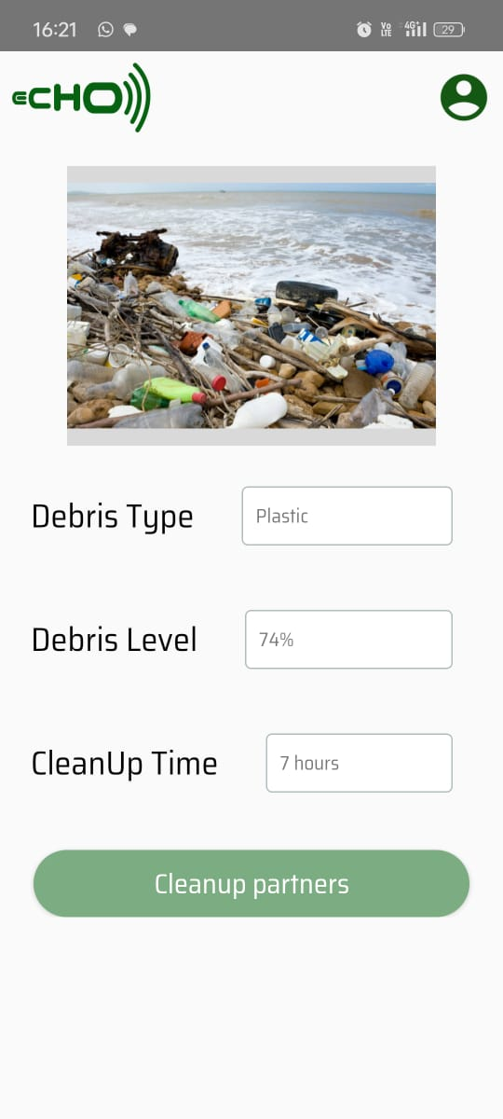



4. User Profile Screen

A dedicated profile page allows users to manage personal details like their name, email, phone number, and address. This personalized approach not only helps track individual contributions to debris reporting but also fosters a sense of ownership and responsibility among users. In future iterations, this feature could be expanded to include usage statistics, gamification elements, or community engagement tools to further motivate environmentally conscious behaviors.

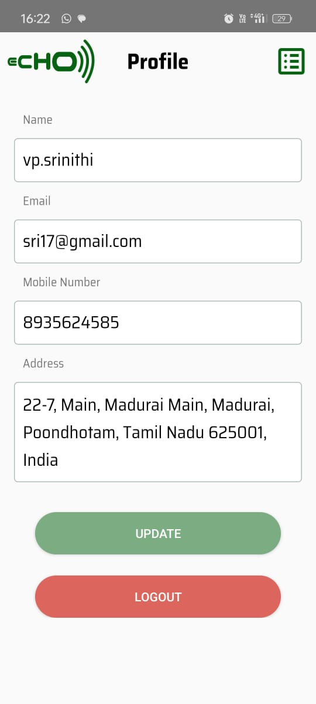

**IX. Conclusion**

The **Android-Based Waste Classification System** leverages **machine learning and image processing** to automate waste categorization, enhancing waste management efficiency. By utilizing **Google ML Kit and Firebase**, the system ensures **real-time classification** and seamless data handling. It significantly reduces human intervention, improves sorting accuracy, and promotes sustainable waste disposal. Future enhancements could include **expanding datasets, integrating IoT-based smart sensors, and refining classification algorithms** for better performance. This system contributes to **environmental conservation by minimizing landfill waste and encouraging recycling practices**.

**X. References**

1. Google ML Kit Documentation - <https://developers.google.com/ml-kit>
2. Roboflow Documentation - <https://roboflow.com>
3. Firebase Database Documentation - <https://firebase.google.com/docs/database>
4. Android Development Guide - <https://developer.android.com>