*PREDICTIVE MAINTENANCE OF PV PANELS BY PROCESSING VISIBLE IMAGES*

Mahalakshmi. R

*UG Scholar, EEE*

*Sathyabama Institute of Science &Technology*,

Chennai, India

mahalakshmiravichandran1@gmail.com

Pushpavalli. M

*Assistant Professor, EEE*

*Sathyabama Institute of Science &Technology*,

Chennai, India

pushpa.murugan@gmail.com

Sivagami. P

*Assistant Professor, EEE*

*Sathyabama Institute of Science &Technology*,

Chennai, India

sivagamitec@gmail.com

Abirami. P

*Assistant Professor, EEE*

*B.S. Abdur Rahman Crescent Institute of Science & Technology,*

Chennai, India

abiramiramkumar@gmail.com

Indhu. G

*UG Scholar, EEE*

*Sathyabama Institute of Science &Technology*,

Chennai, India

indhuganesan122004@gmail.com

Nilananthanna. S

*UG Scholar, ECE*

*St. Joseph’s Institute of Technology*

Chennai, India

nilananthanna13@gmail.com

***Abstract****—* **Solar panels offer a realistic substitute for the traditional energy source due to the increasing global necessity for sustainable energy solutions. Solar energy produces lesser contaminants, lesser operational cost, and a total independence from energy grid systems. Ordinarily, both transient and permanent failures act as inhibitors to performance and longevity of photovoltaic (PV) systems. Such failures include those of shading, dust deposits, bird droppings, and physical damage, having a huge potential for reducing power generation while increasing maintenance costs. Early fault identification and repairs are very important in optimal energy efficiency and reliability of solar power systems. This study deals with the automatic detection and identification of common faults in a solar panel so as to enhance maintenance planning. A dataset of images of affected panels has been compiled, focusing particularly on two types of faults: shadows and bird droppings. Image augmentations like image rotation, scaling, and shearing have enhanced the diversity and robustness of the dataset. The YOLO object detection model was then applied to the analyzed images: it will detect faults and impact areas with high precision. Preprocessing operations included image normalization and data balancing which improved model performance by inducing fewer classification errors. After the model identifies a fault, the system indicates the areas affected and automatically sends an email notifying users of the detected fault. The email notification carries fault details along with an image attachment, thus providing users with visual evidence for prompt action. The applicability of this alert system thus provides timely maintenance and reduces the risk of extended performance reduction. The automated detection of faults would, therefore, reduce the amount of required manual inspection, but at the same time improve fault diagnosis probability and enable predictive maintenance techniques. Real-time monitoring of solar PV will be improved using deep learning in the analysis of PV faults, thus increasing the output energy and reducing the time of operation. Future studies will be focused on the widening of detectable fault types, improved model accuracy, and developing real-time monitoring systems to configure the solar energy system for an even increased efficiency and sustainability level. The results are part of the continuing research geared towards solar panel performance improvement to make renewable energy systems efficient and cheap for mass applications.**

***Keywords—*** ***YOLO model, Image processing, Real-time monitoring), Object detection, Bounding boxes, Solar panel faults***

# Introduction

The impact on the growing global demand for energy with other serious concerns touching on environmental degradation and climate change has made the shift to renewable energy sources inevitable. The major source of energy for long has been fossil fuels, and unfortunately, they are among the largest contributors to greenhouse gas emissions and pollution of the environment. However, renewable energy sources such as solar energy, wind, hydro, geothermal power, etc., have provided sustainable alternatives to diminish carbon footprints and long terms supply of energy security. Among these alternative sources of energy, solar energy has turned out to be among the most promising and widely accepted solutions, as it is plentiful, always available, and has the potential to meet the world's demanded energy needs in future times. Solar energy is harnessed using photovoltaic panels, which convert sunlight to electricity. These panels have many advantages: low operational costs, very little environmental impact, and they can generate energy in remote areas. Solar energy is also essential as a clean renewable energy source to replace fossil fuels, contribute to climate change mitigation, and promote energy independence and security for residential and industrial applications. Solar technology advancements have improved solar panel efficiency and reduced their cost, making them a practical solution for sustainable energy production. In spite of advantages solar generation has, however, suffers several problems, and those that can either limit its performance or reliability include dust accumulation, shading, bird droppings, and physical damage. Regular maintenance and effective detection of faults therefore become critical factors towards ensuring optimal energy output and also prolonging the use of solar panels. Automatic monitoring systems powered by artificial intelligence and image processing techniques have the potential to transform fault detection and maintenance practices in solar energy systems. It serves to detect and respond to faults faster in an increasing way of improving nd reliable as well as cost-effective ways of using solar energy without the doubt of further strengthening the most critical position solar power has been made in the transition into a sustainable energy future. In addition, it has provisions for integrating an email notification mechanism to the same system so that fault alerts can be directly reached to the maintenance team for prompt corrective action, thus minimizing system downtime.

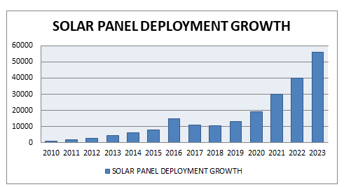

Fig.1. Solar Panel Deployment Growth

The figure 1 depicts a continuous growth in solar panel installation on an annual basis from 2010 to 2023. This growth was almost negligible until 2014, and constant growth has been observed since 2015. A major surge was seen in 2021 with the highest deployment done in 2023, which is above 55,000 units. This rapid growth indicates an increased acceptance of solar technology due to advancements in technology, increasing awareness of renewable energy, and active government involvement in promoting solar energy.

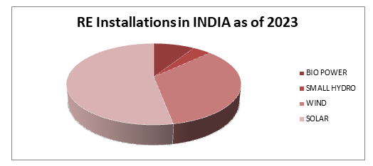

Fig.2. RE Installations in India as of 2023

The pie chart diagram is shown in Fig. 2 titled “RE Installations in INDIA as Implemented in 2023.” The chart visually explains the distribution of various renewable energy sources in India's total installed energy capacity. The sources of energy categorized in the chart are solar, wind, small hydro, and bio power. Among these, solar power takes the largest share, reflecting its leading status in India's renewable energy scenario. Wind energy ranks the second contributor, while small hydro and bio power constitute relatively smaller shares. This distribution shows that India has concentrated efforts on expanding solar energy capacity as its primary source of clean energy. Solar energy is very important for India's energy transition, owing to its availability and sustainable management. Solar energy assists in reducing carbon emissions, reducing fossil fuel dependency, and protecting the environment. With the decreasing cost of solar panels and advancing technologies, solar energy has increasingly become an option for urban and rural communities. Besides, it forms a backbone in rural electrification as a renewable source of power for distant corners. As India continues to pace its way towards renewable energy expansion, solar will become a driver towards energy security and economic development.

II. FAULTS AFFECTING THE PV YIELD

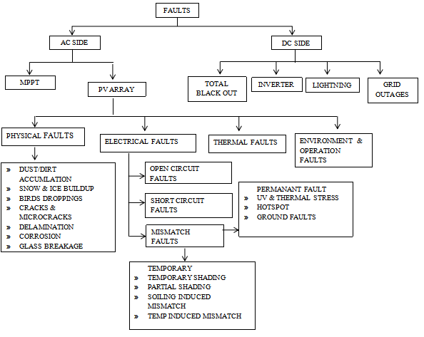

Faults are categorized in the block diagram as affecting photovoltaic yield in the AC and DC parts of the system. In the AC part, the faults occur in the MPPT system and PV array. On the other hand, the array PV is exposed to the following physical faults: dust or dirt accumulation, snow and ice buildup, bird droppings, cracks and microcracks, delamination, corrosion, glass breakage, etc. All of the items above deprive the panel of some efficiencies by either blocking sunlight or damaging components. The array may also experience faulty electrical faults such as open circuit faults, short circuit faults, mismatch faults, etc. Mismatch faults can be classified into temporary and permanent faults. Temporary faults can be caused by shading - partial or temporary, soiling-induced mismatch, and temperature-induced mismatch. DC-side faults are blackout faults, inverter faults, lightning faults, and grid failure. Other examples of faults are thermal faults such as UV and thermal stress, hotspots, and ground faults that reduce the system efficiency due to excessive heat generation or failure of PV components. Other yield losses are attributed to environmental and operational faults, which bring a lot of external factors like weather conditions or system mismanagement. There are different types of faults but they all impact the performance and yield of the overall PV system differently, hence proper maintenance and monitoring in place for optimal energy production.

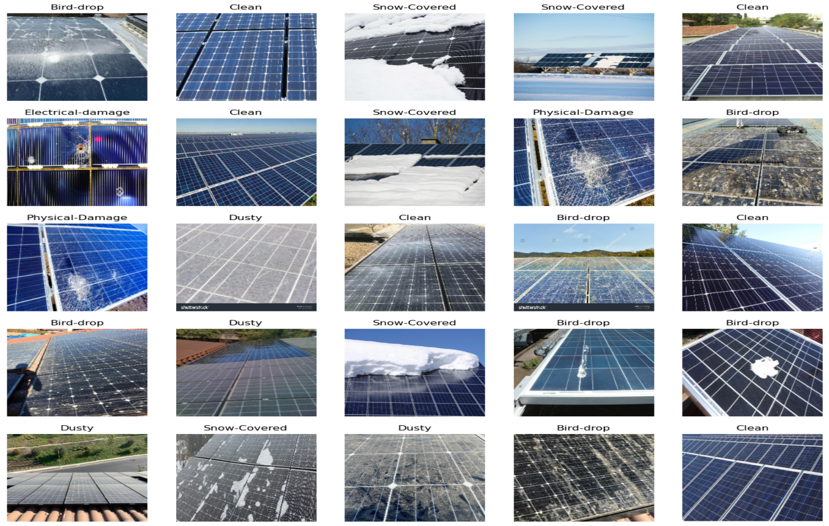 Fig.3. PV Faults

The Fig 3 is an excellent illustration of photovoltaic (PV) panels with the most difficult to express performance killers. For example, snow-covered panels accentuate the efficiency losses due to the fact that the sun is not shining through the snow anymore, which shows that taking care of panels and cleaning them regularly is necessary. In some cases, panels that are either damaged or cracked and were visible even then can cause energy loss, hot spots, and even safety hazards. Dust and dirt accumulation, which can be seen to some extent on the panels, further reduces the energy output, meaning that the panels have to be cleaned more often. As a side note, it is known that uneven lighting or partial shaded areas, which are considered the only possible operation mode of a non-uniform facility, will affect the PV system adversely as well. These surroundings tell us how important it is to identify the fault and fix it to get the best performance out of the solar panel through the years.

III. DIFFERENT APPROACHES TO ALLEVIATE PV FAULT

In 2024, R. Ramaprabha, et al. simulated various faults in the PV system and collected datasets for both normal and faulty conditions. Then it extracted the features of interest from the gathered datasets and tried training a machine learning model with historical data for predicting and classifying faults using new data. It addresses partial shading in PV arrays by employing a progressive, evolutionary MPPT method as an antidote to fight the condition.[1]

In 2023 Zhuang Niu et al, addresses the issue of finding of DC fault arcs in solar power generation networks for safe and stable running. The authors construct an experimental platform and established database of PV DC fault arcs. The methods adopted include statistical analysis time domain and Fourier transform from the frequency domain and wavelet transform from time-frequency domain perspectives. The characteristic values of fault arcs are successfully extracted with these methods that help identify a fault arc. For more comparative value, the three extraction methods are also compared in terms of advantages and disadvantages.[2]

In 2023, Jianhua Cha et al discussed the issue of detection of series arc defects in outdoor photovoltaic setups that is difficult to be identified by weak current variation and influences from environment. Data of arc fault current are obtained based on the experimental platform for arc faults with a practical photovoltaic array. The approach based on data includes the developing of the fault detection model with the application of TCN. Now, it is possible to test the efficiency of the TCN model through the prediction outputs.[3]

In 2023, Xuan Jiao et al introduced a new method of fault diagnosis for large-scale photovoltaic (PV) power plants. This is a real-time system identification without extra hardware, and it distinguishes normal from abnormal operations. The scheme would take into account the short and long time characteristics of the generation system to make it more robust. Simulation and experimental validations have been used to show its effectiveness in various test conditions.[4]

In 2023, Shouvik Mondal et al have explored short circuit faults in grid integrated microgrid with photovoltaic and biomass power generation. The authors modeled the PV and biomass units integrating them with an IEEE-33 test bus system. They tested the system under normal and faulty conditions analyzing the deviation and impact of short circuit faults on the system's working and reliability.[5]

In 2022 Ali Faisal Murtaza, et al presented diode based circuit and algorithm which detects faults, classifies and also localize using a single voltage sensor for an entire small to medium scale solar array equipped with blocking diodes, it is possible to identify between the lines faults and line to ambient faults and estimate the near count of malfunctioning blockss. One voltage sensor has been used for classification and another for determining the exact faulty string. with such a work proposed, the algorithm was expected to be capable of identifying both low impedance and high impedance defects. The suggested method and circuit are broadly evaluated using a physical hardware model. [6]

In 2022 Muhammad Adnan Khan, et al. modeled PV system by one-diode model of MATLAB/Simulink and simulate the modeled system at different operating conditions, such as good and faulty conditions, and analyze I-V characteristics of the modeled system and the actual system, hence, comparing I-V characteristics by six-derived parameters; Vte, MCPF, slope (S), currents ratio (Ri), voltage difference (Dv), and current difference (Di) based upon the sensitivity of these parameters toward different faults to produce different electrical signatures of each fault condition. [7]

In 2020, Pradeep kumar, et al proposed a new differential voltage measurement between neighboring PV modules based fault localization method using optimized arrangement with least number of sensors. It was designed by the method to detect all faults, independent of any detection challenges. This proposed method is validated through testing on a compact solar power system connected to the grid and it effectively identifies different types of array defects through broad studies. [8]

In 2021 N. Ghaffarzadeh, et al researched on solar module network defects and defect identifying methods. The proposed setup identify the faults based on their location of occurrence (e.g., DC side, AC side, specific components).[9]

In 2021 R. Lipták, et al established an electronic model of a solar cell to simulate the operation of a photovoltaic array by analyzing different types of faults in the photovoltaic array and validating the electric model of the photovoltaic array by measuring the P-U curve under different fault conditions The simulation is done by a typical solar PV array with 6x5 PV modules after validating the model.[10]

In 2021 V. Mohanapriya, et al, measured the voltage-current (V-I) characteristics of the solar PV system and comparing them to expected/actual characteristics to calculate power loss and monitor the variations on outcome electric potential are used for approximate count from defective units on a solar setup by employing different formation to detect faults and pinpoint their locations. [11]

In 2021 Laxman Solankee, proposed a system by using existing protection devices like fuses and residual current detectors to try to detect faults in PV systems and extracting discriminatory features from voltage and current data using an appropriate feature extraction technique then classifying various faults on the PV system using a suitable machine learning technique.[12]

In 2021 Ahsan Mehmood, et al developed an algorithm To identify, categorize, and pinpoint line-to-ambient (L-G) and between the lines (L-L) faults in a solar array. Algorithm is capable of identifying defects of any discrepancy in level and magnitude in the solar array by utilizing just single electric flow sensing device. The algorithm refers as well as able to functioning by limited defect barriers and with or without diodes for blocking. The algorithm was closely elaluated in an experimental setup to evaluate its accuracy. [13]

In 2021 A. Appiah, et al presented an overview and review of four major types of PV array faults. Proposed and use of a single evaluation metric to assess the performance of the advanced FDD techniques. A detailed analysis of traditional and modern methods for fault detection and diagnosis(FDD) in addressing these issues. [14]

In 2020 I. U. Khalil, Azhar Ul-Haq, et al developed a mathematical formulation and critical analysis of various PV fault detection techniques. Identification of the nature and causes of different PV faults. Comprehensive review and analysis of existing PV fault detection techniques to provide recommendations for improvement. [15]

In the year 2019, P Sevilla-Camacho et al presented the system by making use of the fluctuations in the AC frequency component of the PV array output voltage during fault conditions. Changes in the total dynamic impedance and AC voltage spectrum are analyzed to observe the location and detection of faults; applying red pulsed light to one panel of the solar array while leaving the remaining panels in the dark conditions. It applies statistical techniques as well as discrete Fourier transforms for feature extraction and classification without any expensive equipment or with the disconnection/modification of the PV array. [16]

In 2019, Dhanup S et al. classified the methods into a framework based on detection strategies and assessment factors, including the types of faults identified, response time, sensor needs, complexity of procedures, number of variables monitored, and the compatibility of protection systems. This framework was used to assess the performance of these methods in detecting line-to-line, line-to-ground, and arc faults, which are common in photovoltaic (PV) systems. [17]

In 2019, A.Haque et al proposed a system that used the thermography and artificial intelligence systems to design a monitoring tool for different types of faults in the PV modules. Application of a neural network (NN) classifier on the transfer characteristics (I-V data) of faulty PV modules to determine their type and location. Using DWT-based signal processing to extract features for dimensionality reduction at the input side of the NN. Adaptation of the developed algorithm for automation of surveillance for 24/7 operation with an average fault detection time of less than 9 seconds.[18]

In 2018 G. J. Tevi, et al reviewed and overviewed of different faults and failures that can affect the performance of photovoltaic (PV) system is observed. This system used a newer techniques like synchronized thermography, to detect these faults on the solar panels.[19]

In 2018 B. Pradeep Kumar, et al analyzed the error identification technique using wavelet packets analysis of PV array current data, voltage data and done simulation of the proposed method using MATLAB/Simulink. Experimental validation of the method on a 1.6-kW solar panel. [20]

In 2017, Andreas Dimitriou, et al, addressed the crucial issue of DC leakage and fault detection in floating PV systems. Light has now been shed on areas that require special attention from the PV community as well as utility management. Floating PV systems are common in European big PV parks, but none of them have grounding for positive and negative DC current-carrying conductors. Regardless of this, systems base other earthing connections on bonding to earth, such as exposed metals like PV module frames and support infrastructures. These can, under fault situations or at normal operation, be energized through DC coupling mechanisms with resultant safety hazards and accelerated DC corrosion. The paper does a critical analysis of these issues with an emphasis on the requirement of enhancing fault detection methodologies in floating PV systems so that the underlying infrastructure is safe. [21]

In 2017, Moath Alsafasfeh, et al designed an automation system for automating the identification of faults in solar energy systems through thermal imaging, which promises detailed and timely alerts in dangerous situations. The developed approach involves the Simple Linear Iterative Clustering (SLIC) Superpixel technique for hot spot detection in the solar panels. Experimental results show the real-time correct detection of hot spots using infrared images with SLIC. These notifications indicate areas where the PV panels are probably not functioning at their usual performance levels. [22]

In 2017 Silei Chen et al proposed an algorithm for identifying in-line electrical discharges in photovoltaic setups under sophisticated interferences. The new algorithm was tested with experiments performed on different levels of PV currents, gap lengths between the arcs and the types of loads to gain deep insight into the features of PV series arc faults. The fault-like conditions peculiarities were targeted to avoid incorrect tripping. The decision feature chosen is with unstable fluctuations of the time domain and extra arc noises of the time-frequency domain. Optimal detection variables and fusion coefficients are established for arc fault discovery by dynamic threshold adjustment based on different normal current levels. The testing on the virtual platform validated the efficiency of the suggested algorithm. [23]

In 2023 Zhuang Niu et al, addresses the issue of finding of DC fault arcs in solar power generation networks for safe and stable running. The authors construct an experimental platform and established database of PV DC fault arcs. The methods adopted include statistical analysis time domain and Fourier transform from the frequency domain and wavelet transform from time-frequency domain perspectives. The characteristic values of fault arcs are successfully extracted with these methods that help identify a fault arc. For more comparative value, the three extraction methods are also compared in terms of advantages and disadvantages.[24]

In 2023, Kai Sun, Xi Xiao, et al presented an approach for fault diagnosis and state evaluation of a distributed photovoltaic (PV) system in the micro grid. The approach proposed by Cat Boost allows for the efficient identification of crack, short circuit, and open circuit faults in micro grid solar systems. Hence, using the context of the Gradient Boosting Decision Tree framework, Cat Boost can provide accurate representations of fault types in photovoltaic systems. In addition, this paper displays the state evaluation through the TOPSIS technique. In this paper, the approach proposed uses the feature importance calculated with Cat Boost as a weight factor of the features with aims to evaluate the operating states of a distributed PV system under various conditions. Experimental results are presented, and Impact, reliability of the suggested method help for improve the intelligent management of distributed PV systems within micro grids.[25]

Four methods are involved in the fault analysis block diagram for photovoltaic (PV) arrays. A machine-learning-based system for open-circuit, short-circuit, ground fault, mismatch, hotspots, and degradation fault identification-based on support vector machine (SVM) and Boost; application of I-V curve signature methods for fault identification series-parallel arc fault, ground fault, mismatch, and open or short circuits; visual imaging techniques using thermal and infrared imaging to identify the issues of bird droppings, snow, shadowing, hotspots, delamination, and dust accumulation; and failure analysis of the faulty modules compared to the normal modules in the investigation of faults such as shadowing, mismatch, hotspots, and degradation.

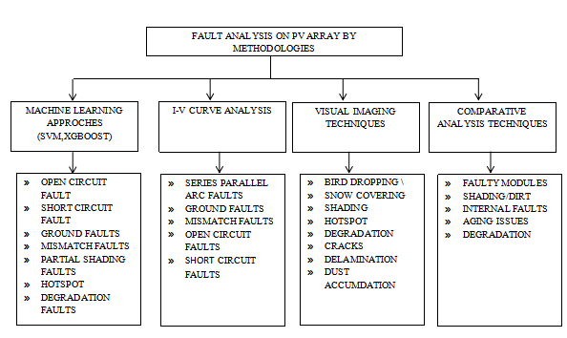

IV. RESEARCH STATUS OF FAULT DIAGNOSIS TECHNOLOGY

Simulated PV faults and trained a machine learning model for fault prediction, using an evolutionary MPPT method for partial shading.[1]Built an experimental setup for DC fault arc detection using statistical, Fourier, and wavelet analysis.[2]Applied a temporal convolutional network (TCN) to detect series arc faults in outdoor PV systems.[3]Developed a real-time fault diagnosis system for PV plants using system identification without extra hardware.[4]Modeled a PV-biomass microgrid on an IEEE-33 test bus to analyze short-circuit fault impacts.[5]Designed a diode-based fault detection system using minimal voltage sensors for classification and localization.[6]Simulated a one-diode PV model in MATLAB to analyze I-V characteristics under faulty conditions.[7]Proposed a fault localization method using differential voltage measurements with optimized sensor placement.[8]Identified PV faults based on location within the system, distinguishing between DC-side, AC-side, and components.[9]Created an electronic PV array model to analyze faults, validating it with power-voltage curve measurements.[10] Measured V-I characteristics to estimate defective units and detect faults by monitoring power variations.[11]Used protection devices and machine learning to classify PV system faults based on extracted voltage and current features.[12]Developed an algorithm for detecting and locating PV faults using a single current sensor, with experimental validation.[13]Reviewed major PV array faults and assessed fault detection techniques using a unified performance metric.[14]Conducted a mathematical analysis of PV fault detection methods, identifying causes and suggesting improvements.[15]Detected PV faults by analyzing AC voltage spectrum changes and using Fourier transforms for classification.[16]Classified PV fault detection methods based on response time, sensor needs, and protection system compatibility.[17]Used thermography and neural networks to classify PV faults, incorporating DWT for feature extraction.[18]Reviewed PV fault types and employed synchronized thermography for fault detection.[19]Applied wavelet packet analysis to PV current and voltage data for fault identification, validated experimentally.[20]Analyzed DC leakage and fault detection in floating PV systems, highlighting safety risks.[21]Developed an automated fault detection system using thermal imaging and SLIC for hot spot detection.[22]Proposed an algorithm for detecting PV arc faults under interference using dynamic threshold adjustments.[23]Created a database of PV DC fault arcs and compared statistical, Fourier, and wavelet methods for extraction.[24]Used CatBoost for PV fault diagnosis, integrating TOPSIS for system state evaluation in microgrids.[25]

V. Proposed Image Processing Technique for Fault Detection

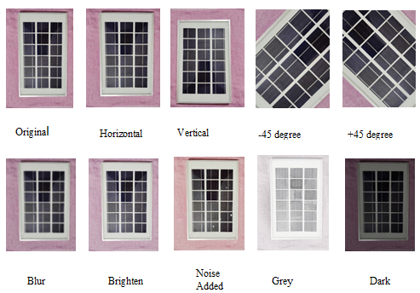

Fig.4. Image Augmentation

Various augmentation techniques applied to a solar panel image for data enhancement in machine learning are illustrated by Fig 4. Original, horizontal flip, vertical flip, and ±45-degree rotations are seen in the first row. The augmentations are blur, brightness adjustment, noise addition, convert to grayscale, and darkening, shown in the second row. These augmentations help to improve model robustness by simulating real-world variations in solar panel images.

Step 1: Image Augmentation

Roboflow applies transformations like rotation, scaling, and shearing to expand the dataset.

* 1. Rotation Transformation (Rotating an image by degrees)

$\left[\begin{matrix}x' \\ y'\end{matrix}\right]$*= $\left[\begin{matrix}cosθ & -sinθ \\ sinθ & cosθ\end{matrix}\right]$ $\left[\begin{matrix}x \\ y\end{matrix}\right]$*

* $(x,y)=$ Original pixel coordinates
* (x', y')= New pixel coordinates after rotation
* $θ=$ Rotation angle
  1. Scaling Transformation (Resizing the image)

$\left[\begin{matrix}x' \\ y'\end{matrix}\right]$*= $\left[\begin{matrix}S_x & 0 \\ 0 & S_y\end{matrix}\right]$ $\left[\begin{matrix}x \\ y\end{matrix}\right]$*

* S_x,S_y = Scaling factors for width and height

$\left[\begin{matrix}x' \\ y'\end{matrix}\right]$*= $\left[\begin{matrix}1 & tanα \\ tanβ & 1\end{matrix}\right]$ $\left[\begin{matrix}x \\ y\end{matrix}\right]$*

* $α,β$ = Shear angles along the x- and y-axes

Step 2: YOLO Bounding Box Annotation (Used in Roboflow Labeling)

Roboflow converts image labels into YOLO format, which requires normalizing bounding box coordinates.

2.1 Bounding Box Center Calculation

$x_{center}=\frac{x_{min}+ x_max }{2W}$, $y_{center}=\frac{y_min+y_max}{2H}$

* (x_min ,y_min) = Top-left corner of the bounding box
* (x_max ,y_max) = Bottom-right corner of the bounding box
* W, H = Image width and height

2.2 Bounding Box Width and Height Calculation

$$w=\frac{x_{min}+x_max}{W},h=\frac{y_min+y_max}{H}$$

* w, h are normalized bounding box width and height (between 0 and 1)

Step 3: Image Normalization for Model Training

Before passing images to the YOLO model, pixel values are normalized to improve convergence.

$I^{'}=\frac{I-I_min }{I_\max{-I_min }}$

* I = Original pixel intensity
* I_min, I_max = Minimum and maximum pixel values in the dataset
* I' = Normalized pixel value (range [0,1])

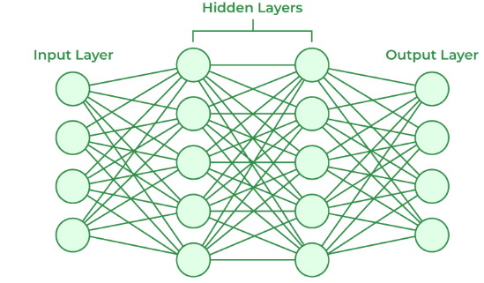

Fig.5. Deep Neural Network[26]

The structure shown in Fig 5 is a deep neural network (DNN) structure with multiple levels. It has an input layer, many hidden layers, and one output layer. Every neuron in a layer is completely connected with all neurons from the next layer. The labels "Normalize the outputs" refer to the application of normalization techniques to stabilize training and improve performance. Such networks can be used for most activities required in machine learning, such as classification, regression, pattern recognition, etc.

Step 4: Dataset Balancing (Handling Class Imbalance in Roboflow)

If the dataset has an unequal number of images per class, Roboflow adjusts the class weights.

$w_{i}=\frac{N}{N_{i}}$

* $w_{i}$ = Weight assigned to class C_i
* N = Total number of images in the dataset
* $N_{i}$ = Number of images in class C_i

Classes with fewer images are given higher weights to ensure balanced training.

Step 5: YOLO Model Training with Loss Function

Once the dataset is ready, the YOLO model is trained. The loss function balances object localization and classification.

ijobj+

* = Weight factor for localization loss
* $\left(x_{i}-x_{i}\right)$ = Ground truth bounding box coordinates
* $pi\left(c\right)$ = Predicted probability for class c
* $λ_{coord}$ = Weight factor for localization loss
* $\left(x_{i}-x_{i}\right)$ = Ground truth bounding box coordinates
* $pi\left(c\right)$ = Predicted probability for class c

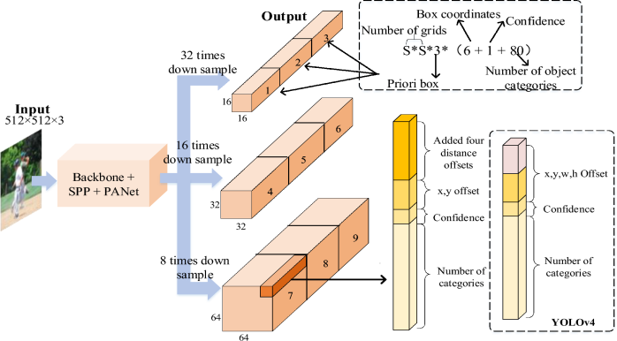

Fig.6. Real Time Object Detection [27]

As shown in Fig 1.5, the overall architecture of the YOLOv4 real-time object detection model is itself enough. Input shown in the figure is an input image of size 512×512×3, is then transformed through SPP and PANet modules into an output through a backbone network. With multi-scale feature extraction, it downsamples feature maps then detects objects at different scales by downsampled at three levels, namely 8, 16, and 32, to make the results available for three sizes. The results are bounding box coordinates, confidence scores, and category classifications. The right side of the image details the structure of output such as offsets and confidence levels for precise localization in the object. Yuolo v4 also enhances the detection in speed and accuracy through multi-scale feature images. The captured images are then processed by Roboflow according to their workflow in image processing for defect detection such shadow and bird poop on solar panels. First, the database is augmented with variations by performing transformations like rotation and scaling and shearing using images. The matrix used to perform the rotation transformation is $\left[\begin{matrix}cosθ & -sinθ \\ sinθ & cosθ\end{matrix}\right]$ so that misconception cannot happen to the model while recognizing defects from a different perspective. The scalings and shearing applied to the images for making diverse thick shapes and dimensions have their relevant matrices. This makes the dataset richer for training purposes. Images follow an annotation step, where irregular areas from animal and human excreta are marked using YOLO′s format bounding boxes. Localization of faults within the bounding box center is achieved with the center calculated as $x_{center}=\frac{x_{min}+ x_max }{2W}$, $y_{center}=\frac{y_min+y_max}{2H}$, The w and h being width and height respectively of the bounding boxes, will use the scale-invariance detection via normalization as follows: $w=\frac{x_{min}+x_max}{W},h=\frac{y_min+y_max}{H}$ using enabling scale-invariant detection. These labeled images, then exported into the YOLO format, are meant for training a model next. Following that is for normalization to standardize all pixel values under the range [0,1] by the equation $I^{'}=\frac{I-I_min }{I_\max{-I_min }}$. This step keeps the model running unaffected by the different lighting conditions and pixel intensities. Roboflow is the process automatic in balancing the dataset for it only capturing two types of faults-shadow and bird poop. The weights would be calculated for each class using $w_{i}=\frac{N}{N_{i}}$ where N is the total number of images and Ni is the number of images of a particular class. This step should prevent the throwing of any bias towards either fault by the model. Once the dataset is prepared, it is sent into the YOLO model for training for the fault detection and classification to be optimal with respect to the loss function that takes into account both localization and classification accuracy. Below is the loss function:

ijobj+

Where $λ_{coord}$ is the weight factor for localization loss $(x_{i},y_{i})$ are the ground truth bounding box coordinates, and $p_{i}(c)$ represents the predicted probability for a specific class. The trained YOLO model then processes new images, automatically detecting faults and marking affected regions with bounding boxes. The final output consists of images where shadow and bird poop areas are highlighted, enabling automated and precise fault detection for solar panels.

PROPOSED STRATEGY

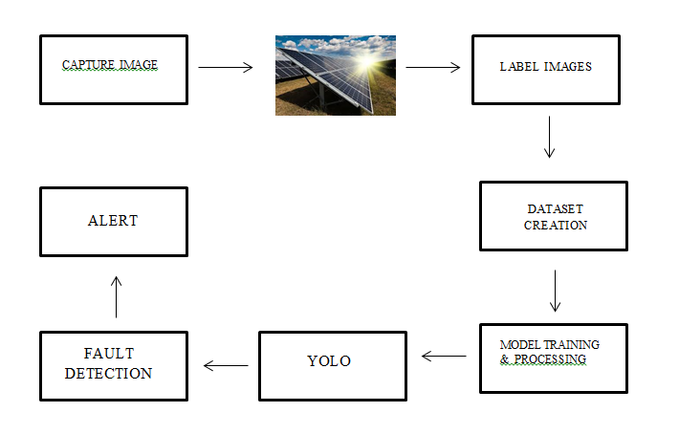

The above block diagram process that detects faults in solar panels like shadows and bird droppings in a systematic way. The first step involves taking images, over 300 in total, to create a diverse and comprehensive dataset. The images depict solar panels affected by shadows of trees, neglecting bird droppings, various lighting conditions, and angles. For some images, paper simulating bird droppings was used to enhance the robustness of the dataset, as it provided a more holistic imaging view from different angles before deployment of models. Thereafter came the labeling phase, whereby bounding boxes were drawn around areas of faults such that the model could actually learn their precise locations. The labeled images were then converted to YOLO format, for uniformity in preparing training inputs for the model, a process that also normalizes bounding box coordinates. The data set was augmented:rotation, scaling, and shearing were applied, to introduce variability into the images and consequently improve generalization in the model. Likewise, the dataset was balanced so that shadow and bird-dropping faults could be represented equally. This augmented dataset was then used to train both object localization and classification in the YOLO model with a fine-tuned loss function. Pixel-wise normalization of images improved convergence of the model, where the model learned to differentiate between shadows and bird droppings based on image patterns rather well. The trained model was then applied to new images that detected faults while marking their locations in bounding boxes. On the whole, the model was well generalized with accurate fault detection, as it could detect the faults despite variation in angles and lighting of the given images. Once detection of the fault is made, the alert mechanism is triggered. When a fault is detected, the user receives an email notification along with the image of the affected panel so that corrective action may be taken immediately. This proactive approach ensures that planned work therefore remains unaffected, thereby giving impetus to quick fixes that maintain the fail-safe functioning of solar panels.

The monitoring has always become a realistic monitoring system designed for fault detection in the solar panels following the model by YOLO, as seen in figure 7. This system thus takes an image in real time from a solar panel, which would be later pre-processed utilizing its techniques to better the quality of the image and the accuracy of the detection. YOLO then processes this image further known as pre-processing to determine if any faults exist. In the case of not finding any defect, the modernised system continues monitoring by taking and analyzing fresh images. If a fault is detected, however, the system classifies the defect type. The model is specifically built to detect two particular types of defect: shadows and bird droppings. When a shadow is found, an alert is announced that indicates to the user of such occurrence since shadows drastically reduce the solar performance of solar panels. Likewise, there is alerting triggered when bird poop is detected, informing the user of the blockage of energy delivery and possible damages occurring over time if unattended. In case of faults, the system would automatically send an email alert to the user with an image of the panel that is faulty. So, it is available for instant verification and corrective measures. After sending an alert, the system logs faults and updates detection results. This logging system assists in monitoring the faults' occurrence over time so that users can analyze the trends and take preventive actions towards improving the overall efficiency of the solar panel system. This real-time monitoring system reduces the necessity for manual checks and lowers the maintenance costs of solar panels while increasing their reliability and performance due to the automation of the fault detection process. Hence performance obstructions are determined and eliminated at the earliest possible opportunity to ensure that energy production and operational efficiency are maximized.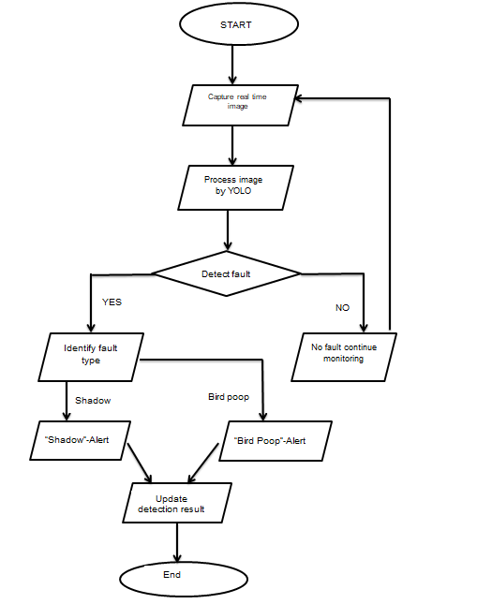

Figure .7.Flowchart

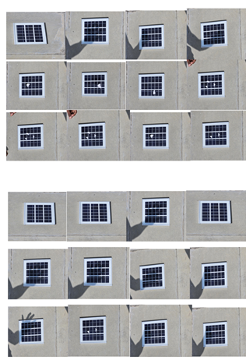

Fig.8. Data Collection

The Fig 8 forms a part of the dataset acquired for this project, presenting different solar panel states under different scenarios. The dataset further includes solar panel tilts, shadows, occlusions, and damage type variations for fault detection and classification. With the captured images, the machine learning model trains and tests itself to identify structural anomalies or external obstructions, contributing to an automated monitoring and maintenance system.

VI. RESULT & DISCUSSION

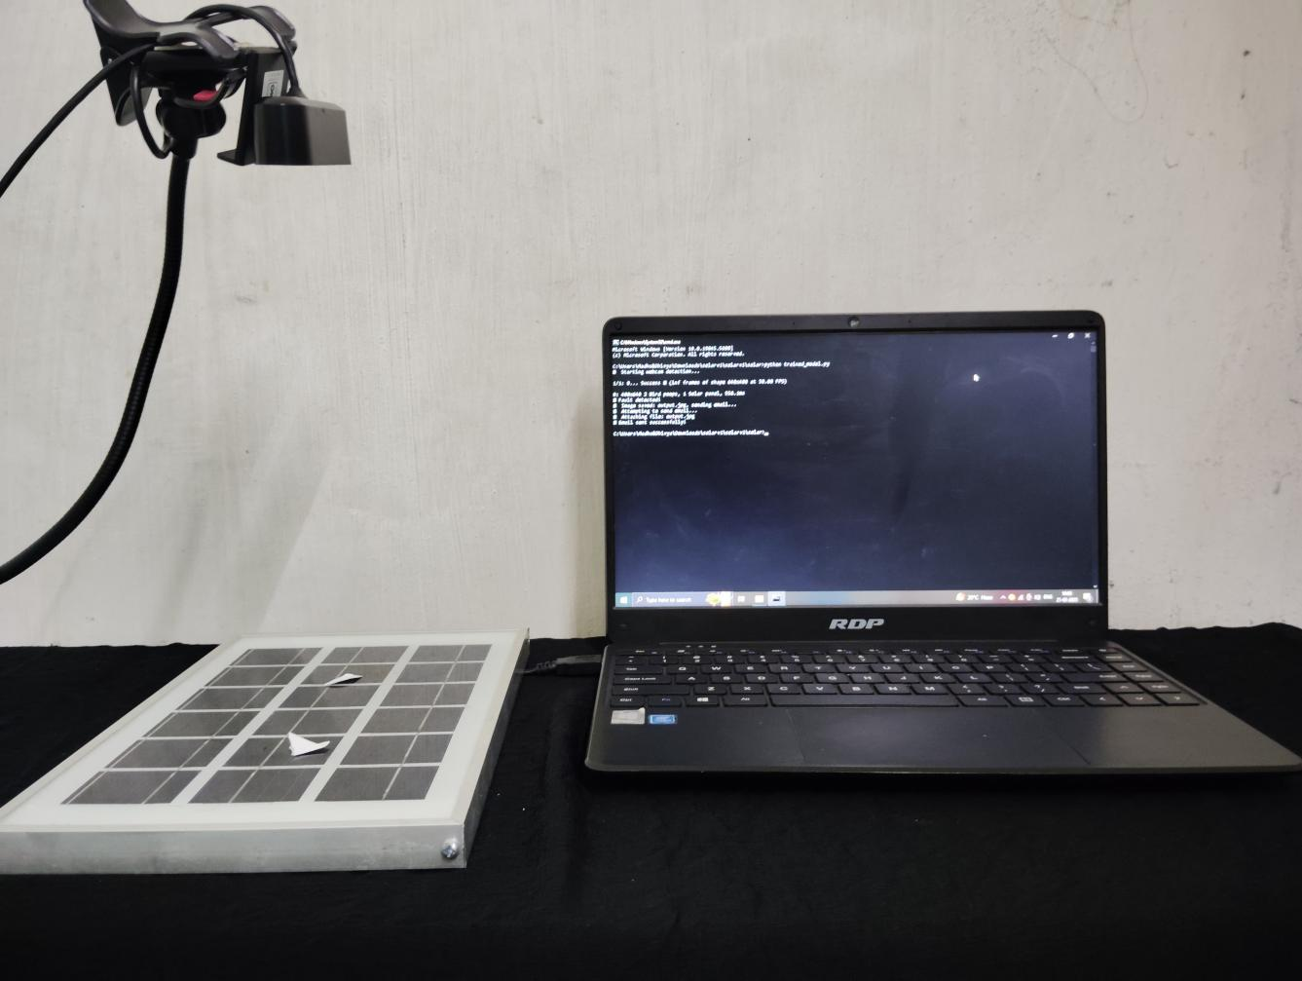

Fig.9.Hardware Setup

This figure 9 shows the hardware setup for the real-time detection of faults on solar panels considered for abnormality detection affecting the panels' performance via image processing techniques. The setup contains a high-resolution camera placed above the solar panel to capture real-time images of the panel surface. The setup ensures continuous monitoring of the panel via this camera, which sends the images to an interfaced laptop for the ensuing analysis. The solar panel appearing in the image has been spoofed with faults such as bird droppings represented by paper pieces to replicate actual conditions so as to establish the detection system's validity. These mock obstructions train and verify the effectiveness of the YOLO (You Only Look Once) object detection model for its applicability in fault detection in conditions of varying light incidence and angle. The images captured by the camera are studied with the YOLO model running on this laptop placed almost side by side with the solar panel, which analyzes images in real time by marking the anomalies and enclosing the problem areas in bounding boxes. The running algorithm for fault detection can be seen on the command prompt of the laptop's screen, where it is rigorously monitoring all the incoming streaming images for potential obstructions, whereby, upon fault detection, it will classify it as either a shadow or an instance of bird droppings and generate an automatic email alert to its user, conveying the acquired image and instructing corrective action immediately. The resulting automation considerably minimizes manual inspections while ensuring improved uptime and overall performance of solar panels. Another utility is that the system preserves a history of detected faults that the users can rely on to establish patterns and subsequently take proactive measures that will enhance efficiency and sustainability of photovoltaic systems.

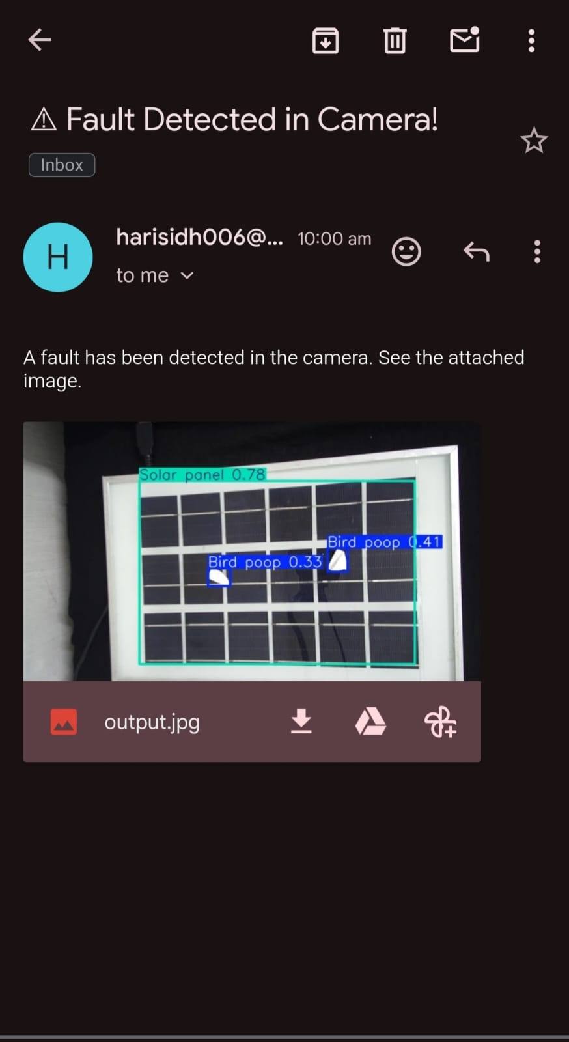

Fig.10.Automated Fault Detection Email with Image Attachment for PV Panel Anomalies

The Fig 10 demonstrates an email alert generated from the actual fault detection system of solar panels in real time about a fault detected in the monitored panel. The alert is sent from the email address specified for the system to the user with the subject: "Fault Detected in Camera! " to inform the user of the fault detected. The body of two messages contains a brief note, informing the recipient about a fault, and along with it carries an image attached "output.jpg", for reference. This image shows the solar panel having bounding boxes for the areas of the faulty tagging "Bird poop" at various points on the surface of the panel, with corresponding confidence levels of 0.33 and 0.41. The bounding boxes indicated with type of fault and confidence levels show visually where the faulty areas are and should be repaired. Users are timely informed via this email alert method and can take further action to remedy the efficiency losses. Also, the process minimizes the requirement for human monitoring while maximizing the overall maintenance as well as reliability of the solar panel system through automation of fault detection and notification.

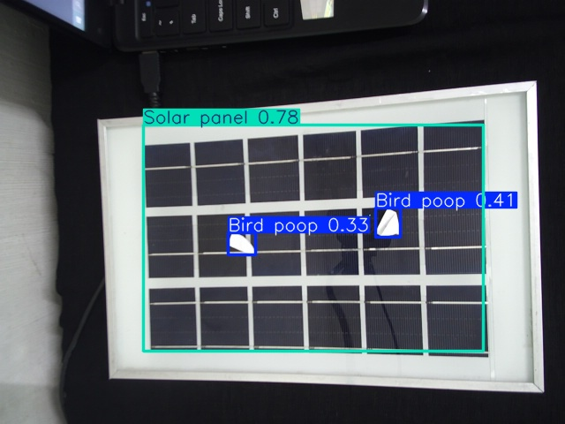

Fig.11.Detected Faults on Solar Panel - Email Output Image.

The following Fig 11 illustrates the output produced by the real-time solar panel fault detection system, which was appended in the email notification. The solar panel in the picture is detected with the YOLO (You Only Look Once) model, and bounding boxes are used to highlight the detected faults. The system has detected two "Bird poop" on the panel, each with a blue bounding box and confidence scores of 0.33 and 0.41, which represent the model's confidence in the detections. The whole solar panel is also indicated with a green bounding box labeled "Solar panel 0.78," representing the detection of the panel itself with a high confidence score of 0.78. These visual markings provide easy identification of the impacted zones, allowing the user to undertake corrective measures. These visual markings provide easy identification of the areas impacted so that the user can undertake corrective measures. The automated fault detection system promptly detects faults, minimizes manual inspection processes, prevents obstruction of efficiency due to faults, and ensures that the solar panels perform at optimum level.

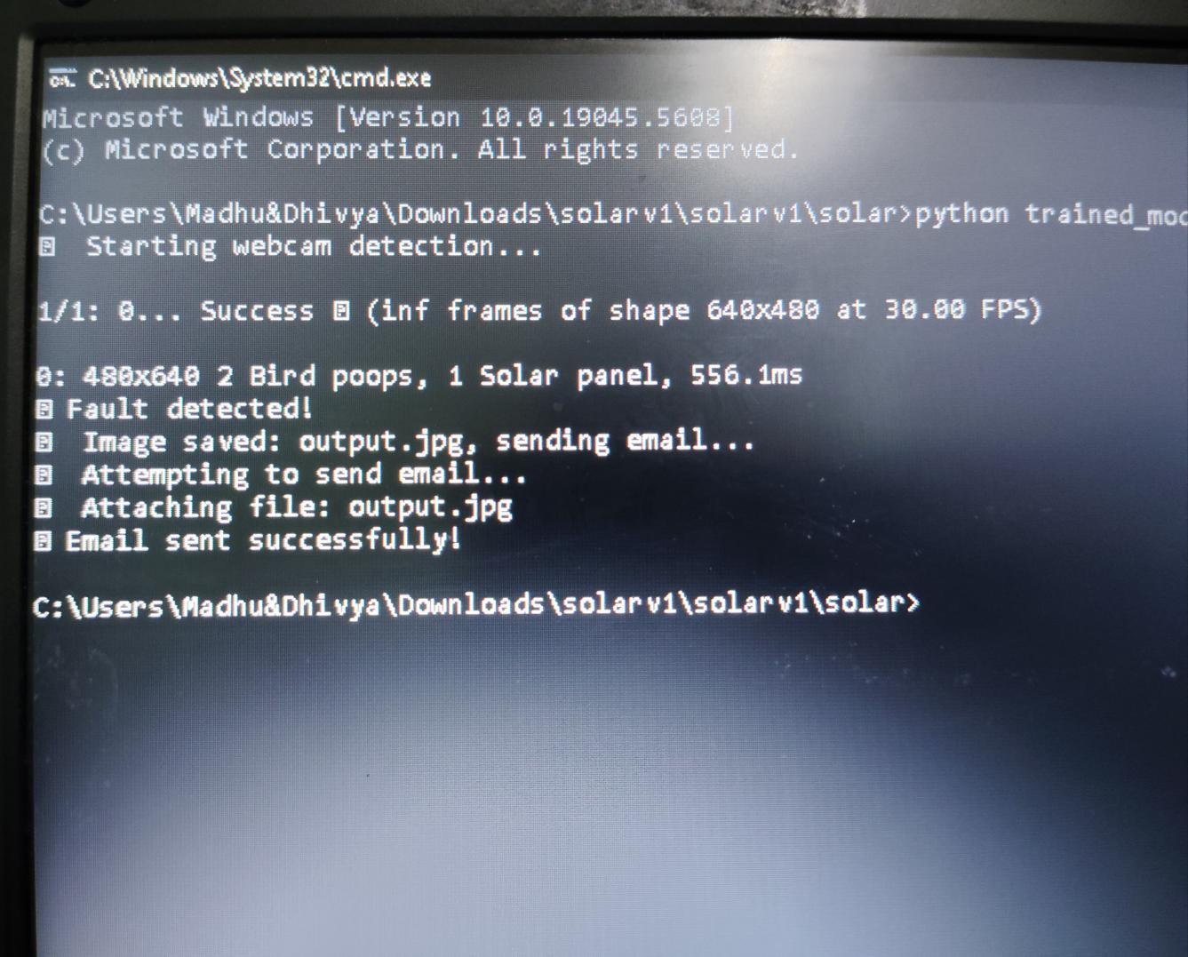

Fig.12.Real-Time Fault Detection and Email Notification Log

Figure 12 depicts a successful command prompt window through which it has operated the entire Python script for real-time solar panel fault detection. The module runs by directing access to the location of the directory and thereby begins the webcam-based detection. The entire process is capable of capturing frames of "640x480" at "30.00 FPS" and processes that framework within it. Here, the system has identified a total of 2 bird poops and 1 solar panel in the frame for fault detection, which took an estimated time of processing around "556.1 Ms." After updating the faults, the system saves it as an image called output.jpg and proceeds to send an email. In doing this, it adds output.jpg to it to send the email notification to a specified recipient, as a message of success shows from "Email sent successfully!” This output demonstrates the system's capacity for realistic fault detection automation and alerts to instigate prompt action against degradation of solar performance due to intrusions.

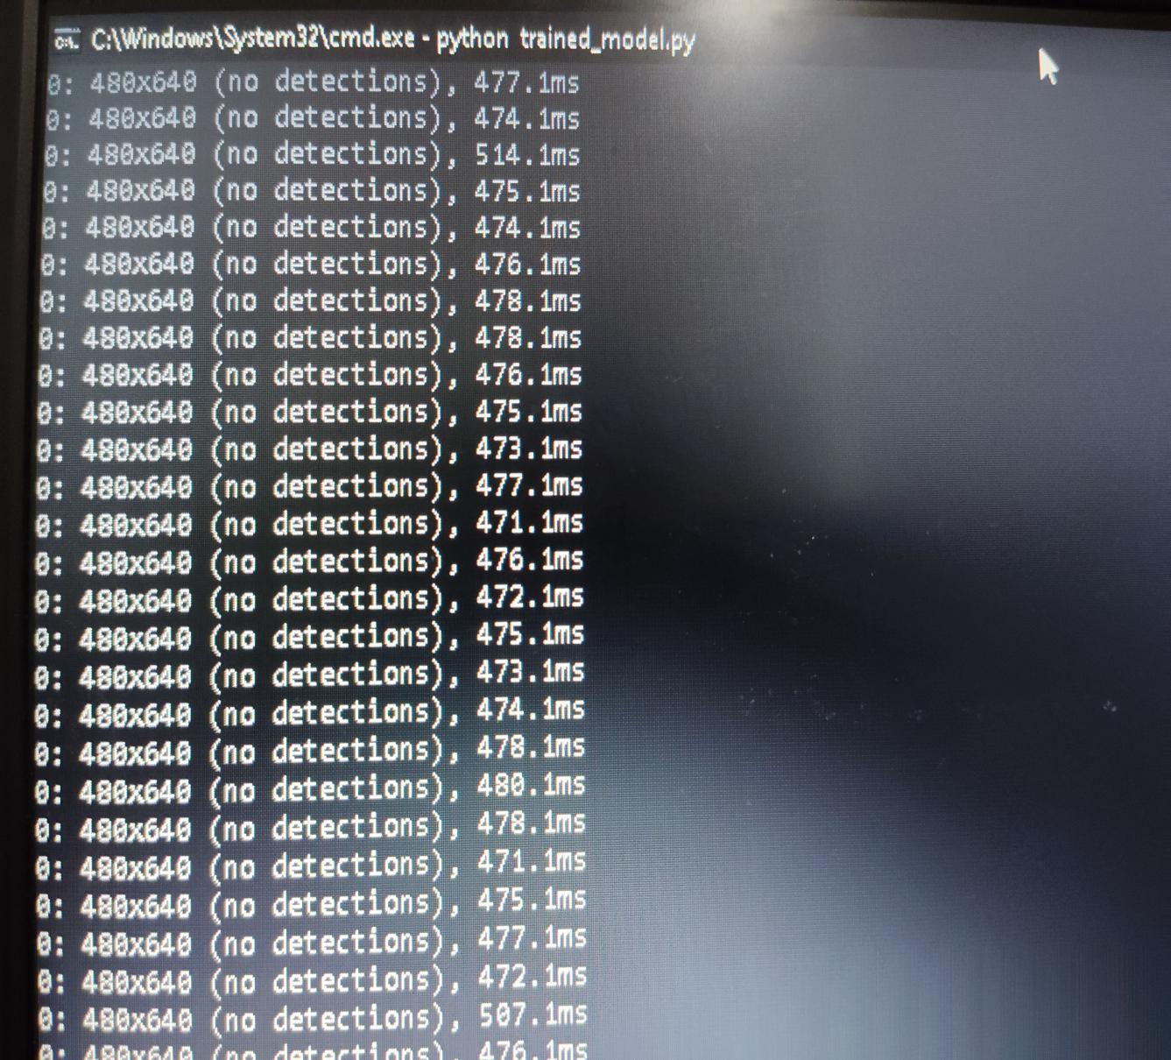

Fig.13.Persistent Scanning: No Anomalies Identified

The Fig 13 actually shows the command prompt window where the Python script "trained_model.py" is running for real-time monitoring and fault detection in solar panels. It is consuming many frames of resolution 480x640 pixels wherein the average time taken for processing each will be around 474-478 ms. At this point, the system goes a long way, reporting that "no detections" were found for all the processed frames. This implies that there may have been no faults such as bird droppings or shadows found on the solar panel during this time. Such a result consistently indicates "no detections," therefore informing the user that the solar panel surface is clear and functioning without any visible obstructions. This is an example of how this system can be said to measure and analyze frames with the utmost efficiency for continuous monitoring and providing feedback at runtime so that it records performance without varying.

The command prompt window running the Python script "trained_model.py" for real-time detection of faults in solar panels is depicted in Fig. 14. The system captures and processes several frames of 480x640 pixels. Each frame is processed by the YOLO-based fault detection model to check for the presence of a solar panel in each frame. The processing time for each frame varies between 467 MS and 589 MS, proving the real-time capability of the system for image analysis. Defects such as shadows and bird droppings are not being recognized in these frames, with only the detection of the solar panel itself, and the system proceeds to track the next frames. Continuous detection of the solar panel, without any anomalies, indicates that the panel is unobstructed in these frames. The ability to process frames smoothly and continuously gives assurance of solar panel monitoring under normal operation and quick identification of faults as they appear.

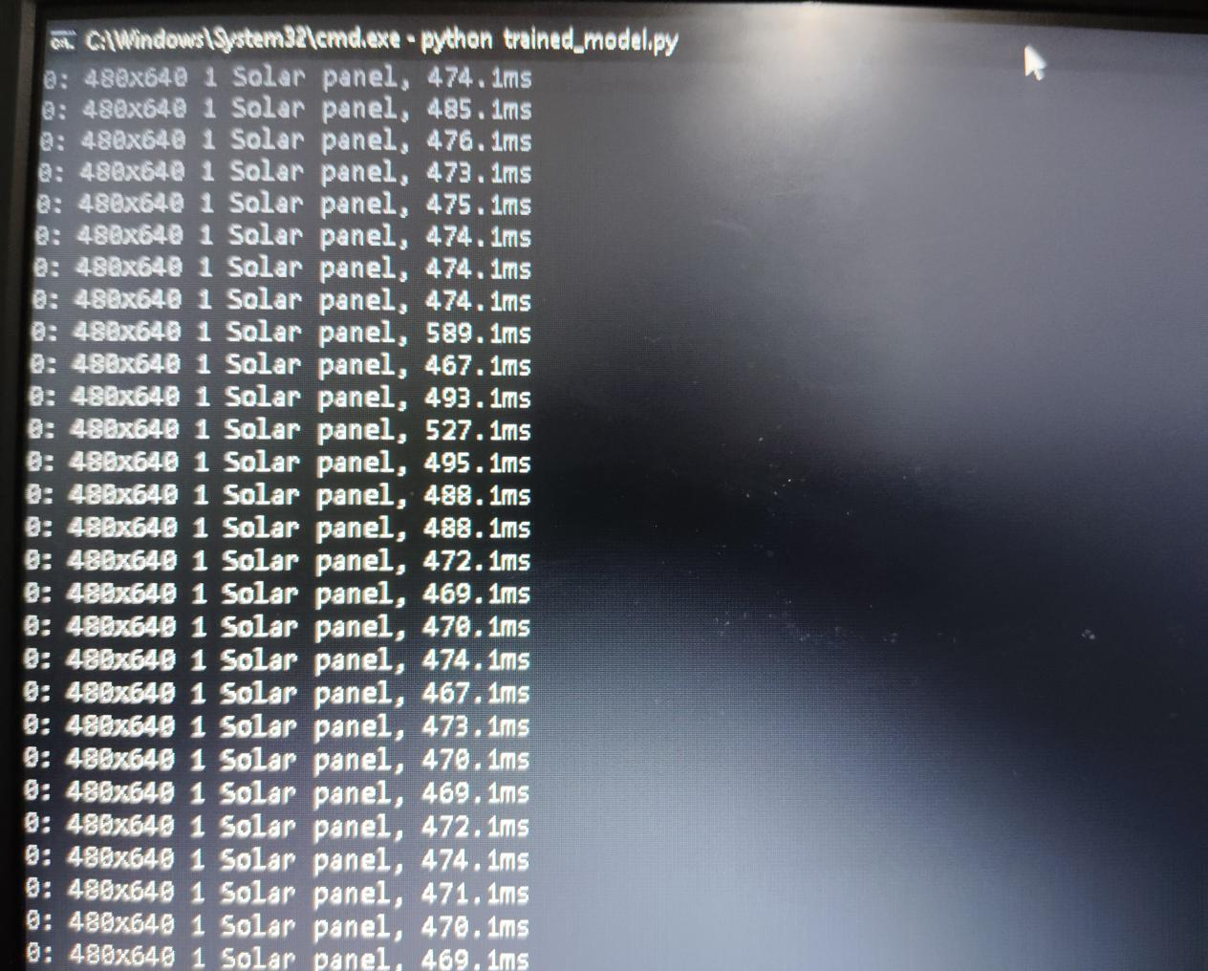

Fig.14.Continuous Monitoring: Solar Panel Identified with Precision

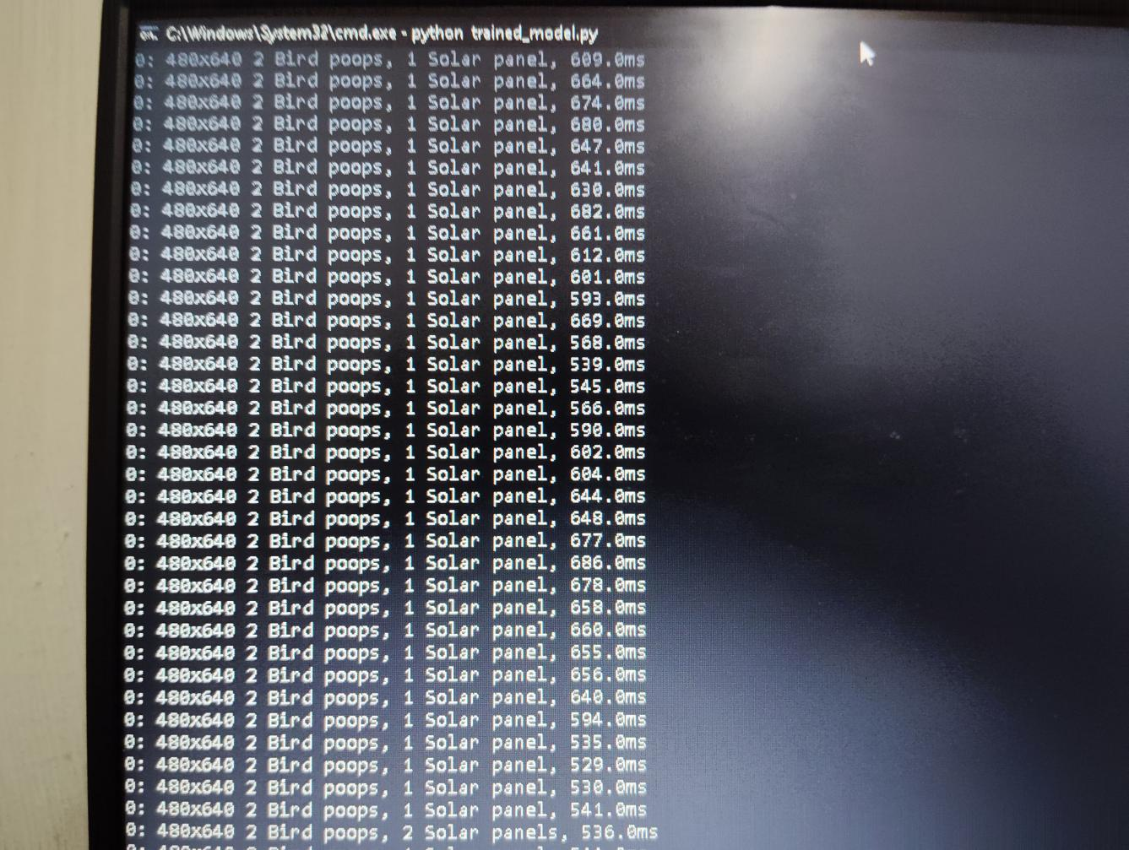

Fig.15.Detection Summary: Bird Droppings Identified on Solar Panel Surface

The Fig 15 depicts command prompt window executing the command prompt window executing the Python script "trained_model.py" for real-time fault detection and classification of solar panels-system takes live frames from the camera, which can have maximum resolution of 480 x 640 pixels, for processing time ranging from about 530 MS to 678 MS. The reports are outcomes that indicate that the fault detection model works with YOLO correctly detected 2 Bird poops and 1 Solar panel in a series of frames. This states that the system is categorizing and identifying the faults at the surface of the panel even when the conditions keep changing. It indicates the robustness of the model and ensures accuracy in detecting minimal obstructions affecting the performance of a solar panel by being able to identify bird droppings on succeeding frames. After identification of faults, the system takes certain stipulated actions like marking faulty regions on the panel by drawing bounding boxes and producing an annotated output image. The output image gets saved as output.jpg and is added to an automated email notification to inform the user of the faults detected. This message bears the subject "fault found" and carries the attached image for visual verification. The longer processing time for a frame compared to blank frame should indicate the additional calculation required to analyze the faults found and define uncertainties in the conclusions. This detection is recorded by the system for future reference, allowing one to analyze the number of faults and act immediately to correct them over time. This action maximizes the efficiency of solar panels by avoiding performance degradation due to long-term obstructions such as bird droppings or shadows. Automating detection of faults and alerts saves a lot of manual check frequencies, increases uptime and efficiency, and cuts operating costs. This deployment is particularly useful for large solar farms where it is not practical to monitor manually, and hence the system is a scalable and dependable solution for real-time monitoring of solar panels.

### Image Collection

### The first step in the fault detection system consists of capturing images of solar panels under different conditions. A dataset was created comprising more than 300 images that were sampled to guarantee a diverse and robust training set, as shown in Fig 1.6. These images include:

### Normal solar panels without faults

### Solar panels with bird droppings - simulated using a piece of paper

### Solar panels with shadows - different angles, different light conditions

### The angles of exposure for the images were thus diversified, along with different lighting conditions, to make the data set generally complex yet favorable for better model performance.

### 2. Image Annotation and Labeling

### After the dataset was collected, the next step was image labeling, which involved drawing bounding boxes around the faults.

### The Roboflow platform was used effectively to label and preprocess the images.

### Bounding boxes were drawn around the bird droppings and shadowed areas to mark their positions.

### Each label was categorized, for example, within the set "Solar Panel", "Bird Poop", "Shadow".

### The images labeled went through a change into the format of YOLO, which normalizes the bounding box coordinates as per the input required by object detection models.

### 3. Data Augmentation and Processing:

### Data Augmentation techniques were applied to generalize the model well and improve its accurate capability in the real world for fault detection. »Rotation - Images are rotated to different angles to simulate different perspectives. »Scaling - images resized for testing detection at different scales. »Shearing - Slight Shearing was done on images to make the model more robust. »Brightness Adjustments - Images dark or bright for different lighting situations, simulated. Dataset balancing was achieved compromising equal number of faulty and non-faulty images so that the model does not get biased towards certain specific fault type detection.

### 4. Model Training Using YOLO

The dataset was then used to train the YOLO model for fault detection on solar panels, allocating it in an 80/20 ratio between the training and the validation datasets, to help the model learn and not overfit. While the training procedure for the YOLO model for detection of faults on solar panels was carried out, real-time detection was ensured from the processing of whole images in a single pass direct using grid-based systems. The process involves an optimization of a loss function that accounts for object localization and classification of detected objects according to the presence or absence of the objects in an attempt to improve accuracy. In an effort to improve model performance, the pixel values were normalized between 0 and 1. This stabilized the learning process and helped the model generalize better under changing illumination conditions. Fine-tuning of other hyper parameters, such as learning rate, batch size, and number of epochs, greatly optimized the model toward getting the best accuracy with minimal training times. Training was done in a cloud environment with GPU, which gave faster computing, better parallel computation, and the ability to handle bigger data. Evaluation of the model was eventually carried out based on recall, precision, and mAP. Modifications were made through data augmentation, additional fine-tuning, and regularization techniques. The end goal with this final model would be real-time detection on solar panels for faults with fast and accurate drawn bounding boxes that would yield efficiency of real-time monitoring along with detecting bird droppings on the surface.

5. Testing and Fault Detection

The model has been evaluated on the new images constructed without any training images present in them. The purpose of the assessment includes testing a model for detecting and classifying faults, which are inclusive of:

• Identification of a solar panel as "Solar panel"

• Marking bird droppings as "Bird poop"

• Shaded area recognized as "shadow."

The YOLO model was thus successful in detecting and labeling faults with bound boxes shown in output images. The detected faults were assigned confidence scores indicating how certain the model was with each detection.

6. Real-Time Monitoring with Webcam

A webcam-based real-time fault monitoring system is enhanced with a trained YOLO model. The system captures and processes live video streams in real-time for:

* Faults detection and classification upon their occurrence.
* Visualization of the fault location with bounding boxes.
* Triggering alerts for faults detected

So, for example, "Bird Poop" if bird droppings and "Shadow" if shadows are detected, with the solar panel itself being also detected as "Solar Panel". The bounding boxes highlight the general fault locations without specifying the actual fault locations.

7. Alert Mechanism and Maintenance Optimization

The alerting system to inform the users about detected faults provides for prompt intervention. The screen is equipped with visual cues to show bounding boxes marking the affected areas and labels differentiating between solar panels and bird droppings. The email notification is automated and forwarded to the intended user along with fault information and an image following detection. The system operates by continuously monitoring in real-time, preventing performance degradation, and minimizing operational costs through early fault detection and timely maintenance, ensuring optimum functioning of the photovoltaic system. Final Outcome and Benefits:

The fault detection system thus completed functions as an automated, scalable, and efficient system to monitor all solar panel health conditions. The main benefits include

* Reduced manual inspection efforts
* Increased fault detection accuracy
* Enhanced solar panel efficiency
* Lower operation and maintenance costs

This contributes to the overall efficiency of solar panels by reducing energy loss caused by faults through YOLO-based deep learning and real-time image processing.

SUSTAINABLE DEVELOPMENT GOALS

This is giving SDG 7 and SDG 9 increased contribution towards making solar energy technology more efficient and innovative in its infrastructure.

SDG 7: Affordable and Clean Energy

The aim of SDG 7 is to ensure access to affordable, reliable, sustainable, and modern energy for all. This system addresses it by enhancing the efficiency and maintenance of solar panels through their absolute performance and longevity. This system minimizes energy losses and maximizes solar energy effectiveness in favor of transitioning the entire world to clean and renewable energy sources by real-time detection and correction of faults such as bird droppings and shadows affecting the system.

SDG 9: Industry, Innovation, and Infrastructure

Build resilient infrastructure, promote inclusive of the sustainablest industrialization, and foster innovation. Integrated advanced technologies: deep learning with real-time monitoring, hence accomplishing predictive maintenance without necessitating the physical visits for inspection. This automates fault detection in solar panels as well and enhances infrastructure resilience, which can be fully brought to practice in the energy industry while contributing development to the sustainable industrial practices.

vii. CONCLUSION

The project successfully developed a real-time fault monitoring system for solar panels which enhances its functioning and lifetime by giving indications of common faults such as shadow and bird dropping. The automated fault detection system is being developed using image processing and machine learning techniques to restrict manual inspection with an increased efficiency of maintenance. A diverse dataset comprising many faults was prepared to train the best model effectively. Augmentation methods such as rotation, scaling, and shearing techniques will be applied to increase the robustness of the model. Train then detected faults effectively localized using the YOLO object detection model with this study. The system works and marks the faulted area at the detection of a fault, sending real-time alerts through email notifications with an image of the detected fault, thus proactively informing maintenance teams. Findings underscore the relevance of automating fault detection as part of solar panel maintenance, reducing energy losses and dissuading long-term damage. This system is scalable and suitable for solar panel management through real-time monitoring, which combined with machine learning, presents an efficient solution. Future work includes diversifying the faults that can be detected, improving the model's accuracy by further training, and applying more sophisticated algorithms for performance enhancement. This provides a good base for the intelligent monitoring of solar panels, thereby helping to accelerate mass adoption of renewable energy through the optimization of solar energy generation.

##### References

[1]Ramaprabha, R., and S. R. Gokularaman. "Analysis and Modification of Fault Detection Methods in Photovoltaic Array." In *2024 Second International Conference on Emerging Trends in Information Technology and Engineering (ICETITE)*, pp. 1-6. IEEE, 2024.

[2]Pa, Mary, M. N. Uddin, and Amin Kazemi. "A fault detection scheme utilizing convolutional neural network for PV solar panels with high accuracy." In *2022 IEEE 1st Industrial Electronics Society Annual On-Line Conference (ONCON)*, pp. 1-5. IEEE, 2022

[3]Cha, Jianhua, Qi Yang, Xiaohua Yang, and Yu Meng. "A Data Driven Method for Arc Fault Detection in Actual Photovoltaic System." In *2023 IEEE 4th International Conference on Electrical Materials and Power Equipment (ICEMPE)*, pp. 1-4. IEEE, 2023.

[4]Jiao, Xuan, Xingshuo Li, Tangwu Yang, Yongheng Yang, and Weidong Xiao. "A novel fault diagnosis scheme for PV plants based on real-time system state identification." *IEEE Journal of Photovoltaics* 13, no. 4 (2023): 571-579.

[5]Mondal, Shouvik, and Arindam Kumar Sil. "Short Circuit Fault Analysis of Photovoltaic and Biomass Based Grid Connected Microgrid System." In *2023 IEEE 3rd Applied Signal Processing Conference (ASPCON)*, pp. 192-196. IEEE, 2023.

[6]Murtaza, Ali Faisal, Hadeed Ahmed Sher, Fahad Usman Khan, Ali Nasir, and Filippo Spertino. "Efficient mpp tracking of photovoltaic (pv) array through modified boost converter with simple smc voltage regulator." *IEEE Transactions on Sustainable Energy* 13, no. 3 (2022): 1790-1801.

[7]Khan, Muhammad Adnan, Khalid Khan, Adnan Daud Khan, Zubair Ahmad Khan, Shahbaz Khan, and Abdullah Mohammed. "A model-based approach for detecting and identifying faults on the DC side of a PV system using electrical signatures from IV characteristics." *Plos one* 17, no. 3 (2022): e0260771.

[8]Pradeep Kumar, Boggarapu, Rajendran Nitheesh, Manickam Chakkarapani, Ganesan Saravana Ilango, and Chilakapati Nagamani. "Estimation of PV module degradation through extraction of I–V curve at inverter pre‐startup condition." *IET Renewable Power Generation* 14, no. 17 (2020): 3479-3486.

[9]Ghaffarzadeh, Navid. "A new method for power quality events detection and classification using discrete wavelet transform and correlation coefficients." *International Journal of Industrial Electronics Control and Optimization* 4, no. 1 (2021): 47-57.

[10]Lipták, Róbert, and István Bodnár. "Simulation of fault detection in photovoltaic arrays." *Analecta Technica Szegedinensia* 15, no. 2 (2021): 31-40.

[11]Mohanapriya, V., B. Sharmila, and V. Manimegalai. "Classification and detection techniques of fault in solar PV system: A review." *Advances in Materials Research: Select Proceedings of ICAMR 2019* (2021): 1155-1164.

[12]Solankee, Laxman, Avinash Rai, and Mukesh Kirar. "An intelligent fault diagnosis scheme for PV array using machine learning techniques." In *2021 IEEE 2nd international conference on electrical power and energy systems (ICEPES)*, pp. 1-5. IEEE, 2021.

[13]Mehmood, Ahsan, Hadeed Ahmed Sher, Ali Faisal Murtaza, and Kamal Al-Haddad. "A diode-based fault detection, classification, and localization method for photovoltaic array." *IEEE Transactions on Instrumentation and Measurement* 70 (2021): 1-12.

[14]Appiah, Sam Yaw. "Delineating Optimal Solar Sites in Atlanta Using GIS and Remote Sensing." (2021).

[15]Khalil, Ihsan Ullah, Azhar Ul-Haq, Yousef Mahmoud, Marium Jalal, Muhammad Aamir, Mati Ullah Ahsan, and Khalid Mehmood. "Comparative analysis of photovoltaic faults and performance evaluation of its detection techniques." *IEEE Access* 8 (2020): 26676-26700.

[16]Sevilla-Camacho, Perla-Yazmín, Marco-Antonio Zuñiga-Reyes, Jose-Billerman Robles-Ocampo, Roger Castillo-Palomera, Jesús Muñiz, and Juvenal Rodríguez-Reséndiz. "A novel fault detection and location method for PV arrays based on frequency analysis." *IEEE Access* 7 (2019): 72050-72061

[17]Pillai, Dhanup S., Frede Blaabjerg, and Natarajan Rajasekar. "A comparative evaluation of advanced fault detection approaches for PV systems." *IEEE Journal of Photovoltaics* 9, no. 2 (2019): 513-527.

[18]Haque, Ahteshamul, Kurukuru Varaha Satya Bharath, Mohammed Ali Khan, Irshad Khan, and Zainul Abdin Jaffery. "Fault diagnosis of photovoltaic modules." *Energy Science & Engineering* 7, no. 3 (2019): 622-644.

[19]Faye, Issa, Gabriel Jean Philippe, Ababacar Ndiaye, Ulf Blieske, Diouma Kobor, and Rudolph Gecke. "Degradation and comparative experimental study of crystalline photovoltaic module after a few years outdoor exposure in casamance and cologne climate." In *2018 7th International Energy and Sustainability Conference (IESC)*, pp. 1-5. IEEE, 2018.

[20]Sreelakshmy, J., B. Pradeep Kumar, G. Saravana Ilango, and C. Nagamani. "Identification of faults in PV array using maximal overlap discrete wavelet transform." In *2018 20th national power systems conference (NPSC)*, pp. 1-6. IEEE, 2018.

[21]Dimitriou, Andreas, Antonis L. Lazari, and Charalambos A. Charalambous. "Understanding of DC leakage and faults in floating photovoltaic systems: Trojan horse to undermine metallic infrastructure and safety." In *2017 IEEE Manchester PowerTech*, pp. 1-6. IEEE, 2017.

[22]Alsafasfeh, Moath, Ikhlas Abdel-Qader, and Bradley Bazuin. "Fault detection in photovoltaic system using SLIC and thermal images." In *2017 8th international conference on information technology (ICIT)*, pp. 672-676. IEEE, 2017.

[23]Chen, Silei, Xingwen Li, and Jiayu Xiong. "Series arc fault identification for photovoltaic system based on time-domain and time-frequency-domain analysis." *IEEE Journal of Photovoltaics* 7, no. 4 (2017): 1105-1114.

[24]Niu, Zhuang, Shaohua Ma, and Zibo Qi. "Research on DC Fault Arc Identification Method in Photovoltaic System." In *2023 IEEE 5th International Conference on Power, Intelligent Computing and Systems (ICPICS)*, pp. 93-97. IEEE, 2023.

[25]Sun, Kai, Xi Xiao, Shouzun Wu, and Lina Chen. "Fault Diagnosis and State Evaluation of Distributed Photovoltaic Systems in Microgrids." In *2023 11th International Conference on Power Electronics and ECCE Asia (ICPE 2023-ECCE Asia)*, pp. 440-445. IEEE, 2023.

[26]BotPenguin, "Deep Neural Networks: Concepts and History Overview," BotPenguin Glossary.

[27]X. Wang et al., "Keypoint regression strategy and angle loss based YOLO for object detection," Scientific Reports, vol. 13, no. 1, p. 18930, Dec. 2023.