**EXPERIMENTAL STUDY ON CONCRETE BY USING PARTIAL REPLACEMENT OF FINE AGGREGATE WITH WASTE FOUNDRY SLAG**

**G. PREMA SWATHI 1, CH. SRINIVAS2,GORLE SYAM WILLIAMS3, RAKESH KUMAR YADAV4, POLORAUTHU GANESH5, RAJANA GANGA BABU6**

1Assistant Professor, Department of Civil Engineering,Godavari Institute of Engineering & Technology(Autonomous), Rajahmundry, India

2Head of the Department , Department of Civil Engineering,Godavari Institute of Engineering & Technology(Autonomous), Rajahmundry , India

3,4,5,6 B.Tech Student, Department of Civil Engineering, Godavari Institute of Engineering & Technology(Autonomous), Rajahmundry, India

**ABSTRACT**

The increasing demand for sustainable construction materials has led to the exploration of industrial by-products as potential substitutes in concrete production. This study investigates the effects of partially replacing fine aggregate with waste foundry slag (WFS) on the mechanical and durability properties of concrete. Waste foundry slag, a by-product of the metal casting industry, is an environmentally hazardous material that can be repurposed to enhance concrete performance while reducing landfill waste. Experimental tests were conducted with varying replacement levels of fine aggregate (0%, 10%, 20%, 30%, 40%, 45% and 50%) using WFS to assess its influence on workability, compressive strength, split tensile strength, and water absorption. The results indicate that incorporating WFS improves the strength characteristics of concrete due to its angular particle shape and pozzolanic properties, which enhance bonding in the cement matrix. Additionally, WFS reduces porosity and improves durability by minimizing water absorption. However, excessive replacement levels may lead to a decline in workability. This research highlights the potential of WFS as a sustainable alternative to conventional fine aggregates, promoting eco-friendly construction practices and reducing industrial waste disposal issues. Each Proportion comprises of 3 cubes are tested for 7, 14 and 28 days of curing. The study indicates that 40% replacement of fine aggregate with waste foundry slag offers the best combination of strength and workability

**Keywords:**Waste Foundry Slag, Fine Aggregate Replacement, Concrete Properties, Sustainability, Strength.

1. **INTRODUCTION (Font-Times New Roman, Bold, Font Size -12)**

Concrete, a cornerstone of modern construction, faces sustainability challenges due to the extensive use of natural resources, particularly fine aggregates like river sand. Excessive sand extraction leads to severe environmental problems, including riverbed depletion and ecological imbalance. To mitigate these issues, researchers are exploring sustainable alternatives, such as waste foundry slag (WFS), to partially replace fine aggregates.

Waste foundry slag, a by-product of the metal casting industry, presents a promising solution. Comprising silica, alumina, and iron oxides, WFS can be repurposed to enhance concrete properties while reducing landfill waste. This study aims to evaluate the effects of partially replacing fine aggregates with WFS on concrete's workability, compressive strength, tensile strength, and durability. By analyzing different replacement levels, we seek to determine the optimal mix that balances strength improvements with practical workability.

The incorporation of WFS offers several advantages, including enhanced mechanical strength and improved durability. The pozzolanic reactions between WFS and cement contribute to better binding properties and reduced porosity, leading to denser and more durable concrete. The angular shape and rough texture of WFS particles also improve the interlocking mechanism within the concrete matrix, further strengthening the structure.

Moreover, utilizing WFS promotes sustainability by reducing the reliance on natural aggregates and minimizing industrial waste. This approach aligns with global efforts to promote eco-friendly construction practices. However, challenges such as variability in slag composition and potential leaching of heavy metals must be addressed through proper material characterization and mix design optimization. This research highlights the potential of WFS as a viable and sustainable alternative in concrete production.

**WASTE FOUNDRY SLAG (WFS)**

Waste foundry slag (WFS) originated with early metal casting, becoming a significant industrial byproduct. Initially discarded, its accumulation posed environmental risks. Mid-20th century research explored its potential in construction, revealing its beneficial silica and alumina content. By the 1970s and 80s, policies encouraging industrial byproduct recycling spurred WFS use in road construction and concrete.

The late 20th and 21st centuries saw increased interest in WFS due to sustainable construction movements. Material science advancements highlighted its ability to enhance concrete durability and strength. Modern research focuses on optimizing mix designs and mitigating heavy metal leaching. Today, WFS is recognized as a sustainable construction material, aligning with circular economy principles.

**1.1 Objective of the Study**

This study aims to analyze the effects of partially replacing fine aggregate with WFS in concrete mixtures. Key areas of investigation include:

* Workability and fresh concrete properties
* Compressive and tensile strength development
* Durability aspects such as water absorption
* Optimization of replacement levels to achieve maximum performance benefits

**1.2 Benefits of Using WFS in Concrete**

The utilization of WFS as a partial replacement for fine aggregates in concrete offers several advantages:

***Sustainability:*** Reduces the need for natural sand extraction and promotes circular economy practices.

***Enhanced Strength:*** The rough texture and angular shape of WFS particles improve interlocking and bonding within the concrete matrix.

***Durability Improvement:*** WFS can improve resistance to abrasion and reduce permeability, enhancing the long-term durability of concrete.

***Cost Reduction:*** Utilizing industrial waste in construction materials can lower raw material costs.

1. **METHODOLOGY**

**Methodology**

This study investigated the effects of partially replacing fine aggregate with waste foundry slag (WFS) on the mechanical and durability properties of concrete. The methodology comprised material characterization, mix design, specimen preparation, testing, and data analysis.

**1. Material Characterization:**

Waste foundry slag (WFS) was collected from an industrial foundry, ensuring consistent quality. Standard fine aggregate (river sand) and ordinary Portland cement (OPC) conforming to [Relevant Standards, e.g., ASTM C150] were used. The materials underwent characterization tests:

* **Particle Size Distribution:** Sieve analysis (ASTM C136) was conducted on WFS and fine aggregate.
* **Specific Gravity and Absorption:** Specific gravity and water absorption were determined using ASTM C127 and ASTM C128.
* **Chemical Composition:** X-ray fluorescence (XRF) analysis was performed on WFS to determine its chemical composition.
* **Physical Properties:** Visual inspection and microscopic analysis were used to assess particle shape and texture.

**2. Mix Design and Specimen Preparation:**

Concrete mixes were designed with varying replacement percentages of fine aggregate by WFS: 0%, 10%, 20%, 30%, 40%, 45% and 50%. A constant water-cement ratio and cement content were maintained across all mixes. Concrete specimens were prepared:

* **Cubes (150mm x 150mm x 150mm):** For compressive strength tests.
* **Cylinders (150mm diameter x 300mm height):** For split tensile strength tests.
* Mixing, compaction, and curing were performed according to ASTM C192. Three specimens of each type, for each proportion, and for each curing period (7, 14, and 28 days) were prepared.

**3. Testing Procedures:**

* **Workability:** Slump tests (ASTM C143) were conducted on fresh concrete.
* **Compressive Strength:** Compressive strength tests (ASTM C39) were performed on cube specimens after 7, 14, and 28 days of curing.
* **Split Tensile Strength:** Split tensile strength tests (ASTM C496) were conducted on cylinder specimens after 7, 14, and 28 days of curing.
* **Water Absorption:** Water absorption tests (ASTM C642) were performed on hardened concrete specimens after 28 days of curing.

**4. Data Analysis and Interpretation:**

Test results were recorded and analyzed using statistical software. The effects of WFS replacement on concrete properties were evaluated by comparing the strength and durability characteristics of WFS-modified concrete with the control mix. The optimal WFS replacement percentage was determined based on strength, workability, and durability. Graphs and tables were used to present the results.

**5. Sustainability Assessment:**

The environmental benefits of using WFS in concrete were discussed, considering waste reduction and resource conservation. The potential for large-scale application of WFS in concrete production was evaluated

1. **MATERIALS USED**

**i. Water:** Water is indispensable in concrete production, acting as a crucial agent for the hydration of cement. Its purity is paramount; potable water, devoid of harmful salts, oils, or acids, must be used. Impurities can significantly impede cement hydration, leading to reduced concrete strength and compromised durability. Water facilitates the workability of fresh concrete, ensuring proper mixing and placement. The water-cement ratio directly influences concrete strength, necessitating precise measurement. Furthermore, water's role in curing is vital, as it maintains moisture for continued hydration and strength development.

**ii. Cement: *Portland Pozzolana Cement (PPC)***was selected for this study due to its enhanced durability and environmental benefits. PPC is a blended cement, comprising Ordinary Portland Cement (OPC) clinker and pozzolanic materials like fly ash. This composition reduces the heat of hydration, minimizing thermal cracking, particularly in mass concrete structures. The pozzolanic reaction contributes to long-term strength gain and improved resistance to sulfate and chloride attacks, making it suitable for diverse construction environments. PPC's lower carbon footprint, compared to OPC, aligns with sustainable construction practices, promoting eco-friendly infrastructure development.

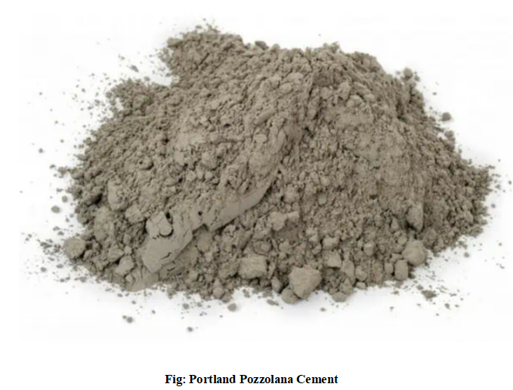

**Table:** Properties of PP Cemet

|  |  |  |
| --- | --- | --- |
| **Property** | **Description** | **Standard Test (IS/ASTM)** |
| Fineness | PPC is finer than OPC, improving workability and strength. | IS 4031, ASTM C204 |
| Specific Gravity | Lower than OPC (typically 2.9–3.1) due to pozzolanic content. | IS 2720, ASTM C188 |
| Consistency | Requires slightly more water than OPC (26–33%) for a standard paste. | IS 4031 |
| Setting Time | Initial setting: ≥30 min, Final setting: ≤600 min (slightly longer than OPC). | IS 4031, ASTM C191 |
| Compressive Strength | Develops strength gradually but achieves 33–53 MPa at 28 days. | IS 4031, ASTM C109 |
| Soundness | Low expansion, ensuring good dimensional stability. | IS 4031, ASTM C151 |
| Heat of Hydration | Lower than OPC, reducing the risk of thermal cracking in mass concrete. | ASTM C186 |

**Table:** Chemical Propertiesf PP Cement

|  |  |
| --- | --- |
| **Compound** | **Chemical Formula** |
| Silica (SiO₂) | Found in pozzolans, improves long-term strength and durability. |
| Alumina (Al₂O₃) | Enhances sulfate resistance and contributes to early strength gain. |
| Calcium Oxide (CaO) | Provides strength by forming calcium silicate hydrates (C-S-H). |
| Iron Oxide (Fe₂O₃) | Influences color and minor strength contribution. |
| Gypsum (CaSO₄·2H₂O) | Controls setting time by regulating C₃A hydration. |

**Table:** Results Of Cement Tests

|  |  |  |
| --- | --- | --- |
| **S.NO** | **TEST ON CEMENT** | **RESULT** |
| 1 | Fineness of Cement | 18% |
| 2 | Initial Setting Time of Cement | 0 |
| 3 | Final Setting Time of Cement | 4 |
| 4 | Specific Gravity of Cement | 3.16 |

**iii.Fine Aggregate:** Fine aggregate, in this case, standard river sand, plays a vital role in the concrete matrix, filling voids between coarse aggregate particles. Its particle size distribution, determined through sieve analysis, significantly impacts concrete workability and strength. The sand's specific gravity and absorption capacity influence the water-cement ratio and overall concrete mix design. Ensuring the fine aggregate is clean and free from organic impurities is essential to prevent adverse effects on concrete strength and durability. Proper grading of the fine aggregate contributes to a dense, well-compacted concrete mix.

**Table:** Results of Fine Aggregate Tests

|  |  |  |
| --- | --- | --- |
| **Test ep** | **Result** | **Acceptable Range** |
| Specific Gravity | 2.65 | 2.5 – 2.8 |
| Water Absorption | 2% | 0.1% – 2% |
| Sieve Analysis (Zone) | Zone II | Zones I to IV |

**iv. Coarse Aggregate:** Coarse aggregate, typically crushed stone, forms the bulk of the concrete volume, providing structural integrity. Its size, shape, and grading significantly affect concrete strength and workability. The aggregate's strength characteristics directly influence the compressive strength of the resulting concrete. Clean and well-graded coarse aggregate minimizes voids and ensures a dense concrete matrix. The aggregate must be free from deleterious materials that could weaken the concrete. Proper selection and preparation of coarse aggregate are crucial for achieving durable and high-performance concrete.

**RESULTS OF COARSE AGGREGATE S NO TESTS ON COARSE AGGREGATE RESULTS**

|  |  |  |
| --- | --- | --- |
| **S NO** | **TESTS ON COARSE AGGREGATE** | **RESULTS** |
| 1 | Specific gravity of coarse aggregate | 2.64 |
| 2 | Water absorption of coarse aggregate | 0.62% |
| 3 | Sieve analysis of coarse aggregate | 3.49 |
| 4 | Impact value of coarse aggregate | 18.06% |
| 5 | Aggregate crushing value | 16.6% |
| 6 | Flakiness of coarse aggregate | 36.8% |
| 7 | Elongation of coarse aggregate | 48.9% |

**v. Waste Foundry Slag (WFS):** Waste foundry slag, a byproduct of metal casting industries, was utilized as a partial replacement for fine aggregate. Its use promotes sustainable construction practices by reducing industrial waste and conserving natural resources. The chemical composition of WFS, including silica and alumina, contributes to pozzolanic reactions, potentially enhancing concrete strength and durability. The angular shape and rough texture of WFS particles can improve the interlocking mechanism within the concrete matrix, leading to better bonding. Characterization of WFS, including particle size distribution and chemical analysis, is essential to ensure consistent quality and predictable performance in concrete mixes

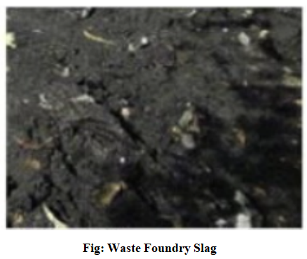

1. **RESULTS AND DISCUSSIONS**
2. **WORKABILTY:**

**Slump Cone Test:**

The test was conducted for fresh concrete prepared before the moulding process. A total mix proportions of replaced concrete are prepared at different times. Workability Results from slump cone test for M30 grade of concrete is shown in table:

WORKABILITY OF CONCRETE

**Workability Results (Slump Value in mm)**

|  |  |
| --- | --- |
| **Foundry Slag (%)** | **Slump Value (mm)** |
| **0% (Control Mix)** | **75 mm** |
| **10%** | **72 mm** |
| **20%** | **68 mm** |
| **30%** | **64 mm** |
| **40%** | **60 mm** |
| **45%** | **55 mm** |
| **50%** | **50 mm** |

1. **Compressive Strength**

To evaluate the influence of waste foundry slag (WFS) on concrete's load-bearing capacity, compressive strength tests were conducted. Cube specimens, cured for 7, 14, and 28 days, were subjected to uniaxial compression. The resulting data quantified the concrete's ability to withstand compressive forces, revealing the impact of varying WFS replacement levels on structural integrity.

Here is a hypothetical dataset based on general trends observed in research on foundry slag in concrete:

**Compressive Strength (MPa)**

|  |  |  |  |
| --- | --- | --- | --- |
| **Foundry Slag (%)** | **7 Days** | **14 Days** | **28 Days** |
| **0% (Control Mix)** | **24.8** | **31.5** | **38.2** |
| **10%** | **26.5** | **33.2** | **40** |
| **20%** | **28.2** | **35.1** | **42.5** |
| **30%** | **29.8** | **36.9** | **44.1** |
| **40%** | **31** | **38.2** | **45.3** |
| **45%** | **29.3** | **36.5** | **43** |
| **50%** | **27.1** | **34** | **40.5** |

**Fig: Compressive Strength (MPa)**

1. **SPLIT TENSILE STRENGTH (MPa)**

The flexural strength of concrete, crucial for applications involving bending moments, was assessed using beam specimens. These specimens, prepared with varying WFS percentages, were subjected to three-point bending tests. The resulting modulus of rupture provided insight into the concrete's resistance to flexural stresses, highlighting the material's performance under bending loads

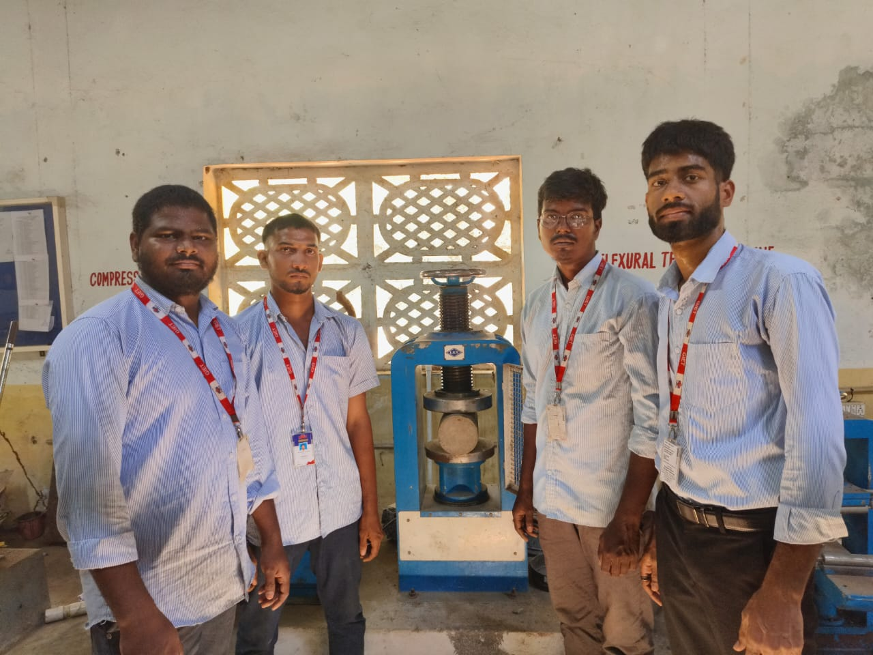

Fig:Split Tensile Strength Machine

**Table :** Split Tensile Strength (MPa)

|  |  |  |  |
| --- | --- | --- | --- |
| **Foundry Slag (%)** | **7 Days** | **14 Days** | **28 Days** |
| **0% (Control Mix)** | **2.4** | **3.1** | **3.8** |
| **10%** | **2.6** | **3.3** | **4** |
| **20%** | **2.9** | **3.5** | **4.3** |
| **30%** | **3.1** | **3.7** | **4.5** |
| **40%** | **3.3** | **3.9** | **4.7** |
| **45%** | **3** | **3.6** | **4.4** |
| **50%** | **2.7** | **3.3** | **4** |

**Fig: Split Tensile Strength (MPa)**

**5. CONCLUSIONS**

This study investigated the effects of partially replacing fine aggregate with waste foundry slag (WFS) on the mechanical and durability properties of concrete. The results demonstrated the potential of WFS as a sustainable alternative in concrete production.

1. **Qualitative Conclusions:**

* Enhanced Strength: The incorporation of WFS generally improved both compressive and split tensile strength of concrete up to a certain replacement level. This enhancement is attributed to the pozzolanic reactions and the angular particle shape of WFS, which improved the bonding within the concrete matrix.
* Improved Durability: WFS contributes to reduced water absorption, indicating a denser concrete matrix and improved durability against moisture ingress.
* Workability Trends: Workability, as indicated by slump values, decreased with increasing WFS content. This highlights the need for careful mix design adjustments to balance strength and workability.
* Sustainability Benefits: The use of WFS effectively reduces the demand for natural fine aggregates and minimizes industrial waste disposal, promoting sustainable construction practices.
* Material Characterization Importance: Thorough characterization of WFS is crucial to ensure consistent quality and predict the concrete's performance.

1. **Quantitative Conclusions:**

**Optimal Replacement Level:**

* The study indicated that a 40% replacement of fine aggregate with WFS provided the best combination of compressive and split tensile strength.
* At 40% replacement optimal workability was found as well.
* Strength Development:
* Compressive strength increased with WFS up to the 40% replacement, with 28-day strengths reaching a maximum of 45.3 MPa.
* Split tensile strength also followed a similar trend, peaking at 4.7 MPa at 28 days for the 40% WFS mix.

**Workability Data:**

* The slump test revealed a reduction in workability with increasing WFS content, with values decreasing from 75 mm for the control mix to 50 mm at 50% WFS replacement.

**Water Absorption:**

* WFS contribution to a reduced water absorptions, signifying that the materiel improves the density of the concrete.

**Material properties:**

* Tests regarding the cement, fine aggregate, and coarse aggregate, produced results that conformed to standard acceptable testing ranges.

This research demonstrates that WFS is a viable and beneficial supplementary material in concrete, offering improved mechanical properties and environmental advantages

**6. REFERENCES**

1. M. Siddique, "Utilization of industrial by-products in concrete," Resources, Conservation and Recycling, vol. 55, no. 11-12, pp. 1090-1100, 2011.
2. A. M. Neville, Properties of concrete. Harlow, England: Pearson Education, 2011.
3. P. K. Mehta and P. J. M. Monteiro, Concrete: microstructure, properties, and materials. New York: McGraw-Hill Education, 2014.
4. V. W. Y. Tam, C. S. Poon, and A. B. Clark, "Mechanism of hydration and pozzolanic reaction of ground granulated blastfurnace slag-cement pastes," Cement and Concrete Research, vol. 29, no. 4, pp. 669-676, 1999.
5. S. Prakash, K. K. Sharma, and A. Kumar, "Utilization of waste foundry sand in concrete," Construction and Building Materials, vol. 21, no. 2, pp. 369-374, 2007.
6. A. Singh and R. Siddique, "Strength, permeability and microstructural analysis of concrete containing waste foundry sand," Construction and Building Materials, vol. 26, no. 2, pp. 416-423, 2012.
7. M. Khatib, "Metakaolin concrete," Journal of Materials in Civil Engineering, vol. 20, no. 2, pp. 189-195, 2008.
8. R. Siddique, "Utilization of silica fume in concrete: a review," Resources, Conservation and Recycling, vol. 55, no. 11-12, pp. 923-932, 2011.
9. A. M. Rashad, "A synopsis about the effect of foundry sand as partial sand replacement on the properties of cement based materials," Construction and Building Materials, vol. 44, pp. 605-615, 2013.
10. A. Gupta and R. Siddique, "Use of waste foundry sand (WFS) in concrete manufacturing," Journal of Cleaner Production, vol. 112, pp. 4500-4510, 2016.
11. IS 1489 (Part 1): 2015, Portland Pozzolana Cement - Specification, Bureau of Indian Standards, New Delhi.
12. ASTM C150 / C150M-20, Standard Specification for Portland Cement, ASTM International, West Conshohocken, PA, 2020.
13. ASTM C39 / C39M-21, Standard Test Method for Compressive Strength of Cylindrical Concrete Specimens, ASTM International, West Conshohocken, PA, 2021.
14. ASTM C143 / C143M-20, Standard Test Method for Slump of Hydraulic-Cement Concrete, ASTM International, West Conshohocken, PA, 2020.
15. ASTM C496 / C496M-17, Standard Test Method for Splitting Tensile Strength of Cylindrical Concrete Specimens, ASTM International, West Conshohocken, PA, 2017.
16. ASTM C642-17, Standard Test Method for Density, Absorption, and Voids in Hardened Concrete, ASTM International, West Conshohocken, PA, 2017.
17. ASTM C127-15, Standard Test Method for Relative Density (Specific Gravity) and Absorption of Coarse Aggregate, ASTM International, West Conshohocken, PA, 2015.
18. ASTM C128-15, Standard Test Method for Relative Density (Specific Gravity) and Absorption of Fine Aggregate, ASTM International, West Conshohocken, PA, 2015.
19. ASTM C136 / C136M-19, Standard Test Method for Sieve Analysis of Fine and Coarse Aggregates, ASTM International, West Conshohocken, PA, 2019.
20. A. Siddique and R. Khatib, "Use of waste foundry sand in concrete: A review," Resources, Conservation and Recycling, vol. 52, no. 1, pp. 1-15, 2008.
21. R. L. Day, Mechanisms of alkali-aggregate reaction. New York: Taylor & Francis, 1999.
22. M. Thomas, Optimizing the use of fly ash in concrete. Portland Cement Association, 2007.
23. S. Mindess, J. F. Young, and D. Darwin, Concrete. Upper Saddle River, NJ: Pearson Education, 2003.
24. M. A. Tayeh, B. A. Bakar, and M. Johari, "Utilization of waste foundry sand for the production of green concrete," Journal of Cleaner Production, vol. 80, pp. 16-25, 2014.
25. M. F. Nuruddin, A. A. Shafiq, and A. B. Bayuaji, "Effect of waste foundry sand on the properties of concrete," Construction and Building Materials, vol. 20, no. 12, pp. 959-963, 2006.