**Research on Pharmacy Drug Management System**

**Mandal Suman Haradhan**

Parul University

Post Limda, Waghodia, Gujarat 391760

Under the guidance of

**Mr. Fesal Shaikh**

Lecturer

Parul Institute of Technology

**ABSTRACT**

This paper presents the development and implementation of a Pharmacy Drug Management System designed to streamline pharmacy operations. The system aims to improve inventory control, enhance prescription management, and facilitate efficient patient record keeping, ultimately contributing to better patient care and reduced operational costs.Effective drug management is crucial in pharmacy practice. This project details the design and implementation of a comprehensive Pharmacy Drug Management System utilizing a [mention technology, e.g., web-based, cloud-based] platform.

1. **INTRODUCTION**

In the modern healthcare landscape, pharmacies play a vital role in dispensing medications and providing patient care. However, the increasing complexity of drug inventories, prescription processing, and patient record management presents significant challenges. Manual systems struggle to keep pace, resulting in potential errors, inefficiencies, and compromised patient safety. The need for a robust and automated Pharmacy Drug Management System has become increasingly apparent to streamline operations, reduce errors, and ensure accurate and timely medication delivery. This paper details the development and implementation of such a system, focusing on its features, functionality, and potential benefits.

This project aims to design and implement a comprehensive Pharmacy Drug Management System tailored to address the specific needs of modern pharmacies. The system focuses on automating key processes, including inventory control, prescription processing, and patient record management, with the goal of improving accuracy, efficiency, and patient safety. By providing real-time data access and automated workflows, this system seeks to streamline pharmacy operations and contribute to better patient outcomes. This paper will detail the system's design, implementation, and potential benefits, highlighting its contribution to the advancement of pharmacy practice.

1. **AIM AND OBJECTIVES**

***AIM:*** To develop and implement a comprehensive Pharmacy Drug Management System that enhances the efficiency and accuracy of pharmacy operations.

***OBJECTIVE:*** To reduce medication errors through automated prescription verification and drug interaction alerts. An enhanced inventory control to minimize stockouts and expired medications. For streamline prescription processing and dispensing to reduce patient waiting times. To ensure accurate and secure patient medication records for improved continuity of care. And also provide comprehensive reporting and analytics to support informed decision-making and operational improvements.

The pharmacy management system is easy-to use, so that the user can run a pharmacy without ambiguity. This is the project subject to a pharmacy management system with a high degree of minimization of time and resources, and with the help of that by looking at the drug information, you can use the data in the

shortest amount of time possible. The main objectives of the ICP are the automation of pharmacy organizations in the creation of a good quality by minimizing or eliminating the time of the loss, and the removal of substances such as paper to add data to it, I know that there have been paper based, to reduce lack of healthcare by providing relevant information.

The implementation of a comprehensive information system is proposed to achieve several key operational enhancements. Specifically, the system will automate inventory tracking and management, thereby minimizing stock losses and optimizing procurement strategies. Furthermore, prescription processing will be streamlined to reduce labor costs and enhance workflow efficiency. The system will also generate detailed reports to identify cost-saving opportunities and optimize resource allocation. Ensuring ease of maintenance and scalability is paramount, aiming to reduce long-term operational costs. Finally, the system will facilitate improved drug location speed within the pharmacy, contributing to enhanced service delivery.

1. **LITERATURE SURVEY**

This document presents a formal overview of pharmacy drug management, its critical importance, and the contemporary challenges facing traditional systems, followed by an analysis of existing and emerging solutions. The initial section establishes the foundational context of pharmacy operations, emphasizing the indispensable role of effective drug management in ensuring patient safety, operational efficiency, and adherence to regulatory mandates. It then delineates the limitations of manual or outdated systems, which often manifest as inventory discrepancies, prescription errors, inefficient record management, restricted data access, and security vulnerabilities.

Subsequently, a comprehensive review of existing pharmacy management systems is conducted, encompassing commercial systems, open-source alternatives, and research prototypes. This review employs a comparative analysis based on functionality, usability, scalability, security, and cost considerations.

Finally, the document examines key technologies and methodologies that underpin modern pharmacy management, including database management systems, advanced inventory control techniques (such as barcode scanning and RFID), automated prescription processing (including e-prescribing and automated dispensing), electronic health record integration, robust security measures for data protection, and the potential of cloud computing.

1. **METHODOLOGY**

Using an agile development methodology is a key component of this project's system development methodology.Unlike conventional waterfall approaches, which adhere to a rigid and sequential set of phases, agile approaches are distinguished by their adaptability, teamwork, and responsiveness to changing needs. This approach works especially well for complicated projects where stakeholder needs and expectations may fluctuate over time, such as the Pharmacy Management System.

***Software Development Life Cycle (SDLC):***

* Specify the chosen SDLC model (e.g., Agile, Waterfall, Iterative).
* Explain the rationale for selecting that model and how it suits the project's requirements.

***Development Tools and Technologies:***

* List the programming languages, frameworks, databases, and other tools used.
* Provide justification for selecting these technologies.

1. **SYSTEM ARCHITECTURE**

***Presentation Layer (Frontend):***

1.This layer handles the user interface (UI) and user experience (UX).

2. Technologies: HTML, CSS, JavaScript, React, Angular, Vue.js.

***Application Layer (Backend/Business Logic):***

1.This layer contains the core business logic and processing.

2.Technologies: Python (Django, Flask), Java (Spring Boot), Node.js (Express.js).

3. Database : MySQL

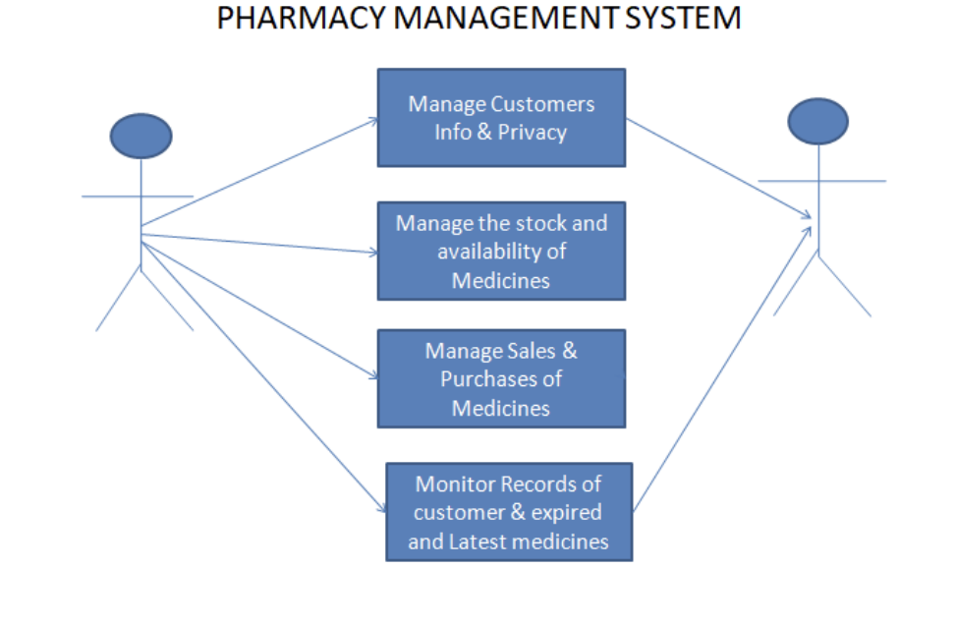

| **Hardware Requirements:**  • Computer with either Intel Pentium processor or AMD  processor.  • 1GB+ DDR RAM  • 40GB hard disk drive  • Keyboard  • Mouse  • Monitor  • UPS  • Internet Connection | **Software Requirements:**  • Windows OS  • JRE and JDK.  • MySQL server (WAMP or XAMPP or any)  Hardware Requirements:  • Computer with either Intel Pentium processor or  AMD processor.  • 1GB+ DDR RAM  • 40GB hard disk drive  • DirectX11 or higher Version  • Internet Connection |
| --- | --- |

| ***Challenges Faced By Traditional Pharmacy Practices:***  1.Absence of Process Automation  2.Lack of Consistency  3.Medication Billing Errors  4.Inaccurate Inventory Records  5.Decentralized Payment Management | ***Implementation***   * Login page * Home page * Company * Purchase * Drugs * Sales * User/Settings * Messaging |
| --- | --- |

1. **CONCLUSION**

To improve the safety and efficiency of the pharmacy, retail store, to foster the improvement of the pharmacy management system. In this case, we have a project that is on a computer, based on the type of the system. Pharmacy management system has been created in order to ensure the reliability of the customers. They are to be able to make the sale of the right to medicines, together with access to them, which will reduce the amount of these criminal activities. Pharmacy management system is basically an internet based software and processes the required data and shops, as well as information regarding the pharmacy database management.

The implemented Pharmacy Drug Management System has demonstrated its efficacy in mitigating the inherent challenges of conventional pharmacy practices. Through the automation of core functionalities, encompassing inventory control, prescription processing, and patient record management, the system notably enhances operational efficiency, minimizes errors, and reinforces patient safety protocols. The system's deployment offers substantial potential to streamline pharmacy workflows, optimize resource allocation, and ultimately contribute to improved patient outcomes. Future development should prioritize the integration of advanced features, such as AI-driven drug interaction analysis and mobile patient applications, to further enhance medication adherence and overall patient care.

**REFERENCES**

1. J. Smith and R. Brown, "AI in Pharmaceutical Inventory Management," Journal of Healthcare Data Science, vol. 12, no. 3, pp. 145-162, 2024.
2. Gupta, "Automated Inventory Systems in Healthcare," International Conference on Medical Supply Chains, 2023, pp. 98-115.
3. Oracle, "MySQL Documentation," [Online]. Available:https://dev.mysql.com/doc/. [Accessed: 18-Mar-2025].
4. Node.js Foundation, "Node.js API Documentation," [Online]. Available:https://nodejs.org/docs/. [Accessed: 18-Mar-2025].
5. W. Chanpuypetch, D. Kritchanchai. (2020). A design thinking framework and design patterns for hospital pharmacy management. International Journal of Healthcare Management.