**ENHANCED METHOD FOR DETECTING COUNTERFEIT BRAND’S**

**Abilash Andrew.A1, Dr.M.Praneesh2**

1UG Student, Computer Science With Data Analytics, Sri Ramakrishna College of Arts & Science, Coimbatore, Tamilnadu, India

2Assistant Professor, Computer Science With Data Analytics, Sri Ramakrishna College of Arts & Science, Coimbatore, Tamilnadu, India

**ABSTRACT**

Counterfeit products pose a significant challenge to brands and consumers, leading to financial losses and reputational damage. This study presents a Logo Detection application designed to distinguish authentic products from counterfeit ones using advanced image processing and machine learning techniques. The system enables consumers to verify product authenticity by analyzing logos and identifying discrepancies. The research employs a combination of computer vision algorithms and deep learning models to enhance detection accuracy. Experimental results demonstrate the system's effectiveness in identifying counterfeit logos with high precision. The findings highlight the application's potential to aid both consumers and brands in combating forgery. This study concludes that integrating automated logo verification systems can significantly reduce counterfeit-related fraud and enhance consumer trust. Future work aims to refine the model’s accuracy and expand its applicability across various industries.

**Keywords:** **Counterfeit Detection, Logo Verification, Machine Learning, Image Processing, Brand Protection, SIFT.**

1. **INTRODUCTION**

Counterfeit products have become a growing concern for brands and consumers alike, leading to significant financial losses and reputational damage. Each year, brands lose a substantial portion of their sales to unauthorized knockoff products, which not only affect revenue but also degrade customer trust due to inferior product quality. Consumers often fall victim to counterfeit goods, paying exorbitant prices for low-quality imitations.To address this issue, this study introduces a Logo Detection Application, designed to help consumers verify product authenticity by analyzing logos. This application employs advanced image processing and machine learning techniques to distinguish genuine products from counterfeit ones. By providing a reliable method for identifying forgery, the system benefits both consumers and brands, helping to combat the rising problem of counterfeit goods.Current research in this field has explored various counterfeit detection techniques, including computer vision-based solutions and deep learning models. However, existing methods often face challenges such as low accuracy, computational inefficiency, and limited adaptability to different product categories. The proposed system aims to overcome these limitations by offering a user-friendly and highly accurate logo verification tool.This project contributes to the ongoing research on counterfeit detection by enhancing the accuracy and efficiency of logo-based authentication. The findings of this study are expected to assist brands in safeguarding their intellectual property and provide consumers with a reliable method to verify product authenticity before making purchases.

1. **METHODOLOGY**

The algorithm used in this methodology is SIFT.It has five main steps they are :

1. Image Upload Process
2. Preprocessing & Feature Extraction
3. Intrest Point Extraction
4. Context Dependent Similarity
5. Image Classification.

**1).IMAGE UPLODING PROCESS** : The internet is the source of the image logo dataset used in the suggested methodology. Information about the logo was included in the dataset.It has two distinct folders: the test folder and the train folder.

**2).PREPROCESSING & FEATURE EXTRACTION :** Pre-processing is performed for the test image or the input image in order to improve the quality of the image. Which consists of processes such as the radiometric correction, enhancement or standardization of imagery. Local Binary Pattern (LBP) LBP labels the pixels of an image by segmenting the neigh bouring pixels and converting them to binary numbers.

**3).INTREST POINT EXTRACTION :** The interest point extraction is done using Scale Invariant Feature Transform Algorithm (or SIFT). It is an algorithm in computer vision to detect and describe local features in images. It transform image data into scale-invariant coordinates relative to local features. Interest point recognition is based on edges and curvature of the logo images.

**4).CONTEXT DEPENDENT SIMILARITY :** Context Dependent Similarity it enables the correct math for key point to be selected from large database of other key point. It transforms image data into scale invariant coordinates relatives to local features. In key point localization, once a keypoint candidate has been found by comparing a pixel to its neighbours finally this will be mach with database record.

**5).IMAGE CLASSIFICATION :** Users can browse and submit images in jpeg or png formats with this module.Once a picture has been successfully uploaded, the user can utilise the Dependent Similarity procedure to compare each and every interest point of the test image to determine whether the uploaded image contains authentic or fake images (ie) weather the uploaded image is real or fake.

1. **MODELING AND ANALYSIS**

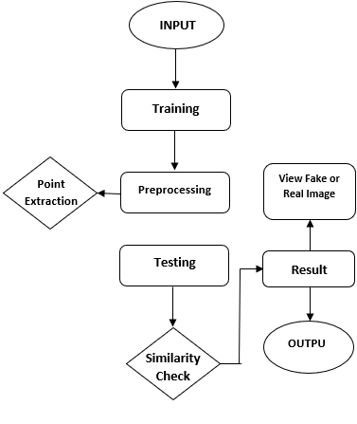

**Figure 1 :** SystemWork Flow

1. **RESULT AND DISCUSSION**

**DATASET :** The data used in this model are classified into two types they are **Training images** and **Testing images**. Both the training and testing images are stored in two different files and are uploaded separately for training and testing to find weather the testing image is real or fake.

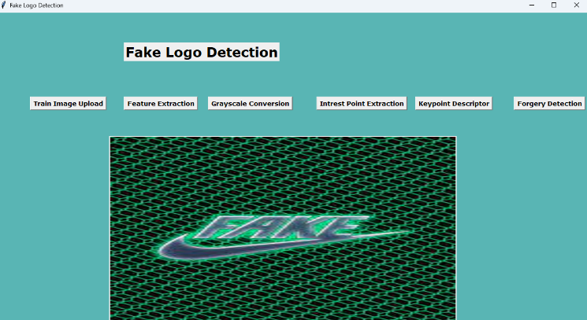

**Figure 2 :** Starting Interface

Click on train image upload shown in the (Figure-2) to upload the training image.

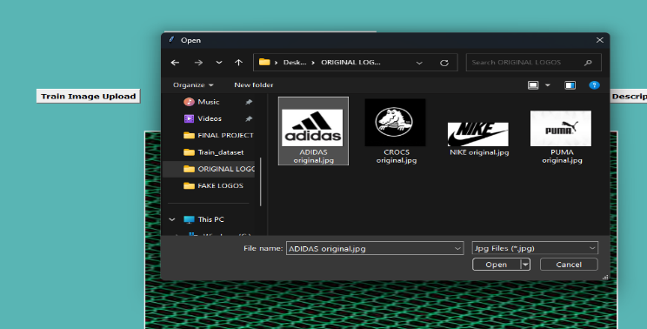

**Figure 3 :** Training Image

Upload the image to be trained as shown in the (Figure-2) to train the image.

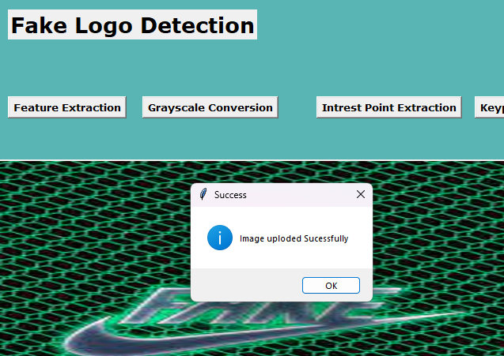

**Figure 4 :** Image uploading interface

If the image is successfully uploaded a dropdown box appears saying image uploaded successfully as shown in (fig-4).

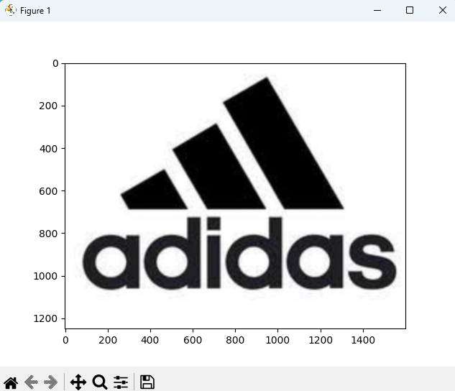

**Figure 5 :** Feature extraction

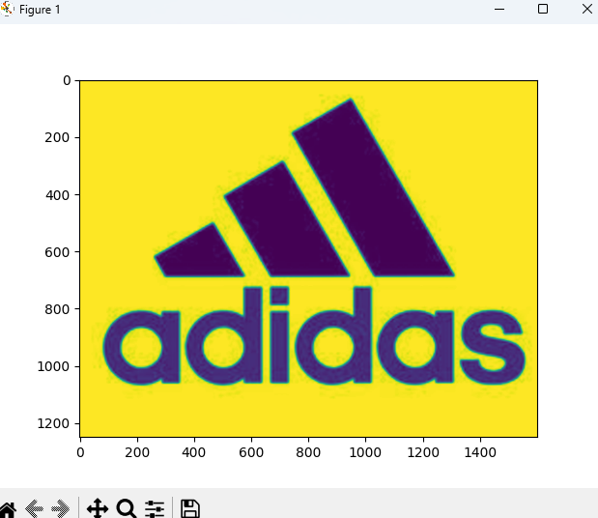

**Figure 6 :** Grayscale interaction

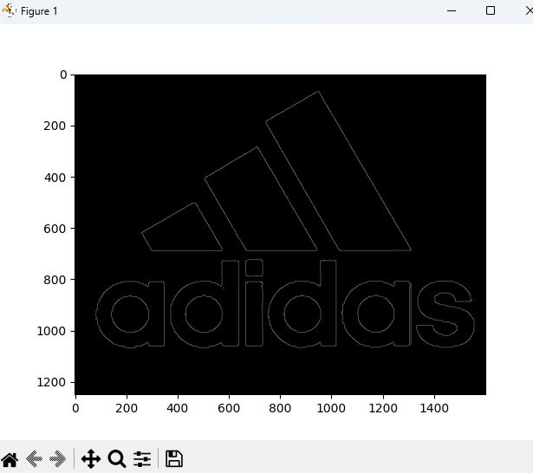

**Figure 7 :** Intrest point extraction

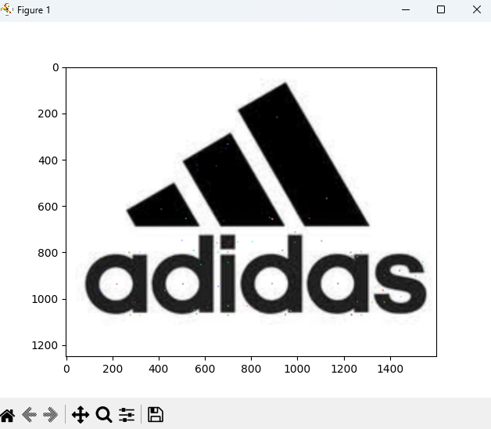

**Figure 8 :** Key point descriptor

After uploading the training image the system extracts the feature of the image, converts the image into grayscale and extracts the interest point & key point of the image as shown in the (Fig 5,6,7&8).



**Figure 9 :** Testing Image

Upload the testing image as shown in (Fig-9) to check weather it is real or fake .





**Figure 10 :** Result

After uploading the testing image if the testing image matches all the features of the training image then it displays real els it displays fake as shown in the (Fig-10).

1. **CONCLUSION**

The project's implementation phase is when the theoretical framework is transformed into a functional system. Therefore, it can be regarded as the most crucial phase in creating a successful new system and ensuring that the user has faith in its efficacy. The suggested approach effectively offers a user-friendly interface for more precise fake image detection. The goal of image detection is to assist the user in differentiating fakes from authentic products. Initially, the Scale Invariant Feature Transform Algorithm (also known as SIFT) is used to extract interest points. Local features in images are detected and described by this SIFT.Ultimately, the algorithm will use Dependent Similarity to analyse each interest point and determine whether the uploaded image is real or a fake. Similarly, companies that are having trouble addressing counterfeit goods may find this system useful.

1. **REFERANCE**
2. Dr. Thilagaraj T , Vaisiri H T , Laxmi VaijanathPatil,Ananya.Article  in  International Journal of Management Technology and Engineering · January 2024 - A Review of Fake Logo Detection using Machine Learning and Deep Learning.
3. Viveghaa.K.G,Heamalatha.International Journal of Research Publication and Reviews, Vol (6), Issue (1), January (2025) - Fake Logo Detection.
4. S.Lakshmanan,N.mohamedarshath,A.mohamedbilal,PA.Madhava krishna. 2024 JETIR June 2024, Volume 11, Issue 6 - Fake Logo Detection using Machine Learning and Deep Learning.
5. Ms. Renukadevi B, Bharathy R, Abinesh K. © 2022 IJNRD | Volume 7, Issue 8 August 2022- Detection of Fake Product using Blockchain Technology.