**Consumer Perception on Sustainability in Brand Marketing**

Authors:

1.Mr. Sunil Hegde

2.Shreya Pandey, 3.Dhriti Singhvee, 4.Nikita Madhan, 5.Sanjal Gudivada, 6.Vaishnavi Reddy

Assistant Professor, Jain (Deemed-to-be University) - Center for

Management Studies - Bangalore

Students, Jain (Deemed-to-be University) - Center for Management Studies - Bangalore India

**Abstract**

Sustainability has become a crucial component of modern brand marketing, with consumers increasingly prioritizing ethical and environmentally responsible business practices. Companies across industries are incorporating sustainability initiatives, such as eco-friendly production, ethical sourcing, and corporate social responsibility, to align with consumer expectations. However, consumer perception of these efforts varies widely, influenced by factors such as trust, transparency, and the growing concern over greenwashing, where companies misrepresent their sustainability claims. While some consumers actively support sustainable brands and are willing to pay a premium for eco-friendly products, others remain skeptical about the authenticity of corporate sustainability commitments.

This research paper examines consumer perception of sustainability in brand marketing across multiple industries, exploring how sustainability claims impact consumer awareness, trust, and purchasing behavior. The study employs a mixed-method approach, incorporating primary research through a Google Forms survey distributed to a diverse respondent base and secondary research from academic literature, industry reports, and case studies. The findings provide insights into consumer attitudes toward sustainability, the role of trust in sustainable branding, and the challenges brands face in maintaining credibility while promoting their environmental and social initiatives.

By analyzing both primary and secondary data, this research highlights key trends and best practices in sustainability marketing, offering recommendations for brands to enhance transparency and build stronger consumer relationships. As sustainability continues to shape the business landscape, understanding consumer perception is essential for companies aiming to create authentic and impactful sustainability strategies.

**Keywords**- Sustainability, brand marketing, consumer perception, eco-friendly products, consumer trust

**Introduction**

Sustainability has become a key pillar in brand marketing, driven by increasing consumer awareness of environmental and social issues. Across industries, brands are integrating sustainability into their core business strategies, promoting eco-friendly products, ethical sourcing, carbon neutrality, and corporate social responsibility (CSR) initiatives. However, the way consumers perceive these sustainability efforts varies significantly. While some consumers actively seek out and support brands that demonstrate a commitment to environmental and social responsibility, others remain skeptical, questioning whether these initiatives are genuine or merely marketing tactics. The growing concern over greenwashing, where companies exaggerate or misrepresent their sustainability claims, has further complicated consumer trust in sustainable brand marketing.

As consumers become more informed, they are demanding greater transparency from brands regarding their sustainability efforts. Many expect companies to provide clear, verifiable information on their environmental and ethical commitments. At the same time, brands face the challenge of balancing sustainability with profitability, as incorporating sustainable practices often requires significant investments in supply chain changes, product development, and responsible sourcing. Despite these challenges, sustainability has emerged as a competitive advantage, with businesses that prioritize it gaining long-term customer loyalty and differentiation in the marketplace.

Furthermore, consumer perception is shifting away from simply seeing sustainability as a value-added optional extra to interpreting it as one of the values on which brands build their foundation. Young consumers especially are predisposed to be environmentally and socially driven in the brands they decide to buy into, expecting a greater level of responsibility and credibility. Consequently, there is ever-greater pressure for brands to embrace sustainability not merely in messaging and communications but along supply chains, operations, and business propositions long-term.

**Objective-**

1. To examine consumer awareness and understanding of sustainability practices in brand marketing.
2. To assess the impact of sustainability initiatives on consumer purchasing decisions and brand preference.
3. To identify the factors that influence consumer trust in brands promoting sustainability.
4. To explore the relationship between sustainability perceptions and long-term brand loyalty.
5. To provide recommendations for brands on aligning sustainability efforts with consumer expectations for better market positioning.

**Review of Literature**

Parker, B., Segev, S., & Pinto, J. (2010).Organizations are increasingly developing green brand identities, positioning themselves on the basis of pro-environmental traits and roles. The "green" label tends to be equated with various other notions like environmental, eco-friendly, energy efficient, and organic. Despite this, the vagueness of the green symbol hinders the creation of a green brand image for the consumer. This research seeks to develop the green brand concept from the consumer's point of view, creating a knowledge foundation for green brand identity management and research. It focuses on college, ethnically diverse consumers as environmentally friendly products gain popularity. Strong brand identity demands continuous alignment between the position communicated and consumer brand image. Reddy, K. P., Osei, B., & Srilakshmi, S. (2023).The business world is adopting green marketing techniques to drive eco-friendly goods and services. An Indian study found that the consumers possess solid environmental values and environmental knowledge concerning eco marketing strategies, highlighting effective communication campaigns as key. Ali, M. J., Ali, M. J., Jony, & Shakil, A. (2017). Bangladeshi young consumers are becoming more mindful of environmental practices and recycling, prompted by education and global knowledge, as cited in a study comprising 200 fans. This change in consumer attitude matters. Grubor, A., & Milovanov, O. (2017). Brands are strong instruments of change, linked to consumers globally and impacting their values and way of life. Effective brands have the ability to create substantial shifts in consumers' behavior and attitudes. Green brands are necessary for eco-marketing policies, yet a gap exists in attitude-behavior between consumers, which keeps green consumers niche. This paper establishes the position of sustainability in branding theory and practice, emphasizing strategies for effective adoption of green values in brand management. Mohd Suk, N. (2013). The research analyzes the effect of environmental advertisement, consumers' attitude towards eco-label, and the effect of eco-brand on green product purchasing behavior. It included 200 customers in Labuan, Malaysia, and employed structural equation modeling. The results indicated that consumers' attitude towards eco-label was the most influential factor to green product purchasing behavior, implying that marketers can enhance sustainability. Javed, T., & Mahmoud, A. B. (2024)**.** The research examines ecological consciousness among Chinese consumers regarding fast fashion and effects of social claims of sustainability upon green brand picture and purchasing plans. Findings indicate a significant positive association and highlight the prominence of philanthropic sustainability campaigns through advertising. Dekhili, S., Achabou, M. A., & Alharbi, F. (2019). This article seeks to analyze the degree to which sustainability information negatively affects consumers' behavior in the context of luxury. Specifically, it investigates the influence of social and environmental characteristics on perceived quality.

Lifang Yao (2013) The research examines how sustainable digital marketing relates to consumer behavior, citing the importance for marketers to reconcile content engagement with not overloading. It further emphasizes the gap between consumers' knowledge of sustainability concerns and what they actually do, and points to the role of open communication and sustainability message. Lim, W. M., Ting, D. H., Sim, J. C. K., Hew, K. M., & Cheong, K. K. W. (2013). This research investigates consumer perception and decision-making based on the effects of green marketing practices. Using qualitative analysis, 12 informants were interviewed to grasp their attitudes and reasons for purchasing green products. Findings indicated that most consumers care about the environment and would be willing to buy green products, but their concerns rest on price and credibility. They are also hesitant when it comes to media overloading. Savale, T. K., Anand, B., Varalaxmi, P., Brahma, A., & Quaye, J. A. (2023). The research investigates consumer adoption and awareness of green products in environmental marketing strategies and identifies lower rates of adoption due to aspects such as eco-labeling, product knowledge, price consciousness, and social norms, providing marketers with insights. Bhatia, Mayank Jain, Amit (2023) A survey of 106 Indian respondents indicated high values and awareness of green marketing practices and products. The study indicates that marketers need to create campaigns for green products, as green values have a positive influence on consumer behavior. George, A. S., & George, A. S. H. (2022). This research assesses the effect of green marketing on consumer behavior with a systematic questionnaire, emphasizing the environmental issues, green values among consumers, and environmental awareness, emphasizing the imperative for companies to adopt innovative approaches.

Babu, H., Kumar, V. J., & Venkatesh, B. R. (2020). Green marketing is a ploy in which firms market their products or services on the premise of their favorable environmental impact with the belief that consumers perceive the "green" aspect of a product as desirable and make buying decisions accordingly. A research carried out by ITC LIMITED detected a positive link. Le, Q. H. (2021). The research investigates the determinants of green marketing decisions among 400 students of Ho Chi Minh City University of Technology at Co-opMart supermarket chain, which indicates cost as the most significant determining factor, followed by convenience and communication. Sujith, T. S. (2017). The green movement is on the rise across the world, with Indian consumers remaining less environmentally conscious. Effective marketing efforts rely on observing trends and positioning products for profitability. Štofejová, L., Král’, Š., Fedorko, R., Bačík, R., & Tomášov, M. (2023). The research examines the impact of green marketing due to digitalization on consumer behavior, which shows that environmental attitude, lifestyle, and green product willingness to pay play a significant role in determining future purchases. Majeed, M. U., Aslam, S., Murtaza, S. A., Szakács, A., & Molnár, E. (2022). The research finds that green marketing has a significant impact on customers' purchase intentions for green products, with green brand image and environmental attitudes as the moderators. It highlights eco-packaging as well as green branding and offers insights for governments and businesses. Mercadé Mele, P., Molina Gómez, J., & Garay, L. (2019). The research examines the impact of green marketing on the image of tourist companies and consumer behavior of the hotel sector, and determines that green marketing indirectly affects trust, loyalty, and word of mouth, among which loyalty exerts the largest effect. Dwipamurti, I. G. A. N., Mawardi, M. K., & Nuralam, I. P. (2018). The research finds that Green Marketing has a significant effect on Brand Image, Purchase Decision, and Brand Image among 18-35-year-old consumers and Starbucks Ubud customers. Kumar, R., & Kushwaha, R. (2017). The research investigates the connection between green marketing instruments and consumer buying behavior, emphasizing the role of trust in eco-labels and eco-brands on India's green product awareness.

Prihandono, D., Wijaya, A. P., Rizqiana, I., Yahya, W. K., Rivai, A. K., & Menang, P. (2020).This research seeks to explore green marketing tools, environmental labels, and green advertising effect on consumer buying behavior in mineral water. This study discusses the Ades brand that carries out an environmental image in Indonesia. Green marketing has been a popular topic for all consumer packaged goods industries during the last decades. The bottled water industry is confronted with great challenges to manufacture an idiosyncratic product to conquer a highly competitive market.

**Research Gap-**

The growing emphasis on sustainability in brand marketing is largely due to a lack of understanding of consumer perception and response to these initiatives. Existing research primarily focuses on corporate sustainability practices, leaving little empirical data on how sustainability claims influence consumer trust, purchasing decisions, and long-term brand loyalty.

There is a significant gap in distinguishing between genuine sustainability efforts and greenwashing tactics, as consumers remain skeptical about the legitimacy of these claims. There is also limited insight into which strategies resonate most with consumers across different demographics, such as age, income, and lifestyle. Comparative analysis of sustainability marketing channels, such as social media, digital platforms, and influencer collaborations, is also lacking.

Additionally, there is a lack of research on how brands can maintain consistent messaging across all marketing touchpoints, including integrating sustainability into product design, packaging, and customer experience while ensuring transparency and authenticity.

**Research Methodology-**

**Primary data:**

A standardised Google Forms survey was created and sent to a large audience in order to learn how consumers view sustainability in brand marketing. The main instrument for collecting data was this survey, which made it possible to compile a variety of consumer insights from various industries.

**Secondary data:**

This study uses secondary research through Research papers and academic publications,Market studies and industry reports from companies in addition to primary data collecting to give a more comprehensive picture of how consumers view sustainability in brand marketing.

**Sample-**

The sample size is determined as 50 respondents' opinions on sustainability in brand marketing.

**Instrument-**

To analyse the data percentage analysis method was applied.

**Data Analysis and Interpretation-**

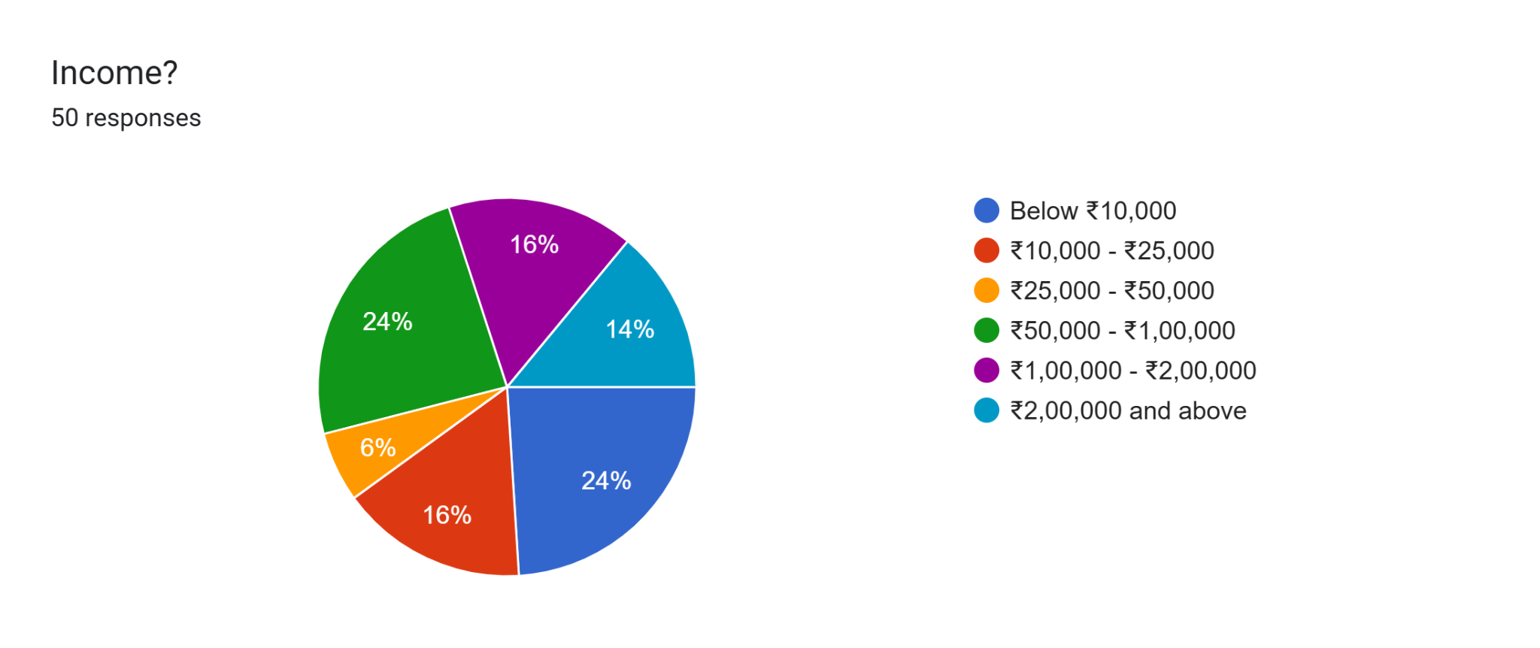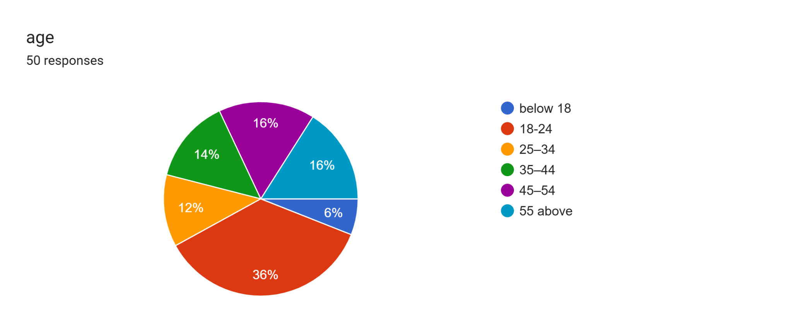

**Interpretation**- Fig 1: The respondents are relatively evenly spread across multiple income brackets. The largest segments, each representing 24%, are those earning between ₹10,000 - ₹25,000 and ₹1,00,000 - ₹2,00,000. Only 6% fall within the ₹50,000 - ₹1,00,000 bracket.

**Interpretation**-Fig 2: The largest group, accounting for 36%, falls within the 18-24 age range, indicating a strong concentration of young adults. A smaller portion, 6%, falls in the below 18 category.

**Forms response chart. Question title: gender?
. Number of responses: 50 responses.Forms response chart. Question title: education?
. Number of responses: 50 responses.**

**Interpretation**-Fig 3: The majority of respondents identify as Female, representing 44% of the total. 32% of respondents identify as Male, while 12% identify as Non-binary/Other, and another 12% preferred not to disclose their gender.

**Interpretation**-Fig 4: The largest group, accounting for 32%, holds a Bachelor's degree. Respondents with a Master’s degree make up 20%, while those with a Doctorate represent 22%. Additionally, 14% have completed High school, and 12% fall into the Other category.

**Forms response chart. Question title: What is your occupation?
. Number of responses: 50 responses.Forms response chart. Question title: How familiar are you with the concept of sustainability in brand marketing?
. Number of responses: 50 responses.**

**Interpretation**-Fig 5: 38% of respondents are students. Employed individuals (both full-time and part-time) follow closely at 32%, indicating a substantial portion of working professionals. 8% fall into the 'Other' category.

**Interpretation**-Fig 6: 24% indicated they were neutral, suggesting a moderate level of understanding without strong familiarity. Meanwhile, 18% admitted to being not very familiar, and another 18% stated they were not at all familiar.

**Forms response chart. Question title: How important is it for brands to adopt sustainable practices?
. Number of responses: 50 responses.** **Forms response chart. Question title: Have you ever chosen a brand specifically because of its sustainability practices?
. Number of responses: 50 responses.**

**Interpretation-**Fig 7: 26% believe that adopting sustainable practices is extremely important.12% consider it not important at all.

**Interpretation**-Fig 8: 46% of respondents acknowledged making such a choice 24% were uncertain, indicating they may have been influenced by sustainability without consciously recognizing it.

**Forms response chart. Question title: what makes you trust a brand’s sustainability claims? (Select all that apply)

. Number of responses: 50 responses.**

Interpretation- Fig 9: The most significant factor is positive consumer reviews, cited by 46% of participants. 2% mentioned an unspecified factor.

**Forms response chart. Question title: Would you like to see more government regulations on sustainable brand marketing?
. Number of responses: 50 responses.Forms response chart. Question title: What role do you think consumers should play in promoting sustainability?
. Number of responses: 50 responses.**

**Interpretation**-Fig 10: While 38% of participants expressed support for increased regulations, 32% remained uncertain, and 30% opposed the idea.

**Interpretation**-Fig 11: 36% believe that consumers should reduce their personal consumption and waste, 28% of respondents consider supporting sustainable brands as the most effective way for consumers to contribute.

**Forms response chart. Question title: How do you think brands should improve their sustainability efforts?
. Number of responses: 50 responses.**

**Interpretation**- Fig 12: 52% of respondents emphasized this step. 26% supported partnering with environmental organizations. This data suggests that consumers prioritize tangible environmental actions alongside better communication and education efforts.

**Forms response chart. Question title: Have you ever stopped purchasing from a brand due to misleading sustainability claims?
. Number of responses: 50 responses.**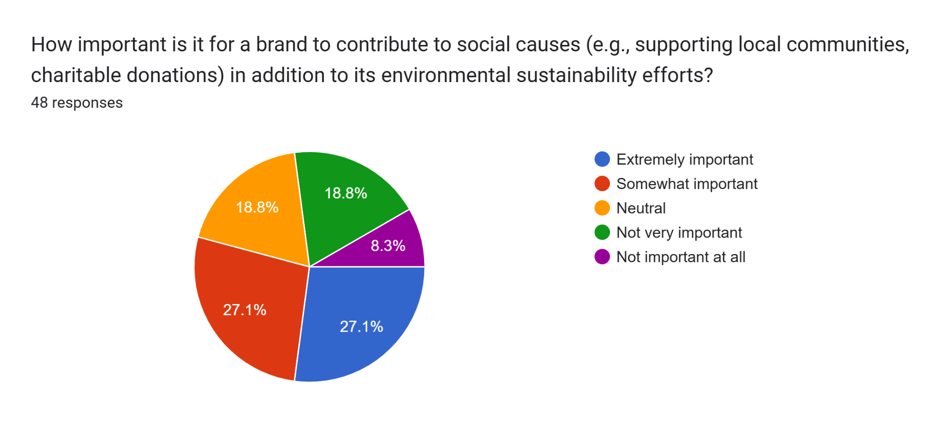

**Interpretation-**Fig 13: 38% have stopped purchasing from a brand due to misleading sustainability claims. 30% are uncertain about their stance.

**Interpretation**-Fig 14: 27.1% rated it as extremely important. Only 8.3% believed it was not important at all.

**Forms response chart. Question title: Do you believe most brands are genuinely committed to sustainability, or are they just using it for marketing purposes?
. Number of responses: 48 responses.Forms response chart. Question title: Which of the following sustainability-related marketing efforts influence your purchasing decisions the most?
. Number of responses: 48 responses.**

**Interpretation**-Fig 15: 43.7% of respondents believe that most brands are engaging in greenwashing — using sustainability as a marketing gimmick rather than a true commitment. 29.2% were unsure about the authenticity of these efforts.

**Interpretation**- Fig 16: 39.6% of respondents highlighted eco-friendly packaging and materials as the most impactful factor. 14.6% emphasized the importance of recognized certifications like Fair Trade or Carbon. 27.1% of respondents preferred clothing and fashion items, making it the most impactful category. 10.4% chose beauty and personal care products.

**Findings -**

Consumer Attitudes Toward Sustainability

* Clothing and fashion items are the most influential category for sustainable brand purchases.
* Food and beverages are the second highest category at 22.9%.
* Other notable categories include home and household appliances (18.8%), electronics and technology products (14.6%), and beauty and personal care products (10.4%).
* Brands should measure sustainability impact through credible certifications, transparent reporting, and clear environmental goals.
* Consumers appreciate transparency and proof in sustainability claims.
* These findings emphasize that consumers are not only aware of sustainability claims but also value credible proof and clear communication when making purchasing decisions.

**Recommendation-**

* Transparency: Brands should provide clear, verifiable information about their sustainability practices to build consumer confidence.
* Authenticity and Consistency: Brands should align their sustainability claims with their core values, actions, and communications.
* Consumer Education: Brands should invest in educational campaigns to inform consumers about sustainable practices and how their purchases can positively impact the environment.
* Social Media and Storytelling: Brands can connect with their audience effectively through engaging narratives that showcase real-life sustainability efforts.
* Tailoring Sustainability Strategies to Specific Demographics: Brands can tailor their sustainability strategies to address individual preferences and priorities.
* Consumer Participation: Inviting consumers to participate in sustainability initiatives strengthens brand loyalty.
* Long-term Commitment to Sustainability: Brands should embed sustainability into their core values and operational strategies to enhance consumer trust and engagement, brands should adopt several strategic approaches to improve their sustainability marketing efforts.

**Conclusion-**

The findings from this research emphasize that sustainability has become a crucial factor influencing consumer perception and purchase decisions in brand marketing. As environmental consciousness continues to grow, consumers are placing greater value on brands that demonstrate genuine commitment to sustainable practices. This study highlights that brands incorporating clear, transparent, and authentic sustainability efforts are better positioned to build trust, foster loyalty, and enhance their market presence.

One key takeaway is that consumers are increasingly aware of greenwashing tactics, which has heightened their demand for verifiable and trustworthy sustainability claims. Brands that provide concrete evidence of their eco-friendly efforts — such as certifications, eco-labels, and transparent reporting — are more likely to gain consumer confidence. Furthermore, educational campaigns play a significant role in enhancing consumer understanding of sustainable practices, encouraging informed decision-making.

The research also underscores the importance of tailored marketing strategies. Brands that effectively align their sustainability messaging with the values and preferences of their target audience are more likely to achieve positive engagement. Leveraging social media platforms and storytelling techniques has proven particularly effective in connecting with consumers emotionally and showcasing genuine environmental efforts.. Brands that integrate sustainability without compromising quality are better positioned to secure long-term consumer trust.

In conclusion, brands that prioritize transparency, authenticity, and consumer engagement in their sustainability marketing efforts are more likely to succeed in building meaningful relationships with their audience. Moving forward, businesses should focus on embedding sustainability as a core value rather than a marketing trend, ensuring their efforts align with consumer expectations and contribute positively to environmental and social well-being.

**References**

1. Ali, M. J., Jony, A. S., & Shakil, A. (2017). *Bangladeshi young consumers are becoming more mindful of environmental practices and recycling*.
2. Babu, H. V. S., Kumar, V., & R, B. (2020). *Positive link between green marketing tactics and consumer behavior as seen in ITC LIMITED research*.
3. Bhatia, M., & Jain, A. (2023). *A survey of Indian respondents indicating high values and awareness of green marketing practices and products*.
4. Dekhili, S., Achabou, M. A., & Alharbi, F. (2019). *The influence of social and environmental characteristics on perceived product quality*.
5. Dwipamurti, I. G. A. N., Mawardi, M. K., & Nuralam, I. P. (2018). *The influence of Green Marketing on Brand Image and Purchase Decision among Starbucks Ubud customers*.
6. George, A. S., & George, H. (2022). *The effect of green marketing on consumer behavior with emphasis on environmental issues and green values*.
7. Grubor, A., & Milovanov, O. (2017). *Brands are strong instruments of change, linked to consumers globally and impacting their values and way of life*.
8. Javed, T., & Mahmoud, A. B. (2024). *Ecological consciousness among Chinese consumers regarding fast fashion and the effects of social claims on sustainability*.
9. Le, Q. H. (2021). *Determinants of green marketing decisions among students at Ho Chi Minh City University*.
10. Lim, W. M., Ting, D. H., Sim, J. C., Hew, K. M., & Cheong, K. K. W. (2013). *Consumer perception and decision-making based on green marketing practices*.
11. Majeed, M. U., Aslam, S., Murtaza, S. A., Attila, S., & Molnár, E. (2022). *The impact of green marketing on customer purchase intentions for eco-products*.
12. Mele, P. M., Gomez, J. M., & Garay, L. (2019). *Impact of green marketing on tourist company image and consumer loyalty*.
13. Mokha, A. K. (2017). *Successive generations' awareness and predisposition toward green products*.
14. Parker, B., Segev, S., & Pinto, J. (2010). *Organizations are increasingly developing green brand identities*. Florida International University, North Miami, FL.
15. Prihandono, D., Wijaya, A. P., Rizqiana, I., Yahya, W. K., & Rivai, A. K. (2020). *The connection between green marketing tools and consumer behavior in sustainable markets*.
16. Ranjan, R. K., & Kushwaha, R. (2017). *The role of trust in eco-labels and eco-brands on India's green product awareness*.
17. Reddy, K. P., Osei, B., & Srilakshmi, S. (2023). *The business world is adopting green marketing techniques to drive eco-friendly goods and services*.
18. Savale, T. K., Anand, B., Varalaxmi, P., Brahma, A., & Quaye, J. A. (2023). *Consumer adoption and awareness of green products in environmental marketing strategies*.
19. Štofejová, L., Král’, Š., Fedorko, R., Baˇcík, R., & Tomášov, M. (2023). *The impact of green marketing and digitalization on consumer behavior*.
20. Sujith, T. S. (2017). *The rise of the green movement across India and consumer environmental consciousness*.
21. Suk, N. M. (2013). *The effect of environmental advertisement, consumers' attitude towards eco-label, and the effect of eco-brand on green product purchasing behavior*.
22. Yao, L. (2013). *The relationship between sustainable digital marketing and consumer behavior*.