GROCERY MANAGEMENT SYSTEM
Author’s: Mr. Vedant Keralekar, Mr. Pruthviraj Chavan, Mr. Dhruvil Rupareliya, Mr. Dushant Bamne
vedantkeralekar@gmail.com, dhruvilrupareliya95@gmail.com
Guide: Mrs. K. G. Raut
Sou. Venutai Chavan Polytechnic, Pune

ABSTRACT
This Grocery Management System is built on React Native and adds some essential functionality to the grocery store. The efficient management of employee records, schedules, roles, and payroll is its primary function. Inventories are monitored, product movements tracked, and reordering managed by automated alerts. It includes an expense tracker to capture and categorize the costs, providing a clear picture of finances.' The product catalogue presents detailed information, and the profitability calculation provides monthly (3-5 days), weekly, or daily figures for a financial analysis. This unified platform helps store owners optimize business performance.

KEYWORDS
The overview of a new product, the management of employees, stock control measures, and expense tracking.

INTRODUCTION

React Native was used to create the Grocery Management System, which aims to simplify various aspects of running a grocery store. The efficient management of employee records, schedules, roles, and payroll ensures smooth workforce management. It monitors the stock level, movements of products and automatically alerted to keep reordering processes to ensure optimal stock levels. Integrated tracker for expenses records and categorizes all transactions. The expenses of the

stores, offering a clear financial picture and help in managing costs.' Product overview provides store owners with comprehensive information, including descriptions and pricing as well as availability and sales data to help them make inventory and snag valuable products. Furthermore, the system utilizes data from sales and expenses to calculate profits on a monthly, weekly or daily basis, providing precise financial information. A centralized platform that offers tools for grocery store owners to manage their employees, stockholders, expenses, and keep tab on financial information is now accessible to all users. Consolidating all these features into a single application helps to improve operational efficiency, reduces manual Employee required and allows for data driven decision making. Ultimately, this Grocery Management System helps store owners improve their business performance and increase profits.

LITERATURE REVIEW

[1]. Nikita Shevtsiv, Graduate Student, Dmitriy Shvets, Senior Lecturer, Nadezhda Karabut, “Prospects for Using React Native for Developing Cross-platform Mobile Applications”,2023 Iraqi Journal for Computer Science and Mathematics (IJCSM).
The article is devoted to the study of determining the best methods and tools for cross-platform development of mobile applications, allowing to accelerate the process of writing application program code. The analysis of the existing technologies used to write mobile applications is carried out, their advantages and disadvantages are considered. The nuances of using the React Native framework, the mechanism of its work, the advantages of working with it are described. The data on the interest of developers in the React Native framework, search trends, the number of downloads of its installation package have analyzed. React Native, framework, Android, iOS, mobile application, development.
[2]. Hayder Sabah Salih, Mohanad G. Yaseen,
Mohammad Aljanabi, “Implementing an Automated Inventory Management System for Small and Medium-sized Enterprises”, 2021 Iraqi Journal for Computer Science and Mathematics (IJCSM).
Implementing an automated inventory management system is crucial for small and medium-sized enterprises to optimize their inventory levels, reduce costs, and improve customer satisfaction. An automated system can help SMEs to efficiently track and manage their inventory, enabling them to make informed decisions about stock replenishment and inventory control. This paper proposes a novel approach to designing an automated inventory management system tailored to the specific needs of SMEs, leveraging advanced technologies such as IoT, RFID, and cloud computing. The proposed system aims to provide real-time inventory tracking, automated stock replenishment, and data analytics to support informed decision-making.
[3]. Kamali Gupta, Deepali Gupta “React Native Application Development”, 2019 International Conference on Cyber Security (ICCS).
The paper on "React Native Application Development" discusses the use of React Native as a framework for building cross-platform mobile applications. React Native enables developers to create native mobile apps for both Android and iOS using a single codebase, reducing development time and increasing efficiency. This paper explores the benefits and challenges of using React Native, including its ability to provide a seamless user experience, improve code reusability, and simplify the development process. It also highlights the potential of React Native to transform the mobile app development landscape, making it an attractive choice for developers and businesses alike.
[4]. Thomas C. G. & A. Jayanthila Devi “A Study and Overview of the Mobile App Development Industry”,2021 International Journal of Applied Engineering and Management Letters (IJAEML).
The paper "A Study and Overview of the Mobile App Development Industry" provides a comprehensive analysis of the current landscape of mobile app development. It examines key trends, technologies, and methodologies shaping the industry, highlighting the rapid growth driven by increasing smartphone usage and consumer demand for innovative applications. The study discusses various development frameworks, market challenges, and the importance of user experience in app design. By analyzing these factors, the paper aims to offer insights into best practices and future directions for developers and businesses in the mobile app sector.

METHODOLOGY

Research stage

To create a Grocery Management System, it is important to identify the store's requirements in terms of employee, stock, and expense management, as well as profit calculations. Market research to identify potential competitors' attributes, and evaluate the effectiveness of React Native. Incite individuals such as store owners and employees for a valuable learning experience. Collect data on inventory, sales, and expenses to comprehend the scope and data flow. This framework guarantees a comprehensive, efficient, and data-driven solution that is tailored to the grocery store's needs.

Data Collection

The Grocery Management System development's data collection phase prioritizes the gathering of extensive data to guide its design and functionality. This involves gathering information about inventory levels, product details, sales records, and expense reports. Worker data, such as work dates, roles, and payroll information, is also important. Meeting all requirements is made possible by engaging with stakeholders such as store owners and employees, which provides valuable insights. The data is utilized to construct a precise, efficient, and personalized solution for the grocery industry.

Workflow Diagram

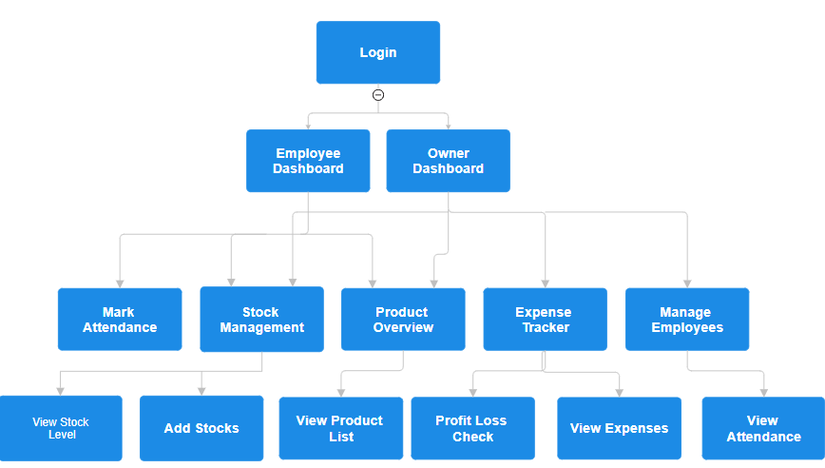

System Architecture
Registration serves as the initial step, signifying the onboarding process for both employees and owners. This suggests a system that requires user accounts for access, enhancing security and data control.
Employee Login and Owner Login represent separate entry points for each user type. This segregation implies that different functionalities are accessible based on user roles. Employees are likely limited to tasks related to their job roles, while owners have access to broader administrative functions.
Employee Dashboard and Owner Dashboard are the central hubs for each user type. Dashboards typically present a summarized overview of key information and frequently accessed features. The content and layout of these dashboards likely vary significantly depending on the user role.
View Assigned Tasks is a function specifically tailored for employees. This indicates a task management system within the application, likely focusing on work assignments, deadlines, and progress tracking.
Product Overview seems to be an employee-specific feature as well. This could indicate a system for product information access, potentially including details like specifications, pricing, and inventory levels.

Development Model
The development model adopted for the implementation of the grocery management system is based on an iterative and incremental approach, specifically the Agile methodology. Agile methodologies emphasize flexibility, collaboration, and weekly report, making them well-suited for dynamic and evolving projects such as grocery management.

Agile Development Process
- The development process was divided into short iterations (sprints), typically lasting one to four weeks, ensuring modular and efficient development.
- Each sprint focused on delivering a specific set of features or functionalities, prioritized based on their value to the end user and system goals.
- Regular testing and validation were conducted to ensure system stability, accuracy, and usability. Collaboration among cross-functional teams, including data scientists, developers, and UX designers, was promoted to accelerate development and optimize system performance.

FUTURE SCOPE

For Grocery Management System, along with exploring artificial intelligence analytics, IoT devices for instant tracking, and mobile payment link-up with customer loyalty programs, multisecurity level installations, advanced languages, administration configurations with devices integration with cloud are listed as the future projects. Furthermore, this my network of networks will be able to by customers like, automated inventory management, personalized marketing based on data insights, voice-assisted shopping, predictive demand forecasting, machine learning for fraud detection, cross-platform compatibility and seamlessly integration with other retail systems. Instant data processing, until you change the rule they must notify you of money, using of the technology of the analysis and more would be the things that bind day functionality to things long-term and people become better off. The combination of such enhancements will support the system in being more resilient, faster, and user-interactive, hence, in line with the needs of supermarkets as they evolve, customer experience will be enhanced as a ripple effect.

REFERENCES

- Nikita Shevtsiv, Graduate Student, Dmitriy Shvets, Senior Lecturer, Nadezhda Karabut, "Prospects for Using React Native for Developing Cross-Platform Mobile Applications" 2023 Iraqi Journal for Computer Science and Mathematics (IJCSM).
- Hayder Sabah Salih, Mohammad G. Yaseen, Mohammad Aljanabi, "Implementing an Automated Inventory Management System for Small and Medium-sized Enterprises”, 2021 Iraqi Journal for Computer Science and Mathematics (IJCSM).
- Kamali Gupta, Deepali Gupta "React Native Application Development" 2019 International Conference on Cyber Security (ICCS).
- Thomas C. G. & A. Jayanthila Devi "A Study and Overview of the Mobile App Development Industry", 2021 International Journal of Applied Engineering and Management Letters (IJAEML).
[5] David Winkelmann, Matthias Ulrich, Michaël Romer, Roland Langrock, Hermann Jahnke, “Dynamic Stochastic Inventory Management in E-Grocery Retailing”, 2024 Bielefeld University, Bielefeld, Germany.
[6] Friday Ugbebor, Michael Adeteye, John Ugbebor, “Automated Inventory Management Systems with IoT Integration to Optimize Stock Levels and Reduce Carrying Costs for SMEs”,2024 Journal of Artificial Intelligence General Science (JAIGS).

