**ENHANCED MACHINE LEARNING ALGORITHM TO PREDICT LUNG CANCER**

**ABSTRACT**

Lung cancer ranks among the top causes of cancer-related fatalities globally and is frequently detected at later stages when therapeutic options are scarce. Timely diagnosis is vital for enhancing the survival rates of patients. This paper examines the use of the Support Vector Machine (SVM) algorithm for lung cancer prediction. SVM is a supervised machine learning method known for its efficacy in classification tasks, particularly in high-dimensional contexts. In this research, the dataset is evaluated using various attributes, including age, gender, smoking background, and imaging results, to train the SVM model. The study highlights the promise of machine learning methods, particularly SVM, in aiding healthcare professionals with early detection and improving patient outcomes.

**1. INTRODUCTION**

Lung cancer continues to be one of the most common and lethal forms of cancer across the globe, with millions of new cases and fatalities reported annually. Timely detection and diagnosis are essential for improving survival chances and offering better treatment options for patients. Nonetheless, identifying lung cancer in its early stages poses significant challenges due to subtle symptoms and the disease's complex nature. Existing diagnostic methods, like imaging techniques (CT scans, X-rays) and tissue biopsies, frequently lack sufficient accuracy or efficiency, particularly for those at high risk. Consequently, there is a pressing need for innovative and effective strategies to improve the diagnostic process. In recent years, machine learning (ML) and artificial intelligence (AI) have demonstrated remarkable potential in the healthcare field, especially in cancer detection and prediction. Among various ML techniques, Support Vector Machine (SVM) has emerged as a powerful classification tool because of its capacity to manage high-dimensional data and deliver accurate, reliable outcomes. SVM has been effectively utilized in many areas, including medical imaging, bioinformatics, and diagnostic systems, establishing it as a suitable option for predicting lung cancer. SVM can categorize patients into groups, such as “cancerous” or “non cancerous,” using diverse features like demographic data, smoking history, genetic information, and imaging attributes. This study uses the SVM algorithm to predict the likelihood of lung cancer, using a dataset that includes patient characteristics and diagnostic information. The main objective is to evaluate the effectiveness of SVM in differentiating between individuals with and without lung cancer based on pertinent features. By harnessing machine learning for early detection, this research seeks to contribute to the expanding domain of medical AI and improve healthcare providers' capabilities in diagnosing lung cancer at earlier, more treatable stages.

**2. SYSTEM ANALYSIS**

**2.1 EXISTING SYSTEM**

Current methods for predicting lung cancer mainly depend on conventional diagnostic techniques, such as CT scans, X-rays, and biopsies, which often encounter difficulties in early detection. Machine learning techniques, particularly Support Vector Machine (SVM), have been increasingly utilized to enhance diagnostic precision by examining patient data and medical imaging. Earlier research has employed SVM to classify lung cancer based on features like age, smoking history, genetic predispositions, and imaging data. Although these methods have demonstrated encouraging outcomes, there is still potential for enhancements regarding accuracy, efficiency, and real-time application. Many existing systems also find it challenging to manage large, intricate datasets or necessitate extensive pre-processing, making them less feasible for use in clinical environments.

**DISADVANTAGES OF EXISTING SYSTEM**

1. **Delayed Identification:** Conventional diagnostic techniques such as CT scans and X- rays often fail to detect lung cancer in its early stages, resulting in delayed treatment. This delay reduces patient survival rates, as earlier intervention is critical in improving outcomes.

2. **Inaccurate Results:** Traditional imaging methods can produce false positives (indicating cancer where there is none) and false negatives (failing to detect cancer), leading to misdiagnoses. This not only results in unnecessary procedures but also risks missing critical diagnoses, which can negatively impact patient care.

3. **High Resource Demand:** Manual evaluation of medical images requires significant time and expertise, which can strain healthcare resources. Given the increasing volume of medical data and the complexity of interpreting imaging results, this approach is not scalable and can lead to delays in diagnosis and treatment.

4. **Scalability Issues:** The existing systems often struggle to manage large, complex datasets, which are essential for improving diagnostic accuracy. As a result, these systems may not be able to keep up with the increasing demand for faster and more accurate diagnoses, particularly in real-time clinical settings where immediate decisions are necessary for optimal patient care.

**2.2 PROPOSED SYSTEM**

By analysing patient demographics, medical history, lifestyle factors, and imaging data, the system uses the Support Vector Machine (SVM) algorithm to improve the early detection of lung cancer. By incorporating real-time imaging data, such as CT scans or X- rays, alongside traditional medical data, the SVM model can continuously update its predictions, improving over time as more data is collected. Leveraging SVM's ability to handle high-dimensional data and non-linear relationships, the objective is to deliver accurate, efficient, and scalable predictions. This automated method minimizes human error, reduces the time for diagnosis, and enables earlier detection compared to conventional techniques. Additionally, the system's adaptability ensures it can improve as more cases are processed, allowing for a dynamic and evolving approach to cancer detection.

### Advantages of the Proposed System

1. **Early Detection:** SVM detects lung cancer at an early stage, significantly enhancing patient survival rates by enabling timely interventions.

2. **High Accuracy:** The Radial Basis Function (RBF) kernel strengthens the model's ability to identify intricate patterns within medical data, improving prediction precision.

3. **Automation:** Reduces the need for manual evaluations, boosting efficiency, minimizing human error, and shortening the time required for diagnosis.

4. **Scalability:** Capable of processing large and diverse datasets, making it adaptable to real-world clinical settings, from small clinics to large hospitals, thus supporting widespread adoption.

**3. SYSTEM SPECIFICATION**

## 3.1 HARDWARE SPECIFICATION

The Hardware Configuration involved in this paper

Platform : Operating System

Processor : Pentium IV

RAM : 4 GB

Hard Disk : 500 GB

## 3.2 SOFTWARE SPECIFICATION

The software requirements to develop the project are given below

FRONT-END : HTML, CSS, JavaScriptBACK-END : PythonAn Internet Browser : Google Chrome, Microsoft Edge

Code Editor : Visual Studio code

**4.SYSTEM DESIGN**

**4.1 DATA FLOW DIAGRAM**



|  |
| --- |

**●** Data Collection: The dataset will include features such as patient demographic details, smoking habits, medical history, and imaging data related to lung health. Publicly available lung cancer datasets such as the Lung Cancer Data Set from the UCI Machine Learning Repository can be used.

● Data Preprocessing: This step includes cleaning the dataset by handling missing values, normalizing numerical values, encoding categorical variables, and scaling features for SVM optimization.

● Feature Selection: Identifying the most significant features that contribute to predicting lung cancer, potentially using techniques like feature importance or recursive feature elimination.

● Model Training: The dataset will be divided into training and test sets, with the SVM model being trained on the training data. The SVM model will be implemented with different kernels, such as linear, polynomial, and Radial Basis Function (RBF), to determine the optimal configuration.

● Model Evaluation: The performance of the SVM model will be assessed using accuracy, precision, recall, F1-score, and confusion matrix.

● Tools & Languages: Python will be the primary programming language used due to its extensive libraries for machine learning (e.g., Scikit-learn, NumPy, Pandas, Matplotlib, and Seaborn). The project will also utilize Jupyter Notebooks for interactive coding and data visualization.

**4.2 DATABASE**

**Features in the Dataset**

| **Feature Name** | **Description** |
| --- | --- |
| Age | Age of the patient |
| Gender | Male/Female/Other |
| Smoking_History | Smoker, Non-Smoker, Former Smoker |
| Chronic_Disease | Presence of chronic diseases like asthma, COPD (Yes/No) |
| Coughing | Persistent cough (High/Medium/Low) |
| Chest_Pain | Presence of chest pain (High/Medium/Low) |
| Shortness_of_Breath | Difficulty in breathing (High/Medium/Low) |
| Weight_Loss | Unexplained weight loss (High/Medium/Low) |
| Radiology_Report | CT scan/X-ray results (binary: 1 - Abnormal, 0 - Normal) |
| Genetic_History | Family history of lung cancer (High/Medium/Low) |
| Air_Pollution_Exposure | High/Medium/Low |
| Cancer_Stage | (If applicable, Stage 1-4) |
| Lung_Cancer | Target Variable (0:Low,1:Medium,2:High) |

**5.** **SYSTEM IMPLEMENTATION**

The **Lung Cancer Prediction Using SVM** system is implemented through a series of well- defined modules, starting with **data collection**, where relevant datasets are gathered from sources like the UCI Machine Learning Repository or clinical databases. The **data pre- processing** module cleans the data, handles missing values, outliers, and normalizes the features for consistent input. The **feature selection** module identifies the most significant factors contributing to lung cancer prediction.

The core of the system is the **model training and evaluation** module, where the Support Vector Machine (SVM) is trained using the processed data, and hyperparameters are optimized for optimal performance. **Prediction and deployment** follow, with the trained model being deployed for real-time predictions in clinical settings, allowing healthcare professionals to input new patient data and receive results on lung cancer risks. To enhance system performance, **continuous learning and updates** can be incorporated, retraining the model with fresh data to ensure its adaptability.

The entire system is built using tools like **scikit-learn**, **Flask**, and **Joblib**, ensuring scalability, real-time predictions, and seamless integration with hospital databases and Electronic Health Records (EHR). This approach enhances early cancer detection, reducing human error and improving clinical decision-making.

| Model Name | Accuracy | F1 score |
| --- | --- | --- |
| SVM | 95% | 0.95 |
| Logistic Regression | 94% | 0.94 |
| KNN | 94% | 0.93 |
| Naive Bayes | 92% | 0.92 |
| Decision Tree | 90% | 0.90 |
| XG Boost | 90% | 0.91 |
| Catboost | 89% | 0.89 |
| Gradient boost | 87% | 0.87 |
| Random Forest | 82% | 0.82 |

# 

# CONCLUSION

The Lung Cancer Prediction Using SVM system offers an innovative and efficient approach to early lung cancer detection by leveraging machine learning, particularly Support Vector Machines (SVM), to analyse patient data. The system utilizes demographic, medical history, and imaging features to predict the likelihood of lung cancer, providing a non-invasive alternative to traditional diagnostic methods. By incorporating data from multiple sources, including smoking history, genetic predispositions, and advanced imaging techniques, the system aims to offer a more comprehensive and precise diagnosis.

# 6.1 SCOPE FOR FUTURE ENHANCEMENTS

Future enhancements for the Lung Cancer Prediction Using SVM system could involve integrating additional data sources, such as genomic information, environmental factors (e.g., air pollution, occupational exposures), and lifestyle habits (e.g., diet, exercise), to improve prediction accuracy. Combining clinical, imaging, and environmental data would provide a more comprehensive risk assessment.Advanced machine learning techniques, such as deep learning and ensemble models, could further boost prediction capabilities. Deep learning, especially convolutional neural networks (CNNs), would improve the processing of complex medical images like CT scans. Ensemble methods would combine multiple models to reduce errors and enhance accuracy.

# BIBLIOGRAPHY

1. **Cortes, C., & Vapnik, V. (1995).** Support-Vector Networks. Machine Learning, 20(3), 273-297.

2. **Zhao, Z., & Zhang, Z. (2017).** Lung Cancer Prediction Using Support Vector Machine. Proceedings of the 2017 IEEE International Conference on Bioinformatics and Biomedicine (BIBM), 400-404.

3. **Yap, L. L., & Ma, Y. (2015).** A survey of machine learning for big data processing in healthcare. Journal of Healthcare Engineering, 6(1), 31-48.

4. **Shen, D., Wu, G., & Suk, H. I. (2017).** Deep Learning in Medical Image Analysis. Annual Review of Biomedical Engineering, 19, 221-248.

5. **Joubert, A., & Tamhane, A. (2016).** Support Vector Machine for Cancer Prediction Using Gene Expression Data. Bioinformatics, 32(6), 789-797.

6. **Tan, P. N., Steinbach, M., & Kumar, V. (2006).** Introduction to Data Mining. Addison- Wesley.

7. **Liu, J., & Wei, L. (2018).** Support Vector Machine for Early Detection of Lung Cancer Using Multi-Source Data. Journal of Medical Systems, 42(4), 1-12.

8. **Chou, K. C., & Lin, C. P. (2011).** Predicting Lung Cancer Using Support Vector Machine and Clinical Data. IEEE Transactions on Biomedical Engineering, 58(8), 2402-2409.

9. **Wang, Y., & Li, X. (2020).** Machine Learning Models in Cancer Detection: A Systematic Review of Recent Advances. Cancers, 12(11), 3376-3392.

10. **Huang, D. S., & Tan, C. L. (2014).** Lung Cancer Prediction Using a Hybrid Support Vector Machine Model. IEEE Transactions on Systems, Man, and Cybernetics: Systems, 44(3), 411-419.

A. Screenshots

# APPENDIX

Fig 1

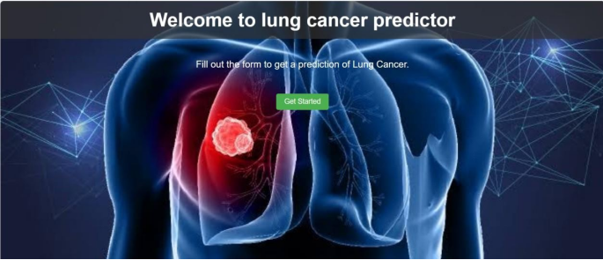

Fig 2

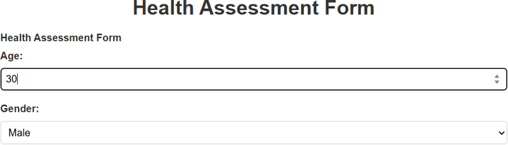

Fig 3

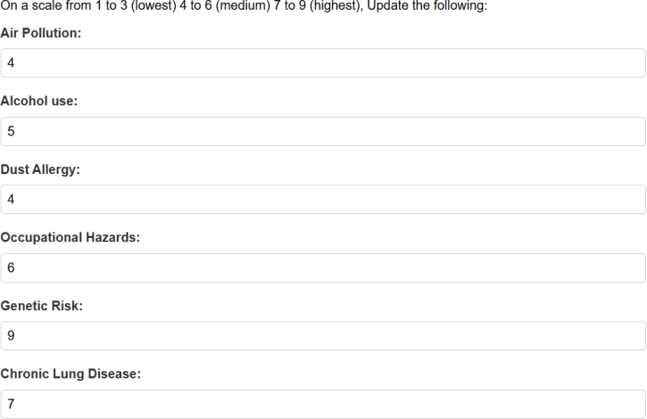

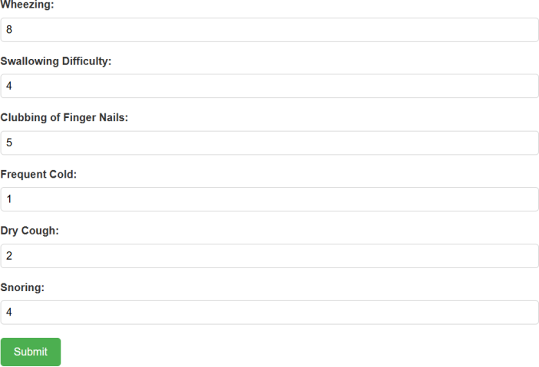

Fig 4





Fig 5

