**Urbanization and Flooding in Bengaluru: Examining the Impact and Sustainable Solutions**

1. **Executive summary**

Bengaluru, also referred to as India's "Silicon Valley," was an agrarian and green city connected by water bodies, but rapid urbanization took over the landscape in the last few decades; the area is now highly industrialized and densely populated. Although this has boosted economic development, it has resulted in very critical environmental issues, such as severe urban flooding. These are increasingly frequent and intense even at moderate rainfall events, thus emphasizing the need for sustainable planning for cities and management of floods.  
  
 This research paper analyzes the effects of fast urbanization on Bengaluru's drainage infrastructure, water bodies, and general flood resilience. Encroachment of natural drainage systems like lakes and stormwater channels (rajakaluves) has significantly decreased the city's capacity to handle rainwater. Unplanned development of infrastructure, poor drainage facilities, and climate change-related extreme weather patterns have all contributed to exacerbating the flooding problem. A study has been able to establish direct correlation between the expansion of cities, reduction of vegetation, and increased flood cases, thus the need for pro-active urban planning.  
  
 An elaborate analysis of secondary data, responses from the surveys, and flood modeling based on GIS points out the factors causing Bengaluru's vulnerability to flood. The analysis shows that the built-up area has increased from 7.97% in 1973 to 86.6% in 2023, whereas the vegetation cover has reduced from 68.2% to a mere 2.9%. This change has led to increased surface runoff, insufficient groundwater recharge, and heightened flood risk. Survey responses also uncover a widespread public belief that urban planning failures and ineffective drainage infrastructure are the root causes of frequent flooding.  
  
 To address these issues, this paper proposes a multi-pronged approach including legal and policy frameworks, enforcing zoning regulations, upgrading drainage infrastructure, and sustainable solutions such as rainwater harvesting, afforestation, and permeable urban surfaces. It further calls for the integration of community participation and technological innovation, including AI-driven flood prediction models and GIS-based urban planning, in building a resilient and flood-proof Bengaluru.  
  
 By adopting these suggestions, Bengaluru can realize sustainable urban growth, reduce the impacts of climate change, and increase its resilience towards future flash flood calamities.

1. **Introduction**

**2.1 Background and Context**

* **Overview of Bengaluru’s Rapid Urbanization**

Bengaluru, often referred to as the "Silicon Valley of India," has undergone unprecedented urban expansion over the past few decades. Once known for its pleasant climate, lush green landscapes, and interconnected water bodies, the city has transformed into a major economic hub, attracting businesses, migrants, and extensive infrastructure development. As the leading information technology (IT) and startup ecosystem in India, Bengaluru has witnessed a population explosion, growing from around 5 million in 2001 to over 14 million in 2023. The rapid urbanization of the city has changed its landscape, resulting in extensive land-use changes, increased built-up areas, and a significant reduction in natural water bodies and green spaces. This unchecked urban growth has led to the most important consequences, namely, alarming growth in urban flooding.

Bengaluru is one of those cities that experienced flooding events, even during the time of moderate rain. September 2022 witnessed devastating floods, which saw the roads and residential areas along with tech parks get submerged into the water. It caused heavy economic losses, displacing thousands of residents in Bengaluru. Similar incidents have been recorded in previous years, highlighting the growing vulnerability of the city to waterlogging and flooding.

* **Urbanization and Its Impact on Flooding**

Natural contours and interconnected chains of lakes previously drained Bengaluru, letting it absorb rain water and avoid inundation. All this changed quickly with the phenomenal growth of this city. Factors that contribute towards the aggravating flood situation

1. **Encroachment of Natural Drainage Systems:**

Much of the city's stormwater drains, rajakaluves (primary and secondary drains), and lake beds have been encroached for residential, commercial, and industrial purposes. It is reported that more than 90% of the lakes in the city have shrunk or disappeared due to illegal constructions, thereby drastically reducing Bengaluru's capacity to absorb and channel stormwater.

1. **Inadequate Drainage Infrastructure:**

The city's existing stormwater drainage system is poor and not maintained properly. The majority of the drains are clogged due to solid waste, modified for construction purposes illegally, or unable to handle the increased surface runoff due to the diminished percolation capacity caused by paved roads and built-up areas.

1. **Infrastructure Gaps and Land-Use Changes:**

Unrealistic growth without planning has resulted in the development of vast impermeable surfaces like concrete roads, buildings, and parking. Groundwater recharge declines significantly as the rainfall runs through in the form of runoff, causing surface overload and even overloading the current drainage systems. Infrastructure gulfs in flood-risk areas also amplify the impact of relatively minor rainfall.

**4. Climate Change and Rainfall Patterns:**

Although urbanization is the prime cause of flooding, erratic and intense rainfall events associated with climate change have made the city's water management system even more fragile. Short spurts of heavy rainfall, with limited drainage capabilities, often create flash floods.

This study will attempt to provide insight that can help policymakers, urban planners, and residents in the long-term, sustainable solution of flood mitigation and water conservation in Bengaluru. This research, through the analysis of past and present urbanization trends, evaluating infrastructure planning failures, and best practices for urban water management, will contribute to building a more resilient and flood-proof city.

**2.2 Increasing instances of urban flooding despite moderate rainfall**

Bangalore's rising cases of urban flooding even at moderate rainfalls trigger some serious concerns resulting from rapid urbanization. The main issues are cited as encroachments on natural drainage systems and inadequate infrastructure that together seriously diminishes the city's capacity to treat the runoff of storm water. Conversion of lakes and tanks to public and private layouts leads to broken natural water flow and haphazard development and lack of proper maintenance of drainage systems further worsens the situation. Solid waste dumping into drains results in blockages, and the reduction in carrying capacity of drains due to siltation increases the worsening of flood risks.

These factors have a serious effect on residents, the economy, and the environment. Residents experience asset damages and loss of workdays due to flooding1. The economy incurs traffic disruptions that hamper business operations and possible property devaluation in flood-prone areas

1. Environmentally, the loss of green cover and water bodies disrupts the ecological balance, increasing surface water flow and the speed of runoff.

Research is needed to analyze the impact of urbanization on drainage systems and water bodies; to identify factors contributing to flooding despite minimal rainfall; and to investigate the role infrastructure, encroachments, and land-use changes play. More importantly, this study will investigate sustainable urban planning and mitigation strategies with a view to giving policy recommendations on improving flood resilience and long-term water management in Bangalore

2. The geographical areas in Bengaluru and urbanization factors this paper will concentrate on, are under some constraints: data availability and the limitation in real-time flood modeling.

**2.3 Problem Statement**

The rapid urbanization of Bengaluru has led to change in the landscape causing floods even with moderate rainfall. The city is known as “concrete jungle” after the IT expansion, which has led to replacement of water bodies and parks with buildings and commercial hubs. During heavy rains, roads are logged with water causing flooding and traffic congestion. Homes are flooded and businesses suffer loses.This comprehensive study aims to explore a correlation between urbanization in Bengaluru, its flood crisis and possible sustainable solutions to manage this problem.

**2.4 Objectives of the Research Paper**

1. To analyze the impact of rapid urbanization on Bengaluru’s drainage systems and water bodies.
2. To identify the key factors contributing to urban flooding despite minimal rainfall.
3. To examine the role of infrastructure planning, encroachments, and land-use changes in increased floods.
4. To explore sustainable urban planning and flood mitigation strategies for Bengaluru.
5. To provide policy recommendations for improving flood resilience and long-term water management in the city.

**2.5 Hypothesis**

**H₀ (Null Hypothesis):** Rapid urbanization in Bengaluru has no significant impact on the frequency and intensity of urban flooding.

**H₁(Alternative Hypothesis):** Rapid urbanization, including unplanned infrastructure development and invasion on natural drainage systems, has significantly contributed to the increased frequency and severity of urban flooding in Bengaluru.

**2.6 Significance of the Study**

* Raise awareness about flooding in key areas of Bengaluru.
* Help better understand the correlation between rapid urbanization and flooding.
* Help policymakers and advisors come up with helpful infrastructure plans for Bengaluru.
* Design sustainable solutions to curb flooding.
* Provide data backed insights to improve flood management.

**2.7** **Scope and Limitations**

* This paper focuses mainly on Bengaluru urban areas.
* The data covered in the paper are historical data and not real-time.
* Most of the data is collected from secondary sources such as government reports which might account for certain inaccuracies.
* The strategies and solutions recommended assumes favorable economic and climate conditions.

**3. Literature Review**

1. Digitalization in Urban Water Governance: Case Study of Bengaluru (2022)

This paper explores the role of digital technologies in urban water governance, focusing on Bengaluru.t discusses how digitalization can enhance flood forecasting and management through real-time data collection and analysis.he study highlights the importance of integrating digital tools for effective stormwater management in rapidly urbanizing cities.

2. The Bengaluru Floods: The Rising Challenge of Urban Floods in India (2022)

This article analyzes the increasing frequency of urban floods in Bengaluru, attributing the issue to rapid urbanization, encroachment of water bodies, and inadequate infrastructure.t emphasizes the need for sustainable urban planning, improved drainage systems, and the restoration of natural water bodies to mitigate flood risks.

3. Urban Flood Hazard Zonation in Bengaluru Using Multi-Criteria Decision Analysis (2024)

This study employs multi-criteria decision analysis to assess flood hazards in Bengaluru and identifies significant flood-causing parameters and emphasizes the need for comprehensive research combining various factors.he analysis aims to provide a reliable flood vulnerability map to aid in effective urban planning and flood mitigation strategies.

4. Applying Narrative Foresight to Deconstruct the Problem of Urban Flooding in the Slums of Bengaluru, India (2024)

This study focuses on the vulnerabilities of migrant slum dwellers in Bengaluru concerning urban flooding. It utilizes narrative foresight to understand the complex challenges faced by marginalized communities and advocates for inclusive policy-making and participatory processes to develop sustainable flood mitigation strategies.

5. Creating Urban Water Resilience in India: A Water Balance Study of Chennai, Bengaluru, Coimbatore, and Delhi (2021)

This research analyzes urban water resilience in large Indian cities, such as Bengaluru, through water balance analysis. It focuses on the threat of rapid urbanization, climate change, and excess withdrawal of water resources. The research strongly suggests IWRM, reinvention of traditional water systems, and implementation of new technologies for enhancing water availability and sustainability. The results form the foundation of a multi-stakeholder strategy to promote urban water resilience and risk governance against water scarcity and floodings.

**3. Research Methodology**

**3.1 Research Design**

In our research, we went for a descriptive research design. This is because it captures the complexities of a situation or population, offering a comprehensive view that quantitative methods might miss. It also provides essential insights that can guide decision-making in fields like public health, education, and marketing. Helps in recognizing changes and patterns over time, which is crucial for strategic planning. This method is less expensive and less time-consuming than experimental designs, making it accessible for various research contexts. Overall, its strengths in clarity, detail, and practical application make descriptive research a suitable design for our research.

**3.2** **Data collection method**

In our research, we have opted for a survey/questionnaire as the preferred choice of primary data collection method. Online Surveys are easy to distribute and can reach a large audience and we can have different sets of data and information and their perspective towards business.They are very scalable, which makes them suitable for efficiently collecting data from big groups.

Additionally, our paper relies heavily on secondary data from government articles, statistics and reports. These data sets have helped us check the correlation between the rapid urbanization and the Bengaluru flooding crisis. The insights provided by verified articles and reports have also been considered in this report.

**3.3** **Sampling method**

The sampling method chosen for this study is Convenience sampling. This is because the survey was conducted among general consumers, who were willing respondents. This approach allowed us to easily collect data from individuals including friends, family, and classmates, ensuring a mix of demographic backgrounds.

**3.4**  **Analysis technique**

In our study, both quantitative and qualitative methods were applied to systematically analyze the survey data, and provide sustainable solutions. The first step involved calculating frequency distributions for each question. This process included counting how often each response option was selected by participants, allowing us to understand the general trends.

Based on the secondary data, Correlation and regression analysis was conducted which helped understand the relationship between population, rainfall and flooding. The time-series analysis in helped examine trends in rainfall, urbanization, and flooding patterns over time in Bengaluru. Additionally, the GIS based analysis using Google Earth Pro, helped visualize the change in Bengaluru’s landscape over the last 14 years.

**4. Data Analysis and Interpretation**

### **4.1 Correlation Analysis**

| **Year** | **Vegetation (%)** | **Built-up (%)** |
| --- | --- | --- |
| 1973 | 68.2% | 7.97% |
| 2002 | 38.7% | 37.7% |
| 2010 | 28.2% | 54.5% |
| 2023 | 2.9% | 86.6% |

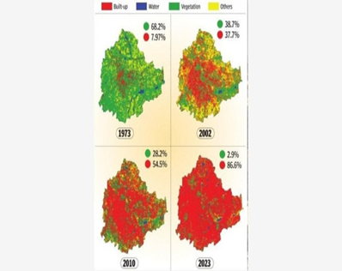

**Source: Oneindia**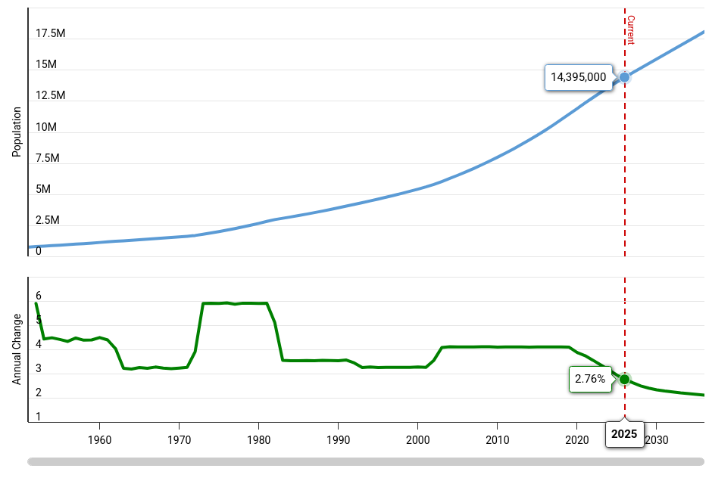

This graph depicts the population growth from 1960 to 2024.

**Source: data.opencity.in**

Year Build up % Rainfall

1973 7.97% 950.33

2002 37.70% 772

2010 54.50% 960.1

2023 84.60% 1020.2

**Interpretation:**

**1.Correlation analysis**

Rainfall and Built-up area Correlation

r= 0.41625

This indicates that there is moderate positive correlation between built up area and rainfall. Here a built-up area means the construction of infrastructure by replacing the natural vegetation in the area due to increase in population. We can see that decrease in natural vegetation and increase in built up area has negatively impacted the climate and thus has increased the rainfall creating havoc in Bangalore.

**Urbanization Impact (Vegetation vs. Built-up)**

**Vegetation Decline:** From 68.2% (1973) to 2.9% (2023)

**Built-up Area Increase:** From 7.97% (1973) to 86.6% (2023)

From the above table we can see that there is decrease in the natural vegetation which indicates a negative impact on the environment. The loss of green land has caused ecological imbalances in Bangalore which has increased the heat and caused poor air quality in the environment.

The increase in built up area implies increase in urbanization in Bangalore over the years. There has been consistent transformation in Bangalore from Garden city to IT and industry hub.

**Recommendations**

**Water and resource management:**

Ensure that rainwater harvesting is made mandatory for all the buildings as it will recharge the groundwater and will help in reducing the flood.

**Afforestation:**

In order to have control on rainfall and climate change plant more trees and increase the vegetation which was lost over the years.

**Improve drainage system:**

Modernize the drainage so that it can handle the heavy rainfall.

**Flood Zoning & Planning:**

Avoid construction in low-lying areas where waterlogging is common.

**2. Time series analysis**

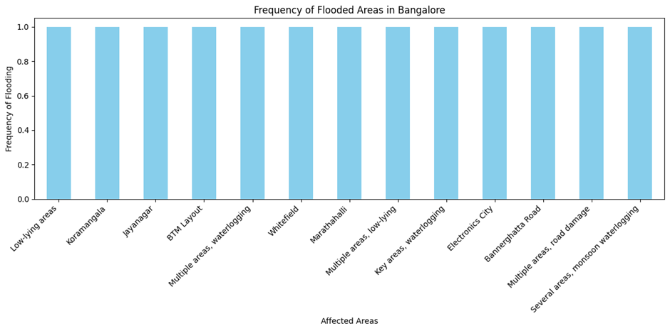

This graph shows the areas affected due to heavy rainfall.

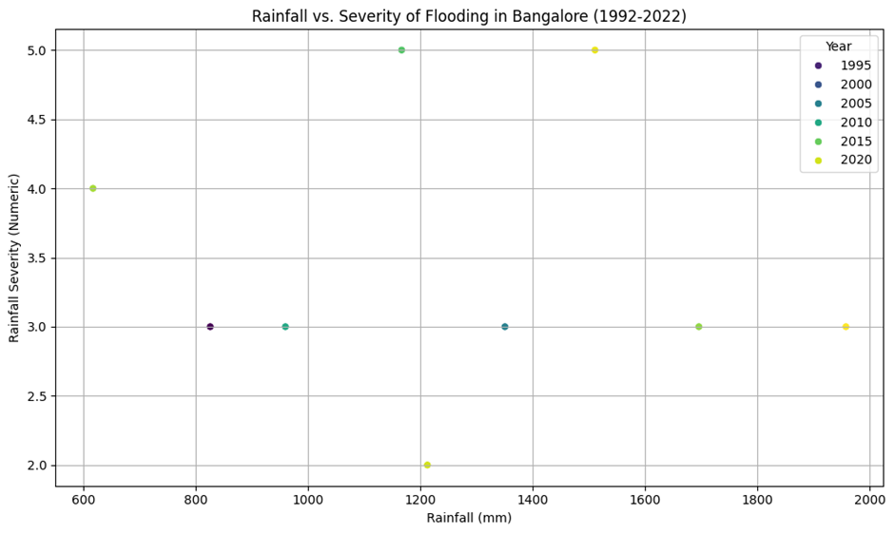

This Scatter diagram shows the rainfall and its intensity of flooding in Bangalore from 1992 to 2022.

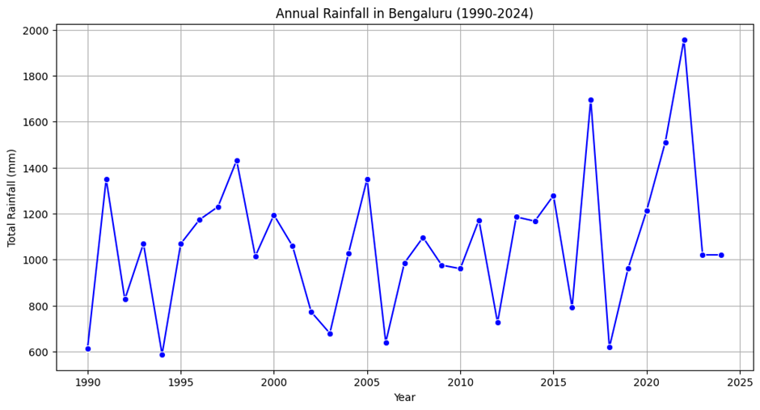

This line graph shows the annual rainfall pattern in Bangalore from 1990 to 2025.

**Interpretation:**

**1.Yearly Trends in Rainfall:**

The annual rainfall data in Bangalore shows very high fluctuations in the rains between 1990 to 2024. We can see that the rainfall pattern has constantly increased from 2019 to 2022 causing severe flooding in the area as well.

In 1994 the rainfall was 590mm which was the lowest compared to all the years. However in 2022 it will be heavy rainfall with approximately 1960mm.

**2. Relationship Between Heavy Rainfall and Flooding:**

Bangalore flooding is correlated with the rainfall especially in the low-lying areas. This can be due to improper drainage systems and urbanization.

2017 (1696mm) and 2021 (1960mm) are the years that have recorded extremely high rainfall, which led to huge flooding in the city. This had caused severe damages. Some of the cities that were submerged were Electronic City, Koramangala, Whitefield and Bannerghatta Road. This depicted that the flood management infrastructure committee failed to take measures in such extreme situations.

**3. Affected Geographical Areas:**

The Graph gives special mention of Koramangala, Jayanagar, BTM Layout, Whitefield and Marathahalli areas regarding floods, showing that these areas have very poor flood management systems.

Electronics City and Bannerghatta Road, which was submerged in 2020, says that despite being an industrial area, it is not safe from flooding events due to poor drainage systems.

**4. Increase in Frequency of Severe Flooding:**

In the scatter diagram we can see that the flooding events were a bit scattered in the earlier years from 1992 to 2010. But it was very frequent from 2014 onwards.

Between 2017 to 2022, there was a rapid increase in the amount of rainfall that constantly resulted in flooding yearly, this was because of climate change due to increase in precipitation and increase in built up areas.

**5. Climatic and Urbanization Factors:** Bangalore rapid urbanization to the IT industry has decreased the green areas which were present before and has resulted in heavy rainfall.

### **4.2 GIS-Based Analysis Using Google Earth Pro**

**(i) A Visualization of Kormangla in 2011 vs 2025.**

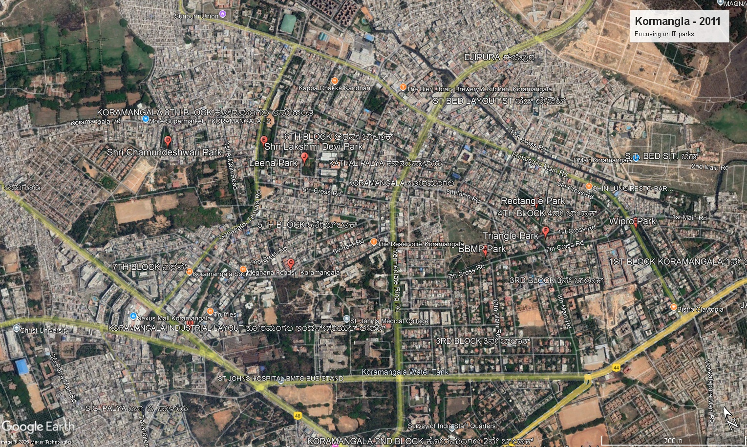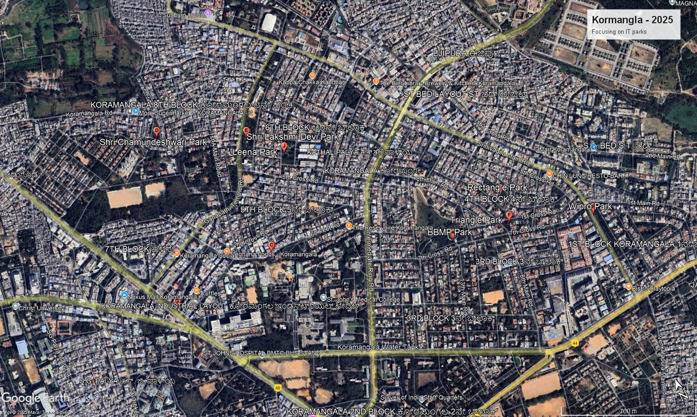

**Interpretation:**

* The 14 year gap shows Kormangla as an evolved urban area with buildings covering some green spaces that were seen in 2011.
* As of 2019, Koramangala was undergoing five major infrastructure projects within a 4-square-kilometer area, including new sewerage and drainage lines, white-topping of roads, and the construction of a flyover.

*\*source - citizenmatters.in*

* Over the last five years leading up to 2024, Koramangala has also witnessed a 42% increase in property prices. This helps us understand the rapid urbanization over the period of last 14 years.

**(ii) Visualization of Whitefield 2011 vs 2025**

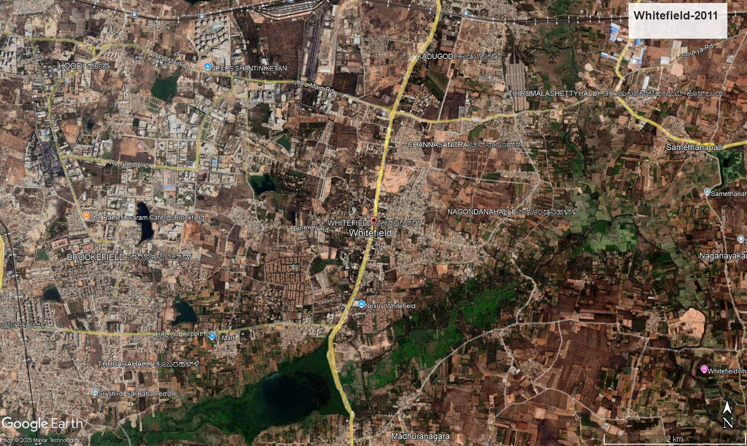

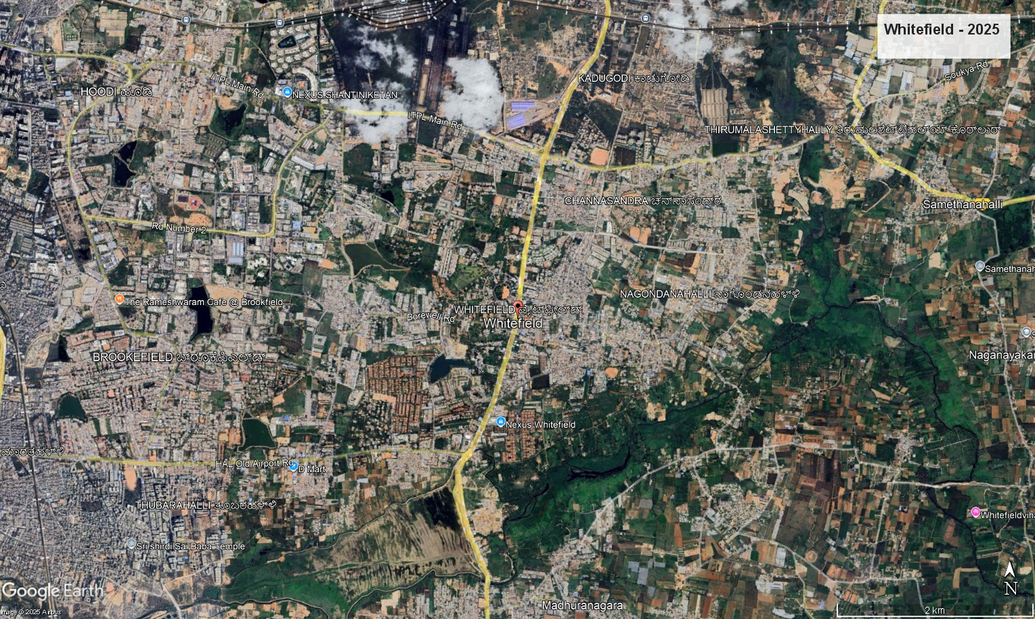

**Interpretation:**

* The 14 year gap shows Whitefield as an evolved urban area with buildings covering some empty lands that were seen in 2011.
* Over the last three years leading up to 2025, property prices in Whitefield have increased by approximately 81.4%. *\*source - 99acres.com*
* Prestige Shantiniketan is an integrated township in Whitefield, Bengaluru, spanning **105 acres**, which began its construction in 2013.

**(iii) Visualization of Electronic city 2011 vs 2025**

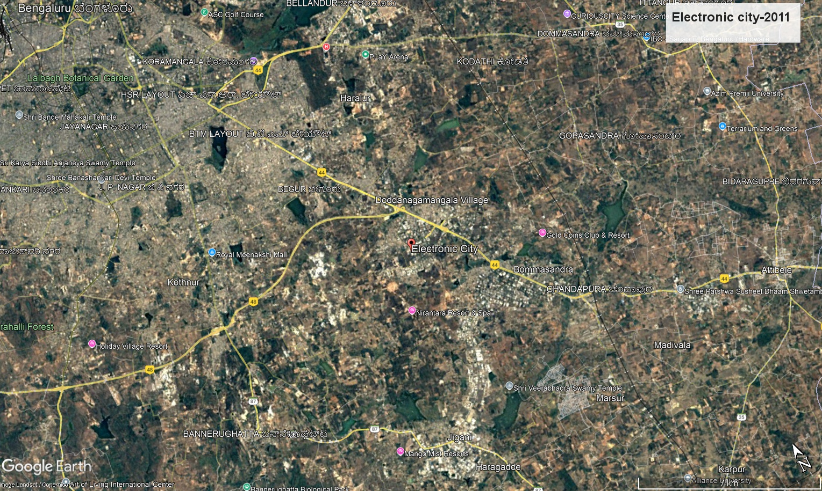

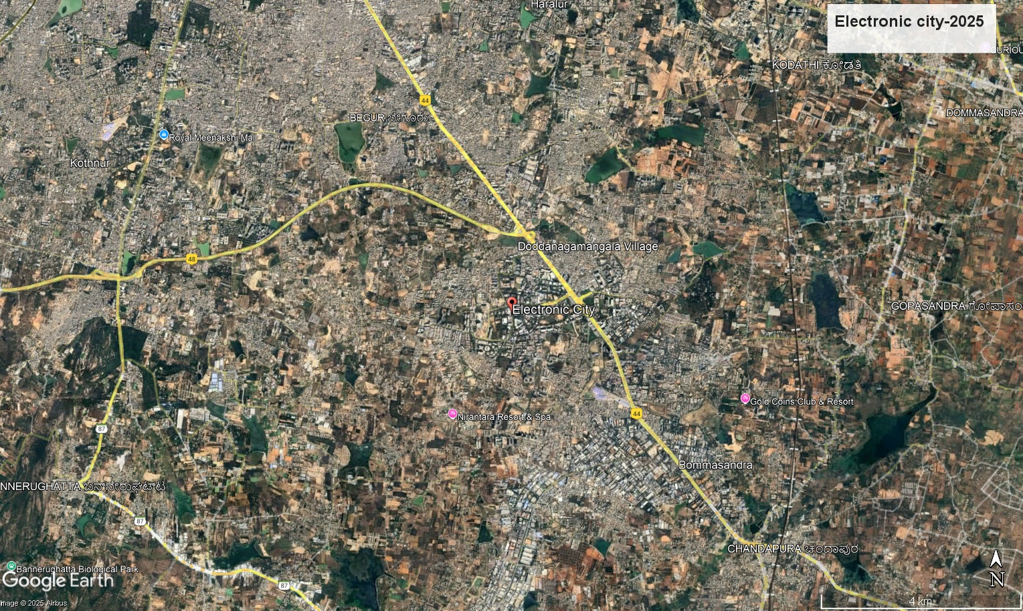

**Interpretation:**

* The 2025 image shows a significant increase in built-up areas in Electronic city, with previously open or sparsely populated regions now covered by residential and commercial structures.
* The rents in Electronic City has experienced a significant 29% year-on-year growth. This increase is due to the influx of IT professionals which lead to enhanced infrastructure.
* ​In October 2024, due to heavy rainfall, in the Electronic City area, roads were submerged, making it hard for commuters to navigate.

**(iv) Visualization of Yelahanka**

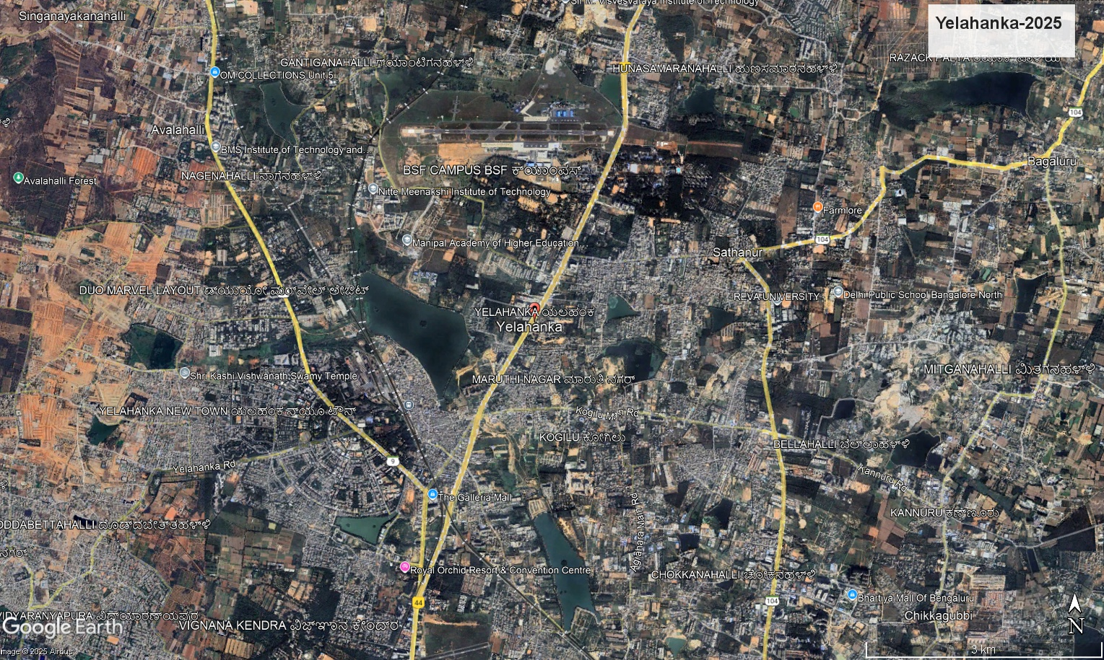

* Yelahanka is a part of the city which has multiple lakes surrounding it.
* Encroachment and poor maintenance of these water bodies have contributed to urban flooding in the area.
* For ex: Puttenahalli Lake was encroached and poorly maintained. This lead to its reduced water retention contributing to floods in the area during heavy rainy rainfalls.

### **4.3. Qualitative Content Analysis**

1. A study by the Energy and Wetland Research Group, Centre for Ecological Sciences, Indian Institute of Science, highlighted that in the 1960s, Bengaluru had around 920 tanks and lakes, which reduced to less than 580 by 1993. The built-up area increased by 466% between 1973 and 2007, leading to a decline in the number of lakes from 159 to 93.

*\*source - B.Pac.in*

1. The India Meteorological Department (IMD) provides data on the total number of flood events during this period, indicating that Bengaluru Urban and Rural districts were among the most affected regions.The number of flooding events in various districts of Karnataka between 1969 and 2019, with Bengaluru Urban experiencing 73 events and Bengaluru Rural 71 events.

**Districts with most flooding events from 1969 - 2019**

| Bengaluru Urban | 73 |
| --- | --- |
| Bengaluru Rural | 71 |
| Dakshina Kannada | 47 |
| Uttara Kannada | 40 |
| Ballari and Raichur | 36 |

*\*source - imd.pune.gov.in*

1. A committee report from August 2015, referenced in a National Green Tribunal (NGT) judgment, highlighted that 3 acres and 10 guntas of Bellandur Lake were encroached upon by project proponents who had not obtained the mandatory clearance from the Sensitive Zone Committee constituted by the Government of Karnataka.

*\*source - bbmp*

1. The BBMP's Budget Estimates for the year 2021-22 allocated ₹119.82 lakhs for "Encroachment Clearance Expenses (Demolition Charges)." This allocation underscores the BBMP's efforts to address encroachments affecting the city's drainage and lake systems.

*\*source - bbmp*

**4.4 Analysis of Google-form responses**

Google form survey was conducted as a source of primary data collection. It was conducted to gain insights into the opinions of the general public regarding the Bangalore urbanization and flooding.

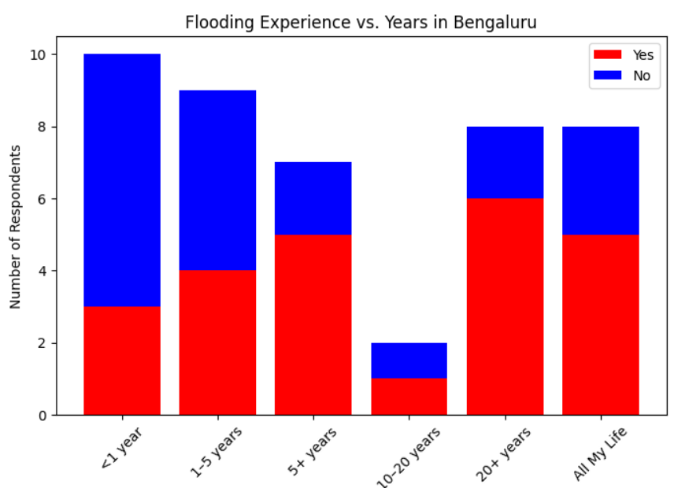

**Interpretation:**

* Several respondents, especially long-term residents, reported experiencing floods in their localities.
* Many agreed the flooding was due to poor **drainage systems, drain blockages, and poor urban planning**.
* Some respondents suggested **removing artificial barriers and improving drainage infrastructure** as potential solutions.

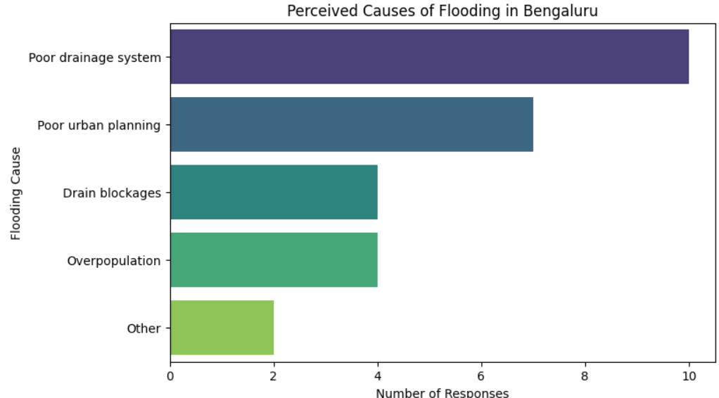

**Interpretation:**

The survey responses show that poor drainage systems and poor urban planning are the most frequently reported causes of flooding in Bengaluru. These two factors together account for 68% of the responses, highlighting systemic infrastructure failures as the primary reasons for urban flooding.

This clearly shows that the general public believe that flooding is a cause of man made problems. Poor urban planning, drainage system, drain blockages and overpopulation being stated as the main causes of flooding.

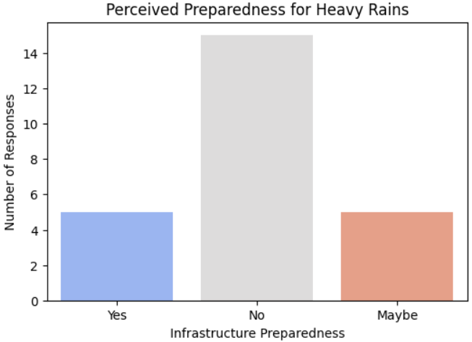

**Interpretation:**

* Majority of the respondents (68%) feels the Banglore’s infrastructure is heavily underprepared for heavy rains.
* The data shows that the population is under confident in the city’s governance to manage flooding.
* This highlights the importance of stricter governance for city’s governance, proper drainage system and faster flood response systems.

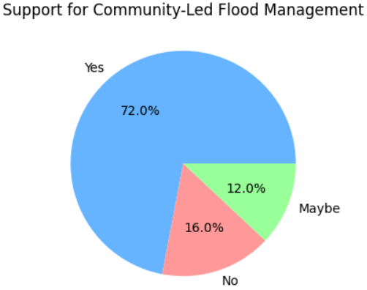

**Interpretation:**

* 72% of the respondents are willing to support community-backed **flood management efforts**, such as rainwater harvesting, better waste disposal, and green infrastructure.
* 12% of the respondents also showed lack of awareness and hesitation towards these initiatives.
* This suggests that the public has a positive attitude towards supporting the government in flood management initiatives.

**5. Findings and Recommendations**

1. **Impact of Rapid Urbanization on Drainage Systems and Water Bodies**

* Bengaluru has lost 90% of its lakes to encroachments, significantly lowering its natural drainage capacity.
* Built-up land rose from 7.97% in 1973 to 86.6% in 2023, with vegetation falling from 68.2% to 2.9%.
* Stormwater drainage (rajakaluves) is clogged, encroached upon, or inadequate to cope with current rainfall intensities.

1. **Key Factors Contributing to Urban Flooding**

* Lack of proper drainage facilities and improper city planning were cited most in questionnaire responses.
* Blockage of drains by trash and construction waste increases flooding.
* Overpopulation puts pressure on drainage systems and adds impenetrable surfaces, resulting in water buildup.

1. **Infrastructure Planning, Encroachments, and Land-Use Changes**

* More than 90% of lakes in Bengaluru have decreased in size or disappeared due to illegal constructions, breaking natural water flow.
* Illegal real estate expansion has converted floodplains into commercial and residential spaces, which leads to frequent waterlogging in areas like Whitefield, Electronic City, and Koramangala.
* The BBMP allocated ₹119.82 lakhs in 2021-22 for encroachment clearance, but illegal developments continue.

1. **Bengaluru’s Flood Preparedness Perception**

* 60% of survey respondents believe the city is underprepared for heavy rains, which shows their loss of confidence in the government.
* Only 20% believe that existing infrastructure can handle rainfall effectively.
* Rainfall trends show an increase from 590 mm in 1994 to 1960 mm in 2022, despite this the city’s flood management has not been upgraded.

1. **Community Willingness for Flood Management**

* 72% of respondents support community-led flood prevention efforts like rainwater harvesting and green infrastructure.
* There we part of responses which hesitated the initiatives highlighting distrust in the government in supporting these initiatives.
* Public sentiment supports collaborative flood management involving both citizens and policymakers.

**RECOMMENDATIONS**

### **1. Strengthening Drainage and Water Management Systems**

* Upgrade and modernize stormwater drains to accommodate high rainfall and prevent waterlogging.
* Implement strict and mandatory rainwater harvesting in all buildings to reduce runoff and recharge groundwater.
* Regular and proper maintenance of rajakaluves to prevent blockages and illegal modifications.

**2.** **Urban Planning and Encroachment Control**

* Ensure strict zoning laws to prevent construction in low-lying flood-prone areas.
* Identify and take back encroached lakes, which helps in natural water flow restoration.
* Implement Flood Zoning and Planning to restrict infrastructure development in high-risk areas.

3. **Policy Interventions and Governance Reforms**

* Strong BBMP enforcement capacity and policies to ensure timely removal of illegal constructions.
* The government must form tie-ups with private organizations and NGOs that can help in creating awareness about flood management.
* Increase flood emergency response teams for better preparedness.

4. **Technology integrated Infrastructure Development**

* Apply new concepts like sponge city by increasing permeable surfaces through green rooftops, urban forests, and bioswales.
* Use GIS-based flood modeling to identify vulnerable zones and improve drainage planning.
* Promote eco-friendly infrastructure that balances urbanization with sustainability.

5. **Community Involvement and Awareness**

* Support community-driven flood control programs such as rainwater harvesting and waste management.
* Conduct awareness campaigns on flood risks and response strategies.
* Encourage fearless whistle blowing of illegal encroachments and and development activities.

**6. Conclusion and Bibliography**

The above discussions reveal that the immediate cause of devastating floods in Bengaluru (and in other urban areas was an extreme point rainfall event. The frequency of such events is increasing due to global warming and climate change. However, while the floods may have been triggered by high-intensity rainfall, the underlying cause is poor urban planning and a total lack of preparedness for urban flood disasters. Urban areas are planned and developed without due consideration for the various components of the hydrological cycle and water infrastructure. Impermeability of surfaces and obstruction of water flow in urban areas increases peak flows in cities to up to 7 times that of rural areas (Tucci, 2006). In the pre-urbanised scenario, 40% of precipitation reenters the atmosphere through evapotranspiration, 50% infiltrates into the soil and runoff accounts for a mere 10%. Post-urbanisation, evapotranspiration returns only 25% of the precipitation to the atmosphere. Another 30% infiltrates into the soil while the remaining 45% becomes part of rainwater drainage.

**References**

1. Anshu and S.Fazal D Firdausi (2019) Urban Resilience and Flash Floods: A Case Study of Chennai Metropolitan City, pp.138-151 in Making Cities Resilient, Springer, Nature, Switzerland AG 2019

2. Comptroller and Auditor General of India (2021) Government of Karnataka Report No. 2 of the year 2021-

Performance Audit of Management of Storm Water in Bengaluru Urban area.

3. Jha, R. (2022) The Bengaluru floods: The rising challenge of urban floods in India. https:/ /www.orfonline.org/

expert-speak/the-bengaluru-floods/

4. Khaladkar, R.M., Mahajan, P.N., and Kulkarni, J.R. (2009) Alarming Rise in the Number and Intensity of Extreme Point Rainfall Events over the Indian Region under Climate Change Scenario. Contribution from IITM Research

Report No. RR- 123.

5. Know about Bengaluru-Open Source India, https://www.opensourceindia.in/about-bengaluru/

6. NDMA, Urban Floods. Ndma.gov.in

7. Ochoa-Rodriguez, S., Smith, K.M., Aivazoglou, M., Pina, R. and Mijic, A. (2022) Urban pluvial flooding and climate change: London(UK), Rafina (Greece) and Coimbra (Portugal) https://www.imperial.ac.uk/grantham/research/ resources-and-pollution/water-security-and-flood-risk/urban-flooding/

8. Ramachandra, T.V. and Majumdar, P.P. (2009) Urban Floods: Case Study of Bangalore, in Journal of the National Institute of Disaster Management, Vol. 3 No. 2, April 2009, pp 1-98.

9. Ramachandra, T.V., Vinay S, Bharath, H. Aithal, (2016) Frequent Floods in Bangalore: Causes and Remedial Measures. ENVIS Technical Report: 123

10. Ramesh, S. (2022), How rain, poor drainage, worse infra- how Bengaluru was hit by a perfect storm and drowned

11.https://theprint.in/environment/heavy-rain-poor-drainage-worse-infra-how-bengaluru-was-hit-by-a-perfect-

storm-and-drowned/1121884/

12. Raven, P.H., Hassenzahl, D.M. and Berg, L.R. (2013) Environment. John Wiley and Sons, Inc.

13. Sanganal, A. (2020) Urban Flood Management- A Case Study of Bangalore. Report Submitted to Administrative Training Institute, Mysuru, 2020.