**ResumeAI :ATS Compatible Resume Builder**

|  |  |
| --- | --- |
|  | **Aishwarya Bansod1, Ketan Bhange2, Nisha Shewale3, Sakshi Yerme4**  1-4(B.E, Dept. Of Computer Engineering, Parvatibai Genba Moze College Of Engineering, Wagholi, India) |

**Abstract—In today’s competitive job market, an optimized resume for an Applicant Tracking System (ATS) is the way to increase one’s chances of getting interviews. An AI resume builder helps candidates build ATS-friendly resumes by using proper formatting, keyword optimization, and customization of resumes according to the job descriptions. These tools streamline the process of resume building by providing real-time feedback, making it more readable, and making the key skills and achievements stand out. AI resume builders save much time by customizing one’s resume to both ATS and human recruiters, thereby enhancing visibility and increasing the chances of success in a job search.**

**Index Terms—ATS (Applicant Tracking System), AI resume builder, Career advancement, Job market competitiveness, Resume optimization, Job search automation**

# **INTRODUCTION**

BEING noticed in today’s job market means more than having an attractive resume. Most companies nowadays use Applicant Tracking Systems (ATS) to sift through resumes before sending them on to hiring managers. Thus, your resume has to be ATS-friendly. Among these tools are AI-powered resume builders that have become the game-changer for job applicants. These tools will not only make sure your resume is formatted properly but also keyword-optimize it, make it more readable, and even job-description-specific. In this guide, we’ll look at how an AI resume builder can help you streamline your job search, increase your chances of landing an interview, and finally secure your next career opportunity.

This experiment is very important because it will help the job seeker know how his or her resume works with the ATS, which most employers use in hiring to reduce the time involved in hiring. With an optimized resume for ATS, a job seeker has a good chance of getting noticed by hiring managers and getting past the filter that automatically removes some resumes. This experiment also shows the importance of AI-powered resume builders in streamlining the resume optimization process, ensuring that resumes are not only

formatted correctly but also tailored with the right keywords and structure.

Ultimately, it provides insights into how small changes in resume preparation can significantly impact job search success in a tech-driven recruitment environment.

To really understand and benefit from optimizing your resume with an AI-powered builder and ATS, some foundational concepts are helpful:

* Basic knowledge of resume writing: Understanding what makes a structure and the essential sections to include in it would be- contact information, experience, education, skills, etc. You should be familiar with what employers typically look for and how resumes are formatted.
* Familiarity with ATS: This is essential knowledge of how applicant tracking systems work. Applicant tracking systems scan resumes for keywords and structures to see if the applicant is a good fit for the job. You know that helps you optimize your resume accordingly.
* Being able to read and interpret job descriptions effectively is important. It allows you to tailor your resume to match the skills, qualifications, and keywords required by the employer.
* Tech Literacy: A basic understanding of AI tools and how they function can help in using AI-powered resume builders effectively. You don’t need to be a tech expert, but comfort with using online tools and software is beneficial.
* Industry-specific knowledge about the specific requirements and trends in an industry will give you a more focused approach towards tailoring the resume to be on par with the expectations of both the ATS and hiring managers from that field.

This background would allow you to fully leverage the AI tools toward optimizing your resume and improving chances of success during the job search process.

The technology behind the AI-powered resume builders and applicant tracking systems (ATS) generally includes a combination of the following:

1.Natural Language Processing (NLP) is one of the key technologies behind AI resume builders, which means it analyses and understands human language to help the system assess the content of your resume and identify relevant keywords and ensure clarity and conciseness in the language. NLP also allows AI to match a resume with the job description; it suggests how to improve the resume and optimizes the resume with proper terminology.

2.Artificial Intelligence (AI) is the backbone of the resume building process, as it helps automate tasks such as keyword analysis, content optimization, and resume formatting. AI algorithms assess how well your resume aligns with job descriptions and make adjustments to improve your chances of passing through ATS filters. Some advanced AI systems can even assess the tone, style, and overall appeal of your resume.

3.Applicant Tracking Systems (ATS) technology itself is a crucial part of the process, since it is supposed to filter resumes based on specific keywords, skills, and qualifications. Modern ATS systems use AI and machine learning to score and rank resumes, making it important for applicants to optimize their resumes accordingly.

4.Data Analytics measure the ability of a resume to performing correlation with user behaviour and industry trends, along with job market demands. This helps refine AI suggestions so the recommendations they give you are fine-tuned to fit with the needs of employers.

It means that these technologies come together and create one powerful tool that can be of great assistance to job seekers by helping them to craft an ATS-optimized resume with a higher probability of standing up in the competitive job market.

Thus, leveraging these highly advanced technologies in AI-powered resume builders helps create resumes that would be visually impressive while also perfectly optimized for scanning by ATS. In the process, this streamlines the production of your resumes and increases chances of getting spotted by recruiters in interviews. Today, it stands as an absolutely crucial tool when looking for employment in a sea of technology-facilitated job hunting.

# **METHODOLOGY**

This would be how the Data Flow for your ATS-Friendly AI Resume Builder works:

* The user will input personal details and upload a Job

Description.

* The AI Engine will parse through the user’s resume and the job description and retrieve relevant keywords for the optimization of the resume on ATS.
* The system offers real-time suggestions on the improvement of the resume by adding missing keywords or rephrasing the content.
* The user will either accept or modify these suggestions.
* The final, optimized resume is generated and exported in ATS-compatible format PDF/DOCX.
* Feedback is received at each stage to ensure that the resume matches the ATS requirement.

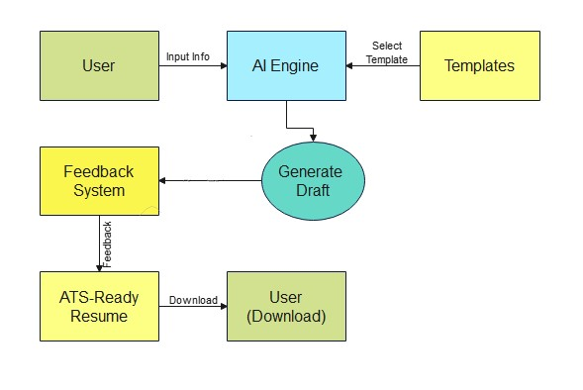

Fig. 1. Dataflow Diagram ATS Friendly AI Resume Builder

Data streams between the user, AI engine, templates, and feedback system are concluded with the downloadable ATS ready resume.

*A. System Architecture*

The architecture comprises multiple interdependent parts that oversee the different processes of resume generation and optimization:

* User Interface (Frontend): This is the interface that allows users to interact with the system. This enables users to input data, interact with the backend, and view results. It communicates with the Backend Server through an API.
* Backend Server (API):The backend talks to all the components, including the User Interface, and to the ATS Optimization Engine, processing user input, asking the database, and retrieving information for the ATS Optimization Engine to optimize.
* ATS Optimization Engine (AI Engine): This component employs AI technology to optimize the resume for use by ATS. This is to enhance the possibilities of a resume

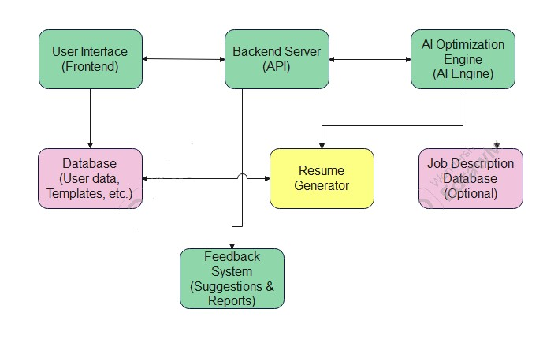

Fig. 2. System architecture of ATS friendly AI resume builder

being selected by an ATS by adjusting keywords and formatting according to job descriptions.

* Database (User Data, Templates, etc.):This is a database for all user information, like templates, preferences, and more data to be used in generating resumes. This would serve as a main repository of information for the system’s data.
* Resume Generator: This system generates resumes according to the input data and data accessible in the database. It fetches data from the Backend Server and provides a final resume.
* Job Description Database (Optional):This optional component contains a database of job descriptions. In this case, the ATS Optimization Engine can build on further refining the resume even to the details provided in the job posting.
* Feedback System (Suggestions and Reports):After generating the resume, the system can provide feedback to the user, offering suggestions for improvement or giving reports about how the resume is likely to perform in an ATS.

# **MODELING AND ANALYSIS**

In this experiment, we will experiment to see the capability of resume builders powered with AI in improving resumes for successful upload to an ATS. These materials and methods are used for testing the strength of the technology. Materials:

* AI Resume Builder Tool: The first major tool for the experiment will be an AI-powered resume builder. Resume, Zety, Rezi, and Job scan are a few of the tools offering ATS-friendly features in creating a resume.
* Mock Resumes: There will be prepared a few sets of mock resumes from various industries (marketing, engineering, healthcare, etc.) for the experiment, which would assess the versatility and efficiency of the AI system for a particular domain or field.
* Job Descriptions: A sample selection of actual job descriptions from websites like LinkedIn, Indeed, and Glassdoor will be used. The AI will identify relevant keywords, skills, and qualifications to include in the resumes based on this analysis.
* ATS Simulation Software: In particular, tools such as Jobscan or any other ATS simulation software will be employed to test how the AI generated resumes perform on being screened by recruiters via an ATS. Such tools give feed-back on keyword matches, format, and even an overall level of ATS compatibility.

Methods:

This chapter provides the steps and procedures followed in order to evaluate the efficiency of AI-powered resume builders in optimizing resumes for ATS.

* Pre-Optimization Resume Preparation
  + Objective: Produce a base resume to be tested before optimization. – Procedure:

∗ A sample resume is produced using general information; which may include, but is not limited to: contact details, job experiences, education, skills, etc.

∗ The resume will result without considering any particular keywords or job description to set up an unoptimized version.

* + Tools Applied: Word processor or any normal resume building software.
* Job Description Analysis and Keyword Extraction
  + Objective: To extract appropriate keywords from a job description that may be used in resume optimization.
  + Procedure:

∗ Pick job descriptions for different industries such as marketing, engineering, and finance

∗ Analyze the job description for important keywords to include skills and qualifications required for the job and experience, plus industry-specific language.

∗ Use AI-enhanced tools to support keyword extraction and priority identification.

* + Tools Used: AI resume builder or online keyword extraction tools (e.g., Jobscan, Resumake).
* AI Resume Optimization
  + Goal: Optimization of the sample resume based on the given keywords and requirements for the ATS. – Process:

∗ Input the sample resume in an AI resume builder.

∗ Use the functionality of the tool to automatically include relevant keywords from the job description into the resume.

∗ The AI will also make suggestions to format and heading styles, verbs used for actions, and writing style, to the best practices in ATS.

* + Tools: AI-powered resume builder like Zety, Rezi, or Resume.
* ATS Simulation Testing
  + Goal: Testing whether the optimized resume scans as good as possible to an ATS. – How To:

∗ Both original, unoptimized resume and the AI optimized resume upload in the ATS simulation tool (like Jobscan or Resume spike).

∗ Rate the resumes based on their compatibility to pass through an ATS, keyword density, layout, and resume structure.

∗ Compare a report for the performance of the optimized resume compared to its baseline version

* + Tools: Use tools simulating ATS (Jobscan, Resume spike).
* Readability of the Resume
* Ensure that the resume optimized by the AI is friendly not only for the ATS but also to a human recruiter – Process:

∗ Determine readability using the Flesch-Kincaid Reading Ease formula or with the help of readability tools.

∗ Study the modifications that the AI makes to the word choice, sentence, and line format in order to make the resume clearer.

* Tools Used: Readability analysis tools, for example,

Hemingway Editor, Flesch-Kincaid Readability Test

* Testing in the Real World
  + Goal: To determine the performance of the optimized resume when put into practice with real applications for jobs. – Method:

∗ Submit the AI-optimized resume to real job postings through ATS-driven platforms (e.g., LinkedIn, Indeed).

∗ Track how many responses, interviews, or call backs are received after submitting the resume.

∗ Compare the response rate of the optimized resume to previous applications submitted with the unoptimized version.

* + Tools Used: Job application platforms (e.g., LinkedIn, Indeed, Glassdoor).
* Data Analysis and Comparison
  + Objective: Analyze the data obtained from ATS simulation tools and real-world testing to determine the effectiveness of AI optimization. – Procedure:

∗ Compare the ATS compatibility and keyword matching score of the original resume versus the optimized resume.

∗ Compare the readability scores of both versions and assess their ease of reading.

∗ Track the success rate of interviews or callbacks for both versions and calculate the percentage improvement.

* + Metrics: Keyword Match Score, Formatting Score, Readability Score, Success Rate

(Interviews/Call backs).

* Optimization Impact Analysis
  + Objective: To measure whether AI optimization increases the percentage of resumes successful. – Procedure:

∗ Determine the Optimization Score using keyword matching, readability, and formatting.

∗ Measure if AI-based optimization enhances the likelihood of a resume passing ATS and being read by recruiters.

* + Tools: ATS simulation software, resume optimization score offered by AI resume builders

Fig. 2. System architecture of ATS friendly AI resume builder

# **RESULTS AND DISCUSSION**

A. Comparison

ATS-Friendly AI Resume Builder optimizes resumes for compatibility with the ATS, with features like ATS testing, keyword suggestions, and real-time feedback to ensure resumes pass the filters of the ATS and match job descriptions. It’s ideal for job seekers targeting large companies or ATS heavy applications. Zety is more of a general resume builder with customizable templates and easy-to-use features. It offers design flexibility and some guidance but does not focus on ATS optimization as much. Best for the user who wants a professionally developed resume quickly, but not necessarily needing the specific ATS focus.

From this comparison we can conclude that, if your goal is optimization for ATS, then the AI Resume Builder would be a better choice. But if you want to have a flexible and visually appealing resume, Zety is your best bet.

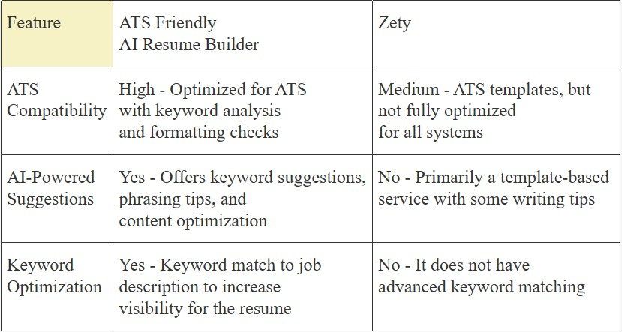

Fig. 3. Comparison between ATS Friendly AI Resume Builder and Zety

This experimental study tested how effective AI Resume builders are in optimizing resumes for ATS. The objective was to find out whether AI would enhance keyword match, readability, and make it more ATS-friendly, and thus increase the change of getting invited for an interview. The experiment showed that AI can significantly enhance resumes by making them more ATS-friendly, readable, and engaging to recruiters. The AI-powered tool was effective in increasing job application success, though real-world results varied depending on job market factors. Future work could involve expanding the experiment to different industries, testing the long-term effectiveness of optimized resumes, and customizing the AI tool for specific job roles to improve precision further. In conclusion, the experiment proved that AI-driven resume optimization can increase a candidate’s chances of being noticed by ATS and recruiters, but more refinement and testing are needed for even better results.

1. **CONCLUSION**

In this research work, we have discussed the development and functionality of JobFit: ATS Optimized AI Resume Builder, a system aimed at assisting job seekers in generating resumes optimized for Applicant Tracking Systems (ATS). The primary aim of this system was to fill the loophole between ATS filtering mechanisms and the candidate’s requirement for standing out in the competitive job market. With the incorporation of artificial intelligence (AI), JobFit provides highly customized resume building suggestions that enhance ATS compatibility while also making applications more effective. The results from this research confirm a number of significant benefits when utilizing JobFit:

• Enhanced ATS Compatibility: Utilizing AI algorithms, the system scans for job descriptions and suggests precise keywords and formatting revisions that improve a resume’s ability to pass an ATS filter.

• Personalized Advice: JobFit is more than mere key-word recommendations, offering personalized guidance depending on the candidate’s career level, desired role, and industry, making the resume contextually appropriate and industry-specific.

• Improved User Experience: With intuitive features, the platform walks candidates through a step-by-step process to maximize their resumes, eliminating ambiguity and giving them clarity on how to increase their prospects in the ATS screening process.

• Efficient Use of Time for Job Seekers: Since it automates resume optimization, JobFit minimizes the candidates’ time needed, enabling them to concentrate on application quality rather than being trapped by formatting limitations or keyword comparison. Therefore, JobFit is a serious step forward when it comes to optimizing job applications. Through the use of AI and comprehension of ATS nuances, this application not only enhances a candidate’s job prospects but also makes it more even for job applicants of any experience level or field. Subsequent versions of the system may emphasize improving the AI model to address changing ATS algorithms and more personalization based on specific tastes and career aspirations.

# **ACKNOWLEDGMENT**

I would like to extend my heartfelt appreciation to all who supported and contributed to this experiment.

First, I would like to thank the developers and teams behind the AI-powered resume builders used in this study, whose innovative tools enabled this research. Special thanks to the creators of Jobscan, Rezi, and Resumake for providing the resources necessary to evaluate ATS compatibility and resume optimization. I also extend my appreciation to the researchers and experts whose previous work on Applicant Tracking Systems, natural language processing, and AI optimization has guided and inspired this study.

Lastly, I would like to acknowledge the participants who allowed their resumes to be tested in the ATS simulations and real-world application scenarios. Their contributions were essential in providing valuable insights for this research. Thanks to all for making this project possible.

# **6. REFERENCE**

1. Dubey, A., Sharma, P., and Verma, K. (2024). A review on AI resume assistant using ML algorithms. International Journal of Creative Research Thoughts (IJCRT), 12(4), 646–654.
2. Gupta, R., and Patel, S. (2024). ResumeFlow: An LLMfacilitated pipeline for personalized resume generation and refinement. ArXiv, 2402.06221, 1–15.
3. Kumar, A., Singh, M., and Yadav, R. (2023). AI resume analyzer for automated screening. International Journal of Creative Research Thoughts (IJCRT), 11(12), 507–515.
4. Nandhini, M., Priya, R., and Ramesh, S. (2021). Automated resume screening using NLP. Journal of Emerging Technologies and Innovative Research (JETIR), 8(3), 510–520.
5. Flesch, R. (1948). A new readability yardstick. Journal of Applied Psychology, 32(3), 221–233.

https://doi.org/10.1037/h0057532

1. Hemingway Editor. (2023). Readability and writing style improvement tool.
2. Jobscan. (2023). How applicant tracking systems work: A complete guide for job seekers.
3. Manning, C. D., and Schutze, H. (1999). Foundations of statistical natural language processing. MIT Press.
4. Rezi. (2023). How AI can improve your resume for ATS.
5. Resumake. (2023). Resume optimization for ATS compatibility. Retrieved from https://www.resumake.io
6. Sullivan, J. L. (2022). ATS resume optimization: The ultimate guide for job seekers. LinkedIn Talent Solutions. Retrieved from https://www.linkedin.com
7. Tucker, L., and Gifford, A. (2021). Artificial intelligence in recruitment: How AI can revolutionize hiring. Journal of Human Resources Technology, 15(4), 45–58.