Investigating the Causes of Home Loan Processing Delays and Their Impact on Borrowers

**Reeth S.1, Nimisa Bhagchandani2, Diya Pinto Moyalan3, Raj Mahesh Mate4, Radhika** **K.5, Pramuk G. J.6**

(Students)

CMS Business School, Jain University, Bangalore, Karnataka (India)

# Abstract

The process of approving a home loan is a pivotal aspect of housing finance but is prone to inefficiencies, delays, and opacity. This research identifies the most significant issues affecting borrowers, such as delayed document verification, bank processing inefficiencies within the organization, and poor communication. These aspects lead to high stress and financial burdens among applicants, influencing their purchase of homes. The study also explores the role of Direct Selling Agents (DSAs) and the possibility of third-party verification services to make the process more efficient. The findings indicate that the use of digital verification systems, enhanced communication, and minimizing dependence on intermediaries can make the process more efficient and provide a borrower-friendlier experience. The research points out the requirement of technology-based solutions and regulatory interventions to enhance transparency and speed up home loan approvals.

**Keywords:** Home loan approval, housing finance, document verification, loan processing delays, borrower stress, financial impact, third-party verification, banking transparency.

# Introduction

Home ownership is a very significant milestone in the life of an individual and a family, and home loans are the economic assistance for it. Obtaining a home loan is a complicated and time-consuming process, as the processing of the loan is delayed, putting the borrower to financial strain and uncertainty. Banks and financial institutions have strict verification procedures like credit checks, legal clearances, and technical checks that contribute to the delay in processing. As much as these controls are necessary to prevent financial losses and ensure cautious lending, they occasionally translate into unplanned delays to the borrowers' dream of becoming homeowners.

Despite contemporary digital banking and computerization, various home loan applicants continue to be subjected to inordinate delays due to inefficient authentication procedures, document requests that remain incomplete, and procedural delays. Such delays translate into monetary terms in the form of increased rental fees, fluctuations in interest rates, or even the denial of a sought-after property. Public sector banks are especially quoted for delayed loan sanctions compared to their private sector counterparts, further frustrating homebuyers. It is important to understand the causes of these delays and how they affect borrowers if the home loan process is to be made more efficient.

This study is intended to examine the main causes of home loan processing delays and their financial and psychological impact on homebuyers. Through a critical examination of the verification and approval processes of banks, the study will consider major bottlenecks and recommend possible solutions to make the process more efficient. Moreover, the study will assess whether the progress in technology and novel verification processes can improve the speed and efficiency of the loan processing process, ultimately both for borrowers and lending institutions.

# Literature Review

**1. Housing Finance in India and Appraisal Process of Home Loans with Specific Reference to Indian Overseas Bank**

This research paper examines the housing finance mechanism in India, specifically the home loan appraisal process in Indian Overseas Bank. It emphasizes the salient steps of loan processing such as eligibility evaluation, document validation, and risk evaluation. The research sees inefficiencies within loan appraisal that are causing the verification of documents to be slowed down and being inconsistent with risks, hence loan disbursal durations are longer than expected. Improved transparency and quicker verification are cited by the research to be responsible for customer satisfaction as well as loan processing reduction.

**2. Examining the Critical Factors Influencing the Housing Loan Borrowers**  
This research examines the determinants that influence home loan borrowers' decision-making process, with a focus on affordability, interest rates, processing duration, and documentation demands. The study points out that slow processing of loans and a lack of transparency are significant concerns for borrowers, especially business individuals and entrepreneurs. The research also shows that customers favor institutions providing faster verification and minimal processing charges. The paper suggests that banks and financial institutions should utilize technology to improve loan processing efficiency and customer experience.

**3. Design of Knowledge Base Model for Home Loan: Case Study of a Bank in India**  
This study develops a knowledge-based system model of home loan processing to automate and streamline document verification and loan approval processes. The research focuses on the application of artificial intelligence and machine learning for enhancing decision accuracy and turnaround time. The model suggests a methodical process for document validation, fraud detection, and credit assessment with the intent to reduce human intervention and make home loan processing more efficient.

**4. Problems Faced by the Customers Regarding the Borrowing of the Loan in State Bank of India – An Analysis**

This study discusses the problems customers experience when seeking home loans from the State Bank of India. Based on the study, it was concluded that the borrowers face problems involving excessive paperwork, poor communication on the part of bank officers, and surprise charges in the terms of loan agreement. Further, it also emphasizes delays in disbursal and approval as major issues for the borrowers. The article posits that enhancing customer education regarding loan processes and digital documentation systems can effectively help solve these problems.

**5. Problems Faced by the Housing Finance Borrowers: A Study Conducted in Punjab**  
This research is concerned with the issues faced by home loan borrowers in Punjab. The study identifies significant hurdles like high processing charges, long approval periods, and strict eligibility standards. The study concludes that borrowers from non-salaried segments face the greatest difficulties owing to irregular income patterns and inflexible documentation norms. It stresses the importance of financial institutions to follow a borrower-friendly approach by providing flexible eligibility standards and quicker verification procedures.

**6. Problems Faced by Borrowers of Home Loan: A Comparative Study with Regards to Public and Private Sector Banks in Nagpur Region**

This comparative analysis assesses the variance in loan processing and customer satisfaction levels between public and private sector banks in the Nagpur region. The study reveals that private banks provide faster loan sanctioning but with higher processing charges, while public sector banks provide lower charges but with more bureaucratic delays. Borrowers complained about the absence of guidance, lengthy documentation, and concealed charges. The study suggests digitization of loan processing, increased transparency, and customer support improvement to enhance the overall borrowing experience.

**7. Customer Satisfaction in Home Loan Services: A Comparative Study of Public and Private Sector Banks in Karnataka**

It is a study of customer satisfaction levels in the home loan segment comparing the services of public and private sector banks of Karnataka. The study brings out the fact that banks are responsible for the housing finance market by offering diversified loan products to satisfy the needs of different customer categories. With increasing competition within the banking sector, both the public and private sector banks will have to aim at providing enhanced customer service, transparency, and competitive interest rates. According to the study, although public sector banks tend to offer lower rates of interest, they have lengthy processing periods resulting from strict verification and documentation procedure. Whereas, private sector banks provide quicker loan sanctioning with a more customer-centric method, but charge higher interest rates and service charges.

**8. A Comparative Study of Home Loan in Public and Private Sector Banks**

This research paper analyzes the procedural variations and the level of customer satisfaction related to home loans provided by public and private banks. The research pinpoints principal challenges borrowers face, including long approval times, documentations, concealed fees, and transparency of loan contracts. The results indicate that public sector banks generally have a more inflexible setup, involving a lot of documentation and longer approval periods, which is discouraging for borrowers in need of speedy financing. Conversely, private banks, while more convenient and faster in processing, tend to have higher interest rates and extra service charges. One of the key findings of the paper is the role of customer-centricity in home loan services. Banks that have better communication, online tracking of applications, and efficient processes tend to have better borrower satisfaction.

**9. Comparative Study of Home Loan Beneficiaries' Satisfaction in Karnataka**

This paper assesses borrowers' levels of satisfaction who have borrowed home loans from public and private sector banks in Karnataka. The research is on the basis of various parameters such as loan sanctioning time, interest rates, repayment flexibility, efficiency of customer service, and ease of borrowing in general. The findings of the study are that although public sector banks offer lower and more stable interest rates, their disbursal process is viewed as slow and bureaucratic. Although private sector banks charge higher interest rates, borrowers prefer them if they value quick disbursal and less paperwork. One of the most important observations of the study is the impact of after-loan services on customer satisfaction. Most borrowers complained of poor communication and delays in services after the loan approval, for instance, in obtaining statements of loans, prepayment processing, and foreclosure processes.

**10. A Comparative Study of Home Loans Offered by Public and Private Sector Banks**

The paper makes a comparative analysis of home loan schemes from public and private banks on the basis of outstanding features including interest rates, processing charges, flexibility in loan tenure, and customer care. The study discovers that borrower preferences determine to a great extent the selection of a home loan lender—those who want low-cost loans with reduced EMIs prefer public sector banks, while those who care about faster sanctions and customized services go for private lenders. The most important implication of this research is the need for transparency in home loan contracts. Most borrowers are in trouble because of concealed fees, ambiguous terms of prepayment penalties, and volatile interest rates in floating loan schemes. The research recommends that regulatory authorities must implement stricter transparency standards to provide equitable lending practices.

**11. Study on Consumer Behavior Towards Housing Loans**

This study explores the determinants of consumer behavior in the Indian housing loan market. The research centers on the most important determinants that compel people to obtain home loans, including interest rates, loan period, processing charges, repayment flexibility, and the reputation of financial institutions. It also investigates the economic and psychological factors that affect decision-making. The research concludes that borrowers value low interest rates and speedy processing, and customer service is essential for loan retention. The article emphasizes that a majority of consumers are moving from the conventional banks to NBFCs because of softer documentation procedures and faster disbursals. Still, the steep interest rates of NBFCs are an area of concern.

**12. Formal Housing Finance System in Digital India: The Inclusiveness Imperative**

The study analyzes the effect of digitization on India's housing finance system, examining how digital platforms are strengthening financial inclusion. The research examines the manner in which banks and NBFCs have embraced online channels to make loan applications easier, less paperwork-intensive, and quicker approvals. The role of the Pradhan Mantri Awas Yojana (PMAY) and digital initiatives by the government in bringing home loans within the reach of lower-income groups is also noted. Nevertheless, the paper also identifies challenges such as cyber security threats, absence of digital literacy among rural borrowers, and issues regarding data privacy. It indicates that even though digitalization has made the process more efficient, there remains a disconnect when it comes to accessibility for marginal groups of society that are having trouble embracing online processes.

**13. The Impact of Regulation on Mortgage Risk: Evidence from India**

This article examines how regulation policies affect mortgage risks in India. The research employs data on more than 1.2 million loans disbursed by a top mortgage financier. It reviews the efficacy of Reserve Bank of India (RBI) rules on financial stability and non-performing assets (NPAs) reduction. It concludes that stringent lending regulations result in reduced default rates but also limit loan access for first-time homebuyers and lower-income borrowers. The paper explains how banks and NBFCs term their loans using models based on credit scores, stability of income, and past loan record. It also juxtaposes India's regulatory environment against other international mortgage markets and discovers that Indian lenders are more conservative in disbursing loans.

**14. Challenges of a Sustainable Housing Finance System in India**

This study examines the structural challenges of the housing finance system in India with an emphasis on sustainability and long-term affordability. The research recognizes major challenges, such as the predominance of urban centers in the availability of housing finance, the unavailability of affordable housing loan products, and the reliance on collateral-based lending. It contends that the Indian housing finance market ignores low-income and rural borrowers, who are frequently disadvantaged by documentation demands and a lack of financial record. The study also analyzes the contribution of government-sponsored financial institutions such as the National Housing Bank (NHB) and their initiatives towards the development of affordable housing finance. The paper indicates that in order for housing finance to be sustainable, banks and NBFCs need to adopt new-age lending models, including microfinance for housing, reduced interest rates for green buildings, and AI-based credit evaluation to facilitate more financial inclusion.

**15. Non-Banking Financial Institutions: Growth and Stability**

This paper analyzes the growth path of Non-Banking Financial Companies (NBFCs) in India, with a specific emphasis on housing finance companies (HFCs). It points out that NBFCs have increasingly grown to play a greater role in housing finance because of their more adaptable loan products, quicker approvals, and reach to self-employed borrowers who are not eligible for loans from traditional banks. The article also examines the financial health of NBFCs and how their profitability, credit quality, and capital adequacy have been changing over the years. The report says that NBFCs are becoming a major force in the Indian mortgage industry but are also coming under the scanner of the regulator for worries over liquidity risk. The study implies that in order to sustain growth, NBFCs will need to reconcile rapid growth with robust risk management structures.

**16. An Analysis of Loan Defaults in Housing Finance Companies**

This paper examines the primary causes of loan defaults in housing finance companies (HFCs). It finds that job loss, rising interest rates, economic downturns, and over-leveraging are the biggest contributors to mortgage defaults. The study highlights that NBFCs and private lenders face higher default rates compared to public sector banks due to more lenient credit policies and riskier borrower profiles. The paper suggests that HFCs should implement stronger risk assessment measures and offer restructuring options for struggling borrowers to mitigate default risks.

**17. Non-Banking Financial Institutions: Growth and Stability**

This report, issued by Reserve Bank of India (RBI), is a comprehensive analysis of the performance of Non-Banking Financial Companies (NBFCs) in 2023-24. It emphasizes strong credit growth of the NBFC segment, at 24.5% of the SCB outstanding credit level as of March 2024. The report further observes recovery in credit quality, profitability, and capital levels, reflecting betterment in balance sheets of the NBFCs. Housing Finance Companies (HFCs) as a regulated NBFC entity experienced double-digit credit growth amid structural developments such as the banking consolidation of one of the principal HFCs. The regulatory environment, that is, Scale-Based Regulation (SBR) initiative of RBI, classifying NBFCs into various tiers on the parameters of size, activity, and risk perception with a view to ensuring proportionate regulation, finds mention in the report.

**18. Perception of Borrowers Towards Housing Finance: A Case Study of Select District in Housing Finance Institution**

This research investigates the perception and level of satisfaction of the borrowers towards housing finance institutions in India, with reference to two districts of Telangana: Karimnagar and Medak. The study, involving a convenience sampling technique, interviews both male and female respondents between the ages of 21 and 60 years. The results indicate a general positive attitude among borrowers towards housing loans, with interest rates, loan processing time, quality of customer service, and transparency of loan terms being the most important factors that determine satisfaction. The research also offers demographic analysis, examining how age, gender, and income levels influence borrowers' attitudes towards housing finance institutions.

# Research Objectives

* To understand how delays in home loan processing affect borrowers financially.
* To identify the main challenges borrowers face in the bank-led verification process.
* To examine whether a faster verification process can benefit home loan applicants.

# Research Methodology

## Research Design

## This study employs a descriptive research design to investigate the causes and consequences of home loan processing delays, their financial and psychological impact on borrowers, and potential solutions to improve the efficiency of the verification process. A combination of primary and secondary data is used to ensure a comprehensive analysis of the problem.

## Data Collection Methods

This research relies on both primary and secondary data sources to gain deeper insights into home loan processing delays.

## Primary Data Collection

Primary data will be gathered using a structured questionnaire, which will be administered online to home loan borrowers. The questionnaire is aimed at collecting quantifiable and qualitative information regarding borrowers' experiences of home loan processing delays, their financial effects, stress levels, and attitudes towards third-party verification services. The survey will have multiple-choice questions, Likert-scale ratings, and open-ended responses to elicit varied opinions.

The primary data collection will focus on the following key areas:

* Loan processing time and delays experienced by borrowers
* Financial impact, including interest rate fluctuations and additional costs
* Psychological impact, such as stress levels and reconsideration of home purchase decisions
* Borrower perception of bank-led verification inefficiencies
* Effectiveness of direct selling agents (DSAs) in loan approval
* Willingness to adopt a third-party verification service for faster loan processing

**Sampling Method**

A non-probability convenience sampling technique will be used, as the survey will be circulated online to individuals who have applied for home loans in India. The target group is home loan borrowers who have passed through the loan sanction process in public and private sector banks. Every attempt will be made to have a representative sample, such as borrowers from various income groups and areas.

## Secondary Data Collection

Apart from primary data, the research will also use secondary data from reliable sources like:

* Journal articles and research papers on home loan processing delays, housing finance trends, and borrowers' experiences.
* Financial institutions' and regulatory agencies' reports on loan disbursement effectiveness and issues in the housing finance market.
* Industry reports and news stories addressing inefficiencies in banks' operations and the contribution of third-party verification services.

This secondary data will be used to place the survey findings in context and offer comparative information on best practices and inefficiencies in the home loan approval process.

## Limitations of the Study

Although this study seeks to offer useful insights, some limitations need to be noted:

* The sample size might not be representative of the whole home loan borrower base in Karnataka.
* The research is based on self-reported data, which can create response biases.
* Secondary data analysis is restricted to publicly reported research and reports.

## Ethical Considerations

Participation of all survey respondents will be voluntary, and they will be informed of the research purpose. The survey will guarantee anonymity and confidentiality, and information will be used only for research purposes.

# Questionnaire

We are conducting research on the effect of delays in processing home loans to borrowers. Your feedback will enable us to pinpoint problems in the verification process and discuss possible solutions. This survey will only take a few minutes, and your responses will be kept confidential.

**Objective: To understand how delays in home loan processing affect borrowers financially**

How stressful was the home loan approval process for you? (Scale: 1 = Not stressful, 5 = Extremely stressful)

* ☐ 1
* ☐ 2
* ☐ 3
* ☐ 4
* ☐ 5

Did delays in the loan approval process make you reconsider or change your home-buying decision?

* ☐ Yes, I postponed my purchase
* ☐ Yes, I chose a different property
* ☐ No, I proceeded despite delays

Did you have to pay a higher interest rate or seek alternative financing due to delays?

* Yes
* No

**Objective: To examine whether a faster verification process can benefit home loan applicants**

How long did your home loan approval process take?

* Less than 1 month
* 1-2 months
* 2-3 months
* More than 3 months

On a scale of 1 to 5, how much did the delay in loan approval impact your financial situation? (1 = No impact, 5 = Severe impact)

* 1
* 2
* 3
* 4
* 5

If your loan approval had been faster, how would it have benefited you financially? (Open-ended question)

Your response: _____________________________

A third-party service could guarantee faster loan verification, would you consider using it?

* Strongly Disagree
* Disagree
* Neutral
* Agree
* Strongly Agree

**Objective: To identify the main challenges borrowers face in the bank-led verification process**

What do you think caused the most delay in your loan processing? (Select all that apply)

* Lengthy document verification process
* Internal bank approval delays
* Multiple verification steps across different authorities
* Lack of transparency in processing timelines

On a scale of 1 to 5, how easy was it to submit and verify your loan documents? (1 = Very easy, 5 = Very difficult)

* ☐ 1
* ☐ 2
* ☐ 3
* ☐ 4
* ☐ 5

Did your bank provide clear updates on the status of your home loan approval?

* Yes, I received regular and clear updates
* Somewhat, but the updates were unclear or infrequent
* No, I had to keep following up for information

What challenges did you face in the document verification process? (Open-ended question)

Your response: _____________________________

Did a direct selling agent (DSA) assist you with your loan application?

* Yes
* No

If yes, do you feel their involvement sped up or slowed down the process?

* Sped up
* Slowed down
* No difference

# Data Interpretation

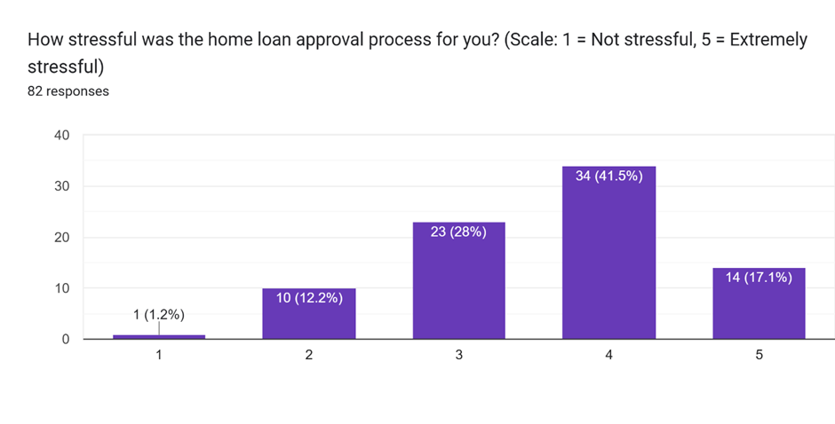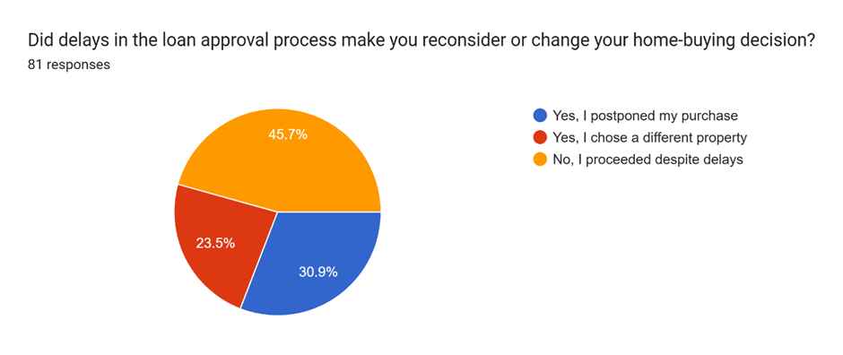

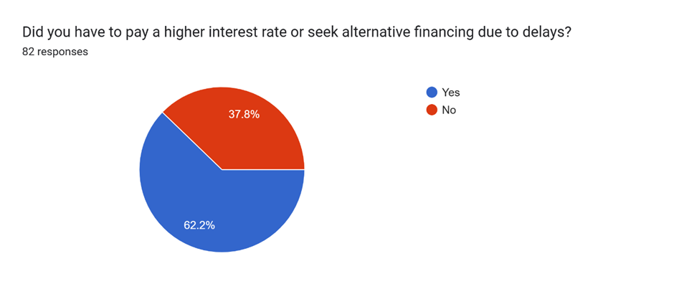

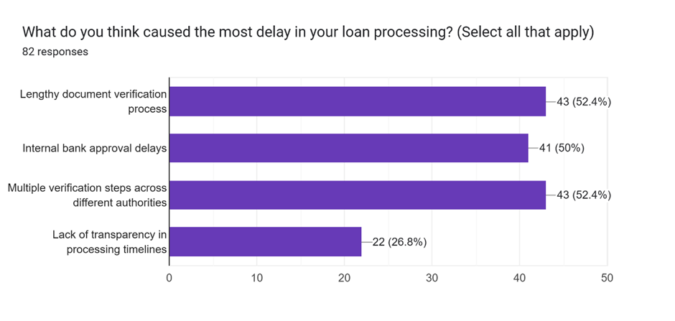

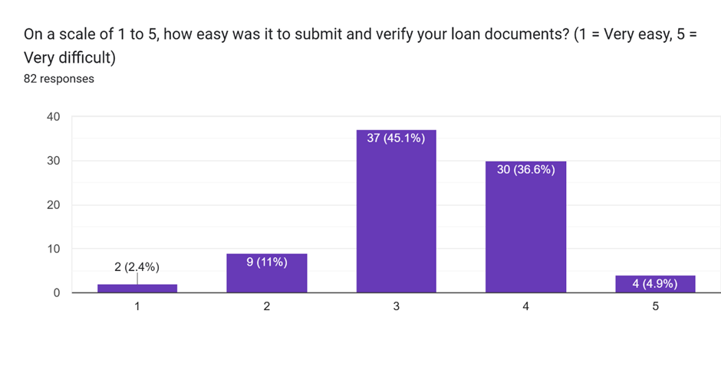

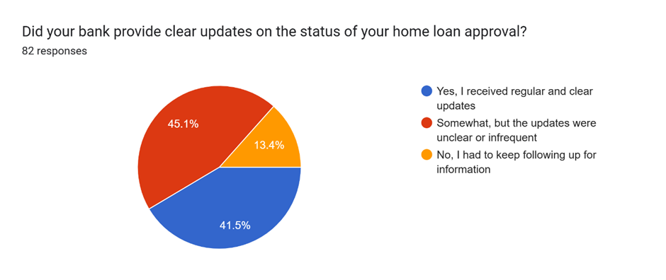

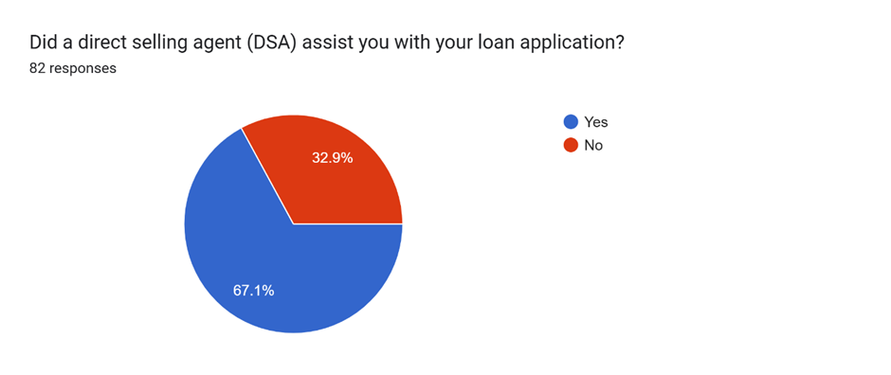

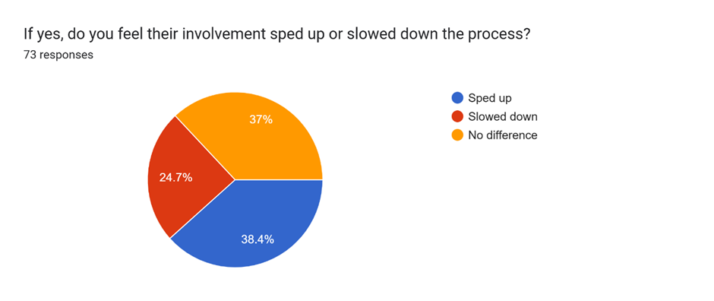

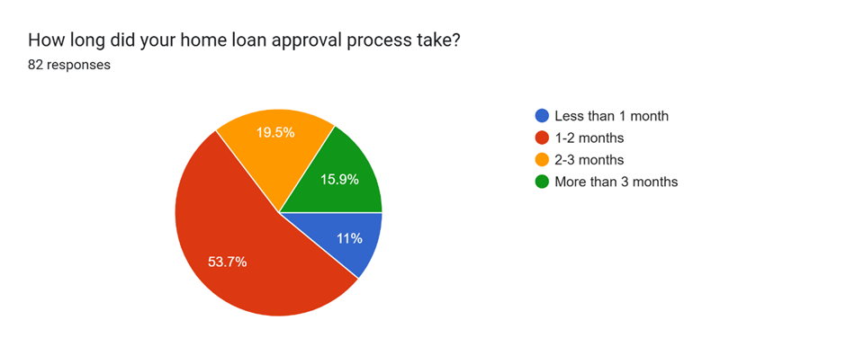

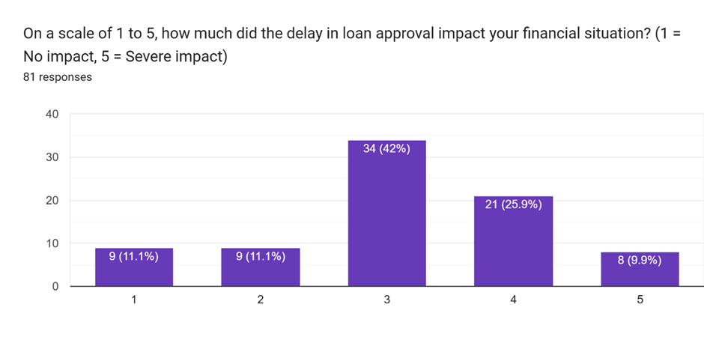

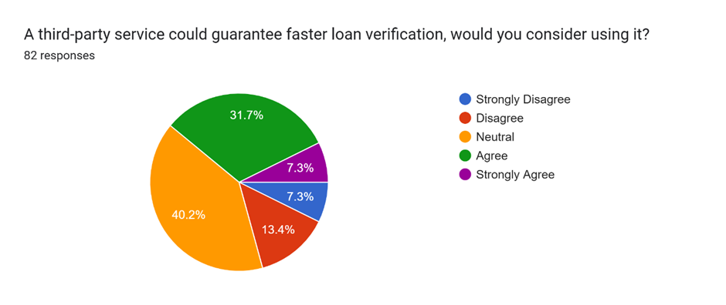

## Interpretation

**Stress Levels in the Home Loan Approval Process**  
A questionnaire of 82 participants quantified the stress levels involved in the process of approving home loans on a scale of 1 to 5 (1: Not Stressful, 5: Extremely Stressful).

* 41.5% (34 respondents) had a stress level of 4, which represents high stress.
* 17.1% (14 respondents) rated their stress level as 5 (extremely stressful).
* 28% (23 respondents) scored their experience as 3 (moderate level of stress).
* 12.2% (10 respondents) rated the process at 2 (minimal stress).
* Just 1.2% (1 respondent) gave it a rating of 1 (not stressful at all). In total, 86.6% of the respondents felt moderate to extreme levels of stress (ratings 3, 4, and 5), indicating a high degree of frustration with the home loan approval process.

**Impact of Loan Approval Delays on Home-Buying Decisions**

* 45.7% proceeded with their purchase despite delays.
* 30.9% postponed their purchase due to delays.
* 23.5% chose a different property altogether.

These results show that although almost half of the participants did not make a change to their home-buying decision, most (54.3%) had to delay or modify their buying plan as a result of delayed loan approval.

**Financial Impact of Loan Delays**

* 62.2% reported having to pay a higher interest rate or seek alternative financing due to loan delays.
* 37.8% suffered no financial strains from delays.

This indicates the majority of buyers experienced greater economic pressure from in-efficiencies with the loan approvals process.

**Causes of Loan Processing Delays**  
The following were the primary reasons for delay in loan processing, according to respondents:

* Lengthy document verification process: 52.4%
* Multiple verification steps across different authorities: 52.4%
* Internal bank approval delays: 50%
* Lack of transparency in processing timelines: 26.8%

These findings suggest that bureaucratic inefficiencies and verification delays are **primary pain points** for applicants.

**Ease of Document Submission & Verification**  
Participants rated the ease of document submission and verification on a scale of 1-5:

* 45.1% rated it a 3 (moderate difficulty).
* 36.6% rated it a 4 (somewhat difficult).
* 4.9% rated it a 5 (very difficult).
* 11% rated it a 2 (somewhat easy).
* 2.4% rated it a 1 (very easy).

The majority found the process to be moderately to highly challenging.

**Clarity of Bank Communication on Loan Status**  
Among respondents:

* 45.1% had to follow up frequently due to unclear updates.
* 41.5% received regular and clear updates.
* 13.4% received inconsistent updates.

This indicates that nearly 60% of applicants faced communication issues with their banks, demonstrating a need for greater transparency.

**Time Taken for Loan Approval**  
Survey results on loan approval duration:

* 53.7% reported 1-2 months.
* 19.5% reported 2-3 months.
* 15.9% reported more than 3 months.
* 11% had their loan approved in under a month.

This confirms that the majority of applicants undergo a lengthy approval process.

**Role of Direct Selling Agents (DSAs) in Loan Applications**

* 67.1% of respondents had assistance from a DSA.
* 32.9% did not use a DSA.

**Impact of DSAs on Loan Processing**  
Among those assisted by a DSA:

* 38.4% believed DSAs expedited the process.
* 37% noticed no difference.
* 24.7% felt DSAs slowed the process.

This suggests that DSAs' impact on efficiency varies among applicants.

**Financial Impact of Loan Delays**  
Participants rated the financial impact of delays:

* 42% rated it as 3 (moderate impact).
* 25.9% rated it as 4 (significant impact).
* 9.9% rated it as 5 (severe impact).
* 22.2% rated it as 1 or 2 (low impact).

Loan delays had a moderate to severe financial effect on a majority of borrowers.

**Preference for Third-Party Loan Verification**  
Respondents’ views on third-party verification services:

* 40.2% were neutral.
* 31.7% agreed, and 7.3% strongly agreed to consider it.
* • 13.4% disagreed, and 7.3% strongly disagreed.

Although most respondents were open to third-party verification, issues around trust can affect adoption.

## Key Takeaways

* Verification processes and internal bank approvals are the primary causes of loan delays.
* Most applicants found document submission and verification moderately to highly difficult.
* Bank communication requires improvement, as many applicants had to follow up frequently for updates.
* The process of home loan approval normally takes 1-2 months, although delays in excess of this are usual.
* DSAs are involved in supporting applications, but their performance is variable.
* Loan delays result in financial strain for most applicants.
* Many homebuyers are open to third-party verification services, though trust remains a concern.

# 

# Findings and Recommendations

## Findings

**1. Loan Processing Delays Bring Significant Stress and Financial Burden**

A clear majority (86.6%) of applicants are stressed to the extreme about being approved. Delaying causes them to incur added financial costs, as 62.2% are compelled to accept higher rates or seek additional sources of funds. Such inefficiency hurts buying a home as 54.3% postponed or switched real property purchase plans due to processing delays.

**2. Ineffective Document Verification and Internal Processing Are Major Bottlenecks**

Slow document verification (52.4%), several verification stages (52.4%), and delayed internal bank approval (50%) are the major causes of long loan processing times. The approval process is generally 1-2 months, but 35.4% of applicants have even longer waits, making home financing a time-consuming and exasperating experience.

**3. Poor Transparency and Communication from Banks**

Almost 60% of applicants have difficulty with inconsistent or vague updates, frequently needing to follow up repeatedly to monitor their loan status. This transparency gap contributes to stress and uncertainty, making it hard for homebuyers to coordinate their purchases.

**4. Inadequate Influence of Direct Selling Agents (DSAs) on Efficiency**

Though 67.1% of applicants availed themselves of the help of DSAs, they are not uniformly effective—38.4% reported finding DSAs to be helpful, yet 24.7% reported that they delayed the process. This indicates that use of DSAs does not necessarily enhance efficiency and may inject unnecessary middlemen into the process.

**5. Willingness for Third-Party Verification but Trust Still an Obstacle**

Although 39% of the respondents showed a willingness to consider third-party document verification services, a significant majority were neutral, and a few were unwilling because of trust issues. This presents an opportunity for third-party verification services, but banks and financial institutions must guarantee credibility and reliability.

## Recommendations

**1. Enhance and Expedite the Document Verification Process**

The home loan sanctioning process is usually delayed because of long document verification processes, numerous manual checks, and the absence of centralized processing. As a third-party verification service, we aim to speed up this process by offering a quicker, more efficient, and standardized verification process for banks and financial institutions. By linking to government databases such as Aadhaar, PAN, and land records, we can enable real-time identity and property ownership verification.

**Action Steps:**

* Create a secure and centralized document upload and verification platform.
* Automate verification through direct API connections with government and financial databases.
* Instill a systematic process of review employing legal and fiscal professionals to check for accuracy.
* Minimize duplicate verification checks by presenting standardized verification reports to banks outright.

**2. Enhance Transparency and Borrower Communication**

Borrowers are often kept in the dark about the progress of their loan application because updates are not available in a timely manner. Through our role as an independent verification service, we can fill in the gap between banks and applicants by offering current tracking of verification. Our platform will enable borrowers to track the status of their document verification, receive reminders, and understand any discrepancies that may occur. This will reduce the necessity of frequent follow-ups with banks and improve overall customer satisfaction.

**Action Steps:**

* Create a borrower-friendly dashboard for tracking document verification status.
* Facilitate automated alerts (through SMS, email, or app) at major verification milestones.
* Provide a support infrastructure to assist borrowers in understanding documentation requirements and preventing rejections.
* Make available easy-to-use checklists for documentation to borrowers to minimize errors and missing details.

**3. Minimize Dependence on Direct Selling Agents (DSAs) and Streamline Loan Processing**

Most home loan borrowers use DSAs to help prepare and process documentation, but their actions do not necessarily result in quicker approvals. Our third-party verification service can substitute the requirement of DSAs by implementing a direct and smooth verification process that is faster, more accurate, and transparent. By introducing pre-verified documents to banks, we can cut out unwanted delays and reduce human intervention, resulting in faster loan approvals.

**Action Steps:**

* Provide banks with authenticated documentation that minimizes the necessity of frequent manual verifications.
* Make standardization of the verification process across various lenders.
* Facilitate hassle-free document transfer between applicants and banks without the use of intermediaries.
* Offer banks a choice to connect directly with our verification system for real-time updates.

**4. Establish Trust and Regulatory Compliance in Third-Party Verification**

Since document verification is part of the loan application process, there is a requirement to comply with banking laws and establish confidence between banks and borrowers. Our verification process must be compliant with strict data protection laws, be transparent in dealing with documents, and be compliant with financial sector standards.

**Action Steps:**

* Obey financial and banking laws to provide security and privacy for the data.
* Perform regular independent audits to confirm the validity and accuracy of our verification methods.
* Collaborate with regulators and financial institutions to make verification guidelines conform to industry standards.
* Train borrowers and banks on the advantages of employing a credible third-party verification service.

# Conclusion

The results of this research indicate glaring inefficiencies in the home loan approval process that result in excessive stress, financial hardship, and disturbance in home-purchasing decision making among applicants. Most of the respondents reported feeling moderate to extreme stress because of delayed verification timelines, internal banking hold-ups, and lack of transparency in communication. These challenges not only affect individual borrowers but also have wider implications for the real estate market, with impacts on buying timescales and financial planning.

One of the most urgent issues is the slowdown due to document verification and multi-level approval processes. A considerable number of respondents mentioned long verification processes and several layers of approval as significant barriers. These inefficiencies tend to compel homebuyers to acquire alternative financing sources at higher rates or delay their property acquisitions entirely. The absence of a unified, streamlined verification system aggravates these slowdowns, necessitating financial institutions to update their process.

Another important issue is the absence of strong and uniform communication by banks. Most applicants complained of needing to follow up repeatedly for information about the status of their loans, which contributed to their anxiety and uncertainty. This indicates a requirement for increased transparency and a systematic communication system that offers current updates to applicants. The position of Direct Selling Agents (DSAs) also had varying reactions, with some borrowers appreciating their value while others felt they were unnecessary additions to the process. This variability points toward minimizing dependency on DSAs and maximizing efficiency in internal bank processing in order to minimize reliance on external agents.

The monetary effect of loan approval delays is another important issue. A considerable percentage of respondents indicated additional financial costs resulting from higher interest rates or other forms of financing prompted by delays. These extra charges render homeownership less affordable and financially possible for most applicants. Mitigating these delays by automating processes, reforming regulations, and third-party verification services can largely minimize the financial burden on borrowers.

Despite the problems, the research also found borrowers willing to embrace alternative measures, including third-party verification agencies, as long as they are supported by firm regulation. This shows that if done correctly with security in place, outsourcing verification to expert agencies would facilitate quicker approval while still preserving data integrity.

Overall, home loan processing demands a boost in efficiency, openness, and consumer support. The use of online verification procedures, improving communication technology, lowering intermeddling dependencies, and infusing third-party services with regulating oversight can enhance banks to formulate a more connected and consumer-courteous loan processing environment. This modification will not merely favor individual loan applicants but shall also serve as a strengthening step towards an overall more effective economic and financial process, supporting residence ownership desires as well as encouraging economic development.

# Bibliography

1. *Housing finance in India and appraisal process of home loans with specific reference to Indian Overseas Bank.* (n.d.). Retrieved from <https://citeseerx.ist.psu.edu/document?repid=rep1&type=pdf&doi=1d760f9bed642776ff17f11bf6a722c27054fc82>
2. *Examining the critical factors influencing the housing loan borrowers.* (n.d.). Retrieved from <https://ijmmsa.com/index.php/ijmmsa/article/view/429/394>
3. *Design of knowledge base model for home loan: Case study of a bank in India.* (2020). In *Lecture Notes in Networks and Systems* (Vol. 121, pp. 237–246). Springer. Retrieved from <https://link.springer.com/chapter/10.1007/978-981-15-4206-0_21>
4. *Problems faced by the customers regarding the borrowing of the loan in State Bank of India–An analysis.* (2019). Retrieved from <https://www.researchgate.net/profile/Nachammai-Shanmuganathan/publication/338003619_PROBLEMS_FACED_BY_THE_CUSTOMERS_REGARDING_THE_BORROWING_OF_THE_LOAN_IN_STATE_BANK_OF_INDIA_-AN_ANALYSIS/links/5df993204585159aa484f462/PROBLEMS-FACED-BY-THE-CUSTOMERS-REGARDING-THE-BORROWING-OF-THE-LOAN-IN-STATE-BANK-OF-INDIA-AN-ANALYSIS.pdf>
5. *Problems faced by the housing finance borrowers: A study conducted in Punjab.* (2016). *International Journal of Humanities and Social Science Invention, 5(8),* 53-58. Retrieved from <https://www.ijhssi.org/papers/v5(8)/version-2/J0508025358.pdf>
6. *Problems faced by borrowers of home loan: A comparative study with regards to public and private sector banks in Nagpur region.* (2019). *Journal of Emerging Technologies and Innovative Research, 6(2),* 345-350. Retrieved from <https://www.jetir.org/papers/JETIR1902061.pdf>
7. *Customer satisfaction in home loan services: A comparative study of public and private sector banks in Karnataka.* (n.d.). *South Eastern European Journal of Public Health.* Retrieved from <https://www.seejph.com/index.php/seejph/article/view/3107>
8. *Comparative study of home loan beneficiaries' satisfaction in Karnataka.* (n.d.). *Migration Letters.* Retrieved from <https://migrationletters.com/index.php/ml/article/view/8965>
9. *Study on consumer behavior towards housing loans.* (n.d.). *International Journal of Innovative Research & Technology.* Retrieved from <https://ijirt.org/publishedpaper/IJIRT163679_PAPER.pdf>
10. *Formal housing finance system in Digital India: The inclusiveness imperative.* (2024). Retrieved from <https://www.researchgate.net/publication/379428309_FORMAL_HOUSING_FINANCE_SYSTEM_IN_DIGITAL_INDIA_THE_INCLUSIVENESS_IMPERATIVE>
11. Campbell, J. Y. (2014). *The impact of regulation on mortgage risk: Evidence from India.* Retrieved from <https://scholar.harvard.edu/files/campbell/files/regulatorsmortgagerisk10sep2014.pdf>
12. *Challenges of a sustainable housing finance system in India.* (2024). Retrieved from <https://citeseerx.ist.psu.edu/document?doi=cbaa4d8e3282db14d1e9540a99b1cf8db563e763&repid=rep1&type=pdf>
13. *Non-banking financial institutions: Growth and stability.* (2024). *Reserve Bank of India.* Retrieved from <https://www.fidcindia.org.in/wp-content/uploads/2024/12/RBI-NBFCs-REPORT-ON-TRENDS-2023-24-26-12-24.pdf>
14. *A comparative study between housing loan ecosystem in India and the United Kingdom.* (n.d.). Retrieved from <https://eelet.org.uk/index.php/journal/article/view/2499>
15. *An analysis of loan defaults in housing finance companies.* (2023). *Indian Institute of Management Bangalore.* Retrieved from <https://www.iimb.ac.in/sites/default/files/2023-12/HFC_Loan_Defaults_Analysis.pdf>
16. *Perception of borrowers towards housing finance: A case study of select districts in housing finance institution.* (n.d.). Retrieved from <https://www.researchgate.net/publication/372807364_Perception_of_Borrowers_Towards_Housing_Finance_A-Case_Study_of_Select_District_in_Housing_Finance_Institution>
17. Mahajan, S. (n.d.). *Housing loan management: A study of Kuc Bank Ltd.* ResearchGate. Retrieved from <https://www.researchgate.net/profile/Shrikrishna-Mahajan/publication/266456367_Housing_Loan_ManageMent_a_study_of_Kuc_BanK_Ltd/links/5432a8b30cf20c6211bc69d6/Housing-Loan-ManageMent-a-study-of-Kuc-BanK-Ltd.pdf>
18. Observer Research Foundation. (2023). *Challenges of a sustainable housing finance system in India.* Retrieved from <https://www.orfonline.org/public/uploads/posts/pdf/20230726002024.pdf>
19. Nagar, R. (2017). *A comparative study on housing loan processes in Indian banks.* Professional Panorama. Retrieved from [https://web.archive.org/web/20180410062433id_/http://www.professionalpanorama.in/wp-content/uploads/2017/03/13.-Rachana-Nagar.pdf](https://web.archive.org/web/20180410062433id_/http:/www.professionalpanorama.in/wp-content/uploads/2017/03/13.-Rachana-Nagar.pdf)
20. Author unknown. (n.d.). *An empirical study on mortgage lending risks and housing finance market trends.* Social Science Research Network. Retrieved from <https://papers.ssrn.com/sol3/papers.cfm?abstract_id=2767342>
21. Author unknown. (n.d.). *Consumer behavior towards housing loans: A microeconomic perspective.* Munich Personal RePEc Archive. Retrieved from <https://mpra.ub.uni-muenchen.de/14352/1/MPRA_paper_14352.pdf>
22. Author unknown. (n.d.). *Customer preferences in home loan services: A comparative study of public and private sector banks.* IMER Tatva. Retrieved from <https://imertatva.com/pdf/A25-V8-CUSTOMER%20PREFERENCES.pdf>