# JEJIREDDY GANESH REDDY, NAKSHITHA R S, ANJANA LINGANAGOUDA PATIL, ANJALI GOYAL, AARUSHI SINGH

MBA Students, Faculty of Management Studies, CMS Business School,

Jain Deemed to be University, Bengaluru, India

Professor DR. Mahalakshmi S, Faculty of Management Studies,

CMS Business School, Jain Deemed to be University, Bengaluru, India

# TOPIC: SUSTAINABLE WASTE MANAGEMENT: A RESEARCH ON WET WASTE CONVERSION INTO FERTILIZER

**ABSTRACT:**

The study focuses on transforming wet waste to fertilizer as a preferable option over landfilling and incineration. Such alternatives are the source of greenhouse gases, wasted nutrients, and harm to the environment. It discusses how to utilize waste using processes such as anaerobic digestion (AD), composting, and subcritical water (SCW) treatment as excellent alternatives for the transformation of organic waste into good fertilizer.

Drawing upon secondary data available in academic journals, government documents, case studies, and industry reports, the analysis assesses the technology processes, economic effects, environmental gains, and guidelines for wet waste conversion policy. Analysis of primary data was also conducted to identify consumer willingness to adopt this fertilizer and measure awareness. The analysis shows that AD, composting, and SCW treatment are effective in the recovery of nutrients, thereby increasing soil fertility, minimizing the use of chemical fertilizers, and supporting a circular economy. Wet waste fertilizer production is economically viable for local communities while keeping landfills low and greenhouse gas emissions low.

Despite these advantages, there are still challenges in streamlining processes, standard fertilizer quality, and infrastructure issues. Government policymakers are advised by the study to formulate efficient policies such as incentives for waste segregation and funding facilities for waste conversion and continued research, development, and public awareness.

# KEY WORDS:

Environmental Impact, Composting, Anaerobic Digestion (AD), Environmental Impact, Nutrient Recovery

**INTRODUCTION:**

Wet waste disposal is increasingly a critical problem to the environment and public health of developing urban areas. Organic waste from restaurants, households, and industries finds its way to landfills or is burnt, emitting greenhouse gases, nutrient runoff, and poisoning the environment. Conventional methods of disposal are energy-wasteful and inefficient at harvesting valuable resources, and recent studies have provided evidence of the correlation between inefficient management of wet waste, soil pollution, and increased carbon footprints. This is where the need for new technologies in making waste productive resources is critical

New waste valorization technologies have now established that nutrient-rich wet waste can be effectively converted into organic high-quality fertilizers through anaerobic digestion, composting, and bioconversion.   
  
These new technologies are not only minimizing the environmental footprint of dumping waste, but also guaranteeing a circular economy in recycling nutrients into the earth. Optimum issues, however, still have to be addressed in terms of maximizing efficiency of the conversions, minimizing loss of nutrients in the final product, and ensuring uniformity of fertilizer quality. This is critical in maximizing agricultural application and minimizing environmental footprint. This study proposes a new model specific to the conversion, processing, and collection of local wet waste, and converts it into an organic fertilizer that is marketable. By merging the existing bioconversion techniques with an affordable local waste collection mechanism, the study intends to create a sustainable waste management system that enhances soil quality and agricultural productivity at the same time. Also, the economic gain from the sale of organic fertilizer can be new sources of livelihood for the locals. This paper makes an addition to existing research on sustainable recovery of resources and provides practical suggestions for policymakers and practitioners to apply circular economy concepts to urban waste management systems.

# LITERATURE REVIEW:

1. **Orner et al. (2021)** demonstrated the utility of anaerobic digestion (AD) for nutrient recovery from organic waste streams such as California municipal sewage sludge, animal manures, and farm residues. The study largely focused on application of AD with nutrient recovery technology in the form of struvite precipitation and ammonia stripping, recovering 50% nitrogen (N) and 66% phosphorus (P) from digestate. The study highlighted the feasibility of AD to meet 11–44% of the synthetic fertilizer demand, depending on the scope of implementation. Issues of high moisture content in digestate, need for sophisticated separation technologies, and economic viability were highlighted. The study highlighted that policy-driven investment in AD infrastructure and human resource training are the most important factors for the upscaling of nutrient recovery in the developing and developed world.
2. **Ojukwu and Egbuchulam (2020)** examined composting cow rumen material, cow bone, and citrus peel into organic fertilizer. The study achieved a ratio of NPK 9-6-4 and weight efficiency of 19%. Convenience and low cost of composting were noted by the authors as making it appealing to small-scale farmers. Drying and grinding raw materials were also noted in the study as enhancing the concentration of nutrients and ease of handling. Since the process was successful, the authors noted some of the limitations, including the requirement of long drying periods and variability of the nutrient content with the feedstock composition. The study concluded that composting organic waste into fertilizer is a feasible way of sustainable agriculture and waste management.
3. **Huzir et al. (2023)** evaluated the efficacy of subcritical water (SCW) treatment in efficiently converting recalcitrant biomass, such as rice straw and chicken feathers, into organic fertilizer. The study demonstrated that SCW treatment at 200–225°C hydrolyzed organic waste into nutrient-rich products with NPK values of up to 5.13% within 7 days. The treatment also killed pathogens and produced solid fuel with a heating value of 17.64 MJ/kg. The scientists considered the prospects of SCW treatment for mixed organic waste but mentioned drawbacks such as high energy consumption and pH and electrical conductivity (EC) optimization requirements. The study concluded that SCW treatment is a promising technology for efficient and speedy waste-to-fertilizer conversion, particularly in regions of high agricultural waste generation.
4. **Azeem Umisa (2015)** investigated the anaerobic digestion process utilized for the conversion of restaurant and hotel food waste to liquid fertilizer facilitated by the introduction of molasses. The analysis of the nutrient content of the produced liquid fertilizer had NPK values of 1.15% nitrogen, 0.308% phosphorus, and 0.77% potassium, as well as the yield of a nutrient-dense pulp by-product. Phytotoxicity tests conducted with mustard seeds confirmed the fertilizer safety at a 0.1% dilution concentration. The research underscored the ease of the process and its cost-effectiveness, rendering it viable for urban regions with high food waste generation rates. It, however, pointed out some drawbacks, including odor control and access to molasses. The results showed that liquid fertilizer production from food waste is a sustainable waste management practice that, at the same time, enhances agricultural productivity.
5. **Arachchige et al. (2020)** prepared an integrated organic fertilizer and pesticide (fertipest) based on neem leaves, cow bone, citrus peel, banana peel, and eggshells. The fertipest was repellent to pests since it had neem, which is azadirachtin-rich. The study emphasized the dual benefit of nutrient supply and biocontrol, reducing the application of chemical fertilizers and pesticides. The authors did note, however, the need for standardized NPK ratio and further research on the long-term impact of fertipest on soil health. The study concluded that fertipest is an affordable and environmentally friendly alternative to organic farming.
6. **Londhe and Bhosale (2015)** researched vermicomposting with Eisenia fetida for organic waste (vegetable, fruit, and agricultural residues) conversion into nutrient-rich compost. High C/N ratio reduction (23.5-9.5) and NPK content improvement were observed in the experiment within 45 days. The authors noted the low energy requirement and environmental benefits of vermicomposting, such as enhanced soil structure and reduced landfill dependency. Temperature sensitivity and the need for large space were, however, noted as the drawbacks. The research concluded that vermicomposting is an efficient and low-cost organic waste management process, particularly in decentralized systems.
7. **Prawisudha et al. (2018)** explored the feasibility of wet torrefaction for the treatment of organic waste to produce solid fuel and liquid fertilizer. The experiment proved that through the treatment of organic waste—banana stems and cabbage—at certain temperature and pressure conditions, it was feasible to increase the calorific value of the solid product and the NPK value of the liquid product. The two-in-one scenario is a cost-effective organic waste valorization method, wherein waste is not only reduced but also transformed into useful products. The results validate the feasibility of employing wet torrefaction as a technology on a large scale for green waste management and solving the issues of soil nutrient depletion.
8. **Mulyani et al. (2019)** conducted research into the suitability and availability of domestic organic waste in Jatinangor, Indonesia, for use as organic fertilizer raw material. The research pointed out that, while agricultural waste and animal waste in the region are abundant, no waste management system exists to properly harness the resource. From the research, it became apparent that well-composted livestock manure would be a good source of macro- and micronutrients and low heavy metal contamination. The study contributes to the development of local organic fertilizer production models that are consistent with sustainable waste management practices and which guarantee soil fertility enhancement.
9. **Sudharmaidevi et al. (2016)** studied the application of thermochemical processing as a rapid process for converting organic waste to organic fertilizer. In the research, it was demonstrated that by applying acid and alkali treatment at controlled temperature, organic waste was transformed to a nutrient-rich fertilizer in hours instead of weeks. The process was a perfect alternative to the traditional composting because it reduced processing time significantly while providing the same nutrient quality. The research also established the environmental benefit of the process, such as the avoidance of leachate formation and increased sanitization of the waste. The research is extremely useful in cities where technologies for rapid waste conversion and disposal are required.
10. **Chew et al. (2019)** presented a step-by-step guide of the process of preparing organic fertilizers from waste biomass. They discussed five different sources such as animal manure, sewage sludge, municipal solid waste, and food waste. They described how organic fertilizers may improve the health of soil and minimize the use of chemical fertilizers, which deplete the soil and contaminate water. The research also considered different composting processes such as vermicomposting and biochar-enhanced composting to enhance nutrient retention and availability. The research indicates that sustainable waste management can utilize multiple waste sources to produce high-quality organic fertilizers and minimize environmental degradation.

**RESEARCH METHODS:**

## This study employs secondary data analysis to explore the feasibility, efficiency, and challenges associated with converting wet waste into fertilizer. Secondary data, which refers to previously collected data from various sources, was utilized to examine the technological processes, economic implications, environmental benefits, and policy frameworks related to wet waste conversion.

## The research methodology involves collecting, categorizing, and analyzing relevant data from peer-reviewed academic journals, government publications, case studies, and industry reports. The goal of this study is to identify the most effective technologies for converting wet waste into fertilizer, assess their economic viability, measure their environmental impact, and explore policy measures that could facilitate their adoption.

In addition to secondary data analysis, this study incorporates **primary data analysis** to gain firsthand insights into public interest, perceptions, and potential market demand for wet waste fertilizers. A structured survey was conducted to collect responses from individuals across various demographics. This section outlines the methodology employed for primary data collection, analysis, and interpretation.

**DATA FINDINGS AND REFERENCES:**

**FIG 1: DISTRIBUTION OF OVERALL INTEREST IN WET WASTE FERTILIZER**

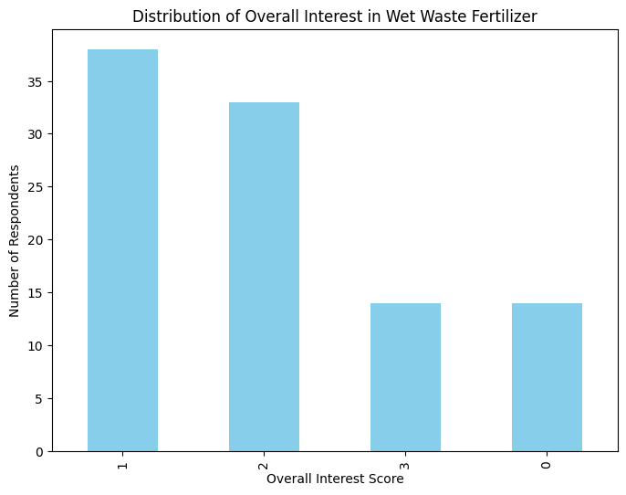

**Key Observations**

The bar chart shows the distribution of respondents' interest in wet waste fertilizer, categorized into four levels (1 = Very Interested, 2 = Interested, 3 = Neutral, 0 = Not Interested). The highest number of respondents falls under "Very Interested," followed by "Interested," while fewer respondents are neutral or not interested.

Analysis:

* A significant proportion of the population (categories 1 and 2) demonstrates a strong interest in wet waste fertilizer. This indicates a potential market for organic fertilizers derived from wet waste.
* The smaller number of respondents in the "Neutral" and "Not Interested" categories suggests that targeted awareness campaigns could further increase interest among these groups.
* This distribution supports the feasibility of your idea, as there is already a baseline level of interest among potential customers.

**FIG 2: MEAN INTEREST LEVEL IN WET WASTE FERTILIZER BY AGE GROUP**

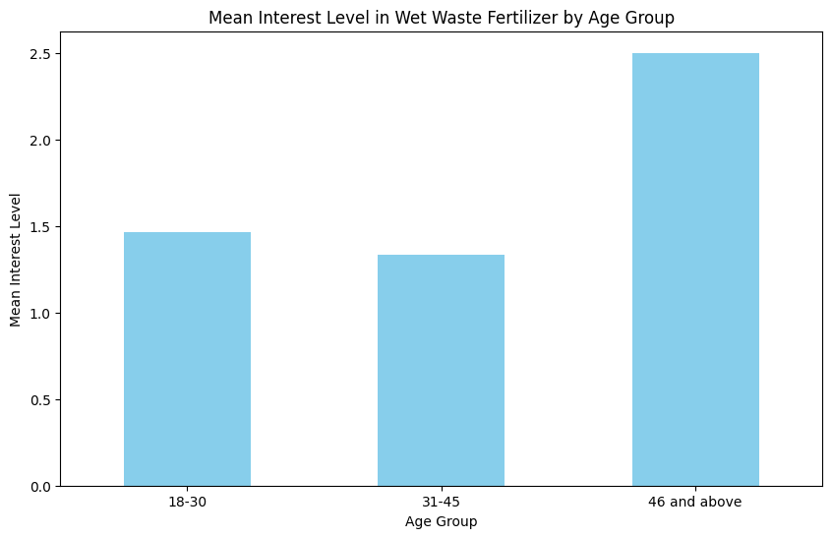

**Key Inferences:**

The bar chart displays the mean interest levels across three age groups: 18–30, 31–45, and 46 and above. The highest mean interest level is observed in the "46 and above" group.

Analysis:

* Older individuals (46+) show significantly higher interest compared to younger age groups. This could be due to greater awareness of environmental issues or direct involvement in agriculture-related activities.
* The younger age groups (18–30 and 31–45) exhibit lower levels of interest, possibly due to limited exposure to sustainable practices or lesser involvement in farming activities.

**TABLE1: ORGANIC FERTILIZER SALES VS. KEY VARIABLES**

| **Year** | **Production Volume (tons)** | **Market Price ($/kg)** | **Fertilizer Sales Revenue ($)** | **Landfill Waste Reduction (tons)** | **Greenhouse Gas Emissions Reduced (kg CO₂e)** |
| --- | --- | --- | --- | --- | --- |
| **2018** | **500** | **0.50** | **250,000** | **1,200** | **3,000** |
| **2019** | **750** | **0.55** | **412,500** | **1,800** | **4,500** |
| **2020** | **1,000** | **0.60** | **600,000** | **2,400** | **6,000** |
| **2021** | **1,250** | **0.65** | **812,500** | **3,000** | **7,500** |
| **2022** | **1,500** | **0.70** | **1,050,000** | **3,600** | **9,000** |
| **2023** | **2,000** | **0.75** | **1,500,000** | **4,800** | **12,000** |

**TABLE 2. OLS Regression Results**

| **Predictor** | **Coefficient** | **Std. Error** | **t-value** | **p-value** | **[0.025, 0.975] Confidence Interval** |
| --- | --- | --- | --- | --- | --- |
| Constant | 4.25e+05 | 3.85e+05 | 1.104 | 0.350 | [-8.01e+05, 1.65e+06] |
| Production_Volume_tons | 25.7250 | 3.661 | 7.028 | 0.006 | [14.076, 37.374] |
| Market_Price_per_kg | -1.5e+06 | 9.04e+05 | -1.660 | 0.196 | [-4.38e+06, 1.38e+06] |
| Landfill_Waste_Reduction_tons | 61.7400 | 8.785 | 7.028 | 0.006 | [33.781, 89.699] |
| GHG_Emissions_Reduced_kgCO2e | 154.3499 | 21.963 | 7.028 | 0.006 | [84.453, 224.247] |
|  | | | | | |

**Key Inferences:**

An ordinary least squares (OLS) regression was conducted to assess the impact of several predictors on **Fertilizer_Sales_Revenue**. The regression model shows an R-squared value of 0.998 (Adjusted R-squared = 0.996), indicating that approximately 99.8% of the variability in fertilizer sales revenue is explained by the predictors in the model. The overall F-statistic (711.8) is statistically significant (p = 9.64e-05), suggesting that the model provides a good fit to the data.

In the regression output, **Production_Volume_tons** has a positive and statistically significant coefficient (coef = 25.7250, p = 0.006), meaning that an increase in production volume is associated with higher sales revenue. **Landfill_Waste_Reduction_tons** also has a significant positive effect (coef = 61.7400, p = 0.006), and **GHG_Emissions_Reduced_kgCO2e** has a significant positive impact (coef = 154.3499, p = 0.006) on sales revenue. In contrast, the coefficient for **Market_Price_per_kg** is not statistically significant (coef = -1.5e+06, p = 0.196), suggesting that within the current model context, variations in market price do not significantly predict fertilizer sales revenue. The intercept, while estimated at 425,000, is also not statistically significant (p = 0.350).

# SUGGESTIONS:

1. Integrated Waste Management Systems: Implement integrated systems that combine waste collection, processing, and conversion into fertilizers. This approach ensures efficiency and maximizes resource recovery.
2. Technological Upgradation: Invest in upgrading existing waste management infrastructure to incorporate advanced technologies like anaerobic digestion and subcritical water treatment.
3. Policy Incentives: Offer financial incentives to farmers and communities adopting organic fertilizers, such as subsidies or tax breaks, to encourage widespread adoption.

# CONCLUSION:

This research has comprehensively explored the potential of converting wet waste into fertilizer as a sustainable waste management strategy. By leveraging advanced technologies such as anaerobic digestion, composting, and subcritical water treatment, it is possible to transform wet waste into high-quality organic fertilizers that enhance soil health and agricultural productivity while reducing environmental degradation.

# REFERENCES:

1. P.B.Londhe, & S.M.Bhosale. (2015). RECYCLING OF SOLID WASTES INTO ORGANIC FERTILIZERS USING LOW COST TREATMENT: VERMICOMPOSTING. *Zenodo (CERN European Organization for Nuclear Research)*. https://doi.org/10.5281/zenodo.1471032

2. Sudharmaidevi, C. R., Thampatti, K. C. M., & Saifudeen, N. (2016). Rapid production of organic fertilizer from degradable waste by thermochemical processing. *International Journal of Recycling of Organic Waste in Agriculture*, *6*(1), 1–11. https://doi.org/10.1007/s40093-016-0147-1

3. Chew, K. W., Chia, S. R., Yen, H.-W., Nomanbhay, S., Ho, Y.-C., & Show, P. L. (2019). Transformation of Biomass Waste into Sustainable Organic Fertilizers. *Sustainability*, *11*(8), 2266. <https://doi.org/10.3390/su11082266>

4. Orner, K. D., Smith, S., Breunig, H. M., Scown, C. D., & Nelson, K. L. (2021). *Fertilizer demand and potential supply through nutrient recovery from organic waste digestate in California*. *206*, 117717–117717. <https://doi.org/10.1016/j.watres.2021.117717>

5. Ojukwu , U., & Egbuchulam, S. (2020). Production and Characterization of Organic Fertilizer from Organic Wastes [Review of *Production and Characterization of Organic Fertilizer from Organic Wastes* ]. *International Journal of Agriculture and Biosciences* .

6. Pandji Prawisudha, Ghani Rais Azka, Budi Triyono, & Pasek, A. D. (2018). Multi-production of solid fuel and liquid fertilizer from organic waste by employing wet torrefaction process. *AIP Conference Proceedings*, *1984*, 030008–030008. <https://doi.org/10.1063/1.5046629>

7. Udara S P R Arachchige, Ranaweera, S. J., A A L T Ampemohotti, Sumedha R G Weliwaththage, & Jaliya Weerakoon. (2020). *Development of an Organic Fertilizer*. *1*(1), 1–7. <https://doi.org/10.1016/0305-0491(75)90096-6>.

8. Syeda Azeem Unnisa. (2015, August 1). *Liquid Fertilizer From Food Waste - A Sustainable Approach*. <https://www.researchgate.net/publication/301548337_Liquid_Fertilizer_From_Food_Waste_-_A_Sustainable_Approach?enrichId=rgreq-c2b245da7759984fc53901fb2701b132-XXX&enrichSource=Y292ZXJQYWdlOzMwMTU0ODMzNztBUzozNTMyNDc0Njc0NTg1NjRAMTQ2MTIzMjE2NzMzMw%3D%3D&el=1_x_2&_esc=publicationCoverPdf>

9. Huzir, N. M., Hussin, M. H., Rosly, M. B., Amin, A. N. R., Asmadi, A. A., Md Ali, A. H., Balasundram, V., Yen, L. P., Goto, M., & Tamunaidu, P. (2023). Rapid production of organic fertilizer using subcritical water treatment on waste biomass. *IOP Conference Series: Earth and Environmental Science*, *1143*(1), 012026. <https://doi.org/10.1088/1755-1315/1143/1/012026>

10. O Mulyani, Y Machfud, Setiawan, A., & Joy, B. (2019). Potential of local organic matters in Jatinangor West Java Indonesia as raw materials for organic fertilizer. *IOP Conference Series Earth and Environmental Science*, *393*, 012048–012048. <https://doi.org/10.1088/1755-1315/393/1/012048>

ACKNOWLEDGEMENT:

We would like to express our special thanks of gratitude to CMS Business School for providing us with such a great project. We would like to extend our gratitude to our mentor for her able guidance and support. Her support and suggestions proved valuable in enabling the successful completion of this project.