Applications of clay based nanocomposites for treatment of waste water
Dr. Meena Chakraborty
Govt. Naveen College Bori, Durg, C.G., India
chakrabortymeena@gmail.com
Abstract
Scarcity of fresh drinking water is a reality of today. Population growth, rapid industrialization and urbanization are responsible for water pollution. Removal of contaminants from waste water is become essential to control water pollution. Waste water contains heavy metals, pesticides, dyes in it. Clay based nanocomposites are found suitable for removal of both inorganic and organic toxic contaminants form waste water. This review will focus on different types of clay used for preparation of nano composites, different types of inorganic and organic pollutants which can be removed by these composites, mechanism of removal of pollutants, advantages and challenges of using clay based nano composites. Future scope of clay based nano composites in waste water treatment is also addressed in the paper.
Keywords: Clay based nanocomposites, pollution, waste water, toxic contaminants.
1 Introduction
Two third of the earth surface is covered with water; still the people are facing the problem of water scarcity. This situation arises due to outburst in population growth. Rapid increase in population becomes the reason for rapid industrialization, deforestation and urbanization, due to which fresh water sources get polluted. Therefore we have to face the problem of shortage of potable water (Amari et al., 2021; Yadav et al., 2019). Rapid industrialization is responsible for non-degradable inorganic toxic pollutants and organic micro contaminants in water bodies (Amari et al., 2021). Industrial waste water coming out from electroplating, mining, textile, wood processing, petroleum refining, tannery factories generally contains toxic metals chromium, mercury, cadmium, lead, arsenic etc in it whereas the waste water coming out from chemical, dyeing, mining and pharmaceutical industries contain drugs, phenols, plasticizers, polybrominated diphenyl ethers, polychlorinated biphenyls, polynuclear aromatic hydrocarbons, and pesticides (Amari et al., 2021; Ayanda et al., 2016; Oladimeji et al., 2024). The common practice for industries is to discharge their waste into nearby water bodies which pollutes the water sources. Hence it become necessary to remove these pollutants from waste water before they are being discharged in water bodies. Then only we can protect our water sources and can solve the problem of potable water scarcity.
There are several methods for removal of inorganic and organic pollutants from waste water such as adsorption (M. Siddeeg et al., 2019; Khulbe and Matsuura, 2018; Sahmoune, 2019), electrolysis (Chebotareva et al., 2020), electrodialysis (Al-Amshawee et al., 2020), ion exchange (Liu et al., 2020), reverse osmosis (Couto et al., 2020), conventional coagulation (Skaf et al., 2020), and chemical precipitation (Verma and Balomajumder, 2020). But these methods are having their own advantages and disadvantages. Methods like electro dialysis, electrolysis, ion-exchange and reverse osmosis are efficient methods for removal of pollutants from waste water but at the same time they required costly experimental set up when used on large scale. Coagulation and chemical precipitation methods are good for the purpose, but during these procedure secondary contaminants includes in treated water, which further required removal treatment (Amari et al., 2021). Therefore adsorption is considered as easy to operate and regenerate materials, cost effective and efficient method for removal of pollutants from waste water (Sharma et al., 2009).
Different adsorbents are used for removal of contaminants from waste water such as polymeric resins (Khan et al., 2020), biomass (Coelho et al., 2020), agricultural wastes (Joseph et al., 2021), industrial by-products, silica beads (He et al., 2020), clay minerals, modified clays (Thiebault, 2020), zeolites (Chen et al., 2020), and activated carbon (Nam et al., 2014). Use of nano structured clay based materials as adsorbent are the recent development in the area of waste water treatment. Nano clay is very efficient adsorbent because of their small size. Due to their small size, they have very large surface area for adsorption (Mamalis, 2007). Large surface area of nano clay composites provides them large number of active sites for adsorption of different chemical entity (Hristovski et al., 2007; Khaleel et al., 1999). In addition to this clay materials are low in cost, easily available in large quantity and environment friendly in nature (Amari et al., 2021). Moreover they exhibit good catalytic efficiency and high chemical reactivity (Yadav et al., 2019). This paper will review the potentiality of nano clay based composites for treatment of waste water.
2 Different types of clay used for preparation of clay based nano composites for waste water treatment
Clays are layered structured polysilicate minerals composed of octahedral aluminum hydroxide oxide and tetrahedral silicate sheets. Kaolinite and serpentine, mica, vermiculite, smectites, pyrophyllite and talc, chlorites, palygorskite and sepiolite are different classes of mineral. Clay minerals are useful for improving the performance of polymeric materials (Amari et al., 2021). Clay based nanocomposites are stable and have good adsorption and ion exchange capacity. Therefore they are one of the best choices for removal of pollutants from waste water (Figure 1). Montmorillonite (MMT), kaolinite, bentonite, halloysite nanotubes (hnts), illite, palygorskite and sepiolite clays are used for preparation of such composites which are useful for removal of heavy metals, such as Cu(II), Fe(III), Cr(VI), Pd(II), Pb(II), Ag(I), Co(II), Zn(II) as well as bacteria, phenol, tannic acid, pesticides, dyes, etc.. (Amari et al., 2021Bhattacharyya and Gupta, 2008; Yadav et al., 2019; Covaliu et al., 2019). Process of treatment of waste water is shown in Figure1.
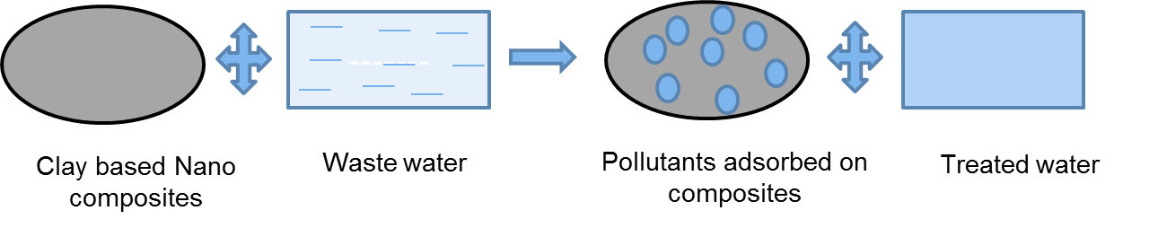
Figure 1: Treatment of waste water through clay based nanocomposites
3 Removal of inorganic and organic contaminants from waste water by using clay based nanocomposites
Due to structural and functional properties of clay based nanocomposites, they are suitable for removal of inorganic and organic pollutants from waste water. They remove inorganic pollutants like heavy metals from waste water by ion exchange and surface complexation mechanism whereas they remove organic pollutants like dyes, pharmaceuticals, and pesticides by adsorption and catalytic degradation mechanism.
3.1 Removal of inorganic pollutants
Rapid urbanization and industrialization increases heavy metal (As, Cd, Hg, Pb, Cr, Fe, Zn, Cu etc.) concentration in water bodies. When these toxic metals enters in human body through water intake, it get accumulated in different organs of the body and causes adverse health effects such as organ damage, neurological issues, gastrointestinal issues, cardiovascular problems and an increased risk of cancer, even long term use of water contaminated with lead and mercury can be life threatening. Therefore removal of toxic heavy metals from water is important for welfare of human beings.
Researchers prepared and used different clay based nanocomposites for removal of heavy metals from water. Chitosan–silver nano particle clay composite is found useful for removal of Cu(II), poly-methacrylic acid grafted chitosan–bentonite for removal of Cd(II), Pb(II) and Hg(II), chitosan/attapulgite composites for removal of Cr(III) and Fe(III), chitosan–Al-pillared montmorillonite nanocomposite for removal of Cr(VI), chitosan-grafted polyacrylic acid bentonite for removal of metals like Ni (II), Cd (II), Zn (II), and Cu (II) from water (Azzam et al., 2016; Khalek et al., 2012; Zou et al., 2011; Wang et al., 2016; Kumararaja et al., 2018)
Humic acid-immobilized-amine modified polyacrylamide-bentonite (HA-Am-PAA-B) nanocomposite is found useful for removal of Cu(II), Zn(II) and Co(II) from industrial waste water with removal efficiency of 106.2 mg g⁻¹, 96.1 mg g⁻¹ and 52.9 mg g⁻¹ respectively (Anirudhan and Suchithra, 2010). E-coli-kaolinite nanocomposite is efficient for removal of iron from waste water with removal efficiency of 16.5 mg g−1 (Quintelas et al., 2009). Researchers prepared organomontmorillonite hydrogel nanocomposite for the removal of lead (II) ions from water with removal capacity of 430 mg g−1 (Irani et al., 2015). Chitosan-clay nanocomposite prepared by the researchers is found to be useful for removal of cadmium (II) ions and chromium (III) ions from water with removal efficiency of 72.31 mg/g and 0.25 mg g−1 respectively (Tirtom et al., 2012; Cittan et al., 2014). Epichlorohydrin crosslinker in chitosan-clay nanocomposite, lignocellulose/montmorillonite nanocomposite and starch/sodium montmorillonite nanocomposite prepared by different researchers are found good for removal of nickel (II) from water with removal efficiency of 32.36 mg g−1, 94.86 mg g−1 and 97.1% (Tirtom et al., 2012; Zhang and Wang, 2015; Garcia-Padilla et al., 2020). Epichlorohydrin crosslinker in chitosan-clay nanocomposite is also good adsorbent for removal of cadmium (II) ions with removal efficiency of 72.31 mg g−1 (Tirtom et al., 2012). Polyaniline bentonite composite is useful for removal of uranium (VI) from water (Liu et al. 2018). Thiourea – formaldehyde/ bentonite composite is useful for removal of Pb (II), Mn (II), and Cr (VI) from water (El-Korashy et al. 2016). The cellulose-montmorillonite nanocomposite is used for removal of Cr (VI) from wastewater with maximum adsorption capacity was 22.2 mg g−1 (Santoso et al. 2019).
Removal of heavy metals by different clay based nanocomposites is summarized in Table 1.
Table 1: Removal of heavy metals by clay based nanocomposites
Metal ion | Clay based Nanocomposites used for removal of metal ion | Reference
Cu(II) | Chitosan–silver nano particle clay composite  Humic acid-immobilized-amine modified polyacrylamide-bentonite  Chitosan-grafted polyacrylic acid bentonite | Azzam et al., 2016  Anirudhan and Suchithra, 2010  Kumararaja et al., 2018
Zn(II) | Humic acid-immobilized-amine modified polyacrylamide-bentonite  Chitosan-grafted polyacrylic acid bentonite | Anirudhan and Suchithra, 2010  Kumararaja et al., 2018
Co(II) | Humic acid-immobilized-amine modified polyacrylamide-bentonite | Anirudhan and Suchithra, 2010
Pb(II) | Organomontmorillonite hydrogel nanocomposite  Poly-methacrylic acid grafted chitosan–bentonite  Thiourea – formaldehyde/ bentonite composite | Irani et al., 2015  Khalek et al., 2012  El-Korashy et al. 2016
Fe(III) | E-coli-kaolinite nanocomposite  Chitosan/attapulgite composites | Quintelas et al., 2009  Zou et al., 2011
Cd(II) | Chitosan-clay nanocomposite  Epichlorohydrin crosslinker in chitosan-clay nanocomposite  Poly-methacrylic acid grafted chitosan–bentonite  Chitosan-grafted polyacrylic acid bentonite | Tirtom et al., 2012  Khalek et al., 2012  Kumararaja et al., 2018
Cr(III) | Chitosan-clay nanocomposite  Chitosan/attapulgite composites | Cittan et al., 2014  Zou et al., 2011
Cr(IV) | Chitosan–Al-pillared montmorillonite nanocomposite  Thiourea – formaldehyde/ bentonite composite | Wang et al., 2016  El-Korashy et al. 2016
Ni(II) | Epichlorohydrin crosslinker in chitosan-clay nanocomposite  Lignocellulose/montmorillonite nanocomposite Starch/sodium montmorillonite nanocomposite  Chitosan-grafted polyacrylic acid bentonite | Tirtom et al., 2012; Zhang and Wang, 2015; Garcia-Padilla et al., 2020  Kumararaja et al., 2018
Hg(II) | Poly-methacrylic acid grafted chitosan–bentonite | Khalek et al., 2012
U(IV) | Polyaniline bentonite composite | Liu et al. 2018
Mn(II) | Thiourea – formaldehyde/ bentonite composite | El-Korashy et al. 2016

3.2 Removal of organic pollutants
Dyes, pesticides, phenol, organic acids etc. are when present in water, even in trace quantity, they degrade the water quality and it is dangerous for human health. Clay based nanocomposites are useful for removal of these pollutants from waste water. Clay based polymeric nanocomposites are good adsorbent for removal of organic pollutants from water. Presence of polymeric hydrophobic part is helpful in adsorption of organic pollutants.
Researchers prepared composites by the combination of chitosan and clay (palygorskite, montmorillonite, bentonite, sepiolite) which are useful for removal of tannic acid, methylene blue, congo red, malachite green, amido black 10B, crystal voilet (Wu and Chen, 2013, Wang et al., 2008; Wang and Wang, 2007; Khalil and Kenawy, 2020; Liu et al., 2015; Mahdavinia and Asgari, 2013). This adsorption follows pseudo second order kinetics and Langmuir adsorption isotherm (Amari et al., 2021). Alginate polymer incorporated clay nanocomposites are useful for removal of phenolic compounds (4-chlorophenol and phenols) from waste water (Hernández-Hernández et al., 2018). Poly-4-vinylpyridine-co-styrene incorporated to montmorillonite clay composite is efficient for removal of trichlorophenol and trinitrophenol from water (Ganigar et al., 2010). Another nanocomposite of modified MMT nanoclay with octadecylamine is found useful for removal of orange G dye from waste water upto 95% in acidic medium (Salam et al., 2017). A composite made up of polyethylene glycol (PEG), acrylic acid and nanoclay is found useful for removal of cationic dye congo red with removal efficiency of 225 mg/l (Bhattacharyya et al., 2015).
Presence of pesticides in water is dangerous for health because they can cause cancer; adversely affect the reproductive system and causes neurological disorders. Therefore removal of pesticides from water is essential. Researchers found that nanocomposite prepared with poly-4-vinylpyridine-co-styrene with modified montmorillonite is useful for removal of pesticides like 2,4-dichlorophenol and atrazine (Zadaka et al., 2009). Hexadimethrine – montmorillonite nanocomposite was found beneficial for removal of mecoprop and clopyralid anionic pesticides from water (Gámiz et al. 2015).
Dyes are mainly discharged off from textile industries in water sources. Dyes are toxic pollutants which are carcinogenic, cause water borne disease and possess adverse effect on aquatic organisms. Therefore removal of dyes from waste water is necessary. Researchers found that chitosan - bentonite nanocomposites are useful for the removal of azo dye tetrazine; chitosan - clay magnetic beads are useful for removal of methylene blue, chitosan-clay nanocomposites are useful for removal of Rhodamin-6 G, chitosan modified nano-organoclay is useful for removal of red-141 (Wan Ngah et al., 2010; Bée et al., 2017; Vanamudan and Pamidimukkala, 2015a; Vanamudan and Pamidimukkala, 2015b). Remazol black B dye can be removed from waste water by using PVI-modified Na bentonite composite with maximum adsorption capacity was 230 mg g−1 (Hernández-Hernández et al., 2016). Starch sodium montmorillonite nanocomposite with polyacrylic acid and polyacrylamide is good enough for removal of safranin dye from water (Zarei et al. 2018).
Clay based nanocomposites used for removal of organic pollutants from waste water is listed in Table 2.
Table 2: Removal of organic pollutants by clay based nanocomposites
Type of organic pollutants | Clay based nanocomposites used for removal | References
Organic acids | Chitosan clay composite | Wu and Chen, 2013
Phenolic compounds | Alginate polymer incorporated clay nanocomposites  poly-4-vinylpyridine-co-styrene incorporated to montmorillonite | Hernández-Hernández et al., 2018  Ganigar et al., 2010
Pesticides | Nanocomposite of poly-4-vinylpyridine-co-styrene with modified montmorillonite  Hexadimethrine – montmorillonite nanocomposite | Zadaka et al., 2009  Gámiz et al. 2015
Dyes | Chitosan - bentonite nanocomposites  Chitosan - clay magnetic beads  Chitosan-clay nanocomposites  Chitosan modified nano-organoclay  Modified MMT nanoclay with octadecylamine  Polyethylene glycol (PEG), acrylic acid and nanoclay composite  Na bentonite composite  Starch sodium montmorillonite nanocomposite | Wan Ngah et al., 2010  Bée et al., 2017  Vanamudan and Pamidimukkala, 2015a Vanamudan and Pamidimukkala, 2015b  Salam et al., 2017  Bhattacharyya et al., 2015  Hernández-Hernández et al., 2016  Zareiet al. 2018

4 Pollutant removal mechanism of clay based nanocomposites
Different types of mechanisms are involved in removal of pollutants from waste water by using clay based nanocomposites such as adsorption, electrostatic interaction, chemical complexation, filtration, size exclusion and redox reaction. Most common mechanism is adsorption. Clay based nanocomposites have large surface area, on which toxic pollutants of waste water get attached through Vander Waals forces. The efficiency of adsorption is affected by pH, adsorbent dose, concentration of pollutants and time required for removal of pollutants. The porous structures of these composites are also helpful for trapping the toxic pollutants from waste water. In addition to this, clay minerals like kaolinite, montmorillonite etc. are having cations on their surface which get easily exchanged with heavy metal ions during adsorption process. Clay minerals and modified clay nanocomposites have charged particles on their surface, due to which they attract oppositely charged ions from waste water through electrostatic interaction. Moreover the different functional groups present on the surface of clay based nanocomposites such as hydroxyl group, carboxyl group, amine etc. easily interact with pollutants of waste water, form stable complexes with them, making them immobalizable. The nano pores available on the surface of clay based nanocomposites behaves like molecular sieves which trap pollutants from waste water easily. Metal incorporated clay based nanocomposites are helpful in reduction of pollutants and convert them in less harmful oxidation state. In this way they reduce the severity or toxicity of that particular pollutant. Because of all these mechanisms, clay based nanocomposites are highly efficient material for removal of inorganic as well as organic pollutants from waste water (Stathi et al. 2007; Ayalew, 2022). Mechanism involved in removal of pollutants from water by clay based nanocomposites are shown in Figure 2.

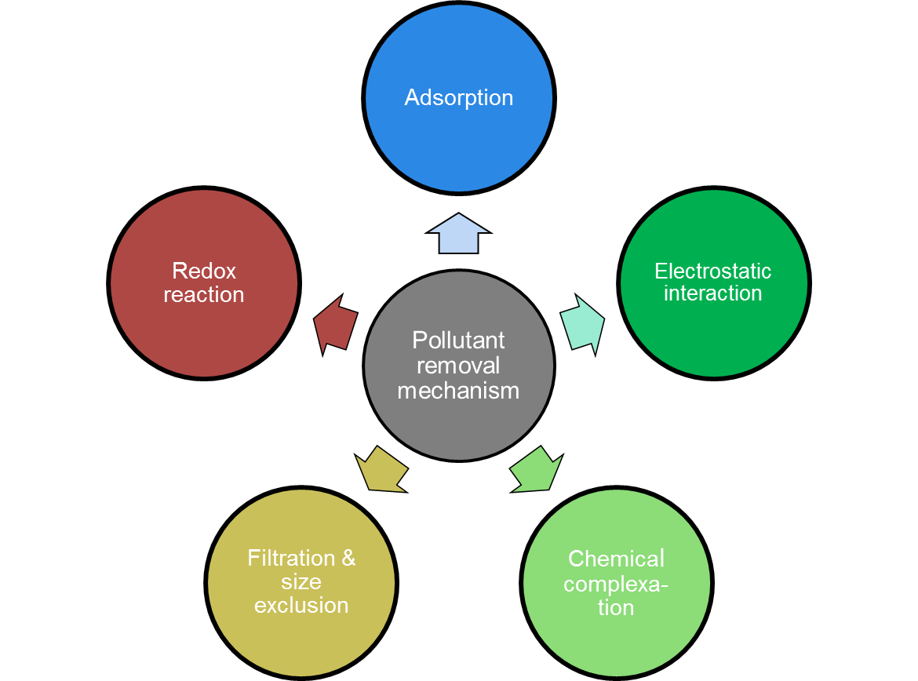
Figure 2: Mechanism involved in removal of pollutants from water by clay based nanocomposites
5 Advantages of using clay based nanocomposites for waste water treatment
Clay-based nanocomposites have large surface area, which enhance their adsorption capacity. Therefore inorganic as well as organic pollutants of waste water get easily adsorbed on its surface. Moreover the layered structure of clay is suitable for intercalation and ion exchange mechanism, which is an additional property for their adsorption efficiency. Clay is eco-friendly in nature and available in huge amount on earth. Therefore Clay-based nanocomposites can be produced on large scale economically and can be easily used for removal of pollutants from waste water. During the preparation of nanocomposites, mechanical strength of clay increased and provides stability to the nanocomposites. Presence of different functional group enhances the catalytic efficiency of the clay based nanocomposites which help them in degradation of organic pollutants from waste water. These composites have antimicrobial properties also, therefore they are efficient in removing bacteria’s from waste water, making them suitable to use for drinking purpose. Because of all these properties clay based nanocomposites are perfect material for treatment of waste water discharged from industries, municipality and agriculture run off (Adeyemo et al., 2017; Gao et al., 2015; Yavuz and Saka, 2013; Auta and Hameed, 2012; Ijagbemi et al., 2010). The properties which make the clay-based nanocomposites useful for wastewater treatment are summarized in Figure 3.

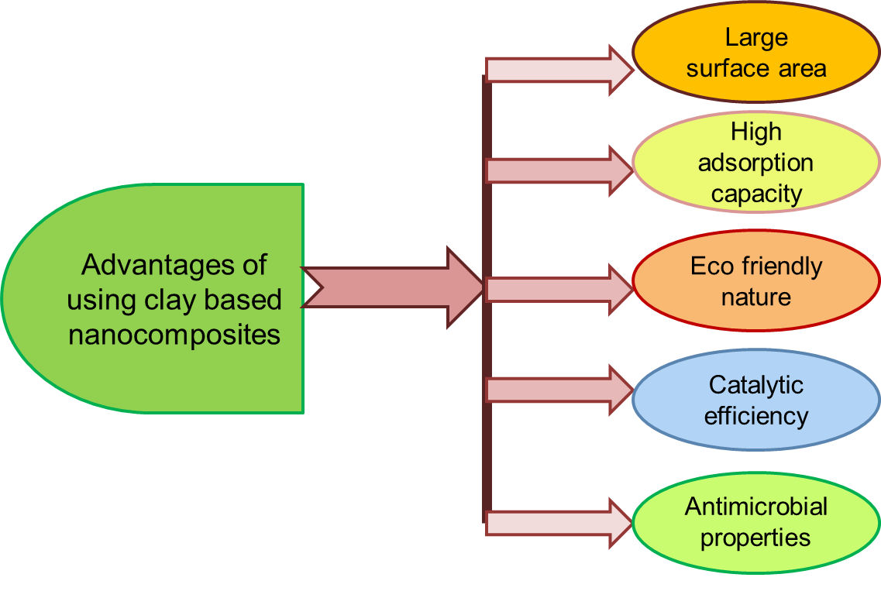
Figure 3: Advantages of using clay based nanocomposites for waste water treatment
6 Challenges in using clay based nanocomposites for waste water treatment
Clay based nanocomposites are very efficient and cost effective material for removal of toxic pollutants from waste water, but there are some challenges which researchers have to overcome for its wide range application in the field of waste water treatment. Removal of toxic pollutants from waste waters through clay based nanocomposites is very much selective process as removal efficiency depends on various factors such as pH, adsorbent dose, temperature, concentration of adsorbate and time required for adsorption. When these composites are used continuously, there is a possibility of degradation of its structure as some pollutants can adhere to its surface strongly. Regeneration of contaminated composite is difficult. In such case these materials cannot be reused for waste water treatment and every time fresh adsorbent is required for pollutant removal process. This fact in turn increases the cost of use of such composites. Furthermore modifications of nanocomposite also enhance the production cost of material. Disposal of used nanocomposites is also a big challenge because used nanocomposites are contaminated with toxic pollutants. Therefore they require a proper disposal management to protect the environment and human beings from these pollutants (Mukhopadhyay et al., 2020; Ayalew, 2022). These challenges are summarized in Figure 4.
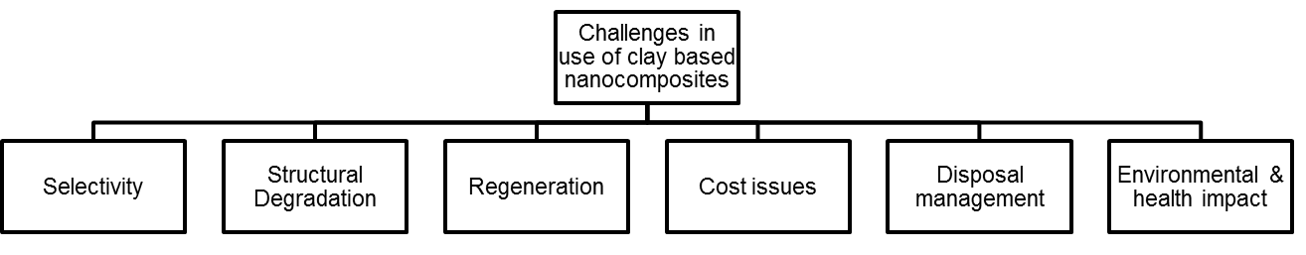
Figure 4: Challenges in using clay based nanocomposites for waste water treatment

7 Future scope of application of clay based nanocomposites for waste water treatment
Clay based nanocomposites have potential application in the field of waste water treatment as they have high surface area, good porosity and efficient adsorption properties. They are capable of removing toxic heavy metals as well as organic pollutants from the effluents coming out from sewage and industries. Further research can be done for enhancing the performance of these materials by modifying the surface area, incorporating different materials and developing easy and economical synthesis mechanism. Future research in this area should also include real-time monitoring capabilities and regeneration and recycling process. Then only these composites can be used widely to scale up the waste water mechanism. As clay is environment friendly in nature, clay based nanocomposites are important for development of economic and sustainable water treatment technology.
8 Conclusion
Clay based nanocomposite has potential application in waste water treatment. These composites have large surface area, porous structure and very good adsorption efficiency. Therefore they are suitable material for removal of toxic pollutants (both inorganic and organic) from waste water. The waste water coming out from different industries contain heavy metals in them which are toxic for human health. Clay based nanocomposite have charges on their surface which can be exchanged with heavy metal ions. Modified clay based nanocomposite have functional groups like carboxyl, hydroxyl, amine etc. and these groups have strong affinity for heavy metals. Therefore the toxic heavy metals can be easily removed from waste water by using clay based nanocomposites. The waste water coming out from textile and leather industries generally contains dyes in them. Waste water from pharmaceutical and pesticide industry contain organic pollutants in them. Clay based nanocomposites are suitable for removal of dyes, pesticides and other organic pollutants from waste water. Hence clay based nanocomposite are highly effective for waste water treatment. Regeneration, structural stability, scalability, environmental impact, health impact and disposal management are still some challenges in the use of clay based nanocomposite for waste water treatment which needs to be addressed. Advance research in the area of improved synthesis methods, recycling process and disposal management can bring revolution in this field. Along with the research, systems have to be developed for integration of clay based nanocomposite with existing waste water treatment technology for its wide range applications. Thus it can conclude that clay based nanocomposite are promising option for waste water treatment because of their huge availability and multifunctionality. On-going research in nanoscience will make it a sustainable approach for treatment of waste water in future.
References
Adeyemo, A. A., Adeoye, I. O., & Bello, O. S. (2017). Adsorption of dyes using different types of clay: a review. Applied Water Science, 7, 543-568.
Al-Amshawee, S., Yunus, M. Y. B. M., Azoddein, A. A. M., Hassell, D. G., Dakhil, I. H., & Hasan, H. A. (2020). Electrodialysis desalination for water and wastewater: A review. Chemical Engineering Journal, 380, 122231.
Amari, A., Mohammed Alzahrani, F., Mohammedsaleh Katubi, K., Salem Alsaiari, N., Tahoon, M. A., & Ben Rebah, F. (2021). Clay-polymer nanocomposites: Preparations and utilization for pollutants removal. Materials, 14(6), 1365. https://doi.org/10.3390/ma14061365
Anirudhan, T. S., & Suchithra, P. S. (2010). Heavy metals uptake from aqueous solutions and industrial wastewaters by humic acid-immobilized polymer/bentonite composite: kinetics and equilibrium modeling. Chemical Engineering Journal, 156(1), 146-156.
Auta, M., & Hameed, B. H. (2012). Modified mesoporous clay adsorbent for adsorption isotherm and kinetics of methylene blue. Chemical Engineering Journal, 198, 219-227.
Ayalew, A. A. (2022). A critical review on clay-based nanocomposite particles for application of wastewater treatment. Water Science and Technology, 85(10), 3002-3022.
Ayanda, O. S., Olutona, G. O., Olumayede, E. G., Akintayo, C. O., & Ximba, B. J. (2016). Phenols, flame retardants and phthalates in water and wastewater–a global problem. Water Science and Technology, 74(5), 1025-1038.
Azzam, E. M., Eshaq, G. H., Rabie, A. M., Bakr, A. A., Abd-Elaal, A. A., El Metwally, A. E., & Tawfik, S. M. (2016). Preparation and characterization of chitosan-clay nanocomposites for the removal of Cu (II) from aqueous solution. International Journal of Biological Macromolecules, 89, 507-517.
Bée, A., Obeid, L., Mbolantenaina, R., Welschbillig, M., & Talbot, D. (2017). Magnetic chitosan/clay beads: A magsorbent for the removal of cationic dye from water. Journal of Magnetism and Magnetic Materials, 421, 59-64.
Bhattacharyya, K. G., & Gupta, S. S. (2008). Adsorption of a few heavy metals on natural and modified kaolinite and montmorillonite: a review. Advances in colloid and interface science, 140(2), 114-131.
Bhattacharyya, R., & Ray, S. K. (2015). Removal of congo red and methyl violet from water using nano clay filled composite hydrogels of poly acrylic acid and polyethylene glycol. Chemical Engineering Journal, 260, 269-283.
Chebotareva, R. D., Remez, S. V., & Bashtan, S. Y. (2020). Water softening and disinfection using an electrolysis unit with a filtering cartridge. Journal of Water Chemistry and Technology, 42, 54-59.
Chen, X., Yu, L., Zou, S., Xiao, L., & Fan, J. (2020). Zeolite cotton in tube: A simple robust household water treatment filter for heavy metal removal. Scientific Reports, 10(1), 4719.
Cittan, M., Tirtom, V. N., Dinçer, A., & Çelik, A. (2014). Epichlorohydrin crosslinked chitosan–clay composite beads for on-line preconcentration and determination of chromium (III) by flow injection flame atomic absorption spectrometry. Analytical Methods, 6(14), 5298-5303.
Coelho, C. M., de Andrade, J. R., da Silva, M. G. C., & Vieira, M. G. A. (2020). Removal of propranolol hydrochloride by batch biosorption using remaining biomass of alginate extraction from Sargassum filipendula algae. Environmental Science and Pollution Research, 27, 16599-16611.
Couto, C. F., Santos, A. V., Amaral, M. C. S., Lange, L. C., de Andrade, L. H., Foureaux, A. F. S., & Fernandes, B. S. (2020). Assessing potential of nanofiltration, reverse osmosis and membrane distillation drinking water treatment for pharmaceutically active compounds (PhACs) removal. Journal of Water Process Engineering, 33, 101029.
Covaliu, C., Paraschiv, G., Stoian, O., Buzatu, B., Mircea, C., & Cristea, C. (2019). Halloysite nanotube applications for heavy metals removal from wastewater. In E3S Web of Conferences (Vol. 112, p. 04010). EDP Sciences.
El-Korashy, S. A., Elwakeel, K. Z., & Abd El-Hafeiz, A. (2016). Fabrication of bentonite/thiourea-formaldehyde composite material for Pb (II), Mn (VII) and Cr (VI) sorption: A combined basic study and industrial application. Journal of Cleaner Production, 137, 40-50.
Gámiz, B., Hermosín, M. C., Cornejo, J., & Celis, R. (2015). Hexadimethrine-montmorillonite nanocomposite: Characterization and application as a pesticide adsorbent. Applied Surface Science, 332, 606-613.
Ganigar, R., Rytwo, G., Gonen, Y., Radian, A., & Mishael, Y. G. (2010). Polymer–clay nanocomposites for the removal of trichlorophenol and trinitrophenol from water. Applied Clay Science, 49(3), 311-316.
Gao, Z., Li, X., Wu, H., Zhao, S., Deligeer, W., & Asuha, S. (2015). Magnetic modification of acid-activated kaolin: Synthesis, characterization, and adsorptive properties. Microporous and Mesoporous Materials, 202, 1-7.
Garcia-Padilla, A., Moreno-Sader, K. A., Realpe, Á., Acevedo-Morantes, M., & Soares, J. B. (2020). Evaluation of adsorption capacities of nanocomposites prepared from bean starch and montmorillonite. Sustainable Chemistry and Pharmacy, 17, 100292.
He, P., Ding, J., Qin, Z., Tang, L., Haw, K. G., Zhang, Y., ... & Valtchev, V. (2020). Binder-free preparation of ZSM-5@ silica beads and their use for organic pollutant removal. Inorganic Chemistry Frontiers, 7(10), 2080-2088.
Hernández-Hernández, K. A., Illescas, J., del Carmen Díaz-Nava, M., Martínez-Gallegos, S., Muro-Urista, C., Ortega-Aguilar, R. E., ... & Rivera, E. (2018). Preparation of nanocomposites for the removal of phenolic compounds from aqueous solutions. Applied clay science, 157, 212-217.
Hernández-Hernández, K. A., Illescas, J., Díaz-Nava, M. D. C., Muro-Urista, C. R., Martínez-Gallegos, S., & Ortega-Aguilar, R. E. (2016). Polymer-clay nanocomposites and composites: structures, characteristics, and their applications in the removal of organic compounds of environmental interest. Med. Chem, 6(3), 201-210.
Hristovski, K., Baumgardner, A., & Westerhoff, P. (2007). Selecting metal oxide nanomaterials for arsenic removal in fixed bed columns: from nanopowders to aggregated nanoparticle media. Journal of hazardous materials, 147(1-2), 265-274.
Ijagbemi, C. O., Baek, M. H., & Kim, D. S. (2010). Adsorptive performance of un-calcined sodium exchanged and acid modified montmorillonite for Ni2+ removal: Equilibrium, kinetics, thermodynamics and regeneration studies. Journal of Hazardous Materials, 174(1-3), 746-755.
Irani, M., Ismail, H., Ahmad, Z., & Fan, M. (2015). Synthesis of linear low-density polyethylene-g-poly (acrylic acid)-co-starch/organo-montmorillonite hydrogel composite as an adsorbent for removal of Pb (ΙΙ) from aqueous solutions. Journal of Environmental Sciences, 27, 9-20.
Joseph, J., Sajeesh, A. K., Nagashri, K., Gladis, E. E., Sharmila, T. M., & Dhanaraj, C. J. (2021). Determination of ammonia content in various drinking water sources in Malappuram District, Kerala and its removal by adsorption using agricultural waste materials. Materials Today: Proceedings, 45, 811-819.
Khaleel, A., Kapoor, P. N., & Klabunde, K. J. (1999). Nanocrystalline metal oxides as new adsorbents for air purification. Nanostructured Materials, 11(4), 459-468.
Khalek, M. D., Mahmoud, G. A., & El-Kelesh, N. A. (2012). Synthesis and characterization of poly-methacrylic acid grafted chitosan-bentonite composite and its application for heavy metals recovery. Chem. Mater. Res, 2(7).
Khalil, A. M., & Kenawy, S. H. (2020). Hybrid Membranes Based on Clay-Polymer for Removing Methylene Blue from Water. Acta Chimica Slovenica, 67(1).
Khan, M.A.; Siddiqui, M.R.; Otero, M.; Alshareef, S.A.; Rafatullah, M. (2020). Removal of rhodamine b from water using a solvent impregnated polymeric dowex 5wx8 resin: Statistical optimization and batch adsorption studies. Polymers, 12, 500.
Khulbe, K. C., & Matsuura, T. (2018). Removal of heavy metals and pollutants by membrane adsorption techniques. Applied water science, 8, 1-30.
Kumararaja, P., Manjaiah, K. M., Datta, S. C., Ahammed Shabeer, T. P., & Sarkar, B. (2018). Chitosan-g-poly (acrylic acid)-bentonite composite: a potential immobilizing agent of heavy metals in soil. Cellulose, 25, 3985-3999.
Liu, H., Xie, S., Liao, J., Yan, T., Liu, Y., & Tang, X. (2018). Novel graphene oxide/bentonite composite for uranium (VI) adsorption from aqueous solution. Journal of Radioanalytical and Nuclear Chemistry, 317, 1349-1360.
Liu, Q., Yang, B., Zhang, L., & Huang, R. (2015). Adsorption of an anionic azo dye by cross-linked chitosan/bentonite composite. International journal of biological macromolecules, 72, 1129-1135.
Liu, Z., Lompe, K. M., Mohseni, M., Bérubé, P. R., Sauvé, S., & Barbeau, B. (2020). Biological ion exchange as an alternative to biological activated carbon for drinking water treatment. Water research, 168, 115148.
M. Siddeeg, S., A. Tahoon, M., & Ben Rebah, F. (2019). Simultaneous removal of calconcarboxylic acid, NH4+ and PO43− from pharmaceutical effluent using iron oxide-biochar nanocomposite loaded with Pseudomonas putida. Processes, 7(11), 800.
Mahdavinia, G. R., & Asgari, A. (2013). Synthesis of kappa-carrageenan-g-poly (acrylamide)/sepiolite nanocomposite hydrogels and adsorption of cationic dye. Polymer bulletin, 70(8), 2451-2470.
Mamalis, A. G. (2007). Recent advances in nanotechnology. Journal of Materials Processing Technology, 181(1-3), 52-58.
Mukhopadhyay, R., Bhaduri, D., Sarkar, B., Rusmin, R., Hou, D., Khanam, R., ... & Ok, Y. S. (2020). Clay–polymer nanocomposites: Progress and challenges for use in sustainable water treatment. Journal of hazardous materials, 383, 121125.
Nam, S. W., Choi, D. J., Kim, S. K., Her, N., & Zoh, K. D. (2014). Adsorption characteristics of selected hydrophilic and hydrophobic micropollutants in water using activated carbon. Journal of hazardous materials, 270, 144-152.
Oladimeji, T. E., Oyedemi, M., Emetere, M. E., Agboola, O., Adeoye, J. B., & Odunlami, O. A. (2024). Review on the impact of heavy metals from industrial wastewater effluent and removal technologies. Heliyon, 10(23).
Quintelas, C., Rocha, Z., Silva, B., Fonseca, B., Figueiredo, H., Tavares, T., 2009. Removal of Cd (II), Cr (VI), Fe (III) and Ni (II) from aqueous solutions by an E. coli biofilm supported on kaolin. Chem. Eng. J. 149 (1), 319–324.
Sahmoune, M. N. (2019). Evaluation of thermodynamic parameters for adsorption of heavy metals by green adsorbents. Environmental Chemistry Letters, 17(2), 697-704.
Salam, M. A., Kosa, S. A., & Al-Beladi, A. A. (2017). Application of nanoclay for the adsorptive removal of Orange G dye from aqueous solution. Journal of molecular liquids, 241, 469-477.
Santoso, S. P., Kurniawan, A., Soetaredjo, F. E., Cheng, K. C., Putro, J. N., Ismadji, S., & Ju, Y. H. (2019). Eco-friendly cellulose–bentonite porous composite hydrogels for adsorptive removal of azo dye and soilless culture. Cellulose, 26, 3339-3358.
Sharma, Y. C., Srivastava, V., Singh, V. K., Kaul, S. N., & Weng, C. H. (2009). Nano‐adsorbents for the removal of metallic pollutants from water and wastewater. Environmental technology, 30(6), 583-609.
Skaf, D. W., Punzi, V. L., Rolle, J. T., & Kleinberg, K. A. (2020). Removal of micron-sized microplastic particles from simulated drinking water via alum coagulation. Chemical Engineering Journal, 386, 123807.
Stathi, Panagiota, Kiriaki Litina, Dimitrios Gournis, Thomas S. Giannopoulos, and Yiannis Deligiannakis. "Physicochemical study of novel organoclays as heavy metal ion adsorbents for environmental remediation." Journal of colloid and interface science 316, no. 2 (2007): 298-309.
Thiebault, T. (2020). Raw and modified clays and clay minerals for the removal of pharmaceutical products from aqueous solutions: State of the art and future perspectives. Critical Reviews in Environmental Science and Technology, 50(14), 1451-1514.
Tirtom, V. N., Dinçer, A., Becerik, S., Aydemir, T., & Çelik, A. (2012). Comparative adsorption of Ni (II) and Cd (II) ions on epichlorohydrin crosslinked chitosan–clay composite beads in aqueous solution. Chemical Engineering Journal, 197, 379-386.
Vanaamudan, A., & Sudhakar, P. P. (2015)b. Equilibrium, kinetics and thermodynamic study on adsorption of reactive blue-21 and reactive red-141 by chitosan-organically modified nanoclay (Cloisite 30B) nano-bio composite. Journal of the Taiwan Institute of Chemical Engineers, 55, 145-151.
Vanamudan, A., & Pamidimukkala, P. (2015)a. Chitosan, nanoclay and chitosan–nanoclay composite as adsorbents for Rhodamine-6G and the resulting optical properties. International Journal of Biological Macromolecules, 74, 127-135.
Verma, B., & Balomajumder, C. (2020). Hexavalent chromium reduction from real electroplating wastewater by chemical precipitation. Bulletin of the Chemical Society of Ethiopia, 34(1), 67-74.
Wan Ngah, W. S., Ariff, N. F. M., & Hanafiah, M. A. K. M. (2010). Preparation, characterization, and environmental application of crosslinked chitosan-coated bentonite for tartrazine adsorption from aqueous solutions. Water, Air, and Soil Pollution, 206, 225-236.
Wang, L., & Wang, A. (2007). Adsorption characteristics of Congo Red onto the chitosan/montmorillonite nanocomposite. Journal of hazardous materials, 147(3), 979-985.
Wang, L., Zhang, J., & Wang, A. (2008). Removal of methylene blue from aqueous solution using chitosan-g-poly (acrylic acid)/montmorillonite superadsorbent nanocomposite. Colloids and Surfaces A: Physicochemical and Engineering Aspects, 322(1-3), 47-53.
Wang, Y. M., Duan, L., Sun, Y., Hu, N., Gao, J. Y., Wang, H., & Xie, X. M. (2016). Adsorptive removal of Cr (VI) from aqueous solutions with an effective adsorbent: cross-linked chitosan/montmorillonite nanocomposites in the presence of hydroxy-aluminum oligomeric cations. Desalination and Water Treatment, 57(23), 10767-10775.
Wu, J., & Chen, J. (2013). Adsorption characteristics of tannic acid onto the novel protonated palygorskite/chitosan resin microspheres. Journal of applied polymer science, 127(3), 1765-1771.
Yadav, V. B., Gadi, R., & Kalra, S. (2019). Clay based nanocomposites for removal of heavy metals from water: a review. Journal of environmental management, 232, 803-817.
Yavuz, Ö., & Saka, C. (2013). Surface modification with cold plasma application on kaolin and its effects on the adsorption of methylene blue. Applied Clay Science, 85, 96-102.
Zadaka, D., Nir, S., Radian, A., & Mishael, Y. G. (2009). Atrazine removal from water by polycation–clay composites: effect of dissolved organic matter and comparison to activated carbon. Water research, 43(3), 677-683.
Zarei, S., Sadeghi, M., & Rezanejade Bardajee, G. (2018). Dye removal from aqueous solutions using novel nanocomposite hydrogel derived from sodium montmorillonite nanoclay and modified starch. International Journal of Environmental Science and Technology, 15, 2303-2316.
Zhang, X., & Wang, X. (2015). Adsorption and desorption of nickel (II) ions from aqueous solution by a lignocellulose/montmorillonite nanocomposite. PloS one, 10(2), e0117077.
Zou, X., Pan, J., Ou, H., Wang, X., Guan, W., Li, C., ... & Duan, Y. (2011). Adsorptive removal of Cr (III) and Fe (III) from aqueous solution by chitosan/attapulgite composites: Equilibrium, thermodynamics and kinetics. Chemical Engineering Journal, 167(1), 112-121.

