**HAND GESTURE CONTROLLER SYSTEM USING VR BOX(MOBILE)**

**Om Hemant Patil*1, Bhuvan Bharat Patil*2, Dipak Jagannath Patil*3 , Ms. Arati P.Deshmukh*4**

*1,2,3Students, Department Of Diploma In Computer Engineering, Marathwada Mitra Manadal’s Polytechnic, Pune, Maharashtra, India

4Lecturer, Department Of Diploma In Computer Engineering, Marathwada Mitra Mandal’s Polytechnic , Pune, Maharashtra, India

**ABSTRACT**

With the rapid advancements in human-computer interaction, gesture-based control systems have gained significant attention. This paper presents a Hand Gesture Controller System using a VR Box (Mobile), developed with OpenCV and Python. The system enables users to interact with virtual environments using predefined hand gestures, eliminating the need for physical controllers. By leveraging computer vision techniques such as image processing and feature extraction, the system recognizes hand gestures and translates them into control commands for immersive VR applications. This research explores the development, implementation, and potential applications of such a system in gaming, training simulations, and assistive technologies.

**Keywords:** Hand Gesture Recognition,Virtual Reality,OpenCV,Python,Computer Vision.

1. **INTRODUCTION**

Virtual Reality (VR) technology has significantly transformed how users engage with digital environments, offering immersive and interactive experiences. Traditional VR systems depend on handheld controllers, which may feel unnatural and limit seamless interaction. Hand gesture recognition is an emerging alternative that allows users to interact naturally using hand movements. This project introduces a Hand Gesture Controller System that employs OpenCV and Python to detect and interpret hand gestures via a mobile camera, eliminating the need for external controllers. The system enhances accessibility, ease of use, and engagement, bridging the gap between physical and virtual interaction, making VR experiences more intuitive.

1. **RELATED WORK**

Research in gesture recognition has been widely explored, focusing on various fields such as gaming, healthcare, and robotics. Traditional methods involve the use of gloves or specialized sensors to track hand movements accurately. However, advancements in computer vision have made real-time gesture recognition possible using cameras and image processing techniques. Deep learning models, such as convolutional neural networks (CNNs), have been applied to improve accuracy, but they demand extensive datasets and high computational power. In contrast, OpenCV-based methods offer lightweight and efficient solutions for real-time hand tracking, making them suitable for mobile applications.

1. **PROBLEM STATEMENT**

Most VR systems rely on external hardware controllers, which can be expensive and restrictive, limiting accessibility for users. These controllers often require complex configurations and do not provide the natural interaction that hand gestures offer. Additionally, the dependency on hardware increases costs and limits portability. The proposed system overcomes these limitations by utilizing a mobile camera for hand gesture recognition using OpenCV and Python. This approach eliminates the need for additional hardware while providing an intuitive and cost-effective solution for VR interaction.

1. **OBJECTIVE**

The objective of this project is to develop a Hand Gesture Controller System that enhances user interaction with Virtual Reality (VR) environments using hand gestures, eliminating the need for physical controllers. The system aims to provide an intuitive and immersive VR experience by integrating computer vision techniques with OpenCV and Python. The key objectives of this project include developing a robust gesture-based VR control mechanism, improving accessibility for individuals with physical disabilities, and ensuring real-time gesture recognition for seamless user interaction. Additionally, the project focuses on reducing hardware dependency by utilizing mobile cameras for gesture tracking, making the system cost-effective and widely accessible.

1. **PROPOSED SYSTEM**

The proposed Hand Gesture Controller System integrates computer vision techniques to detect and interpret hand gestures, eliminating the dependency on physical controllers. The system leverages OpenCV and Python to capture and process hand movements in real-time using a mobile camera. The proposed system comprises key components such as the image processing module, feature extraction, gesture classification, and VR command mapping. The image processing module enhances captured frames by applying grayscale conversion, Gaussian blurring, and thresholding to remove noise and extract relevant hand features. Feature extraction involves contour detection and convex hull analysis to identify hand landmarks such as fingertips and palm center. The recognized gestures are mapped to predefined VR commands, allowing users to navigate and interact seamlessly within a virtual environment. This system ensures an intuitive and immersive VR experience while reducing the need for additional hardware, making it cost-effective and accessible to a broader user base.

1. **METHODOLOGY**

The system follows a structured pipeline for recognizing hand gestures and translating them into VR controls. The mobile camera captures hand movements in real time, and the captured frames undergo grayscale conversion, Gaussian blurring, and thresholding for noise reduction. Contour detection and convex hull analysis identify key hand features such as fingertips and palm center. Based on the extracted features, predefined gestures are mapped to VR commands such as swiping, clicking, and scrolling. The recognized gestures are then converted into VR input commands, enabling seamless interaction.

1. **ARCHITECTURE DESIGN**

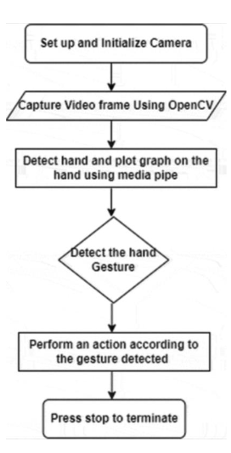

The system consists of various components, including the camera module, which captures real-time video input for hand tracking, and the preprocessing module, which enhances image quality by reducing noise and isolating the hand region. The gesture recognition engine identifies different hand gestures using contour and feature-based analysis. The VR controller interface maps the recognized gestures to corresponding VR commands, while the user interface provides real-time feedback on detected gestures and ensures smooth interaction.

1. **HARDWARE USED IN THE PROPOSED SYSTEM**

To implement the **Hand Gesture Controller System**, the following hardware components are used:

1. **Android Phone**

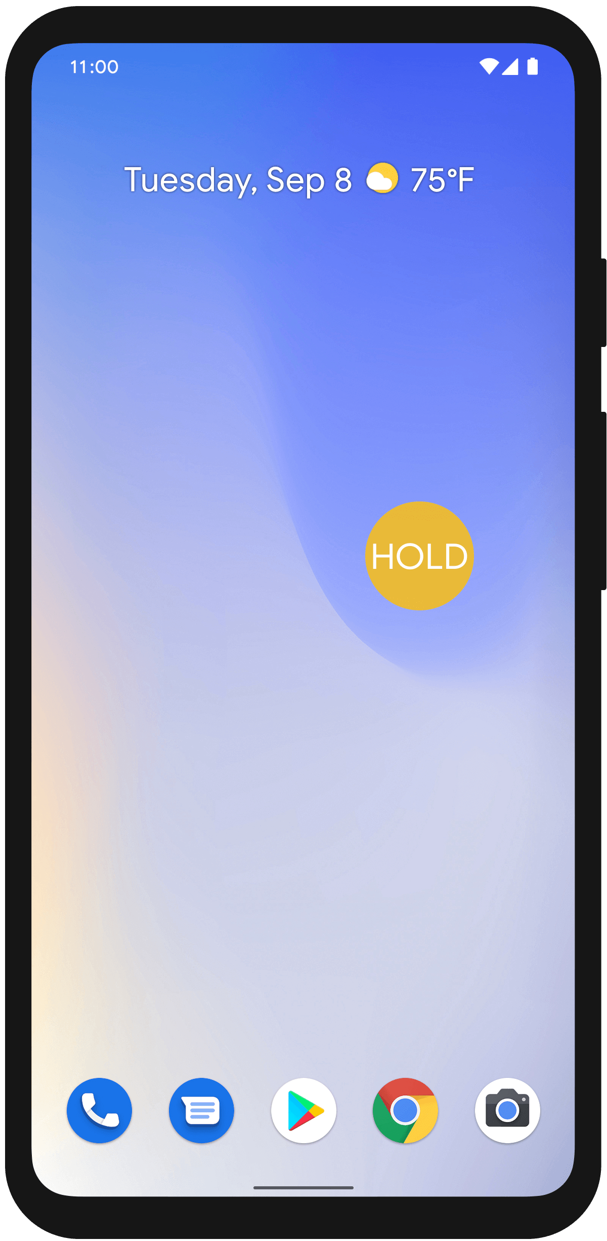

The **Android phone** plays a crucial role in the Hand Gesture Controller System as it serves as both the input device and processing unit. The built-in camera of the phone is utilized to continuously capture hand movements in real time. The phone runs **image processing algorithms** using **OpenCV and Python**, ensuring efficient gesture detection. The portability and accessibility of an Android phone make it an ideal choice for implementing a **cost-effective** and **wireless** gesture recognition system. With advancements in mobile computing power, modern Android devices are capable of handling **real-time image processing** without the need for additional hardware.

#### **2.VR Box (Mobile)**

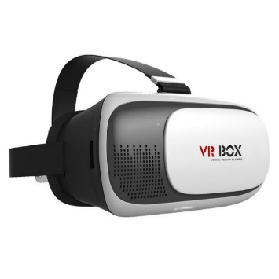

#### A **VR Box** is used to provide an **immersive virtual reality experience** to the user. The **Android phone** is placed inside the VR headset, where it functions as the **display screen** for the virtual environment. The primary function of the VR Box is to enable a **3D interactive experience**, enhancing user engagement. Unlike traditional VR systems that rely on handheld controllers, this setup allows users to interact with the VR environment using **hand gestures**, making the experience more natural and intuitive. The VR Box ensures that the user is fully immersed in the **virtual space**, while hand gestures replace the need for **physical touch controllers**.

#### **3.Laptop**

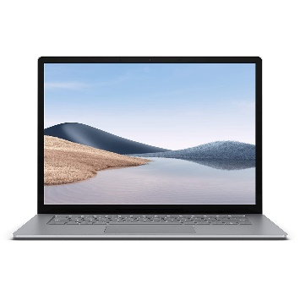

#### A **laptop** is used for **developing, testing, and debugging** the system before deploying it on the Android phone. The laptop runs **Python scripts**, allowing developers to fine-tune **gesture recognition algorithms** and optimize system performance. During the development phase, various **image processing techniques** and **gesture classification methods** are tested on the laptop to ensure accuracy and efficiency. Additionally, if required, the laptop can serve as an **intermediary processing unit**, receiving gesture data from the phone and sending corresponding VR commands wirelessly. This setup is particularly useful for debugging and analyzing system performance before full deployment.

1. **RESULTS AND DISCUSSION**

The system was tested under different lighting conditions to evaluate accuracy and reliability in real-time gesture recognition. Results showed that the system could detect and classify hand gestures with high accuracy even under varying environmental conditions. Performance testing revealed that preprocessing techniques, such as contour detection and feature extraction, significantly improved recognition speed. When integrated with VR applications, the system demonstrated smooth and responsive control, offering an intuitive user experience. The absence of external hardware improved portability and accessibility.

1. **APPLICATIONS**

The Hand Gesture Controller System has multiple real-world applications across various domains. One of the primary applications is in **VR Gaming**, where it enhances immersive gaming experiences by replacing traditional controllers with natural hand gestures. In **Medical Simulations**, it enables medical professionals to interact with virtual surgical environments without physical contact, aiding in training and practice. The system is also beneficial in **Assistive Technology**, helping individuals with physical disabilities by offering an alternative, touch-free interaction method. In **Education & Training**, it facilitates interactive learning experiences, such as virtual lab experiments and skill-based training. Additionally, it can be used for **Smart Home Control**, allowing users to control IoT-enabled smart home devices using simple hand gestures.

1. **CONCLUSION**

This paper presents a cost-effective and intuitive Hand Gesture Controller System using OpenCV and Python, designed for VR Box (Mobile). By utilizing hand gestures for navigation and interaction, the system eliminates the need for traditional controllers, improving accessibility and user engagement. Experimental results demonstrate the effectiveness of real-time gesture recognition in VR applications, confirming its potential in gaming, education, and assistive technologies. Future developments could incorporate deep learning techniques for enhanced recognition accuracy and support for a broader range of gestures.

1. **FUTURE SCOPE**

The Hand Gesture Controller System using VR Box (Mobile) has significant potential for future enhancements and expansions. The implementation of deep learning for gesture recognition can improve accuracy and adaptability. Expanding the gesture vocabulary will allow more intricate interactions in a VR environment. Optimizing algorithms for real-time processing on low-power mobile devices can enhance performance. Integrating voice commands alongside hand gestures can further improve usability and accessibility. Developing a standalone mobile app will provide a complete system for better user interaction and experience.

1. **REFERENCES**
2. G. Rautaray & A. Agrawal, "Vision-Based Hand Gesture Recognition for Human-Computer Interaction," IEEE Transactions on Industrial Informatics, Vol. 9, No. 1, pp. 1-13, 2013.
3. S. Mitra & T. Acharya, "Gesture Recognition: A Survey," IEEE Transactions on Systems, Man, and Cybernetics, Part C (Applications and Reviews), Vol. 37, No. 3, pp. 311-324, 2007.
4. M. Van den Bergh & L. Van Gool, "Combining RGB and ToF Cameras for Real-time 3D Hand Gesture Interaction," IEEE Workshop on Applications of Computer Vision, 2011.
5. J. Shotton et al., "Real-time Human Pose Recognition in Parts from a Single Depth Image," IEEE Conference on Computer Vision and Pattern Recognition (CVPR), 2011.
6. Z. Ren, J. Yuan, and Z. Zhang, "Robust Hand Gesture Recognition Based on Finger-Earth Mover’s Distance with a Commodity Depth Camera," IEEE Transactions on Multimedia, Vol. 15, No. 5, pp. 1110-1120, 2013.
7. C. Keskin, F. Kıraç, Y. E. Kara, and L. Akarun, "Hand Pose Estimation and Hand Shape Classification Using Multi-Layered Randomized Decision Forests," European Conference on Computer Vision (ECCV), 2012.
8. T. Starner and A. Pentland, "Real-Time American Sign Language Recognition from Video Using Hidden Markov Models," MIT Media Laboratory, IEEE Transactions on Pattern Analysis and Machine Intelligence, Vol. 20, No. 12, pp. 1371-1375, 1998.
9. Q. Pu, S. Gupta, S. Gollakota, and S. Patel, "Whole-Home Gesture Recognition Using Wireless Signals," International Conference on Mobile Computing and Networking (MobiCom), 2013.
10. OpenCV Documentation - Open Source Computer Vision Library.
11. M. Mohandes, S. Deriche, and J. Liu, "Image-Based and Sensor-Based Approaches to Arabic Sign Language Recognition," IEEE Transactions on Human-Machine Systems, Vol. 44, No. 4, pp. 551-557, 2014.