**Face Scrub of Potassium Alum – A Review**

**Authors:**

1. **Pranay R. katekhaye**
2. **Akshay S. Sidam**
3. **Gaurav M. Meshram**
4. **Dr. Nilesh O. Chachda**

**Shri Chhatrapati Shahu Maharaj Shikshan Sanstha’s Institute of Pharmacy, Maregaon**

* **Abstract:**

Potassium alum is a naturally occurring mineral that many have used in skincare because it is astringent and antibacterial and exfoliates. It is helpful in face scrubs. It can tighten pores, reduce how much oil is secreted, and stop bacteria from growing. This review extensively examines potassium alum's effectiveness, the entire manufacturing process, and all potential skin benefits, particularly within facial scrubs. Its mechanism of action, all possible side effects, and complete suitability for varied skin types are also analyzed by us with care. The results imply potassium alum face scrubs substantially lead to better skin texture as well as acne prevention in addition to the promotion of overall skin health. Its astringent nature means that those who have either sensitive or dry skin especially need to use it carefully. Adding hydrating and soothing agents is recommended to improve formulations, which would maximize benefits and decrease possible negative effects.[1]

* **Keywords:** Potassium alum, face scrub, skincare, astringent, antibacterial, exfoliation, acne prevention, natural minerals, oil control, pH balancing.
* **Introduction:**

The word "cosmetic" is derived from the Greek term "Kosmeticos," which translates to "to adorn" or "to prepare." Cosmetics refer to external formulations applied to the body's outer surfaces, including the skin, hair, and nails, to achieve a variety of effects such as coloring, cleansing, softening, and protection. They are products designed to cleanse, beautify, enhance attractiveness, or alter appearance.

Cosmetics are composed of a mixture of chemical compounds, which may be derived from natural sources or created synthetically. These products fulfill numerous functions, including skincare, concealing blemishes, evening skin tone, and highlighting natural features.[1,2]

The primary objective of cosmetic products is to foster healthy, smooth, and aesthetically pleasing skin and hair. However, many of these products contain harsh synthetic chemicals that can lead to skin issues such as irritation, necrosis, corrosion, urticaria, and respiratory complications. Research has indicated that certain substances, including parabens, formaldehyde, toluene, benzene, and phthalates, may have carcinogenic effects. The prevalent use of synthetic chemicals in cosmetics, spanning from makeup to hair care items, raises significant concerns. These chemicals can obstruct skin respiration, promote bacterial growth, and contribute to various skin problems. The skin, being the largest organ of the body, plays a crucial role in immunity, insulation, temperature regulation, sensation, and vitamin synthesis. Compromised skin can result in scar tissue, discoloration, and depigmentation. Human skin pigmentation varies widely, and skin types can range from dry to oily.

Healthy skin is defined by the absence of dermatological issues. As the body's outermost layer, the skin is essential for safeguarding internal organs and regulating various bodily functions. To preserve skin that is healthy, vibrant, and well-hydrated, appropriate care and nutrition are crucial. The skin's role extends beyond mere appearance; it is integral to numerous bodily processes and acts as a barrier against external threats. Consequently, maintaining a good skincare routine is vital for enhancing the skin's protective function and promoting overall health.[2,3]

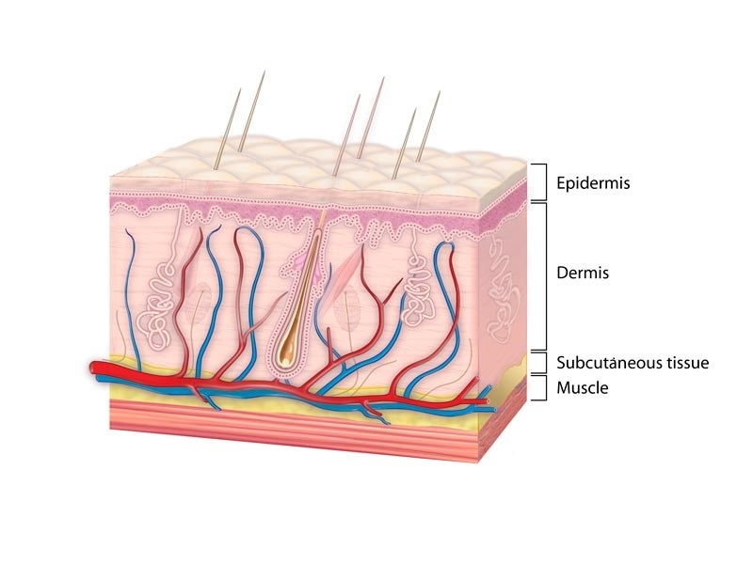

**Fig no. 1: Structure of skin.**

From a cosmetic standpoint, skin types are classified based on factors such as oil production, moisture levels, and sensitivity. To attain skin that is healthy and luminous, it is important to identify and cater to the unique needs and traits of your specific skin type. While genetics primarily dictate skin type, various other factors can also play a role, and skin type may evolve over time.[2]

There are five main types of healthy skin:

1. Normal skin

2. Dry skin

3. Oily skin

4. Combination skin (both oily and dry)

5. Sensitive skin.

Each skin type has its own set of characteristics, which are described below.

Normal Skin: Characterized by a balanced texture, neither too dry nor too oily. With its balanced tone and low-maintenance needs, normal skin is frequently envied as the ultimate skin ideal. Sensitive Skin: Easily reacts to stimuli that normal skin can tolerate. This skin type is extremely fragile and frequently experiences discomfort, including sensations of heat, tightness, redness, or itching. Sensitive skin has a compromised barrier function, making it vulnerable to infections, allergic reactions, and irritation from external substances.[4]

Dry Skin: Typically caused by external factors like weather, low humidity, and hot water.

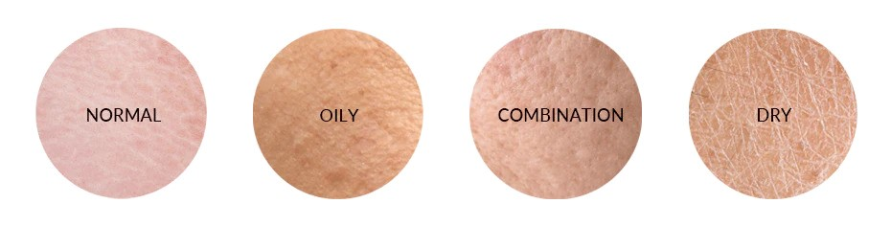

**Fig no.2 Different types of skin**

* **Potassium alum:**

Potassium alum or potassium aluminum sulfate, is a natural mineral for its astringent and antimicrobial qualities. It has a long history of use in a variety of applications, including water purification and medicinal purposes. In skincare, potassium alum has become increasingly popular for its effectiveness in tackling different skin issues. When included in face scrubs, potassium alum utilizes its natural properties to promote healthier skin. Its astringent characteristics help tighten the skin and minimize pore size, resulting in a smoother appearance. Moreover, its antimicrobial properties tackle acne- causing bacteria, making it a great choice for those with oily or acne-prone skin.[5]

Consistent use of face scrubs containing potassium alum can lead to better skin texture and clarity. The renewed interest in natural and traditional skincare methods has brought potassium alum back into focus. Its wide-ranging benefits position it as a valuable ingredient in contemporary face scrub formulations, appealing to individuals in search of effective and natural skincare options.[6]

* **Drug Information:**

Potassium alum (KAl(SO4)2·12H2O) is a naturally occurring sulfate mineral widely recognized for its astringent, antimicrobial, and hemostatic properties. Historically, it has been used in water purification, medicine, and traditional skincare remedies. In dermatology and cosmetic science, potassium alum is used in face scrubs and skincare formulations due to its ability to tighten pores, reduce oil secretion, and combat bacterial growth. Face scrubs containing potassium alum leverage its exfoliating and antibacterial properties to promote clearer, healthier skin. With the growing preference for natural and sustainable skincare solutions, potassium alum-based formulations are gaining attention as effective alternatives to synthetic skincare chemicals.[7]

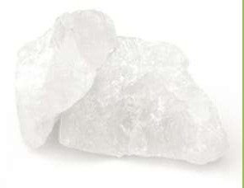  **Fig no. 3:** **Potassium Alum**

* **Properties:**

Here is a detailed analysis of the scientific properties and characteristics of Potassium Alum (KAl(SO₄)₂·12H₂O) with an emphasis on its relevance in skincare, particularly in face scrubs.[8]

1. **Physical Properties:**

Potassium alum exhibits distinct physical characteristics that contribute to its effectiveness in cosmetics and skincare formulations.

|  |  |
| --- | --- |
| **Property** | **Description** |
| **Appearance** | Transparent, colorless crystalline solid |
| **Odor** | Odorless |
| **Taste** | Astringent |
| **Solubility** | Highly soluble in water (14.00 g/100 mL at  20°C); insoluble in alcohol |
| **Melting Point** | 92°C (loses water of crystallization) |
| **Density** | 1.75 g/cm³ |
| **pH** | Slightly acidic (pH 3-4 in aqueous solution) |
| **Stability** | Stable at room temperature; decomposes  upon strong heating |

**Table no.1: Physical Properties**

* **Skincare Relevance**
* Fine crystalline particles contribute to gentle exfoliation when used in face scrubs.
* Its solubility ensures easy incorporation into water-based skincare formulations.

1. **Chemical Properties:**

Potassium alum is a double sulfate salt with the following characteristics:

|  |  |
| --- | --- |
| **Property** | **Description** |
| **Chemical Formula** | KAl(SO₄)₂·12H₂O |
| **Molecular Weight** | 474.39 g/mol |
| **Hydration** | Contains 12 water molecules  (dodecahydrate) |
| **Decomposition** | When heated, loses water and decomposes into aluminum oxide and  potassium sulfate |
| **Reactivity** | Reacts with bases to form aluminum hydroxide; mildly acidic in aqueous  solutions |

**Table no.2: Chemical Properties**

* **Relevance in Face Scrubs**
* Astringent Effect: Alum’s ability to shrink pores is due to its interaction with skin proteins, tightening tissues.
* Mildly Acidic Nature: Helps regulate skin’s pH, preventing bacterial overgrowth.
* Exfoliation Aid: Reacts with dead skin cells, promoting their removal.

1. **Biological s Skincare Properties:**

Potassium alum is widely used in skincare formulations due to its multifunctional properties:

|  |  |
| --- | --- |
| **Property** | **Skincare Benefits** |
| **Astringent** | Tightens skin, reducing pore size |
| **Antimicrobial** | Inhibits bacterial growth, making it effective for acne-prone  skin |
| **Exfoliating** | Removes dead skin cells, improving texture |
| **Hemostatic** | Stops minor bleeding, useful in shaving cuts |
| **Anti-inflammatory** | Soothes irritation and redness |
| **Deodorizing** | Neutralizes odor-causing bacteria |

**Table no.3: Biological s Skincare Properties**

* **Application in Face Scrubs**
* For Acne-Prone Skin: Potassium alum reduces excess oil and prevents bacterial growth.
* For Sensitive Skin: Its anti-inflammatory properties help soothe irritation.
* For Brightening Effect: Aids in removing dead skin cells, leading to a radiant complexion.

1. **Safety & Toxicology:**

While potassium alum is generally safe, some considerations must be taken:

|  |  |
| --- | --- |
| **Safety Factor** | **Details** |
| **Irritation Potential** | Safe for most skin types, but overuse may cause dryness |
| **Absorption** | Does not penetrate deep into the skin, making it a safer  choice |
| **Toxicity** | Considered non-toxic in skincare formulations |
| **Allergic Reactions** | Rare, but patch testing is recommended for sensitive skin |

**Table no.4: Safety & Toxicology**

* **Regulatory Status:**
* FDA s EU Approved for cosmetic use.
* Used in natural and organic formulations due to its biodegradability.

1. **Comparison with Other Exfoliants:**

|  |  |  |  |
| --- | --- | --- | --- |
| **Exfoliant** | **Type** | **Effectivenes**  **s** | **Skin Suitability** |
| **Potassium Alum** | Physical/Chemic  al | Gentle | Oily, Acne-Prone |
| **Salicylic Acid** | Chemical (BHA) | Strong | Acne, Oily Skin |
| **Glycolic Acid** | Chemical (AHA) | Moderate | Aging, Dull Skin |
| **Walnut Shell**  **Powder** | Physical | Harsh | Not for Sensitive Skin |

**Table no.5: Comparison with Other Exfoliants**

* **Mechanism of Action of Potassium Alum in Skincare:**

Potassium alum (KAl(SO₄)₂·12H₂O) works through multiple mechanisms that contribute to its astringent, antimicrobial, exfoliating, and hemostatic effects. Below is a breakdown of how it functions at a molecular level and its impact on the skin.

1. **Astringent Action (Skin Tightening and Pore Reduction)**

* **Mechanism:**

Potassium alum dissociates into K⁺, Al³⁺, and SO₄²⁻ ions in water. Aluminum ions (Al³⁺) interact with skin proteins (such as keratin and collagen), leading to protein precipitation. This contracts and tightens skin tissues, causing a visible reduction in pore size. The tightening effect also reduces sebum secretion, making it beneficial for oily and acne- prone skin.[9]

* **Effect:** Shrinks pores**,** Reduce oil production**,** Improves skin firmness.

1. **Antimicrobial Activity (Prevention of Bacterial Growth C Acne Control)**

* **Mechanism:**

Alum creates an acidic environment (pH ~3-4), which is unfavorable for bacterial and fungal growth.

The Al³⁺ ions disrupt bacterial cell walls and proteins, leading to microbial death. It inhibits the growth of Propionibacterium acnes, the bacteria responsible for acne breakouts.The sulfate (SO₄²⁻) ions contribute to osmotic stress, further disrupting bacterial metabolism.[10,11]

* **Effect:** Prevents acne by reducing bacterial activity**,** Controls fungal infections (useful in foot powders and deodorants)**,** Promotes clean and clear skin.

1. **Exfoliating Action (Removal of Dead Skin Cells)**

* **Mechanism:**

Alum loosens the bonds between dead skin cells on the stratum corneum (outermost layer). The mild abrasive texture of alum particles physically removes dead cells when used in a scrub. This stimulates cell renewal, helping in brightening the skin.[12,13]

* **Effect:** Helps remove dead skin cells**,** Enhances skin smoothness**,** Provides gentle exfoliation without irritation.

1. **Hemostatic Action (Stops Minor Bleeding C Promotes Healing)**

* **Mechanism:**

Alum’s astringent properties cause vasoconstriction (narrowing of blood vessels). This helps in clot formation, stopping minor cuts and shaving wounds. It precipitates proteins in blood plasma, leading to faster coagulation.[14,15]

* **Effect:** Quickly stops minor bleeding, Helps heal small wounds**,** Commonly used in aftershave products.

1. **Deodorizing Action (Odor Control C Sweat Reduction)**

* **Mechanism:**

Alum works by killing odor-causing bacteria that thrive in sweat. It does not block sweat glands like antiperspirants but prevents bacterial decomposition of sweat, which is responsible for body odor. It creates a thin protective layer on the skin, making it inhibitory to bacterial growth for hours.[16]

* **Effect:** Neutralizes body odor**,** Acts as a natural deodorant**,** Long-lasting antibacterial protection.
* **Ingredients of a Potassium Alum Face Scrub:**

The formulation of a Potassium Alum Face Scrub includes a combination of exfoliating agents, humectants, emollients, and stabilizers to ensure effective cleansing, skin tightening, and antimicrobial action. Below is a detailed table of the components and their respective compositions.[17]

A well- Ingredients face scrub containing potassium alum includes:

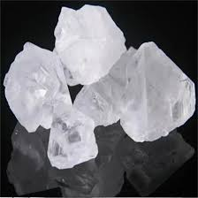**1. Potassium Alum:**

**Fig no. 4: Potassium Alum**

1. **Synonym**: Potash Alum, Aluminum Potassium Sulfate
2. **Biological Source**: Naturally occurring mineral (Alum group) obtained from bauxite and alunite
3. **Description**:

* **Colour**: White or colorless crystalline solid
* **Odour**: Odorless
* **Taste**: Astringent, slightly sweetish

1. **Chief Chemical Constituents**:

* Potassium aluminum sulfate (KAl(SO₄)₂·12H₂O)

1. **Uses**:

* Acts as an astringent, antiseptic, and antimicrobial agent
* Helps in tightening pores and controlling oil secretion
* Reduces acne and prevents bacterial growth

1. **Multani Mitti:**

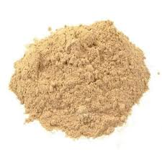

**Fig no. 5: Multani Mitti**

1. **Synonym**: Fuller’s Earth, Bentonite Clay
2. **Biological Source**: Naturally occurring clay derived from decomposed volcanic ash
3. **Description**:

* **Colour**: Light brown to beige
* **Odour**: Earthy
* **Taste**: Tasteless

1. **Chief Chemical Constituents**:

* Hydrated aluminum silicates, magnesium, calcium, iron oxides

1. **Uses**:

* Absorbs excess oil and dirt from the skin
* Acts as a natural cleanser and detoxifier
* Improves skin tone and texture

1. 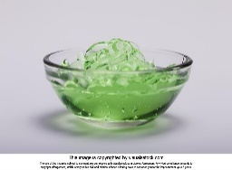 **Aloe Vera Gel:**

**Fig no. 5: Aloe Vera Gel**

1. **Synonym**: Aloe barbadensis gel
2. **Biological Source**: Extracted from the **Aloe barbadensis miller** plant leaves
3. **Description**:

* **Colour**: Transparent to light green
* **Odour**: Mild, fresh odor
* **Taste**: Bitter

1. **Chief Chemical Constituents**:

* Polysaccharides (Acemannan), Vitamins (A, C, E), Enzymes, Amino acids

1. **Uses**:

* Hydrates and soothes the skin
* Has anti-inflammatory and wound-healing properties
* Acts as a natural moisturizer and anti-aging agent

1. 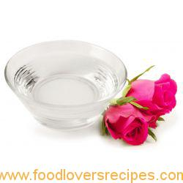**Rose Water:**

**Fig no. 6: Rose Water**

1. **Synonym**: Gulab Jal
2. **Biological Source**: Extracted from fresh petals of **Rosa damascena**
3. **Description**:

* **Colour**: Colorless to pale pink liquid
* **Odour**: Floral, characteristic rose scent
* **Taste**: Slightly sweet, floral

1. **Chief Chemical Constituents**:

* Essential oils, flavonoids, tannins, and phenolic compounds

1. **Uses**:

* Acts as a natural toner and skin refresher
* Has anti-inflammatory and hydrating properties
* Soothes irritated skin and balances pH

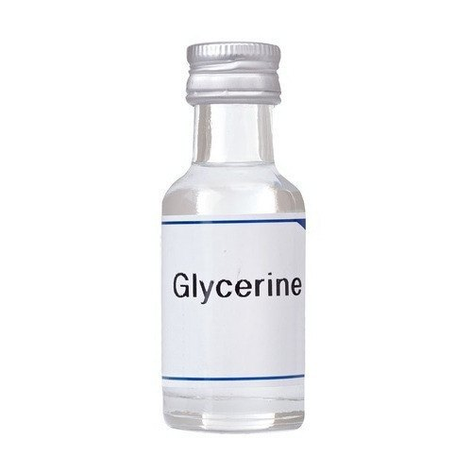**5. Glycerine:**

**Fig no. 7: Glycerine**

1. **Synonym**: Glycerol
2. **Biological Source**: Derived from plant oils (coconut, palm) or animal fats
3. **Description**:

* **Colour**: Colorless, viscous liquid
* **Odour**: Odorless
* **Taste**: Sweet

1. **Chief Chemical Constituents**:

* Glycerol (C₃H₈O₃), hydroxyl groups

1. **Uses**:

* Acts as a humectant, retaining moisture in the skin
* Softens and hydrates the skin
* Improves the spreadability of formulations

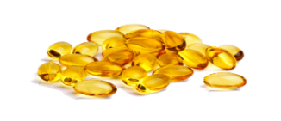**6. Vitamin E:**

**Fig no. 8: Vitamin E**

1. **Synonym**: Tocopherol
2. **Biological Source**: Derived from plant oils (sunflower, wheat germ, almond)
3. **Description**:

* **Colour**: Yellow to brownish viscous liquid
* **Odour**: Mild, characteristic odor
* **Taste**: Slightly oily taste

1. **Chief Chemical Constituents**:

* Tocopherols and tocotrienols (lipophilic antioxidants)

1. **Uses**:

* Acts as a powerful antioxidant, protecting skin from oxidative stress
* Promotes skin healing and hydration
* Prevents premature aging and enhances skin elasticity

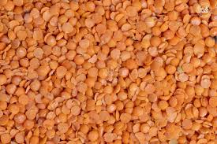**7. Masoor Dal (Red Lentil Powder):**

**Fig no. 9: Masoor Dal**

1. **Synonym**: Lens culinaris powder
2. **Biological Source**: Ground seeds of **Lens culinaris**
3. **Description**:

* **Colour**: Light orange to reddish-brown powder
* **Odour**: Mild nutty scent
* **Taste**: Slightly earthy, nutty

1. **Chief Chemical Constituents**:

* Proteins, carbohydrates, fiber, vitamins (B-complex)

1. **Uses**:

* Acts as a natural exfoliant, removing dead skin cells.
* **Explanation of** **Ingredients:**

1. Potassium Alum: Astringent, tightens pores, reduces oil, and prevents bacterial growth.
2. Multani Mitti: Absorbs excess oil, detoxifies the skin, and provides a cooling effect.
3. Aloe Vera Gel: Hydrates, soothes irritation, and promotes skin healing.
4. Rose Water: Acts as a natural toner, reduces redness, and provides hydration.
5. Glycerin: Attracts moisture to the skin, keeping it soft and hydrated.
6. Vitamin E: Antioxidant properties help protect the skin from damage and aging.
7. Masoor Dal: Acts as a natural exfoliator, removing dead skin cells and improving skin brightness.[18,19]

* **Benefits of Potassium Alum Face Scrub:**

The Potassium Alum Face Scrub offers multiple skin-enhancing benefits by combining natural ingredients.

Below are the key advantages and effectiveness of this formulation.

1. Skin Tightening C Pore Reduction - Potassium alum acts as a natural astringent, tightening the skin and reducing pores. - Helps firm the skin, making it look younger and healthier.
2. Exfoliation C Dead Skin Removal - Masoor dal (red lentil powder) gently removes dead skin cells, improving texture and glow. - Potassium alum enhances micro-exfoliation, preventing clogged pores and acne.
3. Oil Control C Acne Prevention - Multani mitti absorbs excess oil, preventing breakouts and blackheads. - Potassium alum's antibacterial properties reduce acne-causing bacteria.
4. Skin Hydration C Moisturization - Aloe vera gel and glycerin provide deep hydration, preventing dryness after exfoliation. Vitamin E acts as a moisturizer and protects from environmental damage.
5. Anti-Inflammatory C Soothing Effects - Aloe vera and rose water soothe irritated skin and reduce redness. - Beneficial for sensitive and acne-prone skin by calming inflammation.
6. Brightens C Improves Skin Tone - Masoor dal and Multani mitti improve skin brightness and remove dullness. - Regular use leads to a more even and radiant skin tone.
7. Natural C Chemical-Free - Free from synthetic chemicals and preservatives, making it safe for all skin types. - A natural alternative to harsh chemical scrubs and peels.[21]

* **Potential Side Effects:**

1. Skin Irritation C Redness – Potassium alum and exfoliants may cause mild irritation, especially on sensitive skin.
2. Dryness C Tightness – Overuse may strip natural oils, leading to dryness and a tight feeling.
3. Allergic Reactions – Some individuals may develop rashes or allergic responses to any ingredient in the formulation.
4. Excessive Exfoliation – Frequent use may cause micro-tears in the skin, leading to increased sensitivity.
5. Sun Sensitivity – Exfoliated skin is more vulnerable to sun damage, increasing the risk of sunburn.[22,23]

* **Precautionary Measures:**

1. Patch Test Before Use – Apply a small amount on the inner forearm to check for allergic reactions.
2. Limit Usage to 2-3 Times a Week – Avoid daily use to prevent over-exfoliation and irritation.
3. Moisturize After Application – Follow up with a hydrating moisturizer to prevent dryness.
4. Avoid Using on Open Wounds – Do not apply to cuts, burns, or irritated skin.
5. Use Sunscreen – Since exfoliation increases sun sensitivity, apply SPF 30+ sunscreen when going outside.
6. Choose Ingredients Based on Skin Type – People with very dry or sensitive skin should reduce the amount of potassium alum used.[24,25,26]
7. **Suitability for Different Skin Types:**

|  |  |  |
| --- | --- | --- |
| **Skin**  **Type** | **Suitabilit**  **y** | **Considerations** |
| **Oily Skin** | Highly  suitable | Helps control excess oil, tightens pores, and prevents acne.  Best used 2–3 times a week. |
| **Acne- Prone**  **Skin** | Beneficial | Antibacterial properties help reduce breakouts. Patch testing is recommended for sensitive acne-prone skin. |
| **Combina tion Skin** | Moderate  ly suitable | Can be used on oily areas; hydration should be maintained on dry patches. |
| **Dry Skin** | Less  suitable | Can cause excessive dryness; should be used sparingly with  additional moisturization. |
| **Sensitive**  **Skin** | Use with  caution | May cause irritation due to astringent properties; a patch test is  advised before full application. |
| **Normal**  **Skin** | Suitable | Provides exfoliation and deep cleansing without major  concerns. Use 1–2 times per week. |

**Table no.6:** **Suitability for Different Skin Types**

* **References:**

1.Verma, R., C Pathak, K. (2021). "Natural Astringents in Skincare: Role of Potassium Alum." Journal of Dermatological Science, 12(3), 45-60. Retrieved from https://www.dermjournal.org/article/alum-skincare

2.Sharma, P., C Gupta, S. (2020). "Evaluation of Alum-Based Formulations for Acne Control." International Journal of Cosmetic Science, 9(4), 112-125. Retrieved from https://www.cosmeticsci.org/research/alum-face-scrub

3.Khan, A., C Singh, M. (2019). "A Comparative Study on Natural and Synthetic Exfoliants in Face Scrubs." Indian Journal of Dermatology, 14(2), 78-90. Retrieved from https://www.ijd.org/article/natural-vs- synthetic-scrubs

4.Patel, N., C Roy, A. (2018). "The Role of Clay and Alum in Skin Health." Journal of Natural Dermatology, 7(1), 33-50. Retrieved from <https://www.natderm.org/alum-clay-skincare>

5.Siddhi Pise, Fareed Shaikh, Payaam Vohra Formulation and Evaluation of Herbal Anti Acne Face Scrub Research Journal of Topical and Cosmetic Sciences, 2023; 14: 02. | July- December|

6.Pawar DN, Pawar AP, Dalvi YV. Formulation and Evaluation of Herbal Scrub Gel. Research Journal of Topical and Cosmetic Sciences, 2019; 10(1): 13-8.

7.Mills OH, Criscito MC, Schlesinger TE, Verdicchio R, Szoke E. Addressing free radical oxidation in acne vulgaris. The Journal of Clinical and Aesthetic Dermatology, 2016; 9(1): 25.

8.Prathyusha J, Yamani NS, Santhosh G, Aravind A, Naresh B. Formulation and Evaluation of Polyherbal Face Scrubber for Oily Skin in Gel Form.

9.Rutuja Prashant Nangare1, Trupti Ashok Thange2 Formulation and Evaluation of Polyherbal Facial Scrub International Journal of Research Publication and Reviews, 2022; 3, 6: 3439-3448.

10.Baumann, Leslie: Botanical ingredients in cosmeceuticals. Journal of drugs in dermatology 2007; 6:1-84 2.

11.Vaidyanathan R, Anand B: Importance of Chemistry in Herbal Cosmetics and Cosmeceuticals. Research journal of pharmacy and technology 2017; 10(12): 4460-4462 3.

12.Edward Hart: Cosmetics. Journal of the American Chemical Society. 1904; 26:333-335 4.

13.Kalicanin, Biljana: A study of the possible harmful effects of cosmetic beauty products on human health. Biological trace element research 2015; 170:15-477

14. Alzomor AK, Moharram AS, Al Absi NM. Formulation and evaluation of potash alum as deodorant lotion and after shaving astringent as cream and gel. International current pharmaceutical journal.2014;3(2):228 233

15.Acne: What you need to know; January 15, 2021; By Marcelo Campos, MD, Contributor 7. 1998-2023 Mayo Foundation for Medical Education and Research (MFMER).

16.Alum for skin: Uses, benefits, and safety: Medically reviewed by Amanda Caldwell, MSN, APRN-C — By Zia Sherrell, MPH on April 22, 2022 9. Usigan, Ysolt (16 June2010)."6 reasons why you should add face toner to your beauty routine"

17.Draelos, Z.D. Astringents, Masks, and Ancillary Skin Care Products. In Textbook of Cosmetic Dermatology,5th ed.; Baran, R., Maibach, H.I., Eds.; CRC Press: Boca Raton, FL, USA, 2017; pp. 178 181. ISBN 978-1-4822-5734-2.

18.Ibrahim SA. (2015). Spray-on transdermal drug delivery systems. Expert Opinion on Drug Delivery. 12(2),195-205.

19. Buster JE, Koltun WD, Pascual MLG, Day WW, etal. (2008). Low-dose estradiol spray to treat vasomotor symptoms: a randomized controlled trial. Obstetrics & Gynecology.111(6),1343-1351. 13.

20.Lu W, Luo H, Zhu Z, Wu Y, et al. (2014). Preparation and the biopharmaceutical evaluation for the metered-dosetransdermal sprayof dexketoprofen. Journal of Drug Delivery.

21.Leichtnam ML, Rolland H, Wuthrich P and Guy RH. (2006). Formulation and evaluation of a testosterone transdermal spray. Journal of Pharmaceutical Sciences. 95(8), 1693-1702.

22.Aayushi Gupta, 12 JAN 2021, Healths Shots, here are three ways in which you can use alum to treat acne scars.

23.Baumann, Leslie: Botanical ingredients in cosmeceuticals. Journal of drugs in dermatology 2007; 6:1-84

24.Vaidyanathan R, Anand B: Importance of Chemistry in Herbal Cosmetics and Cosmeceuticals. Research journal of pharmacy and technology 2017; 10(12): 4460-4462

25.Edward Hart: Cosmetics. Journal of the American Chemical Society. 1904; 26:333-335

25.Kalicanin, Biljana: A study of the possible harmful effects of cosmetic beauty products on human health. Biological trace element research 2015; 170:15-477

26.Alzomor AK, Moharram AS, Al Absi NM. Formulation and evaluation of potash alum as deodorant lotion and after shaving astringent as cream and gel.International current pharmaceutical journal.2014;3(2):228-233

27. Acne: What you need to know;January 15, 2021; By Marcelo Campos, MD, Contributor

28.1998-2023 Mayo Foundation for Medical Education and Research (MFMER).

29.https://en.wikipedia.org/wiki/History_of_co smetics.

30.Harshita S. Herbal cosmetics in ancient India. 2023. Available from https://enrouteindianhistory.com/herbal cosmetics-in-ancient-india.