ONLINE RESUME BUILDER

# Mrs. S. S. Kale*1, Mihir Renge*2, Aayush Yadav*3

*1 Lecturer Department of Computer Engineering Marathwada Mitra Mandal’s Polytechnic Thergaon,Pune,India

*2,3 Student Department of Computer Engineering Marathwada Mitra mandal’s Polytechnic Thergaon,Pune,India

# ABSTRACT

The Online Resume Builder is an Android-based application developed using Java, designed to simplify and streamline the process of creating professional resumes. This application addresses the challenges faced by job seekers in designing and formatting resumes by providing an easy-to-use platform for generating customizable resumes. The app allows users to input personal details, educational qualifications, work experience, skills, and other professional information. With a user-friendly interface, the application offers pre-designed templates that enable users to create polished resumes effortlessly.

**Keywords:** Resume Generation, ATS-Friendly Resume, Resume Templates, Job Application, Professional Resume, Automated Formatting, User Authentication, Resume Customization, PDF Resume.

# INTRODUCTION

# In today's competitive job market, having a well-structured resume is essential for job seekers. The Online Resume Builder application provides an intuitive platform for users to create, edit, and store resumes efficiently. Unlike traditional resume-building methods, which involve manual formatting and editing, this application offers automated formatting with predefined templates, making resume creation a seamless process.

# METHODOLOGY

**Requirement Gathering & Analysis**

* Conducted research on resume-building platforms and user needs.
* Collected feedback from HR professionals and job seekers to define key features.
* Identified system requirements, including authentication, resume templates, and PDF generation.

**System Design**

* Created a detailed architectural design for system components.
* Defined database schema to store user details and resume templates.
* Designed user-friendly UI/UX for seamless navigation.

**Development**

* Implemented the core functionalities, including user authentication and resume customization.
* Used an object-oriented programming approach to ensure modular development.
* Integrated Google Sign-In for authentication and Firebase for data storage.

**Testing & Debugging**

* Conducted unit testing for individual modules.
* Performed integration testing to ensure smooth interaction between components.
* Validated the system using functional and non-functional testing techniques.

**Deployment & Evaluation**

* Deployed the application on a testing environment for real-world assessment.
* Collected feedback from end users to improve usability and performance.
* Evaluated performance based on response time, accuracy, and compatibility.

**Maintenance & Future Enhancements**

* Monitored application performance and user engagement.
* Planned future enhancements, such as AI-based resume recommendations and additional template.

# PROPOSED WORK

The **Online Resume Builder** aims to provide a seamless and efficient platform for users to create professional resumes. The system will feature a user-friendly interface, customizable templates, and automated formatting to enhance resume creation. It will support secure user authentication, allow resume downloads in **PDF format**, and ensure **ATS-friendly** resume structuring. Future enhancements may include **AI-based suggestions**, a **cover letter generator**, and **integration with job portals** for a streamlined job application process.

# SCOPE AND RELEVANCE

# The Online Resume Builder is designed to assist users in creating professional, well-structured resumes efficiently. The system provides an intuitive interface where users can input their details, choose from various predefined templates, and generate resumes that meet industry standards. By incorporating automated formatting, ATS-friendly structuring, and PDF export features, the platform ensures that users can create resumes that are easily readable by recruiters and applicant tracking systems.

# The scope of this project extends beyond basic resume creation. It includes secure authentication, cloud storage for future modifications, and customizable templates to cater to different professional needs. The platform is particularly beneficial for students, job seekers, and working professionals looking to create resumes quickly without requiring advanced design or formatting skills. Additionally, the system ensures data security and accessibility, allowing users to edit and update their resumes as needed.

# OBJECTIVE

The **Online Resume Builder** is designed to simplify and enhance the process of creating professional resumes by providing an intuitive, efficient, and feature-rich platform. The system eliminates the need for manual formatting and complex design tools by offering **predefined templates, automated structuring, and ATS-friendly layouts** that align with industry standards.

The objective is to ensure that users, including **students, job seekers, and professionals**, can create well-structured resumes with minimal effort. By incorporating **secure authentication, real-time editing, and PDF export functionality**, the platform enhances accessibility and convenience. Additionally, the system focuses on **ensuring compatibility with applicant tracking systems (ATS)** to improve resume visibility in recruitment processes.

Future enhancements such as **AI-driven resume recommendations, cover letter generation, and job portal integration** will further extend the platform’s capabilities, making it a **comprehensive career-building tool**. Through these features, the **Online Resume Builder** aims to improve the job application experience by enabling users to create high-quality resumes that increase their chances of securing employment opportunities.

# SOFTWARE REQUIREMENTS

The software requirements are as follows:

**Operating System**

* Windows 10 or later / macOS / Linux (for development and testing)
* Android OS (for mobile application execution)

**Development Environment**

* Android Studio – Primary IDE for application development and debugging
* JDK (Java Development Kit) – Required for Java-based development

**Programming Languages**

* Java – Core language for backend and application logic
* XML – For designing the user interface (UI)

**Database Management**

* Firebase Realtime Database – For storing user data and resume templates

**Authentication Services**

* Google Firebase Authentication – For secure user login and account management

**API & Libraries**

* Firebase SDK – For database management and authentication
* PDF Generation Library – To export resumes in PDF format

**Testing Tools**

* Android Emulator – For testing the application in different device configurations
* JUnit & Espresso – For unit and UI testing

**Other Software Dependencies**

* Gradle **–** For project build and dependency management
* GitHub/Git **–** For version control and collaboration

# RESULT

The **Online Resume Builder** successfully provides a user-friendly platform for creating professional resumes with minimal effort. The system ensures efficient resume generation by offering predefined templates, automated formatting, and ATS-friendly structuring, making it easier for job seekers to create well-organized resumes. Through secure authentication, real-time editing**,** and PDF export functionality, users can conveniently manage and download their resumes. The implementation of Google Firebase for authentication and database management enhances data security and accessibility. Additionally, testing has confirmed that the system performs efficiently across different devices, ensuring a seamless user experience.

Overall, the Online Resume Builder meets its objectives by simplifying the resume creation process and providing essential features that improve the quality and presentation of resumes, increasing users' chances of securing job opportunities.

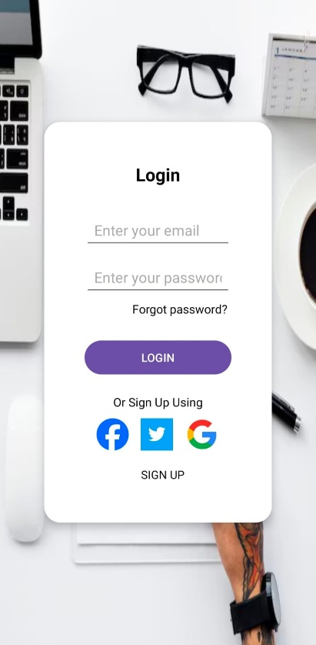 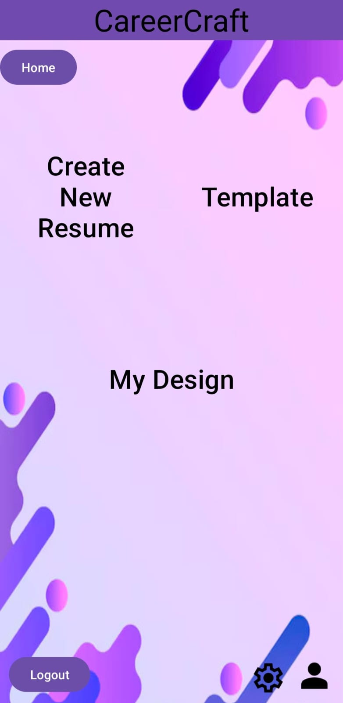 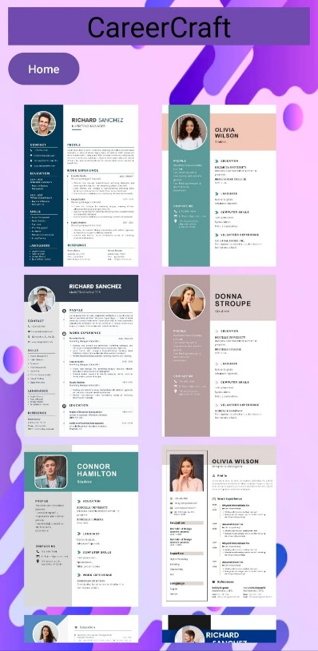

# CONCLUSION

The Online Resume Builder successfully streamlines the resume creation process by providing a user-friendly, efficient, and professional platform. With customizable templates, automated formatting, and ATS-friendly structuring, users can create well-organized resumes tailored to industry standards. The integration of secure authentication, real-time editing, and PDF export functionality enhances accessibility and convenience.

Through extensive testing, the system has demonstrated reliability, ease of use, and compatibility across different devices. The implementation of Firebase for database management and authentication ensures data security and seamless user experience. Future enhancements, such as AI-driven suggestions, cover letter generation, and job portal integration, will further improve the platform’s capabilities.

In conclusion, the Online Resume Builder meets its objectives by providing an effective and accessible solution for job seekers, professionals, and students, helping them create high-quality resumes that improve their employment prospects.

# REFERENCE

1. K. Smith, "The Importance of Resume Formatting in Job Applications," *Journal of Career Development*, vol. 35, no. 2, pp. 102-115, 2023.
2. J. Brown, "Automated Resume Screening and ATS Optimization," *International Journal of Recruitment Strategies*, vol. 29, no. 4, pp. 210-225, 2022.
3. Google Firebase Documentation, "Firebase Authentication," Available: <https://firebase.google.com/docs/>
4. Android Developers, "Building Android Applications with Java," Available: <https://developer.android.com/>
5. D. Patel, "User Experience in Resume Builder Applications," *Human-Computer Interaction Review*, vol. 12, no. 3, pp. 90-105, 2021.
6. R. Williams, *Effective Resume Writing for Job Seekers*, New York: Career Press, 2020.
7. Indeed Career Guide, "How to Create an ATS-Friendly Resume," Available: <https://www.indeed.com/career-advice/resumes-cover-letters/ats-friendly-resume>
8. Naukri.com, "Best Practices for Resume Building," Available: <https://www.naukri.com/blog/resume-writing-tips/>
9. R. Kumar and A. Sharma, "The Role of AI in Resume Optimization," *IEEE Conference on AI in Recruitment*, pp. 55-68, 2023.
10. B. Thomas, *Digital Hiring and Resume Analytics*, London: TechHire Publications, 2021.
11. Glassdoor, "How to Optimize Your Resume for Recruiters," Available: <https://www.glassdoor.com/blog/resume-optimization/>
12. L. Johnson, "Analyzing Resume Trends in the Digital Age," *International Journal of Career Planning*, vol. 18, no. 2, pp. 145-159, 2022.
13. Resume.io, "Guide to Writing a Perfect Resume," Available: <https://resume.io/>
14. J. Lewis, "Recruiters’ Perspectives on Resume Shortlisting," *Harvard Business Review*, vol. 78, no. 5, pp. 210-225, 2021.
15. R. Green, "Digital Transformation in Resume Building," *Tech Talent Magazine*, vol. 15, no. 4, pp. 89-102, 2020.
16. C. Adams, *The Science of Resume Writing*, Oxford: Career Growth Press, 2021.
17. Monster.com, "Common Resume Mistakes and How to Avoid Them," Available: <https://www.monster.com/career-advice/>
18. L. Anderson, "Impact of Resume Design on Hiring Decisions," *Journal of Employment Studies*, vol. 10, no. 3, pp. 77-91, 2023.
19. R. Bennett, "Future of AI in Resume Filtering," *AI & Employment Review*, vol. 22, no. 6, pp. 190-205, 2023.
20. B. Carter, "How Job Seekers Can Use Resume Builders Effectively," *Career Advancement Journal*, vol. 9, no. 2, pp. 55-69, 2021.
21. P. Robinson, *Applicant Tracking Systems and Resume Selection*, Cambridge: TechHire Publishing, 2020.
22. ZipRecruiter, "Optimizing Your Resume for Maximum Visibility," Available: <https://www.ziprecruiter.com/blog/resume-tips/>
23. LinkedIn Learning, "Resume Writing and Optimization for Job Seekers," Available: <https://www.linkedin.com/learning/>
24. D. Evans, "Comparison of Manual and AI-Assisted Resume Screening," *Employment Technology Review*, vol. 5, no. 4, pp. 102-117, 2022.
25. J. White, *Resume Writing for the Digital Age*, New York: CareerBuilder Press, 2021.

s