**A Digital Marketplace for : Development, Challenges, and Solutions**

Soham Sarda1 - [210305105531@paruluniversity.ac.in](mailto:210305105531@paruluniversity.ac.in),

Assi Prof.: Faisal Shaikh1.1

### Abstract

The rise of digital marketplaces has revolutionized the way businesses and consumers interact, providing a seamless platform for buying and selling products and services. This paper explores the development, challenges, and solutions associated with digital marketplaces, focusing on technological advancements, user experience, security, and scalability. The study delves into key factors that influence marketplace success, such as trust, payment integration, and regulatory compliance. Additionally, it highlights the emerging trends shaping the future of online commerce. Through a comprehensive analysis, this research aims to provide insights into overcoming common obstacles and optimizing digital marketplace operations for sustainable growth.

**Keywords**

Digital marketplace, e-commerce, online platforms, technology integration, user experience, payment security, scalability, regulatory compliance, digital transformation, business model.

**I. INTRODUCTION**

The rapid advancement of digital technologies has revolutionized the way businesses operate, leading to the emergence of digital marketplaces. These online platforms facilitate the buying and selling of goods and services by connecting sellers with potential customers in a seamless and efficient manner. The digital marketplace model has gained significant traction due to its convenience, scalability, and ability to reach a global audience.

With the increasing adoption of internet and mobile technologies, businesses are shifting towards online platforms to enhance accessibility and improve customer engagement. Digital marketplaces leverage various technologies, including artificial intelligence, big data analytics, and secure payment gateways, to streamline operations and provide personalized user experiences. However, along with numerous opportunities, these marketplaces also face challenges such as cybersecurity threats, regulatory compliance, and maintaining customer trust.

This research explores the development of digital marketplaces, the challenges they encounter, and potential solutions to enhance their efficiency, security, and overall effectiveness

**II. Origin and Background**

The concept of digital marketplaces has evolved significantly over the past few decades, driven by advancements in internet technology and e-commerce solutions. Initially, online transactions were limited to simple buying and selling through classified advertisements on websites. However, with the rise of platforms like eBay and Amazon in the late 1990s, the foundation for modern digital marketplaces was established. These early platforms introduced features such as online payment systems, customer reviews, and global accessibility, paving the way for the widespread adoption of e-commerce.

As internet penetration and mobile device usage increased, digital marketplaces expanded across various industries, including retail, services, and software. The introduction of cloud computing, artificial intelligence, and blockchain technology further enhanced the capabilities of these platforms, enabling secure transactions, personalized recommendations, and automated operations. Today, digital marketplaces cater to diverse sectors, ranging from B2B and B2C commerce to specialized platforms for software, financial services, and professional networking.

Despite their rapid growth, digital marketplaces continue to face challenges such as regulatory compliance, cybersecurity threats, and maintaining fair competition. Understanding the historical evolution and technological advancements behind these platforms provides a strong foundation for addressing these challenges and improving their overall efficiency.

### ****IV. Objectives****

1. Understanding Digital Marketplace Development
2. Identifying Challenges in Digital Marketplaces
3. Exploring Technological and Strategic Solutions
4. Assessing Future Trends and Innovations
5. Enhancing Security and Data Privacy Measures
6. Improving User Experience and Engagement
7. Evaluating the Role of AI and Automation
8. Analyzing the Impact of Digital Payments and Blockchain
9. Studying Legal and Regulatory Frameworks
10. Investigating Business Models and Revenue Strategies

**V. CURRENT LANDSCAPE OF DIGITAL MARKETPLACE**

The digital marketplace has grown exponentially, transforming the way businesses and consumers interact. It encompasses various platforms, including e-commerce websites, service-based portals, and B2B solutions. Companies like Amazon, eBay, and Alibaba dominate global e-commerce, while platforms like Upwork and Fiverr facilitate freelance services. The rise of mobile commerce and AI-driven recommendations has enhanced user experience and personalized engagement. Additionally, digital payment systems, blockchain integration, and cloud-based solutions have improved transaction security and scalability. However, challenges such as data privacy concerns, cybersecurity threats, and regulatory compliance continue to shape the evolving digital marketplace landscape..

**VI. EMERGING TECHNOLOGIES IN ONLINE MARKETPLACE**

1. **Artificial Intelligence (AI) & Machine Learning (ML)** – AI-driven recommendations, chatbots, and automated customer service enhance user experience and engagement.
2. **Blockchain Technology** – Ensures secure and transparent transactions, reducing fraud and enhancing trust in digital payments.
3. **Cloud Computing** – Provides scalable infrastructure, enabling businesses to manage data efficiently and ensure seamless operations.
4. **Internet of Things (IoT)** – Enhances supply chain management and personalized shopping experiences by connecting smart devices.
5. **Augmented Reality (AR) & Virtual Reality (VR)** – Transforms online shopping by offering interactive product visualization and immersive experiences.
6. **Big Data Analytics** – Helps businesses analyze customer behavior, optimize pricing strategies, and improve marketing efforts.
7. **Voice Commerce** – Smart assistants like Alexa and Google Assistant enable hands-free shopping experiences.
8. **Cybersecurity Advancements** – AI-powered security tools protect user data and transactions from cyber threats.

V**II. CHALLENGES IN THE ONLINE MARKETPLACE**

### ****VII. Challenges in the Online Marketplace****

1. **Security and Privacy Concerns** – Protecting user data from cyber threats, fraud, and data breaches remains a critical challenge.
2. **Trust and Transparency Issues** – Ensuring authentic product listings, preventing counterfeit goods, and maintaining fair pricing are ongoing concerns.
3. **Payment Fraud and Financial Risks** – Digital transactions are prone to fraud, requiring robust security measures and fraud detection systems.
4. **Logistics and Delivery Management** – Efficient order fulfillment, delivery tracking, and last-mile logistics pose significant operational challenges.
5. **Regulatory and Legal Compliance** – Adhering to different tax regulations, consumer protection laws, and data privacy rules across regions is complex.
6. **Market Competition and Saturation** – The growing number of online platforms increases competition, making customer acquisition and retention more difficult.
7. **Customer Trust and Retention** – Providing quality service, handling disputes, and maintaining long-term customer relationships are key challenges.
8. **Technological Integration and Scalability** – Adopting emerging technologies while ensuring system scalability and seamless user experience can be demanding.
9. **Product Return and Refund Policies** – Managing returns, refunds, and exchanges efficiently without financial losses is a major concern.
10. **Digital Divide and Accessibility** – Reaching customers in rural or underdeveloped regions with limited internet access remains an obstacle.
11. **VIII. FLOWCHART**

.

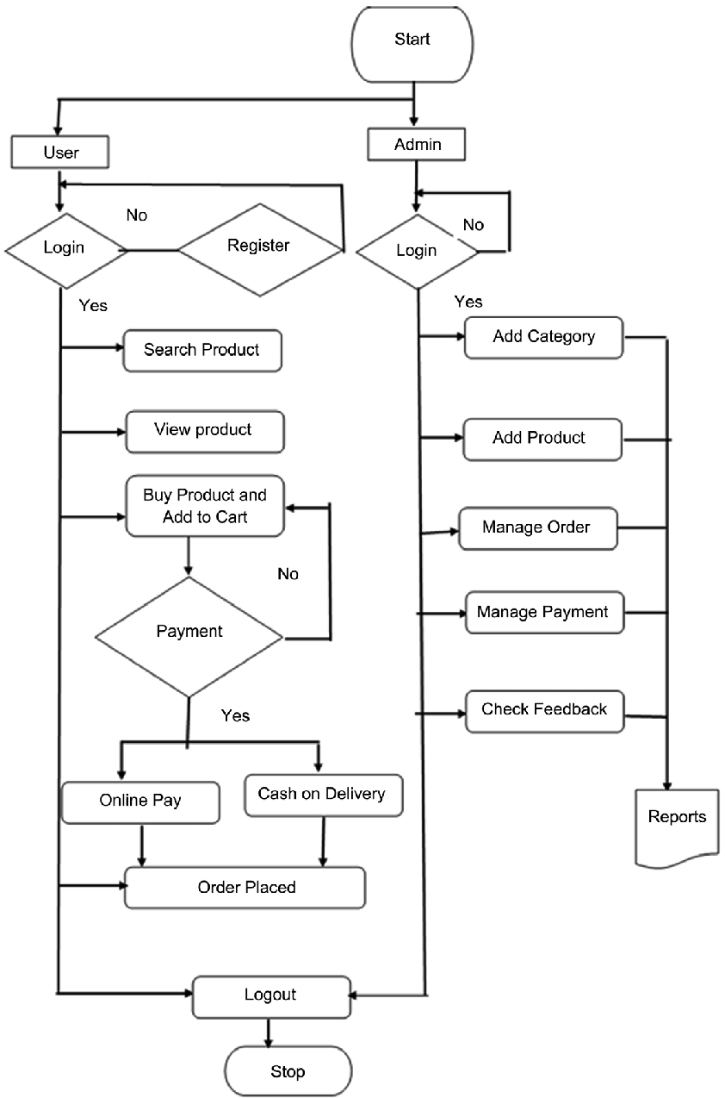

**IX. FUTURE SCOPE**

The future of digital marketplaces is set to be shaped by emerging technologies and evolving consumer demands. Artificial Intelligence (AI) and Machine Learning will play a crucial role in personalizing user experiences, optimizing search results, and detecting fraudulent activities. Blockchain technology is expected to enhance transaction security and transparency, ensuring greater trust among buyers and sellers. Augmented Reality (AR) and Virtual Reality (VR) will provide immersive shopping experiences, allowing customers to visualize products in real-world settings before making purchases. Voice commerce, powered by AI-driven assistants, will simplify transactions and improve customer interactions. With mobile-first commerce becoming the norm, platforms will need to optimize their interfaces for seamless navigation on smartphones. Global expansion of eCommerce will continue, supported by multi-currency payment systems and localized marketplaces. Additionally, sustainability initiatives will gain traction, with businesses prioritizing eco-friendly products and ethical supply chains. Strengthening cybersecurity measures will also be a priority to safeguard user data and transactions. Furthermore, subscription-based and personalized shopping models will drive consumer engagement, while advancements in 5G and edge computing will enhance platform performance. These developments will shape the next generation of digital marketplaces, making them more secure, efficient, and user-friendly.

**X. CONCLUSION**

The digital marketplace has revolutionized the way businesses operate and consumers shop, offering unparalleled convenience, scalability, and global reach. Despite its numerous advantages, challenges such as cybersecurity threats, market saturation, regulatory compliance, and customer trust must be addressed for sustainable growth. Emerging technologies like AI, blockchain, and AR/VR are playing a pivotal role in overcoming these challenges, enhancing security, personalization, and user experience. As digital marketplaces continue to evolve, businesses must adapt to changing trends and consumer expectations. Future developments will focus on improving security, integrating new technologies, and ensuring a seamless, customer-centric shopping experience. With continued innovation and strategic advancements, digital marketplaces will remain a dominant force in the global economy, providing businesses and consumers with more efficient and secure online transactions.

**XI. REFERENCES**

• Laudon, K. C., & Traver, C. G. (2021). E-commerce 2021: Business, Technology, Society. Pearson Education.

• Chaffey, D. (2019). Digital Business and E-Commerce Management: Strategy, Implementation, and Practice. Pearson.

• Tiwana, A. (2013). Platform Ecosystems: Aligning Architecture, Governance, and Strategy. Morgan Kaufmann.

• Hagiu, A., & Wright, J. (2020). ‘When Data Creates Competitive Advantage’, Harvard Business Review, Vol. 98, No. 1, pp. 94–101.

• Brynjolfsson, E., Hu, Y. J., & Rahman, M. S. (2013). ‘Competing in the Age of Omnichannel Retailing’, MIT Sloan Management Review, Vol. 54, No. 4, pp. 23–29.

• Statista. (2023). ‘Global E-commerce Market Size 2023-2027’. Available at: [www.statista.com](https://www.statista.com).

• Kumar, S., & Petersen, P. B. (2006). ‘Impact of E-commerce in Supply Chain Management’, Journal of Business Logistics, Vol. 27, No. 2, pp. 81–100.

• Kaplan, A. M., & Haenlein, M. (2010). ‘Users of the World, Unite! The Challenges and Opportunities of Social Media’, Business Horizons, Vol. 53, No. 1, pp. 59–68.

• Zeng, D., Huang, Z., Yen, J., & Chen, H. (2007). ‘Business Intelligence in E-commerce’, IEEE Intelligent Systems, Vol. 18, No. 6, pp. 12–18.

• Sun, H. (2010). ‘Sellers’ Trust and Continued Use of Online Marketplaces’, Journal of the Association for Information Systems, Vol. 11, No. 4, pp. 182–211