[](https://www.researchgate.net/?enrichId=rgreq-d93457f416ee2ee35328fd9736d20701-XXX&enrichSource=Y292ZXJQYWdlOzMzNTgwNzQ1NTtBUzo5NDc5NzA3ODY3NTA0NjRAMTYwMzAyNTI1NjE5Mg%3D%3D&el=1_x_1&_esc=publicationCoverPdf)

See discussions, stats, and author profiles for this publication at: [https://www.researchgate.net/publication/335807455](https://www.researchgate.net/publication/335807455_Smart_Parking_Management_System?enrichId=rgreq-d93457f416ee2ee35328fd9736d20701-XXX&enrichSource=Y292ZXJQYWdlOzMzNTgwNzQ1NTtBUzo5NDc5NzA3ODY3NTA0NjRAMTYwMzAyNTI1NjE5Mg%3D%3D&el=1_x_2&_esc=publicationCoverPdf)

[Smart Parking Management System](https://www.researchgate.net/publication/335807455_Smart_Parking_Management_System?enrichId=rgreq-d93457f416ee2ee35328fd9736d20701-XXX&enrichSource=Y292ZXJQYWdlOzMzNTgwNzQ1NTtBUzo5NDc5NzA3ODY3NTA0NjRAMTYwMzAyNTI1NjE5Mg%3D%3D&el=1_x_3&_esc=publicationCoverPdf)

**Article** *in* International Journal of Computer Sciences and Engineering · May 2019

DOI: 10.26438/ijcse/v7i5.12041208

CITATIONS

6

READS

14,863

**5 authors**, including:

[](https://www.researchgate.net/profile/Bhagyashree-Dhakulkar?enrichId=rgreq-d93457f416ee2ee35328fd9736d20701-XXX&enrichSource=Y292ZXJQYWdlOzMzNTgwNzQ1NTtBUzo5NDc5NzA3ODY3NTA0NjRAMTYwMzAyNTI1NjE5Mg%3D%3D&el=1_x_4&_esc=publicationCoverPdf)[Bhagyashree Dhakulkar](https://www.researchgate.net/profile/Bhagyashree-Dhakulkar?enrichId=rgreq-d93457f416ee2ee35328fd9736d20701-XXX&enrichSource=Y292ZXJQYWdlOzMzNTgwNzQ1NTtBUzo5NDc5NzA3ODY3NTA0NjRAMTYwMzAyNTI1NjE5Mg%3D%3D&el=1_x_5&_esc=publicationCoverPdf)

Dr D Y Patil School of Engineering and Technology

**3** PUBLICATIONS **9** CITATIONS

[SEE PROFILE](https://www.researchgate.net/profile/Bhagyashree-Dhakulkar?enrichId=rgreq-d93457f416ee2ee35328fd9736d20701-XXX&enrichSource=Y292ZXJQYWdlOzMzNTgwNzQ1NTtBUzo5NDc5NzA3ODY3NTA0NjRAMTYwMzAyNTI1NjE5Mg%3D%3D&el=1_x_7&_esc=publicationCoverPdf)

All content following this page was uploaded by [Bhagyashree Dhakulkar](https://www.researchgate.net/profile/Bhagyashree-Dhakulkar?enrichId=rgreq-d93457f416ee2ee35328fd9736d20701-XXX&enrichSource=Y292ZXJQYWdlOzMzNTgwNzQ1NTtBUzo5NDc5NzA3ODY3NTA0NjRAMTYwMzAyNTI1NjE5Mg%3D%3D&el=1_x_10&_esc=publicationCoverPdf) on 18 October 2020.

The user has requested enhancement of the downloaded file.

 **International Journal of Computer Sciences and Engineering Open Access**

**Research Paper Vol.-7, Issue-5, May 2019 E-ISSN: 2347-2693**

**Smart Parking Management System**

**Amol Pomaji1*, Suraj Boinwad2, Shrikant Wankhede3, Pushpendra Singh4, Bhagyashree Dhakulkar5**

1Computer Department, Dr D.Y.Patil School of Engineering and Technology, Pune University, Pune, India 2Computer Department, Dr D.Y.Patil School of Engineering and Technology, Pune University, Pune, India 3Computer Department, Dr D.Y.Patil School of Engineering and Technology, Pune University, Pune, India 4Computer Department, Dr D.Y.Patil School of Engineering and Technology, Pune University, Pune, India 5Computer Department, Dr D.Y.Patil School of Engineering and Technology, Pune University, Pune, India

DOI: https://doi.org/10.26438/ijcse/v7i5.12041208 | Available online at: [www.ijcseonline.org](http://www.ijcseonline.org/) Accepted: 20/May/2019, Published: 31/May/2019

***Abstract*:** Now days parking are the critical issues in smart city. Due to parking problem traffic problems are increased, the proposed smart parking system implemented using the Android Application that’s provides to user an easy way of booking the parking slots through an application. Given system avoid the problem of traffic conjunction in commercial areas that unnecessarily consumes time, this paper provides the easy reservation system for parking. In this application the user can view various parking slots and check for the availability of slots. Whenever a user books a particular slot it will be marked red and all the available slots will be green. Booking can be done through credit card/net banking. This application also provides an additional feature of canceling the booked slot within 20 minutes from the time of booking. If the user fails to reach the destination on time then the reservation will be cancel and the payment is refunded. On successful payment a parking number is sent to user’s email or to his mobile number for further enquiry. Hence this application reduces the user’s effort and time of searching the parking slot and also avoids conjunction of traffic using the internet of things.

**Keywords—**Car Parking System (CPS), Android application, Parking Control Unit, IoT, ESP8266, Reader, Tag, IR Sensor

## Introduction

Too many cars, too much traffic and there is no enough parking area. This is the situation which is seen in most of the metropolitan cities today. People keep on roaming on roads searching for a parking space to park their vehicles especially at peak hours of time. Our proposed system presents a smart parking system that regulates a number of vehicles to the nearest parking space at any given time based on the parking space availability. Car Parking System (CPS) is implemented using the Operating System Android. The user requests the Parking Control Unit to check the status of available parking slots. As soon as the user request, all the available free slots are displayed to the user. If the availability of parking space is confirmed, the user can book the parking slot and proceed to pay. The vehicle follows its path towards the starting of the parking area. The user fixes his slots by showing his confirmation details to the concerned person at parking area.

After communicating, the vehicle will further follow its path to the allocated parking slot. After successful parking the slot details are updated simultaneously in the Administrators database. Finally the time to find for an empty parking slot is minimized. The main responsibility of the Intelligent Parking System (IPS) is to help the user to find an area where parking is available and total number of slots free in that area. Thus

our proposed methodology reduces the user’s effort and time of searching a parking slot

The purpose of the proposed system to,

* To increase efficiency of the current parking system
* To track the nearest car parking place via router.
* To book available free parking space
* To reduce time and efforts of drivers.
* To update and send notification to user of available space

The rest of the paper is organized as follows, Section I contains the introduction of environmental information and purposed of the proposed system, Section II contain the related work of other project idea, Section III contain the proposed system methodology, Section IV contain the architecture flow steps of system, Section V describes results and discussion, Section VI concludes (research work with future directions).

## Related Work

1. D. J. Bonde “Automated car parking system commanded by android application” in Proc. IEEE Conf.,03-05, Jan 2012 The aim of this project is to automate the car and car parking as well. A miniature model of an automated car parking system that can regulate and manage number of cars that can

be parked in given space at any given time based on the availability of parking slot. Automated parking is a method of parking and existing cars using sensing device. The entering and leaving to the lot is commanded by an android application [1].

1. Yanfeng Geng, Christos G. Cassandras, “A new “Smart Parking” system Infrastructure and Implementation”, Science Direct, Social and Science Behavioral sciences, 1278-1287

,2012 Smart Parking adopts the basic structure of PGI systems. In addition, such a system includes Driver Request Processing Centre (DRPC) and a Smart Parking Allocation Centre (SPAC). The Parking Resource Management Centre(PRMC) collects and updates all real time parking information and disseminates it via internet. The DRPC gathers driver parking requests and real time information(i.e., car location), keep track of driver allocation status, and sends back the assignment result to driver .The Smart Parking Allocation center makes assignment decisions and allocates and reserve parking spots for driver.[2]

1. M. A. R. Sarkar, A. A. Rokoni, M. O. Reza, M. F. Ismail, “Smart parking system with image processing facility” , I. J. Intelligent System and Application, 41-47, 2012. Smart Parking Systems obtain information about available parking spaces, process it and then place the car at that position. A prototype of the parking assistance system based on the proposed architecture was constructed. The effective circular design is introduced having rack-pinion special mechanism which is used to lift and place the car in certain position[5].
2. M. M. Rashid, A. Musa, M. AtaurRahman, and N. Farahana, A. Farhana “Automatic Parking Management System and Parking Fee Collection Based on Number Plate Recognition” International Journal of Machine Learning and Computing , 93-98, 2012. This paper discussed on automatic parking system and electronic parking fee collection based on vehicle number plate recognition. The aim of this research is to develop and implement an automatic parking system that will increase convenience and security of the public parking lot as well as collecting parking fee without hassles of using magnetic card. The auto parking system will able to have less interaction of humans and use no magnetic card and its devices. In additions to that, it has parking guidance system that can show and guide user towards a parking space. The system used image processing of recognizing number plates for operation of parking and billing system. Overall, the systems run with pre-programmed controller to make minimum human involvement in parking system and ensure access control in restricted places.
3. R. Yusnita, FarizaNorbaya, and Norazwinawati Basharuddin “ Intelligent Parking Space Detection System Based on Image Processing”, Internation Journal of Innovation, Management and Technology, 232-253, 2012. This paper aims to present an intelligent system for parking

space detection based on image processing technique that capture and process the brown rounded image drawn at parking lot and produce the information of the empty car parking spaces. It will be display at the display unit that consists of seven segments in real time. The seven segments display shows the number of current available parking lots in the parking area. This proposed system, has been developed in software and hardware platform.

# PROPOSED METHODOLOGY

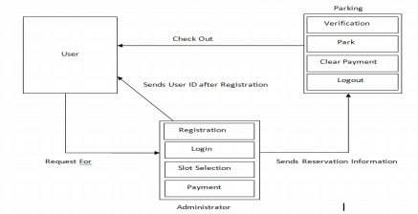

Fig 1. System architecture

Modules Car Parking System mainly consists of three modules. They are

* User Module
* Administrator Module
* Booking Module

## User Module

This module of the application deals with the user interface/user experience. This module provides the user with the flexibility of registering, logging in, booking and making the payment. If the user is new to the application then, the user must register in the application by providing the user’s details. After the registration, the user logs in using the user- id and password. Once the user logs in , then the user browses the parking slot then books that parking slot followed by the making the online payment.

## Administrator Module

This is the operative module of the application. It works in the backend for managing the database and performs various operations on it. The administrator stores all the user’s data in the database as soon as he gets registered with the application. Administrator maintains the details of all parking slots ( both empty and reserved ), their price for booking , user details in database and the modification on these data is only can be done by the administrator. The administrator also provides the payment method to the user.

## Booking Module

This is the main module of the application and it deals with the booking of the parking slot. When the user is ready for booking then the booking module comes in the scenario to provide user the necessary information for booking. The available slot, cost to book the slot and the necessary processing in regards to these, are done by this booking module.

# PROPOSED FLOW

**Hardware Description:**

ESP8266 Controller:

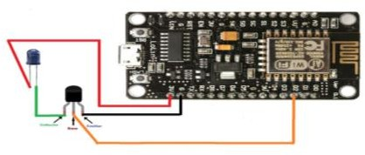A microcontroller is a small and low-cost computer built for the purpose of dealing with specific tasks, such as displaying information in a microwave LED or receiving information from a television’s remote control. Microcontrollers are mainly used in products that require a degree of control to be exerted by the user.

The slot allocation method follows a sequence as stated below:

Step1: Initially the slot selection is made by the user from his mobile phone. He checks for the availability of a parking slot that is nearest to his location. If it is available, he moves to the next stage or else go to the initial state.

RFID Reader:

Fig 3. ESP8266

Step2: Transfers request for parking slot from the mobile using Android application.

Step3: The Parking Control Unit (PCU) gets the slot number requested by the user.

Step4: If the payment is done successfully, then the requested slot is reserved in the parking area.

Step5: After reserving a particular slot by the user then the status of that respective slot will be marked as RED=RESERVED and the remaining will be GREEN=EMPTY.

Step6: As soon as the vehicle gets entered into the parking slot, the timer gets ON and measures the total time.

Step7: As soon as the vehicle moves out of the parking slot, the timer gets OFF and the total cost will be displayed.

# BLOCK DIAGRAM

An RFID reader's function is to interrogate RFID tags. The means of interrogation is wireless and because the distance is relatively short; line of sight between the reader and tags is not necessary. A reader contains an RF module, which acts as both a transmitter and receiver of radio frequency signals. RFID stands for Radio Frequency Identification Reader. There are many uses of RFID reader in today world. It is used to gather information from RFID tags.

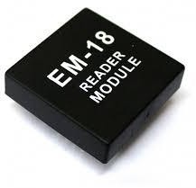

Fig 4. EM-18 Reader

RFID Tag:

RFID tagging is an ID system that uses small radio frequency identification devices for identification and tracking purposes. An RFID tagging system includes the tag itself, a read/write device, and a host system application for data collection, processing, and transmission.

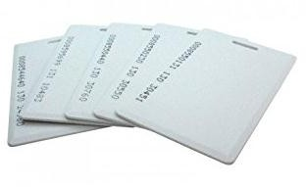

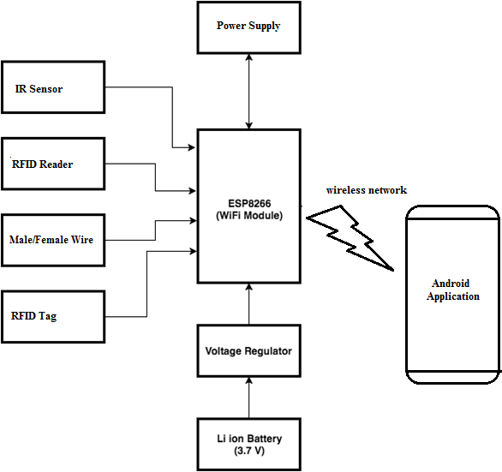Fig 5. RFID Tag

IR Sensor:

Fig 2. System block diagram

An infrared sensor is an electronic device, that emits in order to sense some aspects of the surroundings. An IR sensor can measure the heat of an object as well as detects

the motion.These types of sensors measures only infrared radiation, rather than emitting it that is called as a passive IR sensor.

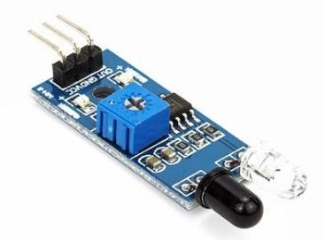

Fig 6. IR Sensor

# RESULT AND DISCUSSION

## Android Application Result:

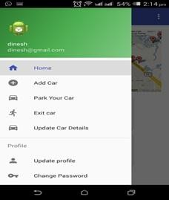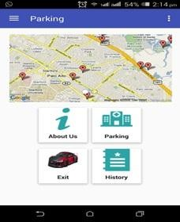

Fig 7. Android application result

Above fig7 show the android application modules, here user can check the parking slot as well as registration to the parking with all vehicle information.

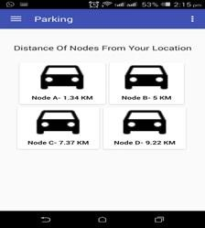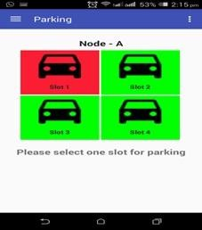

Fig 8. Parking slot indication

Above fig8 shows that available parking slot and full parking slot based on the color, red color meance parking slot is registered and green meance parking slot is available.

## Web Application Result:

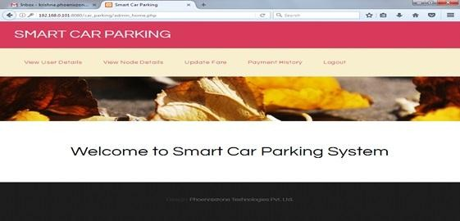

Fig 9. Web module home page

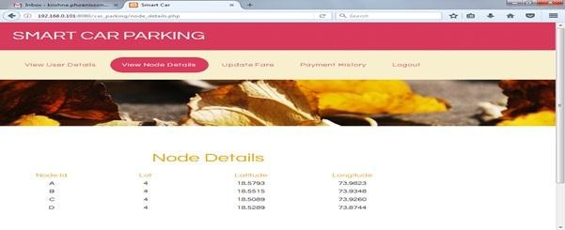

Fig 10. Parking slot node details

# ACKNOWLEDGMENTS

I wish to express my profound thanks to all who helped us directly or indirectly in making this paper. Finally I wish to thank to all our friends and well-wishers who supported us in completing this paper successfully I am especially grateful to our guide Prof. Bhagyashree Dhakulkar ma'am for time to time, very much needed, valuable guidance. Without the full support and cheerful encouragement of my guide, the paper would not have been completed on time.

# CONCLUSION

Smart Parking Management System (SPMS) is used to book parking slots without any great effort by the user using an android device. The user can check the status of parking area and book the parking slot in advance. This will result in overcoming many problems which are being created due to the bad management of the traffic. Mobile computing has proven as the best area of work for researchers in the areas of database and data management so this application is applied

in Android Mobile OS. This application is utilized by can be applied nook and corner due to its easy usage and effectiveness.

# REFERENCES

1. Faiz Ibrahim Shaikh, Pratik Nirnay Jadhav, Saideep Pradeep Bandarkar, Omkar Pradip Kulkarni, Nikhilkumar B. Shardoor “Smart Parking System Based on Embedded System and Sensor Network”, International Journal of Computer Applications (0975 – 8887) Volume 140 – No.12, April 2016 International Journal of Pure and Applied Mathematics Special Issue 171.
2. Thanh Nam Pham1, Ming-Fong Tsai1, Duc Binh Nguyen1, Chyi- Ren Dow1, And Der-Jiunn Deng2 “A Cloud-Based Smart-Parking System Based on Internet-of-Things Technologies”,IEEE Access, Received July 24, 2015, accepted August 16, 2015, date of publication September 9, 2015, date of current version September 23, 2015.
3. El Mouatezbillah Karbab, Djamel Djenouri, Sahar Boulkaboul, Antoine Bagula, CERIST Research Center, Algiers, Algeria University of the Western Cape, Cape town, South Africa,”Car Park Management with Networked Wireless Sensors and Active RFID”„,978-1-4799-8802-0/15 ©2015 IEEE
4. Mr. Basavaraju S R “Automatic Smart Parking System using Internet of Things (IOT)”, (International Journal of Scientific and Research Publications, Volume 5, Issue 12, December 2015)
5. M. M. Rashid, A. Musa, M. Ataur Rahman, and N. Farahana, A. Farhana, “Automatic Parking Management System and Parking Fee Collection Based on Number Plate Recognition.”, International Journal of Machine Learning and Computing, Vol. 2, No. 2, April 2012,Published 2014.
6. Hilal Al-Kharusi, Ibrahim Al-Bahadly, “Intelligent Parking Management System Based on Image Processing”, World Journal of Engineering and Technology, 2014, 2, 55-67.
7. X. Zhao, K. Zhao, and F. Hai, ``An algorithm of parking planning for smart parking system,'' in Proc. 11th World Congr. Intell. Control Autom. (WCICA), 2014, pp. 4965_4969.
8. L. Mainetti, L. Palano, L. Patrono, M. L. Stefanizzi, and R. Vergallo,``Integration of RFID and WSN technologies in a smart parking system,''in Proc. 22nd Int. Conf. Softw., Telecommun. Comput. Netw. (SoftCOM), 2014, pp. 104_110.
9. Harmeet Singh, Chetan Anand, Vinay Kumar, Ankit Sharma, “Automated Parking System With Bluetooth Access”, International Journal Of Engineering And Computer Science ISSN:2319-7242,Volume 3 Issue 5, May 2014, Page No. 5773-

5775

1. C. Shiyao, W. Ming, L. Chen, and R. Na, ``The research and implementof the intelligent parking reservation management system based on ZigBee technology,'' in Proc. 6th Int. Conf. Meas. Technol. Mechatronics Autom. (ICMTMA), 2014, pp. 741_744.

**Authors Profile**

*a).*Pushpendra Singh pursed Bachelor of Computer enginering from Pune University of Pune, India in 2019.He has interest in the area of artificial intelligence,Machine Learning, Deep Learning,Ethical Hacking and IoT. He is member of Computer Society of india(CSI) .

*b)*. Amol Pomaji pursed Bachelor of Computer engineering from Pune University of Pune, India in 2019. He has interest in the area of internet of thing,android. He is member of Computer Society of India(CSI).

1. **Suraj Boinwad pursed Bachelor of Computer engineering from Pune University of Pune, India in 2019.He has interest area in web development.He is member of Computer Society of India(CSI).
2. 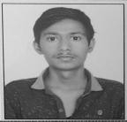Shrikant Wankhede pursed Bachelor of Computer engineering from Pune University of Pune, India in 2019.He has interest in the area of internet of thing(IoT).
3. Bhagyashree Dhakulkar is Graduate in BE (CSE) from St. Aloysius 2001 and ME in Computer Networks from SPPU in 2014. She is an Assistant Professor in DR. D Y Patil School of Engineering And Technology, Lohegaon, Pune