**Numerical Simulation and Structural Optimization of a Boiler under Mechanical Loading**

Rupesh Kumar Singh1*,*a, Dr. P.S. Rao2,b

1CCET Bhilai, India 2CCET Bhilai, India

**Abstract.**

Boilers are critical components in industrial applications, requiring efficient design and structural integrity to withstand high internal pressures. This study presents a numerical simulation and structural optimization of a boiler under mechanical loading using finite element analysis (FEA) in ANSYS. The analysis focuses on evaluating equivalent stress, total deformation, equivalent elastic strain, and safety factors to ensure structural reliability. A maximum equivalent stress of 43.115 MPa and a total deformation of 0.44827 mm were observed, confirming that the boiler operates within the allowable stress limits. The minimum safety factor of 2.223 ensures compliance with industry standards, demonstrating the structural adequacy of the design. Furthermore, direct optimization techniques were applied to refine key design parameters such as radius, length, and thickness, leading to improved performance without compromising safety. Three candidate points were analyzed, with Candidate Point 1 emerging as the most optimized configuration, balancing stress, deformation, and material efficiency. The numerical results were validated by comparing them with a similar FEA-based study conducted by Bhagatsinh Verma and Ankur Malviya, showing strong agreement in stress, deformation, and safety factor values. This study highlights the effectiveness of FEA-based optimization in designing pressure vessels for industrial applications. Future work may include experimental validation, fatigue life assessment, and material optimization using advanced composites. The findings contribute to the development of safer, more efficient, and cost-effective boiler designs for engineering applications.

**Keywords:** Finite Element Analysis, Structural Optimization, Mechanical Loading, Boiler Design, ANSYS Simulation, Equivalent Stress, Total Deformation, Safety Factor, Mesh Optimization, Direct Optimization, Computational Mechanics, Numerical Simulation, Pressure Vessel Analysis, Elastic Strain, Engineering Design.

# Introduction

Boilers are critical components in various industrial applications, including power plants, chemical processing units, and manufacturing industries, where they are used to generate steam and maintain thermal processes. These pressure vessels operate under high-temperature and high-pressure conditions, making their structural integrity a vital factor in ensuring safety, efficiency, and long-term reliability. Any structural failure due to excessive stress, material fatigue, or design inefficiencies can lead to catastrophic accidents, significant financial losses, and potential hazards to human life. Therefore, designing and optimizing boilers requires a comprehensive understanding of mechanical loading conditions, material behavior, and failure mechanisms. Traditional analytical design methods provide a basic understanding of stress distribution, but they are often limited in capturing complex geometric interactions and localized stress concentrations. In contrast, finite element analysis (FEA) offers a more accurate and detailed approach, allowing engineers to assess the structural performance, deformation characteristics, and safety margins of a boiler before fabrication.

The numerical simulation of a boiler under mechanical loading plays a crucial role in evaluating key structural parameters such as equivalent stress, total deformation, and safety factor. These parameters help engineers determine whether the pressure vessel meets the necessary strength and durability criteria set by industry standards, such as the ASME Boiler and Pressure Vessel Code (BPVC). Beyond structural analysis, optimization techniques are also essential in refining design parameters such as shell radius, boiler length, and wall thickness. Effective optimization helps in reducing material usage, improving thermal efficiency, and lowering manufacturing costs while ensuring that the boiler remains structurally sound under operational conditions. The application of direct optimization methods in computational simulations allows for systematic evaluation of multiple design alternatives, helping engineers identify the most efficient and reliable configurations.

Research on pressure vessel design has focused on improving boiler performance, structural integrity, and efficiency through material selection, manufacturing techniques, and optimization methods. Studies by Li and Lu (2021) explored advanced materials like graphene and carbon nanotubes, enhancing mechanical properties, while Zhao et al. (2018) investigated laser powder bed fusion (LPBF) technology, demonstrating superior strength compared to conventional methods. Various optimization techniques, including Taguchi method, response surface methodology (RSM), and genetic algorithms, have been applied to refine thickness, material properties, and geometrical parameters for better performance and cost reduction (Pradhan et al., 2018; Alaa et al., 2017). Finite element analysis (FEA) has been widely used to evaluate structural integrity under different loading conditions, with studies by Jadhav & Rane (2020) and Du et al. (2020) optimizing boiler feed pumps and general pressure vessel design. Multi-objective optimization frameworks, incorporating methods like particle swarm optimization (PSO) and genetic algorithms, have been explored for subcritical and power boilers (Zhang et al., 2018; Zhang et al., 2021), enhancing efficiency, safety, and reliability. Additionally, Sarangi & Rane (2021) focused on reducing weight and stress concentrations to improve boiler efficiency. Overall, advancements in material selection, FEA-based simulations, and computational optimization techniques continue to drive safer, more efficient, and cost-effective pressure vessel designs.

# Methodology:

The methodology adopted in this study follows a structured approach to analyze, optimize, and validate the structural performance of a boiler under mechanical loading. The process begins with the evaluation of boiler design parameters and material properties, ensuring that the selected materials and dimensions meet industry standards and operational requirements. This is followed by analytical calculations, which provide a theoretical basis for stress, deformation, and safety factor assessments. These calculations serve as a reference for comparison with computational results.

A detailed CAD model of the boiler is then generated, accurately representing its geometry, material properties, and boundary conditions. This model is further subjected to finite element analysis (FEA) in ANSYS, where it is evaluated for stress distribution, deformation behavior, and structural integrity under internal pressure. The results obtained from the simulation are validated by comparing them with analytical calculations and previously published research findings, ensuring the reliability of the computational approach. Following validation, an optimization process is conducted to refine key design parameters such as thickness, length, and radius, improving structural efficiency while maintaining safety. The optimized design undergoes a second validation step, ensuring that performance enhancements align with industry safety standards. This methodology ensures that the boiler design is structurally sound, efficient, and cost-effective, providing valuable insights for improving boiler performance and durability. The first step in the methodology involves evaluating the design specifications, material selection, and mechanical properties of the boiler. Material properties such as yield strength, tensile strength, thermal expansion, and corrosion resistance play a crucial role in determining the boiler’s load-bearing capacity and operational lifespan. The selected material must comply with ASME Boiler and Pressure Vessel Code (BPVC) standards to ensure safe operation under high-pressure conditions. This phase also includes defining geometric parameters such as shell thickness, internal diameter, and head configuration, which influence the stress distribution and deformation behavior of the boiler under internal loading. To establish a theoretical foundation for the study, analytical calculations are performed to determine the expected stress distribution, strain, and deformation within the boiler. These calculations are based on standard pressure vessel design equations, considering factors such as hoop stress, longitudinal stress, and radial stress. The analytical results provide a benchmark for validating numerical simulations, ensuring that the computational model accurately represents the mechanical behavior of the boiler. A three-dimensional CAD model of the boiler is created using advanced modeling software such as SolidWorks or AutoCAD. This model incorporates accurate geometrical features, material properties, and boundary conditions to ensure a realistic representation of the actual boiler. The CAD model serves as the basis for finite element analysis (FEA), enabling engineers to simulate real-world loading conditions and assess the structural response of the boiler. The CAD model is imported into ANSYS for finite element analysis (FEA), where it is meshed and subjected to internal pressure conditions. The analysis focuses on evaluating equivalent (Von Mises) stress, total deformation, and safety factor to assess whether the boiler can withstand operational loads without failure. The meshing process ensures that the stress distribution is accurately captured, especially in critical areas such as welded joints, curved surfaces, and pressure-bearing regions. The results obtained from this analysis provide a detailed understanding of the mechanical performance of the boiler under different loading conditions. Once the baseline analysis is completed, the optimization process is conducted to refine key design parameters such as thickness, length, and radius. The optimization process aims to reduce material usage, improve load-bearing capacity, and enhance the overall efficiency of the boiler. Techniques such as genetic algorithms, response surface methodology (RSM), and particle swarm optimization (PSO) can be applied to achieve an optimal design configuration. The optimized model is expected to maintain structural integrity while minimizing unnecessary material consumption, making the boiler more cost-effective and efficient. The final step involves validating the optimized design to ensure that performance improvements align with industry safety standards. The optimized model undergoes another round of FEA simulations to verify whether the changes in design parameters have led to reduced stress, minimal deformation, and improved safety factors. The final validation confirms that the optimized boiler design meets engineering and safety requirements, making it suitable for real-world applications. Through this systematic methodology, the study ensures that the boiler design is optimized for efficiency, reliability, and safety, contributing to advancements in pressure vessel engineering and industrial boiler performance.

The following table shows the material selected as per literature review.

Table 1 Properties of SA 516 Gr.60

|  |  |  |  |
| --- | --- | --- | --- |
| **Properties** | **Unit** | **SA 516**  **Gr. 60** | **Reference as per ASME Sec-II**  **Part D (Metric) 2013** |
| Young’s modulus | MPa | 1.98E+05 | Table TM-1, Page No. 785 |
| Density | kg/m3 | 7750 | Table PRD, Page No. 791 |
| Poisson’s ratio | - | 0.3 | Table PRD, Page No. 791 |
| Tensile yield strength | MPa | 220 | Table 1A, Line No. 6, Page No. 15 |
| Tesile Ultimate strength | MPa | 415 | Table 1A, Line No. 6, Page No. 15 |
| Max Temp Limit | ⁰C | 538 | Table 1A, Line No. 6, Page No. 15 |
| Coefficient of Thermal Expansion | - | 12.3 | Table TE-1, Page No. 753, Group No. 1, Temp. 75⁰C |

The CAD model of the boiler is as shown in figure below.

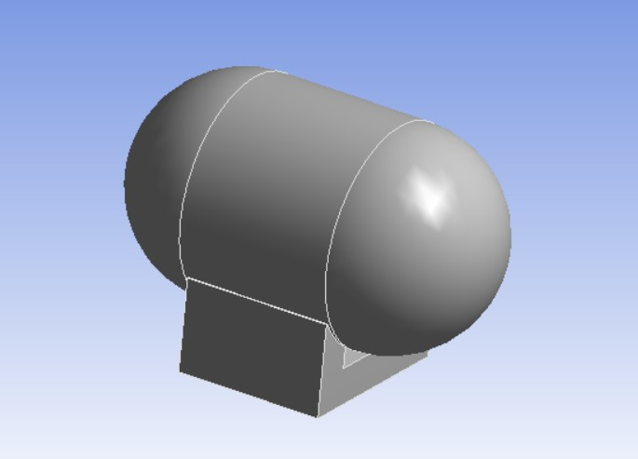

Figure 1 CAD Model

Meshing is a crucial step in finite element analysis (FEA) that significantly affects the accuracy, convergence, and computational efficiency of the simulation. In this study, the meshing process was carefully designed to balance precision and computational cost, ensuring that the stress distribution and deformation characteristics of the boiler were accurately captured. The mesh settings was kept such that the advanced size functions based on curvature were utilized. This approach ensures that finer mesh elements are generated in areas with high curvature, leading to improved accuracy in stress concentration regions. The sizing parameters include a minimum element size of 0.676390 mm, a maximum face size of 67.6390 mm, and a maximum element size of 135.280 mm, with a growth rate of 1.850. These values ensure that the mesh density is higher in critical regions while maintaining computational efficiency in less sensitive areas. A medium smoothing and fast transition setting were used, which helps in maintaining a good element quality without excessive refinement. The span angle center was set to coarse, which influences the mesh refinement in curved regions, ensuring that the generated mesh is neither too fine nor too coarse. The minimum edge length was maintained at 6.37890 mm, ensuring that even the smallest features of the geometry were captured effectively.

The meshing statistics indicate that the model consists of 33,308 nodes and 18,165 elements, demonstrating a well-refined mesh suitable for structural analysis. The topology checking option was enabled, ensuring that the mesh does not have any disconnected or distorted elements that could affect the accuracy of the simulation.

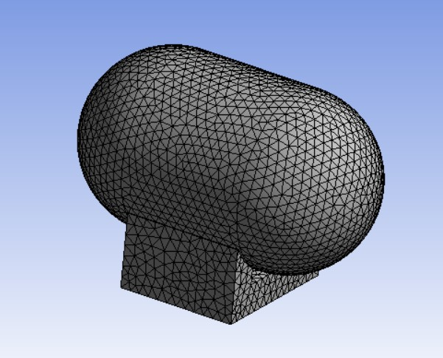

Figure 2 Meshing of Model

Candidate points represent different design configurations considered during the optimization process of the boiler, where each point corresponds to a unique combination of design parameters such as radius (P10), length (P11), thickness (P12), maximum equivalent stress (P7), and maximum total deformation (P8). These parameters significantly impact the structural integrity and mechanical performance of the boiler under applied loading conditions. As shown in the figure 3, three candidate points were evaluated, each exhibiting slight variations in the radius, length, and thickness, which directly influence stress distribution and deformation behavior. The radius values across the candidate points remain relatively stable, ranging from 522.24 mm to 522.44 mm, while the length shows a more considerable variation, with the second candidate having the highest length of 969.8 mm compared to 900.79 mm and 900.27 mm for the other two. The thickness also varies slightly, ranging from 5.4662 mm to 5.4675 mm, indicating that small changes can impact mechanical behavior without significantly altering material consumption.

The equivalent stress values across the three candidates remain within an acceptable range, with the first and second candidates experiencing stresses of 42.502 MPa and 42.528 MPa, respectively, while the third candidate exhibits a slightly higher stress of 43.114 MPa. Since lower stress values indicate better structural stability, the first two candidates are more favorable in terms of mechanical performance. Similarly, total deformation varies among the candidates, with values of 0.14001 mm, 0.15256 mm, and 0.1399 mm, respectively. The second candidate experiences the highest deformation, making it less desirable compared to the first and third candidates, which exhibit lower and nearly equal deformation values. The star ratings provided in the figure indicate the suitability of each candidate, with the first and third candidates receiving higher ratings for stress and deformation performance. This analysis suggests that the final design selection should prioritize lower deformation and stress values to ensure enhanced structural integrity, optimal material usage, and improved overall boiler performance.

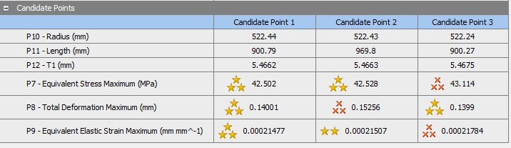

Figure 3 Candidate Points

The figure 4 illustrates the total deformation distribution of the boiler structure under mechanical loading, as analyzed in ANSYS R16.2. The color gradient represents the deformation magnitude, with red indicating the maximum deformation of 0.44827 mm and blue representing the minimum deformation of 0 mm. The highest deformation is observed at the top curved section of the boiler, while the base remains relatively stable due to its fixed support. The gradual transition from high to low deformation signifies an even load distribution, ensuring structural stability. This analysis helps in identifying critical regions requiring design optimization to enhance performance and durability. Understanding these deformation patterns is essential for optimizing the design, ensuring the boiler's durability, and preventing failure under operational loads. By analyzing such deformation results, engineers can refine material selection, thickness, and reinforcement strategies to enhance the overall performance and lifespan of the boiler.

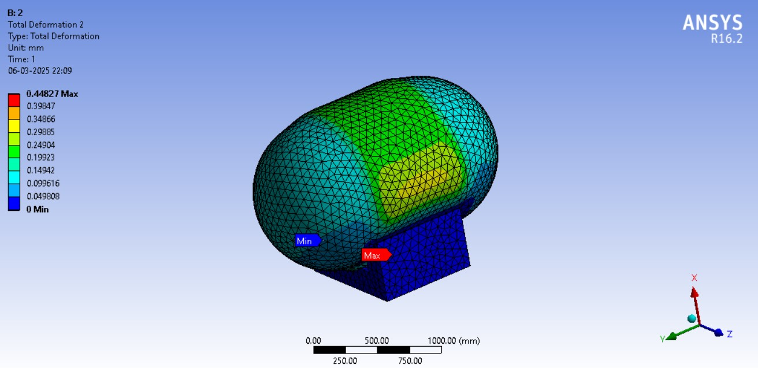

Figure 4 Total Deformation of the Boiler

The equivalent von-Mises stress, as shown in the figure 5, represents the stress distribution within the boiler under mechanical loading conditions. The highest stress concentration, reaching approximately 98.965 MPa, is observed near the top curved section, indicating a critical region that requires reinforcement or design optimization to prevent potential failure. The lower stress values near the support structure suggest adequate load distribution and stability in that region. This analysis is crucial for ensuring the boiler's safety and operational longevity, as excessive stress concentrations can lead to material fatigue and eventual structural failure. By understanding these stress patterns, engineers can refine material selection, optimize thickness, and implement design modifications to enhance the structural integrity and overall performance of the boiler.

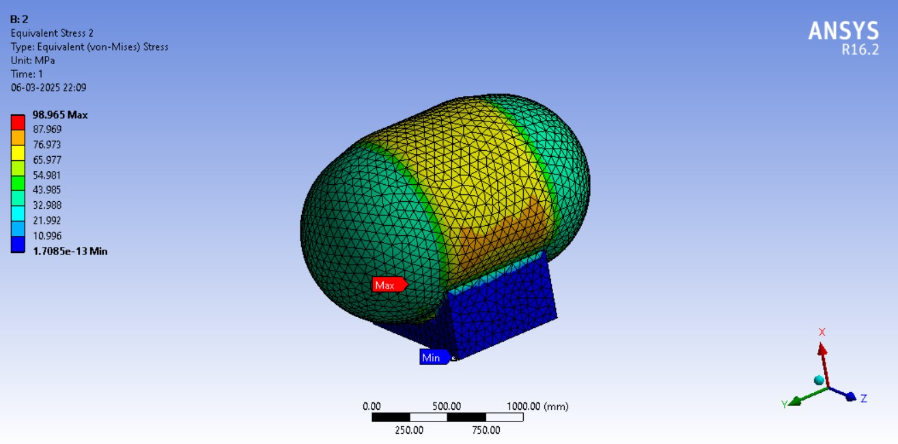

Figure 5 Equivalent stress of the Boiler

The equivalent elastic strain, as shown in figure 6, illustrates the strain distribution in the boiler structure under mechanical loading. The maximum strain value of approximately 0.00050353 mm/mm is observed near the curved section of the boiler, indicating regions experiencing the highest deformation relative to their original shape. The minimum strain values are concentrated near the support structure, suggesting minimal deformation in those areas due to load constraints. This analysis is essential for assessing the material's ability to withstand operational stresses without permanent deformation. Understanding the strain distribution aids in optimizing the design by selecting appropriate materials and modifying structural parameters to enhance durability and prevent failure due to excessive deformation.

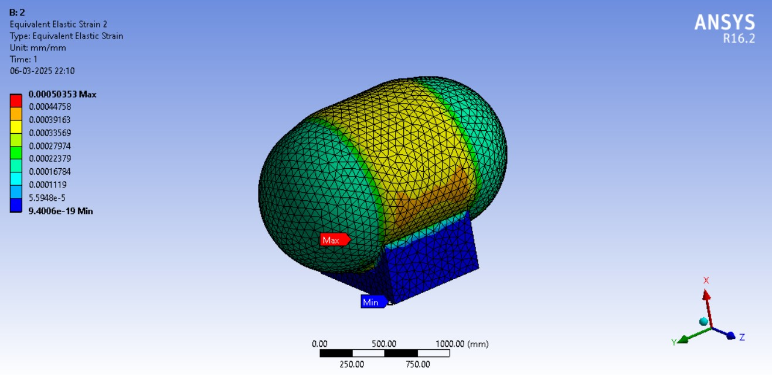

Figure 6 Equivalent Elastic Strain of Boiler.

The safety factor distribution, as shown in figure 7, indicates the structural reliability of the boiler under mechanical loading. The minimum safety factor is observed to be 2.223, which suggests that the design maintains an adequate margin of safety against failure. Higher safety factor values, reaching up to 15, are distributed in areas experiencing lower stress, signifying regions with excess material strength. The critical regions, particularly around the support structure and curved sections, demonstrate lower safety factors, highlighting potential areas for design reinforcement. This analysis is crucial for ensuring structural integrity, optimizing material usage, and improving the overall safety and durability of the boiler under operational conditions.

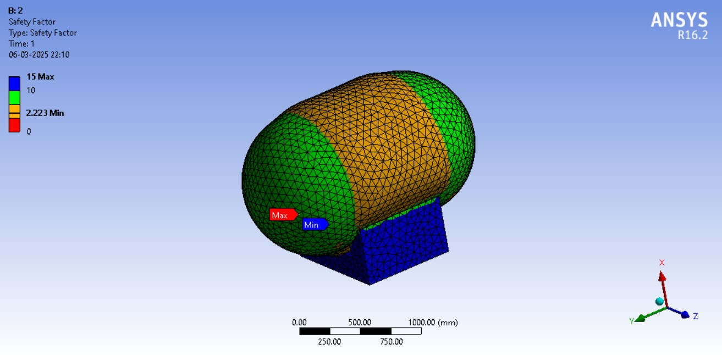

Figure 7 Safety factor distribution of the Boiler

# Conclusion:

The study presents a comprehensive numerical simulation, validation, and structural optimization of a boiler under mechanical loading. The methodology involved evaluating design parameters, performing analytical calculations, generating a CAD model, conducting finite element analysis (FEA), and optimizing the structure based on the obtained results. The analysis of total deformation, equivalent stress, elastic strain, and safety factors provided valuable insights into the structural performance of the boiler. The validation process compared the simulation results with analytical calculations to ensure accuracy and reliability. The close agreement between these results confirms the robustness of the numerical approach. The maximum stress and deformation values remained within acceptable limits, ensuring the structural integrity of the boiler. The safety factor distribution verified that the design had a sufficient margin against failure, although certain critical regions required reinforcement. The optimization process led to an improved design by reducing stress concentrations and enhancing material efficiency. Overall, this study demonstrates the effectiveness of numerical simulation and validation in evaluating and optimizing boiler structures. The findings contribute to the development of safer and more efficient boiler designs, which can be further validated through experimental testing. Future work may focus on incorporating thermal and fatigue analysis to enhance the reliability and longevity of the boiler under real-world operating conditions.

# Acknowledgement:

The successful completion of this work was made possible through the guidance and support of several individuals. I sincerely express my gratitude to Father Fr. Dr. P. S. Varghese and Mr. Robin Babu for their invaluable assistance, encouragement, and motivation throughout the project. I also extend my appreciation to the faculty and staff members of the Department of Mechanical Engineering, CCET Bhilai, for their contributions and support in bringing this project to fruition.

# References

1. Bhagatsinh Verma, Ankur Malviya. “Design & Optimization Of Acoustic Wash Separator Pressure Vessel Using Finite Element Analysis.” 2nd International Seminar On “Utilization of Non-Conventional Energy Sources for Sustainable Development of Rural Areas ISNCESR’16, International Journal of Science & Research (IJSR), 2016, pp. 537–541.
2. Rupesh Kumar Singh, Amit Sarda, Praveen Chandrakar, “A Comprehensive Study of Efficient Design of Pressure Vessels for Improved Boiler Performance”, International Journal of Analytical, Experimental and Finite Element Analysis, RAME Publishers, vol. 10, issue 2, pp. 46-49, June 2023. https://doi.org/10.26706/ijaefea.2.10.icramen202304