**Studying cultural stigma and educational gaps in the adoption of sustainable menstrual products**

1Attur Vaishnavi, 2Sujata Deogharia, 3Nischal P, 4Govindh M, 5Anmol Singh, 6Vishal M

[attur_vaishnavi24@cms.ac.in](mailto:attur_vaishnavi24@cms.ac.in), [sujata_deogharia24@cms.ac.in](mailto:sujata_deogharia24@cms.ac.in), [nischal_p24@cms.ac.in](mailto:nischal_p24@cms.ac.in), [govindh_m24@cms.ac.in](mailto:govindh_m24@cms.ac.in), [anmol_singh24@cms.ac.in](mailto:anmol_singh24@cms.ac.in), [vishal_m24@cms.ac.in](mailto:vishal_m24@cms.ac.in)

MBA Students-24-26 Batch, Faculty of Management Studies, CMS Buisness School, JAIN (Deemed-to-be University), Bangalore

**Abstract**

This study investigates the relationship among menstrual education, cultural stigma, and the use of sustainable menstruation products. It emphasises how, despite the financial and environmental advantages of sustainable choices like reusable pads and menstrual cups, adoption is hampered by cultural taboos and a lack of knowledge. In order to eliminate damaging stigmas and encourage wise decisions, the study highlights the necessity of community-based education initiatives and collaborations with local authorities. The results show that although many respondents are somewhat aware of sustainable goods, their adoption is hampered by cultural attitudes, ignorance, and hygiene concerns. According to the study, boosting the use of sustainable menstruation products requires focused interventions like as education, culturally relevant messaging, and easier availability.

**Introduction**

Menstruation, a natural and recurring physiological process for a significant portion of the global population, remains shrouded in cultural taboos and often suffers from a lack of comprehensive education.

This pervasive silence and misinformation have far-reaching consequences, not only impacting the health, well-being, and dignity of menstruators but also hindering the adoption of more sustainable menstrual hygiene practices. Traditional norms, often rooted in misconceptions and societal shame, can create significant barriers to open discussions about menstruation, leading to inadequate knowledge about menstrual health and available product options. This lack of education, coupled with deeply ingrained cultural stigmas, significantly impedes the uptake of sustainable menstrual products (SMPs) such as reusable pads, menstrual cups, and period underwear, which offer environmental and potentially long-term economic benefits over disposable alternatives.

The environmental burden of disposable menstrual products is substantial, contributing significantly to landfill waste and plastic pollution. Furthermore, the financial strain of consistently purchasing these single-use items can disproportionately affect individuals and families in low-resource settings. Sustainable menstrual products present a viable solution to mitigate these challenges, offering a more environmentally responsible and potentially cost-effective approach to menstrual hygiene management. However, their widespread adoption is not merely a matter of access or affordability; it is deeply intertwined with the prevailing cultural perceptions and the level of menstrual health literacy within communities.

This research endeavors to explore the intricate relationship between cultural stigma, the lack of adequate menstrual education, and the limited adoption of sustainable menstrual products. Recognizing that effective change requires a multi-faceted approach, this study proposes to investigate the potential of community-based education programs and strategic partnerships with local leaders as key interventions to dismantle harmful stigmas and foster a more informed and supportive environment for sustainable menstrual practices. By understanding the nuances of local beliefs and engaging influential community members, this research aims to identify effective strategies for breaking the silence surrounding menstruation and paving the way for the wider acceptance and utilization of sustainable menstrual products.

**Review of Literature**

According to Jaafar, H., Ismail, S. Y., & Azzeri, A. (2023) period poverty is a serious public health issue that is typified by a lack of access to menstruation goods and insufficient management of menstrual hygiene. Through a thorough analysis of the body of research, the authors demonstrated the significant negative impacts on people's general well-being of cultural stigma, a lack of information, and limited access to necessary menstruation supplies. The findings of this study highlight the pressing need for focused public health campaigns to lessen the effects of period poverty, including educational activities, improved product accessibility, and the elimination of social stigmas associated with menstruation. Van Eijk et al. (2022) investigated the public health effects of reusable menstruation pads in their systematic review and meta-analysis. The authors evaluated the products' acceptability, safety, and effectiveness by a thorough review of previous studies, demonstrating their potential as a long-term and successful menstrual hygiene treatment. Reusable pads are well-tolerated, have high user satisfaction, and have few side effects, according to the data, which supports their inclusion in public health initiatives that aim to enhance menstrual hygiene management globally.

Peberdy, E., Jones, A., & Green, D. (2019) investigated how consumer purchase decisions and public knowledge of the environmental effect of menstruation products relate to one another. The researchers used survey data to show a strong link between adopting sustainable menstruation practices and increased environmental consciousness. Their results highlight the value of teaching programs designed to increase public knowledge of the environmental impact of single-use menstruation products and promote the switch to greener alternatives. Elledge et al. (2019) carried out a thorough analysis of the literature on waste disposal and menstrual hygiene management in low- and middle-income nations. The enormous barriers that menstruation people in these areas face—such as limited access to period products, inadequate sanitary facilities, and widespread cultural stigmas—were brought to light by this study synthesis. In order to safeguard the health and dignity of women and girls in LMICs, the authors underlined the vital need to put in place efficient MHM interventions and sustainable waste disposal systems.

Thornton, L. (2011) investigated the significant influence that insufficient menstruation education has on the persistence of stigma. The author exposed the negative consequences of disinformation and silence around menstruation by examining societal standards, educational institutions, and media impacts. Additionally, the study investigates how social media affects how people see menstruation. The results emphasised how important comprehensive menstrual education is to eradicating stigmas and promoting a more knowledgeable and tolerant public view of menstruation. Sommer, M., & Sahin, M. (2013) investigated the worldwide issues of managing menstrual hygiene, emphasising the taboos that prevent advancement. In a thorough analysis, they discovered that widespread stigmas severely hinder teenage girls' access to appropriate MHM, underscoring the need for internationally aware approaches to remove these obstacles and improve menstrual function.

Hennegan, J., Montgomery, P., & Phillips-Howard, P. (2016) evaluated how educational interventions and school-based MHM recommendations affected the wellbeing of girls. Their analysis showed that current recommendations frequently fall short of meeting the requirements of girls, highlighting the importance of culturally competent instruction in debunking misconceptions and encouraging good menstrual hygiene habits. Mason, Kirk, and Yu (2013) investigated how cultural beliefs affected menstruation behaviours in Guinea. According to a cross-sectional assessment, using unsustainable menstrual products is frequently the result of strong cultural traditions paired with a lack of information about menstruation. According to this study, a significant obstacle to the uptake of contemporary sustainable menstruation products is cultural attitudes.

Sumpter, C., & Torondel, B. (2013) examined how student health in LMIC schools is affected by water, sanitation, and hygiene conditions, with a particular emphasis on MHM. In order to combat cultural stigmas and advance sustainable MHM practices, their findings highlight the significance of community-based initiatives. The authors demonstrate that the effectiveness of an intervention depends on the participation of community people and local leaders. Tegegne, T. K., & Sisay, M. M. (2019) examined MHM behaviours among teenage schoolgirls in Northeast Ethiopia and found that disposable menstruation products had a major negative environmental effect. Their research emphasises how urgently sustainable substitutes and greater awareness are needed to lessen the environmental impact of menstrual waste.

A thorough analysis of menstrual hygiene management (MHM) in low- and middle-income nations was carried out by Dittrich, S., Taegtmeyer, M., & Williams, C. (2020), demonstrating the crucial connection between menstrual health and poverty. Their research showed that access to necessary menstruation products is severely hampered by a lack of financial resources combined with pervasive cultural stigmas. This analysis emphasises the intricate relationship between socioeconomic issues and menstrual hygiene, showing how poverty not only restricts access to essential supplies but also feeds a vicious cycle of stigmatisation and insufficient knowledge, which ultimately makes it more difficult to implement healthy MHM practices.

**Research Methodology**

A structured questionnaire was used in this quantitative study to collect primary data on participants' knowledge of sustainable menstruation products, their experiences with cultural taboos, their perceptions of the benefits and drawbacks of these items, and their menstrual education. Each participant had an equal chance of being included in the sample of 85, which was chosen using a straightforward random sampling technique. The participants were given the questionnaire directly, which included a number of closed-ended questions intended to elicit certain answers according to the study's goals. Following that, descriptive analysis was performed to examine the data gathered, offering insights into the distribution and trends of answers within the sample.

**Data Analysis**

**Descriptive Analysis**

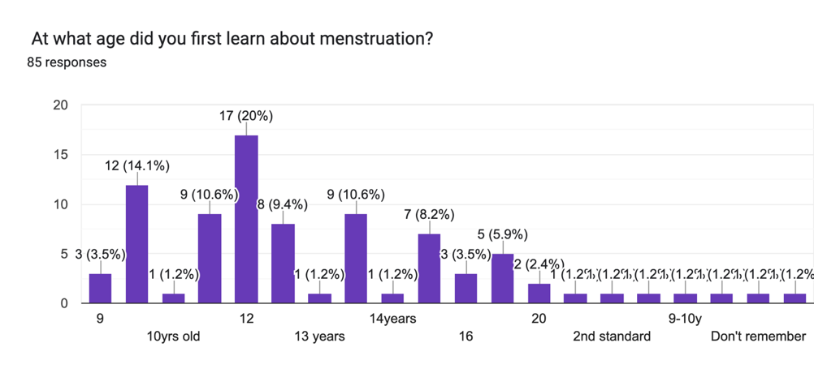Although the most typical age at which people learn about menstruation is 13, or seventh grade, the research shows that a sizable number of people hear about it earlier, at approximately age 11 or even between the ages of 9 and 10. This emphasises the significance of teaching children about menstruation in the early stages of adolescence and pre-adolescence. But there is no one optimal age for instruction, as seen by the vast variety of reported learning ages, which span from 10 to 25. This suggests that education on this topic takes place across different life stages. Interestingly, several respondents had trouble remembering when they first learnt about menstruation, which may indicate recall bias or that early instruction was not remembered. Moreover, the finding that menstruation education is mostly focused in the early years of life is supported by the low frequency of learning at later ages, such as 14, 15, 18, and 25.

The focus on learning around the ages of 13 and 7 highlights the necessity of educational programs that are specifically designed for this age range. The necessity of early intervention and education is highlighted by the fact that a sizable portion of people learn about menstruation before reaching puberty, indicating that curricula should be introduced earlier than previously believed. The wide variety of learning ages also emphasises the need for flexible and adaptive teaching strategies that can accommodate different learning requirements at different phases of life. More interesting and successful teaching techniques are required, as seen by the "don't remember" answers, which cast doubt on the effectiveness and memorability of the existing educational approaches.

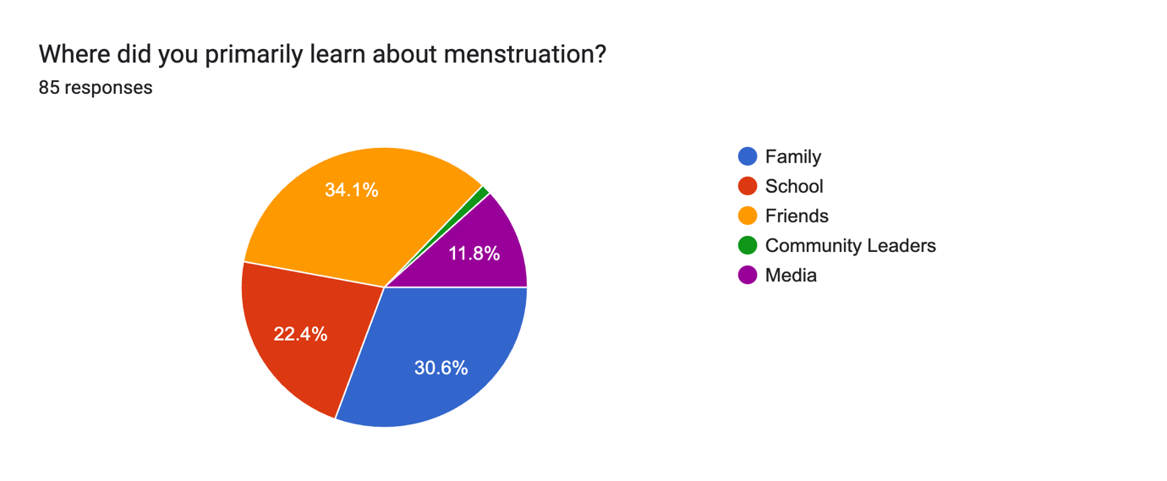

Nearly 65% of respondents cited school (34.1%) and family (30.6%) as their main sources of information regarding menstruation, underscoring the importance of both formal education and family supervision. Another important source is friends (22.4%), highlighting the significance of peer influence. On the other hand, media (1.1%) and community leaders (11.8%) contribute relatively little to the spread of menstruation information. This implies that among the respondents, media outlets and community-based projects are not the main sources of information. The necessity of accurate and efficient menstruation education in these settings is highlighted by the heavy dependence on family and school. The lack of media impact, however, suggests a possible weakness in the use of a variety of venues for wider outreach. These results should be interpreted with caution since they are based on a sample size of 85, which might not accurately reflect a wider population.

The importance of strong educational programs and knowledgeable parental assistance is shown by the dominance of the family and the school in menstruation education. Because friends play such an important role, outreach initiatives should incorporate peer education. The possibility for participation is highlighted by the low impact of community leaders, which indicates a lack of community-based support. In a similar vein, the low media effect calls for investigating methods to use media platforms for the distribution of factual information. For thorough menstruation awareness, it is ultimately essential to concentrate on enhancing peer, family, and school education while increasing community and media involvement.

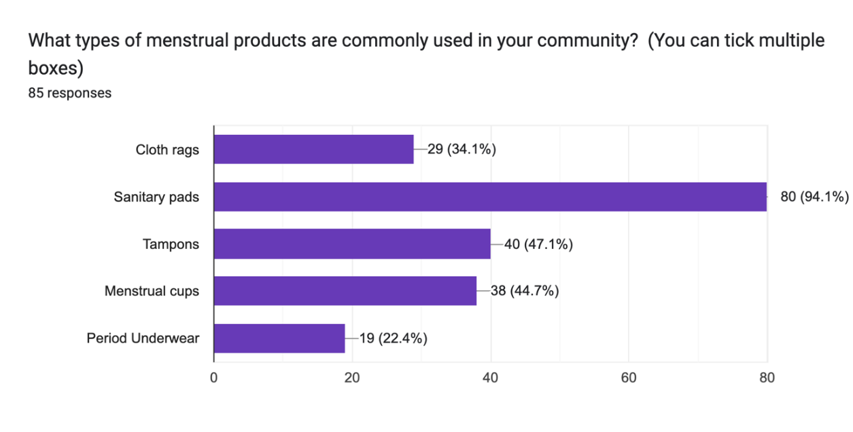

The fact that sanitary pads account for 94.1% of menstruation product consumption shows how popular they are. Menstrual cups (44.7%) and tampons (47.1%) are also widely used, suggesting a high uptake of internal goods. Cloth rags (34.1%) are still widely used, indicating a persistent dependence on conventional techniques. Perhaps because of availability or cost, period pants is the least popular (22.4%). As a reflection of their diverse requirements and preferences, respondents frequently utilise numerous items.

The prevalence of cotton rags and sanitary pads indicates that cost and accessibility are important considerations. The use of tampons and menstrual cups shows knowledge of internal choices, but all items require instruction. The usage of cloth rags draws attention to enduring customs. There is a business potential due to the poor adoption of period knickers. Comprehending these preferences is essential for focused interventions, educational initiatives, and marketing plans aimed at enhancing community menstrual hygiene.

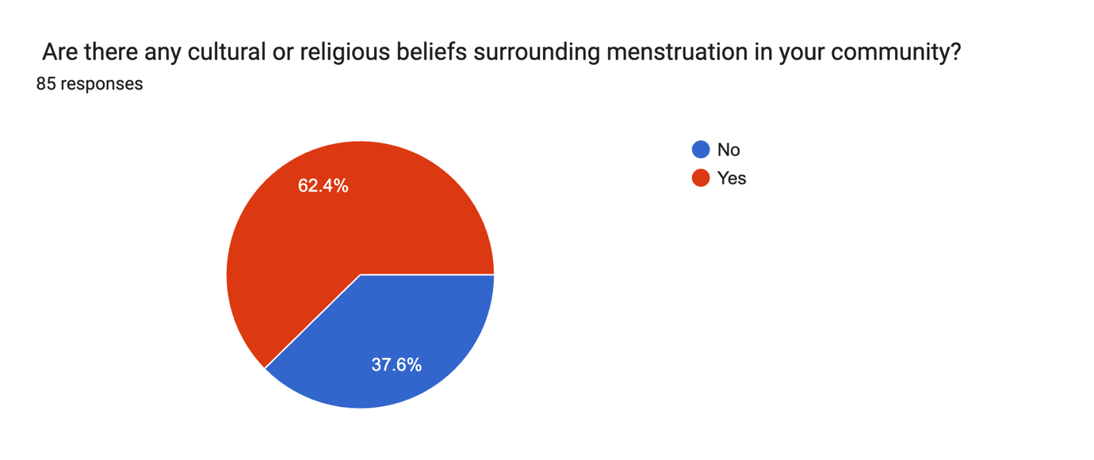

The vast majority of respondents- 62.4% acknowledge that there are cultural or religious attitudes about menstruation in their society, which is far more than the 37.6% who say there are none. This information demonstrates how common these views are among the people that were polled.

Cultural sensitivity in community talks is necessary due to the high prevalence of cultural or religious views around menstruation (62.4%). This draws attention to possible stigma and misunderstandings, highlighting the necessity of education and candid discussion to spread correct information. The sizeable minority (37.6%) who said they had no beliefs points to the diversity of the population. For culturally relevant menstrual health treatments and education, it is essential to acknowledge these dynamics.

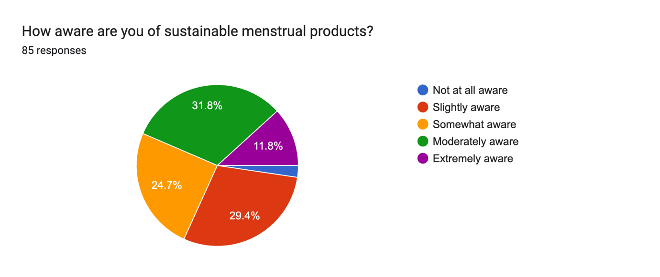

Most people (31.8%) are somewhat aware of sustainable menstruation products, with "slightly aware" (29.4%) and "somewhat aware" (24.7%) coming in second and third, respectively. Extreme awareness is limited to 2.3%, whereas complete unawareness is very modest at 11.8%. In addition to showing that people are generally familiar with sustainable products, this diverse distribution also shows that more education is required to raise respondents' knowledge levels.

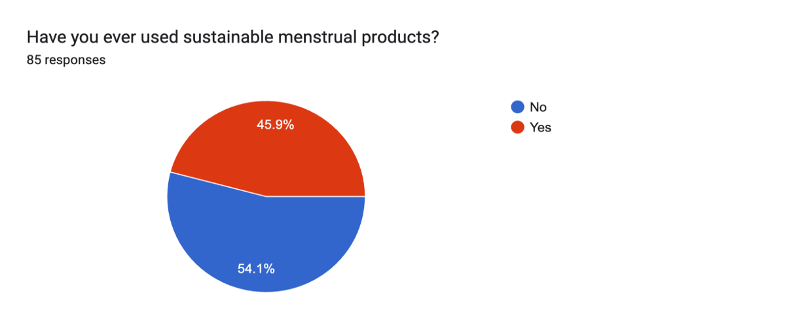There is an obvious need for further education and promotion given the predominance of moderate to minimal awareness of sustainable menstruation products. Targeted information initiatives are necessary to fill the knowledge gap indicated by the limited "extremely aware" section. Even while there is seldom total ignorance, awareness-building is still essential. Although filling in knowledge gaps is crucial, the data points to a bright market for sustainable products. Diverse levels of knowledge highlight the necessity of easily comprehensible information on the advantages and varieties of sustainable choices. In the end, concentrating on advertising and education can greatly increase community awareness and uptake of these items.

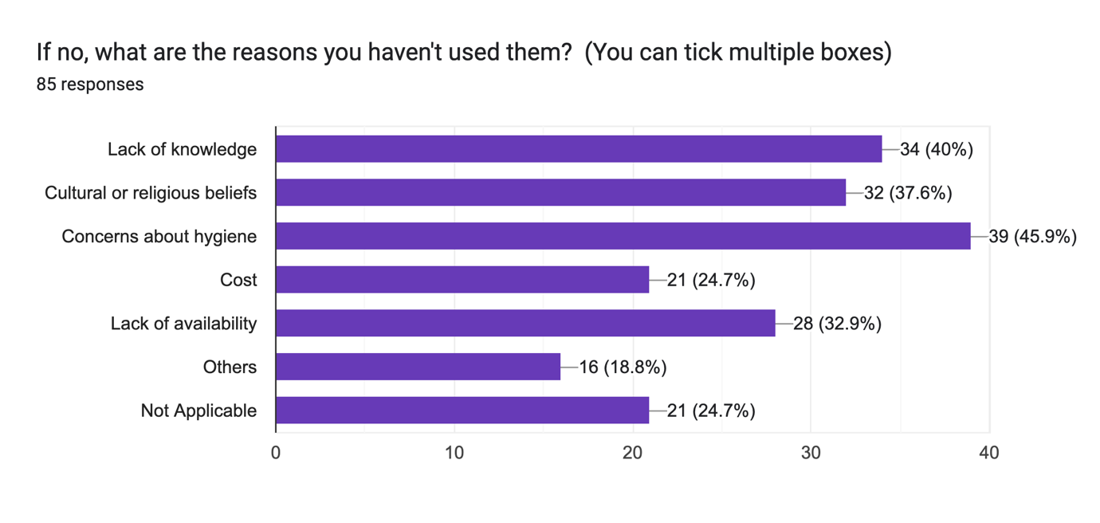  
There is a considerable chance for more adoption of sustainable menstruation products, since only 54.1% of respondents have used them, compared to a noteworthy 45.9% who have not. Cultural or religious views (37.6%), ignorance (40%), and health and hygiene concerns (45%) are the main barriers to consumption. Other considerations like cost (24.7%) and availability (32.9%) are much outweighed by these criteria. To fully comprehend the context of the "Not Applicable" result (24.7%), more research is necessary.

These issues serve as significant barriers to the adoption of sustainable products, even in the presence of some knowledge. Targeted treatments are therefore crucial. Dispelling hygienic misconceptions and giving correct information about the advantages and use of sustainable solutions should be the main goals of educational programs. Addressing and respecting religious and cultural beliefs while yet disseminating truthful facts requires culturally appropriate communications. Finally, in order to remove practical impediments, it is imperative that these items be made more affordable and available.

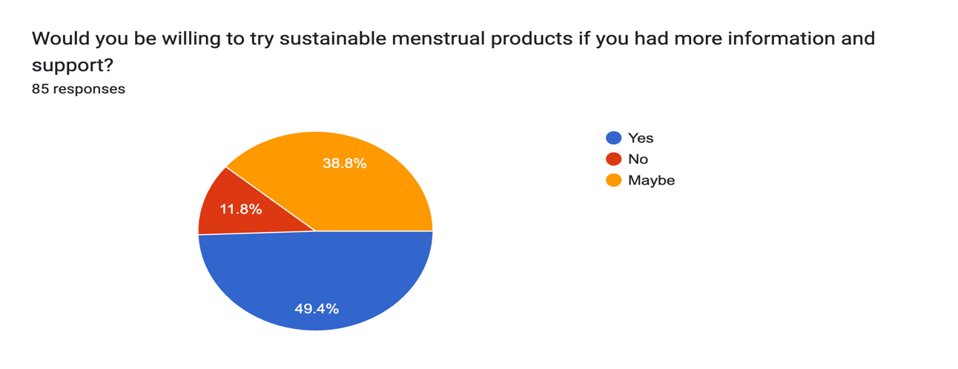

There is a considerable potential for adoption, since almost half (49.4%) of respondents said they would be open to using sustainable menstruation products given further guidance and assistance. The low percentage of outright rejections (11.8%) suggests that people are largely in favour of sustainable choices.

A considerable adoption potential is shown by the great desire to try sustainable menstruation products (49.4%) given more information and assistance. The 38.8% "Maybe" group is a prime candidate for conversion since their hesitancy indicates that they are receptive to influence. This optimistic perspective is further supported by the low rejection rate of 11.8%. It is essential to provide targeted information and support to address hurdles such as cultural unacceptability, use challenges, and cleanliness issues. Adoption of sustainable products in the society may be greatly increased by concentrating on these characteristics.

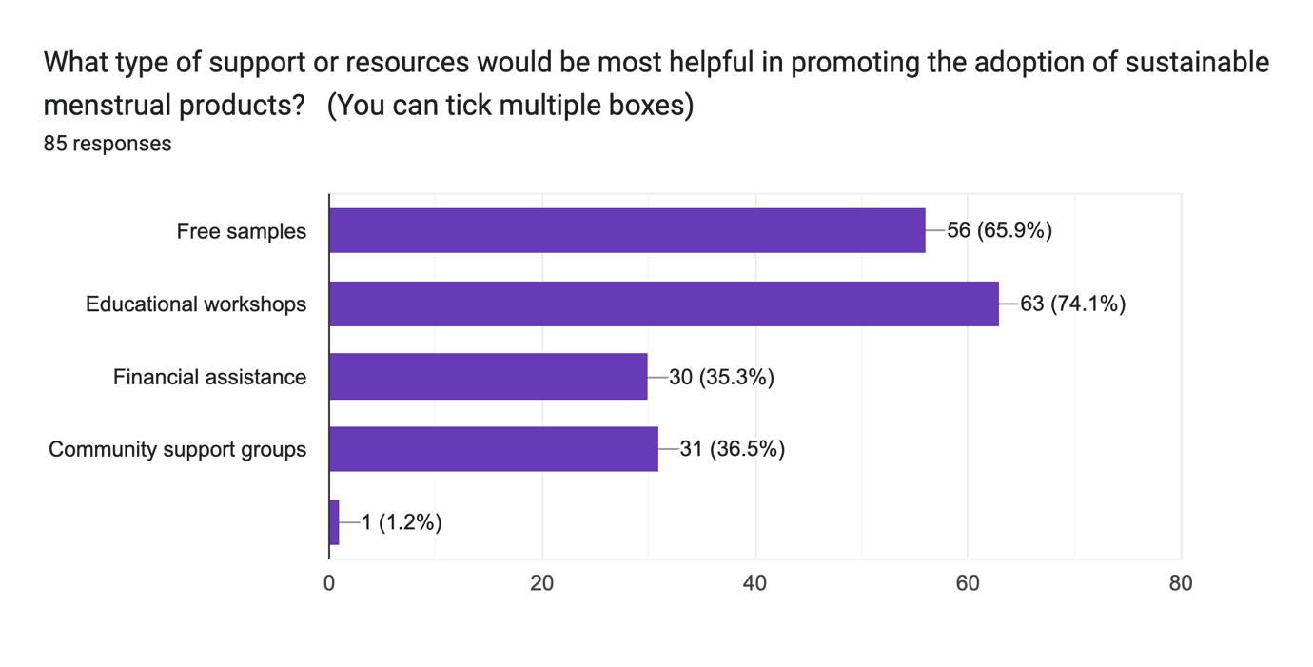

The most beneficial tools for encouraging the use of sustainable menstruation products are educational workshops (74.1%) and free samples (65.9%), underscoring the significance of education and real-world experience. Community support groups (36.5%) and financial aid (35.3%) provide moderate help, suggesting they provide an additional function. The little 1.2% unlabelled bar has no bearing. This information highlights the need for a diversified strategy.

It is essential to give instructional seminars first priority in order to distribute correct knowledge regarding advantages, use, and upkeep. Free samples encourage testing and offer useful practical experience. Although less desirable, community support groups can address issues and create a feeling of shared experience, while financial aid can remove financial obstacles. A complete approach that incorporates instructional sessions, free samples, and supportive resources like community groups and financial aid is necessary to effectively promote the adoption of sustainable products. This multifaceted strategy maximises the possibility of greater community acceptance by addressing a range of needs and concerns.

Findings and Recommendations

* Early Exposure vs. True Understanding: While a notable 15.1% learned about menstruation at age 10, the depth of their understanding at this age is unclear. It's possible this initial exposure was brief or superficial, not necessarily leading to comprehensive knowledge or challenging existing stigmas. This highlights the need to differentiate between initial awareness and meaningful education.
* Confirmation of a Critical Educational Window: The peak learning age of 13 (19.8%) strongly suggests that early adolescence is a crucial period for menstrual health education. This aligns with typical biological development and potential inclusion of this topic in early secondary schooling. However, the significant proportion learning before and after this peak indicates that a "one-size-fits-all" educational approach may not be sufficient.
* Influence of Peer and Informal Learning: The spread of learning ages (11 and 14 showing significant percentages) could also reflect informal learning through peers, family, or other sources. The accuracy and completeness of this informal learning can be variable and may perpetuate existing cultural myths and stigmas.
* The Formal Education System as a Key Touchpoint: The 8.1% learning in "7th grade" underscores the potential reach and impact of the formal education system. However, the fact that other significant percentages learn outside this specific grade level suggests that the timing and consistency of menstrual education within the school system might need review.
* Delayed Awareness and its Implications: The smaller percentages learning at ages 15, 18, and even 25 point to potential failures in the educational system or social structures to provide timely information. This delayed awareness could contribute to feelings of shame, anxiety, and a lack of informed choices regarding menstrual hygiene products, potentially reinforcing reliance on traditional, less sustainable options.
* The "Don't Remember" Category as a Sign of Ineffective Early Education: The individuals who "Don't remember" when they first learned about menstruation might suggest that the initial information was not impactful, delivered too early without proper context, or overshadowed by societal silence and stigma, preventing long-term retention or understanding.
* The Ambiguity of the "9-10y" Category: The aggregated nature of this category masks the specific age at which learning occurred for these individuals. It's crucial to understand if learning primarily happens closer to 9 or 10, as this would inform the optimal timing for early educational interventions. The low frequency here might also suggest that formal education on this topic is less common before age 10.
* Potential Link to Stigma and Product Choice: The age at which someone first learns about menstruation, and the manner in which they learn (e.g., open discussion vs. hushed tones), could significantly influence their attitudes towards menstruation and their willingness to consider and adopt sustainable menstrual products later in life. Early negative experiences or lack of information could reinforce reliance on familiar, often disposable, options.

**Recommendations**

* Advocate for Comprehensive and Age-Appropriate Menstrual Health Education Across All School Levels: Education should not be limited to a single grade. Age-appropriate information should be integrated from primary school onwards, gradually building understanding of the biological, social, cultural, and environmental aspects of menstruation. This includes destigmatizing menstruation and introducing sustainable product options early on.
* Invest in Teacher Training and Resource Development: Educators need adequate training and resources to deliver comprehensive and sensitive menstrual health education. This training should equip them to address cultural sensitivities, challenge stigmas, and provide accurate information about all types of menstrual products, including SMPs.
* Develop Culturally Sensitive Community Outreach Programs: Recognizing that formal education may not reach all individuals or effectively address deeply ingrained cultural beliefs, community-based programs are vital. These programs should be co-created with community members, involve local leaders and influencers, and utilize culturally relevant communication strategies to break down taboos and promote open discussions about menstruation and sustainable choices.
* Targeted Interventions for Parents and Families: Engaging parents and families in menstrual health education is crucial for creating a supportive home environment. Workshops, informational materials, and community events can help parents feel more comfortable discussing menstruation openly with their children and challenging intergenerational stigmas.
* Promote Peer Education and Youth Leadership: Empowering young people to become peer educators can be a highly effective way to disseminate accurate information and challenge negative attitudes among their peers. Providing training and support for youth-led initiatives can foster open conversations and normalize menstruation.
* Address the Specific Needs of Late Learners: Targeted campaigns and accessible resources should be developed for individuals who may have missed early education on menstruation. These initiatives should provide basic information, address potential anxieties or misinformation, and introduce sustainable product options in a non-judgmental manner.
* Conduct Further Research on the Impact of Early Education on SMP Adoption: Longitudinal studies could investigate the correlation between the age and quality of initial menstrual education and the likelihood of adopting sustainable menstrual products later in life. This would provide stronger evidence for the importance of early and comprehensive education.
* Advocate for Policy Changes to Support Menstrual Health and Sustainability: Policy changes at local and national levels can play a crucial role in promoting menstrual health and the adoption of SMPs. This could include mandating comprehensive menstrual health education in schools, subsidizing the cost of sustainable products, and implementing awareness campaigns to challenge cultural stigmas.
* Utilize Digital Platforms for Accessible and Destigmatized Information: Leveraging online platforms and social media can provide accessible and anonymous avenues for individuals to learn about menstruation and sustainable products, potentially overcoming some of the barriers associated with cultural stigma and face-to-face discussions. However, care must be taken to ensure information accuracy and cultural sensitivity.
* Collaborate with Local Organizations and NGOs: Partnering with organizations already working on women's health, environmental sustainability, and community development can amplify the reach and impact of educational initiatives and promote a holistic approach to menstrual health and product choices.

**Conclusion**

This study emphasises the intricate relationship that exists between the use of sustainable menstruation products, cultural stigma, and insufficient menstrual education. The results highlight how important it is to address these interrelated problems in order to improve menstrual health outcomes and encourage sustainable menstrual habits. While a small majority of respondents have used sustainable menstruation products, the survey finds that a sizable number have not, mostly because of cultural or religious views, lack of understanding, and cleanliness concerns. This emphasises the necessity of focused actions to deal with these particular obstacles. The best tools for encouraging adoption are found to be educational sessions and free samples, underscoring the significance of both information sharing and hands-on experience. Even though people learn about menstruation at a variety of ages, the research also shows that early adolescence is a crucial time for menstrual health education. This suggests that education should be age-appropriate and include a range of life stages. In addition, the study highlights the important role that families and schools have in educating people about menstruation and the need of accurate and thorough information in these contexts. A multifaceted strategy is recommended by the research to successfully encourage the adoption of sustainable menstruation products. Promoting thorough and age-appropriate menstrual health education at all educational levels, funding teacher preparation and resource development, creating culturally aware community outreach initiatives, and focussing on parent and family interventions are some examples of how to do this. In the end, this study emphasises how critical it is to dispel the shame associated with menstruation, confront cultural norms, and disseminate correct information in order to create a more encouraging atmosphere for sustainable menstrual practices. It is feasible to greatly boost the uptake of sustainable menstruation products and enhance the general wellbeing of menstruators by tackling the obstacles that have been identified and putting the suggested interventions into practice.

**Bibliography**

Jaafar, H., Ismail, S. Y., & Azzeri, A. (2023). Period poverty: A neglected public health issue. *Journal of Public Health Research*, *12*(3), 2977. [https://doi.org/10.4081/jphr.2023.2977](https://www.google.com/search?q=https://doi.org/10.4081/jphr.2023.2977)

van Eijk, A. M., Jayasinghe, N., Zulaika, G., Mason, L., Sivakami, M., Unger, H. W., & Phillips-Howard, P. A. (2022). Exploring menstrual products: A systematic review and meta-analysis of reusable menstrual pads for public health internationally. *PLOS Medicine*, *19*(12), e1004140. [https://doi.org/10.1371/journal.pmed.1004140](https://www.google.com/search?q=https://doi.org/10.1371/journal.pmed.1004140)

Peberdy, E., Jones, A., & Green, D. (2019). A study into public awareness of the environmental impact of menstrual products and product choice. *Sustainability*, *11*(11), 3122. <https://doi.org/10.3390/su11113122>

Elledge, M. F., Muralidharan, A., Parker, A., Ravndal, K. T., Siddiqui, M., Toolaram, A. P., & Woodward, K. P. (2019). Menstrual hygiene management and waste disposal in low and middle income countries: A review of the literature. WaterAid.

Thornton, L. (2011). The stigma of a stain: The gap in menstrual education. *Sex Education*, *11*(2), 173–187. [https://doi.org/10.1080/14681811.2011.558480](https://www.google.com/search?q=https://doi.org/10.1080/14681811.2011.558480)

Sommer, M., & Sahin, M. (2013). Overcoming the taboo: Advancing the global agenda for menstrual hygiene management for adolescent girls. *American Journal of Public Health*, *103*(9), 1556–1563. [https://doi.org/10.2105/AJPH.2013.301373](https://ajph.aphapublications.org/doi/full/10.2105/AJPH.2013.301373)

Hennegan, J., Montgomery, P., & Phillips-Howard, P. (2016). School menstrual hygiene management guidelines: A missed opportunity for improving girls’ wellbeing. *PLOS Medicine*, *13*(12), e1002167. [https://doi.org/10.1371/journal.pmed.1002167](https://journals.plos.org/plosmedicine/article?id=10.1371/journal.pmed.1002167)

Mason, L., Kirk, J., & Yu, A. J. (2013). Most women do not know what causes menstruation: A cross-sectional survey on menstrual knowledge among women in Guinea. *Reproductive Health*, *10*(1), 1–8. [https://doi.org/10.1186/1742-4755-10-28](https://reproductive-health-journal.biomedcentral.com/articles/10.1186/1742-4755-10-28)

Sumpter, C., & Torondel, B. (2013). A review of the water, sanitation and hygiene conditions in schools, in low-and middle-income countries and the impact on pupils’ health. *International Journal of Environmental Research and Public Health*, *10*(5), 1768–1791. [https://doi.org/10.3390/ijerph10051768](https://www.mdpi.com/1660-4601/10/5/1768)

Tegegne, T. K., & Sisay, M. M. (2019). Menstrual hygiene management and associated factors among adolescent school girls in Northeast Ethiopia. *BMC Pediatrics*, *19*(1), 1–9. [https://doi.org/10.1186/s12887-019-1589-2](https://bmcpediatr.biomedcentral.com/articles/10.1186/s12887-019-1589-2)

Dittrich, S., Taegtmeyer, M., & Williams, C. (2020). Menstrual hygiene management in low-and middle-income countries: A review of the literature. Journal of Global Health, 10(1). <https://www.jogh.org/documents/issue202001/jogh-10-010308.htm>