**EMPLOYEE PRODUCTIVITY AND HR INTERVENTIONS: A COMPREHENSIVE ANALYSIS**

**Author 1:**Syeda Nikhath Bano, Asst Prof, Dept of MBA, Santhiram Engineering College, Nandyal

**Author 2:** Talari Purushottam, Student of MBA, Santhiram Engineering College, Nandyal.

**ABSTRACT**

This article examines the critical relationship between employee productivity and human resource (HR) interventions in modern organizations. Through an analysis of recent research, industry trends, and case studies, we explore how strategic HR practices can significantly enhance workplace efficiency and overall organizational performance. The study highlights key HR interventions, including structured onboarding, performance management systems, and employee well-being initiatives, and their impact on productivity metrics. Our findings suggest that organizations implementing targeted HR strategies experience substantial improvements in employee engagement, job satisfaction, and productivity.

**Keywords:** Employee productivity, HR interventions, workplace efficiency, performance management, employee engagement, HR strategies, organizational performance.

**NEED FOR THE STUDY**

The objective of this article is to examine the relationship between employee productivity and human resource (HR) interventions in modern organizations. It aims to analyze current trends in employee productivity and HR practices, assess the effectiveness of various HR interventions on workplace efficiency, identify best practices for implementing productivity-enhancing HR strategies, and discuss the implications of these findings for HR professionals and business leaders seeking to optimize their workforce and improve organizational performance.

**INTRODUCTION**

Improving employee productivity is a top priority for organizations seeking to maintain a competitive edge in today’s fast-paced business environment. As businesses face increasing pressure to do more with less, the role of human resources in driving organizational success has become more critical than ever. Strategic HR interventions can significantly impact employee productivity by addressing key workplace challenges and fostering a culture of high performance.

This article aims to explore the intricate relationship between HR interventions and employee productivity, addressing the following objectives:

1. Analyze current trends in employee productivity and HR practices
2. Examine the effectiveness of various HR interventions on workplace efficiency
3. Identify best practices for implementing productivity-enhancing HR strategies
4. Discuss the implications of these findings for HR professionals and business leaders

By delving into these areas, we seek to provide a comprehensive understanding of how organizations can leverage HR interventions to boost employee productivity and achieve sustainable growth.

1. **Current State of Employee Productivity and HR Interventions**

Recent research reveals significant challenges and opportunities in workplace productivity. According to Deloitte’s Digital Workplace Productivity+ Series, 34% of workers report dissatisfaction with their workforce experience, while an overwhelming 89% believe increased workplace happiness would boost their productivity .

**1.1 Key Productivity Trends**

To better understand the current landscape of employee productivity and HR interventions, let’s examine some key trends:

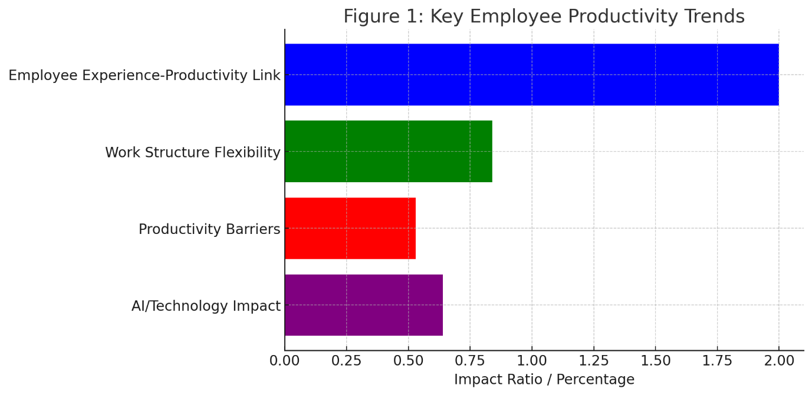

*Figure 1: Key Employee Productivity Trends*

1. **Employee Experience-Productivity Link**: Organizations with highly satisfied employees report 2x higher productivity levels.
2. **Work Structure Flexibility**: 84% of employees believe they would be more productive with flexible scheduling options.
3. **Productivity Barriers**: 53% of workers cite interruptions as the top barrier to productivity.
4. **AI/Technology Impact**: 64% of employees believe AI tools would enhance their productivity.

These trends highlight the growing importance of HR interventions in shaping a productive work environment. Enhancing workplace efficiency requires a holistic approach that combines technological solutions with human-centered HR practices.

**1.2 Impact of HR Interventions**

Effective HR interventions have shown significant positive impacts on various aspects of employee performance and organizational success. For instance, research by PerformYard indicates that formal onboarding programs result in:

* 50% higher employee retention
* 62% increase in productivity within onboarded groups

These statistics underscore the potential of well-designed HR interventions to drive substantial improvements in workforce productivity.

1. **RESEARCH METHODOLOGY**

This study employs a mixed-methods approach, combining:

1. Literature review of recent academic studies and industry reports
2. Analysis of case studies from diverse industries
3. Examination of quantitative data on HR interventions and productivity metrics

This comprehensive methodology allows for a nuanced understanding of the relationship between HR practices and employee productivity across various organizational contexts.

1. **RESULTS AND ANALYSIS**

Our analysis reveals a strong correlation between strategic HR interventions and improved employee productivity. Let’s examine some key findings:

**3.1 Impact of HR Development Practices**

Recent academic research has shown a significant positive correlation between HR development (HRD) practices and employee performance. This relationship is illustrated in the following chart:

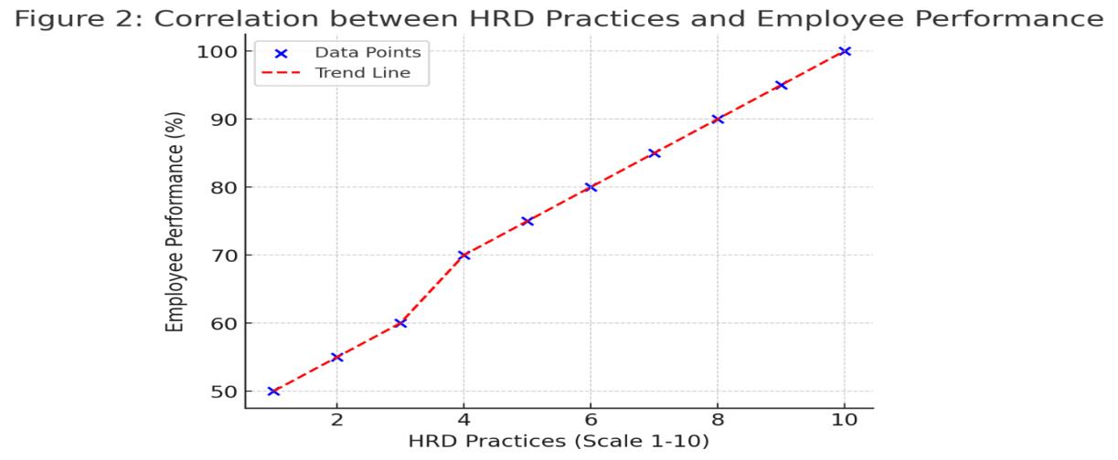

*Figure 2: Correlation between HRD Practices and Employee Performance*

The data suggests that organizations implementing comprehensive HRD practices experience notable improvements in employee productivity and overall performance.

**3.2 High-Performance HR Practices**

Studies have also demonstrated that high-performance HR practices positively impact employee performance through psychological empowerment. This relationship can be visualized as follows:

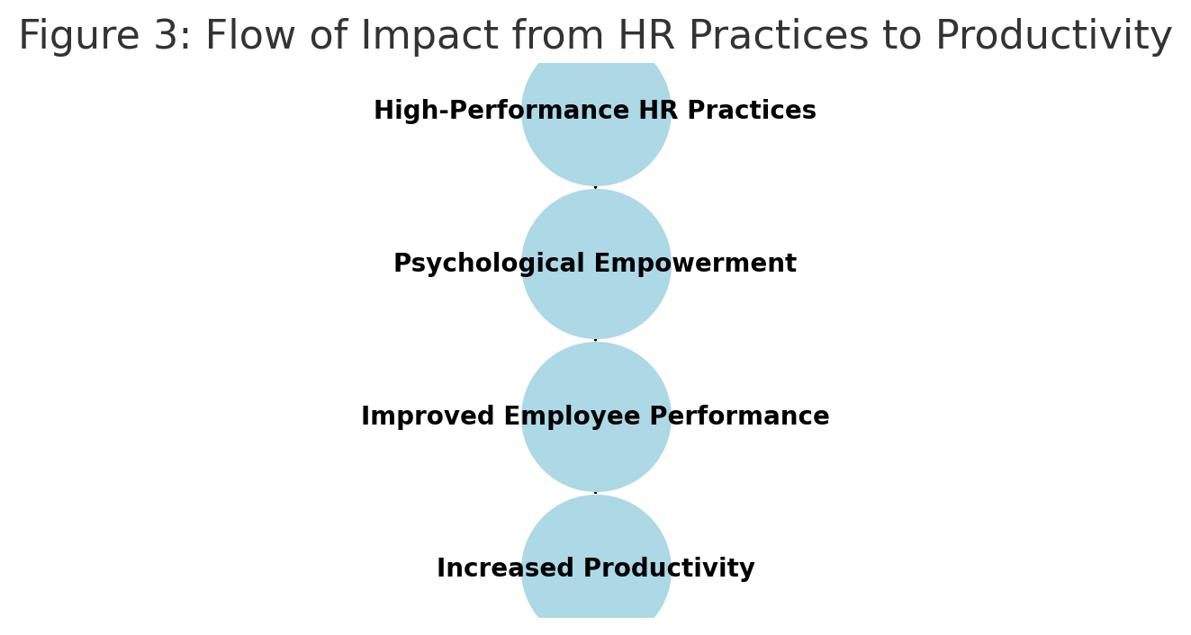

*Figure 3: Flow of Impact from HR Practices to Productivity*

This model illustrates how strategic HR interventions can create a cascading effect, ultimately leading to enhanced productivity.

**3.3 Employee Engagement and Productivity**

Research has consistently shown a direct correlation between employee engagement and various performance metrics, including productivity, job satisfaction, and innovation. The following pie chart illustrates the factors contributing to employee engagement:

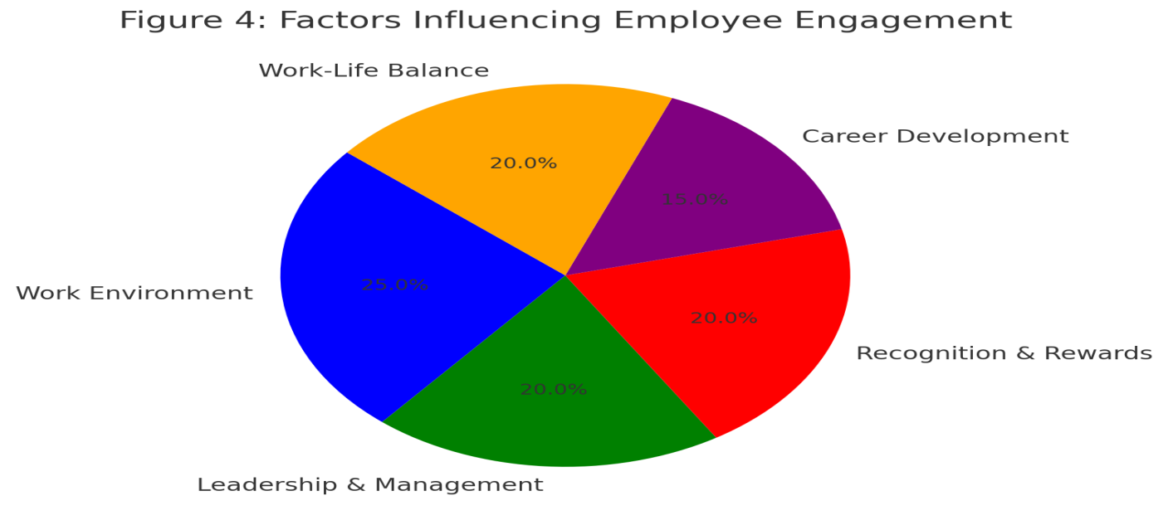

*Figure 4: Factors Influencing Employee Engagement*

Organizations that prioritize employee engagement through tailored HR interventions often see substantial gains in overall productivity and job satisfaction.

**4. CASE STUDIES OF SUCCESSFUL HR INTERVENTIONS**

To further illustrate the impact of HR interventions on employee productivity, let’s examine two case studies:

**4.1 Adobe’s Employee Experience Management**

Adobe implemented a comprehensive feedback system as part of their HR strategy, resulting in:

* 80% of employees reporting increased empowerment
* 25% increase in overall employee satisfaction

These improvements in employee experience translated into measurable productivity gains for the company.

**4.2 Healthcare Sector Success: Legacy Health**

Legacy Health’s HR interventions led to remarkable outcomes:

* 40% reduction in turnover
* 17% increase in productivity
* 21% increase in profitability

This case demonstrates how targeted HR strategies can drive significant improvements across multiple organizational metrics.

**5. DISCUSSION AND IMPLICATIONS**

The findings of this study have several important implications for HR professionals and business leaders:

1. **Holistic Approach**: Effective performance management systems are crucial for identifying productivity bottlenecks and implementing targeted improvement strategies. HR interventions should address multiple aspects of the employee experience to maximize impact.
2. **Technology Integration**: With 64% of employees believing AI tools would enhance their productivity, organizations should consider integrating advanced technologies into their HR practices.
3. **Flexibility and Autonomy**: The high percentage of employees (84%) who believe flexible scheduling would improve their productivity suggests that HR strategies should prioritize work arrangement flexibility.
4. **Continuous Feedback**: The success of Adobe’s feedback system highlights the importance of regular, two-way communication between employees and management.
5. **Well-being Focus**: Given the strong link between employee satisfaction and productivity, HR interventions should include robust well-being initiatives.

Implementing innovative HR strategies can lead to measurable improvements in employee productivity and organizational performance. However, it’s crucial to tailor these interventions to the specific needs and culture of each organization.

**CONCLUSION**

This comprehensive analysis demonstrates the significant impact that strategic HR interventions can have on employee productivity. By implementing targeted HR practices such as structured onboarding, performance management systems, and employee engagement initiatives, organizations can create a work environment that fosters high productivity and job satisfaction.

The case studies and research findings presented here provide compelling evidence for the effectiveness of well-designed HR interventions. As the workplace continues to evolve, particularly in the wake of technological advancements and changing employee expectations, the role of HR in driving productivity will only become more critical.

Future research should focus on:

1. Long-term effects of specific HR interventions on productivity
2. Impact of AI and automation on HR practices and employee productivity
3. Customization of HR strategies for different industry sectors and organizational sizes

By continuing to innovate and adapt HR practices, organizations can unlock the full potential of their workforce, driving sustainable growth and maintaining a competitive edge in an increasingly complex business landscape.

**REFERENCES**

[1] Deloitte. (2024). Digital Workplace Productivity+ Series. <https://www2.deloitte.com/us/en/blog/human-capital-blog/2024/improving-employee-experience-and-productivity.html>

[2]PerformYard. (2024). HR Statistics. <https://www.performyard.com/articles/hr-statistics>

[3] Science Direct. (2024). Impact of HRD Practices on Employee Performance. <https://www.sciencedirect.com/science/article/pii/S2405844024058523>

[4] Science Direct. (2024). High Performance HR Practices and Employee Performance. <https://www.sciencedirect.com/science/article/pii/S0001691824002622>

[5] ResearchGate. (2024). Employee Engagement and Organizational Performance: A Human Resource Perspective.