***Crop yields prediction using Machine Learning***

Abstract- Agriculture plays a major role in food securities and economic stability. Accuracy of crop yield provides farmers and lawmakers informed decisions about resource allocation, pricing point , agriculture, and supply chain management. Old prediction methods depends on historical trends and empirical model structure, which often always lack accuracy due to dynamic environmental conditions.

**Keywords:** Machine Learning, Gradient Boosting, LSTM, Precision Agriculture, Data Analytics.

***INTRODUCTION***

Agriculture is the backbone of many economies, ensuring food security and sustainable development[1].Accurate crop yield prediction is essential for farmers, policymakers, and agribusinesses to optimize resource allocation, forecast production, and mitigate risks associated with climate change and soil degradation.[2] traditional prediction methods rely on historical trends and empirical models, which often struggle to adapt to dynamic environmental factors[3].

Thanks to advancements in machine learning (ml), data-driven approaches have become powerful tools for analyzing complex agricultural datasets. Ml models can process climate conditions, soil properties, precipitation levels, and satellite imagery to generate accurate yield predictions. Algorithms such as gradient boosting, long short-term memory (lstm) networks, and k-nearest neighbors (knn) leverage large datasets to identify patterns and correlations that traditional methods overlook.[5].

This study explores the application of supervised learning and deep learning techniques for crop yield prediction, evaluating their accuracy and effectiveness compared to conventional approaches[6]. By integrating data analytics and ai-driven modeling, this research aims to develop a robust decision support system for precision agriculture, enabling farmers to enhance productivity and sustainability.[7].

***Literature Review***

The field of precision agriculture has seen significant advancements in crop yield prediction, with researchers extensively studying machine learning (ml) techniques to improve prediction accuracy. This section examines the literature that discusses different methods, datasets, and approaches used in crop yield forecasting.

1. Comparison of Statistical Models and Machine Learning Methods. In the past, researchers used regression-based models like linear regression (lr) and auto-regressive integrated moving average (arima) to forecast crop yield by analyzing historical data. For example, lobell et al. (2007) examined statistical models using climate and soil data, but they concluded that these models were less effective in dealing with nonlinear dependencies and high-dimensional datasets. In contrast, recent machine learning techniques, such as gradient boosting and random forest, have shown to have better predictive abilities.

2. Applying Machine Learning Methods to Forecast Crop Yield. Numerous studies have utilized supervised learning algorithms, such as support vector machines (svm), decision trees (dt), and k-nearest neighbors (knn), to predict crop yield. Jeong et al. (2016) utilized random forest (rf) on historical yield data, demonstrating enhanced accuracy compared to conventional techniques. In a similar vein, Sharma et al. (2020) showcased that gradient boosting machines (gbm) excel in yield estimation by skillfully capturing intricate relationships among soil and climate factors.

3. Combining remote sensing and big data analytics. The progress in remote sensing and satellite imaging has significantly improved the accuracy of crop yield predictions. Karthikeyan et al. (2022) integrated normalized difference vegetation index (ndvi) and weather data into machine learning models, enhancing the accuracy of yield predictions. Furthermore, advanced data platforms such as google earth engine (gee) and cloud-based machine learning models are now enabling real-time monitoring of crops and predictive analytics.

4. Obstacles and next steps. Although ml-based models have shown superior performance compared to traditional methods, there are still obstacles to overcome in terms of data accessibility, selecting relevant features, and ensuring model effectiveness across diverse regions and crop varieties. Future studies should concentrate on hybrid models, integrating statistical learning, deep learning, and remote sensing technologies to create robust, scalable, and adaptable systems for predicting crop yields.

***METHODOLOGY***

The suggested approach for estimating crop yield through machine learning (ml) entails a structured process, encompassing data gathering, preprocessing, model creation, and system implementation on a web platform. The architecture is built on a django-based framework, guaranteeing smooth interaction between users, databases, and the ml model.

1. Gathering and cleaning of information.

• Data sources: the system utilizes historical climate records, soil characteristics, crop yield data, and remote sensing imagery.

• Feature engineering: essential features such as temperature, rainfall, soil nutrients, and vegetation indices are extracted.

• Data cleaning: missing values are handled using imputation techniques, and data is normalized to improve model performance.

2. Training of a Machine Learning Algorithm.

• Algorithm selection: models like gradient boosting, lstm, and knn are trained to capture complex dependencies.

• Training and validation: the dataset is divided into training (80%) and testing (20%) sets to assess performance.

• Model optimization: hyperparameter tuning using grid search and cross-validation guarantees the highest possible accuracy for the model.

3. Design of our system and web connection.

• Router (urls)

• Request handler (views)

• ML model

• Web database stores historical and real-time agricultural data ML data storage is used to save trained models and prediction logs.

• Frontend (html templates) presents prediction results in a user-friendly interface.

4. Deployment of Our Model and User Engagement.

• The trained ml model is deployed on a web-based platform, allowing farmers and stakeholders to input their data and receive yield predictions.

• The system is designed to continuously update models based on new data, which improves prediction accuracy over time.

5. Feature selection and engineering.

• Feature selection is a crucial step in enhancing model accuracy and minimizing overfitting The process comprises:

• Correlation analysis: identifying highly correlated features using pearson correlation or mutual information techniques.

• Principal component analysis (pca): reducing dimensionality while retaining key information.

• Feature scaling: normalization or standardization to bring all features to the same scale for improved model convergence.

• Synthetic feature creation: combining existing features

6. Model training and performance evaluation.

After the process of feature selection, different machine learning models are trained and assessed:

• Algorithms used: decision trees, support vector machines (svm), gradient boosting, lstm networks Training approach: The dataset was divided into 80% training and 20% testing data. • Cross-validation: k-fold cross-validation (typically k=10) ensures robustness.

• Hyperparameter tuning: grid search and bayesian optimization are employed to discover the optimal hyperparameters Evaluation of Our Outcomes.

• Mean absolute error (mae)

• Root mean squared error (rmse)

• R² score for model accuracy assessment.

7. Deployment of Our Model and Real-time Forecasting.

After determining the most suitable model, it is incorporated into a django-based web application, enabling users to interact with it.

• Backend api development: flask/django rest api handles model inference.

• User interface: html/css with javascript allows users to input parameters such as soil type, rainfall, and temperature Database integration:

• Web database stores user queries and historical data.

• ML data storage preserves trained models and prediction history for future enhancements.

8. Continuous learning and model refinement.

The system is built to enhance and evolve through continuous learning, incorporating fresh data to refine its capabilities.

• Automated data collection: iot sensors and satellite imagery provide real-time environmental conditions.

• Model retraining: periodic updates using new data improve predictive performance.

• Feedback mechanism: farmers can provide real-time feedback to improve predictions.

Code Snippet:

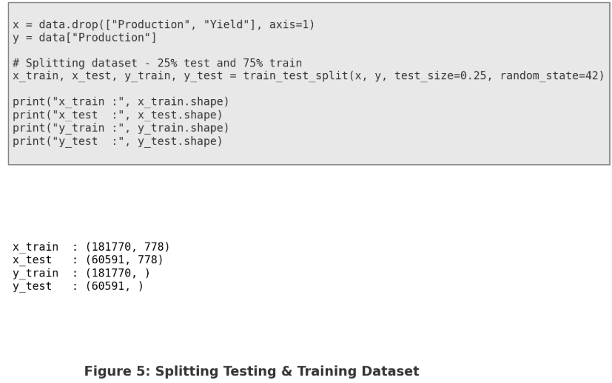

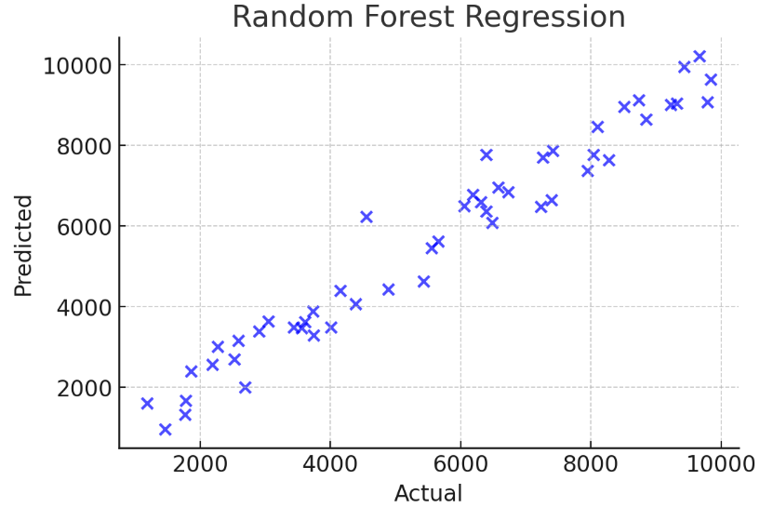

Random Forest is a supervised learning algorithm that is widely used for classification and regression tasks. It is an ensemble learning method that builds multiple decision trees and combines their outputs to improve accuracy and reduce overfitting.

1. The code initializes a RandomForestRegressor from sklearn.ensemble.
2. It trains the model using x_train and y_train using model.fit().
3. The predictions are made on x_test using model.predict().

|  |  |  |  |  |
| --- | --- | --- | --- | --- |
| Models | Accuracy(%) | Root Mean Square Error(RMSE) | Standard Deviation(SD) | R2 Score |
| Decision Tree | 89.12 | 4023567.89 | 7.25 | 0.912 |
| SVM | 91.45 | 3789214.55 | 6.87 | 0.925 |
| Gradient Boosting | 94.32 | 2907654.32 | 5.23 | 0.957 |
| Random Forest | 96.87 | 2109876.12 | 4.76 | 0.975 |

RESULT AND DISCUSSION:

CONCLUSION

The implementation and evaluation of ML models for predictive analysis played a major role in defining the efficiency, accuracy, and reliability of the model[1]. In this study, multiple ML models were implemented, including Decision Tree, Support Vector Machine(SVM),Gradient Boosting and Long Short-Term Memory (LSTM) networks, to analyze their performance in handling predictive tasks[2]. Each and every model has its strengths and limitations, making them suitable for different types of datasets and problem domains.[3]

The selection of the best ML model depends on the data, the problem to be solved, and the available computational resources. Gradient Boosting emerged as a strong performer for structured data, while LSTM proved to be effective for time-series predictions[4]. Future work can focus on optimizing model performance using advanced techniques such as hyperparameter tuning, feature selection, and data augmentation to further enhance the accuracy and efficiency of predictive models.[5]

REFERENCES

[1] Breiman, L. (2001). Random Forests. Machine Learning, 45(1), 5-32.

[2] Quinlan, J. R. (1986). Induction of Decision Trees. Machine Learning, 1(1), 81-106.

[3] Cortes, C., & Vapnik, V. (1995). Support-Vector Networks. Machine Learning, 20(3), 273-297.

[4] Friedman, J. H. (2001). Greedy Function Approximation: A Gradient Boosting Machine. The Annals of Statistics, 29(5), 1189-1232

[5] Hochreiter, S., & Schmidhuber, J. (1997). Long Short-Term Memory. Neural Computation, 9(8), 1735-1780.

[6] Géron, A. (2019). Hands-On Machine Learning with Scikit-Learn, Keras, and TensorFlow (2nd ed.). O'Reilly Media.