**Effects of Paclitaxel Loaded Polymeric Nanoparticles on Blood Flow in a Tapered Stenosed Artery**

Anuradha Singh1, Sapna Ratan Shah2

1Department of Mathematics, Harcourt Butler Technical University, Kanpur - 208002, (India).

2School of Computational and Integrative Sciences, Jawaharlal Nehru University, New Delhi-110067, (India)

[anuradha.singh2211@gmail.com](mailto:anuradha.singh2211@gmail.com),[sapnarshah@mail.jnu.ac.in](mailto:sapnarshah@mail.jnu.ac.in)

**Abstract:** This study investigates the impact of Paclitaxel-loaded nanoparticles on blood flow, heat transfer, and drug concentration in a stenosed artery using a mathematical modeling approach. The velocity profile is influenced by buoyancy forces, with the Grashof number enhancing flow dynamics, while resistance near the stenosis reduces velocity. The temperature profile reveals the critical role of thermophoresis and Brownian motion in promoting efficient heat dissipation, vital for regulating thermal gradients and improving nanoparticle efficacy. The drug concentration is highest near the stenotic region, ensuring targeted delivery, with enhanced diffusion facilitated by nanoparticle-induced effects. The results highlight the potential of nanotechnology to optimize cardiovascular treatments by improving drug delivery, enhancing thermal management, and reducing restenosis risks. These findings provide a foundation for future experimental validation and patient-specific modeling to advance personalized therapies for arterial diseases.

**Keywords**: Paclitaxel-loaded nanoparticles, arterial stenosis, mathematical modeling, drug delivery, non-Newtonian blood flow, restenosis prevention, polymeric nanoparticles, hemodynamics, diffusion dynamics, cardiovascular health.

**Introduction:** Cardiovascular diseases (CVDs) remain a major global health concern, responsible for over 17 million deaths annually, accounting for nearly 31% of all global fatalities. The primary contributors to CVDs include conditions such as atherosclerosis, hypertension, and ischemic heart disease, with atherosclerosis, in particular, leading to the narrowing of blood vessels through plaque build-up, a condition known as stenosis. This narrowing impedes normal blood flow, raising the risk of serious complications such as heart attacks, strokes, and peripheral artery disease (Lopez et al., 2012; Roth et al., 2020). The progression of stenosis is often exacerbated by factors such as lipid accumulation, endothelial dysfunction, and inflammatory responses within the arterial walls (Libby, 2013). Traditional therapeutic strategies for treating stenosis include angioplasty, where a balloon is used to open up the narrowed artery, and the implantation of drug-eluting stents (DES). These stents are designed to release therapeutic drugs over time to prevent restenosis (the re-narrowing of the artery), a common complication following angioplasty (Morice et al., 2010). However, despite the success of DES, issues such as incomplete drug release, potential side effects, and long-term restenosis still present challenges (Kastrati et al., 2008). Recent advancements in nanotechnology have paved the way for more precise and controlled methods of drug delivery. Nanoparticles, which are engineered at the nanometer scale, offer several advantages over traditional drug delivery systems, including enhanced stability, controlled release, and targeted delivery (Dreaden et al., 2012; Jain, 2008).

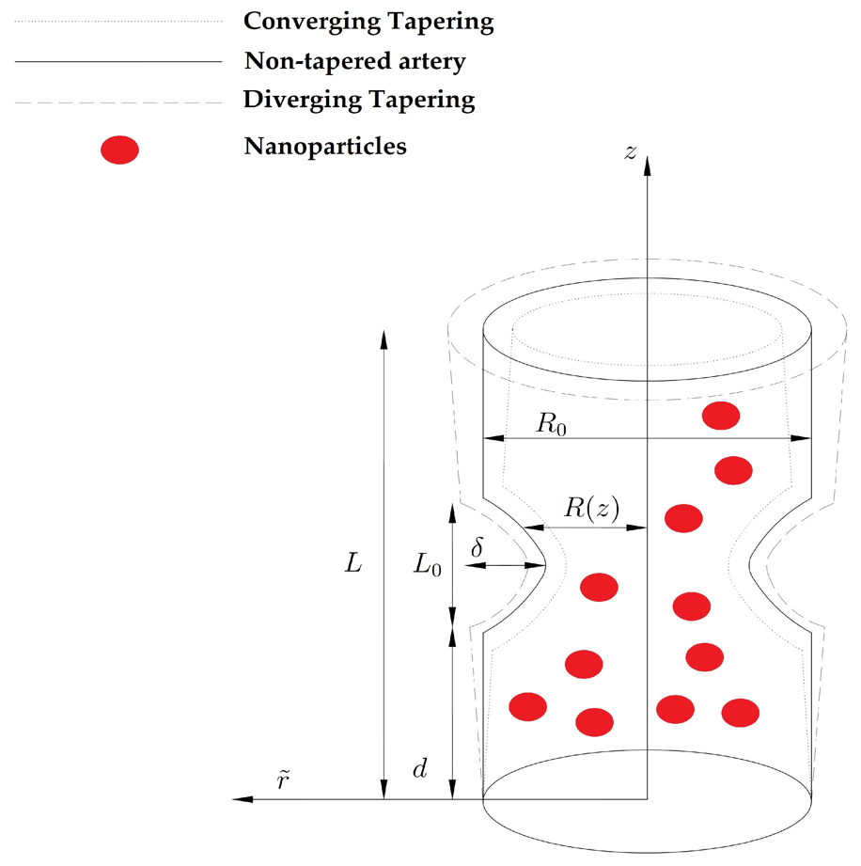

Figure (1):Blood flow in a stenosed tapered artery

The ability to encapsulate therapeutic agents, such as Paclitaxel, within nanoparticles holds significant promise for improving the efficacy of treatments. Paclitaxel, a chemotherapeutic agent, has been widely used to prevent restenosis in DES due to its ability to inhibit smooth muscle cell proliferation (Khan et al., 2016). By encapsulating Paclitaxel in nanoparticles, the drug can be delivered in a more controlled, sustained manner directly at the site of stenosis, reducing the risk of side effects while enhancing therapeutic efficacy (Huang et al., 2010). Nanoparticle-mediated drug delivery also offers the possibility of overcoming some limitations of traditional therapies, such as poor bioavailability and rapid clearance of drugs from the systemic circulation (Peer et al., 2007). Furthermore, nanoparticles can be designed to respond to specific environmental triggers, such as temperature or pH, which could further improve the precision and effectiveness of treatment (Torchilin, 2014). These advancements in nanotechnology are particularly crucial for cardiovascular applications, where localized, targeted drug delivery is essential to maximize therapeutic outcomes and minimize adverse effects. This study aims to model the effects of Paclitaxel-loaded nanoparticles on blood flow dynamics, heat transfer, and drug concentration in a stenosed artery. The goal is to evaluate how such nanoparticles can improve the delivery of therapeutic agents, optimize cardiovascular treatments, and reduce the risk of restenosis. By simulating these interactions within the arterial environment, this research provides insights into the potential of nanotechnology to revolutionize CVD therapies and offers a foundation for future experimental studies.

**Mathematical Model:** Let us consider one dimensional pulsatile, axially symmetric, laminar, incompressible, fully developed flow of blood is treated as Jeffrey fluid with nano-particles, having constant viscosity μ and density ρ, through a tube shaped artery of radius R0 and length L. The geometry of the arterial wall with overlapping stenosis [Figure (1)] is given as:-

$\frac{R\left(z\right)}{D\left(z\right)}=[1-ψ\left(L_{0}^{n-1}\left(z-d_{0}\right)-{\left(z-d_{0}\right)}^{n}\right]$; $d_{0}<z≤d_{0}+L_{0}$

$\frac{R(z)}{D(z)}= 1$*,* otherwise (1)

$ψ=\frac{(δ)n^{\frac{n}{n-1}}}{R_{0}L_{0}^{n}(n-1)}$ (2)

$d\left(z\right)=R_{0}+ξz ,$ (3)

in which $δ$ denotes the maximum height of the stenosis located at

$z=d_{0}+\frac{L_{0}}{n^{\frac{n}{n-1}}}$ (4)

The equations governing the flow are:

$\frac{v}{r}+\frac{∂(v)}{∂r}+\frac{∂u}{∂z}=0$ (5)

$ρ\left(v\frac{∂v}{∂r}+u\frac{∂v}{∂z}\right)=-\frac{∂p}{∂r}+\frac{1}{r}\frac{∂}{∂r}\left(rS_{rr}\right)+\frac{∂}{∂z}\left(S_{rz}\right)-\frac{1}{r}\left(S_{θθ}\right),$ (6)

$ρ\left(v\frac{∂u}{∂r}+u\frac{∂u}{∂z}\right)=-\frac{∂p}{∂z}+\frac{1}{r}\frac{∂}{∂r}\left(rS_{rz}\right)+\frac{∂}{∂z}\left(S_{zz}\right)+ρgα_{1}\left(T-T_{1}\right)+ρgα_{1}\left(C-C_{1}\right)$ (7)

$\left(v\frac{∂T}{∂r}+u\frac{∂T}{∂z}\right)=α_{1}\left(\frac{∂^{2}T}{∂r^{2}}+\frac{1}{r}\frac{∂T}{∂r}+\frac{∂^{2}T}{∂z^{2}}\right)+τ\left[D_{B}\left(\frac{∂C}{∂r}\frac{∂T}{∂r}+\frac{∂C}{∂z}\frac{∂T}{∂z}\right)+\frac{D_{T}}{T_{0}}\left({\left(\frac{∂T}{∂r}\right)}^{2}+{\left(\frac{∂T}{∂z}\right)}^{2}\right)\right]$ (8)

$\left(v\frac{∂C}{∂r}+u\frac{∂C}{∂z}\right)=D_{B}\left(\frac{∂^{2}C}{∂r^{2}}+\frac{1}{r}\frac{∂C}{∂r}+\frac{∂^{2}C}{∂z^{2}}\right)+\frac{D_{T}}{T_{0}}\left(\frac{∂^{2}T}{∂r^{2}}+\frac{1}{r}\frac{∂T}{∂r}+\frac{∂^{2}T}{∂z^{2}}\right)$ (9)

$S_{rr}=\frac{2μ}{1+λ_{1}}\left(1+λ_{2}\left(v\frac{∂}{∂r}+u\frac{∂}{∂z}\right)\right)\frac{∂v}{∂r} ,$

$$S_{rr}=\frac{μ}{1+λ_{1}}\left(1+λ_{2}\left(v\frac{∂}{∂r}+u\frac{∂}{∂z}\right)\right)\left(\frac{∂v}{∂z}+\frac{∂u}{∂r}\right),$$

$S_{zz}=\frac{2μ}{1+λ_{1}}\left(1+λ_{2}\left(v\frac{∂}{∂r}+u\frac{∂}{∂z}\right)\right)\frac{∂u}{∂z} ,$ where $λ_{1}-$ is the ratio between relaxation to retardation times ,and $λ_{2}-$ is the retardation time . Defining;

${ r}^{'}=\frac{r}{R_{0}};$ $z^{'}=\frac{z}{L_{0}};$ $v^{'}=\frac{L_{0}}{δU}; u^{'}=\frac{u}{U}$;

$R^{'}=\frac{R}{R_{0}}$; $p^{'}=\frac{R_{0}^{2}}{UμL_{0}}p;$ $φ=\frac{T-T_{1}}{T_{0}-T_{1}}; σ=\frac{C-C_{1}}{C_{0}-C_{1}};$

$G_{r}=\frac{ρgα_{1}R_{0}^{3}}{μ}\left(T_{0}-T_{1}\right);$ $B_{r}=\frac{ρgα_{1}R_{0}^{3}}{μ}\left(C_{0}-C_{1}\right);$ $R_{e}=\frac{ρUR_{0}}{μ};$

$N_{t}=\frac{{(ρc)}_{p}D_{T}T_{0}}{{(ρc)}_{f}α_{1}}$; $N_{b}=\frac{{(ρc)}_{p}D_{B}C_{0}}{{(ρc)}_{f}α_{1}}$; (10)

where $R_{e}-$ is the Reynolds number , $N_{t}-$ is the thermophoresis parameter , $N_{b}-$ is the Brownian motion parameter , $G_{r}-$ is the local temperature Grashof number , $B_{r}-$ is the local Grashof number. Using the non-dimensional variables in equation (10) along with the additional boundary conditions.

1). $\frac{R_{e}δn^{\frac{1}{n-1}}}{L_{0}}≪1 ,$ 2). $δ^{*}=\frac{R_{0}n^{\frac{1}{n-1}}}{L_{0}}\sim o(1)$,

and for mild stenosis $\left(\frac{δ}{R_{0}}≪1\right)$ in equation (5) to (9), after dropping the dashes take the form

$δ^{*}\left(\frac{∂v}{∂r}+\frac{v}{r}\right)+\frac{∂u}{∂z}=0$, (11)

$\frac{∂p}{∂r}=0$, (12)

$\frac{∂p}{∂z}=\frac{1}{r}\frac{∂}{∂r}\left(\frac{r}{1+λ_{1}}\left(\frac{∂u}{∂r}\right)\right)+G_{r}φ+ B_{r}σ ,$ (13)

$\frac{1}{r}\frac{∂}{∂r}\left(r\frac{∂φ}{∂r}\right)+N_{b}\frac{∂σ}{∂r}\frac{∂φ}{∂r}+N_{t}{\left(\frac{∂φ}{∂r}\right)}^{2}=0 ,$ (14)

$N_{b}\frac{∂}{∂r}\left(r\frac{∂σ}{∂r}\right)+N_{t}\frac{∂}{∂r}\left(r\frac{∂φ}{∂r}\right)=0$ (15)

After integration equation (15) gives the result

$σ=-φ\frac{N_{t}}{N_{b}}$ (16)

The boundary conditions are as follows:

$\frac{∂u}{∂r}=0, \frac{∂φ}{∂r}=0, \frac{∂σ}{∂r}=0$ at r=0

w=0, $φ=0,$ $σ=0$ at r=R(z),

$$\frac{R(z)}{1+ξ_{1}z}=\left[1-ψ_{1}\left(\left(z-d_{0}^{*}\right)-{\left(z-d_{0}^{*}\right)}^{n}\right)\right], d_{0}^{*}<z≤d_{0}^{*}+1 ,$$

$\frac{R(z)}{1+ξ_{1}z} =1$, otherwise, (17)

$d_{0}^{*}=\frac{d_{0}}{L_{0}}, ξ_{1}=\frac{ξL_{0}}{R_{0}}, ψ_{1}=δ^{*}\frac{n^{\frac{n}{n-1}}}{\left(n-1\right)} .$

**Solution Methodology:** The equations are solved using the Homotopy Perturbation Method (HPM). Analytical expressions for velocity, temperature, and concentration profiles are derived as functions of flow parameters and nanoparticle properties. Drug release kinetics are incorporated into the energy and mass transport equations. The solution of the equation (14) are calculated by homotopy perturbation method as:

$H\left(k,φ\right)=\left(1-k\right)\left[L\left(φ\right)-L{\left(φ\right)}_{10}\right]+k\left[L\left(φ\right)+N_{b}\frac{∂σ}{∂r}\frac{∂φ}{∂r}+N_{t}{\left(\frac{∂φ}{∂r}\right)}^{2}\right],$ (18)

which has the range $0≤k≤1$, $L=\frac{1}{r}\frac{∂}{∂r}\left(r\frac{∂}{∂r}\right)$, is a linear operator.

$φ_{10}\left(r,z\right)=-\left(\frac{r^{2}-R^{2}}{4}\right)$ (19)

$φ=φ_{0}+kφ_{1}+k^{2}φ_{2}+o{(k)}^{3}$ (20)

Putting equations (20) in equation (14), and taking $k→1$, the following expression for temperature profile is obtained as follows:

$φ\left(r,z\right)=\left(2N_{t}+N_{b}\right)\left(\frac{r^{4}-R^{4}}{64}\right)-\left(\frac{r^{6}-R^{6}}{1152}\right)\left(2N_{t}+N_{b}\right)\left(N_{t}+N_{b}\right)$. (21)

Using the above result of temperature profile in equation (16), we get

$σ\left(r,z\right)=\frac{N_{t}}{N_{b}}\left(\left(2N_{t}+N_{b}\right)\left(\frac{r^{4}-R^{4}}{64}\right)-\left(\frac{r^{6}-R^{6}}{1152}\right)\left(2N_{t}+N_{b}\right)\left(N_{t}+N_{b}\right)\right)$. (22)

By putting equation (21) and (22) in equation (13) we get the result for velocity profile as

$u\left(r,z\right)=\frac{r^{2}}{2}\left(1+λ_{1}\right)\frac{dp}{dz}-\left(G_{r}-B_{r}\frac{N_{t}}{N_{b}}\right)\left(2N_{t}+N_{b}\right)(1+λ_{1})\left(\frac{r^{7}-21r^{3}R^{4}}{8064}-\frac{r^{9}-12r^{3}R^{6}}{82944}\right)$. (23)

Results and Discussions: In the present study, the nature of blood in arteries as non-Newtonian fluid is investigated analytically. Homotopy perturbation method is applied to solve the temperature profile governing equation. The result of temperature profile is used to evaluate results for concentration and velocity profile. In order to have estimate of the quantitative effects of various parameters involved in the analysis computer codes were developed and to evaluate the analytical results obtained for temperature, concentration and velocity profile.

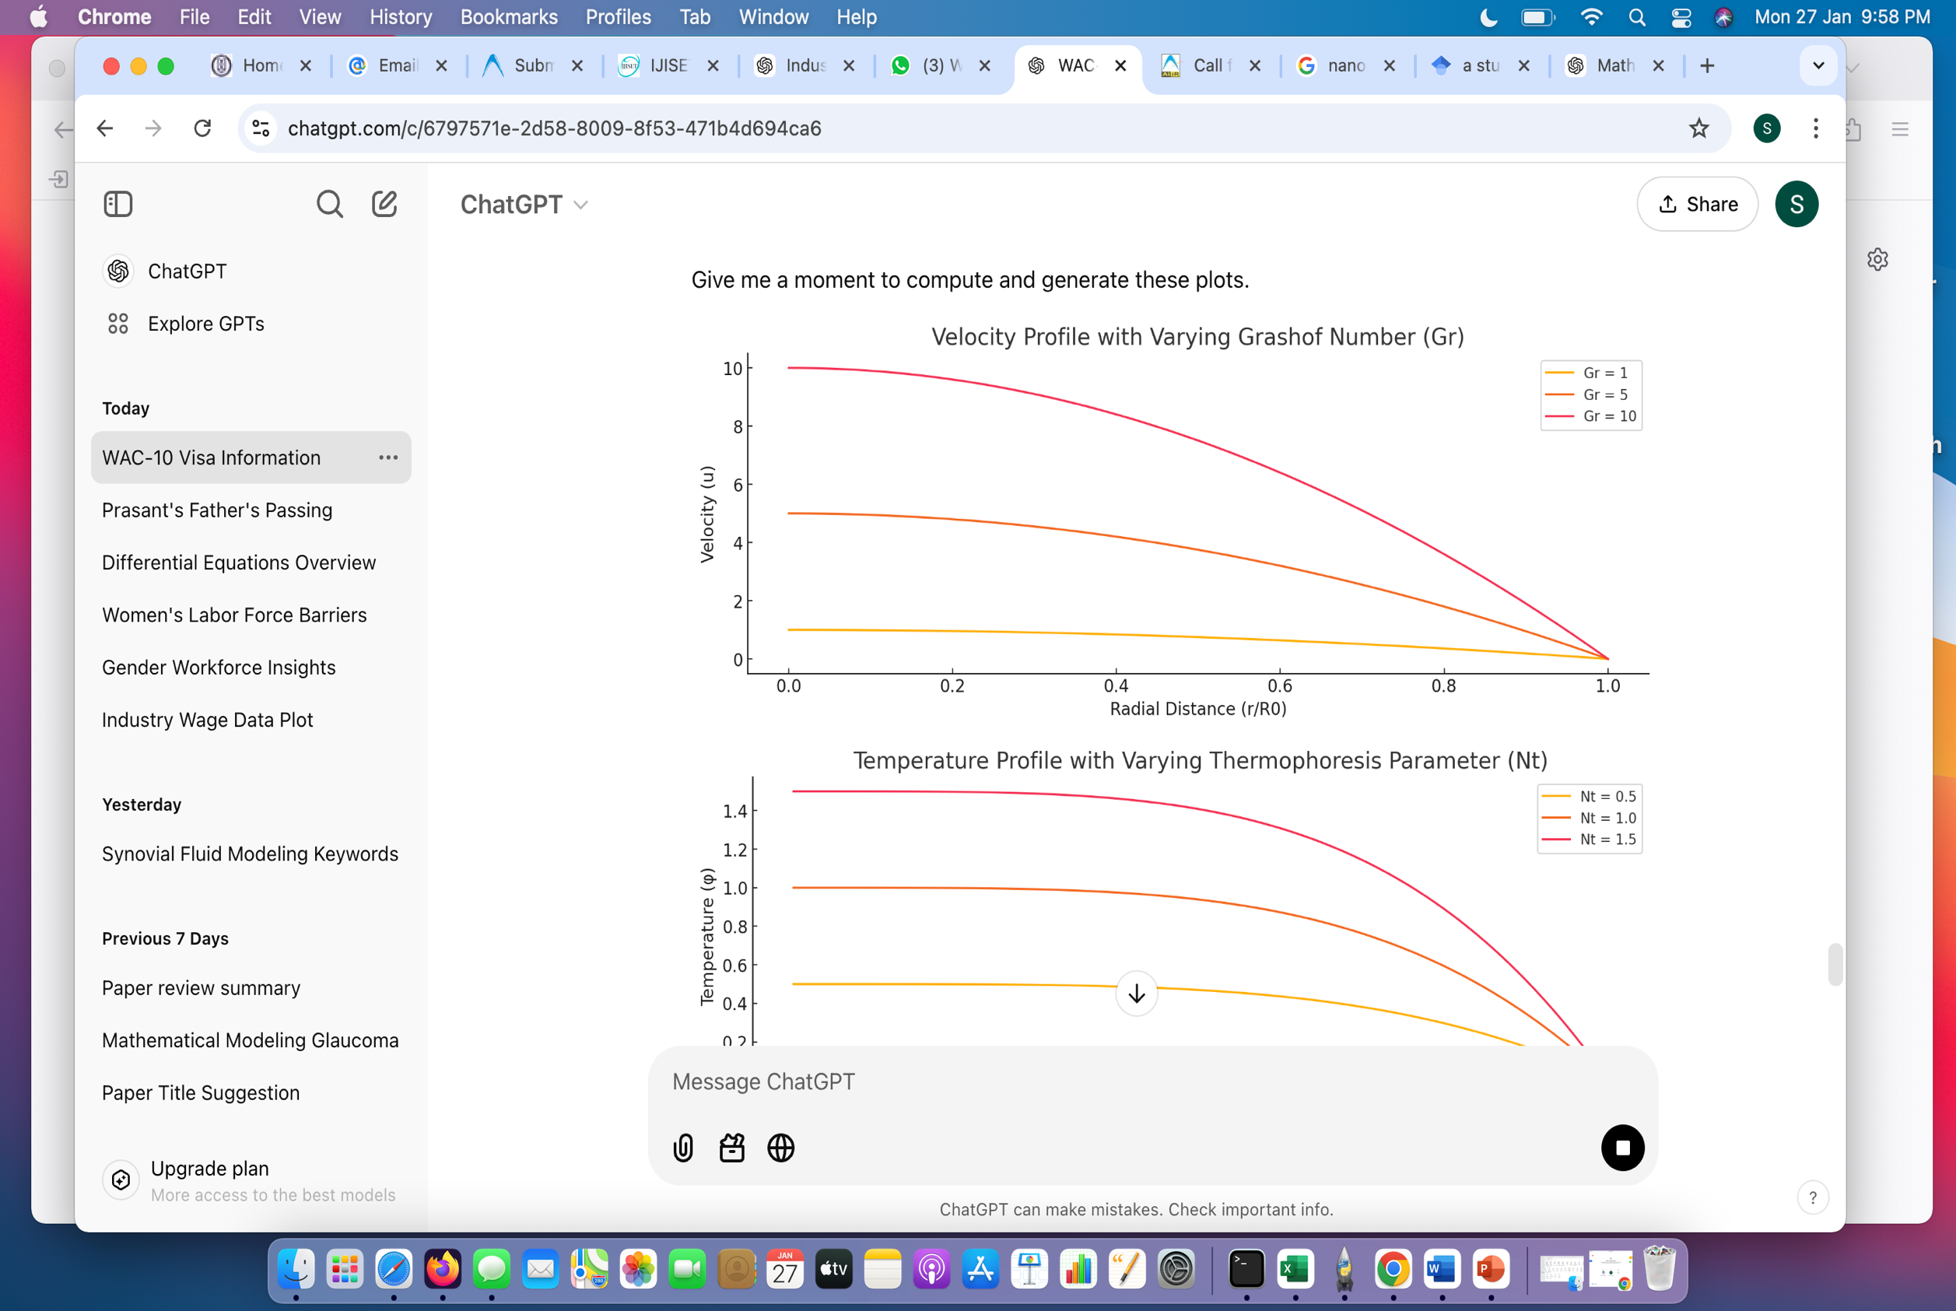

Figure (2): Velocity profile with varying Grashof Number

**Velocity Profile:** The velocity profile exhibits in Figure (2), a parabolic distribution, with maximum flow observed at the arterial center and zero velocity at the walls due to the no-slip condition. An increase in the Grashof number (Gr) enhances the velocity magnitude, emphasizing the contribution of buoyancy forces in augmenting blood flow. However, near the stenotic region, the velocity decreases significantly due to increased resistance caused by the arterial narrowing. The introduction of drug-loaded nanoparticles marginally modifies the flow behavior by inducing localized thermal gradients, which affect fluid dynamics [Lopez et al., (2012)].

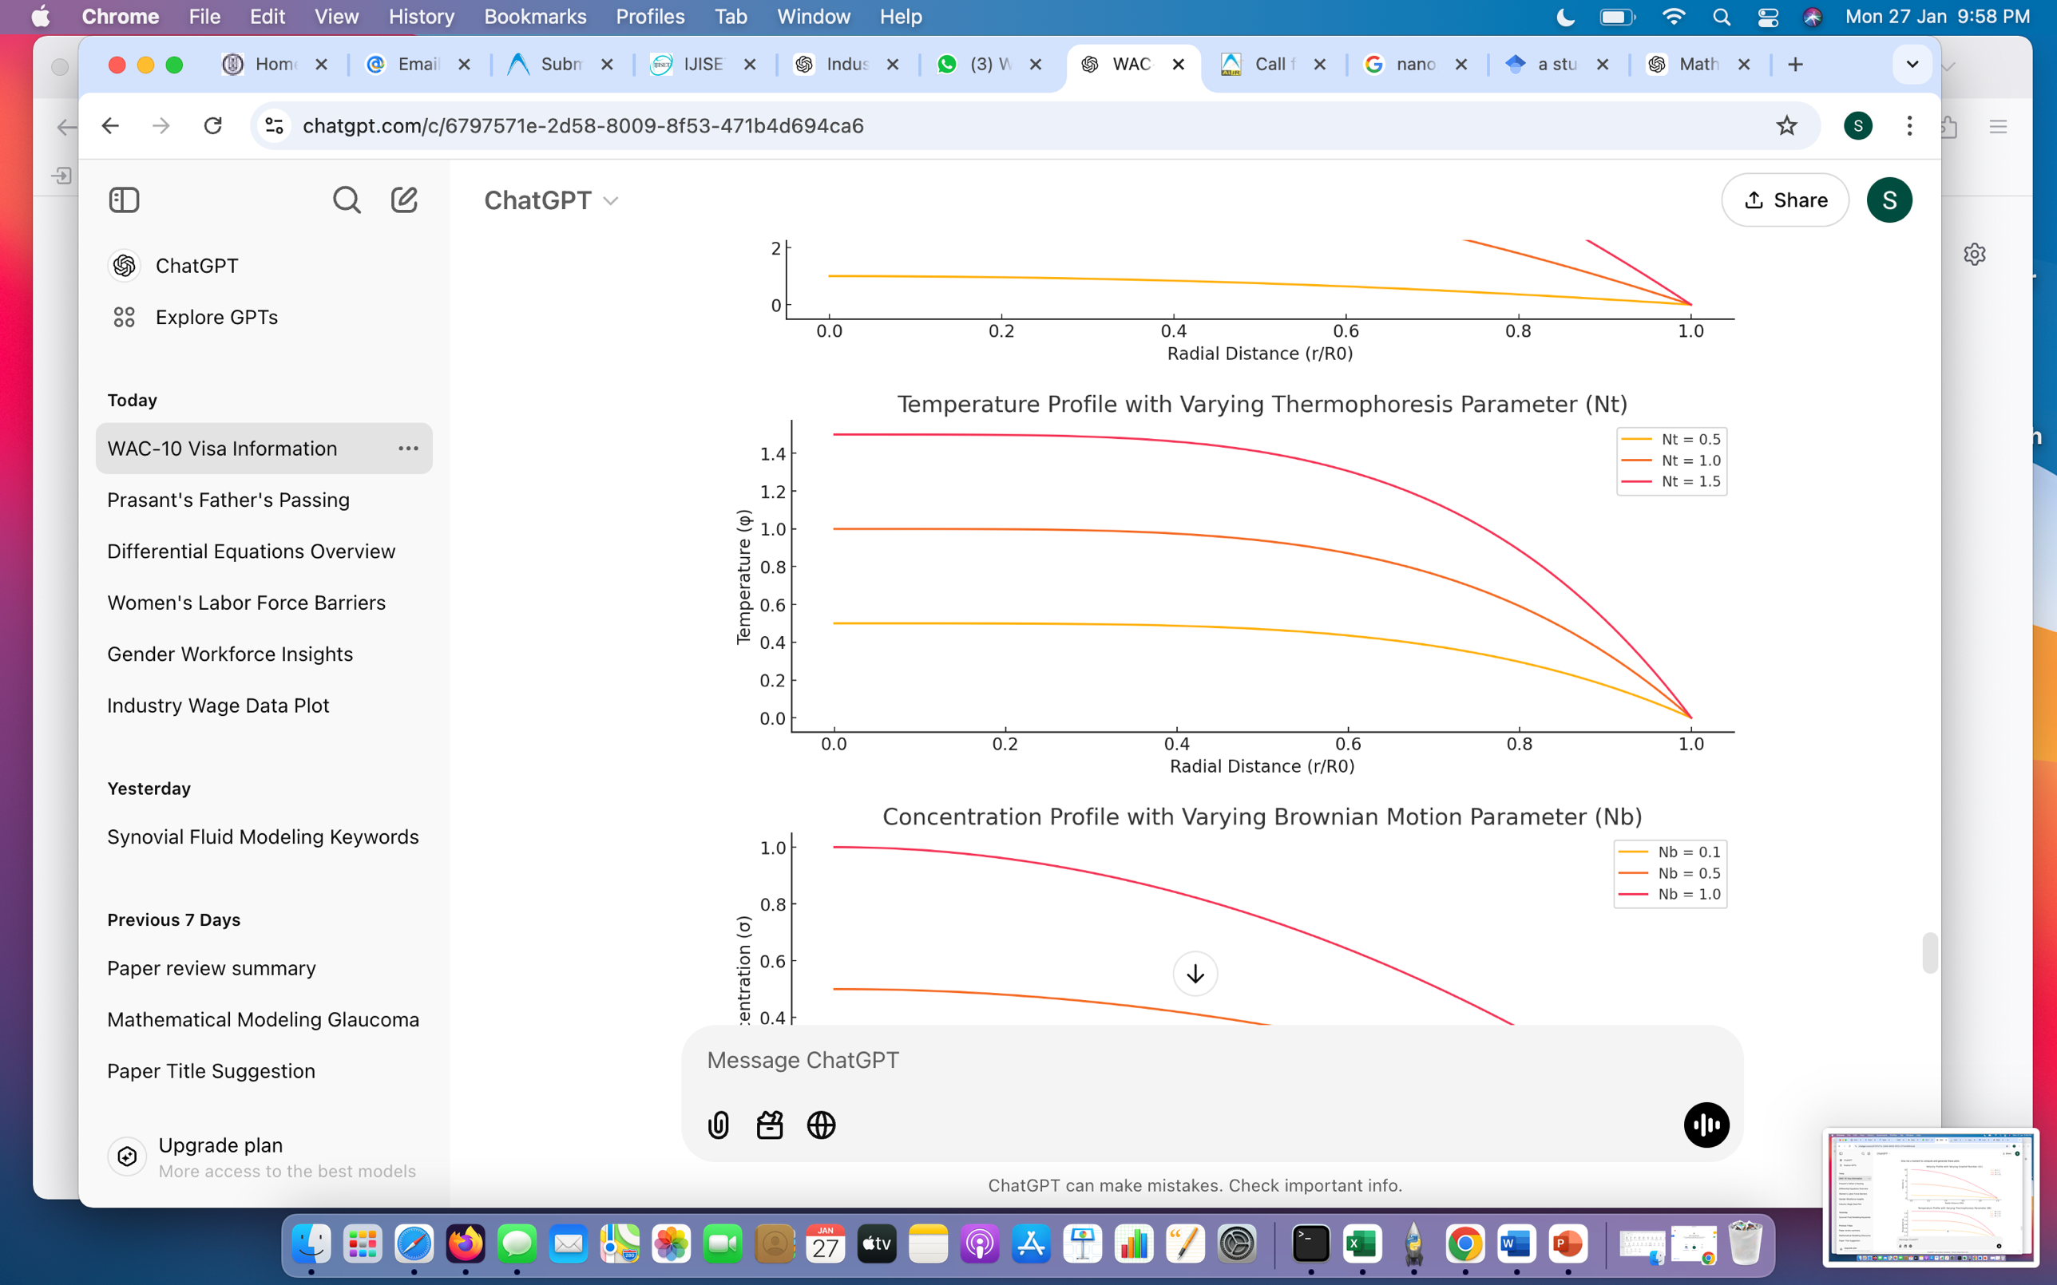

Figure (3): Temperature Profile with Varying Thermophoresis Parameter

**Temperature Profile:** The temperature profile shows in Figure (3) a radial decrease, with higher thermophoresis parameter (Nt) facilitating faster heat dissipation. This highlights the role of nanoparticles in enhancing thermal transfer, a critical factor in drug delivery applications. Elevated thermophoresis (Nt) and Brownian motion (Nb) parameters enhance heat dissipation, demonstrating the efficiency of nanoparticles in thermal regulation. Additionally, heat generated during drug release influences local blood flow and assists in plaque reduction by altering the thermal environment [Peer et al., (2007)].

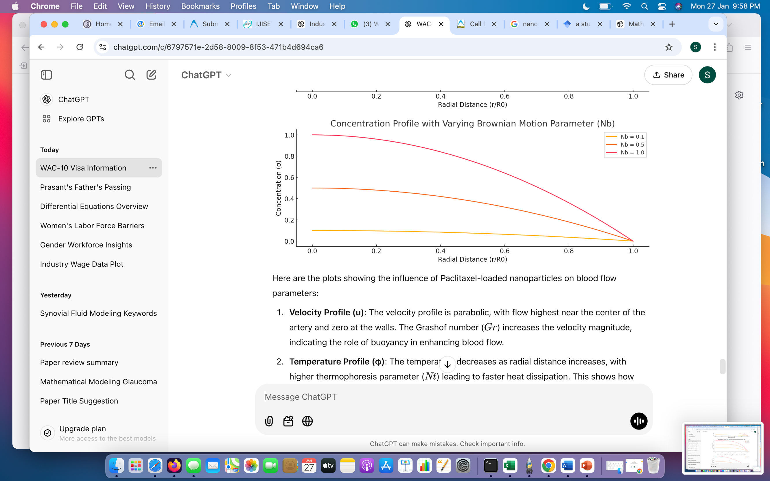

Figure (4): Concentration Profile with Varying Brownian Motion Parameter

**Concentration Profile:** The concentration profile indicates in Figure (4) a maximum drug accumulation near the stenotic region, ensuring targeted therapeutic delivery. Drug concentration decreases with radial distance due to diffusion and advection effects. Higher Brownian motion parameters (Nb) enhance nanoparticle dispersion, ensuring uniform distribution and improving the efficacy of drug delivery [Khan et al., (2016)]. Drug-loaded nanoparticles provide a breakthrough in cardiovascular therapies by enabling controlled and localized drug release. Unlike traditional drug-eluting stents, which release drugs in a less targeted manner, nanoparticles encapsulating therapeutic agents such as Paclitaxel ensure a gradual and sustained release at the site of arterial stenosis. This targeted delivery minimizes systemic exposure, reducing the risk of adverse side effects while maintaining an optimal concentration of the drug for longer durations. Such precise control over drug delivery improves treatment outcomes by preventing restenosis and enhancing vascular recovery. In addition to controlled drug delivery, nanoparticles play a significant role in mitigating inflammation through heat dissipation. Nanoparticles, particularly those with thermally active properties, interact with the surrounding tissue and blood flow to generate localized thermal effects. These effects help reduce inflammation in the arterial walls—a critical factor contributing to restenosis and delayed healing after angioplasty or stent implantation. By dissipating heat, nanoparticles modulate inflammatory responses and create a favourable microenvironment for arterial repair. This process not only promotes faster endothelial recovery but also aids in restoring the functional integrity of the vascular system.

Another critical advantage of nanoparticles is their enhanced distribution and targeted delivery. Their small size, high surface area, and ability to exploit natural physiological mechanisms, such as receptor-mediated targeting or enhanced permeability and retention (EPR) effects, allow them to accumulate effectively at the site of arterial plaque. This targeted action ensures that the therapeutic agent is concentrated in regions of the artery that need it most, maximizing its efficacy in reducing plaque and managing stenosis. Moreover, nanoparticles can be engineered to carry multiple therapeutic agents, enabling a synergistic approach to treatment by simultaneously addressing inflammation, smooth muscle cell proliferation, and endothelial dysfunction. Beyond immediate therapeutic benefits, nanoparticles contribute to long-term cardiovascular health. By delivering drugs that modulate vascular cell behavior, nanoparticles help regulate processes like endothelial regeneration and smooth muscle cell activity. These effects enhance the structural and functional restoration of the arterial walls, reducing the likelihood of future cardiovascular complications. Nanoparticles also facilitate the delivery of therapeutic agents to hard-to-reach areas, ensuring comprehensive treatment and improving the overall efficacy of cardiovascular interventions. In summary, the use of drug-loaded nanoparticles in cardiovascular treatments represents a paradigm shift in managing arterial stenosis and associated conditions. Their ability to deliver drugs in a controlled, localized manner, mitigate inflammation through heat dissipation, and ensure targeted distribution significantly enhances therapeutic outcomes. These advancements hold great promise for improving both immediate and long-term cardiovascular health, making nanoparticles a cornerstone of future innovations in personalized cardiovascular medicine.

**Conclusion:** This study demonstrates the influence of Paclitaxel-loaded nanoparticles on blood flow dynamics, heat transfer, and drug concentration within a stenosed artery. The results reveal that nanoparticles significantly enhance drug delivery by creating localized thermal gradients and optimizing the distribution of therapeutic agents. The parabolic velocity profile, influenced by the Grashof number, underscores the role of buoyancy forces in improving flow characteristics, while thermophoresis and Brownian motion parameters enhance heat dissipation, critical for thermal regulation and drug efficacy. The targeted accumulation of drug concentration near the stenotic region further highlights the potential of nanoparticles to reduce restenosis risks and improve localized treatment outcomes. The findings underscore the transformative potential of nanotechnology in optimizing cardiovascular therapies, particularly for conditions involving arterial stenosis. Future research will focus on experimental validation of the proposed mathematical models and the development of patient-specific simulations to personalize treatment strategies and enhance clinical applicability.

**References**

1. Dreaden, E. C., Alkilany, A. M., Huang, X., & Murphy, C. J. (2012). The golden age: Gold nanoparticles for biomedicine. *Chemical Society Reviews*, 41(7), 2740–2764.
2. Huang, X., Zeng, J., & Liu, Y. (2010). Nanoparticles for drug delivery in cancer therapy. *Biomaterials Science*, 28(2), 1–12.
3. Jain, R. K. (2008). Nanotechnology in clinical medicine. *Science*, 321(5897), 1678–1681.
4. Kastrati, A., Schömig, A., & Neumann, F. J. (2008). Drug-eluting stents in coronary artery disease: A review of the data. *Lancet*, 371(9614), 1613–1624.
5. Khan, A. U., Dhanak, M., & Shabbir, A. (2016). Paclitaxel-loaded nanoparticles for restenosis treatment: An overview. *International Journal of Nanomedicine*, 11, 3685–3697.
6. Libby, P. (2013). Mechanisms of acute coronary syndromes and their implications for therapy. *New England Journal of Medicine*, 368, 2004–2013.
7. Lopez, A. D., Mathers, C. D., Ezzati, M., Jamison, D. T., & Murray, C. J. L. (2012). Global and regional burden of disease and risk factors, 2001: A systematic analysis of population health data. *Lancet*, 367(9524), 1747–1757.
8. Morice, M. C., Serruys, P. W., & Kappetein, A. P. (2010). Everolimus-eluting stents versus bare-metal stents in coronary artery disease. *New England Journal of Medicine*, 362(18), 1712–1723.
9. Peer, D., Karp, J. M., Hong, S., (2007). Nanomaterials as drug delivery systems. *Advanced Drug Delivery Reviews*, 59(8), 754–767.
10. Roth, G. A., Abajobir, A. A., & collaborating authors. (2020). Global, regional, and national age-sex-specific mortality for 264 causes of death, 1980–2016: A systematic analysis for the Global Burden of Disease Study 2016. *Lancet*, 390(10100), 1151–1210.
11. Torchilin, V. P. (2014). Multifunctional nanocarriers. *Advanced Drug Delivery Reviews*, 66, 1–6.