**CAPTURING EVIDENCE FOR PROTECTION AND**

**ENABLING EMERGENCY CALLS**

Dr. Kavitha Soppari

Assoc. Professor and Head

Dept. of CSE (AI & ML)

ACE Engineering College

Hyderabad, India

Mrs. Jangam Bhargavi

Assistant Professor

Project Coordinator

Dept. of CSE (AI & ML)

ACE Engineering College

Hyderabad, India

Mr. Ragi Rajesh  
Assistant Professor

Project Guide

Dept. of CSE (AI & ML)

ACE Engineering College

Hyderabad, India

Erroju Vaishnavi

Student, CSE-AI&ML Dept

ACE Engineering College

Hyderabad, India

Vallapureddy Rithika Student, CSE-AI&ML Dept

ACE Engineering College

Hyderabad, India

Bobbala Bhanuprasad

Student, CSE-AI&ML Dept

ACE Engineering College

Hyderabad, India

**ABSTRACT**

A dual-function system integrating two key modules: a Spy Camera Module and a Portable SOS System, designed to enhance personal safety and surveillance in critical situations. The Portable SOS System is equipped with a panic button, which, when activated, immediately sends an emergency alert via SMS to a pre-configured contact number, informing them of the distress situation. Alongside this alert, the Spy Camera Module is triggered to begin recording video footage, storing it securely on an SD card for later review. This ensures that critical moments are captured for post-event analysis and evidence collection. A key feature of the system is the ability to stream live video from the spy cam, which is accessible remotely through a web interface. This enables real-time situation monitoring, providing responders or loved ones with instant visual updates. The SOS system's compact and portable nature makes it ideal for personal use, offering a practical solution for situations such as personal threats, accidents, or emergencies. It combines the critical functions of emergency alerting, remote monitoring, and evidence recording into a single system. It ensures that help can be summoned promptly while also documenting the event comprehensively. This fusion of surveillance and safety technology serves as an effective tool for enhancing personal security and ensuring a swift response in emergencies. **Keywords:** Personal Safety System, Spy Camera Module, Portable SOS System, Emergency Alert, Panic Button, SMS

Notification, Video Surveillance, Live Video Streaming, SD Card Storage, Post Event Analysis, Evidence Collection, Emergency Response, Real-Time Updates, Safety Technology, Accident Monitoring, Personal Threats, Integrated System.

**INTRODUCTION**

Personal safety has become a significant concern in today's fast-paced and unpredictable world. Emergencies such as harassment, accidents, and medical crises can arise without warning, often leaving individuals vulnerable and without immediate assistance. Traditional safety solutions like mobile applications or standalone surveillance devices offer partial solutions, but they fail to address the complete spectrum of needs during such situations. These include instant communication for help, real-time monitoring, and post-incident evidence collection, all in a single, reliable system. This project aims to bridge the gap by creating a comprehensive and innovative safety device. The proposed system integrates three critical functions: emergency alerting via SMS, live video streaming for real-time monitoring, and secure evidence recording for future analysis. Unlike existing solutions that rely on external devices like smartphones, this system is designed as a standalone device, ensuring uninterrupted operation even when external resources are unavailable. The device operates independently with a compact and portable design. It features a user-friendly interface for activating the system in emergencies, ensuring that even under stress, the device can be used efficiently. By combining advanced communication technology, video surveillance, and secure storage, this project provides a complete solution for personal safety and accountability.

**Background and Context of the Project**

The demand for robust personal safety systems has significantly increased due to rising incidents of harassment, accidents, and emergencies in everyday life. Existing safety measures often fall short of providing holistic solutions that ensure immediate help, real-time monitoring, and evidence documentation. This section explores the challenges in personal safety, highlights the limitations of existing wearable devices, and introduces the technologies and components chosen for the proposed solution.

The system design integrates a microcontroller (Arduino Nano/ESP32), camera module (OV7670), GSM module (SIM800L), memory card module, rechargeable battery, and panic button into a small, wearable shell with a focus on portability, simplicity, and dependability. While the camera module records video for offline storage or real-time streaming, the microcontroller serves as the processing unit, controlling inputs and outputs.The memory card module offers safe storage for recorded video, while the GSM module enables SMS communication. Long-term operation is guaranteed by a high-capacity battery, and in an emergency, the system is activated by a tactile panic button.

This system importance and drive stem from its capacity to tackle important personal safety issues by combining evidence recording, emergency alerting, and real-time monitoring into a single gadget. It seeks to provide useful documentation for legal or investigative purposes while enabling people to take decisive action in urgent circumstances.

**ARCHITECTURE**

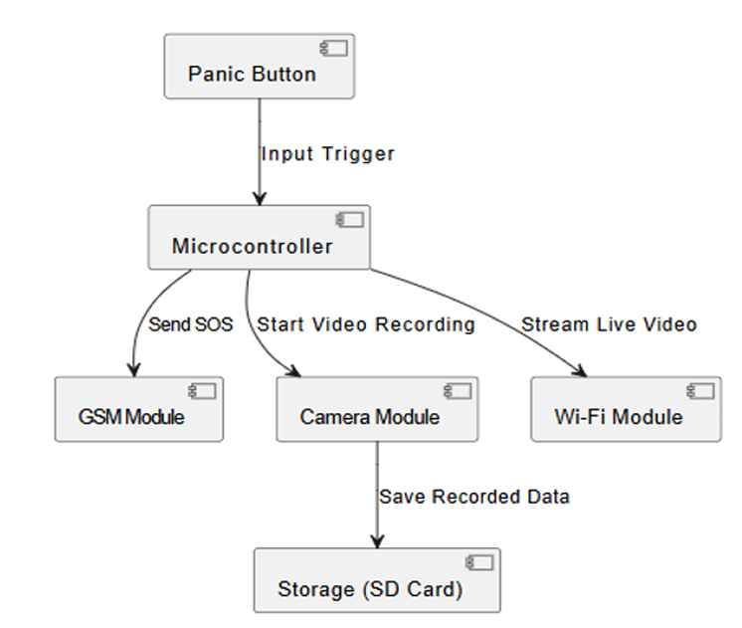

System Architecture Components The system is divided into several components:

• **Input Layer:** The input data, including medical records, demographic data, and health status, is collected from various sources like electronic health records (EHR) or user input.

• **Processing Layer:** This layer includes data preprocessing steps (e.g., missing value imputation, feature scaling), followed by model training using machine learning algorithms.

• **Output Layer:** The output includes risk predictions and recommendations, which can be presented to healthcare providers through a user interface or a report. responsiveness.

**LITERATURE REVIEW**

**Introduction to IoT-Based Smart Wearable Devices for Human Safety**

The growing interest in the application of Internet of Things (IoT) technologies has led to significant advancements in wearable devices for human safety. These devices leverage sensors and wireless communication to monitor the user’s health and environment, and provide real-time data to ensure safety and prompt emergency responses when necessary. In this section, the research papers reviewed explore various IoT-based wearable solutions for improving safety in diverse contexts, such as healthcare, outdoor activities, and workplace environments.

**Research Paper Summaries**

**[1] IoT-Based Smart Wearable Device for Human Safety (ResearchGate)**

This research discusses the design of a smart wearable IoT device aimed at enhancing human safety through real-time health monitoring and emergency response systems. The device integrates sensors for temperature, motion, and heart rate to detect anomalies such as falls, fever, or irregular heartbeats, leveraging IoT modules like Wi-Fi and Bluetooth to transmit data to cloud servers for analysis. Key contributions include a layered architecture combining hardware sensors (e.g., PPG for SpO₂ and heart rate), edge computing for data processing, and cloud-based storage for continuous health tracking. Safety features involve automated alerts to emergency contacts or medical personnel when abnormalities are detected, with GPS integration enabling precise location tracking during crises. However, challenges persist in optimizing battery life due to high power consumption from continuous wireless communication, as well as ensuring robust data encryption to protect sensitive health information during transmission. This study aligns with broader IoT-driven trends in healthcare, emphasizing remote monitoring solutions for timely interventions in emergencies.

**[2] Smart Wearable Health Monitoring System (IEEE Xplore, Paper 1)**

The research presents an IoT-enabled wearable health monitoring system designed to track physiological parameters like body temperature, heart rate, and blood pressure using integrated sensors such as PPG modules and thermistors, with data transmitted via Bluetooth or Wi-Fi to a cloud-based platform for real-time analysis. The system architecture employs layered hardware-software integration, combining wearable devices (e.g., wrist-worn sensors), edge computing units (like Raspberry Pi), and cloud servers to enable scalable data storage and remote access for healthcare providers. Key features include automated alerts for abnormalities (e.g., fever or arrhythmia) through mobile/web interfaces, GPS-enabled emergency location tracking, and cost-effective prototyping using Arduino modules and 3D-printed components. Challenges involve optimizing battery life in continuous wireless operation and balancing data security with user-friendly design for non-technical populations. By leveraging IoT communication protocols and cloud analytics, the system demonstrates practical applications in pandemic management and chronic disease monitoring while addressing scalability through modular sensor networks.

**[3] A Smart Wearable System for Monitoring Human Health (IEEE Xplore, Paper 2)**

This research presents a wearable health monitoring system integrating ECG, temperature, and motion sensors to enable continuous tracking of physiological parameters like heart rate variability, body temperature fluctuations, and movement patterns. The device employs machine learning algorithms to analyze sensor data streams for predictive health insights, detecting early signs of cardiac anomalies, falls, or stroke risks through pattern recognition in ECG waveforms and accelerometer data. Key innovations include a multi-layered architecture combining low-power Bluetooth (BLE) for wireless data transmission, cloud-based storage for longitudinal health tracking, and edge computing modules to reduce latency in emergency detection. Challenges involve balancing measurement accuracy against false alarms—addressed through high-resolution PPG signal processing—and managing data volumes via optimized REST APIs that achieved sub-300ms response times in testing. The system demonstrates applicability in elderly care by enabling contactless monitoring aligned with COVID-19 protocols, while its modular sensor design allows customization for chronic disease management. Future directions emphasize expanding sensor fusion techniques and refining ML models using larger heterogeneous datasets to improve predictive capabilities in safety-critical scenarios.

**SYSTEM REQUIREMENTS**

**Functional Requirements**

* Trigger emergency alerts via a panic button. Stream live video from the spy camera to a web interface.
* Record and store video footage securely on an SD card.
* Send SMS alerts with pre-configured messages to designated contacts.

**Hardware Requirements**

* Microcontroller: For processing and system control.
* Camera Module: For live streaming and recording.
* GSM Module: For sending SMS alerts.
* Micro SD Card Module: For secure storage of video footage.
* Wi-Fi Module: For live video streaming via a web interface.
* Power Supply: Battery-operated for portability.

**Software Requirements**

* Embedded C/C++: For microcontroller programming.
* Web Interface: For live video streaming and remote monitoring.
* File System Support: For storing video files on the SD card.

**Conclusion**

AURA - The Evidence Capturer is an advanced personal safety device designed to provide immediate assistance in emergency situations. It seamlessly integrates SOS alerting, real-time monitoring, and evidence recording into a compact and portable form factor. Unlike conventional safety devices, AURA not only enables rapid emergency responses but also securely captures and stores crucial evidence, ensuring accountability and facilitating legal proceedings if necessary. By addressing the limitations of existing safety solutions, AURA enhances personal security with a proactive approach. With future advancements, it has the potential to become a cutting-edge safety tool, offering users a heightened sense of security and peace of mind in any situation.

**REFERENCES**

[1] Dongare Uma, Vyavahare Vishakha and Raut Ravina, “An Android Application for Women Safety Based on Voice Recognition”, Department of Computer Sciences BSIOTR wagholi, Savitribai Phule Pune University India, ISSN 2320–088X International Journal of Computer Science and Mobile Computing (IJCSMC) online at www.ijcsmc.com,Vol.4 Issue.3, pg. 216-220, March- 2015

[2] MAGESH KUMAR.S and RAJ KUMAR.M, “IPROB – EMERGENCY APPLICATION FOR WOMEN”, Department of Computer science Sree Krishna College of Engineering Unai village Vellore (TN) India, ISSN 2250-3153 International Journal of Scientific and Research Publications, online at the link www.ijsrp.org , Volume 4, Issue 3, March 2014.

[3] Vaijayanti Pawar, Prof. N.R.Wankhade, Dipika Nikam, Kanchan Jadhav and Neha Pathak, “SCIWARS Android Application for Women Safety”, Department of Computer Engineering, Late G.N.S.COE Nasik India, ISSN: 2248-9622 International Journal of Engineering Research and Applications Online at the link www.ijera.com, Volume 4, Issue 3(Version 1), pp.823 826, March 2014.